Django

python manage.py createsuperuser

1，更新python3

python -V查看

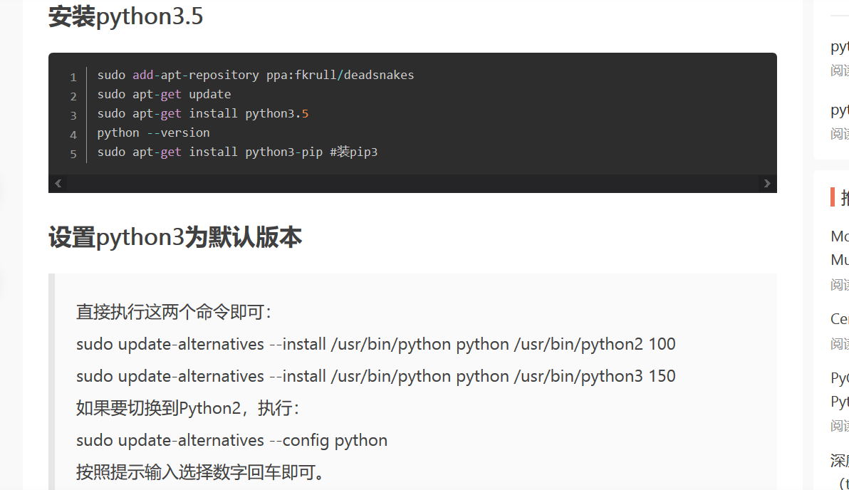

4，安装mysql

安装mysql:

报错：就

sudo apt-get install python3.6-dev libmysqlclient-dev

*sudo apt-get install mysql-server mysql-client*

然后mysql -V查看mysql是否安装成功

sudo apt-get install libmysqlclient-dev python3-dev

然后

pip install mysqlclient就不会报错找不到'mysql_config'了

mysql -u root -p

sudo service mysql restart

修改编码 l两个地方

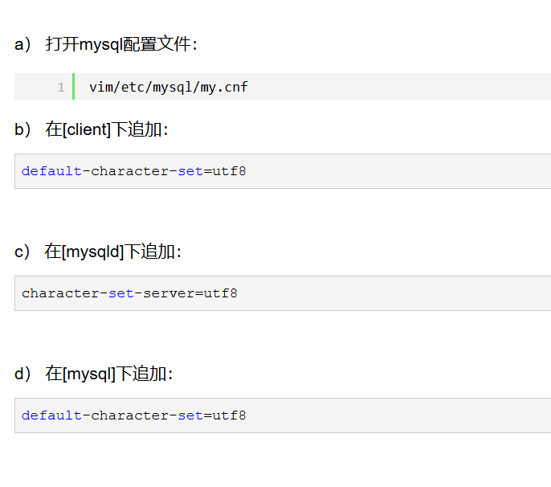

2，安装uwisg

启动uwsgi -d --ini uwsgi.ini

uwsgi --stop uwsgi.pid

uwsgi --reload uwsgi.pid

配置文件

#[uwsgi]

#socket = 127.0.0.1:8000

#chdir = /home/test1

#wsgi-file=test1/wsgi.py

#processes=4

#threads=2

#master = True

#pidfile=uwsgi.pid

#daemonize = uwsgi.log

[uwsgi]

chdir = /home/test1

module = test1.wsgi:application

socket = 127.0.0.1:8000

master = true

daemonize = /home/test1/run.log

disable-logging = true

wsgi-file = /home/test1/test1/wsgi.py

pidfile=/home/test1/uwsgi.pid

3，安装Nginx

sudo apt-get update

sudo apt-get install nginx

• 重启Nginx (sudo) service nginx restart

• 启动Nginx (sudo) service nginx start

• 停止Nginx (sudo) service nginx stop

更改上传文件大小

打开配置文件default，路径/etc/nginx/sites-available/default

配置文件

##

##

# You should look at the following URL's in order to grasp a solid understanding

# of Nginx configuration files in order to fully unleash the power of Nginx.

# http://wiki.nginx.org/Pitfalls

# http://wiki.nginx.org/QuickStart

# http://wiki.nginx.org/Configuration

#

# Generally, you will want to move this file somewhere, and start with a clean

# file but keep this around for reference. Or just disable in sites-enabled.

#

# Please see /usr/share/doc/nginx-doc/examples/ for more detailed examples.

##

# Default server configuration

#

server {

listen 80 default_server;

listen [::]:80 default_server;

# SSL configuration

#

# listen 443 ssl default_server;

# listen [::]:443 ssl default_server;

#

# Note: You should disable gzip for SSL traffic.

# See: https://bugs.debian.org/773332

#

# Read up on ssl_ciphers to ensure a secure configuration.

# See: https://bugs.debian.org/765782

#

# Self signed certs generated by the ssl-cert package

# Don't use them in a production server!

#

# include snippets/snakeoil.conf;

root /var/www/html;

# Add index.php to the list if you are using PHP

index index.html index.htm index.nginx-debian.html;

server_name 101.132.227.130 ;

location / {

# First attempt to serve request as file, then

# as directory, then fall back to displaying a 404.

#try_files $uri $uri/ =404;

include uwsgi_params;

uwsgi_pass 127.0.0.1:8000;

}

location /static {

alias /home/static;

}

location /media {

alias /home/test1/media;

}

}

# Virtual Host configuration for example.com

#

# You can move that to a different file under sites-available/ and symlink that

# to sites-enabled/ to enable it.

#

#server {

# listen 80;

# listen [::]:80;

#

# server_name example.com;

#

# root /var/www/example.com;

# index index.html;

#

# location / {

# try_files $uri $uri/ =404;

# }

#}

5，安装项目的相关库

根目录pip install -r plist.txt

收集静态文件

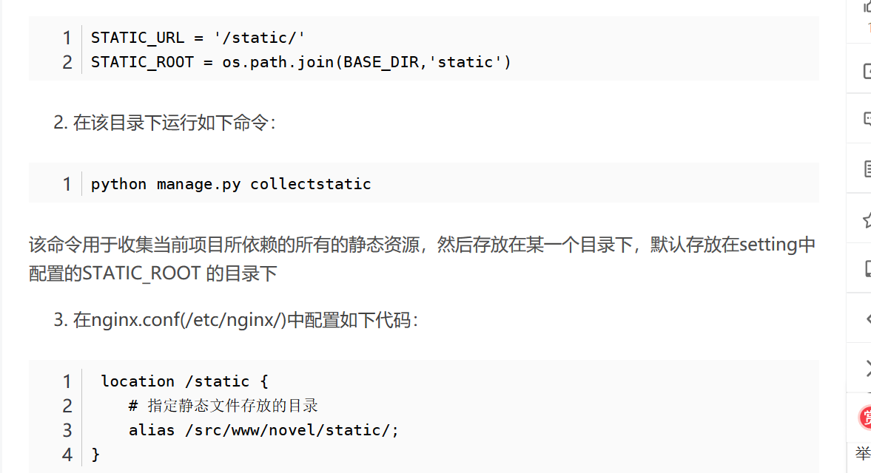

python manage.py runserver 0.0.0.0:8000

python manage.py makemigrations

python manage.py migrate

python manage.py createsuperuser

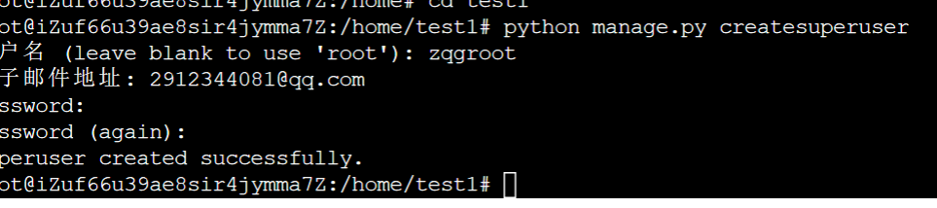

Ps：Zqg666666