Day 4 Instructions

# Story

Your boss at the Department of Aetherial Incidents Investigation inspected your report and has made a few changes. He uses the Track Changes system in Word.

# Part 1: Accept or Reject your Boss’ Changes

1. Turn on Track Changes.
2. Accept all changes to the Table, as well as all changes in Section 2, Section 6, Figure 1 Caption, Contribution Notes, and Acknowledgement.
3. In Section 6, remove “for the illiterate”. Seriously, Victor, what’s wrong with you? (He’s a high elf, that’s why.)
4. Reject all changes in Section 3.

# Part 2: Create a SmartArt to illustrate the situation.

1. Below Section 6, create a SmartArt that looks like this (use the Relationship -> Converging Radial style):

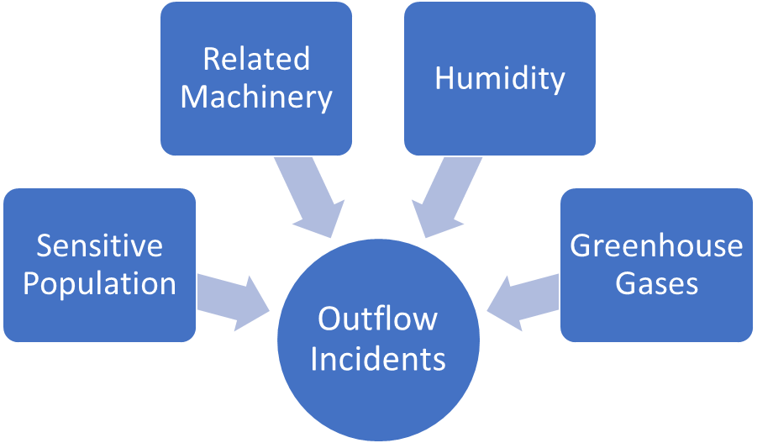

1. Add a caption “Factors affecting frequency and severity of Aetherian Outflows”
2. Replace {Fig. XX} added by Talius with an actual cross-reference.

# Part 3: Work with him.

1. Read the comments made by your incident handling commander, Victor Talius.
2. After you resolve each of his comment, click on “Resolve”.
3. Update the Table of Contents and Table of Figures.
4. Turn off Track Changes.

**Report Title: Regarding the current Aetherian Outflow Incident in Whitemarsh.**

Authors: YOUR NAME[1], Victor Talius[2]

1. Faculty of Education, Chandrakasem Rajabhat University
2. Department of Magical and Aether Control, Vesteria Civil Government

Table of Contents

Table of Contents 1

Section 1: Introduction 2

Section 2: Nature of Aetherian Outflows 2

Subsection 2A: What causes Aetherian Pressure? 2

Subsection 2B: Hazards created by Aetherian Outflows 2

Subsection 2C: Previous Incidents 2

Section 3: Damage Report at Whitemarsh 3

Section 4: Situation Control 3

Subsection 4A: Refugee Camps 3

Section 4B: Outflow Redirection 4

Section 5: True Cause of Outflows in Whitemarsh 4

References 5

# Table of Figures

Figure 1 List of cases during each major Aetherian Outflow Incident 3

Figure 2 Triage Assessment Flowchart 4

# Section 1: Introduction

Whitemarsh is one of the most magically volatile areas of the Vesteria Kingdom and is extremely prone to various forms of Aether-related incidents. So far, we have detected a controllable level of Aetherian fluctuation. However, due to recent disturbances in Aetherian projections in the Whitemarsh area, there is a very high level of Aetherian Outflow out of Whitemarsh.

# Section 2: Nature of Aetherian Outflows

Aether works just like air, having pressure and similar properties that can be considered parallel to conventional physics. When there is a high level of Aether pressure in an area, the Aether diffuses towards areas with lower pressure.

## Subsection 2A: What causes Aetherian Pressure?

Although it is known that Aether is generated by using any form of magic, manmade levels of pressure are not enough to cause outflows that would affect entire regions or cause medical complications.

## Subsection 2B: Hazards created by Aetherian Outflows

Flux of Aether happens all the time, everywhere, because it is impossible for Aether to be equally pressurized. Unlike wind, Aether flows create stress on biological beings capable of utilizing Aether, i.e., *magical* people and animals. Generally, lower flux levels do not cause serious stress, but greater Aether flux can overwhelm people and animals and can potentially affect non-magical beings as well. (Remember that there is no such thing as a completely non-magical human.)

In addition to biological damages, physical damages can also occur with Aether-sensitive devices. If possible, the mana cores should be removed during severe Aetherian outflows.

## Subsection 2C: Previous Incidents

Previous incidents have occurred in places such as the Great Forest (containing a sylph settlement), the Elven Rock, and even unlikely places like Orsimus, the capital of the orcs, as shown in Figure 1.

Figure Number of cases during each major Aetherian Outflow Incident

It is noteworthy that although the Elven Rock outflow event triggered medical cases in fewer sentient beings (humans, elves, etc.) compared to the recent Whitemarsh incident, it is noteworthy that Elven Rock has much less population. In contrary, the infrastructure damage was considerably higher in … due to the prevalence of magical instruments used by the elves.

# Section 3: Damage Report at Whitemarsh

All three villages around Whitemarsh were evacuated as all sentients, regardless of magical status and race[1], were disturbed by the incident. Catastrophically, the Outflow has also triggered apparitions of spirits that aggressively attack humans, livestock, and property alike. Although no deaths have been reported yet, the medical complaints and insurance claims are rising day by day.

# Section 4: Situation Control

The Whitemarsh regional government and Vesteria national government have responded as described in the following subsections.

## Subsection 4A: Refugee Camps

The Whitemarsh Guards were dispatched into the area, helping set up various refugee camps. Food is adequate, but due to Whitemarsh waters being highly toxic in general [2], carts of water barrels have to be brought in from the surrounding areas. The lords of the nearby castles are charging a high price to bring water out of their domains, but this is the best option we have right now.

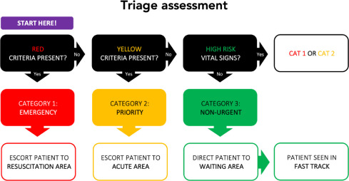

Figure Triage Assessment Flowchart

We have triaged most of the casualty following the methods shown in Figure 2 above (Mitchell, et al., 2021). The triage situation is shown in Table 1 below. Most of the “Green” casualty were already dismissed.

Table Triaging situation in Whitemarsh

|  |  |  |  |
| --- | --- | --- | --- |
| Village or Municipality | Red | Yellow | Green |
| Agorastan | 80 | 121 | 15 |
| Death Swamp | 140 | 90 | 5 |
| Blue Shrine | - | 22 | 40 |
| Makilash | 10 | 10 | 43 |
| Urshilaku | 1 | 10 | 26 |
| Vorost | - | 12 | 40 |



## Section 4B: Outflow Redirection

Professor Tobias from the Aether Institute has spearheaded a preliminary outflow redirection using Aether Stream Pylons, creating an artificial upward flux. This helps displace at least 80% of the Outflow upwards, reducing immediate adverse effects (Tobias, 1018).

# Section 5: True Cause of Outflows in Whitemarsh

Together with the Security Council, we have investigated the Outflows and have determined that the area naturally has a stronger underground presence of Aether. While this Aether usually disperses normally, the recent development of swamp gas extraction machines around Whitemarsh has affected the natural dispersion channels, causing a blockage in the normal flow. This blockage in turn creates a buildup of Aether Outflow that violently bursts like a broken pipe once sufficient underground pressure is reached.

However, we have yet to fully investigate the reason behind the underground pressure itself. As explained, manmade Aether flow is usually insufficient to affect beings, but in this case of a long-term buildup, even a small Aether emitter can cause enough pressure if left over time.

# Section 6: Predicting and Handling Future Outflow Incidents

Although the reasons remain unclear, we have determined a few variables that could be predicted. First, we have determined that the presence of Aether-sensitive population and Aether-related machinery both contribute to the frequency and severity of Outflows. Second, the type of terrain matters, as humid areas tend to trigger Outflows more frequently. Third, it has also been confirmed that the Outflows can be caused by a very high level of gasses known to the common civilizations as “Greenhouse Gases” or GHGs. The factors are illustrated for the illiterate in {Fig. XX}.

# References

Mitchell, R., Bue, O., Nou, G., Taumomoa, J., Vagoli, W., Jack, S., . . . Cameron, P. (2021). Validation of the Interagency Integrated Triage Tool in a resource-limited, urban emergency department in Papua New Guinea: a pilot study. *The Lancet Regional Health – Western Pacific*.

Tobias, P. (1018). Aetherian Outflow Redirection using Aether Stream Pylons. *Aetherian Studies Journal*, 200-205.

# Ethics Statement

The first author did most of the report write-up, corrections, and formatting in Microsoft Word. VT was the incident handling commander. This work uses aggregated human data and therefore does not require a separate human experiment review. All authors contributed to the final review of the paper and have no conflicts of interest.

# Acknowledgement

VT has received on-going funding from the Aether Science Institute. The fund from the ASI was partially used in this investigation. VT also expresses his gratitude to Chandrakasem Rajabhat University for providing manpower to help document and report the problem.

1. Including predominantly (60%) human population, followed by elves (22%) and dwarves (5%). Most others are beastfolk.
2. Toxicity caused by a high amount of methane and sulfur gases.