Rachit Bodhare

Questions:

1. Create an application and integrate sentry with it. Push error messages to the sentry

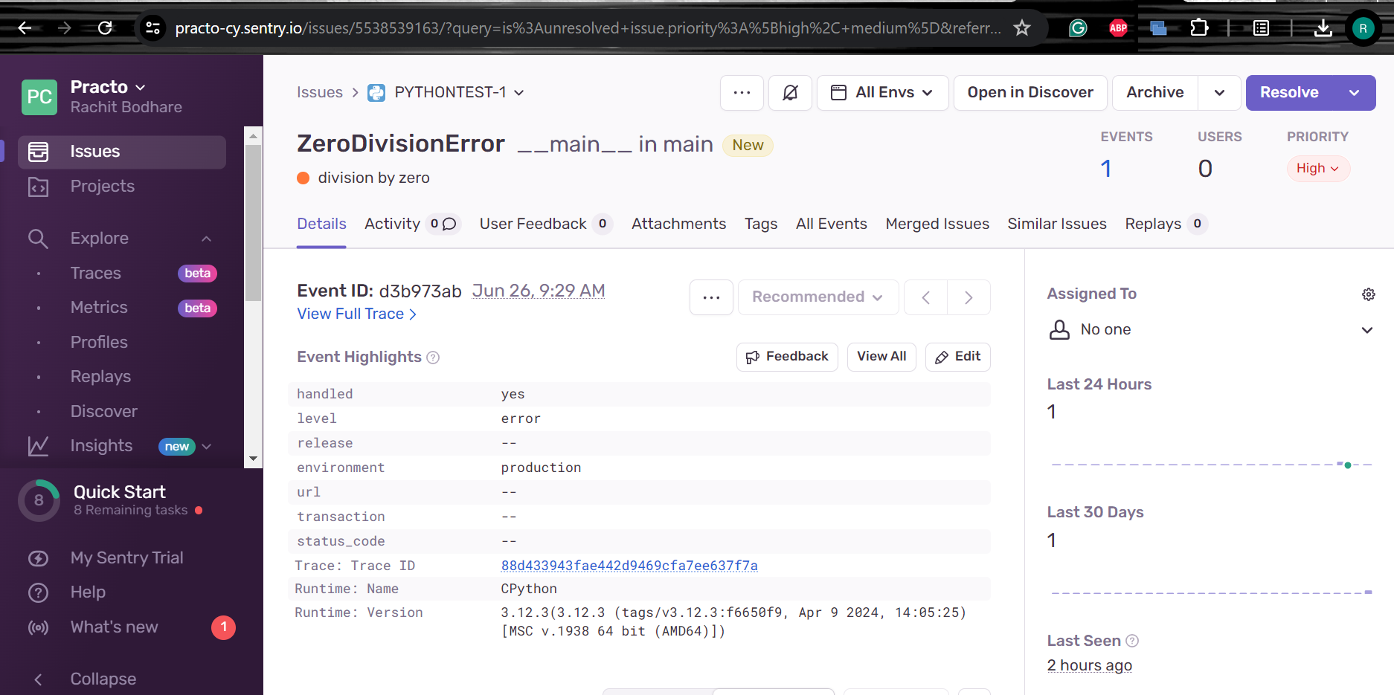

1. Mention commands for updating a staging with a particular branch for a service

Get to the desired branch

git checkout <branch_name>

pull the latest changes

git pull origin <branch_name>

Update staging environment

docker-compose down

docker-compose up -d –build

1. Command for starting a staging

To start staging environment:

docker-compose up -d

1. Create a staging with the services: Accounts, nav, Communicator, Ray-app, Ray-api, QMS, Store  
   The deployment of one product will fail, explain why the deployment has failed