Rachit Bodhare

ERD image:

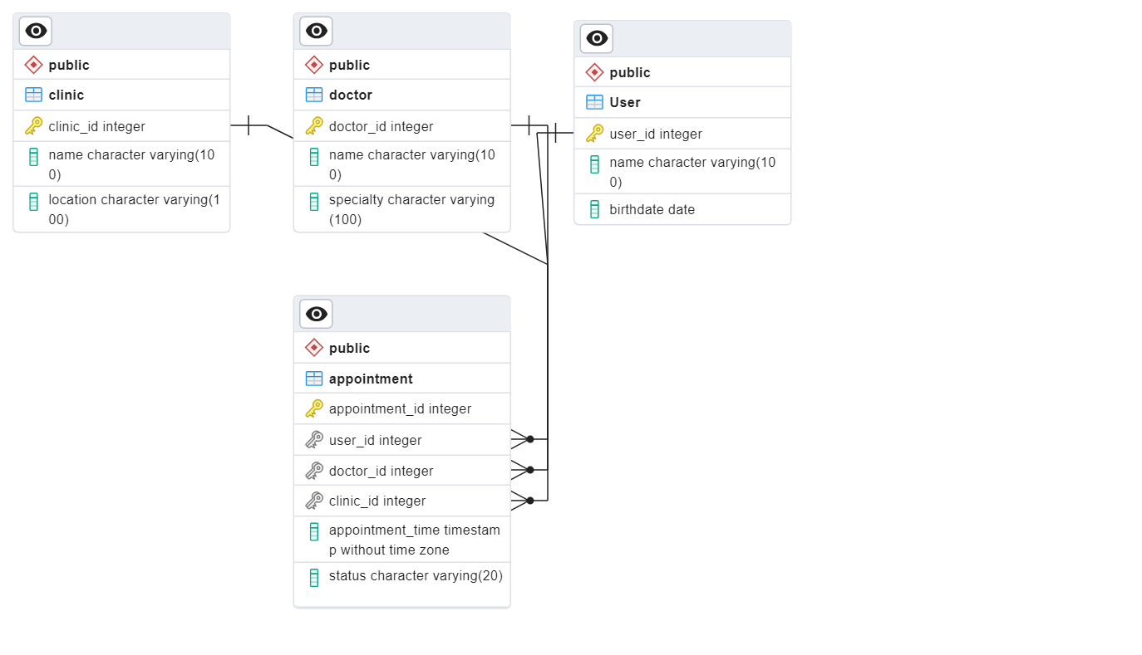

Query 1 Execution:

Query 1 Explain Analyze:

Query 2 Execution:

Query 2 Explain Analyze:

Query 3 Execution:

Query 3 Explain Analyze:

Query 4 Execution:

Query 4 Explain Analyze:

Query 5 Execution:

Query 5 Explain Analyze:

