Hotel Reservation System
Software Requirements Document
V 1.0


 | Prepared By | Reviewed by | Approved By
Name | Rajeshwar Chary
Role | Team member | Project Leader/ Team Leader/ Team Member | Project Manager/ Team Leader
Signature | VS
Date | 12/15/2014

Table of Contents
1 Introduction 3
1.1 About this document 3
1.1.1 Purpose & Scope of the document 3
1.1.2 Intended Audience 3
1.2 About the Software System 3
1.2.1 Scope of the system 3
1.2.2 System Perspective 4
1.2.3 System diagram 4
1.2.4 System Environment 5
1.2.5 User Characteristics 5
1.2.6 Impact of the System 5
1.2.7 Assumptions, Risks / Constraints 6
1.2.8 Design Constraints 6
2 System Requirements 7
2.1 Functional Requirements 7
2.1.1 Add Hotels Module 8
2.1.2 Search Hotels Module 12
2.1.3 Cancel/Edit Reservations Module 16
2.1.4 Registration and Authentication Module 19
2.2 Payment Module 22
User Interface Requirements 22
User Interface Requirements 24
2.3 Nonfunctional Requirements 25
2.3.1 UI Requirements: Inn 25
2.3.2 Performance Requirements: Pnn 26
2.3.3 Installation, Deployment & Operational Requirements: Onn 26
2.3.4 Maintainability & Portability Requirements: MPnn 26
2.3.5 Security Requirements Snn: 26
3 Requirements / Use Case Summary Table 26
4 Make /Buy analysis 27
4.1 Reusable components 27
5 Annexure 27
6 Change Log 27

Introduction

About this document

Purpose & Scope of the document
The purpose of the software requirements document is to systematically capture requirements for the project and the system “Hotel Reservation System” to be developed. Both functional and non-functional requirements of this system are captured in this document. It also serves as the input for the project scoping.
The scope of this document is limited to addressing the requirements from a user, quality, and non-functional perspective. It is recommended that design aspects are not added in this document

Intended Audience
Project Team

About the Software System
The following section will cover aspects related to
Hotel Reservation System (HRS) application. HRS is a system used for managing the supply activities of different medicines to various vendors. It checks the stock updates, sales details and also helps to order medicines.

The following are the modules in this proposed system
- Add/Edit hotel details
- Reserve hotel
- Cancel and Edit Reservations
- Registration and Authentication
- Payment

Scope of the system
The scope of the system is explained through its modules as follows
- Add/Edit Hotel Details – This module will be used by administrators to register the details of a hotel into the system. The administrator should have the details of the hotels to be entered into the system. The hotel details will contain information about the hotels, rooms and rates.

- Search and Reserve Hotel -- This module will be used by customers to search for hotels based on specific criteria and Reserve the hotel.

- Cancel and Edit Reservations -. This Module will be used by the customer to Modify the existing details or cancel a Hotel Reservation.

- Registration and Authentication : This module is used by the customer to register his/her details into the system so that he/she can login into the system for reservation / cancellation of hotel booking.
- Payment - This use case will be used by customers to make payment once he has made a reservation in a particular hotel Exclusions

The system will operate only on the modules discussed above and will not include any additional functionality.
Use Case Diagram
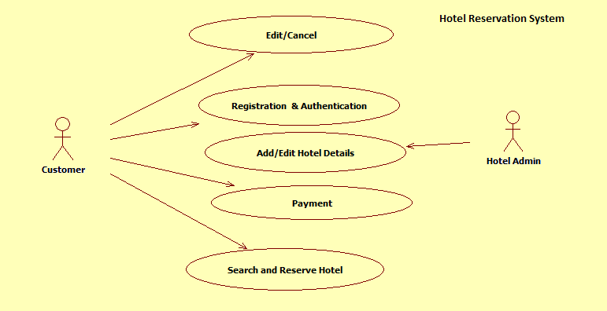

System Perspective
The HRS is an independent software system developed to manage the activities like Adding or Editing New Hotels, Customer Registration, Search and Reserve Hotels, Payment, Editing and Canceling reservation details etc., using the Java/Dotnet architecture.

System diagram

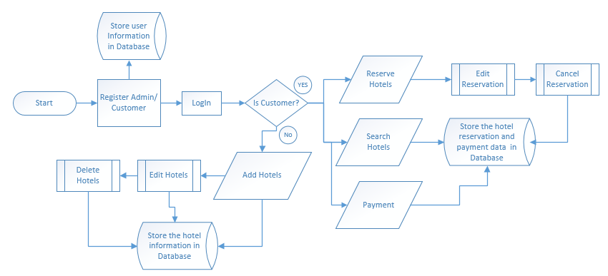

System Environment
The “HRS” application will be operated from the client server with parallel processor support. When a user connects to the Web Server, the Web Server will interact with the Database after processing the business logic to transfer data to and from a database.
- Java/J2EE or .NET Framework application deployment.
- My SQL/SQL server database for data storage

Architecture diagram

Physical Architecture:
A physical architecture is an arrangement of physical elements, (system elements and physical interfaces) that provides the designed solution for a product, service, or enterprise. It is intended to satisfy logical architecture elements and system requirements. Hotel Reservation Process follows a three layered architecture namely presentation layer, business logic layer and data access layer.
- Presentation Tier is the tier in which the users interact with an application. Presentation Tier contents Shared UI code, Code Behind and Designers used to represent information to user.
- Business Tier is mainly working as the bridge between Data Tier and Presentation Tier. All the Data passes through the Business Tier before passing to the presentation Tier. Business Tier is the sum of Business Logic Layer, Data Access Layer and Value Object and other components used to add business logic.
- Data Tier is basically the server which stores all the application’s data. Data tier contents Database Tables, XML Files and other means of storing Application Data.
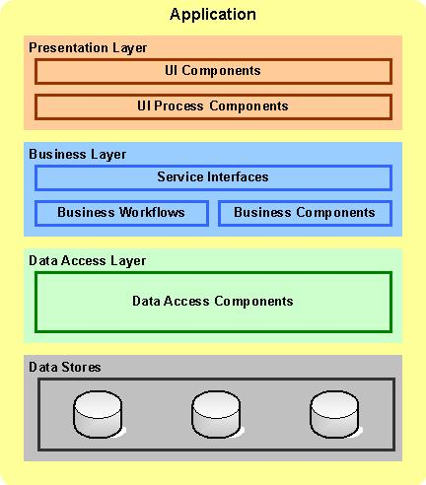

Logical Architecture:
The Logical Architecture defines the Processes (the activities and functions) that are required to provide the required User Services. Many different Processes must work together and share information to provide a User Service. The Processes can be implemented via software, hardware, or firmware. The Logical Architecture is independent of technologies and implementations.
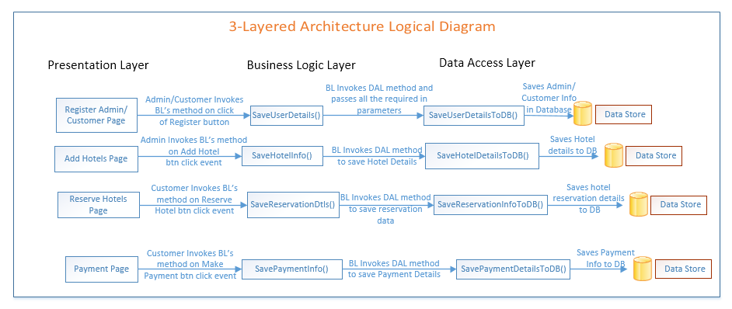

User Characteristics
The application should be user friendly; in such a way that the user would not need any software and hardware knowledge. The user may be new to the client products having never used them before.
The types of users likely to use the system are as follows,
- Client
- Delivery Assurance Group, Process Engineering group
- Developers, testers, other associates in the project

Impact of the System
This is a new product which is developed for internal users. Expected impact of the product is to automate existing manual processes in order to make them more efficient and cost effective.

Assumptions, Risks / Constraints
Assumptions:
- The processing admin must possess prior knowledge on HRS operations undertaken offline.
- The admin should have the details of the Hotels to be registered updated into the system.
Risks:
- If there is any failure in Reservation/Cancelation and payment processes, the system should be able to handle such a financial risk.

Design Constraints
- The Admin registration module and the Hotel registration modules should remain independent, without affecting Hotel Reservation System.
- Application should have single login feature. Login functionality should be the Welcome Page for the application.
- Only Hotel administrator and registered Customers can access the application.
- None of the application features can be accessed without login.

System Requirements

Functional Requirements
Hotel Reservation Process  Req-2.1.1 | Home Page
Functional Requirements |  | When the User enter the following link http://localhost:8080/HotelReservationSystem in the browser, Home page appears which will have a short welcome message; a brief introduction to the purpose of the Hotel Reservation Process, the User can choose appropriate options.  Under home page, we need below interface.
Home page Interface Requirements |  | - Login/Signup  - About Us  - Contact Us

Add Hotels Module

Add Hotels Page
Hotel Reservation System  Req-2.1.1.1 | Add Hotels Page
Functional Requirements | This module will be used by administrators to register the details of a hotel into the system. The administrator should have the details of the hotels to be entered into the system. The hotel details will contain information about the hotels, rooms and rates.
User Interface Requirements | - Hotel Name: The Hotel name should be filled by the admin  - Country: The Country should be selected by the admin  - City: The City should be selected by the admin  - Hotel Description: The City should be selected by the admin  - Number of AC Rooms : Number of AC Rooms should be updated by admin.  - Rate per night for adult in AC room: Rate per night for adult in AC room should be updated by admin.  - Rate per night for a child in AC room: Rate per night for a child in AC room should be updated by admin.  - Rate per night for a child in Non AC room: Rate per night for a child in Non AC room should be updated by admin
Trigger | Administrator triggers the functionality once it receives the hotel, room and rate details.
Pre-Conditions | The administrator should have the data to be feed into the system.
Post Conditions | The data will be updated into the system and a unique id will be generated
Success End Condition | Display the successful registration message with the generated unique id.
Failed End Condition | The system should throw an error message if one of the validations is wrong. The error message and error code needs to be identified during design. The validation and business rules are mentioned in the business rules section.
Steps & Actions | - System should display all the necessary fields in the screen.  - Hotel ID needs to be 7 characters long with the first 3 characters coming from the Hotel Name and rest 4 characters should be a number  - System needs to store the hotel details into the system
Business Rules & Validation | - The Hotel ID must be unique for each hotel.  - Hotel name must be alphabet and should not exceed 20 characters. It should not contain any special symbols or special characters.  - Country and city must be populated from the database. For the selected country only its associated cities should appear on the output screen.  - Hotel description must be a maximum of 150 characters.  - Number of AC and Non Ac rooms must be integer and it should not be less than 1 and greater than 300. The total room is the addition of AC and Non Ac rooms and will be calculated automatically.  - Room type (Ac and Non Ac) must be populated from the database.  - Rate per night for children will be integer and must be a positive integer ranging between 1000 and 3000. (For Non Ac Rooms 1000-2000 and for Ac Rooms 2001-3000).  - Rate per night for adult will be integer and must be a positive integer ranging between 2000 and 4000. (For Non Ac Rooms 2000-2500 and for Ac Rooms 2501-4000).

Edit Hotels Page

Hotel Reservation System  Req-2.1.1.2 | Edit Hotels Page
Functional Requirements | This module will be used by admin to edit the hotel details from the system.
User Interface Requirements | Hotel Id : Admin must select available Hotel id from a dropdown list.
Trigger | Administrator triggers the functionality once he/she receives the updated hotel details as well as the rate details.
Pre-Conditions / Assumptions | The admin has the updated hotel details as well as rate details to be edited in the system.
Post Conditions | The hotel details as well as rate details modification is successfully registered in the system.
Success End Condition | On success, a message should be displayed “Data Updated Successfully”
Failed End Condition | The system should throw an error message if the validation is wrong. The error message and error code needs to be identified during design. The validation and business rules are mentioned in the business rules section.
Steps & Actions | - Admin should be able to search a hotel by the hotel id and get the data about hotels and their respective rates.  - The below information displayed by the system for the selected hotel id should be non-editable.  - Hotel Id  - Country  - City  - Total Rooms  - Along with the non-editable details, the system should display the below information which can be editable.  - Hotel Name  - Hotel Description  - Number of Ac Rooms (ranging between 1 and 300)  - Number of Non Ac Rooms (ranging between 1 and 300)  - Room type  - Rate for one night for one children  - Rate for one night for one adult
Business Rules & Validations | - If the Admin changes the number of Ac and Non Ac rooms, the total available rooms will be equal to the addition of number of Ac and Non Ac rooms.  - Total rooms, Rate for one night for one children and Rate for one night for one adult must be positive integers and must follow the same validation rules as the previous section. (Add Hotels Use Case)

Delete Hotels Page

Hotel Reservation System  Req-2.1.1.3 | Delete Hotels Page
Functional Requirements | This module will be used by the admin to delete the hotel details from the system.
User Interface Requirements | Hotel Id : Admin must select available Hotel id from a dropdown list.
Trigger | Administrator triggers the functionality once he/she receives the deleted hotel details as well as rate details.
Pre-Conditions / Assumptions | Admin can delete a Hotel which is already registered in the system.
Post Conditions | The hotel details as well as rate details modification is successfully registered in the system.
Success End Condition | On success a message should be displayed “Data Deleted Successfully”
Failed End Condition | The system should throw an error message if the validation is wrong. The error message and error code needs to be identified during design. The validation and business rules are mentioned in the business rules section.
Steps & Actions | - Admin should be able to search a hotel by the hotel id and get the data about hotels and rates.  - System should display all the information for a specific hotel and it should be non-editable.  - Hotel Name  - Country  - City  - Hotel Description  - Number of AC Rooms  - Number of Non AC Rooms  - Room Type  - Rate for one night for one children  - Rate for one night for one adult  - Admin should be privileged to delete these hotel details from the system.
Business Rules & Validations | - If the Admin changes the number of Ac and Non Ac rooms, the total available rooms will be equal to the addition of number of Ac and Non Ac rooms.  - Total rooms, Rate for one night for one children and Rate for one night for one adult must be positive integers and must follow the same validation rules as the previous section. (Add Hotels Use Case)

Search Hotels Module

Search Hotels Page

Hotel Reservation System  Req-2.1.2.1 | Search Hotel Page
Functional Requirements | This module will be used by customers to search for hotels based on specific criteria.
User Interface Requirements | - Hotel ID: Represents the ID for the hotel that the user wants to book the hotel  - Hotel Name: The Hotel name should be filled by the admin  - Country: The Country should be selected by the admin  - City: The City should be selected by the admin  - Hotel Description: The City should be selected by the admin  - Number of AC Rooms : Number of AC Rooms should be updated by admin.  - Rate per night for adult in AC room: Rate per night for adult in AC room should be updated by admin.  - Rate per night for a child in AC room: Rate per night for a child in AC room should be updated by admin.  - Rate per night for a child in Non AC room: Rate per night for a child in Non AC room should be updated by admin
Trigger | Customer triggers the functionality to search for a hotel based on his/her specific criteria.
Pre-Conditions / Assumptions | It is not mandatory for a customer to login with the Customer ID/Password to search for a hotel.
Post Conditions | The hotel details, availability and rate details are displayed.
Success End Condition | The relevant hotel details needs to be displayed.
Failed End Condition | If the customer’s search criteria do not match with the details stored in the system a message will be displayed to the user “Search Found No Relevant Results”.
Steps & Actions | - System should display all the necessary search  Criteria in the screen.  - System should display the results matching the  search criteria
Business Rules & Validations | - The Medicine name should contain only alphabets and space.  - All fields are mandatory.  - Registration Date should not be lesser than system date.

Reserve Hotel Page
Hotel Reservation System  Req-2.1.2.2 | Reserve Hotel Page
Functional Requirements | This module will be used by customers to reserve the hotel of his/her choice.
User Interface Requirements | - Hotel ID: Represents the ID for the hotel that the user wants to book the hotel  - Booking Date: User should update the Booking Date.  - Arrival Date: User should update the Arrival Date.  - Departure: User should update the  - Date: Departure Date.  - Number of Adults: User should update the Number of Adults.  - Number of Children: User should update the Number of Children.  - Number of Nights: User should update the Number of Nights.  - Total Rooms: User should update the Total Number of Rooms.  - Room Type: User should update the Room type.
Trigger | Customer triggers the functionality to reserve hotel for specific duration, no of persons, no of rooms and type of room.
Pre-Conditions / Assumptions | - The user should be logged in with the Customer ID/Password to reserve a hotel.  - The user should have the hotel, room and other details existing in the system (like room type, number of rooms required, arrival and departure date and total price for the reservation).
Post Conditions | The hotel is booked/reserved for the particular customer and also the room availability details are updated in the system.
Success End Condition | On successful reservation of a hotel this message will be displayed “Hotel Reserved Successfully, Note your booking id: - XXXXXXXXXX”.
Failed End Condition | The system should throw an error message if the validation is wrong. The error message and error code needs to be identified during design. The validation and business rules are mentioned in the business rules section.
Steps & Actions | - System should reserve the room and hotel details in the system.  - System should check whether the selected room is not booked for other users on the same date and same time.
Business Rules & Validations | - Arrival date must not be earlier than the current date. Date format must be in “DD/MM/YYYY”.  - Booking Id must be unique for each reservation.  - Booking date must be the current date and this field must be read only.  If the duration of reservation already exists (may be same duration or falls under any existing duration) in the database then the database will be updated as follows:-  - Available Ac Rooms = Available Ac Rooms – Number of room required. (Assume customer can select only one type of room only in a reservation irrespective of number of persons and rooms).  - Available Non Ac Rooms = Available Non Ac Rooms – Number of room required. (Assume customer can select only one type of room only in a reservation irrespective of number of persons and rooms).  - Occupied Ac Rooms = Occupied Ac Rooms + Number of room required.  - Occupied Non Ac Rooms = Occupied Non Ac Rooms + Number of room required.  - Available Ac Room and Non Ac Room, Occupied Ac Room and Non Ac Rooms must always be positive integer.  If the duration of reservation is a new one (is not the same duration that exists in the database or does not fall under any existing duration) in the database then a new record will be inserted in the database:-  - Available Ac Rooms = Total Ac Rooms – Number of room required. (Assume customer can select only one type of room only in a reservation irrespective of number of persons and rooms).  - Available Non Ac Rooms = Total Non Ac Rooms – Number of room required. (Assume customer can select only one type of room only in a reservation irrespective of number of persons and rooms).  - Occupied Ac Rooms = Number of room required.  - Occupied Non Ac Rooms = Number of room required.  - Available Ac Room and Non Ac Room, Occupied Ac Room and Non Ac Rooms must always be positive integer.

Cancel/Edit Reservations Module

Cancel Reservations Page

Hotel Reservation System  Req-2.1.3.1 |  | Cancel Hotel Reservation Page
Functional Requirements | This module will be used by customers to cancel hotel reservation for a specific duration.
User Interface Requirements | - Booking ID: Represents the Booking ID for the Customer  - Hotel ID: Represents the ID for the hotel that the user wants to book the hotel  - Booking Date: User should update the Booking Date.  - Arrival Date: User should update the Arrival Date.  - Departure Date: User should update the Arrival Date.  - Number of Adults: User should update the Number of Adults.  - Number of Children: User should update the Number of Children.  Number of Nights: User should update the Number of Nights.
Trigger | Customer triggers the functionality to cancel reservation.
Pre-Conditions / Assumptions | The user should be logged in with the Customer ID/Password to cancel a hotel.
Post Conditions | The booking / reservation details for a particular customer will be deleted from the system.
Success End Condition | Display the successful result message.
Failed End Condition | The system should throw an error message if the validation is wrong. The error message and error code needs to be identified during design. The validation and business rules are mentioned in the business rules section.
Steps & Actions | Details for a booking id should be displayed and if the customer wishes to cancel this booking id it should be deleted from the system.
Business Rules & Validations | - A booking can be cancelled only within 3 days of reservation. If any booking that has been done is more than 3 days before the cancellation date, then cancellation should not be allowed for the user.  - When a booking is cancelled the room availability details must be updated in the system. The rules are as follows :-  If the duration of the cancelled reservation is same or is in between any existing reservation for the same hotel then  - Available Non Ac Rooms = Available Non Ac Rooms + Cancelled Non Ac Rooms.  - Occupied Non Ac Rooms = Occupied Non Ac Rooms - Cancelled Non Ac Rooms.  - Available Ac Rooms = Available Ac Rooms + Cancelled Ac Rooms.  - Occupied Ac Rooms = Occupied Ac Rooms - Cancelled Ac Rooms.

Edit Reservations Page

Hotel Reservation System  Req-2.1.3.2 |  | Edit Reservation Details Page
Functional Requirements | This module will be used by the customers to modify an existing reservation.
User Interface Requirements | - Booking ID: Represents the Booking ID for the Customer  - Hotel ID: Represents the ID for the hotel that the user wants to book the hotel  - Booking Date: User should update the Booking Date.  - Arrival Date: User should update the Arrival Date.  - Departure Date: User should update the Arrival Date.  - Number of Adults: User should update the Number of Adults.  - Number of Children: User should update the Number of Children.  - Number of Nights: User should update the Number of Nights.
Trigger | Customer triggers the functionality to modify the details of his/her booking / reservation.
Pre-Conditions / Assumptions | The user should be logged in with the Customer ID/Password to modify an existing reservation.
Post Conditions | The details should be saved in the system wherever applicable.
Success End Condition | Display the successful result message.
Failed End Condition | The system should throw an error message if the validation is wrong. The error message and error code needs to be identified during design. The validation and business rules are mentioned in the business rules section.
Steps & Actions | - Details for a booking id should be displayed and if the customer wishes to cancel this booking id it should be deleted from the system.
Business Rules & Validations | - Arrival date must be on or after current date. Date format must be “DD/MM/YYYY”.  - Departure date must be after arrival date. Difference between arrival and departure date must be maximum 7. Date format must be “DD/MM/YYYY”.  - Room availability must be updated by following the same business rules as in the cancel reservation module.  - Total person per room must not exceed 4.  - If the total number of nights exceeds 5 a discount of 2.5% must be given on the Bill Amount.  - Number of nights must be calculated automatically based on the duration.  - Bill Amount = (Number of adults * Rate per night per adult) + (Number of children * Rate per night per child). With respect to hotel.  - Bill Amount will be displayed once the user updates the details.

Registration and Authentication Module

Register Customer Details Page
Hotel Reservation System  Req-2.1.4.1 |  | Register Customer Page
Functional Requirements | This module will be used by customers to register their details into the system.
User Interface Requirements | - Customer Name: The Customer name should be filled by the user  - Password: The Customer Password should be filled by the user  - Confirm Password: The Customer confirm Password should be filled by the user  - Date Of Birth: Customer need to update the date Of Birth.  - Contact Number: Customer Need to update their Contact Number  - Email Address: Email address should be updated  - Country: The Country should be selected by the user  - City: The City should be selected by the user  - Pin Code: The pin code should be selected by the user
Trigger | Customer uses the functionality to register his/her details into the system so that he/she can login into the system for reservation / cancellation of hotel booking.
Pre-Conditions / Assumptions | The customer already has the details to be saved into the system
Post Condition | Customer details should be saved into the system.
Success End Condition | Display the successful registration message with the generated unique id.
Failed End Conditions | The system should throw an error message if the validation is wrong. The error message and error code needs to be identified during design. The validation and business rules are mentioned in the business rules section.
Steps & Actions |  |  | System should save the user details.
Business Rules & Validations |  |  | - First character of the generated Customer Id must be the first character of the Customer Name and next characters will be a combination of numbers, symbols and characters. Customer Id must be 5 characters long.  - Customer Name can’t have any digits or special symbols.  - Password must be alphanumeric and must contain at least one symbol and it should not contain the customer name. Password should not allow any blank spaces. Password can’t be more than 25 characters.  - Password and confirm password must be the same.  - Date of birth must be in “DD/MM/YYYY” format and earlier than current date.  - Age will be calculated and saved in table.  - If Age is 1 to 50 then Customer Type (in database) will be “Normal Citizen” and if Age is more than 50, then Customer Type will be “Senior Citizen”.  - Email Id should be in correct format.  - Phone number must start with “+91” followed by 10 digit mobile number which will start with 7, 8 or 9.  - City, country must be strings only.  - Pin code should be 6 digits only and can’t start with 0.

Authenticate User Page
Hotel Reservation System  Req-2.1.4.2 |  | Customer Authentication Page
Functional Requirements |  | This module will be used by customers to login into the system for various purposes like payment, make reservation and cancel reservations modules.
User Interface Requirements |  | - Customer ID: The Customer name should be filled by the user  - Contact Number: Displays the Contact Number of the customer  - Password: The Customer Password should be filled by the user
Trigger | Customer triggers the functionality to login to the system.
Pre-Conditions / Assumptions | The customer details must already exist in the system.
Post Condition | The customer can login into the system.
Success End Condition | The customer can book the hotels or cancel/edit the reservation and can make the payment.
Failed End Condition | The system should throw an error message if the validation is wrong. The error message and error code needs to be identified during design. The validation and business rules are mentioned in the business rules section.
Steps & Actions | System should authenticate the user details.
Business Rules & Validations | - Customer Id and Old password must match with the database. If not, throw an error message.  - New password must not be the same as the old password.  - New password and confirm password must be the same.  - Password must be alphanumeric and must contain at least one symbol and it should not contain the customer name. Password should not allow any blank spaces.

Payment Module

Payment Details Page
Hotel Reservation System  Req-2.2.1.1 | Payment Details Page
Functional Requirements | This module will be used by customers to make payment once he has made a reservation in a particular hotel.
User Interface Requirements | - Bank Name: The Bank name should be filled by the user  - Credit card Number: The Credit card Number should be selected by the user  - Card Type: The Card Type should be selected by the user  - Name on Card: User needs to update the Name on Card  - Expiry Date: Expiry Date should be updated by the user.  - CVV Number: CVV Number should be updated by user.  - Account Number: Account Number should be updated by the user.  - Pin Number: Pin Number should be updated by the user.
Trigger | Customer triggers the functionality to make payment once his/her booking / reservation is complete
Pre-Conditions / Assumptions | - The user should be logged in with the Customer ID/Password to make payment.  - The reservation details must be already generated.  - The bank details table must be already populated with some dummy data.
Post Conditions | Payment details will be saved into the System.
Success End Condition | Payment Report will be generated.
Failed End Condition | The system should throw an error message if the validation is wrong. The error message and error code needs to be identified during design. The validation and business rules are mentioned in the business rules section.
Steps & Actions | - Enter the proper bank details and required payment should be made.  TABLE: BANK_DETAILS  TABLE: PAYMENT_DETAILS
  Bank_Id | Bank_Name
  HDFC | HDFC Bank
  SBI | State Bank of India
  ICICI | ICICI Bank
  Credit_Card_No | Card_Type | Name_On_Card | Expiry_Date | CVV | Acct_no | PIN
  4123654527842621 | VISA | NAME1 | 05/20 | 769 | 0064562352 | 3413
Bussiness Rules & Validations | - Credit card number must allow only integers and will be 16 digits long.  - Name on card must allow only alphabets and should not exceed 30 characters.  - Expiry date must be in the format “MM/YY”. (Like “12/19”).  - Cvv number must allow only numbers and will be 3 digits long.  - Account number must allow only numbers and should start with “00”. Total length of this field is 10.  - Pin will allow only numbers and must be either 4 digits or 6 digits long.  - If the logged in user type is senior citizen then a discount of 5% will be given on the total price.  - When saving the transaction details a unique transaction id should be generated. It will be a random alphanumeric number and 8 characters long.

Payment Report Page

Hotel Reservation System  Req-2.2.1.2 | Payment Report Page
Functional Requirements | This module will be used by customers to view a report that will show the details of the payment made against a particular reservation.
User Interface Requirements | - Bank Name: The Bank name should be filled by the user  - Credit card Number: The Credit card Number should be selected by the user  - Card Type: The Card Type should be selected by the user  - Name on Card: User needs to update the Name on Card  - Expiry Date: Expiry Date should be updated by the user.  - CVV Number: CVV Number should be updated by user.  - Account Number: Account Number should be updated by the user.  - Pin Number: Pin Number should be updated by the user.
Trigger | Customer triggers the functionality to generate a report once he/she has made a payment against a particular reservation.
Pre-Conditions / Assumptions | - The user should be logged in with the Customer ID/Password to view the report.  - The payment details must be saved in the database.
Post Conditions | None
Success End Condition | A payment report should be generated.
Failed End Condition | The system should throw an error message if the validation is wrong. The error message and error code needs to be identified during design. The validation and business rules are mentioned in the business rules section.
Steps & Actions | - System should display all the necessary booking criteria in the screen.  - System should display the results matching the booking criteria
Business Rules & Validations | None

Nonfunctional Requirements

UI Requirements: Inn
- The front end should be user-friendly and pleasant
- Any error message or exception displayed to the user should be user-readable (and not technical)
- All entered values should be validated
- The UI screens are designed with any theme color along with the logo of the company.
- Exceptions should not be shown on console.
- No debug message should come on console.
- All the errors and exceptions should be logged to log file.
- Log file path should be configurable.
- Database connections should be configurable.
- It should not be hard coded.
- Requirements involving UI features should be taken care in console accordingly

Performance Requirements: Pnn
- All front-end pages should be served up in less than 5 seconds post click when up to 1000 users are on the application concurrently.
- Since it’s a financial operations application, transactions should be safe and fast.

Installation, Deployment & Operational Requirements: Onn
- Application Java and J2EE deployment with My SQL database or SQL Server database for persistence
Or
Application .NET Framework deployment with SQL Server database for persistence
- This system must be up 24X7

Maintainability & Portability Requirements: MPnn
- If the allocated memory space for the existing application needs to be increased then it should be possible without any impact to performance

Security Requirements Snn:
- No unauthorized users should be able to log on to the system
- User Id/Login Id should have combination of letter and numeric values, none of the special characters are allowed (#,@,$,%,&).
- Validate the user id/login id and password, accordingly to the user it will redirect to the appropriate page.

Requirements / Use Case Summary Table

Business Requirement ID | Software Requirements ID | Short Description | Requirement Provider (Originator) | Priority | Complexity | Requirement type | Remarks
BR001 | SR001 | Add ,Edit and Delete Hotel Details | Client | High | Medium | UI screen & backend processing | -
BR002 | SR002 | Search and Reserve Hotel | Client | Medium | Medium | UI screen & backend processing | -
BR003 | SR003 | Edit Or Cancel Reservation Details | Client | High | Medium | UI screen & backend processing | -
BR004 | SR004 | Customer Registration and Authentication | Client | Medium | Medium | UI screen & backend processing | -
BR005 | SR005 | Payment | Client | High | High | UI screen & backend processing | -

Make /Buy analysis

Reusable components
The HRS can be used to handle to Hotels.

Annexure
NA

Change Log
Please note that this table needs to be maintained even if a Configuration Management tool is used.
Version Number | Changes made
V1.0 | First version developed by Rajeshwar Chary V on Dec 15 2014.
V1.1 | <If the change details are not explicitly documented in the table below, reference should be provided here>
V1.1 | Page no | Changed by | Effective date | Changes effected
V1.2 | <If the change details are not explicitly documented in the table below, reference should be provided here>
V1.2 | Page no | Changed by | Effective date | Changes effected

