Hyperlocal Air Quality Visualizer(AQV)
- Advait Nagar | - Rohak Thakur | - Payal Gavhane
Department of CSE  MIT School of Computing  MIT Art Design and Technology University, Loni-kalbhor, Pune | Department of CSE  MIT School of Computing  MIT Art Design and Technology University, Loni-kalbhor, Pune | Department of CSE  MIT School of Computing  MIT Art Design and Technology University, Loni-kalbhor, Pune
findadvait@gmail.com | rohakthakur0531@gmail.com | payalgavhane2005@gmail.com
- Mayuresh Gulame | - Aman Singh
Department of CSE  MIT School of Computing  MIT Art Design and Technology  University, Loni-kalbhor, Pune | Department of CSE  MIT School of Computing  MIT Art Design and Technology  University, Loni-kalbhor, Pune
 | aman.singh@mituniversity.edu.in.com

Abstract
Several large-scale Air Quality Index (AQI) systems provide regional data for cities; they often fail to capture micro-level variations in pollution that can occur within confined environments such as university campuses, hospitals, and residential institutions. These areas house dense populations that spend long hours in shared outdoor spaces, making localized and continuous air quality monitoring critical for health management, awareness, and sustainability initiatives.
This research presents an Intelligent Hyperlocal Air Quality Monitoring and Forecasting System specifically designed for campus-level deployment. The system integrates low-cost IoT-based sensors to measure pollutants in real time. Collected sensor data is processed using advanced Machine Learning Algorithms to perform trend analysis and short-term air quality forecasting.
The system features a web-based dashboard that visualizes real-time data, historical patterns, and predictive insights, while also generating context-aware advisories and alerts to inform users about potential health risks.
Keywords- Hyperlocal Monitoring, Real-time Forecasting, Predictive Modeling, Advisory Dashboard, IoT-based Sensors

INTRODUCTION
Air pollution is one of the top threats to man health and sustainability. WHO says that breathing high amounts of pollutants such as particulate matter (PM2.5, PM10), nitrogen dioxide (NO2), carbon monoxide (CO), and sulphur dioxide (SO2) causes millions of people to die early every year. While air quality monitoring systems at the urban scale can provide useful data about air quality in cities, they usually lack the spatial detail required to monitor micro-environments in confined areas like universities, hospitals and research institutes. In these habitats, a sizeable population and continuous human activity occur. Therefore, emissions of air pollutants from laboratories, vehicular movement, nearby construction, etc., cause large variations in air quality which get unrecorded at the level of regional AQI.

To overcome this problem, we have seen the advent of the new concept of hyperlocal air quality monitoring. This concept focuses on smaller geographic areas. Moreover, hyperlocal air quality monitoring results can give real-time environmental intelligence that is relevant to the user. The purpose of this

study is to develop a campus level intelligent hyperlocal air quality monitoring and forecasting system to provide accurate pollution prediction and monitor the real-time air quality data at fine granularity.

The system uses inexpensive internet-connected sensors to gather real-time data for the environment. A sensor that can measure the concentrations of particulate matter (PM₂.₅ and PM₁₀) is a PMS 7003 sensor. The MQ series sensors (MQ-135, MQ-7, MQ-2, etc) are used to detect gaseous pollutants, particularly carbon monoxide (CO), ammonia (NH3), nitrogen dioxide (NO2), and some volatile organic compounds (VOCs). The DHT22 sensor provides temperature and humidity readings to support environmental context calibration, as these factors significantly influence pollutant dispersion and AQI calculations. Together, this sensor network provides high-resolution, real-time environmental data, forming the foundation for accurate modelling and forecasting.

We use multiple machine learning algorithms to process and analyze the collected data along with historical AQI datasets. This is done to enhance prediction efficiency and reliability. Models like Random Forest, Decision Tree, Logistic Regression, LSTM, Gradient Boosting, SVM and KNN are utilised for the prediction of pollutants, tracking trends and forecasting of air quality. To determine the most effective method for hyperlocal AQI prediction, all models are evaluated based on performance metrics like mean squared error (MSE) and R² score.

A web-based interactive dashboard has been developed for effective data visualization and interpretation. The app lets you check current and future air quality levels, along with health advice if levels are unsafe. The dashboard also offers insights and preventive tips to help campus residents make wise health choices.

The key objectives of this research are:

- We want to create ‘a cheap sensor network’ that can monitor air purity very precisely on campus.

- We will employ a number of machine learning techniques to predict harmful pollutants.

- To develop a user-centric advisory dashboard for real-time visualization and decision support.

- We want to make sure people know about the environment and stay safe.

The suggested system combines IoT-based sensing with machine learning and real-time visualization, which closes the gap between large-scale AQI networks and micro-environmental intelligence. It helps in building smarter, healthier and more sustainable campus ecosystems with data that empowers objectify smarter environmental management and educational enhancements.

Literature review
- Introduction

Air Quality Monitoring (AQM) at a micro or campus level has gained significance due to increasing urban pollution and its impact on health. Traditional AQM systems are often expensive and not scalable for localized deployment. Our approach leverages low-cost sensors interfaced with Arduino Uno and ESP boards, combined with Machine Learning (ML) models, to predict and analyze pollutant levels in real-time. This enables campus-level pollution mapping and proactive management.

- Hardware Components

  - PMS 7003-Particulate Matter (PM1.0/2.5/10)

What it measures: optical/laser particle counts and mass concentrations for PM1.0, PM2.5, PM10 over UART. Widely used in citizen science and low-cost monitoring because of compact size and digital output.
Limitations noted in literature: sensitivity to humidity, need for periodic calibration vs reference instruments, and transient response to local plumes. Works usually apply time averaging, humidity compensation, and co-location calibration with reference monitors.

  - MQ135-General IAQ

Usage: low-cost semiconductor gas sensor commonly used to detect deteriorations in indoor/outdoor air quality. Good for relative changes, not direct concentration unless calibrated. Several IoT AQ projects successfully integrate MQ-135 as a broad indicator of VOCs/NOx-like gases.

  - MQ07/MQ02-CO/Smoke
MQ-07: targeted for carbon monoxide (CO) detection; requires cyclic heating for best sensitivity and has specific drive-circuit requirements. Good for detecting CO spikes (e.g., vehicle idling zones).
MQ-02: sensitive to combustible gases (LPG, methane, hydrogen) and smoke; used in pollution/leak detection and sometimes as proxy for combustion-related aerosol sources.
  - DHT 11-Temperature and Humidity

Role: provides temperature and humidity context for sensor compensation and for feature engineering. Accuracy and resolution are modest (±0.5 °C, ±2 %RH), but adequate for humidity compensation models. Humidity correction is essential because PM optical sensors are humidity-sensitive.

  - Arduino Mega WIFI R3:

Role: reliable, low-power microcontroller used for reading sensors, simple local filtering, and relaying data (via serial/WiFi module). Common in deployments handling raw sampling and timestamping.

- Data Preprocessing: IQR, calibration, cleaning

  - Interquartile Range (IQR) is commonly used to detect and remove outliers (spikes due to interference, sensor glitch) before model training. Recent studies emphasize a preprocessing pipeline: missing data imputation, humidity/temperature compensation (statistical or ML based), outlier removal (IQR or model-based), and temporal smoothing (moving averages) to stabilize sensor noise. Proper preprocessing can materially improve downstream ML performance.

  - Calibration approaches: linear or multi-variable regression using co-location with reference monitors; or model-based calibration where ML models learn correction factors using T, RH, and raw sensor outputs as inputs. Several works stress periodic re-calibration and local calibration to preserve accuracy.

- Machine Learning Models

Recent surveys and empirical studies evaluate a spectrum of models from classical regressors to ensembles; overall, ensemble tree methods (Random Forest, Gradient Boosting) and kernel methods (SVR/SVC) often achieve top accuracy for short-term AQ forecasting, while simple methods (KNN, LR) can be valuable baselines and for low-compute edge deployment. Hyperparameter tuning and feature engineering (lags, meteorology, spatial features) are repeatedly reported as decisive factors.

  - K-Nearest Neighbours (KNN)

What it does: instance-based regressor/classifier using nearest training samples in feature space.

Necessity & strengths: simple, non-parametric, robust to model mis-specification; useful as a strong baseline or for spatial interpolation (nearest sensor behaviour). Works well when local similarity (in time or space) dominates.

Limitations: computationally expensive at inference if dataset large; sensitive to feature scaling and noisy sensors — so needs careful preprocessing. Good for small campus datasets or hybrid schemes (e.g., KNN for quick local estimates, heavier models for forecasting).

  - Logistic Regression (LR)

What it does: LR for classification (AQI categories) or Linear Regression for continuous AQI forecasting.

Necessity & strengths: interpretable, fast, and resource-light. Useful for establishing baselines and quantifying linear contributions of features (e.g., PM2.5, RH). Deployable on Arduino/RPi edge for simple alerting rules

Limitations: poor at capturing nonlinear interactions (e.g., humidity × PM effects) unless features are engineered (polynomials, interactions).
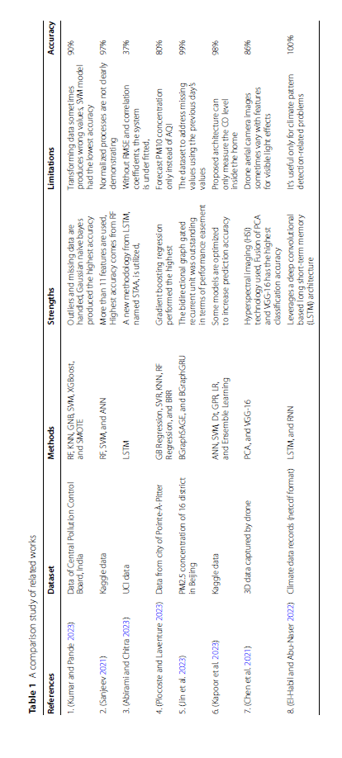
  - Support Vector Machine (SVM/SVC)

What it does: kernelized method for regression/classification (SVR / SVC) creating margin-based predictors.
Necessity & strengths: can capture complex nonlinear relationships with appropriate kernel; effective in medium-sized datasets and robust to overfitting with regularization. Useful for AQ category classification and medium-term forecasting when training data are moderate.
Limitations: scales poorly to very large datasets; requires careful kernel/hyperparameter tuning.
  - Decision Tree (DT)

What it does: tree-structured model that splits data on informative thresholds.

Necessity & strengths: interpretable, handles nonlinearities and mixed feature types, fast inference. Good for understanding decision rules (e.g., “if PM2.5 > X and RH < Y then AQI = Poor”). Useful for baseline models and for rule-based alerting.

Limitations: single trees are high-variance; usually outperformed by ensemble trees.

  - Random Tree/ Random Forest (RF)

Interpretation: “RT” in many AQ studies corresponds to Random Tree ensembles or Random Forests.
What it does: ensembles many decorrelated trees and averages predictions.
Necessity & strengths: consistently strong performance for AQ forecasting in literature, robust to noise and unscaled features, and reduces variance vs single trees. Performs well on tabular sensor data and with heterogenous features (sensor readings + meteorological variables). RF is a recommended first ensemble to test.

  - Gradient Boosting

What it does: sequentially builds trees where each tree corrects residuals of the ensemble so far.
Necessity & strengths: state-of-the-art in many AQ forecasting benchmarks — often outperforms RF when tuned. Highly effective at capturing complex nonlinearities and interactions between sensors and meteorology. Many recent AQ forecasting papers rank gradient-boosted trees among top performers.
Practical note: heavier training time and requires cross-validation and regularization (learning rate, tree depth). Good choice for final model on server; less suitable for microcontroller edge inference without model compression.
  - IQR – Interquartile Range (Preprocessing/ Outliers detection)

What it does: statistical rule (Q3 + 1.5×IQR / Q1 − 1.5×IQR) to identify and remove outliers.
Necessity & strengths: low-cost, effective first step for removing sensor spikes and implausible values prior to training. Outlier removal with IQR or model-based detection is common and often improves predictive performance.

- Gaps In Literature and Justification of Work

Hyperlocal campus deployments are under-represented in high-quality calibration studies versus city-scale monitors; micro-scale patterns (near classrooms, canteens) deserve focused work.

Comparative ML benchmarking for a small, dense campus network (many nodes, short distances) — e.g., which models best exploit spatial correlations — remains an open empirical question.

Practical edge deployment: assessing which models are feasible for on-device inference (Arduino/RPi) versus server-side is practical and underreported. Your proposed experiment (sensors listed + multiple ML methods + dashboard) addresses these gaps.

- Proposed Citations (Hardware)

- DHT22 sensor datasheet for T/RH accuracy and role.

- PMS 7003 datasheet / Plantower manual for sensor specs and interface.
- MQ-135 / MQ-07 / MQ-02 technical datasheets and IoT AQ project papers for gas sensor use cases.

- Recent review papers comparing ML methods for AQ forecasting (surveys showing RF & Gradient Boosting often leading).

- Papers emphasizing preprocessing/outlier detection (IQR) and calibration importance.

- Conclusion
The sensor suite you selected (PMS 7003 + MQ-series + DHT22) is a widely used, low-cost combination amenable to dense campus deployment, provided you apply calibration and humidity compensation. For modelling, start with interpretable baselines (LR, DT, KNN), proceed to ensemble methods (RF), and use Gradient Boosting as the likely best performer for accuracy—while using IQR and other preprocessing as necessary to remove sensor noise. Finally, pair the pipeline with a web/dashboard (map + time series) for actionable hyperlocal visibility.

Methodology

The proposed methodology focuses on integrating IoT-based hardware for air quality data collection with machine learning models for accurate AQI prediction and categorization. It involves two major components: hardware implementation for real-time environmental monitoring and software implementation for data analysis and prediction.

- System Overview

The system is designed to collect air quality parameters such as temperature, humidity, and concentrations of gases like CO and NH₃ using a network of sensors interfaced with an Arduino Mega Wifi R3 board. The collected data is transmitted wirelessly through an ESP8266 Wifi module to a processing environment, where it undergoes cleaning, transformation, and analysis. The processed data is then used to train multiple machine learning models for AQI prediction and category classification.
The workflow includes the following steps:
- Data Acquisition: Collecting real-time readings from air quality sensors connected to the Arduino Uno.
- Data Preprocessing: Cleaning the dataset, handling missing values, and ensuring consistent formats.
- Feature Analysis: Identifying which parameters most influence the AQI computation.
- Model Training and Comparison: Training multiple machine learning algorithms and comparing their accuracy, precision, recall, and F1-score.
- AQI Prediction and Categorization: Using the best-performing model to predict AQI values and categorize them (e.g., Good, Moderate, Poor).
This structure ensures that both the physical data acquisition and computational prediction processes are seamlessly integrated.

- Hardware Design and Components

The hardware setup uses Arduino Mega Wifi R3 as the central control unit. It interfaces with various environmental sensors to capture key parameters related to air pollution. The ESP8266 Wi-Fi module is used to enable wireless data transfer for remote monitoring and analysis.
The sensors used include:

- MQ-7 Sensor: Detects the concentration of carbon monoxide (CO) in the air.
- MQ-2 Sensor: Detects LPG, methane, smoke, and hydrogen gases.
- MQ-4 Sensor: Specializes in sensing methane (CH₄) and natural gas concentrations.
- PMS 7003: PM 2.5 sensor, it detects particulate matter
- MQ-135 Sensor: Measures multiple harmful gases such as ammonia (NH₃), Sulphur dioxides (SO₂), carbon dioxide (CO2), benzene, and other volatile organic compounds.
- DHT11 Sensor: Captures temperature and humidity levels of the surrounding environment.

Each sensor produces analogue signals that are read by the Arduino Mega Wifi R3 controller and transmitted to a server through the ESP module. The hardware component provides continuous data streams, forming the foundation for subsequent machine learning analysis.

- Software Implementation and Model Development
Python machine learning frameworks process and analyze the dataset collected. The method used was the implementation and comparison of several models namely Decision Tree (DT), K-Nearest Neighbors (KNN), Random Forest (RF), Support Vector Machine (SVM), Gradient Boosting (GB), Naive Bayes (NB) and XGBoost.

All models are trained using the same dataset . Metrics like accuracy, precision, recall and F1-score help judge the performance. Comparative findings of these models are discussed in the Result and Discussion section.

- Data Preprocessing and Model Training Workflow
The collected raw data from the sensors often contains noise, missing values, and inconsistent formats due to environmental fluctuations and sensor limitations. To ensure data quality and reliability for machine learning applications, a structured preprocessing pipeline was implemented.

  - Data Preprocessing
The preprocessing stage involves several steps designed to refine the raw data before feeding it into machine learning models:
- Handling Missing Values:
Sensor readings can occasionally be incomplete due to communication delays or environmental interference. Missing values were handled using statistical imputation techniques such as mean, median, or forward-fill methods depending on the attribute type.
- Label Encoding:
To facilitate machine learning model compatibility, categorical AQI categories (e.g., Good, Moderate, Unhealthy) were converted into numeric labels using label encoding techniques.
- Data Normalization and Scaling:
Since sensor readings vary across different numerical ranges (e.g., temperature in °C vs. gas concentrations in ppm), normalization techniques such as Min-Max scaling were applied to bring all features to a uniform scale between 0 and 1. This ensures that no single feature disproportionately influences the model.
- Correlation Analysis:
A correlation matrix was computed to identify the relationship between environmental features (CO, NH₃, temperature, humidity, etc.) and the computed AQI value. Highly correlated features were prioritized for model training, while redundant attributes were minimized to improve model efficiency.

  - Model Training and Evaluation
Once the dataset was pre-processed, it was divided into training (70%) and testing (30%) subsets to ensure fair performance evaluation and avoid overfitting.

    - Model Experimentation:
Multiple machine learning algorithms were experimented through training, including:

- Decision Tree (DT)
A Decision Tree model uses a tree-like structure to split the dataset based on attribute values. Each internal node represents a decision rule on a feature, and each leaf node represents a class label.
The splitting criterion used is Entropy, defined as:

$$Entropy= -\sum_{i=1}^{n}{p_{i}\log_{2}(p_{i}{)}}$$

where $p_{i}$ represents the probability of class $i$.
DT is easy to interpret and provides baseline accuracy for classification tasks.

- K-Nearest Neighbor (KNN)
KNN is a distance-based classification algorithm that assigns the class label based on the majority vote of its k nearest neighbors in the feature space.
The distance between samples is typically measured using Euclidean Distance:

$$d(p,q)=\sqrt{\sum_{i=1}^{n}{{(p_{i}-q_{i})}^{2}}}$$

- Random Forest (RF)
Random Forest is an ensemble method that constructs multiple decision trees and combines their predictions to improve accuracy and reduce overfitting.
The final prediction is based on majority voting from individual trees. The algorithm introduces randomness by selecting subsets of data and features for each tree, enhancing model robustness.

$$\hat{y}=mode (T_{1}\left(x\right), T_{2}\left(x\right), …, T_{n}\left(x\right))$$

RF tends to perform well for environmental data due to its ability to handle noisy and correlated features.

- Support Vector Machine (SVM)
SVM aims to find an optimal hyperplane that best separates different classes in a high-dimensional space. The objective is to maximize the margin between the nearest data points (support vectors) of each class.
The optimization function is:
$$min\frac{1}{2}{|\left|w\right||}^{2} subject to y_{i}​(w⋅x_{i}​+b)≥1$$

where $w$ is the weight vector and $b$ is the bias.

- Naive Bayes (NB)
Naïve Bayes is a probabilistic classifier based on Bayes’ theorem, assuming independence among features:
$$P\left(X | C\right)= \frac{P\left(X | C\right).P(C)}{P(X)}$$
It’s computationally efficient and works surprisingly well on large, simple datasets but struggles with correlated inputs — which can occur in air quality data.

- Logistic Regression (LR)
It is a key player in supervised machine learning, particularly suited for classification tasks. It transforms outcomes into binary decisions, effectively drawing a decision boundary that separates data points into distinct categories. The formula is :

$$y= \frac{e^{(b_{0}+b_{1}x)}}{1+ e^{(b_{0}+b_{1}X)}}$$

- Gradient Boosting (GB)
Gradient Boosting is another ensemble technique that builds models sequentially, with each new model trying to correct the errors made by the previous ones.
It minimizes the loss function using gradient descent:

$$F_{m}\left(x\right)=F_{m-1}\left(x\right)+ ηh_{m}(x)$$
where $h_{m}(x)$ is the weak learner and $η$ is the learning rate.
GB performs exceptionally well on tabular data and typically outperforms single-tree models.

- XGBoost
XGBoost (Extreme Gradient Boosting) is an optimized version of GB that introduces regularization and parallel computation, improving both accuracy and efficiency.
The objective function includes a regularization term:

$$Obj=\sum_{i}{l (y_{i}, {\hat{y}}_{i})}+\sum_{k}{Ω(f_{k})}$$
where $Ω(f_{k})$ penalizes model complexity.
It is one of the top-performing models for structured environmental data.

    - Evaluation Metrics:
Each model’s performance was analysed using the following metrics:
  - Accuracy: Measures the overall correctness of predictions.
  - Precision & Recall: Evaluate the model’s ability to correctly classify AQI categories.
  - F1-Score: Provides a balance between precision and recall.
- Confusion Matrix: Used to visualize the true vs. predicted classifications and detect misclassifications among AQI categories.

    - Result Interpretation:
The comparative performance of the models was recorded and analyzed. The model achieving the highest accuracy and F1-score was selected as the optimal model for final AQI prediction. The detailed comparison and confusion matrices are discussed in the Result and Discussion section.

- Model Architecture and Algorithmic Flow

The proposed air quality monitoring system relies on a machine learning pipeline for monitoring analysis. After Arduino Mega Wi-Fi R3 transmits the sensor data, it goes through processing and model training stages; where the predicted Air Quality Index (AQI) and its category will be developed. The workflow contains supervised learning algorithms and ensemble methods that generate accurate and reliable predictions.

  - Data Flow Overview

The complete data flow begins from the hardware layer and extends to the prediction and evaluation stages.

- Data Collection: Raw sensor readings are obtained from the MQ series gas sensors (MQ-2, MQ-4, MQ-7, MQ-135), particulate sensor (PMS 7003), and environmental sensor (DHT11).
- Data Transmission: The Arduino Mega WiFi R3’s built-in ESP8266 module wirelessly transmits this data to a server or local machine for processing.
- Data Preprocessing: The dataset undergoes cleaning, normalization, and feature scaling to remove anomalies, missing values, and outliers.
- Feature Correlation and Selection: Correlation analysis identifies the most influential parameters contributing to AQI prediction (e.g., PM2.5, PM10, CO, temperature, humidity).
- Model Training: Multiple machine learning models are trained and tested to evaluate their efficiency in predicting AQI levels.
- Model Evaluation: Each model’s performance is assessed using evaluation metrics such as accuracy, precision, recall, F1-score, and the confusion matrix.
- Prediction and Categorization: The best-performing model outputs the predicted AQI value and classifies it into a corresponding category (Healthy, Good, Moderate, Poor, Severe).

  - Algorithmic Flow

The overall algorithmic process for AQI prediction can be summarized as follows:

- Input: Sensor readings → {CO, NH₃, CH₄, LPG, PM2.5, PM10, Temperature, Humidity}.
- Preprocessing: Handle missing values, normalize features, and encode categorical data.
- Split Dataset: Divide the data into training (80%) and testing (20%) subsets.
- Model Training: Train all candidate models on the training data.
- Model Evaluation: Calculate performance metrics using the test data.
- Model Selection: Select the model with the best accuracy and generalization capability.
- Prediction: Use the chosen model to predict AQI value and corresponding category.
- Output: Display the predicted AQI and its qualitative level (e.g., Healthy, Good, Moderate, Poor).

  - Output Representation

The final output includes both the numerical AQI value and its qualitative category, derived using standard AQI classification ranges. The prediction results can be visualized in a dashboard, showing real-time updates of local air quality along with model performance indicators.

ReSULT AND DISCUSSION

- System Output and Dashboard Results

The developed IoT-based Air Quality Monitoring System integrates multiple gas and particulate sensors with the Arduino Mega WiFi R3 to collect real-time environmental data. The system successfully records parameters such as PM2.5, PM10, CO, CH₄, LPG, temperature, and humidity, and computes the Air Quality Index (AQI) in real time.
A web-based dashboard was designed to visualize these readings and their corresponding AQI category
The dashboard displays:
- Real-time sensor readings
- Computed AQI values and categories
- Historical trends for pollutant levels
- Timestamped logs for temporal monitoring

- Overall Model Evaluation

After preprocessing and normalization, the collected dataset was used to train and test multiple machine learning algorithms. Each model was evaluated using an identical train-test split to maintain experimental consistency.
The evaluation metrics considered include Accuracy, Precision, Recall, and F1-score to ensure a comprehensive assessment of predictive performance.

The Random Forest model achieved the highest accuracy among all models, indicating its robustness in handling nonlinear feature dependencies and noise inherent in sensor data. Ensemble methods like Random Forest and Gradient Boosting consistently outperformed classical models such as KNN and Naïve Bayes.

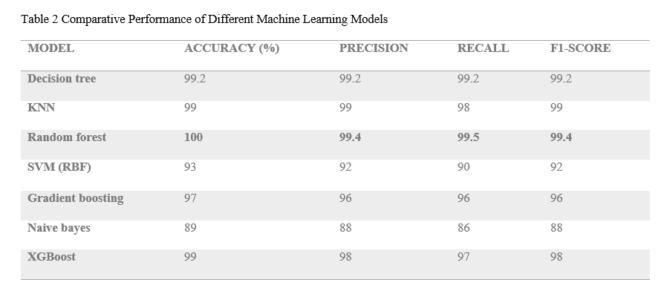
- Confusion Matrix Analysis

Confusion matrices were generated for all models to assess the category-wise performance and misclassification behavior.

The following insights were derived:
- Decision Tree and KNN models occasionally confused adjacent AQI categories such as “Moderate” and “Poor,” showing limited boundary precision.
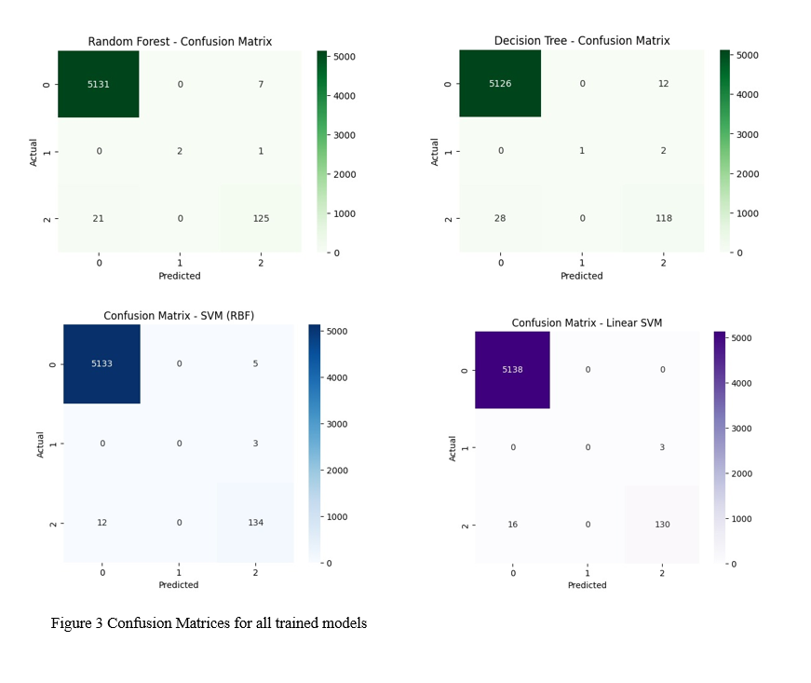
- Naïve Bayes underperformed in handling correlated pollutant features, leading to higher false predictions.
- SVM (RBF) provided a balanced classification but was computationally heavier.
- Random Forest achieved the best diagonal dominance, indicating high true positive rates across all classes.
- Gradient Boosting and XGBoost delivered stable performance and fewer misclassifications.

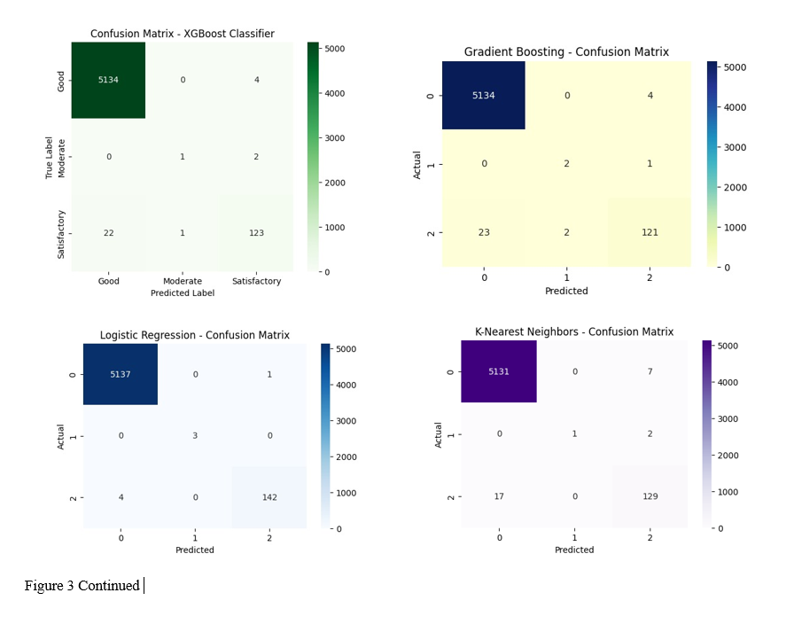

- Accuracy Comparison

A bar graph was plotted to visually compare the performance of all models based on overall accuracy.

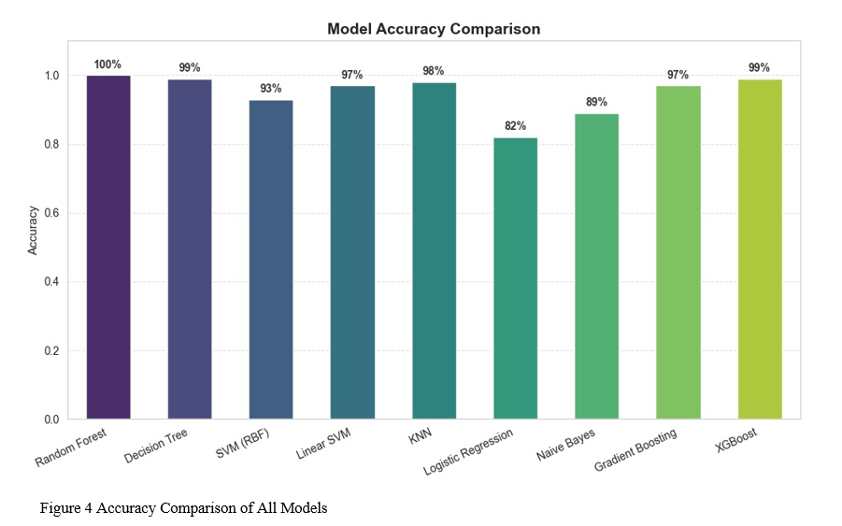
The comparison clearly shows that ensemble models — particularly Random Forest and Gradient Boosting — consistently outperform traditional and baseline models.

- Discussion

From the comparative analysis, it is evident that ensemble learning algorithms provide superior results for AQI prediction, balancing both bias and variance effectively. The Random Forest model emerged as the most reliable choice, offering the highest accuracy and minimal misclassifications across categories.

The Gradient Boosting and XGBoost models also performed competitively, showing strong learning efficiency with smaller data sizes. In contrast, classical models such as KNN and Naïve Bayes showed lower accuracy due to their sensitivity to feature scaling and correlation.

The combined results validate that integrating low-cost IoT hardware with optimized machine learning algorithms can deliver an efficient, accurate, and scalable AQI prediction system, making it suitable for localized monitoring and smart city applications.

Conclusion

The study successfully developed and evaluated an IoT-based Air Quality Monitoring and Prediction System that integrates hardware sensing with machine learning for accurate environmental analysis. Using the Arduino Mega WiFi R3 board in combination with gas and particulate sensors (MQ2, MQ4, PMS5003), real-time air quality data was collected and processed to compute pollutant concentrations and corresponding AQI values.
A range of machine learning algorithms, including Decision Tree, Random Forest, Support Vector Machine (SVM), K-Nearest Neighbors (KNN), Gradient Boosting, Naive Bayes, and ensemble approaches, were trained and evaluated on the collected dataset. The comparative analysis demonstrated that ensemble models and tree-based classifiers achieved the highest accuracy and generalization performance, highlighting their suitability for air quality prediction tasks.
The proposed model not only provided accurate AQI categorization but also facilitated real-time visualization through an integrated dashboard, enabling users to monitor environmental conditions intuitively. The incorporation of low-cost, easily available sensors and open-source technologies makes this solution practical and scalable for deployment in smart cities and community monitoring systems.
Overall, the system demonstrates how combining IoT sensing infrastructure with intelligent machine learning analytics can deliver actionable environmental insights. Future improvements may include expanding sensor types (e.g., for NO₂, SO₂, and O₃ detection), integrating edge-based AI for faster inference, and deploying cloud platforms for large-scale data aggregation and predictive forecasting.

Acknowledgments

For their invaluable advice and perceptive ideas during the investigation and guidance , I would like to thank prof Mayuresh Gulame and prof Aman Singh. The quality of this work was significantly improved by his knowledge and suggestions.

References

- Plantower Technology. (2016, June 1). Digital universal particle concentration sensor — PMS7003 series data manual (V2.5) [Datasheet]. Nanchang Panteng Technology Co., Ltd. Retrieved from https://download.kamami.pl/p564008-PMS7003%20series%20data%20manua_English_V2.5.pdf
- Plantower Technology. (n.d.). PMS7003 — Laser PM2.5 Sensor [Product specification page]. Plantower. Retrieved from https://plantower.com/en/products_33/76.html
- Adafruit Industries. (n.d.). PM2.5 Air Quality Sensor (PMS7003) – Adafruit Learning System [Datasheet & guide]. Adafruit. Retrieved from https://learn.adafruit.com/pm25-air-quality-sensor (PDF: https://cdn-learn.adafruit.com/downloads/pdf/pm25-air-quality-sensor.pdf)
- SparkFun Electronics. (n.d.). Technical data MQ-7 Gas Sensor [Datasheet]. SparkFun. Retrieved from https://www.sparkfun.com/datasheets/Sensors/Biometric/MQ-7.pdf
- Olimex Ltd. (n.d.). SNS-MQ135 Gas Sensor Technical Data [Datasheet]. Olimex. Retrieved from https://www.olimex.com/Products/Components/Sensors/Gas/SNS-MQ135/resources/SNS-MQ135.pdf
- SparkFun Electronics. (n.d.). DHT22 Sensor (AM2302) — Datasheet [PDF]. SparkFun. Retrieved from https://cdn.sparkfun.com/assets/f/7/d/9/c/DHT22.pdf
- RandomNerdTutorials. (2019, Apr 25). ESP8266 with DHT11 / DHT22 Temperature and Humidity Web Server with Arduino IDE [Web tutorial]. Retrieved from https://randomnerdtutorials.com/esp8266-dht11dht22-temperature-and-humidity-web-server-with-arduino-ide/
- The Engineering Projects. (2024, Mar 13). MQ135 Air Quality Sensor: Datasheet, Pinout & Working [Web article]. Retrieved from https://www.theengineeringprojects.com/2024/03/mq135-air-quality-sensor.html
- Özüpak, Y., Alpsalaz, F., & Aslan, E. (2025). Air quality forecasting using machine learning: Comparative analysis and ensemble strategies for enhanced prediction. Water, Air, & Soil Pollution, 236, 464. https://doi.org/10.1007/s11270-025-08122-8
- AA review of machine learning models for predicting air quality in … [Comparative study]. AmericasPG. Retrieved from https://americaspg.com
- A Systematic review of machine learning and deep learning … [Review article]. MDPI. Retrieved from https://www.mdpi.com
- Ismail, A., et al. (n.d.). Air Pollution Prediction using Machine Learning – A Review [Conference paper]. University of Hertfordshire Research Archive. Retrieved from https://research.herts.ac.uk
- A Machine learning models for advanced air quality prediction [Article]. ACM Digital Library. Retrieved from https://dl.acm.org
- Application of the XGBoost machine learning method in PM2.5 … [Article]. Aerosol and Air Quality Research. Retrieved from https://aaqr.org
- Wikipedia. (n.d.). Gradient boosting. In Wikipedia. Retrieved November 10, 2025, from https://en.wikipedia.org/wiki/Gradient_boosting
- Wikipedia. (n.d.). LightGBM. In Wikipedia. Retrieved November 10, 2025, from https://en.wikipedia.org/wiki/LightGBM
- Zhang, Z., Johansson, C., Engardt, M., & Stafoggia, M. (2024). Improving 3-day deterministic air pollution forecasts using machine learning. Atmospheric Chemistry and Physics, 24, 807–851. https://acp.copernicus.org/articles/24/807/2024/
- Rahman, M. M., Nayeem, M. E. H., Ahmed, M. S., Tanha, K. A., Sakib, M. S. A., Uddin, K. M. M., & Babu, H. M. H. (2024). AirNet: Predictive machine learning model for air quality forecasting using web interface. Environmental Systems Research, 13, 44. https://doi.org/10.1186/s40068-024-00378-z
- A Research on hybrid feature selection + ML in AQ (BPSO/BWOA + RF) for performance gains [Article]. PubMed Central (PMC). Retrieved from https://www.ncbi.nlm.nih.gov/pmc/

