How to set it up

Give the user group permissions to the target table, show target table

Configure the followup.html file

followup.html

Open the followup.html file (in the rootfolder of the app) and configure it as you want, it nows contain an example.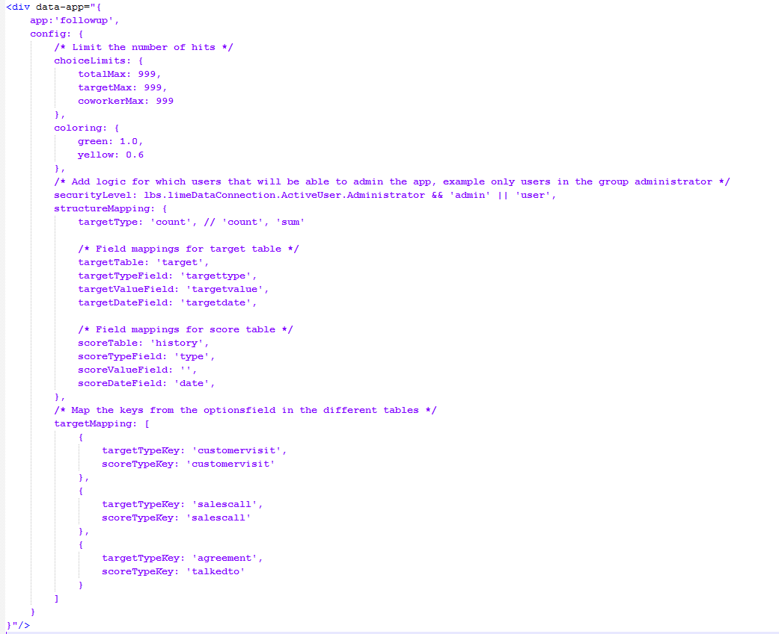

In the Install folder you can find 4 files

1. Code_ for_ThisApplication and index
2. Followup.bas
3. FollowupChildData.cls
4. FollowupParentData.cls

1. Code for thisapplication and index

Take the code from the file and paste it in the Setup sub in ThisApplication and the index actionpad.

2. Followup.bas

Insert the Followup.bas file in the VBA. Run the sub Install() to create the necessary localization posts for the app.

3. FollowupChildData.cls

Insert the FollowupChildData.cls file in the VBA.

4. FollowupParentData.cls

Insert the FollowupParentData.cls file in the VBA.