Followup

This app will help you keep track of how you and the company are doing to reach your monthly goals for the different activity types.

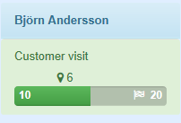

* 10 = Number of done Customer visits.
* 6 = Where you should be right now.
* 20 = Monthly goal.

If you hover over the progress bar you will see how many percent that is done against the monthly goal.

If you hover over the mark for where you should be right now you will see how many percent that is done against that value.

Colors

The tile are represented in tree colors, red, yellow and green. You set the percentage representing the colors by specifying the limit for the yellow and green color in the config.

Example: yellow on 0.75 and green on 1.0 will end up in

0% - 74% - Red

75% - 99% - Yellow

100% + - Green

The targets

In the Target table each coworker gets a goal per activity and month. Only coworkers with goals will be shown.

Security level

Admin user

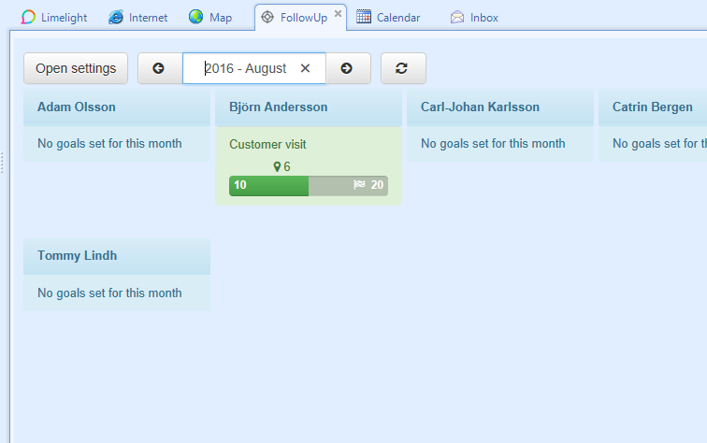

Regular user

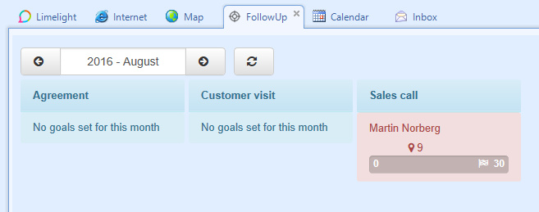

Option menu



If you have admin rights for the followup app you will be able to open up a menu.

Here you can choose which coworkers or goal types you want to see. A regular user will only be able to see their own tiles.

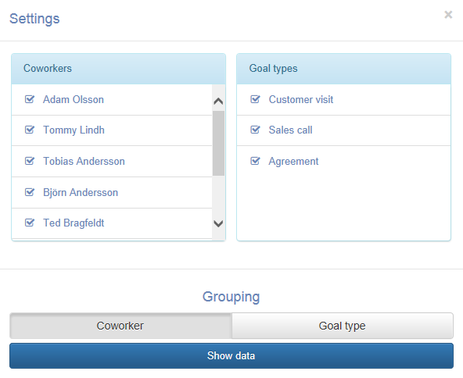

To change month you can use the arrows or press the date to open up a calendar.

