**HTTP**

**Summary:** It took me a while to realize the usage for HTTP; based on the sample code below, it looked like it was used to simply drag the contents of a webpage into a java application. It wasn’t until I discovered the PokeAPI that I realized just how much more helpful HTTP could be. By pulling in JSON data, I was able to then parse out information using HashMaps and ArrayLists. In this project, I integrated QCJSON and Java Collections in order to fetch some information about different Pokemon. Feel free to play around with the code; it’s pretty simple, but I think I may build on the idea for a personal project.

**Code from Internet:** I retrieved the following code from <http://www.vogella.com/tutorials/AndroidNetworking/article.html>

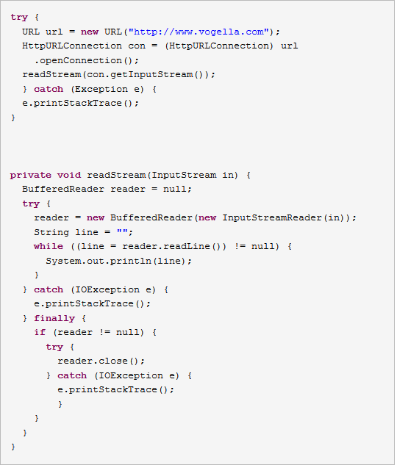

**My Sample Code:** The following link leads to my GitHub repository for HTTP, where I use the HTTP.java file to run through some test cases using HTTP connections. That class and the GetPokemonInfo.java class are the only two needed for this to work. The GetPokemonInfo.java class is where all the magic happens. In this class, I use a combination of HTTP communication, QCJSON, and Java Collections to find information on any given Pokemon. The code can be found here: <https://github.com/Lundberg-Jonathan/HTTP/tree/master/src/http>

**Sharing Video:** <https://www.youtube.com/watch?v=rvwZLn6hAtg>

**Group Meeting Teaching:** I took a few minutes to explain how HTTP works and some common usages of HTTP here: <https://youtu.be/P21CvG6x74Q?t=7m26s> (transitions into the next link)

And here is where I went through and did a little code sharing and explanation as I walked through the steps of the code: <https://youtu.be/P21CvG6x74Q?t=8m19s> (ends at 9:12)