**JSON & File I/O**

Code from Internet: 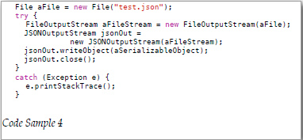

(From *Real Life Java, p. 39)*

My Sandbox Code: <https://github.com/Lundberg-Jonathan/JSON/tree/master/src/json>

Teaching: https://www.youtube.com/watch?v=rvwZLn6hAtg (Sharing Video)

<https://youtu.be/P21CvG6x74Q?t=9m24s> (Group Meeting)