**JUnit Testing**

Code from Internet: 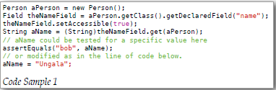

(From *Real Life Java*, p 10)

My Sandbox Code: <https://github.com/Lundberg-Jonathan/JUnit/blob/master/test/pokemoncollection/AddPokemonHandlerTest.java>

<https://github.com/Lundberg-Jonathan/JUnit/tree/master/src/pokemoncollection>

Teaching: <https://www.youtube.com/watch?v=HfQ0odOvCK4> (Sharing Video)

<https://youtu.be/P21CvG6x74Q?t=22m24s> (Group Meeting)