Use Case # [1: Add a gift idea]
GENERAL CHARACTERISTICS
Intent | As a user I want to add a new gift idea for one ore several person such that when I need a gift idea for someone I can simply look at this person and find a list a potential (‘to offer’) gifts
Scope
Level | Business Level
Author | Paul Schuhmacher
Last Update: | 31/08/2020
Status | conceptualization
Primary Actor | User
Secondary Actors | None
Preconditions | The User is on the Home page or on a person details Page. person have been registered in the application
<Dynamic Preconditions> | <[list of Use Cases # that must have run successfully | scenario diagrams that must be previously run]>

Assumptions
Trigger | Button
Success Post Condition | A gift Idea instance is persisted  It creates a gift for any recipient registered on the gift idea. The view to add a gift idea is closed
Failed Post Condition | Nothing happens : the gift idea is not persisted, no gifts are created.  Returns to the previous page
< Models> | GiftIdea, Gift, User, person, Tags, Categories
Operations Concepts | User gives information about the gift idea (title, description, image, url) for possible person among its contacts (not mandatory, a gift idea can be input without a particular person in mind)
Overview

MAIN SUCCESS SCENARIO
Step | Action
S | A gift idea is registered by providing information about it, and eventually about possible person who might be interested by this gift. User can add a person if missing and will be registered on the wisherlist (list of person registered on a gift idea, person that we think could be interested in this gift) automatically. User can add a tag or a category to the gift idea on the fly, or create new ones. When the gift idea is recorded by the system, a gift with a status ‘to offer’ is created for each person references by the gift idea
1 | This use case starts when the button ‘Add A Gift Idea’ is pushed
2 | User enters GiftIdea’ title, description, url, image, tags and categories
3 | User enters a wisherlist among existing person within the app, or a group
4 | User validates the gift idea, return to the previous page

EXTENSION SCENARIOS
Step | Branching Action
2.A | Add a new tag
2.A | [2.A Button Create tag is pushed:]  [2.A.1 Use case : Create a tag]
2.B | Add a new category
2.B | [2.B Button Create new category is pushed:]  [2.A.1 Use case : Create a category]
3.A | Create a person and add it to the wisherlist
3.A | [3.A Button Create a person is pushed:]  [3.A.1 Use case : Create a person]

RELATED INFORMATION
Performance | None
Frequency | Once or twice a day maximum
<Concurrency> | No
<Superordinate Use Cases> | Create a person, Create a Tag, Create a Category
OPEN ISSUES
Future Considerations | The template for creating a gift idea (the View) will be specialized by a category (for example, for a book we will have a Author, Editor fields). Exemple of categories (general (classic, default), book, movie, event...)
Due Date
Additional information
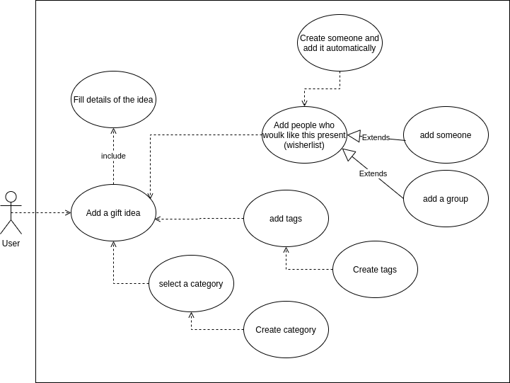
Voir vue “ajouter idée cadeau”

