Use Case # [1: Add a gift idea]
GENERAL CHARACTERISTICS
Intent | As a user I want to add a new gift idea for one ore several person such that when I need a gift idea for someone I can simply look at this person and find a list a potential (‘to offer’) gifts
Scope
Level | Business Level
Author | Paul Schuhmacher
Last Update: | 31/08/2020
Status | conceptualization
Primary Actor | User
Secondary Actors | None
Preconditions | The User is on the Home page or on a person details Page. person have been registered in the application
<Dynamic Preconditions> | <[list of Use Cases # that must have run successfully | scenario diagrams that must be previously run]>

Assumptions
Trigger | Button
Success Post Condition | A gift Idea instance is persisted  It creates a gift for any recipient registered on the gift idea. The view to add a gift idea is closed
Failed Post Condition | Nothing happens : the gift idea is not persisted, no gifts are created.  Returns to the previous page
< Models> | GiftIdea, Gift, User, person, Tags, Categories  Use cases included : Create a person, Create a Tag, Create a Category
Operations Concepts | User gives information about the gift idea (title, description, image, url) for possible person among its contacts (not mandatory, a gift idea can be input without a particular person in mind). The idea appears as an item in the ‘to offer’ list of users referenced by the idea. When the item is set to ‘obtained’ or ‘offered’, the system removes the person’s reference on the idea and shows that the gift has been offered to him and create a gift record (like a log or a transaction) that points to the idea and the person. It is possible to say ‘offer again this gift to this person’ and the reference will be added again to the idea, and then the idea will appears again as an item in the ‘to offer’ list of the user.
Overview

MAIN SUCCESS SCENARIO
Step | Action
S | A gift idea is registered by providing information about it, and eventually about possible person who might be interested by this gift. User can add a person if missing and will be registered on the wisherlist (list of person registered on a gift idea, person that we think could be interested in this gift) automatically. User can add a tag or a category to the gift idea on the fly, or create new ones.
1 | This use case starts when the button ‘Add A Gift Idea’ is pushed
2 | User enters GiftIdea’ title, description, url, image, tags and categories
3 | User enters a wisherlist among existing person within the app, or a group
4 | User validates the gift idea, return to the previous page

EXTENSION SCENARIOS
Step | Branching Action
2.A | Add a new tag
2.A | [2.A Button Create tag is pushed:]  [2.A.1 Use case : Create a tag]
2.B | Add a new category
2.B | [2.B Button Create new category is pushed:]  [2.A.1 Use case : Create a category]
3.A | Create a person and add it to the wisherlist
3.A | [3.A Button Create a person is pushed:]  [3.A.1 Use case : Create a person]

RELATED INFORMATION
Performance | None
Frequency | Once or twice a day maximum
<Concurrency> | No
<Superordinate Use Cases>
OPEN ISSUES
Future Considerations | The template for creating a gift idea (the View) will be parameterized by the selected category (for example, for a book we will have a Author, Editor fields). Exemple of categories (general (classic, default), book, movie, event...)
Due Date
Additional information
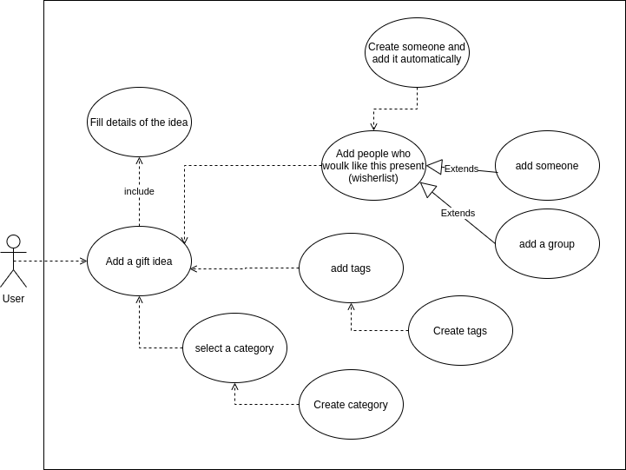
Voir vue “ajouter idée cadeau”

