**INSY6212**

**Assignment 2**

**Group 7**

**Student Numbers: ST10439763, ST10441749, ST10441754, St10437579, ST10450036, ST10437993**

**Student Names: Joshua Linnett, Gregory Claase, Christopher Claase, Khumo Ratsoana, Mandlenkosi Njabulo Zama, Lungelo Muswenkosi Sokhela**

Contents

**Question 1** 3

Question 1.1 3

Question 1.2 4

Question 1.3 4

**Question 2** 5

Key 5

WBS 9

**Question 3** 10

Question 3.1 10

Question 3.2 13

**Question 4** 14

References 17

# **Question 1**

## Question 1.1

A project evaluation form is an institutionalized tool which is used to identify and document the feasibility, scope, and probable impacts of a project before and in the course of its execution (WallStreetMojo, 2023). It gives the stakeholders a chance to study in a systematic way if a project is coherent with strategic objectives, financial resources, and timescale expectations (WallStreetMojo, 2023). The form typically includes spaces for project goals, resources required, potential dangers, expected benefits, and success criteria (WallStreetMojo, 2023).

For our Emergency SOS Services app project, it is important to have a project evaluation form as:

1. **Clarifies project objectives** – It ensures that all the people taking part understand why the app is being developed, such as making the community safer and allowing for rapid response to emergencies.
2. **Facilitates well-informed decision-making** – It supports a formalized cost overview, resources, and expected results, which can be utilized to validate the project and request approval.
3. **Catches potential risks in advance** – Issues like poor network connectivity, cross-platform compatibility, or budget constraint can be realized in advance.
4. **Facilitates resource planning** – It helps establish how many developers, designers, and QA testers will be needed, which will see demand for the project based on its needs.
5. **Serves as a reference point for monitoring and evaluation** – After the project is underway, the evaluation form acts as a reference point when tracking progress toward objectives, milestones, and cost.

Overall, using a project evaluation form for this app project offers formal planning, reduces uncertainty, and ensures the greatest potential for completing the project within time and within budget.

## Question 1.2

**What is cross-platform development?**

Cross-platform development is a method in which one codebase can be run on more than one operating system, such as Android and iOS, through the assistance of integration frameworks like Flutter or React Native (Singh, 2025). It is a time and cost saver in development, offers feature and integration consistency, and is less maintenance-intensive, as changes or corrections are made once (Singh, 2025). For the Emergency SOS Services app, cross-platform development allows both Android and iOS users to enjoy the same features in the same manner, which keeps the project timeline and budget intact.

**How will cross-platform development contribute to meeting our project timeline?**

Cross-platform development keeps the project timeline extremely short. As the team only needs to write and test one codebase, the development time is shorter than if individual native apps needed to be written (Mărcuță, 2025). All platforms can also be updated, debugged, and feature-added simultaneously, which eliminates delays (Mărcuță, 2025). In terms of the Emergency SOS Services app, this equates to basic features like sending alerts, sharing the location, and notifying emergency contacts being delivered more quickly, allowing the project to meet the 12-month cycle and monthly milestones deadlines comfortably.

For the emergency SOS Services, the potential risks of following the cross-platform development trend for the system in developing and being released is:

**Performance Concerns**.

Due to different frameworks, there may be a major difficulty in ensuring optimal Application performance in cross-platform development. This is especially so in resource intensive apps compared to the native performance (Suria International Services, 2024). This would require the developers, to be sure to balance the optimization of the efficiency, and the reusability of the code in development. (Suria International Services, 2024)

**Security.**

Cyberattacks can happen to any software. Cross-platform struggles with this because of small updates; native apps can fix vulnerabilities because small patch frequency (Suria International Services, 2024). This would leave volumes of data in a vulnerable state on non-native platforms; this will be an issue with the Emergency SOS Service System being complaint with any legal parameter with the security when dealing with patient’s health information stored on the application. This will require third party tools to used to tackle this issue. (Suria International Services, 2024)

**Compatibility Challenges**.

Cross-platform app development encounters compatibility issues across different devices or operating systems versions. We must ensure that the Emergency SOS Service application, can run on a consistent basis with functionality across various hardware and software systems configurations (Cameron, 2024). This must be done to ensure that developers develop APIs that cover different systems to ensure compatibility for all devices. (Cameron, 2024)

For the Emergency SOS Service system, cross-platform development can enhance user experience due to better user accessibility to be able to access the application from any device or operating system making it flexible for the user on what device they access the application from (Edwards, 2024). This also offer a user experience that stays consistent across devices whether it be a mobile app, web app, or desktop, the interface, functionality and performance of the application will remain consistent and uniformly throughout the different devices. (Edwards, 2024)

## Question 1.3

**Company**

**Project Name**: Community Emergency SOS Service System

**Project Description**: Build an Emergency SOS Service system application for a community resident.

**Business Case**: Community-driven technology initiative

1. Improve the quality of life for residents.

2. Establish community’s tech outreach and our Company as reliable in the engagement space.

**Project Deliverables**:

1. Project Plan.

2. System Design

3. Application full development.

4. Network Plan deployment.

5. Migrated and tested application.

6. Program documents.

**Project Benefits**:

1. Boosted reputation

2. Promotion resource

**Project Budget**: R1 750 000.00

**Project Team Members**:

Project Manager

Full Stack Developer

Backend Developer

Frontend Developer

Network Engineer

Designer

Systems Architect

Security Engineer

Database Administrator

Deployment Engineer

# **Question 2**

## Key

|  |  |  |  |  |
| --- | --- | --- | --- | --- |
| WBS | Task Name | Resource Names | Cost | Milestone |
| **0** | **Emergency SOS System** |  | **R1 406 000,00** | **No** |
| **1** | **Planning And Analysis** |  | **R174 800,00** | **No** |
| 1.1 | Identify Problem | Project Manager | R6 400,00 | No |
| 1.2 | Identify Stakeholders | Project Manager | R6 400,00 | No |
| **1.3** | **Identify Requirements** |  | **R74 400,00** | **No** |
| 1.3.1 | Identify Functional Requirements | Full Stack Developer, Security Engineer, Systems Architect | R38 400,00 | No |
| 1.3.2 | Identify Non-Functional Requirements | Designer, Frontend Developer, Systems Architect | R36 000,00 | No |
| 1.4 | Define Project Scope | Project Manager | R9 600,00 | No |
| **1.5** | **Plan Resources** |  | **R44 000,00** | **No** |
| 1.5.1 | Hire Staff | Project Manager | R22 400,00 | No |
| 1.5.2 | Plan Equipment | Systems Architect | R12 000,00 | No |
| 1.5.3 | Plan Rates | Project Manager | R9 600,00 | No |
| **1.6** | **Create Project Plan** |  | **R34 000,00** | **No** |
| 1.6.1 | Draft Project Plan | Systems Architect, Project Manager | R22 400,00 | No |
| 1.6.2 | Liaison With Community And Update Plan To Feedback | Community Testers[1], Project Manager | R11 600,00 | Yes |
| **2** | **Designing** |  | **R242 400,00** | **No** |
| **2.1** | **Create Diagrams** |  | **R28 800,00** | **No** |
| 2.1.1 | Use Case Diagram | Designer, Systems Architect | R9 600,00 | No |
| 2.1.2 | UML Class Diagram | Designer, Systems Architect | R9 600,00 | No |
| 2.1.3 | Activity Diagram | Designer, Systems Architect | R9 600,00 | No |
| 2.2 | Design User Interface | Designer, Frontend Developer | R33 600,00 | No |
| 2.3 | Design Database | Database Administrator | R16 800,00 | No |
| 2.4 | Design Backend Architecture | Backend Developer, Full Stack Developer | R42 000,00 | No |
| 2.5 | Design Network Architecture and Internet Connection | Network Engineer, Security Engineer | R56 000,00 | No |
| 2.6 | Ensure Encryption Standard Is Set And Security Practices Are Designed for | Security Engineer | R20 000,00 | No |
| 2.7 | Ensure Application Complies with Laws | Project Manager | R9 600,00 | No |
| **2.8** | **Design Documentation** |  | **R35 600,00** | **No** |
| 2.8.1 | Create Design Documentation | Designer, Systems Architect | R24 000,00 | No |
| 2.8.2 | Liaison With Community And Update Design To Feedback | Community Testers[1], Project Manager | R11 600,00 | Yes |
| **3** | **Development** |  | **R471 600,00** | **No** |
| **3.1** | **Database Development** |  | **R34 400,00** | **No** |
| 3.1.1 | Create DB and Tables | Database Administrator | R16 800,00 | No |
| 3.1.2 | Add Constraints | Database Administrator | R7 200,00 | No |
| 3.1.3 | Insert Test Data | Database Administrator | R4 800,00 | No |
| 3.1.4 | Merge DB with Main Development Branch After Approval | Database Administrator, Full Stack Developer | R5 600,00 | Yes |
| **3.2** | **Backend Development** |  | **R153 200,00** | **No** |
| 3.2.1 | Create Classes | Backend Developer | R28 000,00 | No |
| 3.2.2 | Create Exceptions | Full Stack Developer | R12 800,00 | No |
| 3.2.3 | Structure Logic | Backend Developer, Systems Architect | R52 000,00 | No |
| 3.2.4 | Connect to DB | Full Stack Developer | R6 400,00 | No |
| 3.2.5 | Connect to Emergency Service Provider Contacts | Backend Developer | R14 000,00 | No |
| 3.2.6 | Enable Emergency Notification Contacts | Backend Developer | R8 400,00 | No |
| 3.2.7 | Integrate With Cross Platform API | Full Stack Developer | R28 800,00 | Yes |
| 3.2.8 | Merge Backend with Main Development Branch After Approval | Backend Developer | R2 800,00 | Yes |
| **3.3** | **Frontend Development** |  | **R36 000,00** | **No** |
| 3.3.1 | Connect to Backend | Full Stack Developer | R6 400,00 | No |
| 3.3.2 | Develop Layout | Designer, Frontend Developer | R14 400,00 | No |
| 3.3.3 | Create Navigation | Frontend Developer | R4 800,00 | No |
| 3.3.4 | Validate Inputs | Frontend Developer | R7 200,00 | No |
| 3.3.5 | Merge Frontend with Main Development Branch After Approval | Full Stack Developer | R3 200,00 | Yes |
| **3.4** | **Networking** |  | **R192 000,00** | **No** |
| 3.4.1 | Implement Servers | Network Engineer, Server[1] | R128 000,00 | No |
| 3.4.2 | Ensure Redundancy And Proper Encryption is In Place | Security Engineer | R20 000,00 | No |
| 3.4.3 | Connect Application to Internet | Network Engineer | R12 000,00 | No |
| 3.4.4 | Enable GeoLocation and Ability to Share Location to Emergency Provider | Full Stack Developer | R32 000,00 | No |
| 3.5 | Finalise Development | Full Stack Developer, Network Engineer, Security Engineer | R56 000,00 | Yes |
| **4** | **Testing** |  | **R221 200,00** | **No** |
| **4.1** | **Alpha Testing** |  | **R50 000,00** | **No** |
| 4.1.1 | Unit Testing | Backend Developer | R14 000,00 | No |
| 4.1.2 | Integration Testing | Full Stack Developer | R16 000,00 | No |
| 4.1.3 | Penetration Testing | Security Engineer | R20 000,00 | No |
| **4.2** | **Beta Testing** |  | **R52 000,00** | **No** |
| 4.2.1 | Get Beta Users From a Select Group In Community | Project Manager | R32 000,00 | No |
| 4.2.2 | Beta Users Test System and Gain Feedback | Community Testers[10] | R20 000,00 | No |
| 4.3 | Fix Issues found | Full Stack Developer, Network Engineer, Security Engineer | R112 000,00 | No |
| 4.4 | Finalise First Iteration of Program | Systems Architect | R7 200,00 | Yes |
| **5** | **Deployment** |  | **R296 000,00** | **No** |
| 5.1 | Stage Deployment | Deployment Engineer | R12 000,00 | No |
| **5.2** | **Migrate Systems** |  | **R151 200,00** | **No** |
| 5.2.1 | Migrate Data to Databases | Database Administrator | R9 600,00 | No |
| 5.2.2 | Implement New System | Backend Developer, Frontend Developer, Full Stack Developer, Network Engineer, Security Engineer | R65 600,00 | No |
| 5.2.3 | Beta Deploy | Deployment Engineer | R12 000,00 | No |
| 5.2.4 | Gain Feedback And Update | Full Stack Developer | R64 000,00 | No |
| 5.3 | Deploy To Public | Deployment Engineer | R16 800,00 | Yes |
| 5.4 | Monitor And Maintain Application | Backend Developer, Full Stack Developer, Security Engineer | R100 000,00 | No |
| 5.5 | Document Program For Maintenance And Update | Project Manager | R16 000,00 | Yes |

## WBS

# **Question 3**

## Question 3.1

## Question 3.2

<https://github.com/Lungelo21/INSY6212-A2-Group-7>

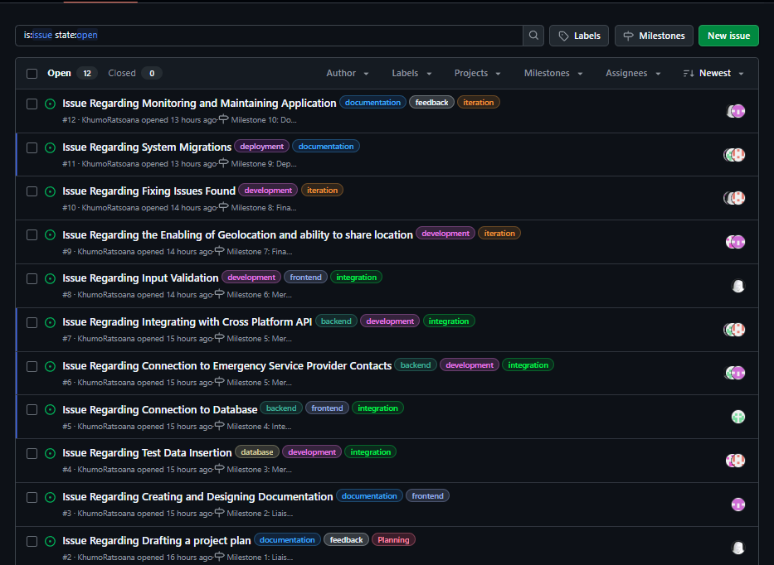

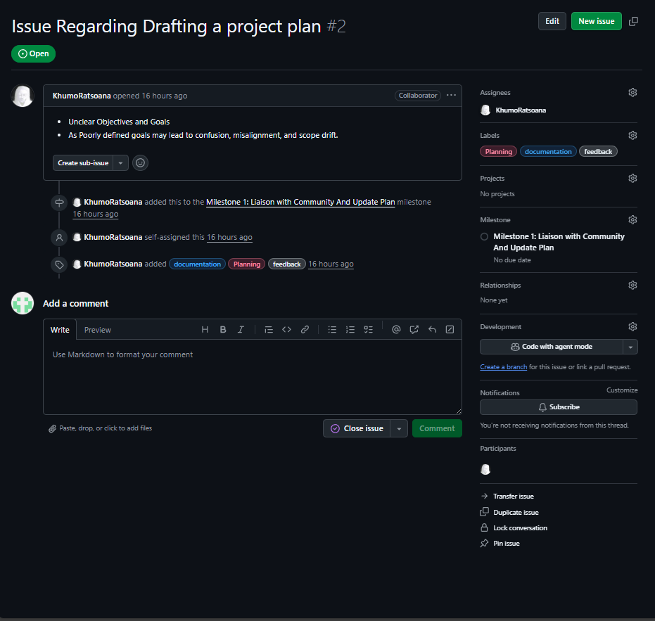

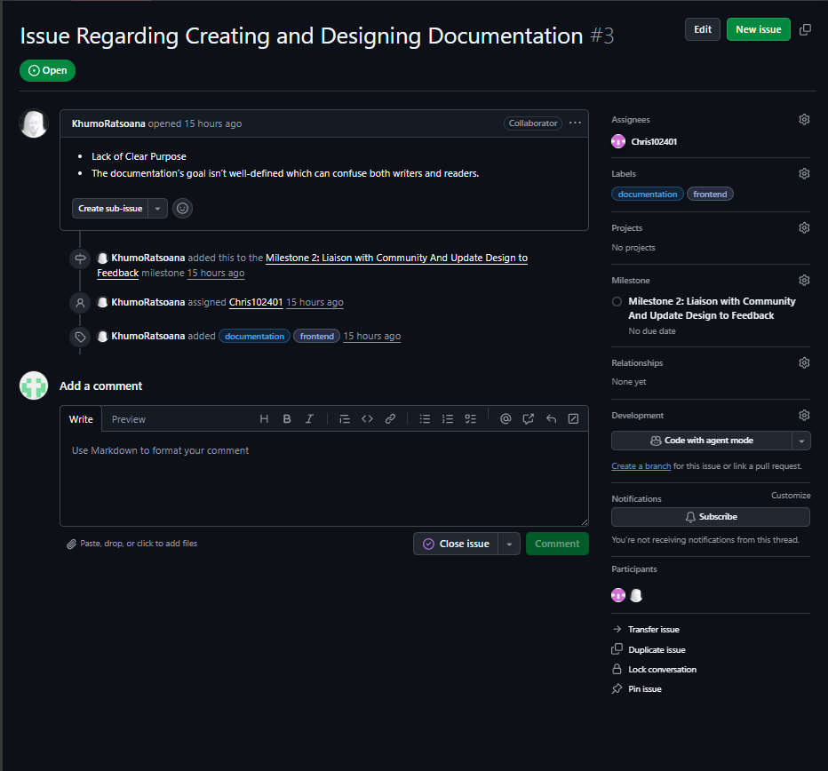

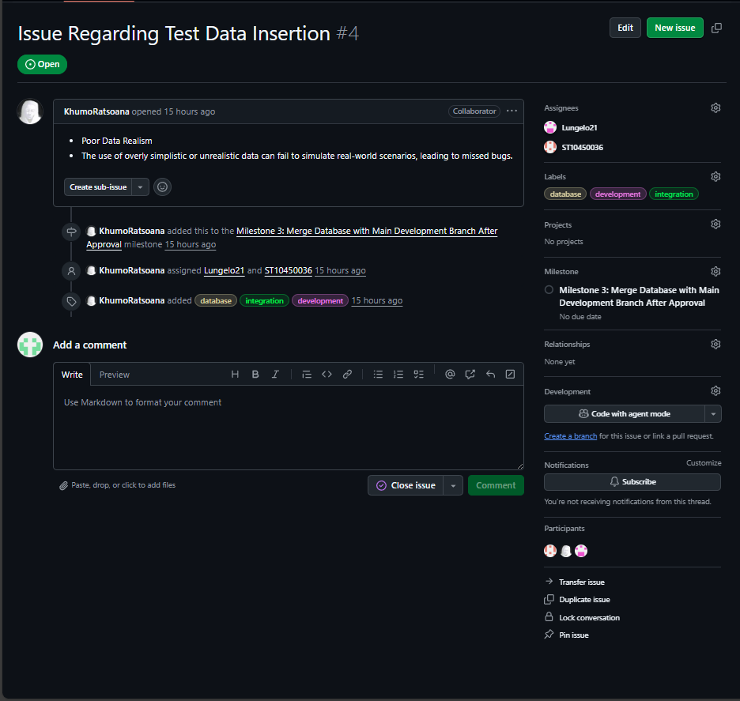

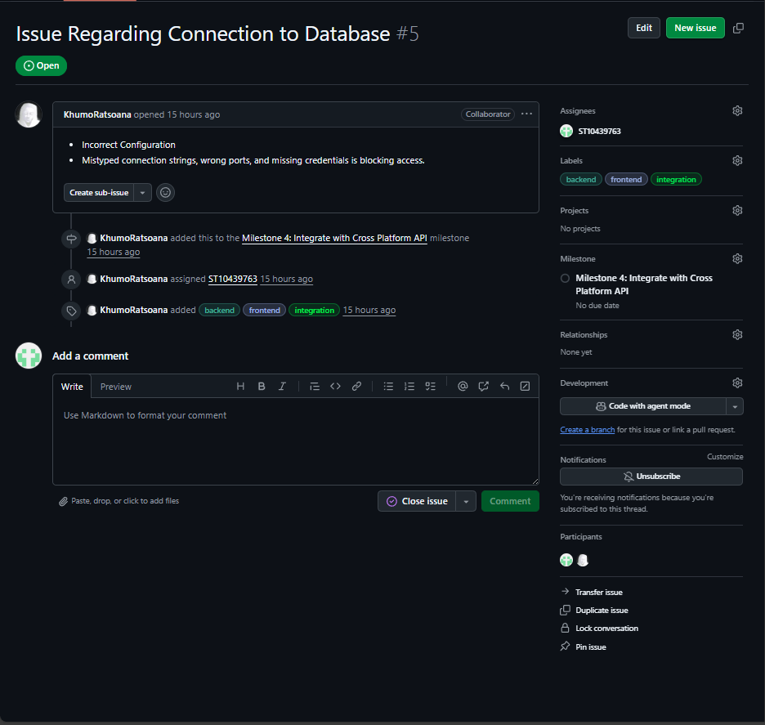

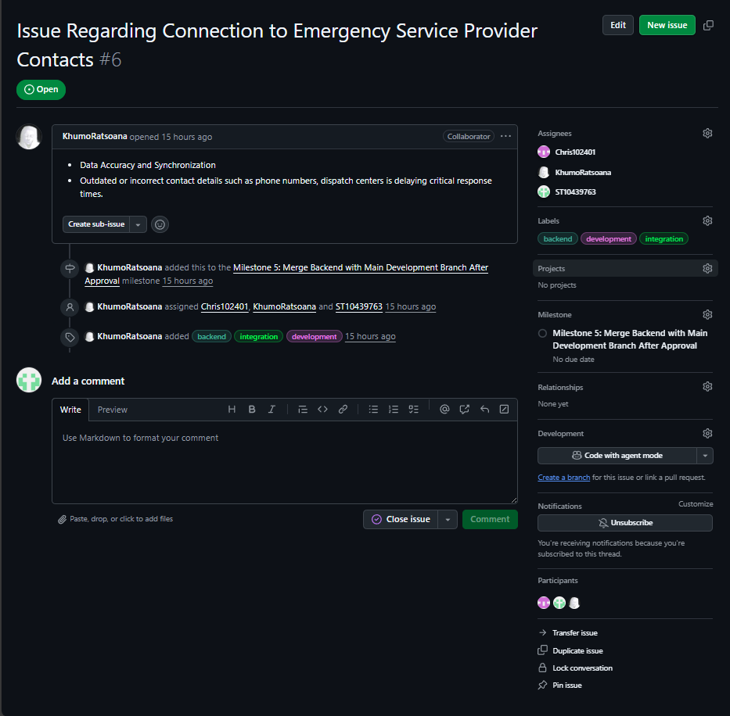

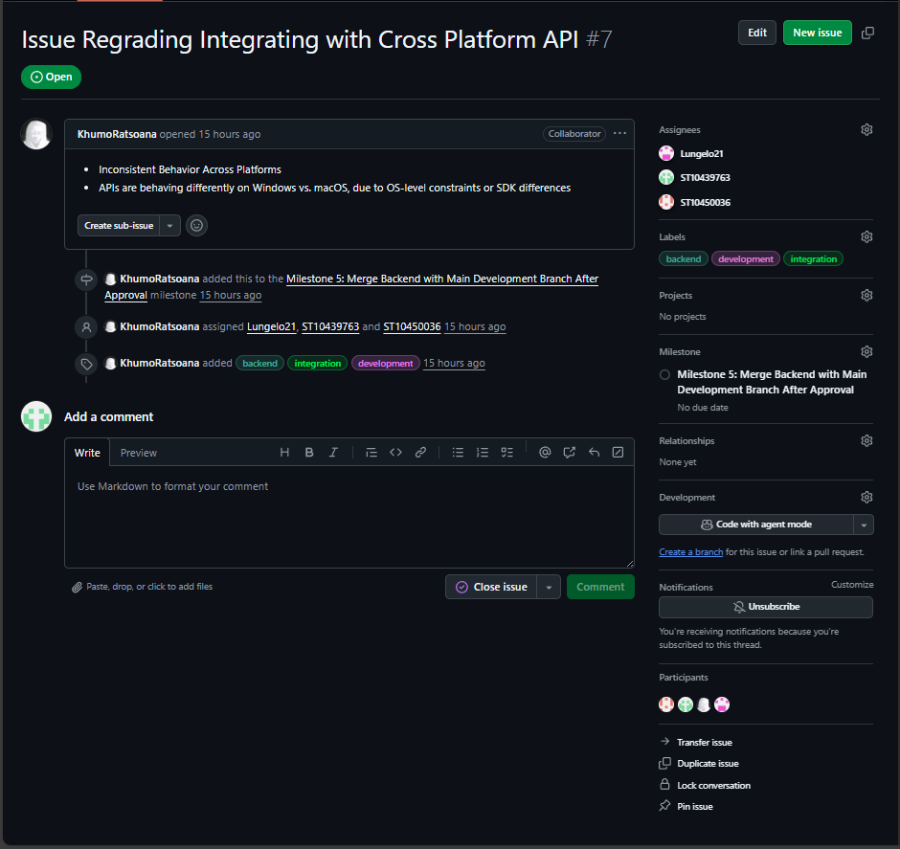

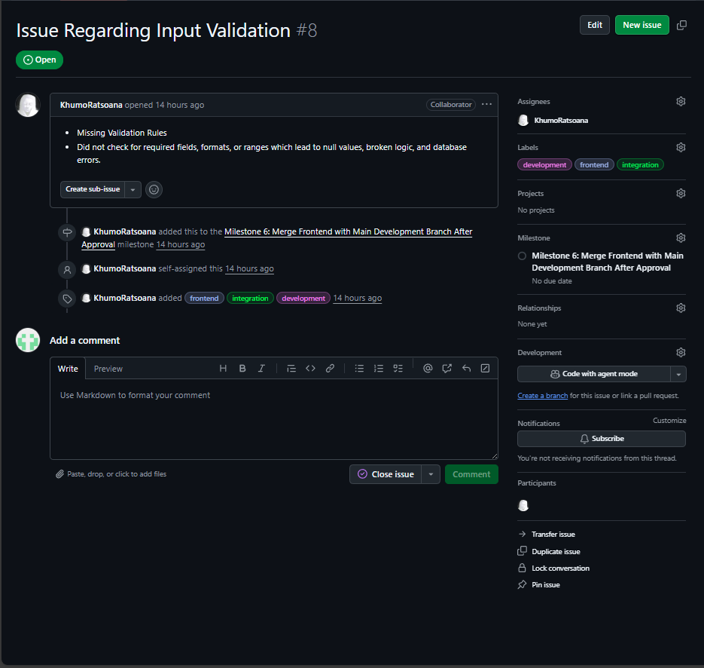

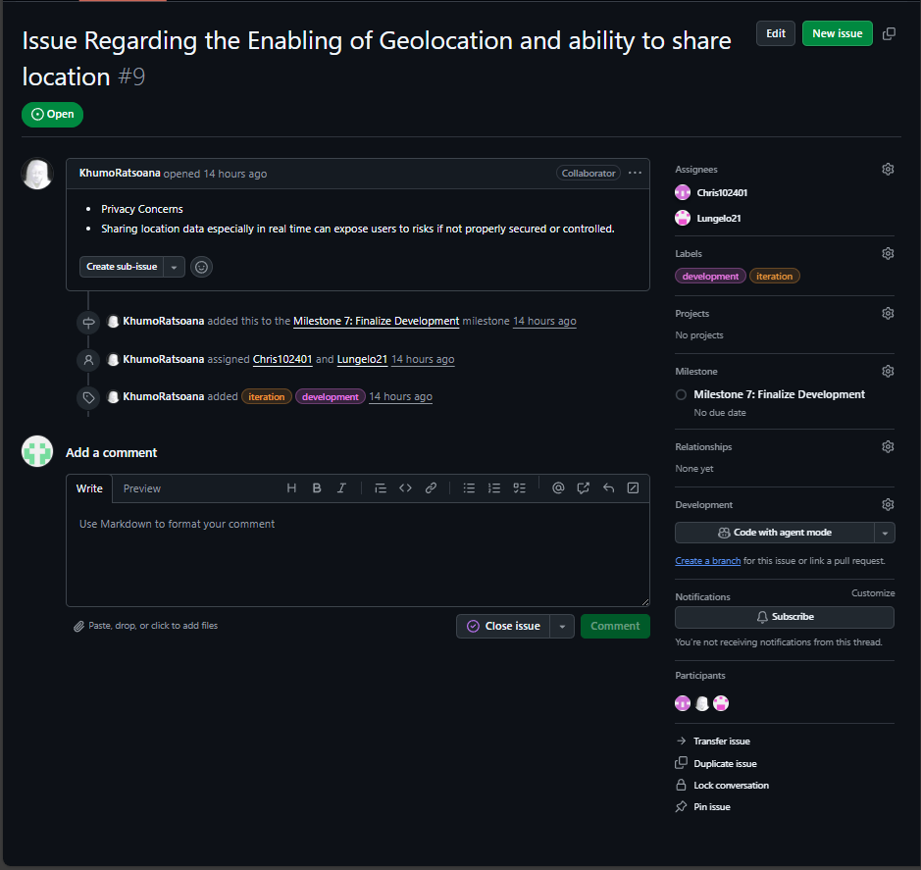

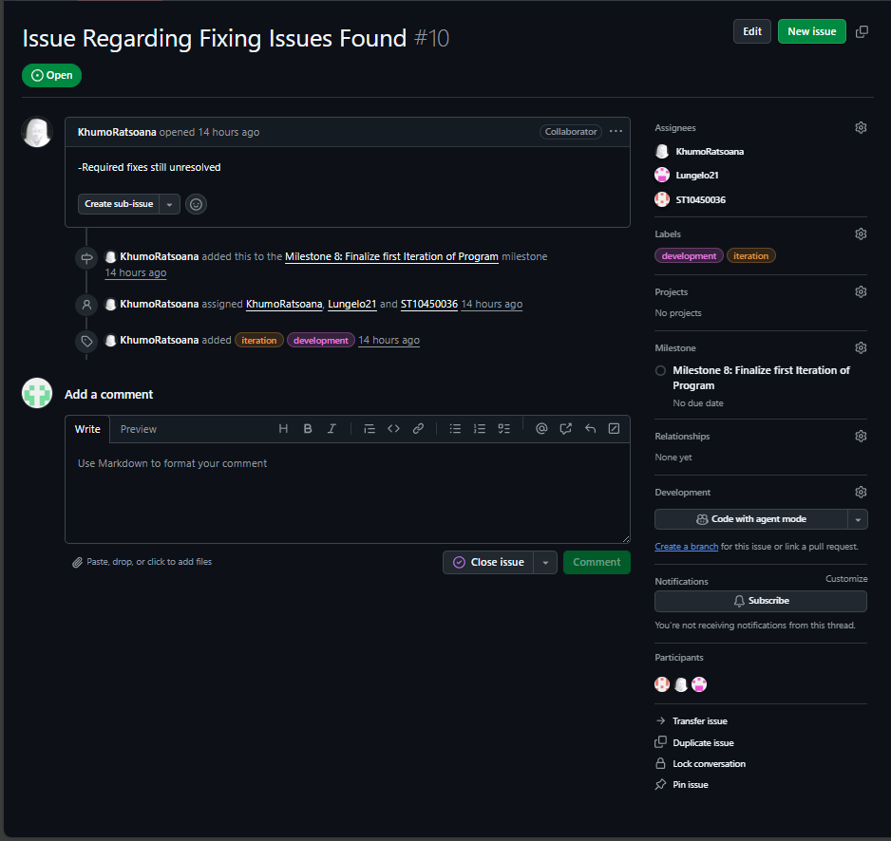

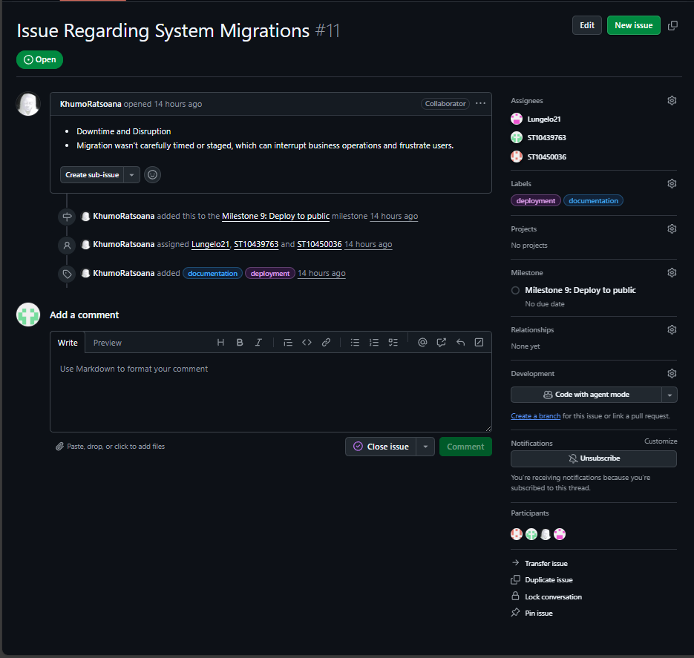

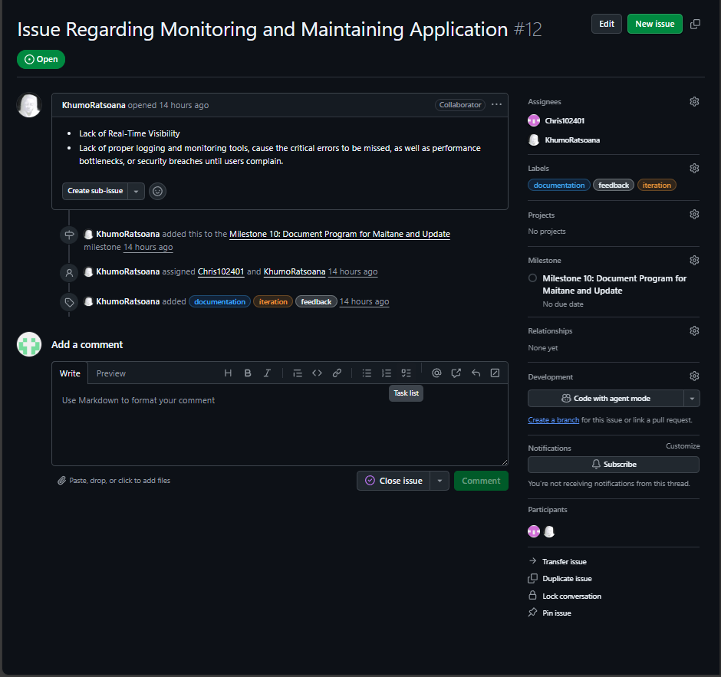

# **Question 4**

|  |  |
| --- | --- |
| **KEY** | |
| **WBS** | **TITLE** |
| **0** | **Emergency SOS System** |
| **1** | **Planning And Analysis** |
| 1.1 | Identify Problem |
| 1.2 | Identify Stakeholders |
| **1.3** | **Identify Requirements** |
| 1.3.1 | Identify Functional Requirements |
| 1.3.2 | Identify Non-Functional Requirements |
| 1.4 | Define Project Scope |
| **1.5** | **Plan Resources** |
| 1.5.1 | Hire Staff |
| 1.5.2 | Plan Equipment |
| 1.5.3 | Plan Rates |
| **1.6** | **Create Project Plan** |
| 1.6.1 | Draft Project Plan |
| 1.6.2 | Liaison With Community And Update Plan To Feedback |
| **2** | **Designing** |
| **2.1** | **Create Diagrams** |
| 2.1.1 | Use Case Diagram |
| 2.1.2 | UML Class Diagram |
| 2.1.3 | Activity Diagram |
| 2.2 | Design User Interface |
| 2.3 | Design Database |
| 2.4 | Design Backend Architecture |
| 2.5 | Design Network Architecture and Internet Connection |
| 2.6 | Ensure Encryption Standard Is Set And Security Practices Are Designed for |
| 2.7 | Ensure Application Complies with Laws |
| **2.8** | **Design Documentation** |
| 2.8.1 | Create Design Documentation |
| 2.8.2 | Liaison With Community And Update Design To Feedback |
| **3** | **Development** |
| **3.1** | **Database Development** |
| 3.1.1 | Create DB and Tables |
| 3.1.2 | Add Constraints |
| 3.1.3 | Insert Test Data |
| 3.1.4 | Merge DB with Main Development Branch After Approval |
| **3.2** | **Backend Development** |
| 3.2.1 | Create Classes |
| 3.2.2 | Create Exceptions |
| 3.2.3 | Structure Logic |
| 3.2.4 | Connect to DB |
| 3.2.5 | Connect to Emergency Service Provider Contacts |
| 3.2.6 | Enable Emergency Notification Contacts |
| 3.2.7 | Integrate With Cross Platform API |
| 3.2.8 | Merge Backend with Main Development Branch After Approval |
| **3.3** | **Frontend Development** |
| 3.3.1 | Connect to Backend |
| 3.3.2 | Develop Layout |
| 3.3.3 | Create Navigation |
| 3.3.4 | Validate Inputs |
| 3.3.5 | Merge Frontend with Main Development Branch After Approval |
| **3.4** | **Networking** |
| 3.4.1 | Implement Servers |
| 3.4.2 | Ensure Redundancy And Proper Encryption is In Place |
| 3.4.3 | Connect Application to Internet |
| 3.4.4 | Enable GeoLocation and Ability to Share Location to Emergency Provider |
| 3.5 | Finalise Development |
| **4** | **Testing** |
| **4.1** | **Alpha Testing** |
| 4.1.1 | Unit Testing |
| 4.1.2 | Intergration Testing |
| 4.1.3 | Penetration Testing |
| **4.2** | **Beta Testing** |
| 4.2.1 | Get Beta Users From a Select Group In Community |
| 4.2.2 | Beta Users Test System and Gain Feedback |
| 4.3 | Fix Issues found |
| 4.4 | Finalise First Iteration of Program |
| **5** | **Deployment** |
| 5.1 | Stage Deployment |
| **5.2** | **Migrate Systems** |
| 5.2.1 | Migrate Data to Databases |
| 5.2.2 | Implement New System |
| 5.2.3 | Beta Deploy |
| 5.2.4 | Gain Feedback And Update |
| 5.3 | Deploy To Public |

# References

Mărcuță, C., 2025. *Exploring the Limitations and Potentials of Cross-Platform Development - A Comprehensive Guide.* [Online]   
Available at: https://moldstud.com/articles/p-exploring-the-limitations-and-potentials-of-cross-platform-development-a-comprehensive-guide  
[Accessed 22 September 2025].

Singh, M. P., 2025. *Top 7 Ways Cross-Platform App Development Saves Costs.* [Online]   
Available at: https://engineerbabu.com/blog/how-cross-platform-app-development-saves-costs/#:~:text=Cross-platform%20app%20development%20has%20become%20a%20strategic%20approach,by%20utilizing%20a%20single%20codebase%20across%20multiple%20platforms  
[Accessed 22 September 2025].

WallStreetMojo, 2023. *Project Evaluation.* [Online]   
Available at: https://www.wallstreetmojo.com/project-evaluation/  
[Accessed 22 September 2025].