**DEDICATED PIZZA ANDROID APP(Pizzero)**

**DEVELOPMENT DURATION: 3 MONTHS(JAN - MARCH)**

**PROBLEM:** Workers and freelancers with tight schedules lack necessary time to prepare a meal for themselves.

**GOAL:** design and develop a dedicated app for pizzero that allows users to easily order and pick up fresh, healthy and delicious pizza.

**USER JOURNEY MAP**

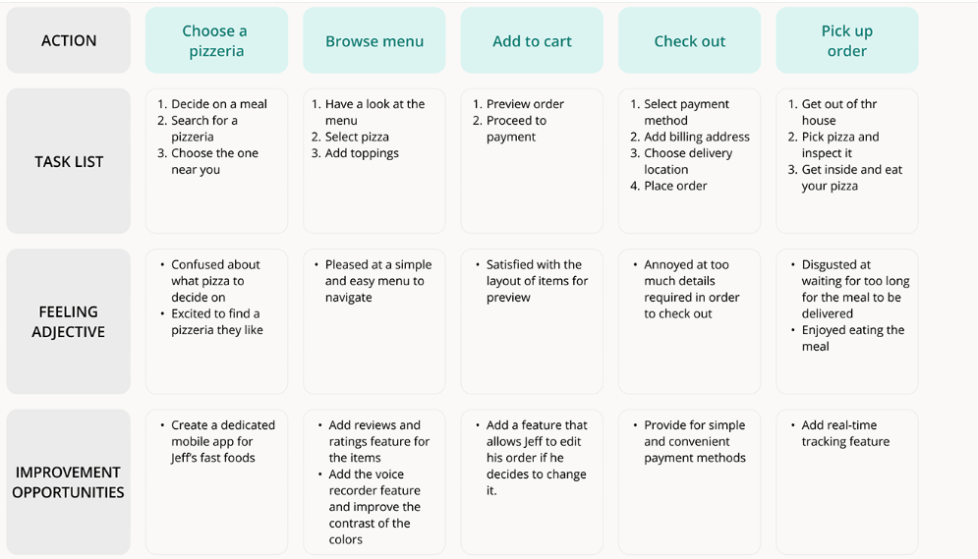

**DESIGN PROCESS: Paper wirefra**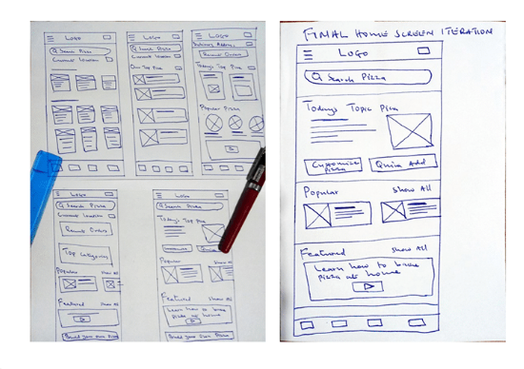

**DIGITAL WIREFRAMES: Sign up and sign-in pages**

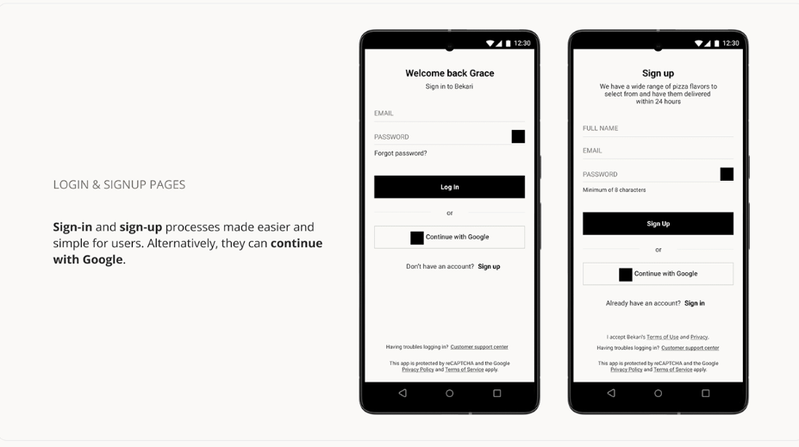

**Usability and study findings:**

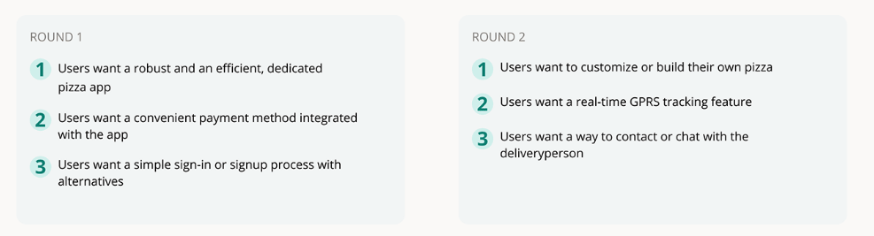

**Refined Designs:**

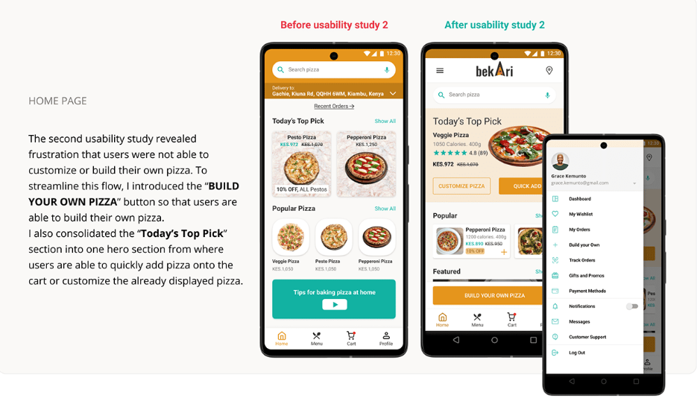

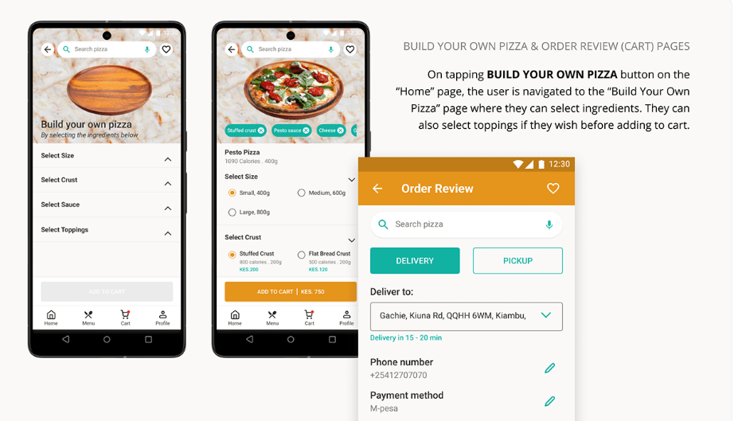

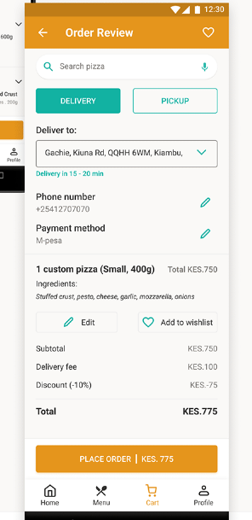

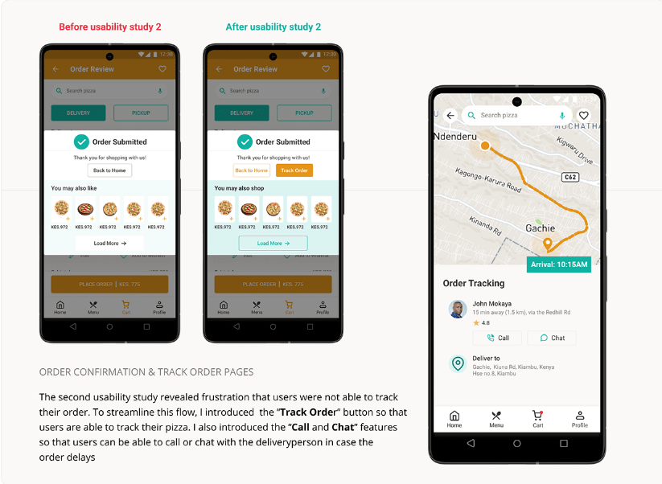

**OTHER SCREENS:**

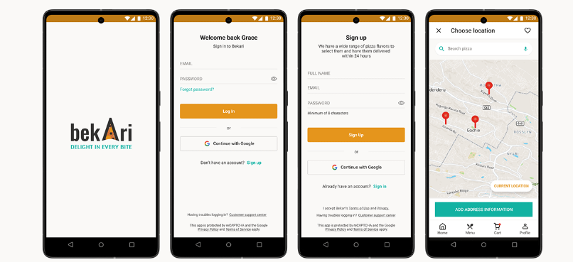

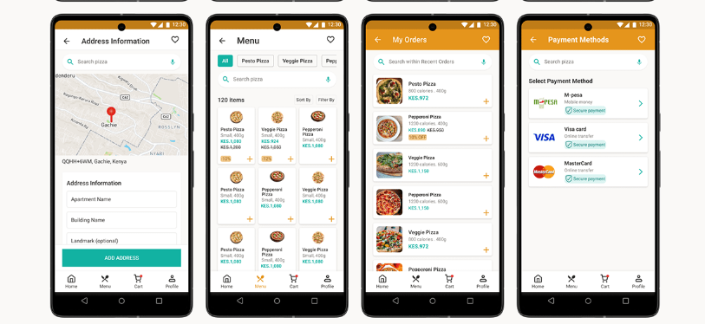

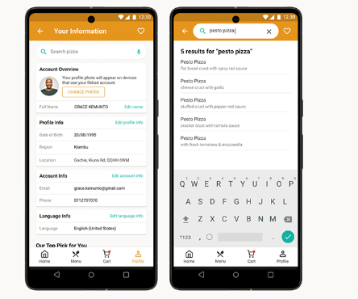

**Next Steps:**

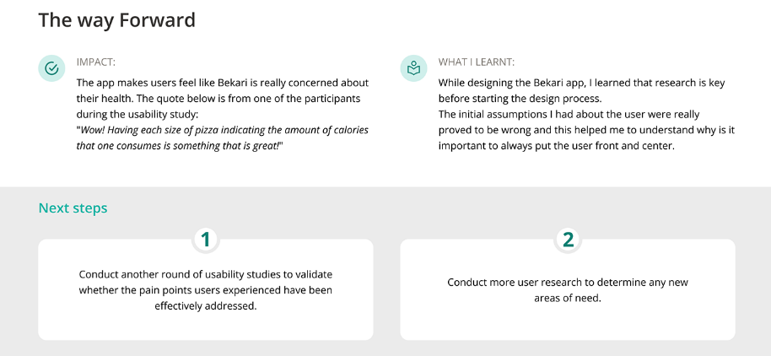

**User roles in the application:**

**1. Customer/User**:

1. **Primary Functionality**: Browse the pizza menu, customize pizzas (size, crust, toppings), add to cart, place orders, view past orders, and make payments.
2. **Permissions**:
   1. Browse the menu
   2. Select pizza options (size, toppings, etc.)
   3. View cart and order summary
   4. Place an order and make payments
   5. View past order history(UI design pending)
   6. Access profile and settings

**2. Admin/Store Manager**:

1. **Primary Functionality**: Manage the pizza menu (add/remove items, customize prices), view orders, track order status, manage users (if needed), and perform other store management tasks.
2. **Permissions**:
   1. Add/edit/remove menu items (sizes, crusts, toppings)
   2. Manage pricing and special offers
   3. View all orders and their statuses (pending, preparing, completed)
   4. View and manage customer accounts (optional)
   5. Manage app settings (if applicable)
   6. View reports (sales, customer behavior, etc.)

**3. Delivery Person** (Optional):

1. **Primary Functionality**: Deliver orders to customers and update the order status in the system (e.g., order picked up, on the way, delivered).
2. **Permissions**:
   1. View the assigned deliveries
   2. Update delivery status
   3. Communicate with the customer (if needed)

**4**.**Customer Support** (Optional):

1. **Primary Functionality**: Assist customers with issues, complaints, or inquiries. They can handle refunds, address user issues, and manage customer queries.
2. **Permissions**:
   1. View and manage customer complaints
   2. Access order histories for troubleshooting
   3. Provide support via chat or call

***Break Down of Admin/ Store Manager***

Dashboard of the admin in your pizza app, here are some key statistics and data points to display to help them monitor the app’s performance, manage operations, and track essential metrics.

1. **Total Orders**:

**Total Number of Orders**: Show how many orders have been placed overall.

**Orders Today/This Week/This Month**: Provide time-based insights like the number of orders placed today, this week, and this month.(will create it’s own screen for this)

2. **Order Status Breakdown**:

**Pending Orders**: Show the number of orders that are yet to be processed or confirmed.

**Completed Orders**: Show the number of completed orders.

**Cancelled Orders**: Show any orders that have been cancelled

3. **Revenue Statistics**:

**Total Revenue**: Display the total revenue earned so far.

**Revenue Today/This Week/This Month**: Show time-based revenue statistics.

**Average Order Value**: Calculate and display the average order value for all orders.

4. **Most Popular Items**:

**Top 5 Most Ordered Pizzas**: Show the top-selling pizzas in the app.

**Top 5 Add-Ons/Extras**: Display popular add-ons like drinks, sides, and desserts.

5. **Customer Data**:

**New Customers Today/This Week/This Month**: Track how many new customers signed up.

**Most Active Customers**: Display a list of top customers by order count or order value.

**Total Registered Users**: Show the total number of users who have registered on the platform.

6. **Delivery Data**:

**Average Delivery Time**: Show the average time it takes to deliver an order.

**Total Deliveries Today/This Week/This Month**: Provide insights into how many deliveries were made during these timeframes.

**Pending Deliveries**: Display the number of pending deliveries.

7. **Order Source**:

**Online Orders**: Display the number of orders made through the app.

8. **Payment Data**:

**Payment Methods Breakdown**: Show statistics for the different payment methods (e.g., card payments, cash on delivery, etc.).

**Pending Payments**: Show the number of orders that are awaiting payment.

9. **Customer Feedback/Reviews**:

**Average Customer Rating**: Show the average rating across all customers

**Recent Reviews**: Display a list of recent customer reviews and feedback on pizzas, delivery, or service.

10. **Promotions and Discounts**:

**Active Discounts/Coupons**: Show details of any active promotions or coupons currently in use.

**Discount Usage**: Track how many times the discounts have been used in the current period.