# SUMMARY

Topic title: Real estate business

Student name: Nguyen Duc Van

Student ID: 102210195. Class: 21TCLC_DT2

|  |  |
| --- | --- |
| DA NANG UNIVERSITY  **UNIVERSITY OF SICIENCE AND TECHNOLOGY**  FALCUTY………………………………………… | **THE SOCIALIST REPUBLIC OF VIETNAM**  Independence - Freedom - Happiness |

# GRADUATION PROJECT REQUIREMENTS

Student Name: …..…………….………….…….. Student ID :………………...

Class:…………… Faculty:..................................... Major:…………...........................

1. *Topic title:*

………………………………………………..…………………………………………

…………………………………………………………………………………………..

1. *Project topic :* ☐*has signed intellectual property agreement for final result*
2. *Initial figure and data:*

……………………………………..……………………………………………..……......……………………………………………………………………………………………..………………………………….…..………………………..………………………*Content of the explanations and calculations:*

…...………………………………………………………………………………………

…...………………………………………………………………………………………

…...………………………………………………………………………………………

…...………………………………………………………………………………………

…...………………………………………………………………………………………

1. *Drawings, charts (specify the types and sizes of drawings):*

…...………………………………………………………………………………………

…...………………………………………………………………………………………

…...………………………………………………………………………………………

…...………………………………………………………………………………………

|  |  |
| --- | --- |
| 1. *Name of instructor:* | *Content parts:* |
|  |  |
|  |  |
|  |  |

1. *Date of assignment: ……../……./201…..*
2. *Date of completion: ……../……./201…..*

|  |  |
| --- | --- |
|  | *Đà Nẵng, date month year 201* |
| **Head of Division**…………………. | **Instructor** |

# PREFACE

# ASSURRANCE

I hereby declare that:

1. The graduation project report, Topic name: Real Estate Business System, is my own research work under the direct guidance of the lecturer ................................
2. I have read, researched, translated documents and synthesized the knowledge that has made this report and ensure that it has not been copied anywhere.
3. The theories in the thesis are all used from the documents as I have referred to in the reference section in the report.

If there is any violation, I will take full responsibility.

Student Performed

Nguyen Duc Van

# TABLE OF CONTENT

SUMMARY 3

GRADUATION PROJECT REQUIREMENTS 4

PREFACE i

ASSURRANCE ii

TABLE OF CONTENT iii

LIST OF PICTURES v

LIST OF TABLES vi

LIST OF SYMBOL, ACRONYM vii

INTRODUCTION 1

1. Purpose of implementation 1

2. Objective of the topic 1

2.1. System Target 1

2.2. Features 1

3. Scope 2

4. Target customers 2

5. Development technology 2

CHAPTER 1: THEORETICAL FOUNDATION 3

CHAPTER 2: SYSTEM DESIGN AND ANALYSIS 4

2.1. Business analysis 4

2.1.1. Buyer's business 4

2.1.2. Broker's business 4

2.1.3. Admin's business 4

2.2. System design 5

2.2.1. Use-case diagram 5

2.2.2. Activity diagram 8

2.2.3. Sequence diagram 9

2.3. Database design 14

2.3.1. ER (entity-relationship) 14

2.3.2. Converting an implementation model into a system model 14

2.3.3. Database schema 20

2.4. Real estate prediction system development 21

2.4.1. Real estate valuation model 25

2.4.2. Real estate price forecast model 26

2.5. Apply NSFW image and toxic content classification models 26

2.5.1. NSFW image classification models 26

2.6. Chapter Conclusion 27

CHAPTER 3: IMPLEMENTATION AND RESULTS EVALUATION 27

CHAPTER 4: CONCLUSION AND DEVELOPMENT DIRECTION 28

REFERENCES 29

APPENDIX 1 1

APPENDIX 2 2

# LIST OF PICTURES

Figure 2.1 General use case diagram 5

Figure 2.2 User management use-case diagram 5

Figure 2.3 Post moderation use case diagram 6

Figure 2.4 Profile management use case diagram 6

Figure 2.5 Account upgrade management use case diagram 7

Figure 2.6 Post management use case diagram 7

Figure 2.7 Favourite post management use case diagram 8

Figure 2.8 Client Operation Principle 9

Figure 2.9 Admin Operation Principle 9

Figure 2.10 Registration/Login Flow 10

Figure 2.11 Real estate article management flow as a user 12

Figure 2.12 Account upgrade flow 13

Figure 2.13 The ER entity relationship model 14

Figure 2.14 Relational Model 20

Figure 2.15 Real estate valuation model features 21

Figure 2.16 Real estate price forecast features 22

Figure 2.17 Q-Q Plots After Optimal Normalization per Feature 23

Figure 2.18 Comparison of Q-Q Plots of **Price per m²** across different transformation methods 23

Figure 2.19 Scatter plot of features vs. **Price** 24

Figure 2.20 Selected features in order from best to worst 24

Figure 2.21 Optimal number of features 24

Figure 2.22 Recursive Feature Elimination with correlated features 25

# LIST OF TABLES

Table 2.1 Describe role table attributes 14

Table 2.2 Describe user table attributes 15

Table 2.3 Describe token table attributes 15

Table 2.4 Describe transaction histories table attributes 16

Table 2.5 Describe favourite properties table attributes 16

Table 2.6 Describe category table attributes 16

Table 2.7 Describe property table attributes 17

Table 2.8 Describe house table attributes 17

Table 2.9 Describe furnished status table attributes 17

Table 2.10 Describe type of house table attributes 18

Table 2.11 Describe house characteristics table attributes 18

Table 2.12 Describe house characteristic mapping table attributes 18

Table 2.13 Describe land table attributes 18

Table 2.14 Describe type of land table attributes 18

Table 2.15 Describe land characteristics table attributes 19

Table 2.16 Describe land characteristic mapping table attributes 19

# LIST OF SYMBOL, ACRONYM

|  |  |
| --- | --- |
| Symbol, Acronym | Detailed explanation |
| PMML | Predictive Model Markup Language |
| HTTPS | HyperText Transfer Protocol Secure |
| PKL | Extension for files created with Pickle |
| API | Application Programming Interface |
| ONNX | Open format for storing machine learning models |
| NSFW | Not safe for work |

# INTRODUCTION

## Purpose of implementation

* Searching and buying real estate today is difficult, especially in determining the real value of the property, comparing suitable options and accessing transparent information. Buyers often spend a lot of time searching for properties that meet their needs in terms of location, area, amenities and finance, while sellers have difficulty reaching potential customers.
* Therefore, an online real estate business system can help display information visually, support filtering and comparing options, and integrate price prediction technology to help buyers and sellers make more accurate decisions

## Objective of the topic

### System Target

* Help users quickly post and search for suitable real estate based on filters with many characteristics.
* The real estate valuation feature provides a reference price close to the market, helping users minimize the risk of incorrect valuation, supporting the brokerage team or real estate sellers and buyers to save time in valuation and negotiation.
* The system will also support predicting real estate fluctuations to support customers' buying or selling decisions.
* Integrating VNPay, safe and convenient online payment when customers want to upgrade their account to use more features of the application.

### Features

* For guest
  + Search and filter by needs: price, area, location, property type, ...
  + View property details with images, prices and legal information, ...
  + Displays detailed information of the property along with the price determined by the property valuation system.
* For member
  + Post real estate with full information: images, descriptions, prices, legal status, ...however, the number of posts will be limited to 3.
  + You can save posts that interest you as well as upgrade your account to be able to use more features of the application.
* For brokers
  + Customers with upgraded accounts will be supported by the system to forcast real estate price in the future.
  + The number of posts posted by the brokerage account will also be up to 30.
* For admins:
  + Update account status.
  + View article details and moderate it.

## Scope

* Property type: house, land.
* Geographical scope: Da Nang
* Language: Vietnamese

## Target customers

* Real Estate Buyers/Sellers
* Real Estate Companies or Brokers

## Development technology

* Project management: Github
* Language: Java, Python, Reactjs
* Framework: Spring boot
* Database: Mysql
* Encryption & security: Security, HTTPS Token

# THEORETICAL FOUNDATION

## Overview of Python and Jupyter Notebook

### Python

Python is a widely used high-level programming language applied in web development, software engineering, data science, and machine learning (ML). Developers favor it due to its simplicity, efficiency, and cross-platform compatibility.



Figure 1.1 Python

**Benefits of Python include:**

* Developers can easily read and understand Python programs because the language has a simple syntax that resembles English.
* Python improves developer productivity as fewer lines of code are typically needed to write a program compared to other programming languages.
* Python has a large standard library that contains reusable code for almost any task, so developers don't need to write everything from scratch.
* Developers can easily integrate Python with other popular programming languages such as Java, C, and C++.
* Python is cross-platform and can be used on various operating systems, including Windows, macOS, Linux, and Unix.

### Jupyter Notebook

Jupyter Notebook is an open-source web application that allows users to create and share documents containing code, equations, visualizations, and narrative text. It is widely used in data science, machine learning, academic research, and educational settings.



Figure 1.2 Jupyter

Benefits of Jupyter Notebook:

* Jupyter allows users to run code in small chunks, making it ideal for testing and debugging.
* The integration with libraries like Matplotlib, Seaborn, and Plotly makes visualizing data easy within the notebook itself.
* Users can mix narrative text (using Markdown) with code and outputs, creating comprehensive reports or tutorials.
* Notebooks make it easy to share code, data, and results, ensuring that research is reproducible.

## Overview of Java and MySQL

### Java

Java is a class-based, object-oriented programming language that is designed to have as few implementation dependencies as possible. It is intended to let application developers Write Once and Run Anywhere (WORA), meaning that compiled Java code can run on all platforms that support Java without the need for recompilation. Java was developed by James Gosling at Sun Microsystems Inc. in May 1995 and later acquired by Oracle Corporation, and is widely used for developing applications for desktop, web, and mobile devices.



Figure 1.3 Java

Java is known for its simplicity, robustness, and security features, making it a popular choice for enterprise-level applications. Java applications are compiled to bytecode that can run on any Java Virtual Machine. The syntax of Java is similar to C/C++.

Since Java runs on the JVM, it may not be as fast as languages that are compiled directly, such as C/C++. This can be a concern for applications that require high performance.

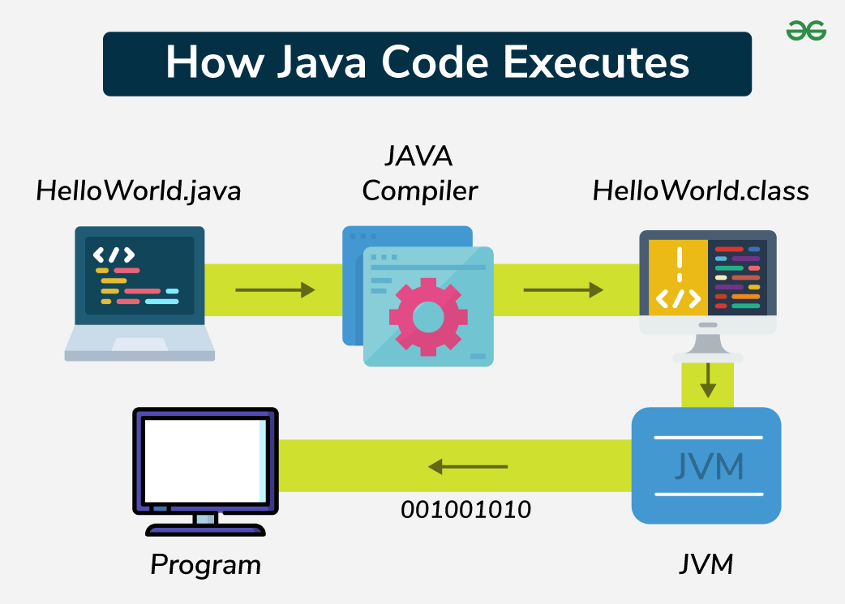

Figure 1.4 The compilation and interpretation process of Java

### Spring Boot

Spring Boot is a combination of the Spring Framework and an embedded server, allowing you to build web applications, microservices, and standalone JAR applications. It supports features like Microservices, REST API, and JPA databases, making app development simpler and more efficient.



Figure 1.5 Spring Boot

Advantages of Spring Boot:

* It creates standalone Spring applications.
* It makes testing web apps easier with embedded HTTP servers like Tomcat, Jetty, and others. No need to distribute WAR files.
* No XML configuration required.

### MVC model

### MySQL

## Overview of ReactJS and ChakraUI

### Reactjs

### ChakraUI

# SYSTEM DESIGN AND ANALYSIS



## Business analysis

### Buyer's business

* **Visiting customers**
  + View property list: can view all properties posted on the system.
  + View property details: view description, images, price, area, number of rooms,… At the same time, the real estate price will be displayed as determined by the system.
  + Register account: if you want to save posts or make transactions, visitors must register an account.
  + Search and filter properties: search by keywords, filter by characteristics of property.
* **Members** are those who have registered an account and can use all the features:
  + All rights of visitors.
  + Update profile and account information: Change contact information and fullname.
  + Upgrade account: choose an account upgrade package to use more features and pay directly through the payment gateway.
  + View transaction history: track completed or pending transactions.
  + Buyer accounts can also post properties for sale, but are limited to 3
  + Manage personal post: edit, update, or delete posted real estate post.
  + Save to favorites: add properties to your favorites list for easy access later.

### Broker's business

* Brokerage account is a registered and upgraded account
* Having all rights of member
* This account will be used for additional features of the system: predict real estate trends.
* The article limits the posts that can be posted by this account to 30

### Admin's business

* Account status control: lock or unlock client accounts.
* Post moderation: review, approve or reject real estate posts.

## System design

### Use-case diagram

#### General use-case diagram

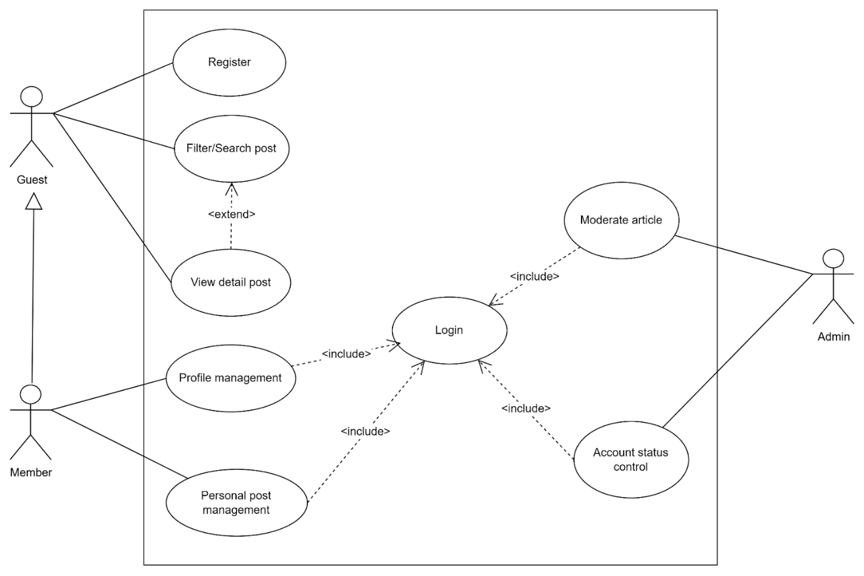

Figure 2.1 General use case diagram

#### Admin use-case diagram

* Account status control

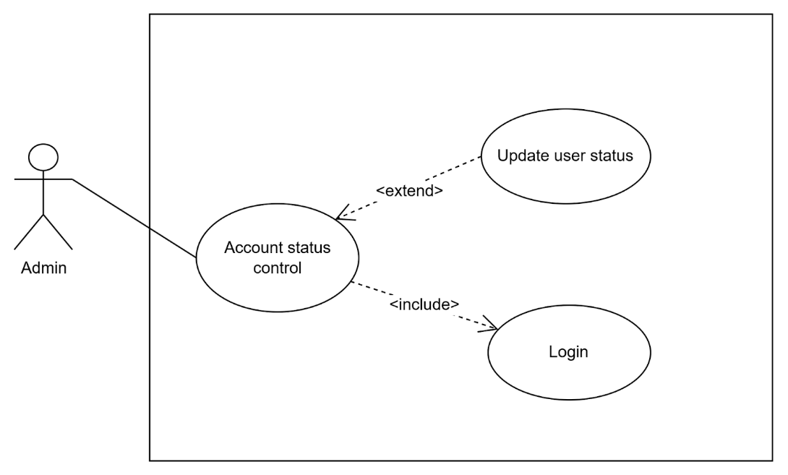

Figure 2.2 User management use-case diagram

* Post moderation

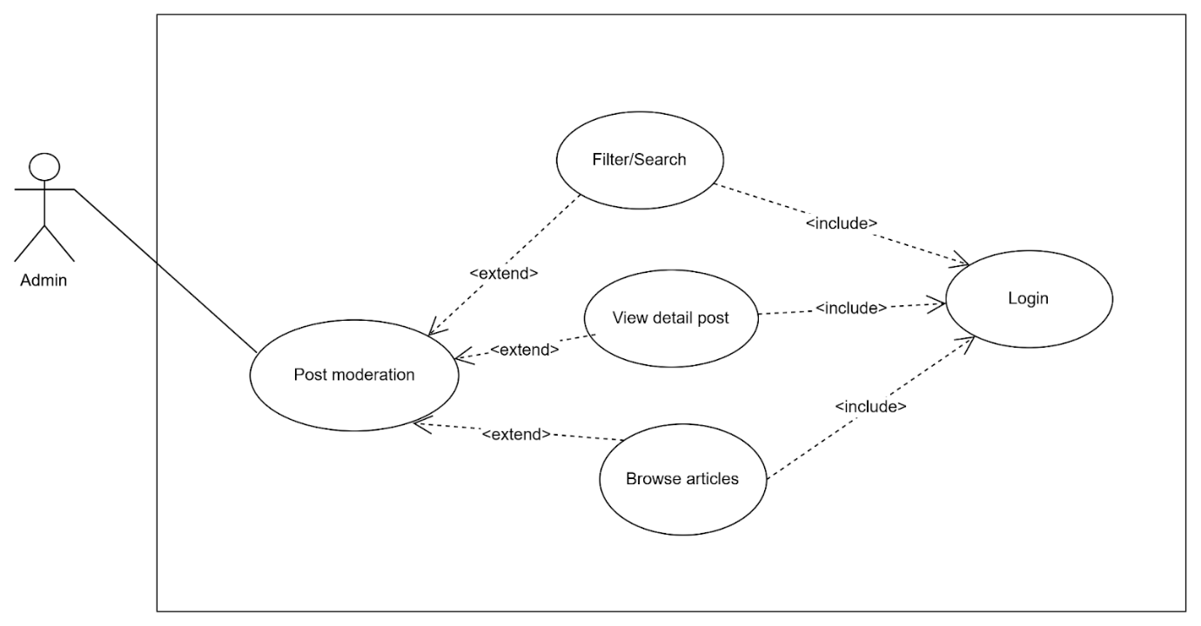

Figure 2.3 Post moderation use case diagram

#### User use-case diagram

* Profile management

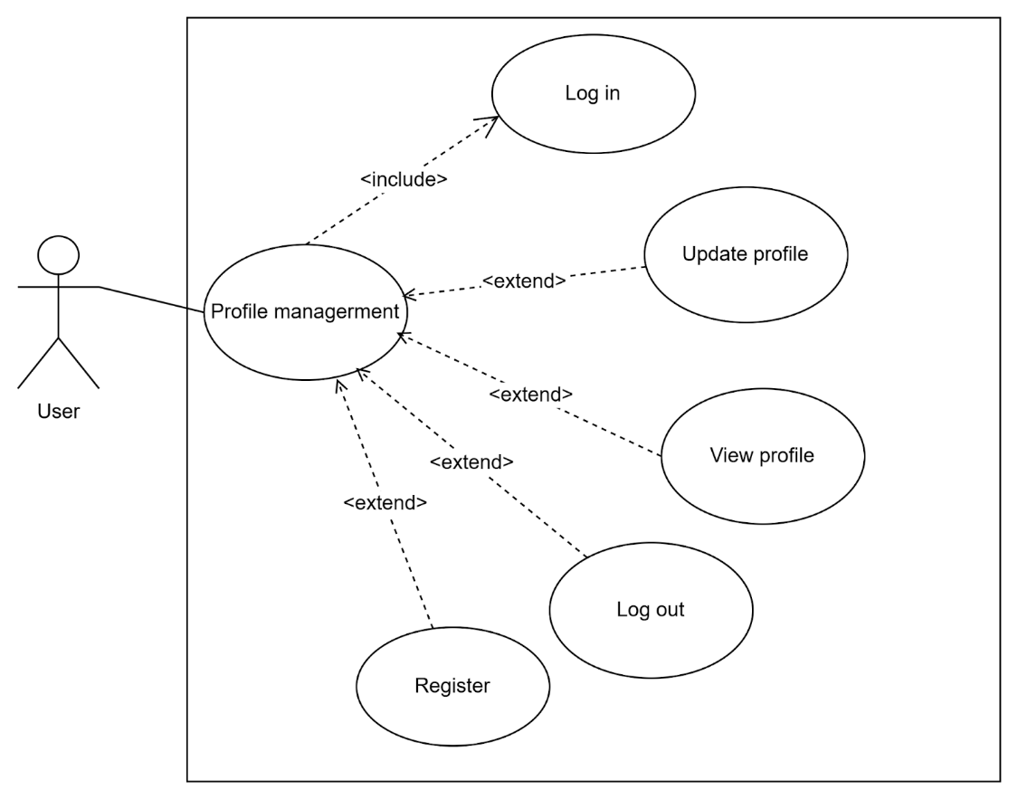

Figure 2.4 Profile management use case diagram

* Account upgrade management

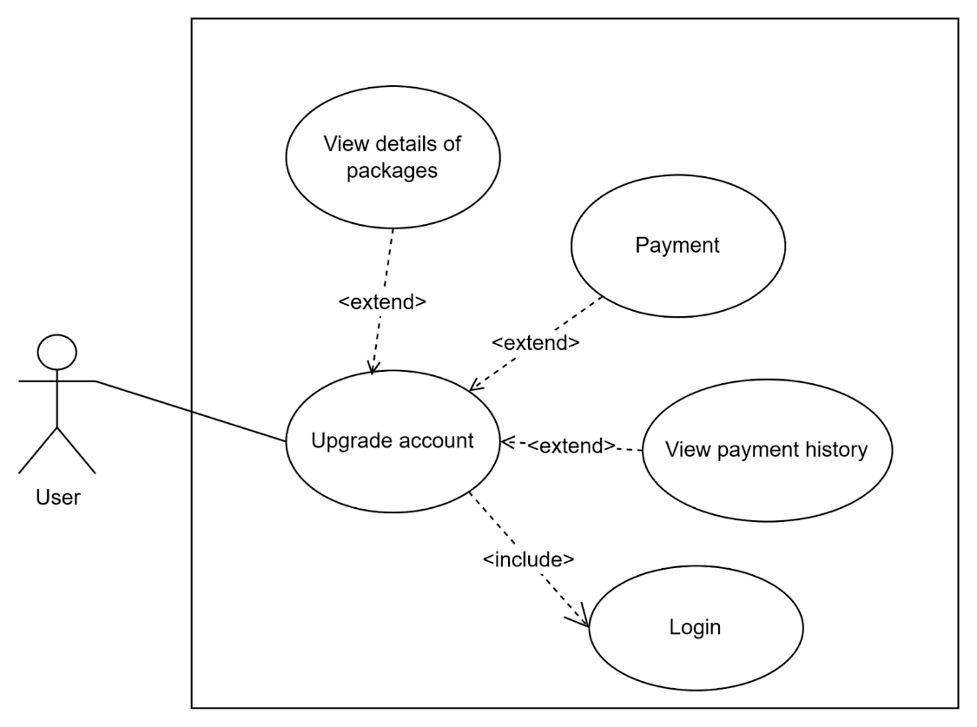

Figure 2.5 Account upgrade management use case diagram

* Post management

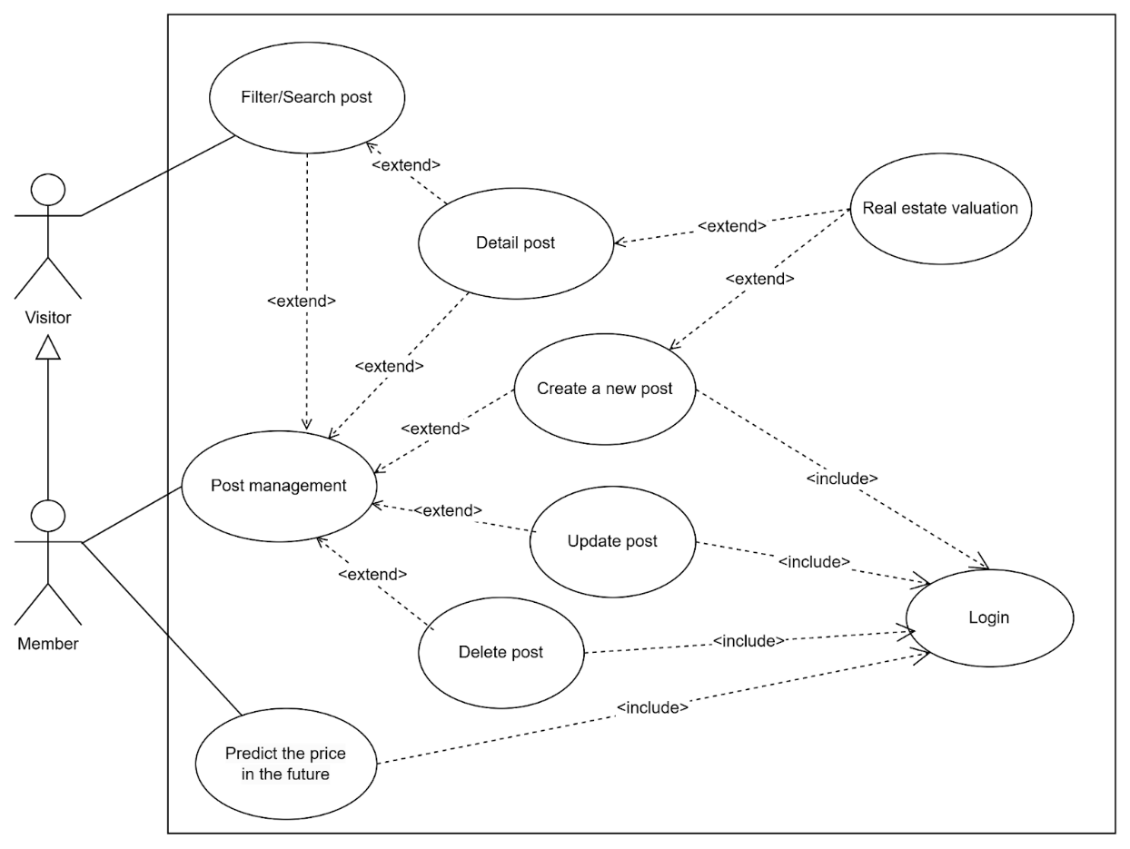

Figure 2.6 Post management use case diagram

* Favourite post management

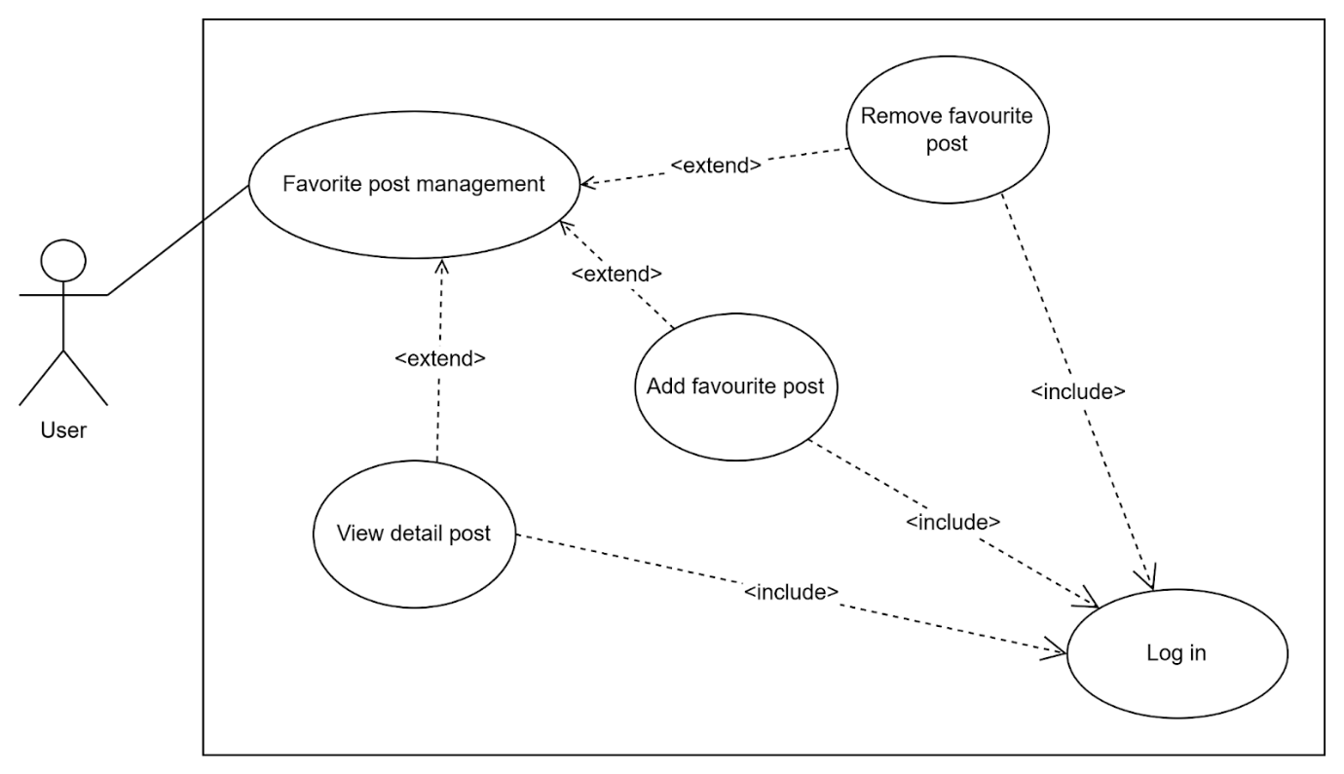

Figure 2.7 Favourite post management use case diagram

### Activity diagram

* The stream of activities access to the buyer/seller 's website

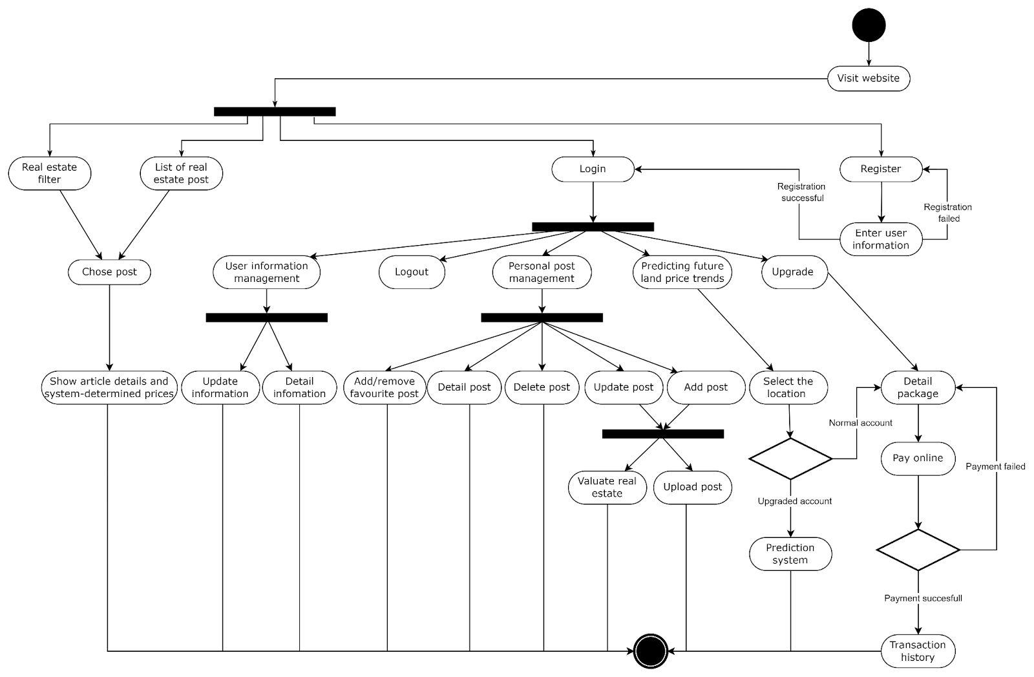

Figure 2.8 Client Operation Principle

* The stream of activities access to the admin website

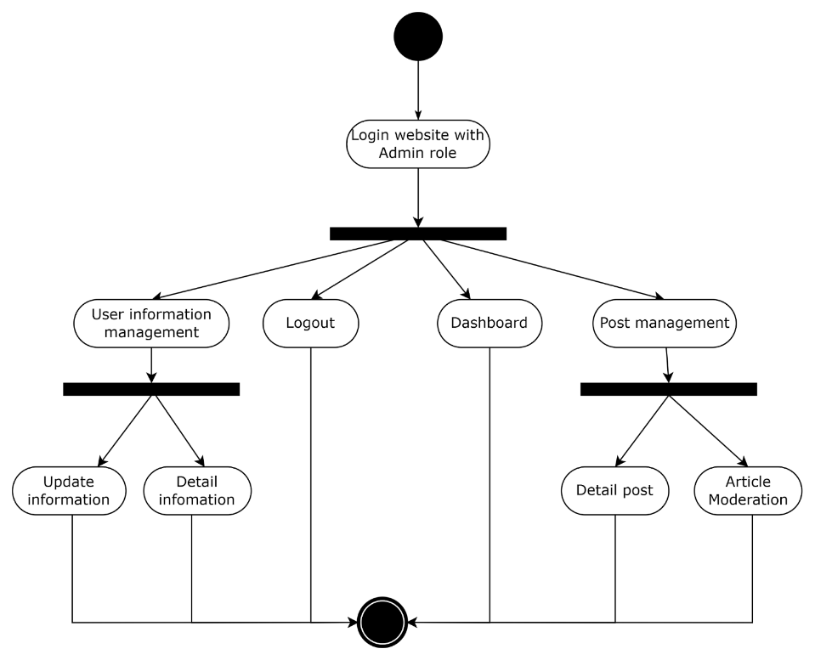

Figure 2.9 Admin Operation Principle

### Sequence diagram

* Login/Signup flow design

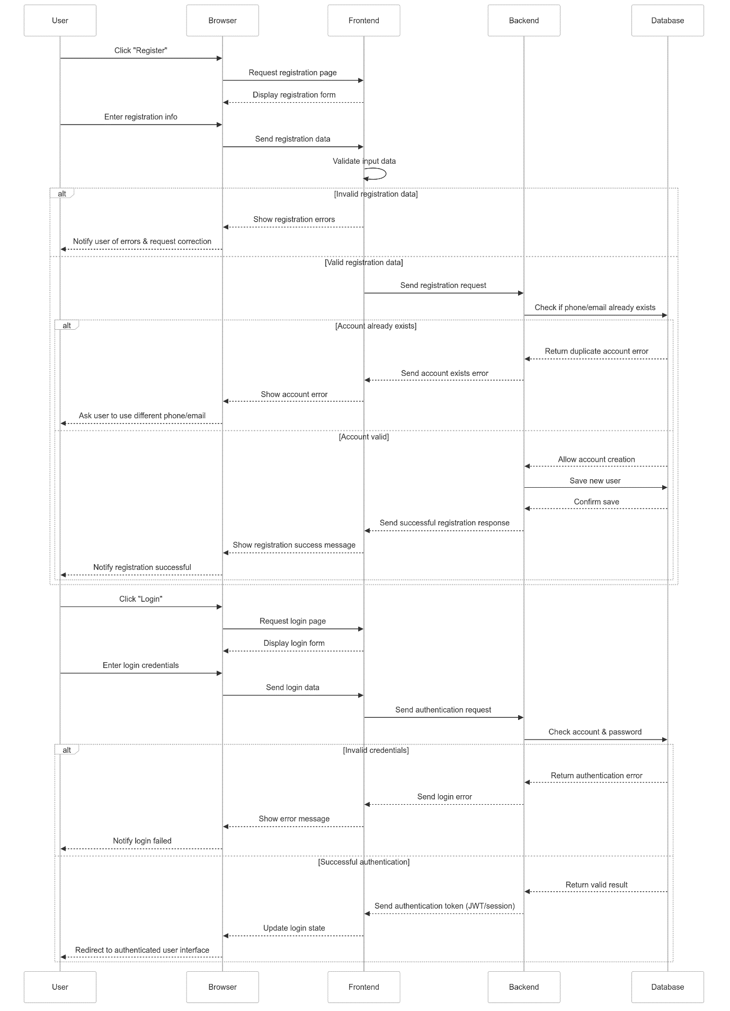

Figure 2.10 Registration/Login Flow

* Real estate article management flow design

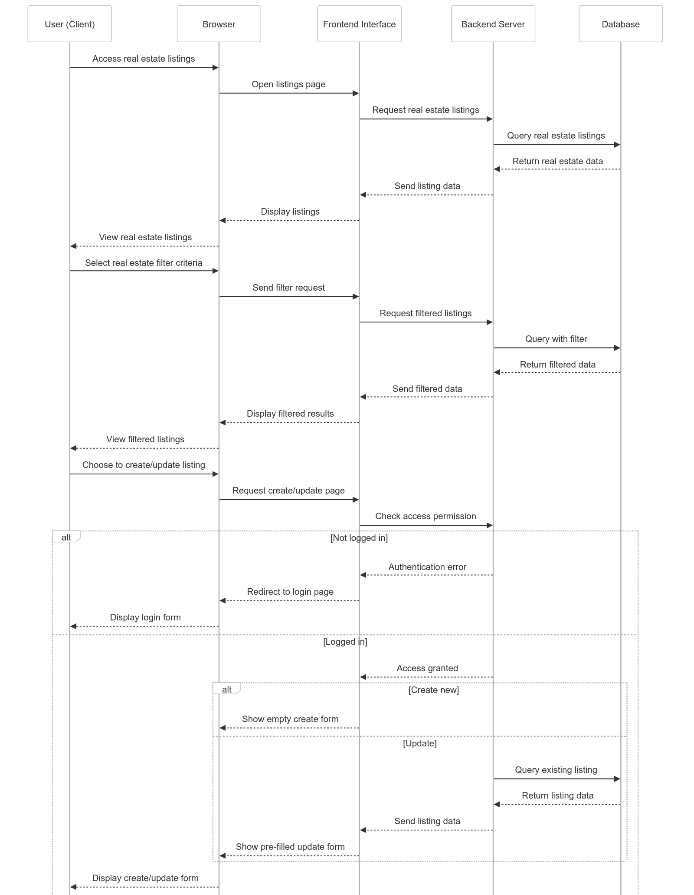

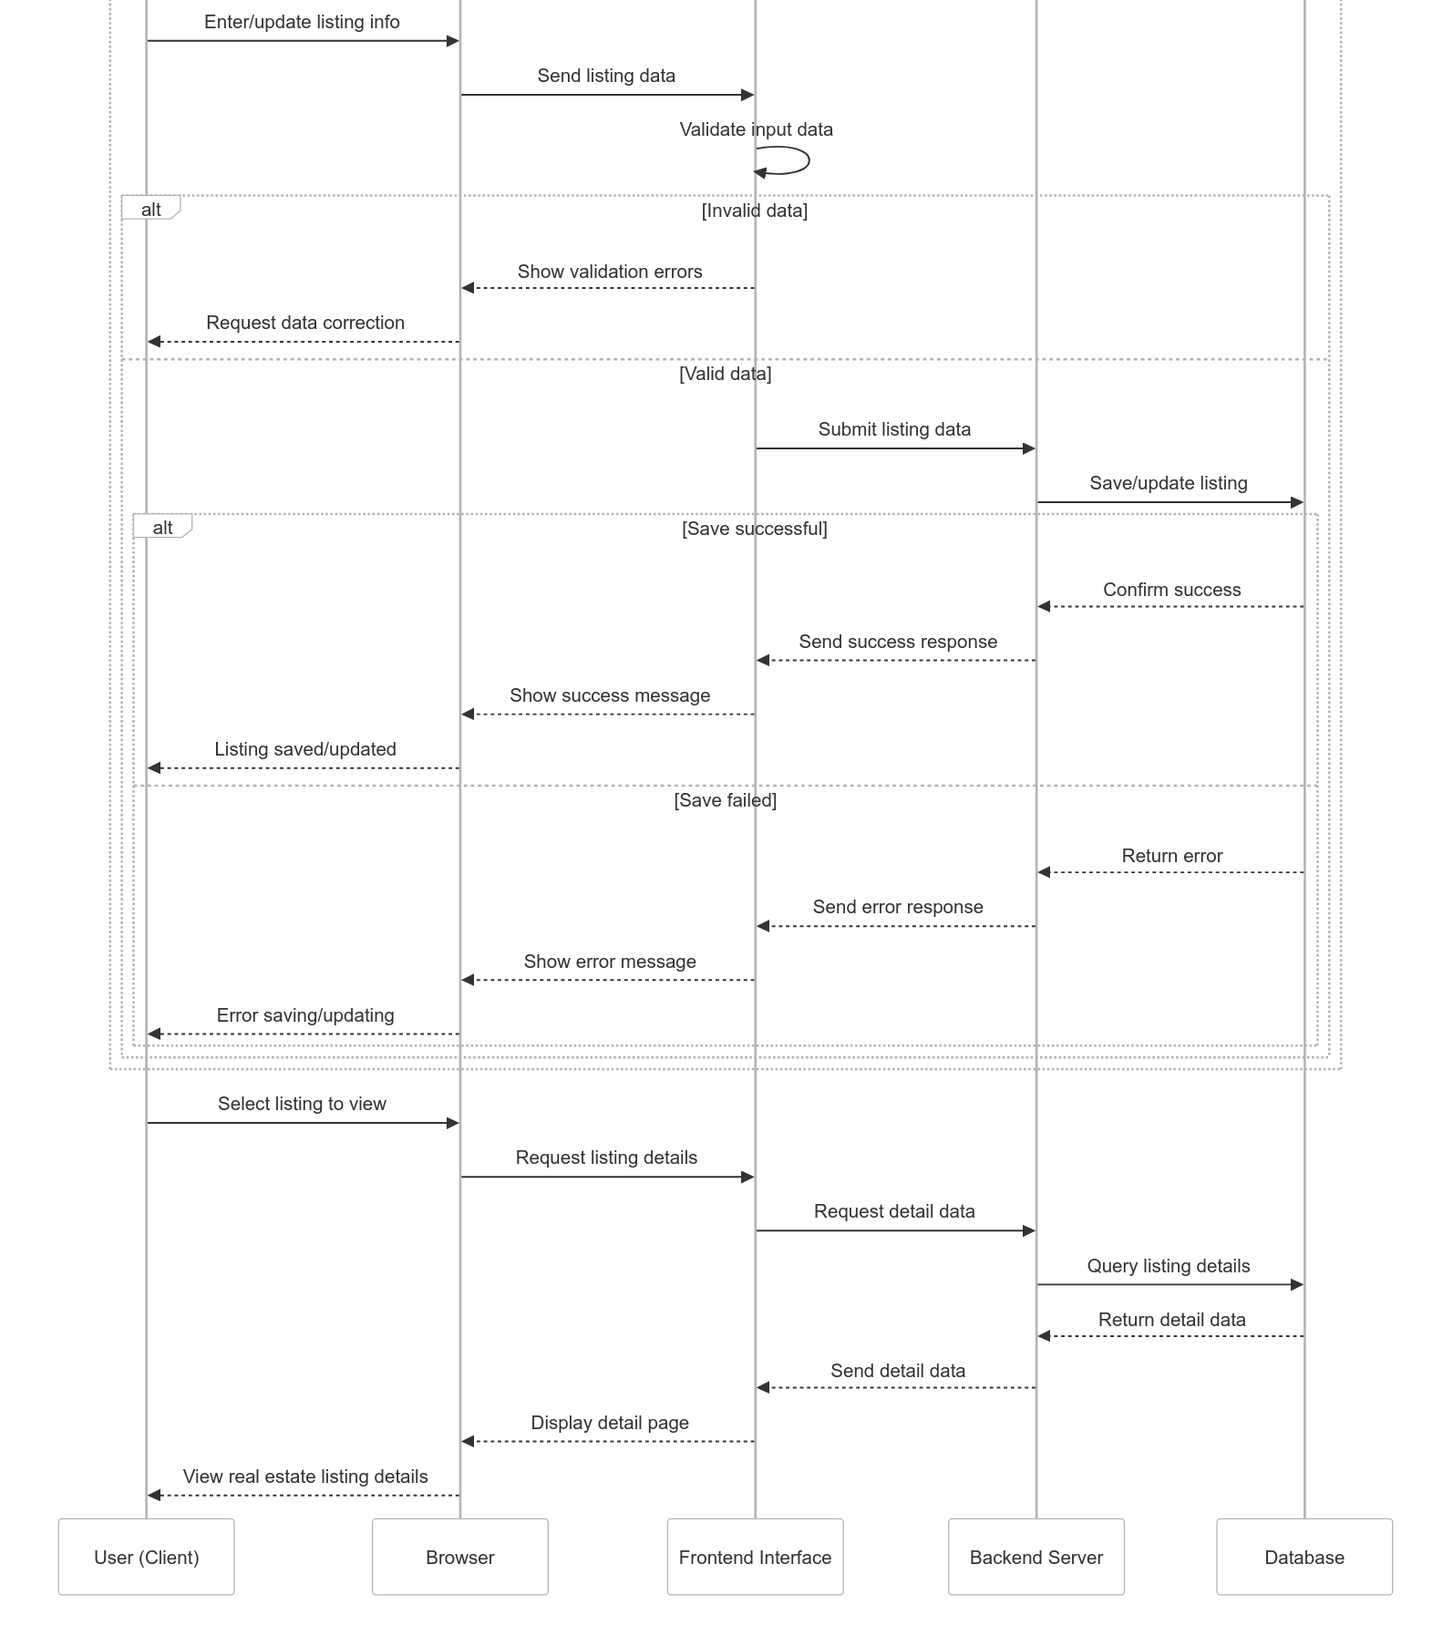

Figure 2.11 Real estate article management flow as a user

* Design of account upgrade flow integrating online payment

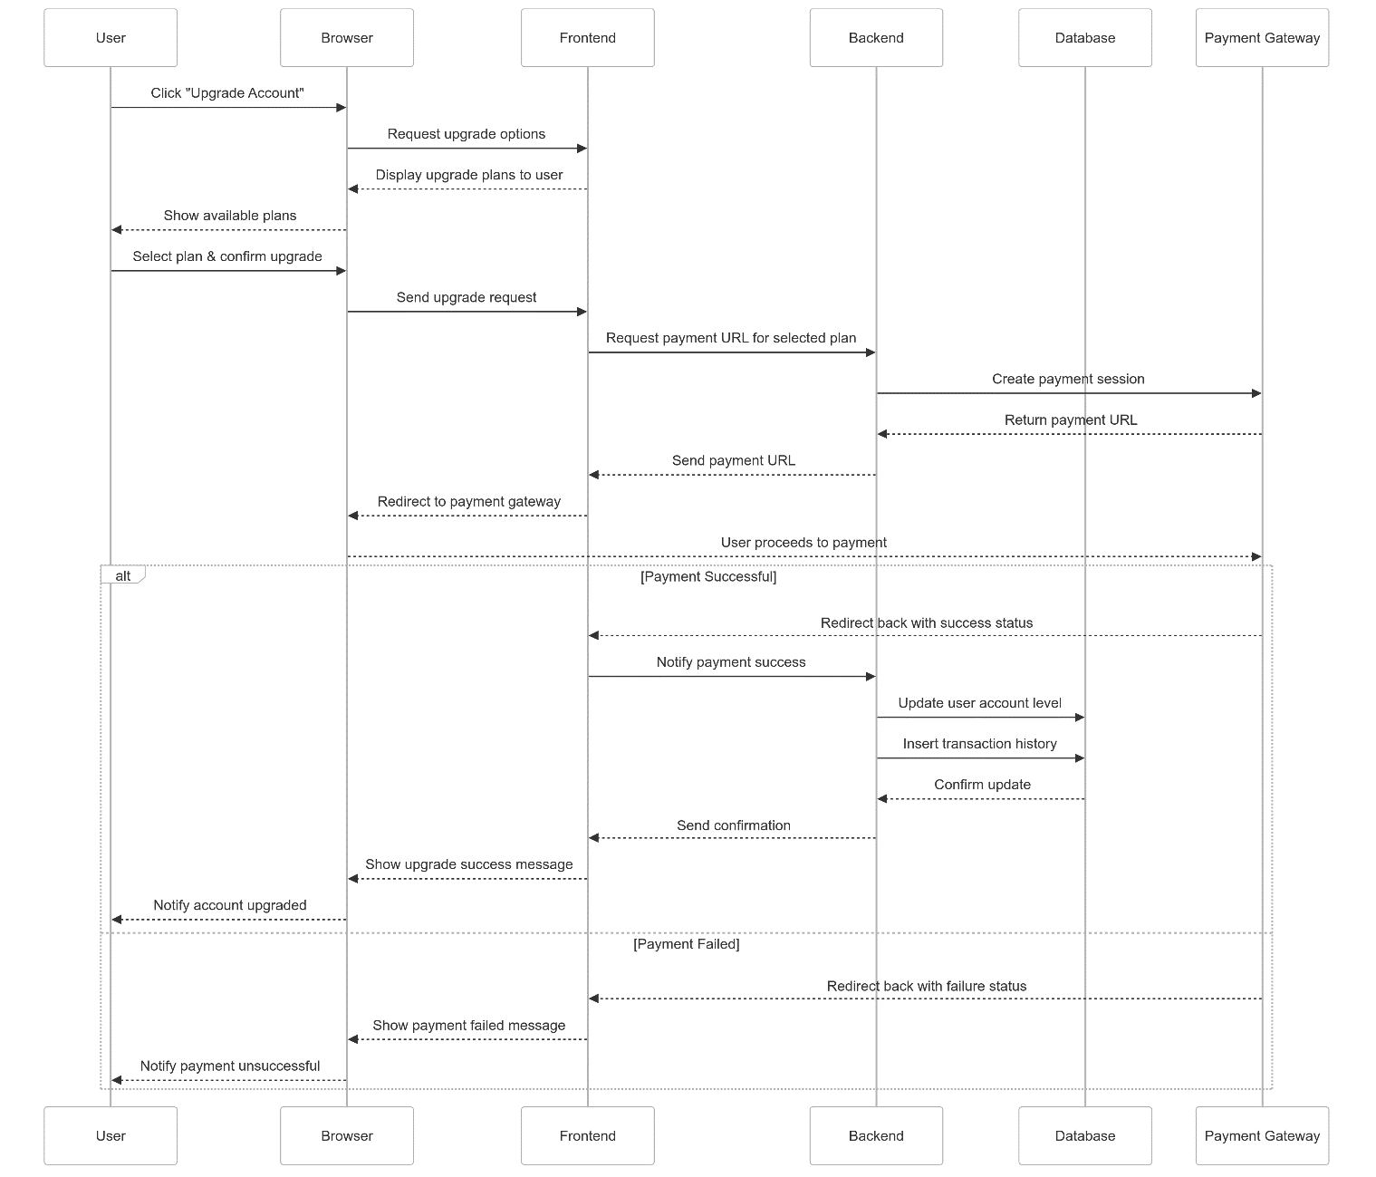

Figure 2.12 Account upgrade flow

## Database design

### ER (entity-relationship)

The ER entity relationship model is represented as

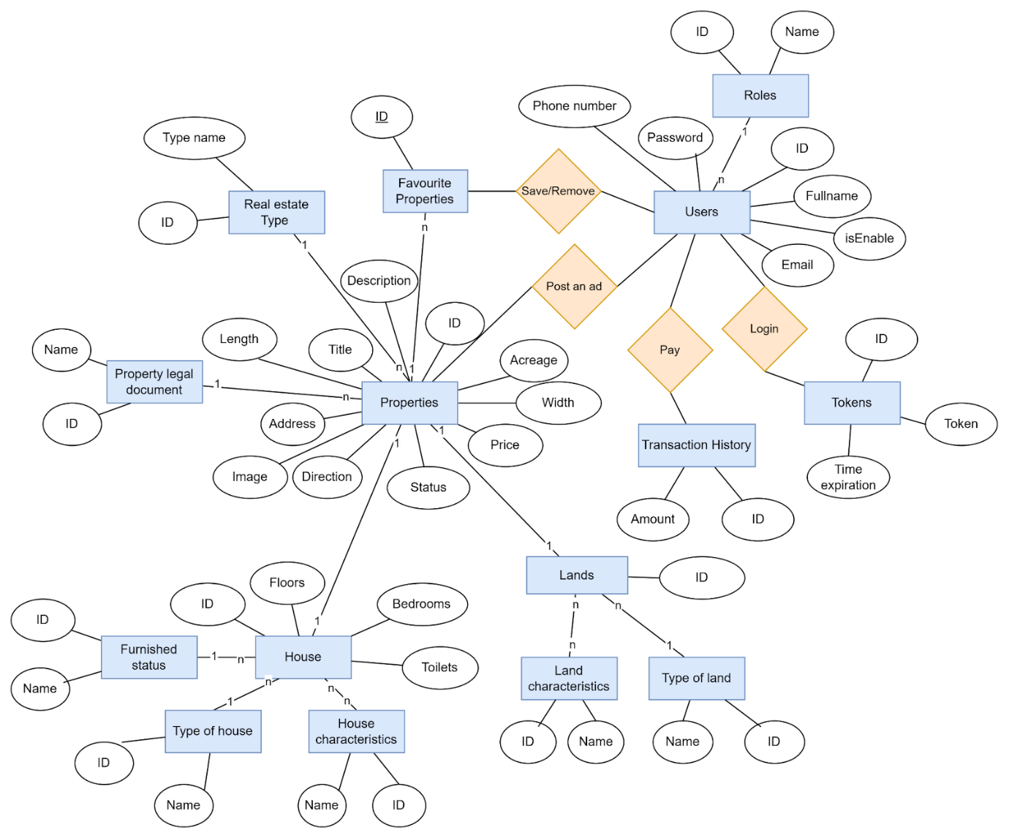

Figure 2.13 The ER entity relationship model

### Converting an implementation model into a system model

* Role table (roles)

|  |  |  |  |  |
| --- | --- | --- | --- | --- |
| Field Name | Data Type | Required | Constraint | Description |
| role_id | Integer | Not null | Primary Key | Code of permission |
| name | Enum | Not null |  | Name of permission |

Table 2.1 Describe role table attributes

* User table (users)

|  |  |  |  |  |
| --- | --- | --- | --- | --- |
| Field Name | Data Type | Required | Constraint | Description |
| user_id | Integer | Not null | Primary Key | Code of user |
| role_id | Integer | Not null | Foreign Key | Permission |
| isEnable | Boolean | Not null |  | User account is active or inactive |
| fullName | String | Not null |  | Full name of user |
| email | String | Not null |  | Email of user |
| password | String | Not null |  | Password of user(will be encrypted before entering the database) |
| phone | String | Not null |  | Phone number of user |
| created_at | LocalDataTime |  |  |  |
| updated_ad | LocalDataTime |  |  |  |

Table 2.2 Describe user table attributes

* Token table (tokens)

|  |  |  |  |  |
| --- | --- | --- | --- | --- |
| Field Name | Data Type | Required | Constraint | Description |
| token_id | Integer | Not null | Primary Key | Code of token |
| user_id | Integer | Not null | Foreign Key | User |
| token | String | Not null |  | A temporary or persistent string used to authenticate and authorize a user or system |
| created_at | LocalDataTime |  |  |  |
| updated_ad | LocalDataTime |  |  |  |

Table 2.3 Describe token table attributes

* Transaction history table

|  |  |  |  |  |
| --- | --- | --- | --- | --- |
| Field Name | Data Type | Required | Constraint | Description |
| transaction_id | Integer | Not null | Primary Key | Code of token |
| user_id | Integer | Not null | Foreign Key | User |
| amount | Number | Not null |  | Amount paid |
| created_at | LocalDataTime |  |  |  |
| updated_ad | LocalDataTime |  |  |  |

Table 2.4 Describe transaction histories table attributes

* Favourite property table (favourite_properties)

|  |  |  |  |  |
| --- | --- | --- | --- | --- |
| Field Name | Data Type | Required | Constraint | Description |
| favourite_ property_id | Integer | Not null | Primary Key | Code of favourite property |
| user_id | Integer | Not null | Foreign Key | User |
| property_id | Integer | Not null | Foreign Key | Property |
| created_at | LocalDataTime |  |  |  |

Table 2.5 Describe favourite properties table attributes

* Category table (categories)

|  |  |  |  |  |
| --- | --- | --- | --- | --- |
| Field Name | Data Type | Required | Constraint | Description |
| category_id | Integer | Not null | Primary Key | Code of category |
| Name | String | Not null |  | Name of category |

Table 2.6 Describe category table attributes

* Property table (properties)

|  |  |  |  |  |
| --- | --- | --- | --- | --- |
| Field Name | Data Type | Required | Constraint | Description |
| property_id | Integer | Not null | Primary Key | Code of property |
| user_id | Integer | Not null | Foreign Key | User |
| category_id | Integer | Not null | Foreign Key | Type of property |
| property_legal _document_id | Integer | Not null | Foreign Key | Type of property legal document |
| status | Enum | Not null |  | Approved or canceled |
| title | String | Not null |  | Title appears at the top of the article |
| description | String | Not null |  | Detailed description of the article |
| region | String | Not null |  | Province name |
| district_name | String | Not null |  | District name |
| ward_name | String | Not null |  | Ward name |
| street_name | String | Not null |  | Street name |
| longitude | Number | Not null |  | Coordinates |
| latitude | Number | Not null |  |
| direction | Number | Not null |  | Main direction of real estate |
| area | Number | Not null |  |  |
| length | Number | Not null |  |  |
| width | Number | Not null |  |  |
| images | String | Not null |  | Contains image links |
| price | Number | Not null |  |  |
| created_at | LocalDataTime |  |  |  |
| updated_ad | LocalDataTime |  |  |  |

Table 2.7 Describe property table attributes

* House table (houses)

|  |  |  |  |  |
| --- | --- | --- | --- | --- |
| Field Name | Data Type | Required | Constraint | Description |
| house_id | Integer | Not null | Primary Key | Code of house |
| property_id | Integer | Not null | Foreign Key | Code of property |
| furnished_ status_id | Integer | Not null | Foreign Key | Interior condition |
| house_ type_id | Integer | Not null | Foreign Key | Type of house |
| floors | Integer | Not null |  |  |
| bedrooms | Integer | Not null |  |  |
| toilets | Integer | Not null |  |  |

Table 2.8 Describe house table attributes

* Furnished status table (furnished_status)

|  |  |  |  |  |
| --- | --- | --- | --- | --- |
| Field Name | Data Type | Required | Constraint | Description |
| furnished_ status_id | Integer | Not null | Primary Key | Code of furnished status |
| name | String | Not null |  | Describe the condition of the interior |

Table 2.9 Describe furnished status table attributes

* Type of house table (house_type)

|  |  |  |  |  |
| --- | --- | --- | --- | --- |
| Field Name | Data Type | Required | Constraint | Description |
| house_ type_id | Integer | Not null | Primary Key | Code of house type |
| name | String | Not null |  | House type description |

Table 2.10 Describe type of house table attributes

* House characteristics table (house_characteristics)

|  |  |  |  |  |
| --- | --- | --- | --- | --- |
| Field Name | Data Type | Required | Constraint | Description |
| house_ characteristic_id | Integer | Not null | Primary Key | Code of house  characteristics |
| name | String | Not null |  | House characteristics description |

Table 2.11 Describe house characteristics table attributes

* + Here create an additional table (house_characteristic_mappings) to hold the characteristic keys of the house object.

|  |  |  |  |  |
| --- | --- | --- | --- | --- |
| Field Name | Data Type | Required | Constraint | Description |
| house_characteristic_ mapping_id | Integer | Not null | Primary Key | Code of house  characteristic mapping |
| house_ characteristics_id | Integer | Not null | Foreign Key | House  characteristics |
| house_id | Integer | Not null | Foreign Key | House |

Table 2.12 Describe house characteristic mapping table attributes

* Land table (lands)

|  |  |  |  |  |
| --- | --- | --- | --- | --- |
| Field Name | Data Type | Required | Constraint | Description |
| land_id | Integer | Not null | Primary Key | Code of house |
| property_id | Integer | Not null | Foreign Key | Code of property |
| land_type_id | Integer | Not null | Foreign Key | Type of land |

Table 2.13 Describe land table attributes

* Type of land table (land_types)

|  |  |  |  |  |
| --- | --- | --- | --- | --- |
| Field Name | Data Type | Required | Constraint | Description |
| land_type_id | Integer | Not null | Primary Key | Code of land type |
| name | String | Not null |  | Land type description |

Table 2.14 Describe type of land table attributes

* Land characteristics table (land_characteristics)

|  |  |  |  |  |
| --- | --- | --- | --- | --- |
| Field Name | Data Type | Required | Constraint | Description |
| land _ characteristic_id | Integer | Not null | Primary Key | Code of land  characteristics |
| name | String | Not null |  | Lanđ characteristics description |

Table 2.15 Describe land characteristics table attributes

* + Here create an additional table (land_characteristic_mappings) to hold the characteristic keys of the land object.

|  |  |  |  |  |
| --- | --- | --- | --- | --- |
| Field Name | Data Type | Required | Constraint | Description |
| land _characteristic_ mapping_id | Integer | Not null | Primary Key | Code of land  characteristic mapping |
| land _ characteristics_id | Integer | Not null | Foreign Key | Land  characteristics |
| house_id | Integer | Not null | Foreign Key | Land |

Table 2.16 Describe land characteristic mapping table attributes

### Database schema

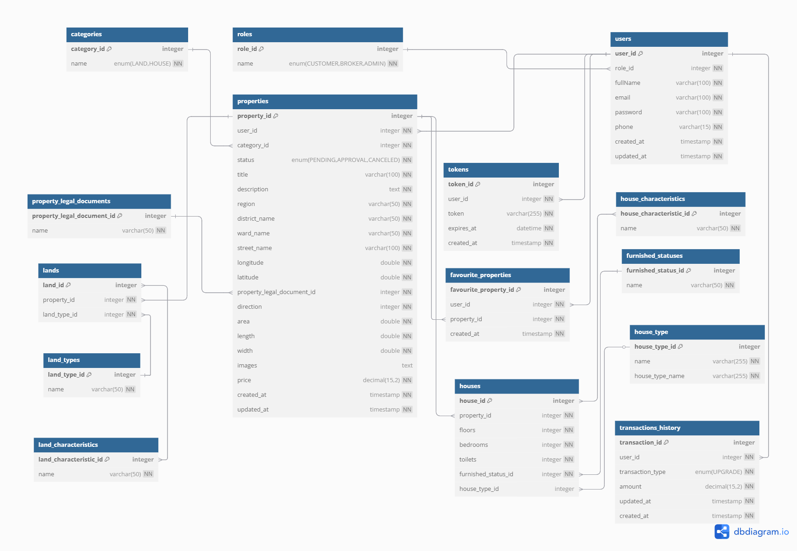

Figure 2.14 Relational Model

## Real estate prediction system development

* The problem of predicting real estate prices will be divided into two types including:
  + Real estate valuation: users will provide information related to land or the house they want to sell or buy for the system to evaluate.
  + Real estate price forecast: the system will predict the price in the near future of a certain area given by users at the same level.
* Common processing steps of the two models
  + Data Crawling: collect data from the “Nhà tốt” website and have “RawData.csv” file with … samples.
  + Data Cleaning: after handling missing and outlier values, the process returns a cleaned dataset containing the following fields and is exported as “Cleandata.csv”:
    - Real estate valuation:

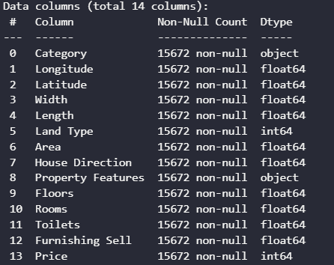

Figure 2.15 Real estate valuation model features

* + - Real estate price forecast:

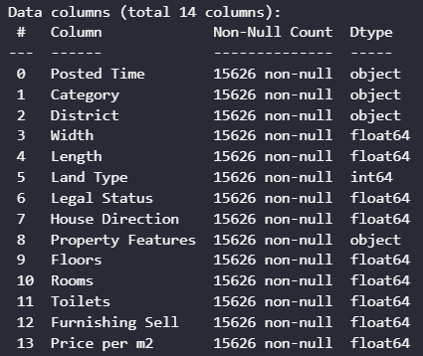

Figure 2.16 Real estate price forecast features

* + - The two problems use slightly different features. For the valuation model, exact coordinates are included since price can vary significantly even along the same street. For the forecasting model, time becomes a crucial factor, and detailed coordinate data is sparse. Therefore, we generalize location by district and use **price per m²** as the target variable.
  + Feature Engineering:
    - Feature Tranformation:
      * First, one-hot encoding is applied to categorical variables such as **property category, land type, direction, furnishing status** and **district.**
      * For numerical features, various normalization techniques (e.g., Z-score, log, sqrt, min-max, arsinh) are tested. The most effective method is selected based on distribution analysis.
      * The result is a transformed dataset exported as “TransformedData.csv”.

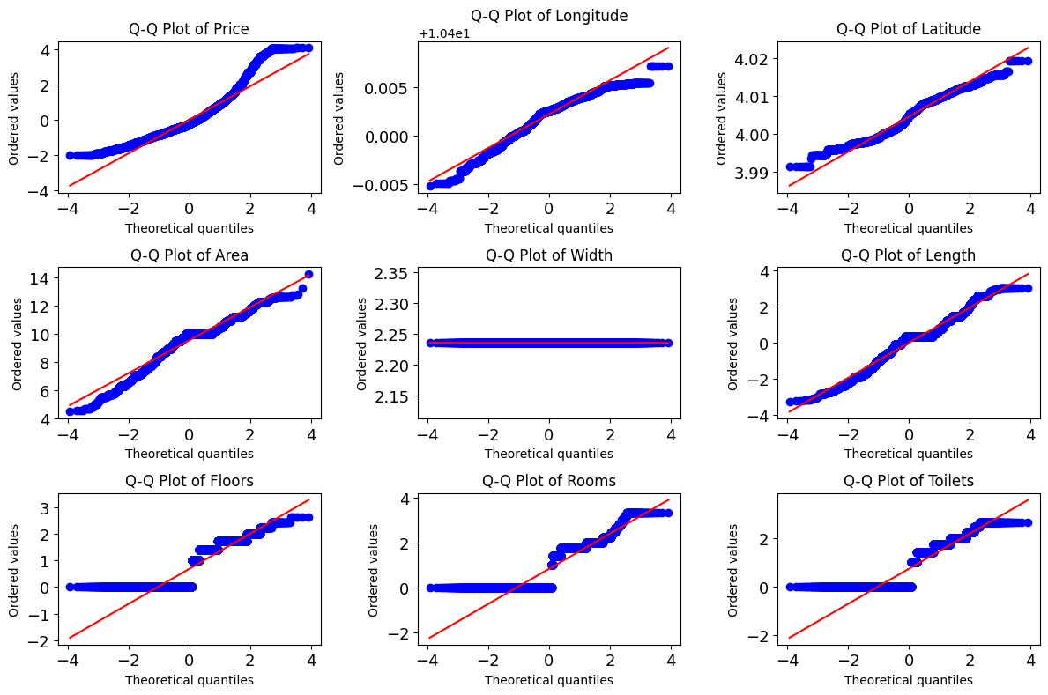

Figure 2.17 Q-Q Plots After Optimal Normalization per Feature

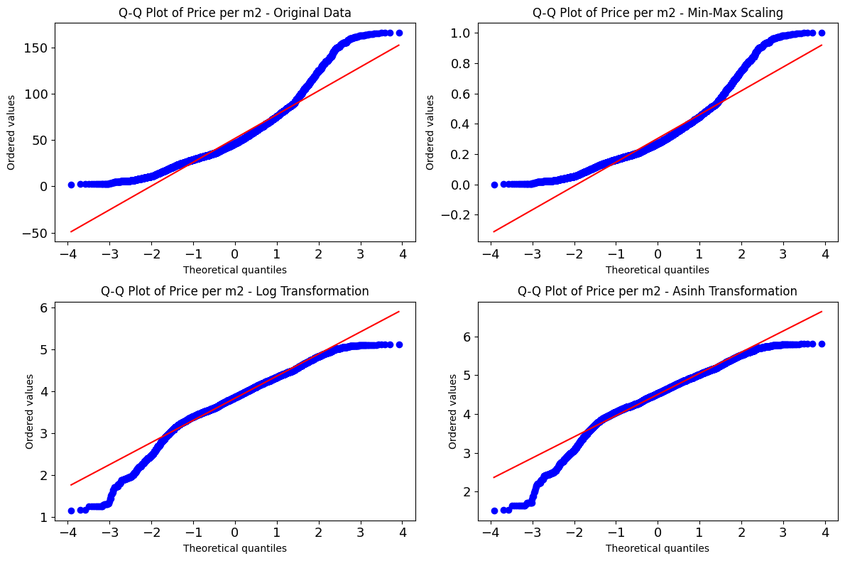

Figure 2.18 Comparison of Q-Q Plots of **Price per m²** across different transformation methods

* + - Feature Selection:
      * Observing the relationships between the coordinates (Longitude, Latitude), area, and width with the target variable (Price), it was noted that these features have a slight correlation with the target. 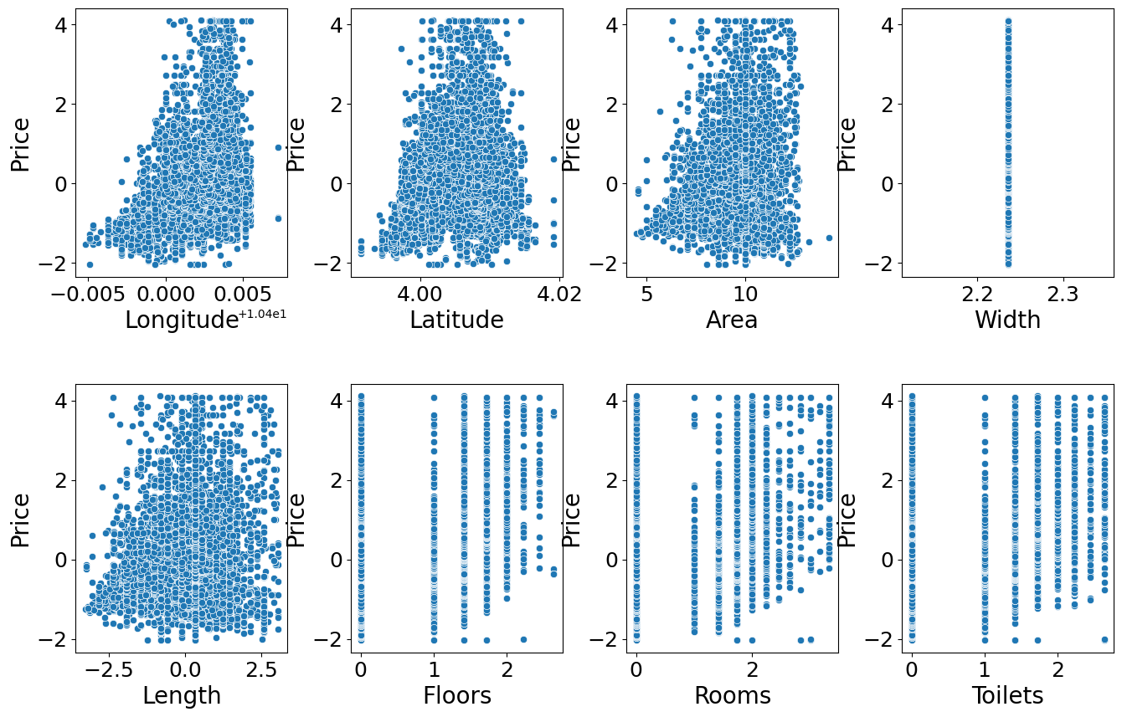

Figure 2.19 Scatter plot of features vs. **Price**

* + - * **SelectKBest** was used to rank the features based on their correlation with the target, with **Longitude** and **Latitude** being the most influential.

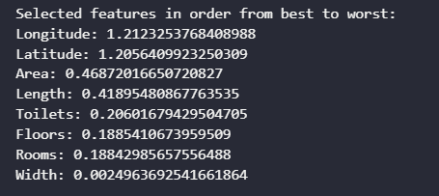

Figure 2.20 Selected features in order from best to worst

* + - * The **RFECV** method was then applied, selecting the optimal number of features, which is 8 in this case. The best set of features for predicting the target variable includes **Longitude, Latitude, Area, Width, Length, Floors, Rooms,** and **Toilets**.

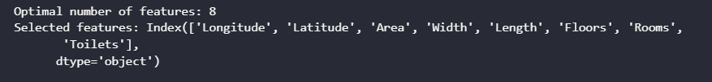

Figure 2.21 Optimal number of features

* + - * The plot of the **RFECV** shows the relationship between the number of selected features and the mean test accuracy.

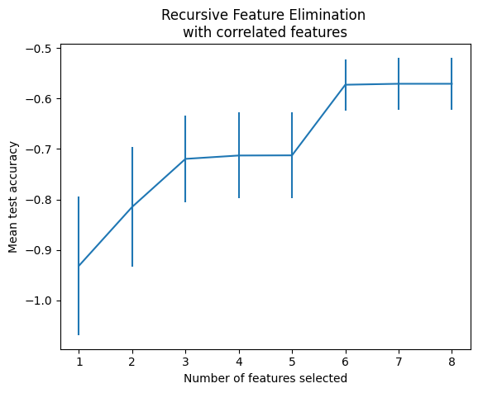

Figure 2.22 Recursive Feature Elimination with correlated features

### Real estate valuation model

* The dataset is divided into two parts:
  + 80% for the training set (…sample)
  + 20% for the test set (…sample)
* Three regression algorithms are applied to build the models: Linear Regression, Ridge Regression, and Random Forest Regression.
* The evaluation metrics for Random Forest Regression model achieved the best performance are presented below

|  |  |  |
| --- | --- | --- |
|  | Train set | Test set |
| MSE |  |  |
| RMSE |  |  |
| MAPE |  |  |
| R-Squared | 80.7% | 76.02% |

Table 2.17 Evaluation metrics table for the real estate valuation models

### Real estate price forecast model

* To handle time-based patterns, we extracted temporal features from the **Posted Time** field:
  + **year, month, day, day of week** and **quarter**: These help capture seasonality and time-related trends.
  + Cyclical Encoding: **month** and **dayofweek** are converted into sine and cosine values to preserve their cyclical nature (e.g., December is close to January).
* The dataset was split into two parts:
  + 80% for training (… samples)
  + 20% for testing (…samples)
* Three forecasting models were applied for comparison: XGBoost Regressor, LightGBM Regressor, Facebook Prophet.
* The evaluation metrics for XGBoost Regressor model achieved the best performance are presented below

|  |  |  |
| --- | --- | --- |
|  | Train set | Test set |
| MSE |  |  |
| RMSE |  |  |
| MAPE |  |  |
| R-Squared | 80.42% | 68.29% |

Table 2.18 Evaluation metrics table for the real estate price forecast models

## Apply NSFW image and toxic content classification models

### NSFW image classification models

In this project, I integrated the NudeNetv2 model to detect and classify sexually explicit content in images. I utilized the pre-trained “classifier_model.onnx” for efficient inference.

The model categorizes content into two classes:

* safe – The image/video is not sexually explicit
* unsafe – The image/video contains nudity or explicit content

I cloned the repository and used the available ONNX version of the classifier to perform predictions on image data.

This classification component plays a crucial role in automatically filtering out inappropriate content, enhancing the safety and compliance of our platform.

## Chapter Conclusion

This chapter provides the reader with an overview of the real estate business operations, offering insights into the key activities and processes involved in the industry. It also includes an analysis and design of the system architecture, along with a detailed discussion of the database model. Additionally, the chapter focuses on the development of a price support system, which aims to assist buyers by offering pricing assistance and making real estate transactions more accessible.

# IMPLEMENTATION AND RESULTS EVALUATION

# CONCLUSION AND DEVELOPMENT DIRECTION

# REFERENCES

# APPENDIX 1

# APPENDIX 2