NELSON MANDELA AFRICAN INSTITUTION OF SCIENCE AND TECHNOLOGY
(NM-AIST)
WIRELESS AND MOBILE COMPUTING
NETWORK & CRYPTOGRAPHY IN WIRELESS DEVICES - LAB2
LUNODZO MWINUKA
- Code simulation
- Caesar cipher algorithm
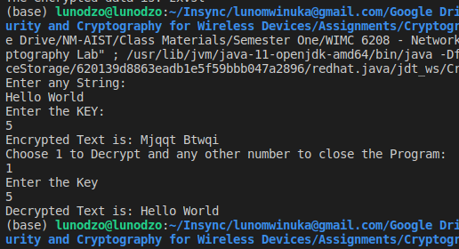
- StringXOR127
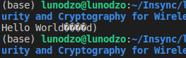
(Something is wrong with the output)

- StringXOR0
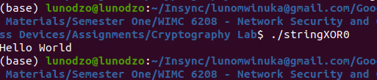

- Substitution cipher
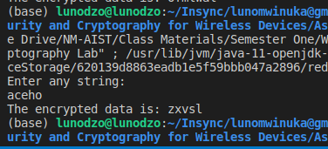

- Hill cipher
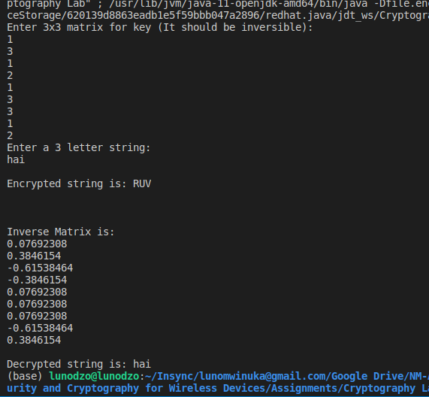

- DES
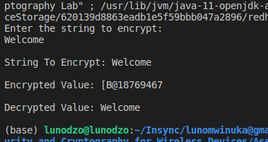

- BlowFish
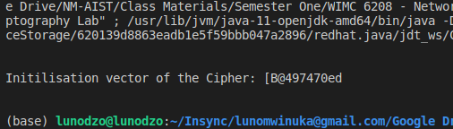

Input File
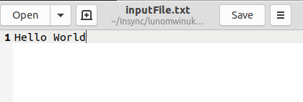

Output File
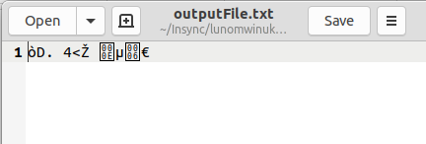
(A challenge on extracting file information)

- AES
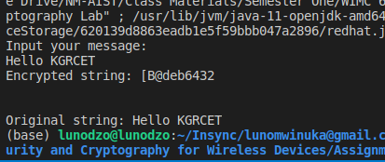
It does not match the document since the key is generated in every execution.

- BlowFish cipher (JOptionPane)
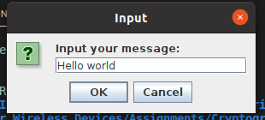
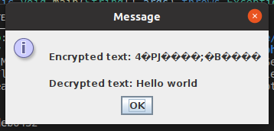
- RSA
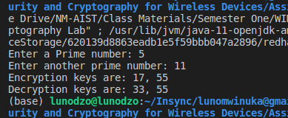

- DIFFEHELLMAN
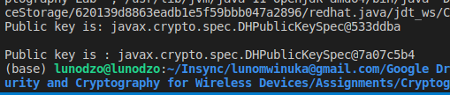

- SHA1
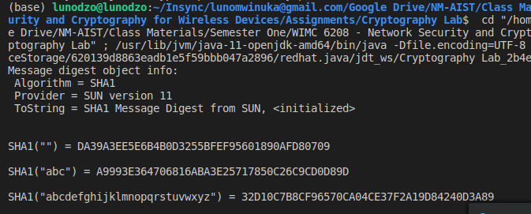
- MD5
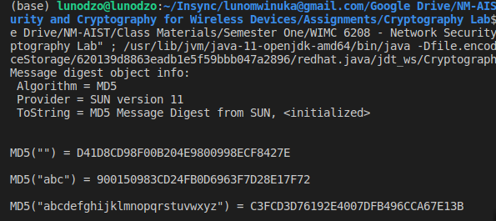

- Discussing the difference between the following Algorithms:
- Blowfish, DES, AES and RC4 (Symmetric encryption algorithms)

 | DES | AES | RC4 | Blowfish
Encryption & Decryption  (Block size) | Carries 64-bit plaintext and makes 64-bit cipher text | Operates at 128-bits block size, with 10, 12 or 14 rounds. | It uses a variable length key value of 256 bits to initialize a 256-bit state table. | Operates at 64-bits block size
Key size | Uses 56-bit (effective) key for encryption and decryption | Uses 128, 192 or 256 bits depending on number of rounds | Uses 40-2048 bits | Uses a variable - length key value from 32bits to 448bits.
Mechanism | Two (2) permutations (P-boxes); initial and final permutation with 16 Feistel rounds. Each uses different 48-bit round key from the key | Works on a 4x4 column-major order matrix of bytes | A key input is a pseudorandom bit generator that produces a stream 8-bit number that is unpredictable without knowledge of input key, The output of the generator is called key-stream, is combined one byte at a time with the plaintext stream cipher using X-OR operation. | Check messages that are not products of 64bits in size and trudge them.  It is reserved for applications where the key is not varied frequently. It is substantially faster than most encryption algorithms when performed in 32-bit microprocessors with huge data caches.
Comments | Raises some potential issues when encrypting several gigabytes of data with the same key (a gigabyte is not that big nowadays). | Proven to be efficient in both software and hardware.  It was selected through an open competition involving hundreds of cryptographers during several years. Basically, you cannot have better than tha | Does not take a separate nonce alongside the key and is considered to be more malleable than common block ciphers. | Blowfish can use huge keys and is believed secure, except with regards to its block size, which is 64 bits, just like DES and 3DES.

- Difference between Diffie-Hellman and RSA
Diffie-Hellman is used to generate a shared secret in public for later symmetric ("private-key") encryption while RSA is used to come up with a public/private key pair for asymmetric ("public-key") encryption

Diffie-Hellman | RSA
Creates a shared secret between two (or more) parties, for symmetric cryptography | Used to perform "true" public-key cryptography
Key identity: (gen^{s}₁)^{s}₂ = (gen^{s}₂)^{s}₁ = shared secret (mod prime) | Key identity: (m^{e})^{d} = m (mod n) (lets you recover the encrypted message)

- Message Digest [MD-series] and Secure Hash Function [SHA-series]

MD5 | SHA1
MD5 stands for Message Digest. | While SHA1 stands for Secure Hash Algorithm.
MD5 can have 128 bits length of message digest. | Whereas SHA1 can have 160 bits length of message digest.
The speed of MD5 is fast in comparison to SHA1's speed. | While the speed of SHA1 is slow in comparison to MD5's speed.
To make out the initial message the aggressor would want 2^128 operations whereas exploitation the MD5 algorithmic program. | On the opposite hand, in SHA1 it’ll be 2^160 that makes it quite troublesome to seek out.
MD5 is simpler than SHA1. | While SHA1 is more complex than MD5.
MD5 provides indigent or poor security. | While it provides balanced or tolerable security.
In MD5, if the assailant needs to seek out the 2 messages having identical message digest then the assailant would need to perform 2^64 operations. | Whereas in SHA1, assailants would need to perform 2^80 operations which is greater than MD5.

- Hill cipher, caesar cipher and a simple substitution cipher
- Caesar cipher uses a simple shift to determine the encrypted text. If you use a left shift of 3, you get a cipher that looks like:
Examples extracted from WIKIPEDIA.
Plain: ABCDEFGHIJKLMNOPQRSTUVWXYZ
Cipher: XYZABCDEFGHIJKLMNOPQRSTUVW

So, any X in the encrypted string would be an A when decrypted, Y is B, etc.
- Simple substitution cipher is a more generic form where instances of one value are always replaced with instances of another value. For example, all X's are replaced with Q's. So, Caesar cipher is a specific type of substitution cipher, but not all substitution ciphers are Caesar ciphers.
- Hill cipher is a poly-graphic substitution cipher based on linear algebra. Each letter is represented by a number modulo 26. Often the simple scheme A = 0, B = 1, …, Z = 25 is used.

To encrypt a message, each block of n letters (considered as an n-component vector) is multiplied by an invertible n × n matrix, against modulus 26.

To decrypt the message, each block is multiplied by the inverse of the matrix used for encryption.

The matrix used for encryption is the cipher key, and it should be chosen randomly from the set of invertible n × n matrices (modulo 26).

