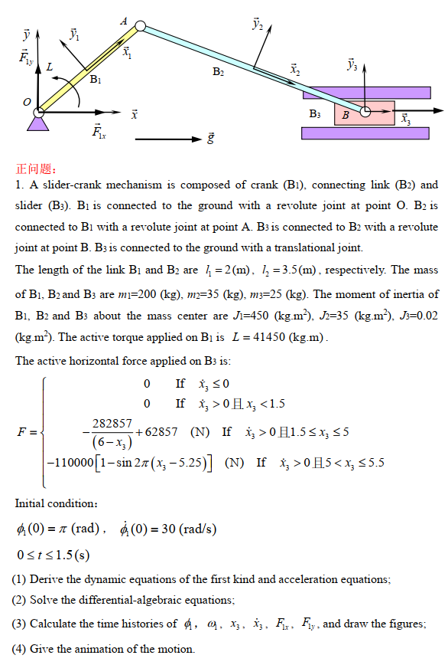

|  |  |  |  |  |  |  |  |  |
| --- | --- | --- | --- | --- | --- | --- | --- | --- |
| Constraints | |  | | |  | | |  |
| Type | No |  |  |  |  |  |  |  |
|  | 1 |  |  |  | 1 | [-1 0] |  | 0 |
|  | 2 |  |  |  | 1 | [-1 0] |  | 0 |
|  | 3 | 2 | [-1.75 0] |  | 1 | [1 0] |  |  |
|  | 4 | 3 | [0 0] |  | 2 | [1.75 0] |  |  |
|  | 5 |  |  |  | 3 | [0 0] |  | 0 |
|  | 6 |  |  |  | 3 | [0 0] |  | 0 |

1. Equations of constraints, dynamics, and acceleration.







1. Results

Solve to obtain coordinates, velocities, and accelerations:

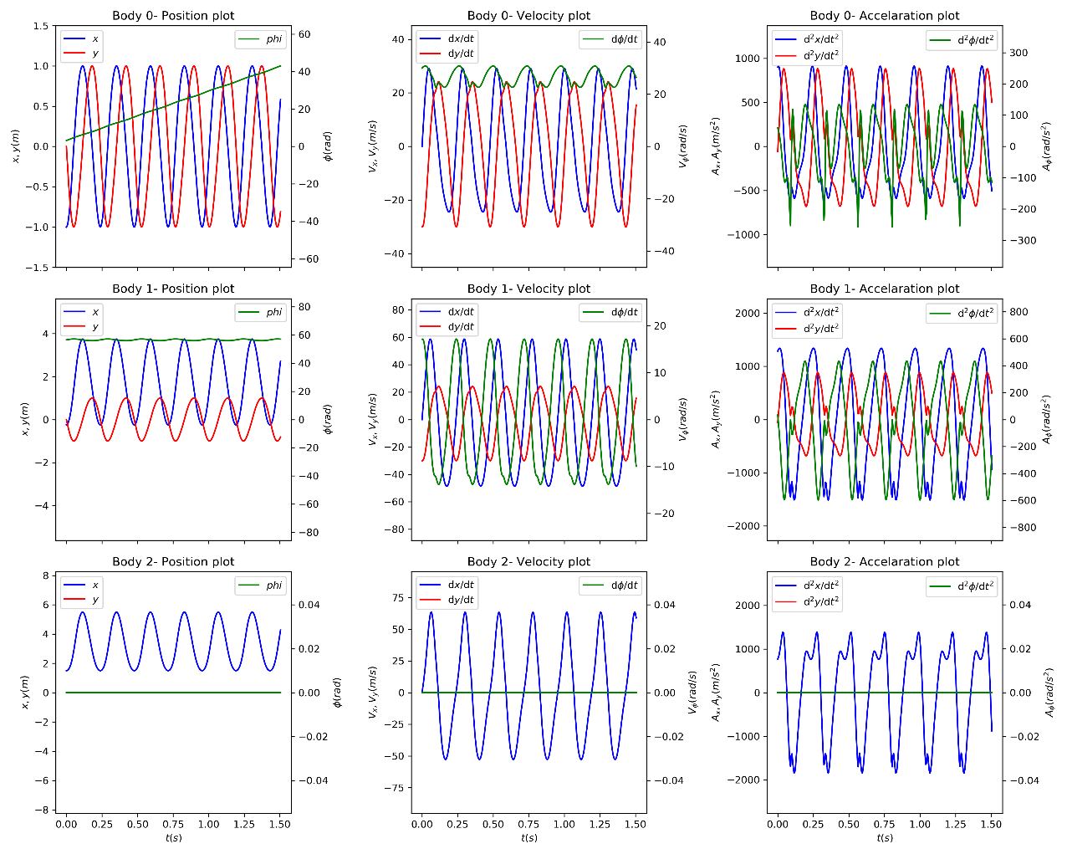

The Lagrangian multipliers corresponding to  are

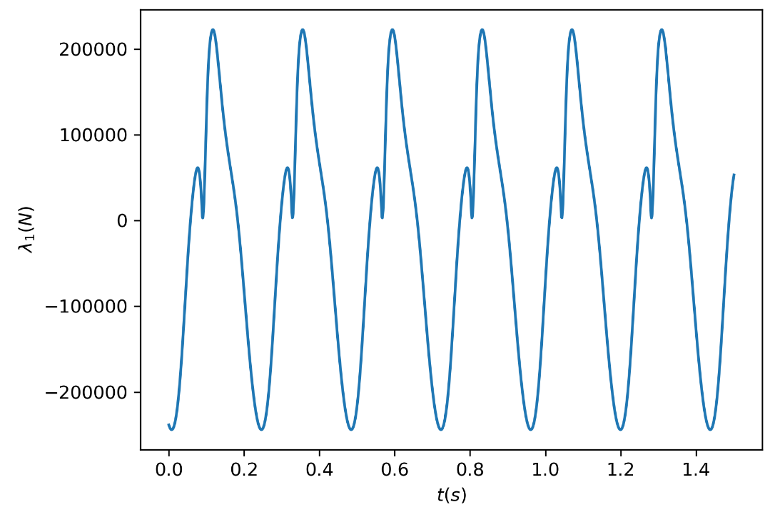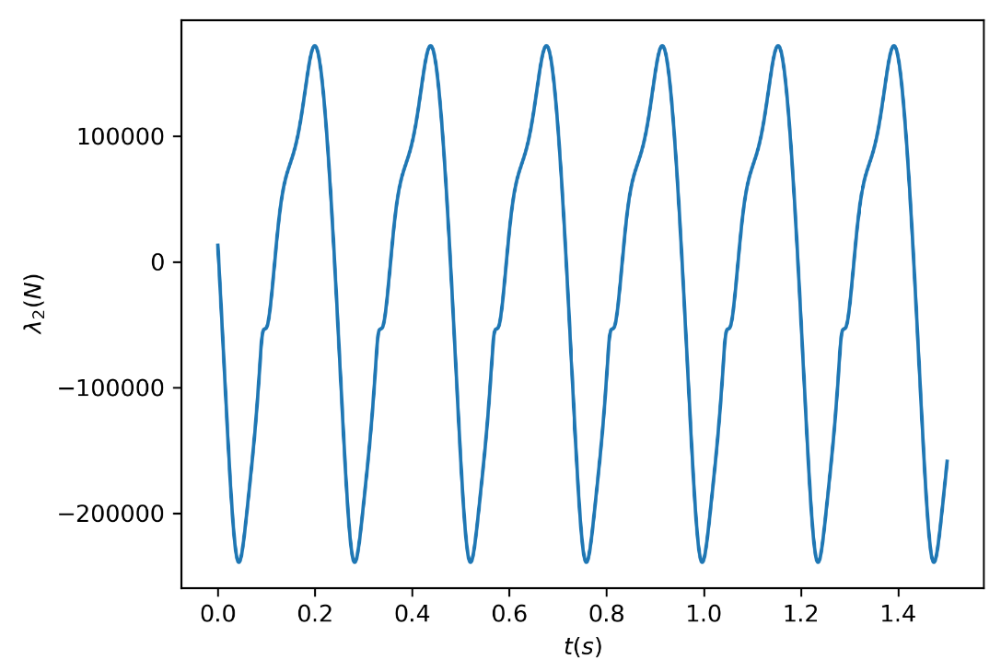

where .

1. See .mp4 files for animations.

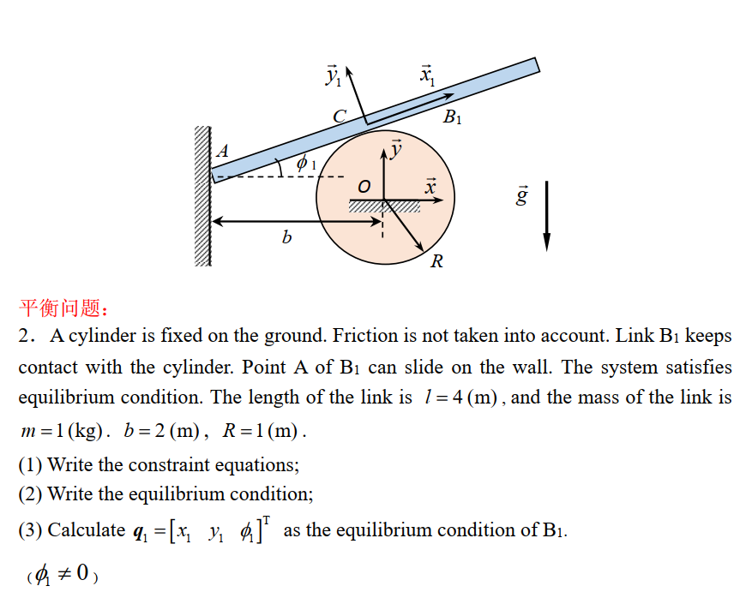

1. Constraints

The cylinder is Body 0.

|  |  |  |  |  |  |  |  |  |
| --- | --- | --- | --- | --- | --- | --- | --- | --- |
| Constraints | |  | | |  | | |  |
| Type | No |  |  |  |  |  |  |  |
|  | 1 |  |  |  | 1 | [-2 0] |  | -2 |
|  | 2 | 0 | [0 0] |  | 1 | [0 0] | [-1 0] | 1 |

1. Equations of equilibrium















Equilibrium condition:



Results:



