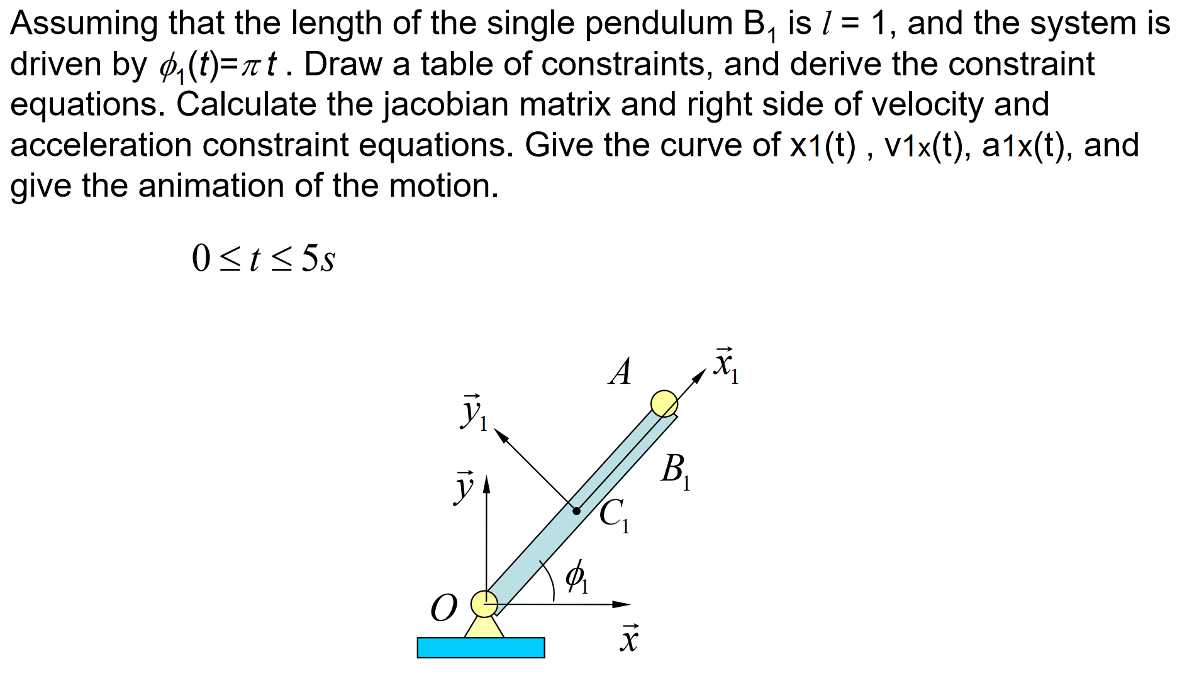

Constraints

|  |  |  |  |  |  |  |  |  |  |
| --- | --- | --- | --- | --- | --- | --- | --- | --- | --- |
| Constraints | |  | | |  | | |  |  |
| Type | No |  |  |  |  |  |  |
|  | 1 |  |  |  | 1 | [0 0] |  | 0 |  |
|  | 2 |  |  |  | 1 | [0 0] |  | 0 |  |
|  | 3 |  |  |  | 1 | [0 0] |  |  |  |

1. Constraint equations



1. Jacobian



1. Right hand side of velocity equations



1. Right hand side of acceleration equations



1. Work flow

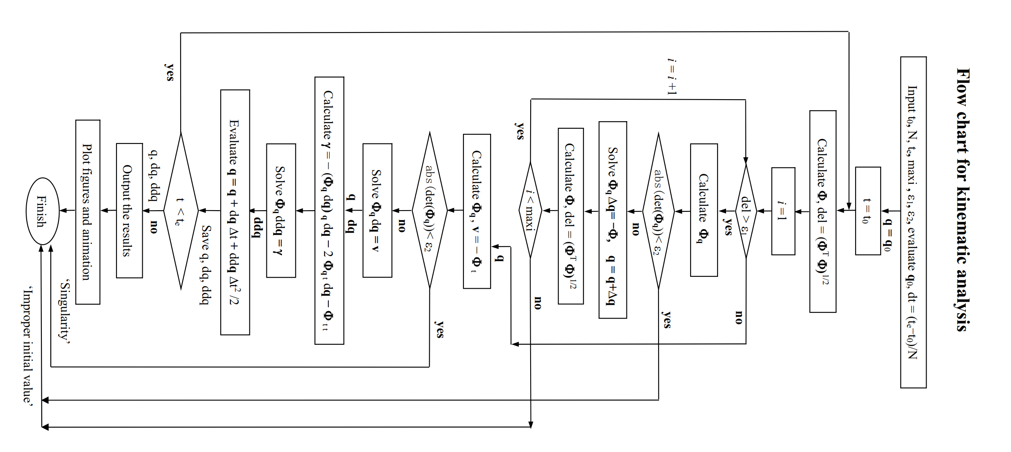

1. Results

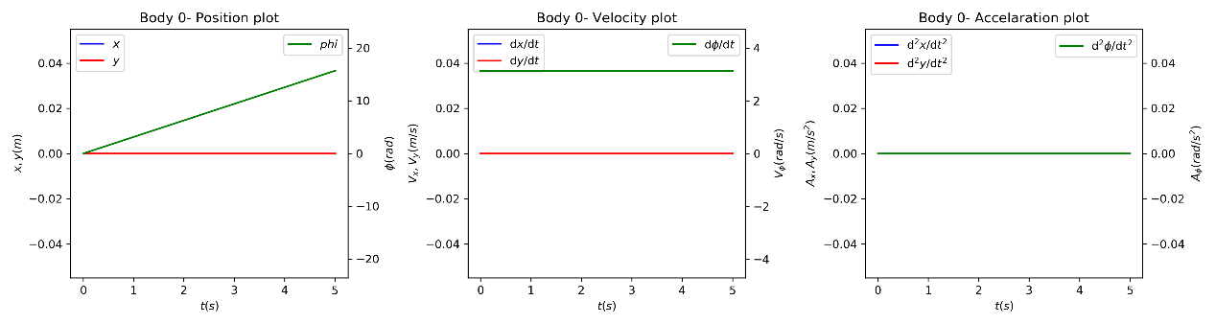

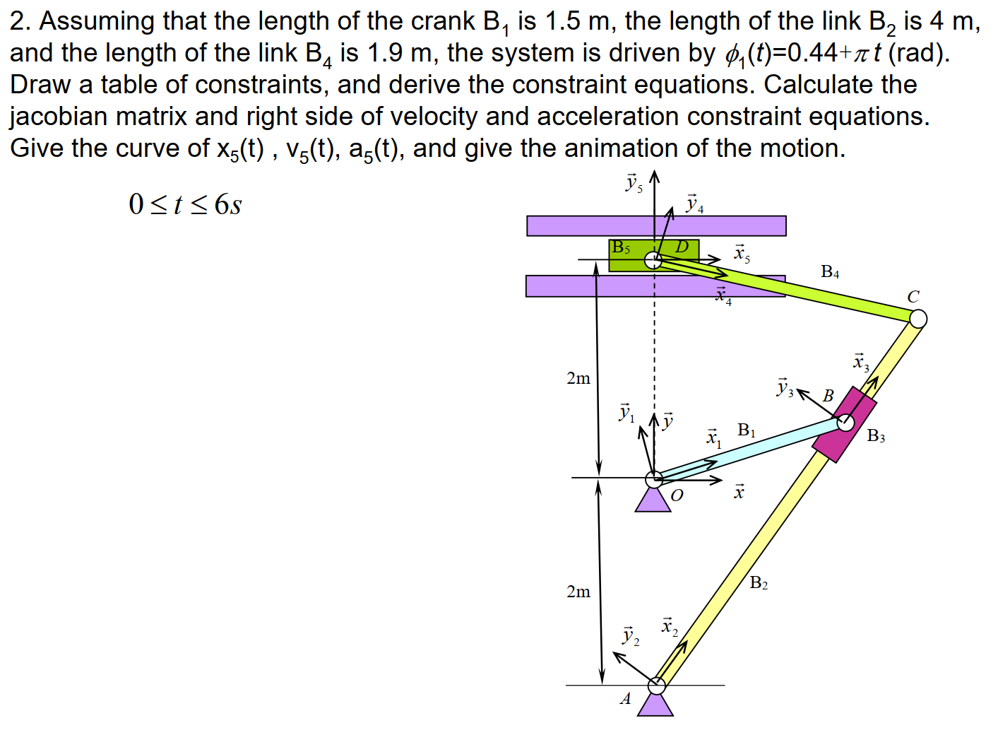

Constraints

|  |  |  |  |  |  |  |  |  |
| --- | --- | --- | --- | --- | --- | --- | --- | --- |
| Constraints | |  | | |  | | |  |
| Type | No |  |  |  |  |  |  |
|  | 1 |  |  |  | 1 | [0 0] |  | 0 |
|  | 2 |  |  |  | 1 | [0 0] |  | 2 |
|  | 3 |  |  |  | 2 | [0 0] |  | 0 |
|  | 4 |  |  |  | 2 | [0 0] |  | 0 |
|  | 5 | 3 | [0 0] |  | 1 | [1.5 0] |  |  |
|  | 6 | 3 | [0 0] | [1 0] | 2 | [0 0] | [1 0] |  |
|  | 7 | 4 | [1.9 0] |  | 2 | [4 0] |  |  |
|  | 8 | 5 | [0 0] |  | 4 | [0 0] |  |  |
|  | 9 |  |  |  | 5 | [0 0] |  | 4 |
|  | 10 |  |  |  | 5 |  |  | 0 |
|  | 11 |  |  |  | 1 |  |  | 0.44+ |

1. Constraint equations



1. Jacobian



1. Right hand side of velocity equations



1. Right hand side of acceleration equations



1. Results

