A little problem of move part:

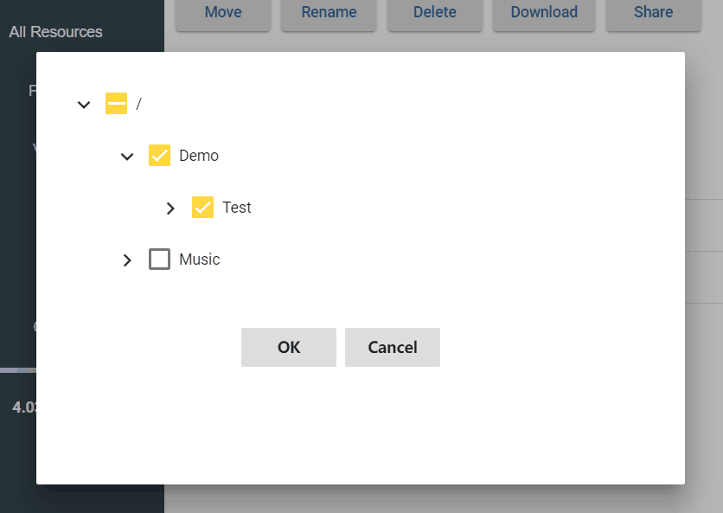

We can’t realize that only choose one checkbox. If users choose more than one checkbox, the destination of move will be the last one.

So, when doing demonstration, just click one is fine.