环境相关依赖
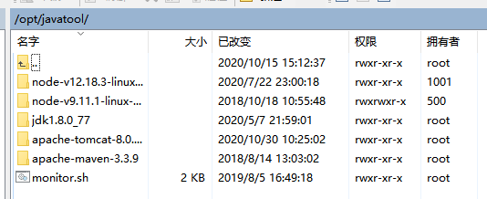
软连接配置
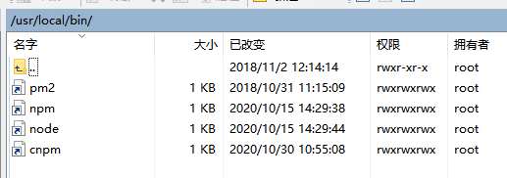

软连接生成命令
ln -s /opt/javatool/node-v12.18.3-linux-x64/bin/node /usr/local/bin/

cd /opt/javatool/
wget https://npm.taobao.org/mirrors/node/v12.18.3/node-v12.18.3-linux-x64.tar.gz
tar -zxvf node-v12.18.3-linux-x64.tar.gz
rm -rf node-v12.18.3-linux-x64.tar.gz
ln -s /opt/javatool/node-v12.18.3-linux-x64/bin/npm /usr/local/bin/
ln -s /opt/javatool/node-v12.18.3-linux-x64/bin/node /usr/local/bin/

