Source of BTree:

In our program, we relied an external python lib named "BTrees" to create Btree index.

Here is the official doc: https://pypi.org/project/BTrees/#description

1 Where are the files after unzip?

{unpack dir}/root/mnt/project

You can modify my testfile “test.txt” under this path.

2 How to run the program?

Crate a test file called “test.txt” where 1 operation appears 1 line, put the test file in current path, then our program could read it line by line.

the following screenshot is a sample of testfile.

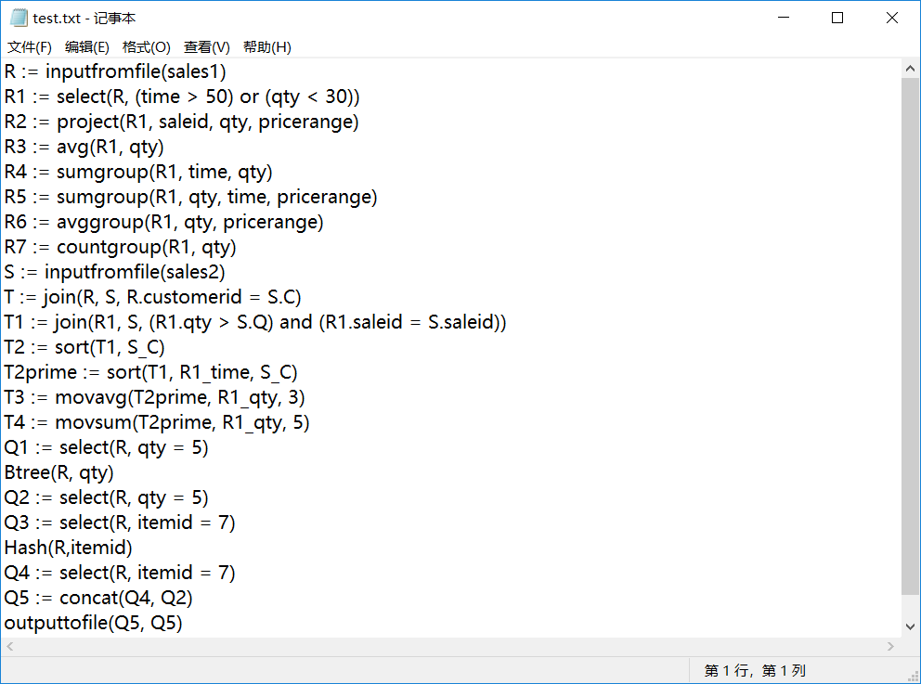

3 How to check the output table?

All resulting tables will be stored in file “ll4123_yf1357_AllOperations. txt” after you run the program (located in current path).

If you want to check individual table, you can also add a line outputtofile (tablename, tablename) in testfile. A separate file named “ll4123_yf1357_tablename.txt” will appear in current path.

the following screenshot is a sample of all resulting tables.

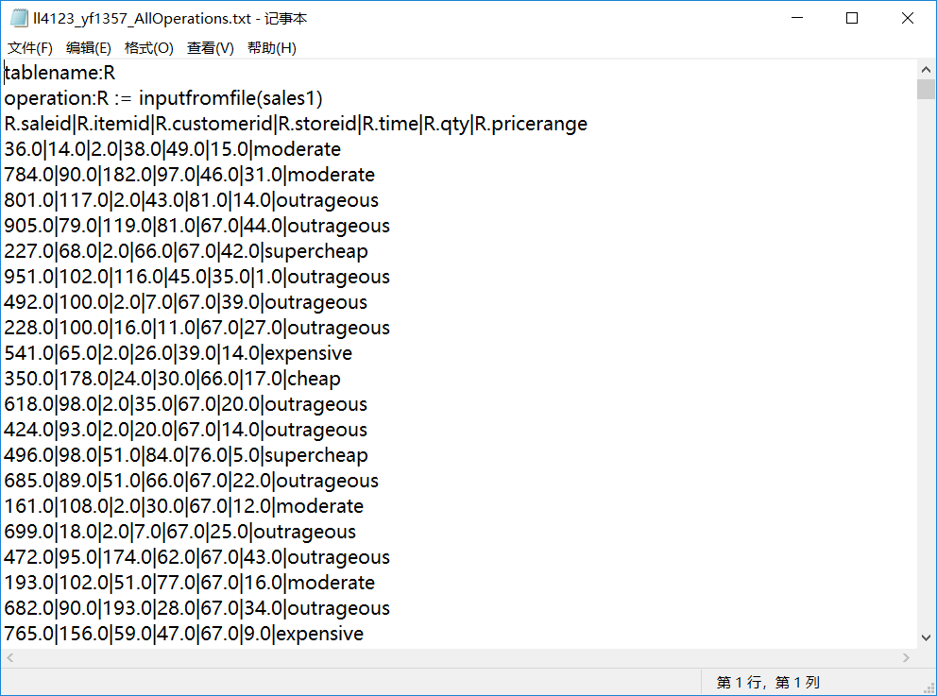

4 How to import raw data?

What you need to do is only put “rawdata.txt” in current path, and add a line “storetable:= inputfromfile(rawdata)” to testfile, all data in “rawdata.txt” would be stored in “storetable”. Then you can have further operation on “storetable”.

5 How to check the running time of each operation?

Each time a operation is executed, the running time of it would be printed in Console. The order of printed time is the same as the order of operation in testfile. 1 operation-> 1 running time.

the following screenshot is a sample of running time.

