Article
Auditable Anomaly Detection for Unattended Delivery Lockers: A Calibrated Rule Pipeline with Field-Footage Boundaries and a Pre-Deployment Audit
Jinhui Huang $​^{1,}$*
1 College of Computer and Artificial Intelligence, Northeast Forestry University, Harbin 150040, China; 2088239568@qq.com
* Correspondence: 2088239568@qq.com
Featured Application
The calibrated, rule-based pipeline described in this paper provides an auditable and CPU-only monitoring layer for unattended delivery lockers and other grid-structured self-service cabinets. A two-part pre-deployment audit—a geometric check and a colour-domain collision check—predicts, before alarms are enabled, whether a given site needs recalibration or colour-model adjustment.
Abstract
Unattended delivery lockers are now public infrastructure, yet their operation is supervised only passively: cameras, when present, serve forensics rather than proactive alerting. This paper develops and evaluates an auditable anomaly detection layer for a campus food-delivery locker under a deliberately constrained budget—one CPU-only computer, open-source components, fully local processing. The system estimates each compartment’s open/closed state from calibrated regions, tracks users, and raises six event types through per-compartment rules whose thresholds are all named parameters, so every alarm can be audited: it names a compartment, a measured quantity and a threshold. Evaluation proceeds in three tiers. On a 119-clip rendered benchmark the pipeline attains perfect clip- and event-level scores, verifying that the specified decision procedure executes end-to-end; a paired ablation attributes the gain to re-association, and an analytic replay bounds the door-alarm threshold without re-runs. On 15 field recordings from six installations, uncalibrated deployment emits one event every 4.4 s (197 of 261 are alarms), whereas a real door-left-open episode is detected by the system’s darkness-ratio statistic with a wide margin (0.94 against a 0.15 threshold, controls below 0.04). Finally, a two-part pre-deployment audit—geometric coverage and clothing-versus-package colour collision (28.3% of person-frames)—predicts which rules misfire at a new site.
Keywords: anomaly detection; unattended delivery locker; edge vision; behaviour state machine; auditable rule engine; CPU-only inference

1. Introduction
Cities increasingly depend on unattended service infrastructure: parcel lockers, food-delivery cabinets, self-service kiosks and similar facilities that store, transfer and release goods without a member of staff present. The scale of this layer is no longer marginal. Parcel-locker networks are treated in logistics research as a fixed element of last-mile planning [1,2,3], smart-retail studies treat automated pickup points as a standard channel [4], and the facilities themselves are now part of campus, residential and transit environments. These installations share three properties that make them an interesting computer-vision problem. First, they hold third parties’ property around the clock, so losses and contamination are attributed through the facility rather than to a visible person. Second, they operate in public space where the only pervasive sensor is a camera, and where privacy requirements push processing towards the edge [5,6]. Third, and least explored, their failures are operational rather than dramatic: a compartment left ajar, food collected by the wrong person, a package taken from a compartment somebody else left open. Cameras at such sites, when they exist at all, are used forensically—footage is reviewed after a complaint. The supervision gap is therefore not one of signal quality but of timeliness and accountability: nobody is alerted while the door stands open, and when an alert does come, the operator must be able to answer which compartment, which quantity, and which threshold produced it.
Figure 1 shows examples of the installations this paper targets, drawn from publicly available recordings of real locker use. This paper studies that gap on a concrete instance: a campus food-delivery locker served by a single low-cost computer. The scenario was selected because it concentrates the general problem in a measurable form. A project-team survey of campus users (120 valid responses out of 130; described in Section 5) found that 86.7% of respondents consider current locker use to carry security risks, 91.7% support automated behaviour recognition, 88.3% require the supervision to be non-intrusive, and 74.2% are concerned about low-illumination operation. From the operational vocabulary of the site—obtained by mapping the survey’s risk statements onto directly observable states—four alarm classes emerge: a compartment door left open after a retrieval, one person collecting two or more packages, a package collected from a compartment that a previous user left open, and loitering without retrieval. Each corresponds to a state that a calibrated vision pipeline can measure rather than a behaviour that must be classified: a timer on a compartment, a count of carried objects, a flag with a lifetime, an accumulated presence time.
Building such a layer under the actual deployment budget—one CPU-only machine, no additional sensors, open-source components, local processing only—implies a different design point from the mainstream of video anomaly detection. Modern VAD research is dominated by learned normality models, from reconstruction and prediction autoencoders [7] to weakly supervised spatio-temporal transformers [8] and vision-language models [9,10,11]. These methods are powerful, but they answer a different question: they score how unusual a clip is, and their output is not attributable to a compartment or a person. For a facility whose operator must act on specific, enumerable incidents and justify each action to customers, the useful primitive is not an anomaly score but an auditable event: a named condition over measured quantities, produced by a rule that can be inspected, configured and unit-tested. The trade-off is explicit—rule-based analytics must anticipate the behaviour vocabulary, while learned models might discover unanticipated anomalies—and for a managed site with a fixed set of operational concerns, the anticipatable direction is the favourable one. made the same argument for rule-driven surveillance event detection a decade ago; what has changed since is that the perception components (person detectors, trackers) are now strong enough on commodity hardware that the remaining difficulty is calibration and accountability, not detection per se.
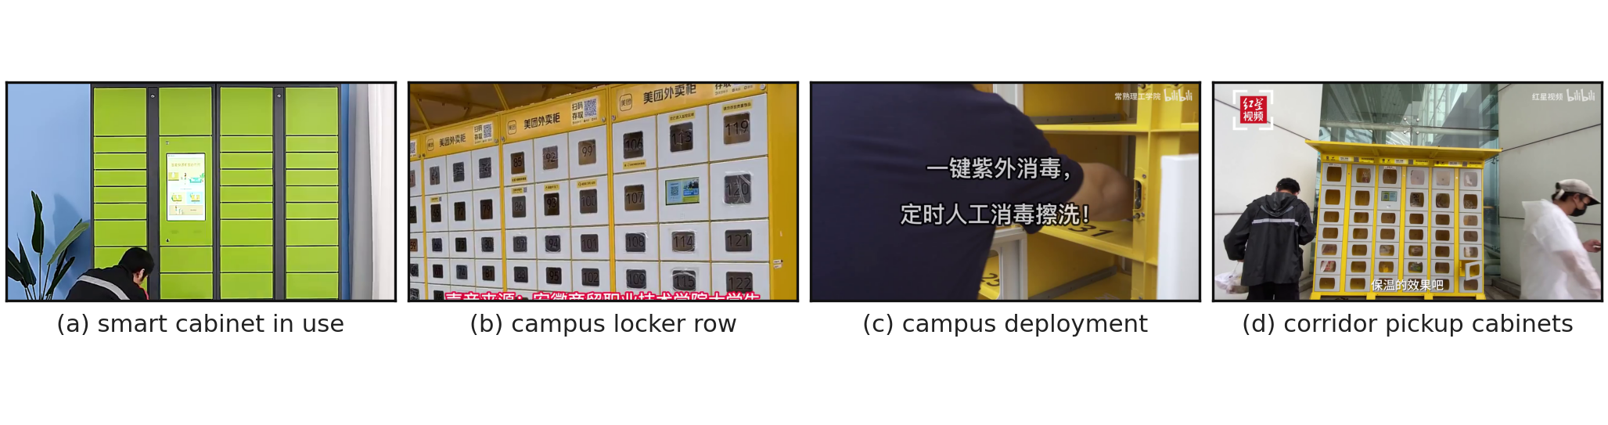
Figure 1. The deployment domain, as it exists in the field: frames from publicly available recordings of real locker use (Section 5.5). Left to right: a manufacturer-branded smart cabinet in use; a campus food-locker row; a campus deployment under installation; and a corridor of pickup cabinets during a contactless-delivery trial. The installations differ in brand, cabinet geometry, colour scheme, camera pose and illumination—the diversity that the calibration and audit procedures of this paper are designed to handle. Frames are reproduced from publicly available recordings; their published titles are listed in the Data Availability Statement, and no recording is redistributed.
The design in this paper therefore treats the fixed deployment geometry as an asset: a one-time calibration marks the pickup area and the compartment grid, and every subsequent judgment—zone membership, door-state regions, proximity to a compartment—is expressed in calibrated coordinates as pure functions. On top of this calibration sit three layers: a detection-and-tracking stage with explicit guards against the failure modes we measured (partial boxes, multi-second detector gaps, occlusion); a per-compartment door-state estimator that decides open/closed from a contrast statistic relative to the frame’s median brightness, with person-pixels masked out and a hold policy for occluded states; and a rule engine whose per-track and per-compartment state machines emit the six event types. Every threshold is a named configuration parameter with a documented default, and several defaults are non-arbitrary: they were widened or narrowed in response to measured failure modes, a fact we document so that the configuration can be reproduced rather than guessed.
Evaluation is organized around what each class of evidence can support; the classes are kept separate throughout. A 119-clip rendered behaviour benchmark, generated by the same scene geometry as the calibration, establishes correctness under same-distribution conditions—it verifies that the implementation executes the specified decision procedure end-to-end. A paired ablation isolates the contribution of each failure-repair mechanism, and an analytic replay over recorded event timelines bounds the sensitivity of the main alarm threshold without re-running any video. Beyond these controlled experiments, the paper adds two elements that speak directly to deployment. First, a field-footage boundary study: 15 recordings from six real locker installations (roughly 20 min, multiple brands and cabinet layouts) are run through the complete pipeline in both constrained and calibrated configurations; among these recordings is a real, unambiguous door-left-open episode whose duration we measure, and against which the system’s own door statistic is validated (a calm 0.94 reading during the episode versus a 0.15 threshold, with three neighbouring control compartments staying below 0.04). Second, a pre-deployment audit procedure: because the package detector is a colour-domain proxy, saturated warm-toned clothing can be mistaken for carried packages—an effect we observed on field footage and then quantified—so we define and validate a two-part audit (geometric coverage plus clothing-versus-package colour collision) that predicts, before alarms are enabled, which sites will produce spurious alerts under the default configuration. On the field corpus, 28.3% of person-frames carry collision risk (289 of 1020; Wilson 95% CI 25.7–31.2%), with a per-site spread from 6.9% to 66.7% that matches the observed spurious-alarm pattern.
The contributions of this paper are:
- An auditable problem formulation and system (§3–§4): compartment-attributed anomaly detection for an unattended locker, in which every alarm reduces to a named observable, a declared threshold and a measured value, so that an operator can answer “which door, which quantity, which threshold” for any event.
- A formalized calibrated pipeline (§4): one-time calibration of the compartment grid and pickup area; a statistical model of the door-state decision with occlusion handling; a two-stage association scheme with geometric guards whose thresholds are derived from measured detector behaviour; and event state machines whose alarm latency is predictable from their parameters. An analytic replay method for threshold sensitivity is derived and self-verified against measured counts.
- A field-footage boundary study (§7): the behaviour of the complete pipeline on 15 recordings from real installations, including the quantified failure of uncalibrated transfer (approximately one spurious alarm per 4.4 s of footage), the validation of the door statistic on a real open-door episode, and a taxonomy of the deployment domain (brands, cabinet geometry, camera pose, illumination) that the corpus covers.
- A pre-deployment audit procedure (§7): a geometric audit and a colour-collision audit that convert the field findings into an installation-time checklist; the collision measure is defined, measured across the corpus, and checked against the observed spurious-alarm pattern.
- Reproducibility under a CPU-only budget (§6): a complete open-source stack with measured per-stage costs, a HOG fallback, and a demonstration that the full pipeline sustains real-time operation on a single commodity computer, together with the measured envelope—including per-frame cost decomposition and the multi-view scaling limit—at which this claim holds.
The remainder of this paper is organized as follows. Section 2 reviews related work. Section 3 formulates the problem and describes the system design; Section 4 details the methods and their parameterization. Section 5 describes the experimental setup, including the field corpus; Section 6 reports the controlled experiments; Section 7 reports the field-footage boundary study and the audit validation. Section 8 discusses boundaries and implications, and Section 9 concludes.

2. Related Work

2.1. Unattended facilities and locker supervision
The literature on delivery lockers is dominated by logistics questions—location planning, utilization, customer satisfaction—rather than by supervision. Parcel-locker network design has been studied with p-median formulations on real trip data [2], and user-centric locker selection has been optimized for campus last-mile logistics [3]; both lines of work treat the locker as an interface for handover, not as a monitored space. Camera-based supervision of such facilities is scarce. The closest works detect the open/closed state of a door or the presence of objects inside a single controlled cabinet, typically with a frontal calibrated camera and a single per-cabinet decision [12]; retail-vision surveys reach the analogous conclusion for shelf and cabinet item recognition [13]. Two requirements distinguish the present setting: an alarm must name one compartment among many, and it must be attributable to a tracked person. Both are absent from cabinet-level methods, which aggregate visual evidence into one decision before any identity is established. The system studied here instead treats each compartment as an independently monitored entity, which is precisely what makes per-compartment alarms—and their audit—possible.

2.2. Video anomaly detection
Video anomaly detection (VAD) has moved through reconstruction- and prediction-based autoencoders, one-class and density models, weakly supervised multiple-instance learning over spatio-temporal backbones, and—most recently—multimodal and vision-language approaches. Recent surveys map this trajectory comprehensively [7,11,10]: Wu et al. [11] organize the field from task settings to foundation-model trends, and Barbosa et al. [10] synthesize multimodal and weakly supervised approaches; sequence-level methods continue to improve fine-grained temporal localization [8], and open-vocabulary detection is being re-purposed for VAD through promptable vision-language models [9]. Edge deployment is an explicit concern of this literature: lightweight two-branch systems target consumer hardware, and low-light smart-camera pipelines distribute enhancement and detection across IoT-edge devices [14]. At the same time, a parallel line argues for explicit knowledge in surveillance: rule-driven event detection frameworks encode domain vocabulary directly [15], loitering detection reduces to a rule over tracked positions [16], and recent hybrid systems blend learned perception with rule-based or explanation mechanisms to make anomaly decisions inspectable [17,18]. The position of the present work is close to this last family, with one deliberate difference: not only the decision but also the evidence chain is rule-based. The system measures per-compartment states and tracked positions, and every alarm carries the compartment number and the measured quantity that crossed a threshold. This is what we call auditable anomaly detection, and it is the property that makes the system usable for responsibility attribution in a shared facility—an application requirement that generic anomaly scores do not satisfy, whatever their accuracy [15].

2.3. Lightweight detection, tracking and edge deployment
Efficient detectors from the YOLO family provide a practical accuracy–latency trade-off for CPU deployment [19,20], and successive generations are repeatedly benchmarked on embedded targets [21]; the smallest variants are the standard choice when inference must share a machine with other workloads [22]. Classical descriptors such as HOG with a linear SVM [23] remain relevant as degradation fallbacks rather than competitors. Tracking-by-detection with data association supplies the identity that behaviour rules require [24], and occlusion is the dominant failure mode of that pipeline in surveillance settings; a recent survey systematizes occlusion handling across the tracking lifecycle [25]. Two of the guards used in this paper—re-association across multi-second detection gaps, and rejection of partial (upper-body) boxes—are instances of the trajectory-recovery and track-management strategies catalogued there, with thresholds derived from our own measurements rather than from generic defaults. Finally, the edge-computing rationale—moving inference to the data for latency, cost and privacy [5]—is realized here in its strictest form: the entire pipeline, including the operator console, runs on one machine and no video leaves it, with de-identification-style privacy arguments [6] satisfied by construction. The measured cost decomposition and the multi-view scaling limit (Section 6) are reported so that this claim is a quantity rather than a slogan.

3. Problem Formulation and System Design

3.1. Scenario, geometry and notation
A site consists of one locker bank and one fixed camera viewing it. The bank contains a known set of compartments $K=\{1,…,K\}$, physically arranged in rows and columns. The camera is static during operation; its pose is arbitrary but chosen so that the compartment fronts and the ground area in front of the bank are visible (the installation guidelines in Section 7.3 state the practical conditions). Let $V$ denote the video, a sequence of frames $v_{t}$ at source rate $f_{s}$; all processing is causal—decisions at time $t$ may use frames up to $t$ only—and fully local.
Two coordinate systems are used. The image system is the pixel grid of $v_{t}$, of size $W×H$. The panel system is attached to the locker front, which is a plane $Π$. For a point on $Π$ with panel coordinates $(X,Y)$, its image $x=(x,y,1)$ is given by the plane-induced homography
$x ∼ H X, H∈R^{3×3}, X=(X,Y,1)^{⊤},$ (1)
where $∼$ denotes equality up to scale. The homography is estimated once, during installation, from correspondences between panel and image points (Section 4.1), and is fixed thereafter. Three derived structures are stored as normalized polygons (coordinates in $[0,1]^{2}$ relative to $W×H$): the pickup-area polygon $P$, the compartment polygons $\{C_{k}\}$, and—optionally—auxiliary zones. Storing polygons in normalized coordinates makes every geometric query resolution-independent: for any frame size, a polygon is mapped to pixels by scaling, and no threshold refers to absolute pixel values. We return to the consequences of this invariance in Section 5.1.
A track $τ$ is a temporally coherent person hypothesis with a bounding box, a stable identifier, a foot point $ϕ(τ)∈R^{2}$ (bottom-centre of the box), a last-seen timestamp $t_{τ}$ and a trusted box height ${\hat{h}}_{τ}$. A scene observation at time $t$ is the tuple
$o_{t} = ( D_{t}, \{d_{k}(t)\}_{k∈K}, \{n_{k}(t)\}_{k∈K}, \{c_{τ}(t)\}_{τ} ),$ (2)
where $D_{t}$ is the set of person detections, $d_{k}(t)∈\{\text{open},\text{closed},\text{unknown}\}$ is the estimated door state of compartment $k$, $n_{k}(t)∈N_{0}$ is the number of package-like objects detected inside $C_{k}$, and $c_{τ}(t)$ is the number of package-like objects attributed to track $τ$ as carried. The rule engine consumes the observation stream $\{o_{t}\}$ and emits events; its state is a finite set of per-track and per-compartment variables.

3.2. Event definitions
The system recognizes six event types (Table 1). Two are informational and record the normal flow of a retrieval; four are alarms corresponding to the operational concerns of Section 1. Each alarm is defined as a predicate over the state trajectories of the observation stream, not as a classification of a video segment. Writing $T_{k}^{open}(t)$ for the accumulated open time of compartment $k$ up to $t$ (defined precisely in Section 4.5), the four alarm predicates are:
$\begin{matrix}\text{DoorLeftOpen}(k): & ∃t: T_{k}^{open}(t)≥τ_{open},\end{matrix}$ (3)
$\begin{matrix}\text{MultiRetrieval}(τ): & ∃t: c_{τ}(t)≥n_{multi},\end{matrix}$ (4)
$\begin{matrix}\text{FlaggedRetrieval}(k): & ∃t: (f_{k}=1) ∧ (n_{k}(t^{−})>n_{k}(t)),\end{matrix}$ (5)
$\begin{matrix}\text{Loitering}(τ): & L_{τ}(t)≥τ_{loit} ∧ e_{τ}≥n_{entries} ∧ μ_{τ}<τ_{peak},\end{matrix}$ (6)
where $τ_{open}=10$ s, $n_{multi}=2$; $f_{k}$ is the flag set by (3) and cleared when the compartment is confirmed closed ($τ_{close}=1.5$ s of consistent closed evidence); $L_{τ}(t)$ is accumulated nearby time, $e_{τ}$ the entry count into the pickup area and $μ_{τ}$ the longest single visit. The last conjunct of (6) encodes a domain decision made with the site’s operators: a person who simply stands at the locker for a long single visit (waiting for a phone lookup, reading messages) is normal; loitering requires repeated approaches without a long single visit. Events of the same type and the same target are suppressed within a cooldown window $τ_{cool}=30$ s, and each suppression is counted in a dedicated statistic so that the suppression rate is auditable rather than implicit.
Table 1. The six event types, severities and default thresholds. Every threshold is a named configuration parameter (Table 2); the cooldown between repeated events of the same type and target is $τ_{cool}=30$ s.
Event | Severity | Trigger (default)
Pickup-area entry | info | foot point enters $P$ (debounced, 2 frames)
Door closed | info | flagged door confirmed closed for $τ_{close}=1.5$ s
Loitering | warning | nearby $≥15$ s with $≥3$ entries, no single visit $≥8$ s
Door left open | warning | compartment open $≥τ_{open}=10$ s
Multiple packages | critical | one person carries $≥n_{multi}=2$ packages
Retrieval from flagged door | critical | package removed from a flagged compartment
Two properties of this vocabulary matter operationally. First, the alarms are state-based: each fires when a measured quantity crosses a declared threshold, which is why the system raises them by rule rather than by classification, and why their firing latency is predictable (Section 4.6). Second, the vocabulary is closed and configurable: thresholds can be re-tuned per site without touching code, and vocabulary items that other deployments might add (e.g., camera occlusion) are deliberately absent because they are deployment conditions rather than user behaviours.

3.3. Architecture and data flow
Figure 2 summarizes the architecture; all stages run as threads of a single process on one machine. A local video source feeds a detection–tracking stage that outputs person boxes with stable identities. A scene-observation stage converts detections into the structured observation of (2): per-compartment visual evidence for the door state, handheld package counts, and the zone of each tracked person. A rule engine then evaluates the predicates of Section 3.2 over the observation stream, maintains per-track and per-compartment state, and emits events. Every event is persisted to a local database together with a snapshot of its evidence frame; a web console—served from the same machine, so that no video leaves the host—renders the live view with the calibrated grid and per-compartment states overlaid, lists the event stream with thumbnails, and exposes the configuration. The display loop and the detection loop are decoupled: display publishes the newest frame to the detection thread, so a slow inference stage degrades the detection rate but never the smoothness of the live view.
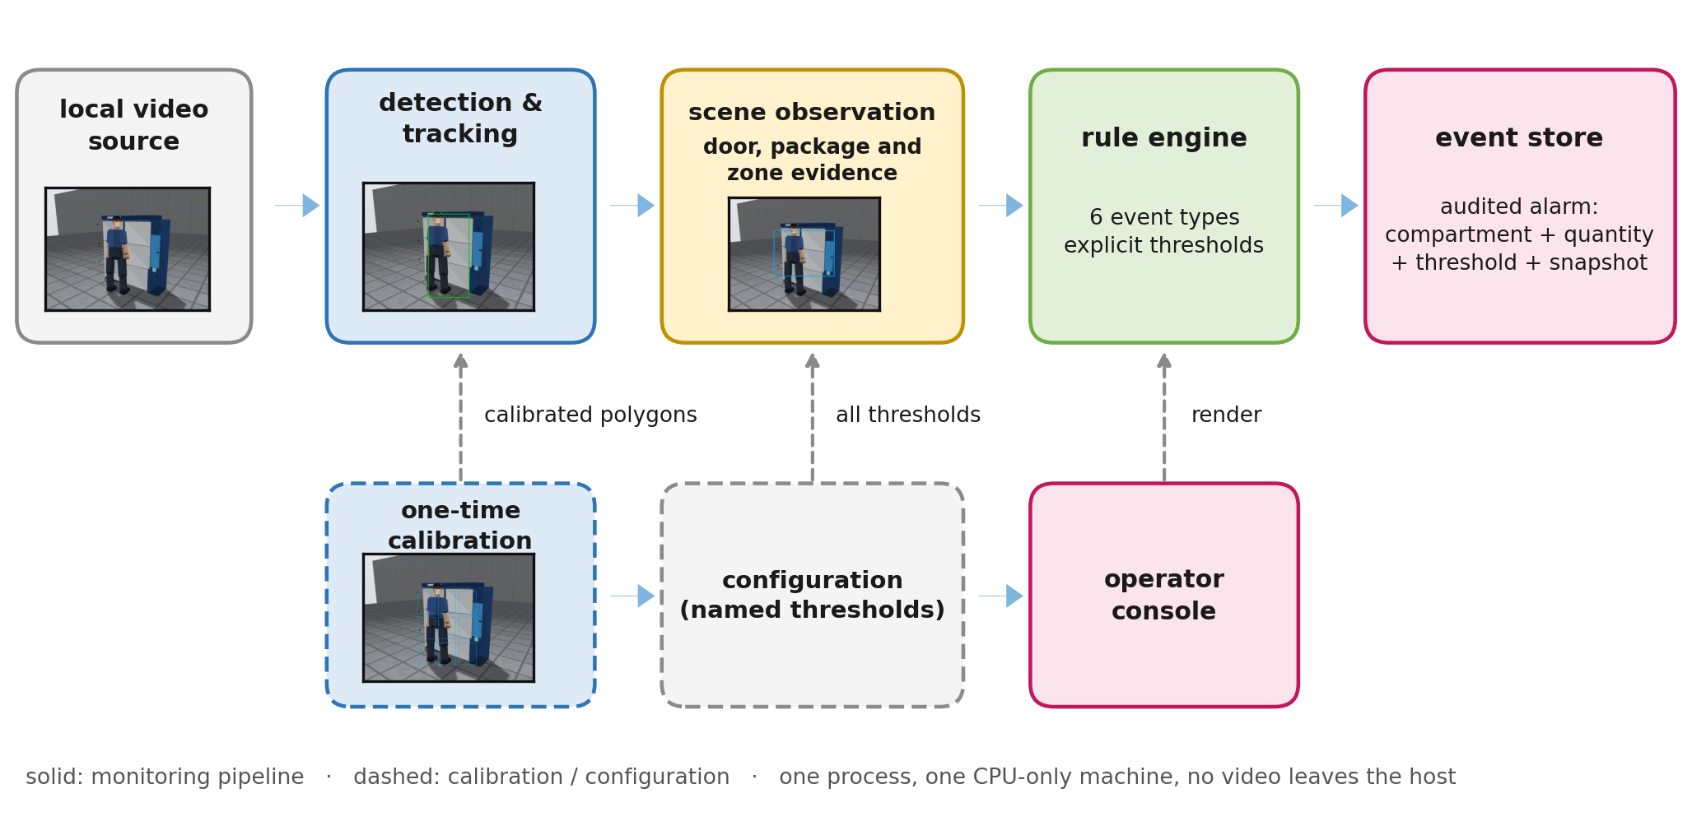
Figure 2. System architecture. The solid path is the monitoring pipeline; every module runs on a single CPU-only computer and no video leaves the machine. All thresholds live in one configuration object; the calibration stage writes the geometric part of it. Events persist with an evidence snapshot so that each alarm can be audited after the fact.

3.4. Operating constraints
The design constraints, fixed before any method choice, are: (i) one personal computer with CPU-only inference—no GPU, camera, or embedded accelerator; (ii) local video files or image sequences as the only input source (no capture hardware); (iii) free and open-source components only; and (iv) every threshold a named, documented configuration parameter rather than a constant embedded in code. Constraints (i)–(iii) shape the perception stack (lightweight detector, explicit fallback) and (iv) is what makes the pipeline auditable: an administrator can inspect, justify and change every decision boundary, and the experiments can vary thresholds analytically (Section 4.6).

4. Method

4.1. One-time calibration
Because the deployment geometry is fixed and known, the system exploits it rather than estimating it online. Calibration proceeds in two steps, supported by two interactive tools. First, the pickup-area polygon $P$ is drawn once on a reference frame: it covers the ground region in front of the bank where a retrieval user stands, and may exclude passage lanes. All zone queries are point-in-polygon tests of the foot point $ϕ(τ)$ against $P$:
$z(τ)=\left\{\begin{matrix}\text{pickup}, & \text{pointPolygonTest}(P,ϕ(τ))≥0, \\ ⌀, & \text{otherwise.}\end{matrix}\right.$ (7)
Second, the compartment grid is fitted. The operator marks the four corners of the locker panel (top-left, top-right, bottom-right, bottom-left) and declares the row and column counts $(R,C)$; with a margin fraction $μ$ that compensates for the frame width of each door, the polygon of compartment $(r,c)$ ($0≤r<R$, $0≤c<C$) is generated by bilinear interpolation of the panel corners $q=(q_{TL},q_{TR},q_{BR},q_{BL})$:
$b(u,v) = (1−v)[(1−u)q_{TL}+uq_{TR}] + v[(1−u)q_{BL}+uq_{BR}],$ (8)
evaluated at the corners $(\frac{c+μ}{C},\frac{r+μ}{R})$, $…$, $(\frac{c+1−μ}{C},\frac{r+1−μ}{R})$. Since the panel is planar, the exact mapping between panel and image is the homography (1); the bilinear construction (8) is a four-point interpolation of that map, which we adopt because it requires no world-coordinate metrology—only four visually identifiable corners—and because the door statistic below is an area aggregate that tolerates centimetre-level grid error at the boundary. Both tools render an overlay of the generated polygons on the reference frame so that the operator can verify the fit visually before the system runs (Figure 3), and both export the result in the normalized coordinate format of Section 3.1. Changing the camera pose requires re-running the calibration; no threshold is hard-coded against a pixel layout, and the audit in Section 7.3 includes a geometric coverage check of the fitted grid.
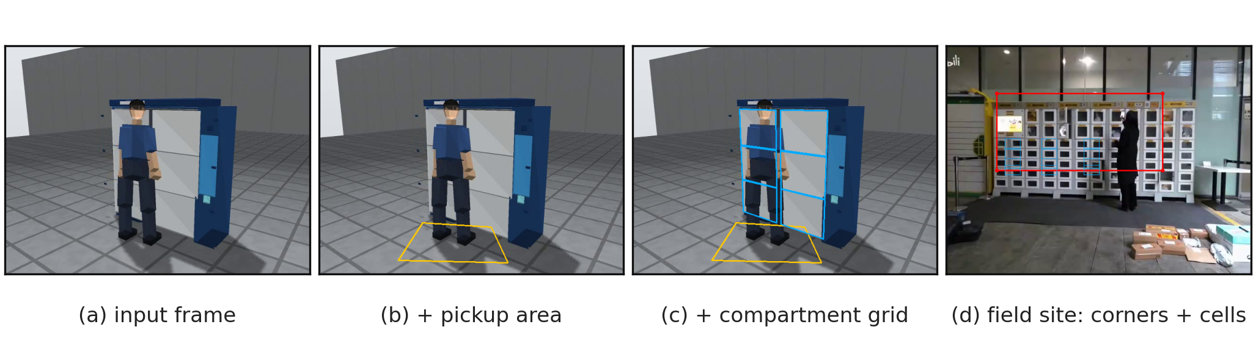
Figure 3. One-time calibration, shown on the rendered scene and on field footage. (a) the reference frame; (b) with the pickup-area polygon $P$ drawn on the ground in front of the bank; (c) with the compartment grid generated by (8) after the operator marks the four panel corners; (d) the same procedure applied to a real installation (Section 7), with the marked corners and the resulting cells overlaid. Both tools export normalized polygons, so the procedure is identical on the rendered benchmark (Section 5) and on real sites.

4.2. Detection, tracking and geometric guards
Person detection uses a COCO-pretrained lightweight detector at input size 480 and confidence threshold 0.35 [20]; when the deep runtime is unavailable the system falls back to a HOG descriptor with a linear SVM [23], replacing only the detector and keeping all downstream logic identical. Both backends are exercised in the experiments; the fallback preserves the alarm contract rather than the detector’s accuracy, and never alarms on a normal clip (Section 5.3).
Tracking is association-based, with three mechanisms whose parameters were set by measured failure modes. Each detection $d$ is matched to the live track $τ$ maximizing the intersection-over-union
$IoU(d,τ) = \frac{|B(d)∩B(τ)|}{|B(d)∪B(τ)|} ≥ θ_{iou}=0.30,$ (9)
where $B(⋅)$ is the bounding box; matching is greedy in decreasing IoU and each track accepts at most one detection per frame. Stage two re-associates the unmatched detections: a detection joins a recent track whose foot point is the nearest within radius $ρ_{reid}=45$ px, provided the track’s age does not exceed $τ_{reid}=12$ s. The need for stage two is empirical: on the rendered benchmark, standing persons are intermittently missed by the detector for 4.1–10.5 s, and without re-association one physical person fragments into several tracks, resetting accumulated presence and destroying the predicates of (6) (Section 6.5). The radius is bounded by the geometry of the scene: a person walking across the campus scene moves at most about $120$ px/s at the working distance, so $45$ px covers the worst-case displacement during a detection gap only if the gap is short; therefore the radius is deliberately conservative (favour splitting over merging), and the long-gap case is handled by track age alone, where the two-tracks risk of merging is negligible because the arrival interval between different persons at the bank is much longer than the allowed re-association windows.
Two guards protect the association against partial detections—upper-body boxes that the detector emits when a person bends towards a compartment. Both operate on the principle that a partial box moves the foot point spuriously: its bottom edge sits mid-frame rather than at the person’s feet. The first guard compares the foot-point displacement between consecutive accepted detections against a speed bound:
$∥ϕ_{t}−ϕ_{t′}∥_{2} > v_{\text{max}} (t−t′)+b, v_{\text{max}}=150 px/s, b=40 px,$ (10)
where $ϕ_{t′}$ is the previously trusted foot point; the second guard is a box-height test against the track’s trusted height,
$h_{t} < ρ_{h} \hat{h}, ρ_{h}=0.70,$ (11)
matched to the measured geometry of partial boxes (an upper-body box retains roughly $47$ % of the full height on the benchmark, so $0.70$ separates the modes with margin while leaving ordinary box-height variation—perspective and gait—admissible). When either guard fires, the frame updates neither the trusted foot point nor the trusted height, and the zone state is held rather than re-evaluated; Algorithm 1 states the complete procedure. The guards are pure functions with unit tests, and their contributions are isolated by the ablation (Section 6.5).
Algorithm 1. Two-stage track association with geometric guards (per frame).
1 | Require: detections $D_{t}$; live tracks $T$; thresholds $θ_{iou},τ_{ttl},τ_{reid},ρ_{reid},v_{\text{max}},b,ρ_{h}$
2 | Ensure: association pairs; updated track set
3 | $L←\{τ∈T:t−τ_{last}≤τ_{ttl}\}$
4 | match $L×D_{t}$ greedily by (9)
5 | for all unmatched $d∈D_{t}$ do
6 | $C←\{τ∉\text{matched}:0<t−τ_{last}≤τ_{reid} ∧ ∥ϕ(d)−ϕ(τ)∥≤ρ_{reid}\}$
7 | if $C≠∅$ associate $d$ with the nearest track in $C$ then
8 | end if
9 | end for
10 | create a new track for every still-unmatched detection
11 | drop tracks with $t−τ_{last}>τ_{reid}$; mark guarded frames per (10)–(11)

4.3. Per-compartment door state
The open/closed state of compartment $k$ is estimated from its visual appearance, because no per-door sensor exists at the target installations. The estimator rests on one contrast observation: when a door is closed, the region shows the reflective door panel; when it is open, the region exposes the dark interior. Let $γ(x)$ be the grayscale value of pixel $x$ in frame $v_{t}$ and $m={median}_{x}γ(x)$ the frame median, which tracks global illumination changes. Define the dark indicator and the darkness ratio of $C_{k}$ as
I(x)=1[γ(x)<κ m], rk(t) = 1|Ckvis|x∈Ckvis​I(x), κ=0.62, (12)
where Ckvis=Ck\τ​B(τ) excludes pixels covered by current or recent person boxes (occlusion masking). Following the design of Section 3.2, the state decision is
${\hat{d}}_{k}(t)=\left\{\begin{matrix}\text{open} & r_{k}(t)≥η, η=0.15, \\ \text{closed} & \text{otherwise,}\end{matrix}\right. \text{provided} ν_{k}(t) = \frac{|C_{k}^{vis}|}{|C_{k}|} ≥ ν_{\text{min}}=0.50;$ (13)
when the visibility condition fails, the estimator returns unknown and the state machine holds the previous value rather than guessing.
Why this decision rule is well-posed can be seen from a two-population model. Suppose that, conditioned on the door state, the pixels of $C_{k}^{vis}$ are drawn independently from distributions with dark-pixel probabilities $ε_{c}$ (closed) and $ε_{o}$ (open), $ε_{c}<ε_{o}$. Then $r_{k}$ is the mean of $n_{k}=|C_{k}^{vis}|$ Bernoulli variables with $E[r_{k}∣\text{closed}]=ε_{c}$ and $E[r_{k}∣\text{open}]=ε_{o}$; the threshold $η$ separates the states whenever $ε_{c}<η≤ε_{o}$. The probability of a false “open” decision on a closed compartment obeys the Chernoff bound
$\text{Pr}[r_{k}≥η | \text{closed}] ≤ \text{exp}(−n_{k} D(η ∥ ε_{c})), D(a∥b)=a\text{ln}\frac{a}{b}+(1−a)\text{ln}\frac{1−a}{1−b}.$ (14)
With the field measurements of Section 7 ($ε_{c}≈0.07$ for a real closed door including its edge pixels, $η=0.15$) and a compartment of about ${10}^{3}$ visible pixels, the bound gives a false-open probability below ${10}^{−15}$ per frame; the empirical margins are much wider still ($ε_{c}≤0.07$ and $ε_{o}≈0.94$ on the measured episode), which is what makes a single global $η$ defensible across doors and brands. Two properties of the bound determine where it applies, and both are measured rather than assumed. Pixel independence is a modelling approximation—door edges and shadows correlate neighbouring pixels—so the operative number is the measured margin ($ε_{c}≤0.07$ against $ε_{o}≈0.94$) rather than the bound itself; and the model presumes that closed means “reflective door panel”, which places lockers whose doors carry large dark viewing windows outside its stated scope. Such sites are handled by measurement, not by assumption: the audit of Section 7.3 includes a per-site check of $ε_{c}$, and Section 7 reports a real installation where this check required recalibration. Finally, ${\hat{d}}_{k}$ is deliberately a binary decision rather than an angle estimate, because all six event types are defined on discrete states; $η$ is therefore directly interpretable as the open/closed decision boundary.
The estimator’s remaining design choices address the three failure modes we measured. (i) Occlusion: person pixels are excluded as in (12), and when more than half of $C_{k}$ is covered the state is undecidable and held—the system prefers abstention to a guess. The look-back window that defines “recent” person boxes is short ($1.0$ s of recent track boxes) because a longer window lets the residual boxes of persons who already left keep occluding a compartment, freezing its state and causing missed door alarms, an effect we observed during development and fixed by shortening the window. (ii) Brightness drift: the ratio is computed against the frame median, which cancels smooth global changes such as dusk or cloud cover; abrupt changes (a light switched on) do not move the decision because both the reference and the compartments brighten together. (iii) Partial boxes: guarded by (10)–(11) at the tracking stage, so the estimator is never handed a mid-frame foot point as if it were a person standing still. Algorithm 2 states the per-compartment procedure and its flag state machine; the flag itself (set at $τ_{open}$, cleared after $τ_{close}$ of consistent closed evidence) is a hysteresis element, and its two timers are the only door-related state.
Algorithm 2. Per-compartment door state and flag state machine (per frame).
1 | Require: frame $v_{t}$; compartment polygons $\{C_{k}\}$; recent track boxes; thresholds $κ,η,ν_{\text{min}},τ_{open},τ_{close}$
2 | Ensure: door states; door events
3 | for all compartments $k$ do
4 | if $ν_{k}(t)<ν_{\text{min}}$ hold state($k$) then
5 | else
6 | $r_{k}←$ darkness ratio (12); ${\hat{d}}_{k}←$ decision (13)
7 | end if
8 | if ${\hat{d}}_{k}=\text{open}$ $T_{k}^{open}+=Δt$; reset $T_{k}^{closed}$ $T_{k}^{closed}+=Δt$; reset $T_{k}^{open}$ then
9 | if $f_{k}=0$ and $T_{k}^{open}≥τ_{open}$ $f_{k}←1$; emit DoorLeftOpen($k$) then
10 | end if
11 | if $f_{k}=1$ and $T_{k}^{closed}≥τ_{close}$ $f_{k}←0$; emit DoorClosed($k$) then
12 | end if
13 | end for

4.4. Handheld package counting
The evidence for retrieval events is a count of package-like objects associated with each track. Package-like objects are connected components of a fixed colour-domain mask in HSV space (hue within $[15,95]$, saturation $≥130$, value $≥90$, area within $[60,1200]$ px), a proxy calibrated on the target domain (food containers and delivery bags in warm tones). A blob counts as carried by track $τ$ when its centre falls inside the box of $τ$ expanded horizontally by $35\%$ and vertically by $15\%$; the expansion is required because a package borne with an outstretched arm lies outside the detector’s box, and the guard on the expansion excludes regions that overlap a compartment polygon, so that packages resting on the shelf are not counted as carried. Adjacent blobs of different package colours (gap $≤10$ px) are merged into one package. The predicate of (4) then fires when the count reaches $n_{multi}=2$. Because the mask is a colour proxy, its domain assumptions are checked at installation by the audit of Section 7.3, and its behaviour on field footage is quantified in Section 7.

4.5. Rule engine, event algebra and latency
The rule engine consumes $\{o_{t}\}$ and maintains, per track, the zone state with a two-frame debounce, accumulated nearby time, entry count, longest single visit and the set of fired events; per compartment, the flag $f_{k}$ and the two timers of Algorithm 2. One step of the engine realizes the predicates (3)–(6) and the cooldown; the complete procedure is Algorithm 3. Two properties of the engine make the system auditable in an operational sense.
Alarm latency is predictable. Consider the door alarm (3). The accumulator $T_{k}^{open}$ advances only while the estimator reports “open”, so if compartment $k$ is opened at time $t_{0}$ and the estimator reports the first “open” at $t_{0}+δ$ (the detection delay), the alarm time is
$t_{alarm}(k) = t_{0}+δ+τ_{open},$ (15)
provided the compartment stays open throughout. On the benchmark, the measured alarm times sit at $14.1$–$16.3$ s in clips whose doors open in the first seconds, consistent with (15) at $τ_{open}=10$ s and $δ$ of order the detection period; more importantly, the same identity makes threshold changes replayable: the opening time is recoverable from the recorded alarm as $t_{0}=t_{alarm}−τ_{open}−δ$, and every statement about a different threshold can be derived without re-running video. Section 4.6 turns this into a method and verifies it against the measured counts.
Cooldown is keyed and counted. Suppression is keyed by (event type, target), so a repeated alarm for the same door waits $τ_{cool}$ while an alarm for a different door passes immediately; the number of suppressed events is exposed as a first-class statistic. During the benchmark evaluation the cooldown suppressed 299 repeated firings over 29 190 processed frames—without it, ongoing situations (a door still open) would flood the event log, and with it the log remains a faithful record of distinct situations.
Algorithm 3. Behaviour rule engine (per frame).
1 | Require: observation $o_{t}$; time $t$; configuration
2 | Ensure: event list
3 | associate detections to tracks (Algorithm 1); update zone with a $ζ$-frame debounce per (7)
4 | if debounced zone entry and cooldown ok then emit PickupEntry
5 | if $L_{τ}≥τ_{loit}$ and $e_{τ}≥n_{entries}$ and $μ_{τ}<τ_{peak}$ and not yet fired then emit Loitering
6 | update door states and flags (Algorithm 2) and emit door events
7 | if $c_{τ}≥n_{multi}$ and cooldown ok then emit MultiRetrieval
8 | if $f_{k}=1$ and $n_{k}$ decreases and cooldown ok then emit FlaggedRetrieval($k$)
9 | suppress repeats per (type, target) within $τ_{cool}$; count suppressions

4.6. Analytic replay of threshold sensitivity
Because the alarms are threshold predicates over recorded quantities, their sensitivity to a parameter does not require re-running any video. We use this in two ways: as a method, to characterize the usable range of the door threshold at zero cost, and as a self-check, by verifying that the replay reproduces the measured counts at the deployed value.
For each door event recorded in an evaluation run, let $t_{alarm}$ be its alarm time; by (15) the (estimated) opening instant is
${\hat{t}}_{0} = t_{alarm}−τ_{open}−δ,$ (16)
with $δ$ the mean detection delay, and let $A_{k}$ be the available open duration of the compartment—the time from ${\hat{t}}_{0}$ until the compartment is confirmed closed, or until the clip ends. Under an alternative threshold $τ′$, the door alarm fires iff the compartment remains open for that long, and the derived flagged-retrieval alarm fires iff, additionally, the package is taken after the flag is raised. Writing the recorded retrieval instant as $t_{take}$, the replay computes
Rdoor(τ′)=1Nk​1[Ak≥τ′], (17)
Rflag(τ′)=1Nk​1[Ak≥τ′ ∧ ttake≥t0+τ′], (18)
over the $N$ door events of the recording. Both formulas are exact under two stated assumptions—the open interval is contiguous (no re-opening), and $δ$ is constant across clips—which hold on the benchmark and can be checked per event from the recorded timeline. The verifications and the resulting operating recommendations are reported in Section 6.6; the same mechanism is what makes the field episode of Section 7.2 interpretable against the deployed threshold.

4.7. Computational cost model
All per-frame work beyond detection is linear in the number of persons and compartments. The association is $O(|L||D_{t}|)$ in the worst case but runs with one to three tracks in practice; the package mask is one HSV threshold plus connected components; the door estimator reads only compartment pixels, which cover about $13\%$ of a $640×480$ frame for the six-compartment layout. Writing $T_{det}$ for per-frame detection cost and $T_{obs}$ for the complete observation step, the sustained detection rate of one view is
$f_{det} = \frac{1}{T_{det}+T_{obs}}, N_{views} ≤ \frac{1}{f_{s} (T_{det}+T_{obs})}$ (19)
for an $f_{s}$-frame-per-second source: the number of views one machine can monitor at frame rate is bounded by the same budget, which turns “one machine suffices” into a measured inequality rather than a slogan. Section 6.4 reports the measured terms and the implied envelope, including the multi-view limit that this economy does not reach.

5. Experimental Setup

5.1. Hardware, software and fixed configuration
All experiments ran on a single personal computer with an Intel Core i5-12500H (16 logical cores) and 15.7 GB of RAM under Windows 11, using Python 3.13.9, PyTorch 2.14.0+cpu, Ultralytics 8.4.161, OpenCV 4.12.0 and Flask 3.1.3. Inference is CPU-only; input is always a local video file. Unless stated otherwise, the detector runs at input size 480 with confidence threshold 0.35 and IoU threshold 0.50, and the rule parameters are the defaults of Table 2. The system, its calibration tools and the evaluation scripts are the same code base that serves the operator console.
Table 2. Default configuration. Every entry is a named parameter of the configuration object rather than a constant in the code; the defaults below are those used in all experiments unless explicitly varied.
Group | Parameter | Value
Detection | confidence threshold | 0.35
 | IoU threshold / input size | 0.50 / 480
 | HOG input width | 320 px
Tracking | IoU match threshold $θ_{iou}$ | 0.30
 | short track TTL $τ_{ttl}$ | 3.0 s
 | re-association TTL $τ_{reid}$ | 12.0 s
 | re-association radius $ρ_{reid}$ | 45 px
 | foot-speed guard $v_{\text{max}}$ / margin $b$ | 150 px/s / 40 px
 | box-height ratio guard $ρ_{h}$ | 0.70
 | zone debounce $ζ$ | 2 frames
Door state | median factor $κ$ / open threshold $η$ | 0.62 / 0.15
 | minimum visibility $ν_{\text{min}}$ | 0.50
 | occlusion look-back | 1.0 s
Rules | door-open alarm $τ_{open}$ | 10 s
 | close confirmation $τ_{close}$ | 1.5 s
 | multi-package count $n_{multi}$ | 2
 | loitering $τ_{loit}$ / $n_{entries}$ | 15 s / 3
 | single-visit peak $τ_{peak}$ | 8 s
 | compartment proximity factor | $×1.45$
 | event cooldown $τ_{cool}$ | 30 s
Runtime | display / detect rate | 30 / 15 fps

5.2. Rendered behaviour benchmark
The behaviour benchmark consists of 119 clips (84 abnormal, 35 normal) rendered as 640$×$480 videos at 15 fps, 10–22 s per clip (29 190 frames). This sample size bounds the resolution of every rate reported below: Wilson 95% intervals are 96.9–100% for the 119 clips, 90.1–100% for the 35 normal clips and 91.6–100% for the 42 door events, while a 0/21 outcome excludes recall above 15.5% rather than establishing it at zero. The abnormal half covers four event classes with 21 clips each: door left open, multiple packages by one person, retrieval from a flagged compartment, and loitering; the normal half contains complete retrievals. The clips are produced by a scripted three-dimensional scene generator that renders the locker with the compartment layout used by the calibration (Figure 3) together with scripted human trajectories and package placements; ground truth—per-compartment door angle, retrieval instants and the expected event type of every clip—is exported programmatically, so the evaluation involves no manual annotation. Because the test scene, the calibration and the renderer are consistent, results on this benchmark verify correctness under same-distribution conditions: that the implementation executes the specified decision procedure and that the declared thresholds behave as intended. They are not, and are not used as, an estimate of generalization to unseen scenes.
The accompanying survey referenced throughout the paper was conducted by the project team among campus locker users: 130 questionnaires were distributed and 120 valid responses were recovered (92.3%). The response pattern—86.7% perceiving security risks in current locker use, 91.7% supporting automated behaviour recognition, 88.3% requiring non-intrusive supervision and 74.2% concerned about low illumination (Wilson 95% CIs at $n=120$: 79.4–91.6, 85.3–95.4, 81.4–92.9 and 65.7–81.2%, respectively; questionnaire recovery 120 of 130, 95% CI 86.4–95.8)—motivated the requirements of Section 1 and is reported here so that the event vocabulary and the operating constraints can be traced to their origin.

5.3. Real-image detector benchmark
To anchor the detector comparison on real photographs rather than rendered scenes, the backends are evaluated on a fixed 500-image subset of the COCO val2017 person class [26] (400 images containing persons plus 100 without; 1670 ground-truth boxes; fixed sampling seed 20260925, manifest stored with the evaluation logs). Metrics are average precision at IoU 0.5 (VOC all-point interpolation, greedy matching, crowd annotations excluded) and precision/recall/F1 at the operating confidence 0.35, together with single-image inference time measured on the deployment machine after a warm-up pass. Three backends are compared: YOLOv8n, its successor YOLO11n [21], and the HOG+SVM fallback [23].

5.4. Real surveillance footage
As an additional real-domain probe, the complete pipeline (detection, observations, rules, event emission) runs over all 15 328 frames of the 16 CUHK Avenue training sequences [27]—a real scene with no relation to the locker geometry. The geometric rules have no correspondence to compartments by construction, so this experiment is reported as a boundary study and measures the operational quantity that matters before calibration—how many alarms an uncalibrated deployment emits per minute (Section 6.7).

5.5. Field corpus
The field corpus consists of 15 publicly available recordings of real locker use, gathered from video-sharing platforms to represent the deployment domain as it actually exists. In total 19.1 min of footage (1145 s) covering at least six distinct physical installations: a campus locker bank at Fudan University (several clips), a static campus bank used for meal storage and retrieval, a campus deployment at Changshu Institute of Technology, a Fengchao express-locker site, an indoor food-locker room, an Xintian smart-cabinet deployment, a canteen pickup cabinet at a university west building, and a campus deployment at a college in Wuhu; the corpus also includes three vendor demonstration clips and one television report on contactless pickup. The recordings differ in resolution (640$×$368 to 1280$×$720), aspect ratio (landscape and portrait), camera motion (static surveillance-style framing to handheld close-ups), and illumination (outdoor daytime to artificially lit interiors at night). Table 3 summarizes the corpus; per-frame statistics (brightness, motion) and per-site audit quantities are reported there because they matter for both the transfer results (Section 7) and the audit procedure (Section 7.3).
The recordings are used exclusively as footage—they are fed to the pipeline as inputs, not redistributed—and the paper reports only aggregate statistics and a small number of frames as qualitative evidence, with the source recordings identified in the data availability statement. No personal identifying information is analyzed; the recordings are public, and the analysis is limited to gross behaviour (presence, door state, carried objects).
Table 3. Field corpus. One row per recording (sorted as processed); motion is the median inter-frame difference within a mid-clip window in 8-bit grey levels (higher = more camera/global motion), collision is the colour-domain audit of Section 7.3 (fraction of person-frames in which at least two package-coloured blobs fall inside a person box), and events is the number of events emitted by the uncalibrated configuration of Section 7.1 (informational and alarm events combined; 197 of the 261 are alarms).
ID | Scene (abbreviated) | Dur (s) | Resolution | Motion | Collision | Events
v01 | Fudan campus, courier deposit | 45.9 | 852$×$480 | 2.02 | 55.4% | 20
v02 | Fudan campus, pickup | 32.7 | 852$×$480 | 11.11 | 39.3% | 4
v03 | Fudan campus, courier deposit (long) | 318.6 | 852$×$480 | 9.09 | 48.3% | 74
v04 | Campus bank, storage/retrieval (static) | 240.3 | 852$×$480 | 0.61 | 6.9% | 48
v05 | Fengchao express, door-closing clip | 50.0 | 1280$×$720 | 1.23 | 46.9% | 10
v06 | Food locker, close-up clip | 26.9 | 854$×$474 | 4.66 | 11.1% | 1
v07 | Indoor locker room, multi-user | 88.4 | 1280$×$720 | 4.14 | 30.1% | 24
v08 | Changshu campus deployment | 31.8 | 1280$×$720 | 4.74 | 41.7% | 5
v09 | Xintian smart cabinet, usage flow | 56.8 | 640$×$368 | 3.07 | 19.0% | 6
v10 | Express locker, vendor demo (portrait) | 24.4 | 720$×$1280 | 0.63 | 47.6% | 7
v11 | TV report, contactless pickup | 84.1 | 1280$×$720 | 5.03 | 29.9% | 44
v12 | Handover cabinet, vendor demo | 21.1 | 1280$×$720 | 8.32 | 0.0% | 0
v13 | Express locker, vendor demo | 59.5 | 720$×$720 | 2.96 | 50.0% | 8
v14 | Wuhu college deployment | 17.8 | 720$×$1280 | 1.96 | 66.7% | 4
v15 | Canteen pickup cabinet | 46.5 | 1280$×$720 | 2.28 | 43.6% | 6
 | Total | 1144.8 | — | — | 28.3% | 261

6. Controlled Experiments

6.1. Behaviour-level evaluation on the rendered benchmark
A first question the benchmark must answer is where the system’s behaviour actually lives: does the alarm semantics come from the detector, or from the rules on top of it? Comparing the complete pipeline against a detector-only baseline and against a HOG-based fallback answers it directly. Arm A1 applies the detector alone (a clip is predicted abnormal if a person is detected in any frame); A2 is the complete pipeline; A3 replaces the deep detector with the HOG fallback while keeping every rule and threshold identical. Table 4 and Figure 4 show the outcome, and it is unambiguous: the detector contributes presence, the rules contribute meaning.
Table 4. Clip-level results of the three arms on the 119-clip behaviour benchmark (84 abnormal / 35 normal; confusion counts in TP/FP/FN/TN order, A1 84/35/0/0, A2 84/0/0/35, A3 60/0/24/35).
Arm | Precision | Recall | F1 | Accuracy
A1: detector only | 0.706 | 1.000 | 0.828 | 0.706
A2: YOLOv8n + rules | 1.000 | 1.000 | 1.000 | 1.000
A3: HOG + rules | 1.000 | 0.714 | 0.833 | 0.798
The outcome separates the two contributions cleanly. The detector alone already recovers every abnormal clip (recall 1.000), but it also flags all 35 normal retrievals, since a person appears in every one of them; its clip-level precision is therefore only 0.706. Adding the rule engine removes exactly these false positives and lifts the complete pipeline to precision, recall and F1 of 1.000—the behaviour semantics evidently come from the rules rather than from the detector. The HOG fallback tells a complementary story: sharing the same rules, it preserves a precision of 1.000—it never raises an alarm on a normal clip—and misses 24 of the 84 abnormal clips (recall 0.714). For an alarm system this is the correct direction of failure: precision stays at 1.000 and silence is preferred to noise, which is the property that makes HOG a safe continuity path when the deep runtime is unavailable. The 24 misses are not scattered: they are exactly the 21 multiple-package clips and 3 of the 21 loitering clips—the classes that require locating people and their carried packages.
Event-level scoring sharpens where the fallback breaks (Table 5). With YOLOv8n every expected event of all four classes is detected: 42/42 door-left-open events across the two door-related classes and 21/21 in each of the others, with micro and macro P/R/F1 all 1.000. Under HOG, door-left-open events remain perfect, because that judgment reads compartment appearance rather than people, and loitering retains 18 of 21 detections; but retrieval-from-flagged-door collapses to 1/21 and multiple-package to 0/21. The two views expose different failure surfaces: the substitution that costs a third of the clips also removes two event classes almost entirely.
Table 5. Event-level results of A2 and A3 on the benchmark. Micro P/R/F1: A2 1.000/1.000/1.000; A3 0.910/0.581/0.709.
 | A2 (YOLOv8n) |  |  | A3 (HOG)
Event | TP | FP | FN | TP | FP | FN
Door left open | 42 | 0 | 0 | 42 | 0 | 0
Retrieval from flagged door | 21 | 0 | 0 | 1 | 0 | 20
Multiple packages | 21 | 0 | 0 | 0 | 0 | 21
Loitering | 21 | 0 | 0 | 18 | 6 | 3
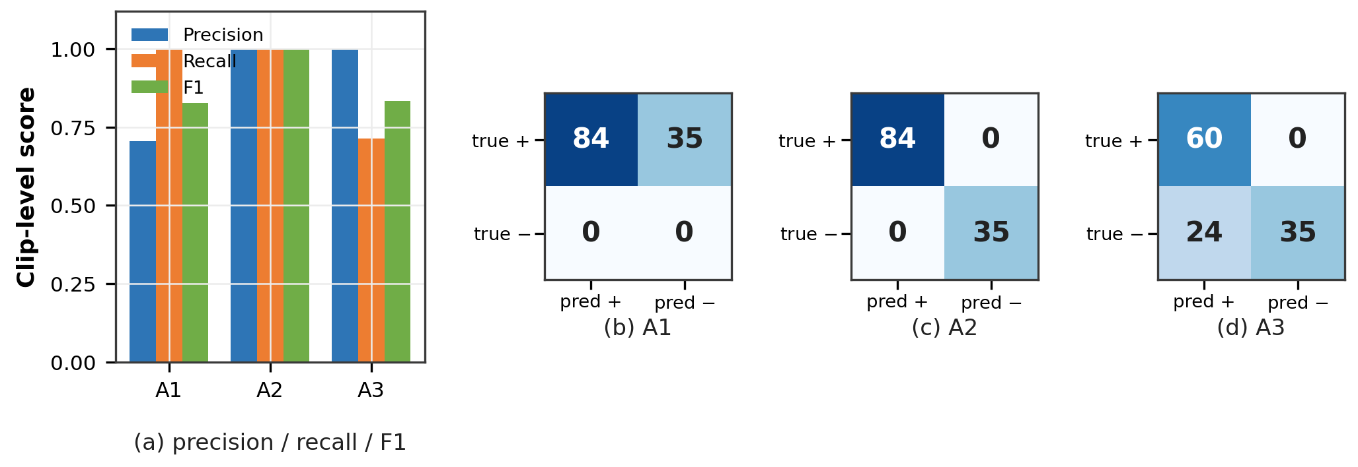
Figure 4. Clip-level results of the three arms. Left: precision, recall and F1. Right: confusion matrices (rows = true class). A1 confuses every normal clip with an abnormal one; A2 is diagonal; A3 trades sensitivity for the same zero false-alarm rate.
The time structure of the alarms is itself a check of the design. On the benchmark, the multiple-package rule—which carries no waiting threshold—fires as soon as the second package becomes visible (7.5–7.7 s into the clip), while the two rules that wait fire at latencies implied by their own thresholds: loitering at 15.0–15.3 s against its 15 s accumulation threshold, and door-left-open at 14.1–16.3 s where the 10 s threshold applies to the accumulated open time, consistent with (15). In retrieval-from-flagged clips the door alarm always precedes the retrieval alarm by 1.1–2.5 s (median 1.28 s), the delay between flagging the compartment and the package leaving it. A rule therefore does not fire at an arbitrary frame: its latency is the threshold it declares plus the detection delay, which is what makes the alarms auditable in time as well as in quantity.

6.2. A second, cross-scene rendered set
The benchmark above shares its scene generator with the pipeline’s calibration. The decisive test is transfer, so we rendered a second set with the same behavioural scripts but under a different camera pose and field of view (eye moved from $(2.35,1.92,−3.25)$ to $(1.05,2.30,−2.60)$, FOV ${48}^{∘}​→​{62}^{∘}$) and different illumination (key light re-aimed, intensity $0.78​→​0.60$, ambient $0.34​→​0.46$), and—the step that makes this a transfer test—re-calibrated the compartment polygons and pickup region for that view before evaluating, so the measurement tests the rules rather than a stale geometry. The set contains 20 clips (16 abnormal, four normal).
The door statistic transfers cleanly under the new view: on the re-calibrated cells the closed-state maximum is $0.024$ against an open-state minimum of $0.277$ (separation $+0.254$), with all six compartments correctly assigned and no false “open” reading at the deployed $η=0.15$. At the pipeline level the geometry- and state-machine-based rules transfer without per-scene tuning—door-left-open is detected on 8 of 8 expected clips, loitering on 4 of 4, and retrieval-from-flagged-compartment on 3 of 4—giving an event-level micro $P=1.000$, $R=0.750$, $F_{1}=0.857$; twelve of the sixteen abnormal clips are flagged and none of the four normal clips is false-alarmed (binary clip-level accuracy $0.800$), while 15 of the 20 clips are fully correct at the per-event level. This is the audit’s prediction, confirmed: the colour-collision audit of Section 7.3 singles out the package colour proxy as the component that will not transfer, and it is the only one that does not—the multiple-package rule rests on package colour rather than on geometry and fires on none of its four clips—while every geometry-anchored rule transfers with zero per-scene tuning (door-left-open 8/8, loitering 4/4, flagged retrieval 3/4). The calibration-first design therefore behaves as specified: the rules transfer exactly where their assumptions hold, and the assumption that breaks is the one the pre-deployment audit is built to test.

6.3. Detector benchmark on real images
The detector choice at the edge is a design decision, not a tuning detail: inference must share a CPU with the rest of the pipeline, so the smallest model of a current family is the natural candidate, and it must be checked on real photographs rather than rendered scenes. Both nano-scale generations clear the accuracy bar for this application, and the HOG fallback does not come close. On the 500-image COCO subset [26] (Table 6, Figure 5) YOLOv8n achieves AP@0.5 of 0.514 with a balanced operating point at the deployed confidence (P=0.896, R=0.525, F1=0.662); YOLO11n performs comparably in accuracy (AP@0.5 0.494, F1 0.646) at essentially the same CPU cost (median 26.9 ms versus 26.0 ms per image after a warm-up pass on an otherwise idle machine; CPU-only timings are load-sensitive, so the same measurement taken under concurrent load gave 28.4 ms and 66.5 ms respectively, which is why the idle figures are reported)—so at this CPU-only, smallest-scale operating point the two generations are interchangeable in both accuracy and cost. This is consistent with benchmark studies that report marginal accuracy differences between recent YOLO generations at the nano scale and attribute their differences mainly to training behaviour [21]. We therefore keep YOLOv8n as the default and report YOLO11n as a validated alternative. HOG trades accuracy for a zero-dependency runtime (AP@0.5 0.005, recall 0.019): its curve never leaves the leftmost 1.9% of the recall axis, whatever threshold it is given. That gap is the quantitative reason for the fallback positioning: HOG keeps the pipeline alive when the deep runtime is unavailable, and the experiments above show it does so without raising a single alarm on a normal clip.
Table 6. Detector benchmark on 500 COCO val2017 images containing persons (1670 ground-truth boxes). AP is average precision at IoU 0.5; P/R/F1 are at the operating confidence 0.35; inference time is the median per-image cost on the deployment machine after a warm-up pass on an otherwise idle machine.
Metric | YOLOv8n | YOLO11n | HOG + SVM
AP@0.5 | 0.5135 | 0.4942 | 0.0051
Precision@0.35 | 0.8957 | 0.8941 | 0.2581
Recall@0.35 | 0.5246 | 0.5054 | 0.0192
F1@0.35 | 0.6616 | 0.6458 | 0.0357
Median ms/image | 26.0 | 26.9 | 5.1
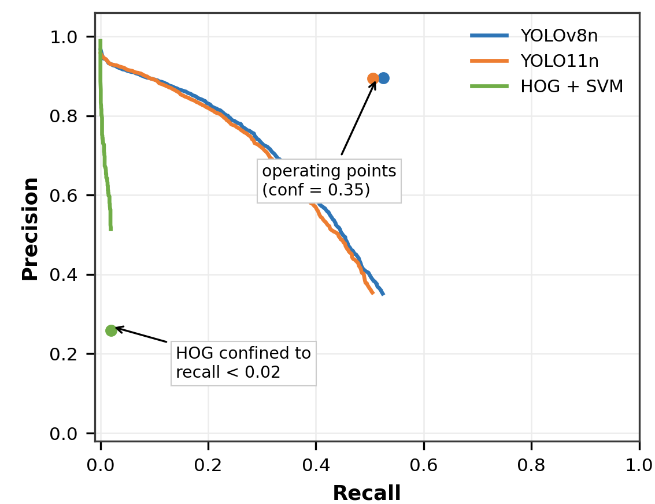
Figure 5. Precision–recall curves on the COCO subset. The HOG curve is confined to the leftmost 1.9% of the recall axis; YOLOv8n and YOLO11n track each other closely, with YOLOv8n holding a slight advantage at every operating point.

6.4. Real-time behaviour and the cost envelope
The budget question has a comfortable answer, and the cost structure behind it is the reason the calibration-first design is affordable on a CPU. On the synthetic footage (640$×$480 at 15 fps) both backends process every frame in real time ($≈$14.9 fps for display and detection); on real surveillance video (640$×$360 at 25 fps) the display loop runs at $≈$24 fps with either backend while detection is throttled only by the configured interval (Table 7). Figure 6 decomposes why: the detector alone accounts for about 24 ms (YOLOv8n) and 20 ms (HOG), whereas the complete observation step—package colours and per-compartment door estimation included—adds only a few milliseconds (27 ms and 22 ms totals). Everything downstream of detection is therefore nearly free, which is exactly the property that lets the rule and audit layers run beside inference; the frame budget of a 15 fps source is 66.7 ms, so the measured totals leave headroom for the console and the persistence layer running beside the pipeline.
Applying the cost model (19) to the measurements bounds the multi-view envelope: at $T_{det}+T_{obs}≈27$ ms per frame, a single machine sustains one 15–25 fps view comfortably but cannot serve three 25 fps views on one process within the 40 ms budget (three views would need $≈$81 ms). Scaling to several locker banks per machine therefore requires the geometric cascade discussed in Section 8 or one process per view sharing an event store—both compatible with the present design, neither implemented here.
Table 7. Real-time behaviour on CPU (fps). The real-surveillance rows use the configured detection interval (four frames for YOLOv8n, two for HOG).
Source | Backend | Display | Detection
640$×$480 @15 fps (synthetic) | YOLOv8n | 14.93 | 14.93
 | HOG | 14.89 | 14.91
640$×$360 @25 fps (real) | YOLOv8n | 24.27 | 7.70
 | HOG | 24.04 | 11.54
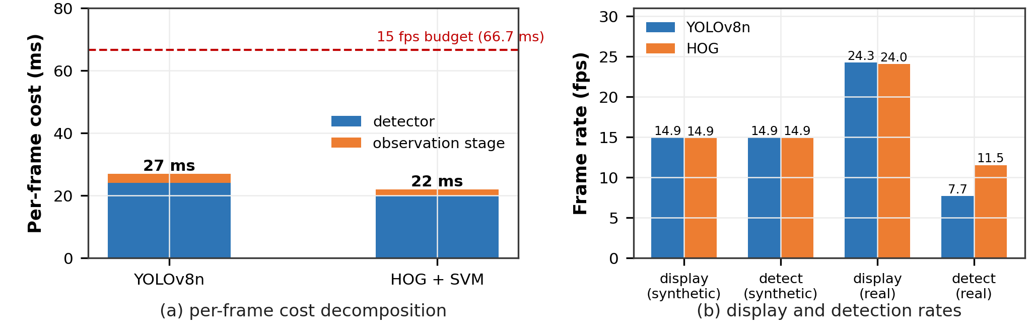
Figure 6. (a) Per-frame cost decomposition inside the processing process (640$×$480 frames, $n=40$): detector alone and the complete observation step, against the 66.7 ms frame budget of a 15 fps source; the HOG figure is measured with the deep-learning runtime resident in the same process, and standalone it costs 5.1 ms per image (Table 6). (b) measured display and detection rates for both backends on the synthetic and the real source, i.e. the measurements tabulated in Table 7.

6.5. Contribution of the failure-repair mechanisms
The ablation attributes the system’s robustness to one mechanism above all others (Table 8, Figure 7). Over a paired subset of 20 clips (four per behaviour class, four normal retrievals, one changed parameter per row), removing the re-association stage costs all four loitering events and turns four abnormal clips into misses (16 of 20 clips versus 12 of 20; Wilson 95% CIs 58.4–91.9% and 38.7–78.1%), while leaving the door-related and multiple-package classes untouched; the other three configurations are identical to the complete system. The mechanism behind the number is directly observable: a person standing motionless in front of a locker is missed by the detector for multi-second stretches, so without re-association the track is destroyed, its accumulated presence resets, and the 15 s accumulation threshold is never reached. Door events survive the same ablation because they depend on compartment appearance rather than track continuity—a deliberate property, and one reason the door channel is the system’s backbone.
Removing the occlusion look-back changes nothing on this subset; removing the partial-box guards leaves detection unchanged but admits one spurious loitering event, which the segment-level columns of Table 8 do not show. Both guards repair failure modes associated with sustained stationary presence, and the requirement analysis removed that class from the event vocabulary (a person waiting at a locker is normal); the remaining 119 clips therefore contain few instances that exercise them, so this ablation measures their cost rather than their benefit: on footage without these failure modes both guards can be disabled at zero cost, whereas re-association is load-bearing (20/20 with it, 16/20 without it, Table 8). The occlusion guard’s benefit is measured on real footage, where it turns a would-be misleading reading into an explicit abstention (Section 7.2).
Table 8. Ablation of the failure-repair mechanisms over 20 paired clips (segment-level counts; correctly detected events out of the 20 expected, and event-level false positives, which the segment columns conceal).
Configuration | Segment TP | Segment FP | Segment FN | Event TP | Event FP
Complete system | 16 | 0 | 0 | 20/20 | 0
w/o re-association | 12 | 0 | 4 | 16/20 | 0
w/o occlusion look-back | 16 | 0 | 0 | 20/20 | 0
w/o partial-box guards | 16 | 0 | 0 | 20/20 | 1
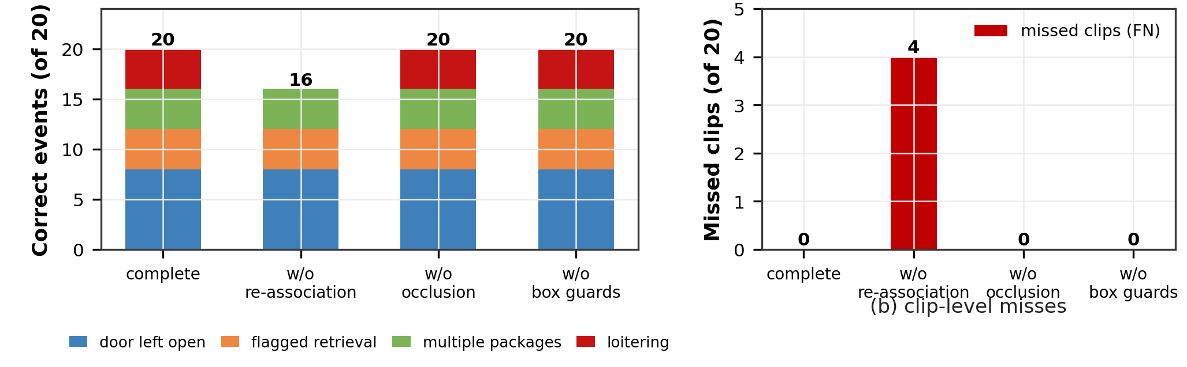
Figure 7. Ablation over 20 clips. Left: correctly detected events per class. Right: missed abnormal clips (FN) and false alarms (FP) at the clip level. Only the re-association stage changes clip-level detection on this subset; the partial-box guards add one event-level false positive, as discussed in the text.

6.6. Threshold sensitivity by analytic replay
The replay of the recorded timelines turns the main threshold question into a direct, derivable statement, and the answer is a usable range rather than a single value. Because the alarm conditions are thresholds rather than learned parameters, the behaviour of the 119 clips under any door-open threshold $τ′$ follows from their recorded timelines without re-running a single video, via (16)–(18); at the deployed value the replay reproduces the measured counts exactly (42/42 door-left-open, 21/21 retrieval-from-flagged), which is what makes its extrapolation a verification rather than a speculation (Table 9).
Table 9. Sensitivity to the door-open alarm threshold, obtained by replaying the recorded timelines of the 119 clips. The 10 s row reproduces the measured counts exactly.
$τ_{open}$ | Door left open | Flagged retrieval | Effect
5 s | 42/42 | 21/21 | earlier alarms only
10 s (default) | 42/42 | 21/21 | as measured
15 s | 42/42 | 0/21 | retrieval events lost
20 s | 0/42 | 0/21 | door events lost
Three regimes appear (Figure 8). Below the deployed value both event types keep recall 1.000: in the flagged clips the compartment remains open for 15.7–18.3 s (median 17.1 s), so a shorter threshold only reports earlier. At 15 s the door alarm still fires for every clip, but the retrieval-from-flagged event collapses to zero, because the package is taken 11.1–12.5 s after the door opens (median 11.3 s)—before the longer threshold would have flagged the compartment, exactly the ordering that event exists to catch. At 20 s the door alarm itself disappears, because no clip keeps a compartment open that long (maximum available duration 18.3 s). The usable range of $τ_{open}$ is therefore bounded from above by two measurable quantities of the site: how long compartments actually stand open, and how quickly people collect from an unclosed one. Concretely, full recall of both event types requires $τ_{open}≤11.1$ s (the earliest recorded retrieval instant); any threshold above 12.5 s retains the door alarm for every clip but no retrieval-from-flagged event, and above 18.3 s the door alarm disappears as well. Because each class contributes only 21 or 42 events, a 0/21 outcome excludes recall above 15.5% at 95% confidence rather than establishing it at zero, so these boundaries are located to that resolution. Both are observable during deployment, and the recorded distributions are the kind of evidence an administrator should collect before re-tuning this threshold. The same mechanism–replay rather than re-run–applies to the other rule parameters, since their events are equally grounded in recorded observable quantities.
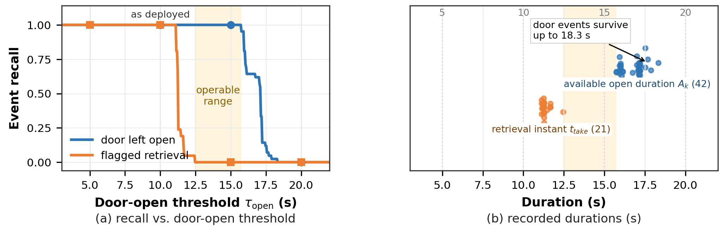
Figure 8. Sensitivity to the door-open alarm threshold. Left: recall of the two door-derived event types as a function of the threshold. Right: distribution of the available open duration across the 42 door events, with the candidate thresholds marked; the gap between the flagged-retrieval instants (11.1–12.5 s) and the door availability (15.7–18.3 s) is a band (12.5–15.7 s) in which the door alarm still fires for every clip but no retrieval-from-flagged event survives; full recall of both requires $τ_{open}≤11.1$ s.

6.7. Long-run behaviour on real, uncalibrated footage
Running the complete pipeline over all 15 328 frames of the Avenue sequences probes the behaviour on real imagery with no relation to the locker geometry (Figure 9). With YOLOv8n the run sustained 28.6 fps at a median inference cost of 33.0 ms, completed 535 s of continuous processing, and never produced a frame without a detection (0 of 15 328 frames; Wilson 95% upper bound 0.03%); the overall mean is 8.13 persons per frame. The more instructive number is how often events occurred: in 535 s of real footage the uncalibrated geometry produced 19 alarm events—approximately one alarm every 28 s—all of them from the door-derived classes, which is the direct consequence of a polygon that does not correspond to a compartment sitting over arbitrary dark image content and crossing the dark-ratio threshold intermittently. An uncalibrated deployment would therefore emit a continuous stream of door-derived alarms, not because detection fails but because the geometric rules lose their meaning. This is a design boundary, expressed in the currency an operator cares about (alarms per minute), and it is why the system exposes no uncalibrated operating mode. With HOG the same run produces a comparable event count through an entirely different failure mode—18 events with essentially no persons detected—which shows that the geometric channel and the person channel fail independently.
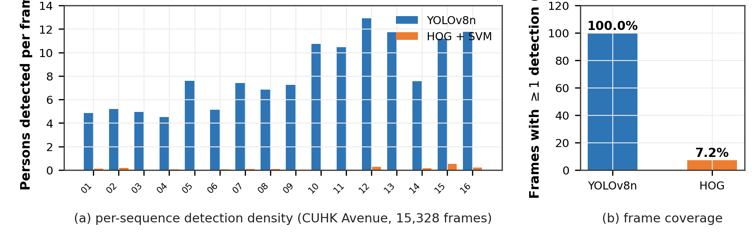
Figure 9. Long-run behaviour on uncalibrated real footage (CUHK Avenue; (15 328 frames, uncalibrated). Left: persons detected per frame for each of the 16 sequences (YOLOv8n; HOG never exceeds 0.53 persons per frame). Right: share of frames containing at least one detection (100% versus 7.2%).

7. Field-Footage Study
The controlled experiments establish that the pipeline is correct under same-distribution conditions and that its thresholds behave as declared. Neither question—does the system work when the scene is not the one it was calibrated on, and what does it take to make an unfamiliar site work—can be answered on rendered data by construction. This section therefore reports the field study on the 15 recordings of Section 5.5, in three parts: the behaviour of the uncalibrated configuration (Section 7.1), a validated door event on real footage (Section 7.2), and the two audits that predict and repair the observed failures (Section 7.3).
The field recordings carry no frame-level ground truth; results in this section are therefore measured system behaviour, supported by manual verification of specific episodes and frames rather than precision/recall against labels. Every claim below is bounded to what the footage can support, and the failure attributions were verified by inspecting the evidence snapshots the system stores with every event.

7.1. Uncalibrated transfer: what an unconfigured deployment does
The complete pipeline is run over each recording with the factory-default configuration (i.e., the compartment grid and pickup polygon of the rendered benchmark, which correspond to no real site). Over the corpus, the uncalibrated configuration emits 261 events in 1145 s—197 alarms and 64 informational events, i.e. one alarm every 5.8 s and one event every 4.4 s (Table 3, last column; Figure 10, left). The distribution across recordings is itself informative. The vendor demo with no people (v12) produces zero events, as it should. The static campus bank (v04) produces 48, the two courier-deposit recordings (v01, v03) produce 20 and 74, and the TV report (v11) produces 44. Three failure mechanisms account for the majority of these alarms, and each was verified by inspecting the stored snapshots:
- Geometric mismatch. The default compartment polygons land on arbitrary scene content—in one snapshot they cover a person’s torso, in another the centre of a real locker bank with no relation to its actual doors (Figure 10, right). Since the dark-ratio statistic is meaningful only for a region that is actually a door, these polygons cross the threshold intermittently; 77 of the 261 events are door-derived and trace to this mechanism (10 door-left-open events in v03, 11 in v04, 7 in v11, and so on).
- Colour collision. The multiple-package rule misfires on warm-toned apparel—in one snapshot the person’s saturated yellow T-shirt is fragmented into package-coloured blobs inside his own box, producing a spurious “carrying 4 packages” event. 146 of the 261 events are of this class.
- Scenario mismatch. Courier-deposit recordings legitimately contain people carrying many packages; a rule tuned for self-service retrieval reads normal courier work as an alarm even when the colour evidence is correct. This contributes to the same 146, and recalibration does not address it: it is a vocabulary mismatch between courier deposit and self-service retrieval, resolved by configuration rather than by geometry (Section 8).
These events are not noise but a measured boundary: uncalibrated, the pipeline emits one event every 4.4 s, and every event traces to one of three mechanisms that the pre-deployment audit detects in advance. The Avenue result (Section 6.7, one alarm per 28 s) anticipated the first mechanism; on content dominated by lockers and users the rate rises to one event every 4.4 s and the corpus identifies the other two mechanisms, which is exactly the material the audit of Section 7.3 turns into an installation procedure.
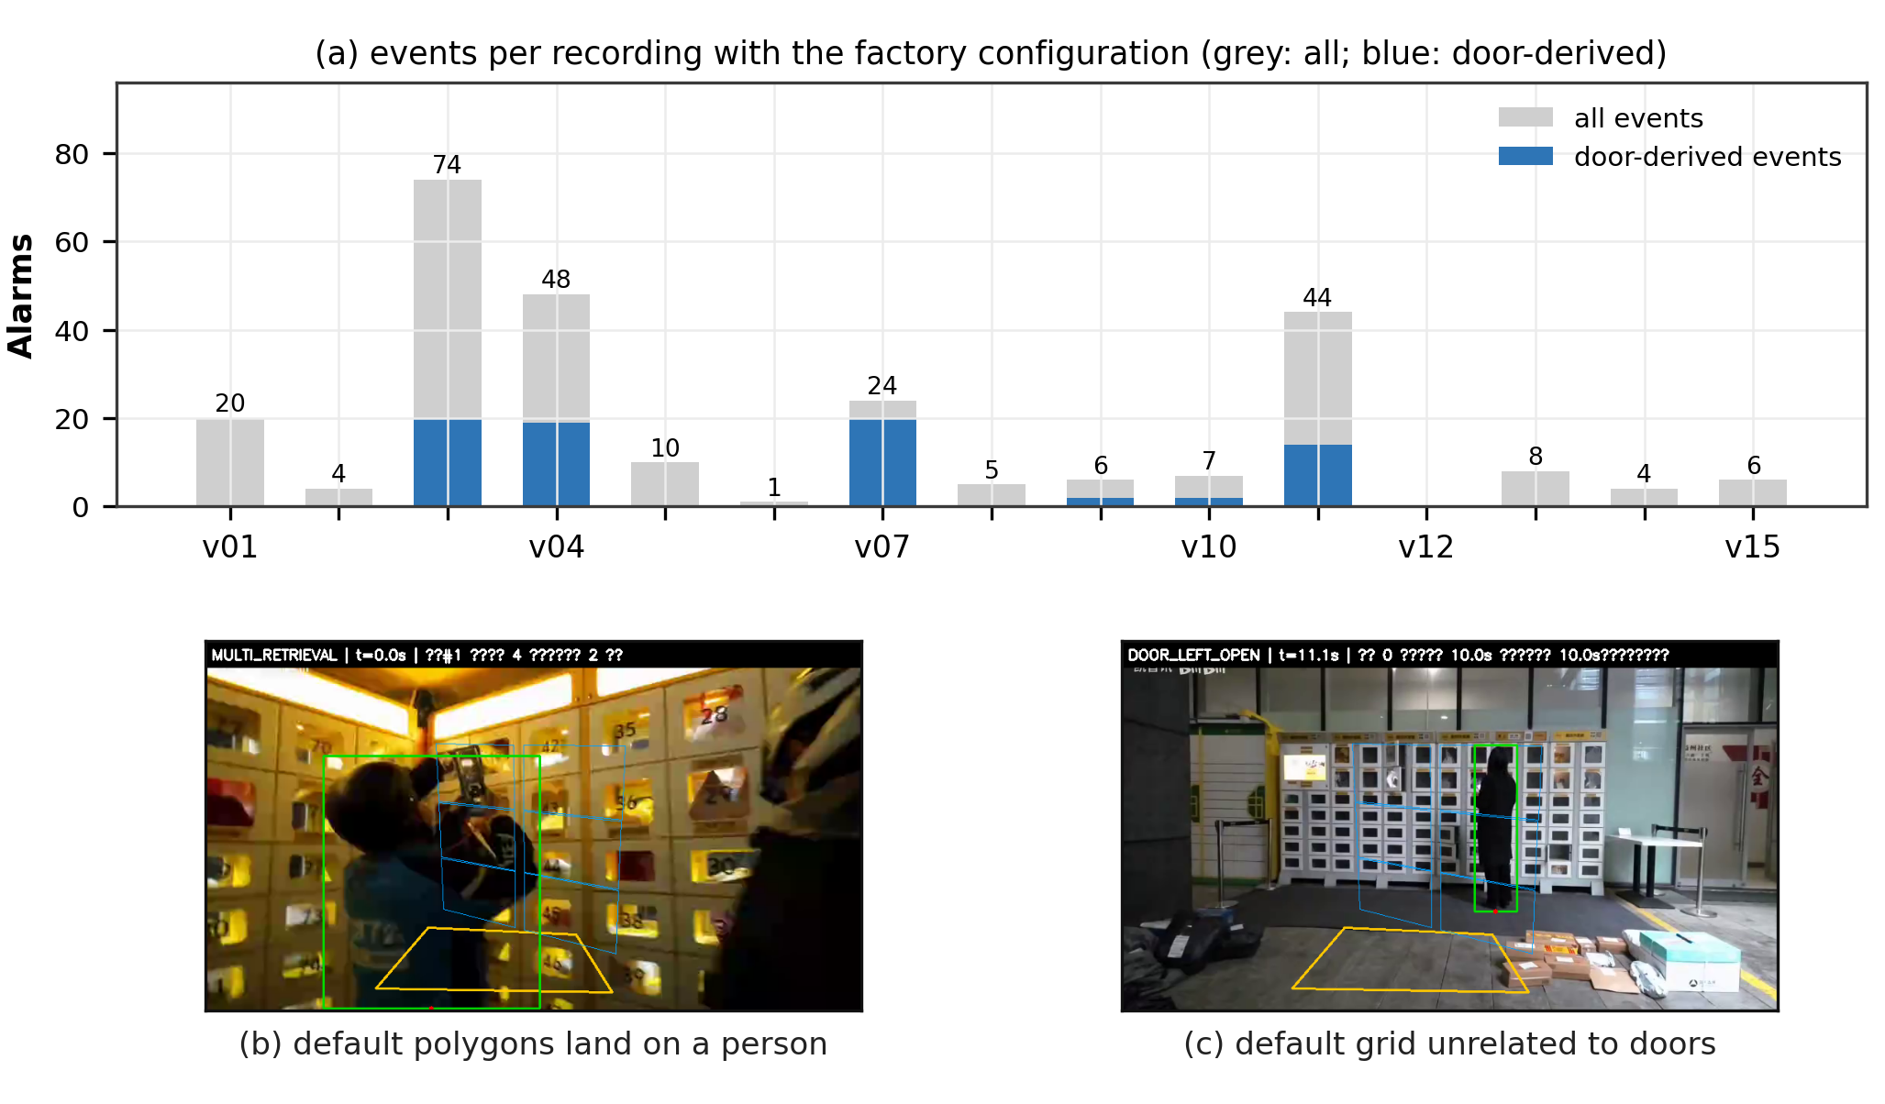
Figure 10. Uncalibrated transfer on the field corpus. Left: events emitted per recording by the factory-default configuration (grey: all events; darker bars: door-derived events), against the recording duration on the secondary axis; v12 (no persons) is the control at zero. Right: two evidence snapshots—the default polygons landing on a person’s torso (courier close-up) and on the centre of a real locker bank with no relation to its doors.

7.2. A real door-left-open episode, measured by the system’s own statistic
Among the recordings is a public-service clip whose subject is precisely the operational problem this paper addresses: a Fengchao express-locker user retrieves a parcel and walks away without closing the compartment. The episode is unambiguous and occupies a camera-stable interval (median motion 0.2–1.3 px/frame between 6.2 and 24 s); the door stands open for at least 5 s—the camera settles with the door already open, and a subsequent user closes it at $≈$11.3 s. It therefore provides a rare opportunity: a real open door, on a real locker, in footage the system has never seen.
Four compartment-sized regions are defined by hand on this clip—the open compartment ($k^{*}$) and three neighbouring compartments used as controls—and the system’s own statistic (12)–(13) is evaluated over 6–21 s (sampled every 0.2 s) with the deployed parameters ($κ=0.62$, $η=0.15$). The result (Figure 11) is a clean separation. While the door stands open (6.3–9.2 s), the compartment reads $r_{k^{*}}=0.939$ on average with range $[0.935,0.960]$ across the 13 unoccluded samples (standard deviation 0.007; 95% CI of the mean 0.934–0.943), while the three controls read 0.006, 0.011 and 0.030 (maxima 0.007, 0.013 and 0.031): every control sample stays below the 0.15 threshold, and the open compartment exceeds it by a factor of six. During the closing interaction (9.4–13.0 s) the arriving user’s body covers more than half of the compartment in 18 of 19 samples (95% CI 75.4–99.1%); the estimator reports the state as undecidable and holds it, exactly as the visibility policy prescribes, rather than sampling a partially blocked region. After the correction—door closed, user gone (13.5–21 s)—the same region reads 0.027 on average (range $0.000$–$0.040$), a factor of roughly 35 below the open state and far under threshold, and the controls remain at or below 0.11 throughout. The statistic therefore separates the three situations the state machine must distinguish—open, closed, and undecidable—on real hardware, with the deployed parameters and without any per-clip tuning.
Two readings matter here. First, the failure boundary established in Section 6.7 is a boundary of geometry, not of the metric: given regions that actually correspond to doors, the darkness-ratio statistic transfers to real hardware (a real locker with dark viewing windows, under artificial light) without any parameter change, with margins an order of magnitude wider than the threshold. Second, the episode’s duration (at least 5 s) is below the deployed 10 s alarm threshold, and the replay of Section 6.6 already tells us what that means: at $τ_{open}=5$ s this compartment would have been flagged promptly; at 10 s it would not have alarmed at all had the arriving user been a little earlier. The field episode therefore also calibrates intuition about $τ_{open}$ for real user behaviour—open doors here last seconds, not the 15–18 s of our rendered clips—which is part of why the threshold-audit replay is offered as a deployment tool rather than a fixed recommendation.
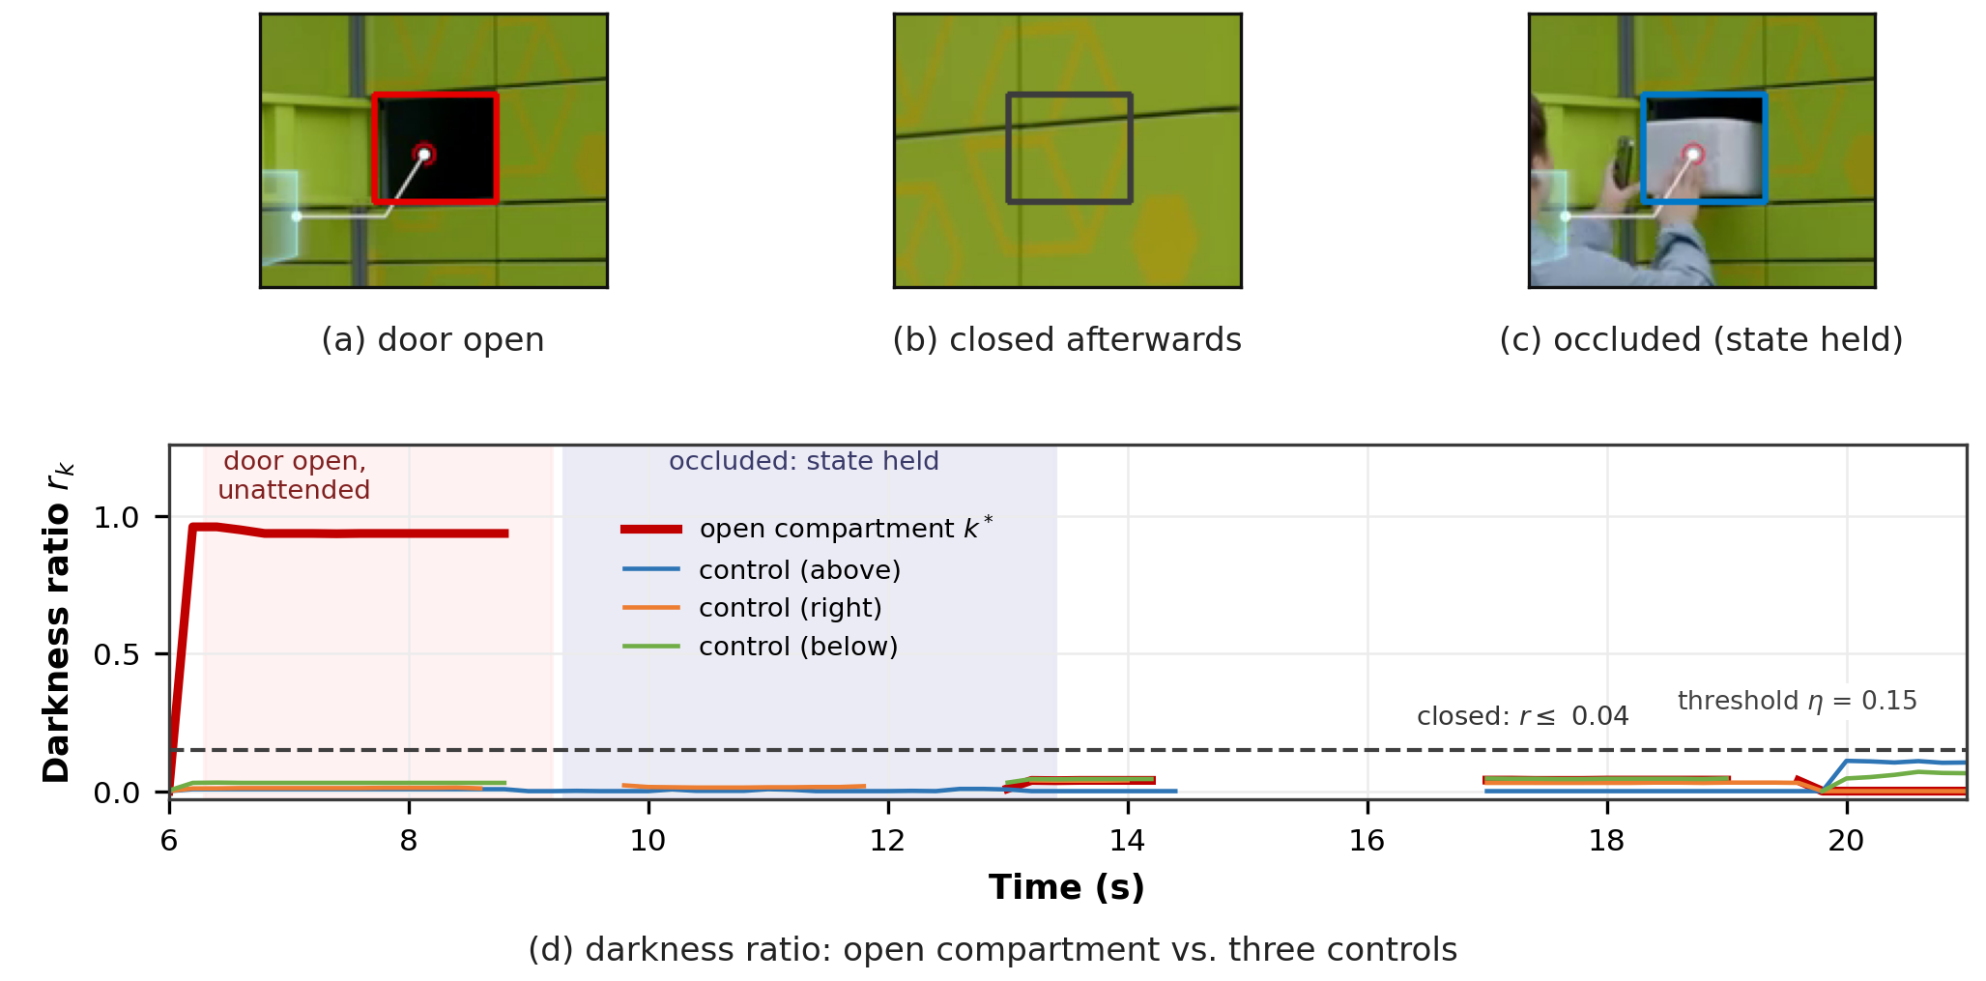
Figure 11. The door statistic on a real open-door episode. Top: three frames of the episode (door open; closed after the correction; the arriving user occluding the compartment), with the calibrated region of the open compartment ($k^{*}$) outlined. Bottom: the darkness ratio $r_{k}$ for the open compartment and three controls over 6–21 s; the red shading marks the interval in which the door stands open, the blue shading the interval in which the compartment is occluded by the arriving user and the state is held, and the dashed line is the threshold $η=0.15$. The open compartment exceeds the threshold throughout; every control sample stays below it.

7.3. Pre-deployment audits
The field findings convert into two audits that run before alarms are enabled, and which we now define, measure on the corpus, and validate.

7.3.1. Geometric audit
The geometric audit is a coverage check during calibration: every compartment polygon is overlaid on the reference frame, and the operator confirms (i) that each polygon contains a door and fits it within a small tolerance, (ii) that the union of polygons covers the locker front, and (iii) that the pickup polygon lies on the ground area in front of the bank. The verification overlay is the same rendering used by the calibration tool (Figure 3, right). The failure it prevents is exactly the first mechanism of Section 7.1: polygons that do not correspond to doors. Because the check is visual and the calibration is one-time, its cost is minutes per site.

7.3.2. Door-appearance audit and threshold recalibration
The door statistic’s second assumption—that a closed door is a bright, reflective surface—does not hold universally. The static campus bank of the corpus (v04, KaiPuxun-brand lockers) has doors with large smoked-glass viewing windows: the “closed” appearance already contains substantial dark area. Applying the audit to this site, we fit twelve compartment cells on the static view, mask out person boxes as the system does, and measure $r_{k}$ over 1152 samples across 240 s. The baseline distribution has median 0.292 and $p_{90}=0.328$—above the default threshold $η=0.15$, which would classify 98.6% of all samples as “open” (1136 of 1152; Wilson 95% CI 97.8–99.1%) on a locker whose doors are overwhelmingly closed. Recalibrating per site is straightforward because both modes are measurable: the audit scans candidate thresholds and reports the fraction of samples classified “open”, giving 0.5% at $η=0.45$ and 0.3% for $η∈[0.55,0.75]$ (Figure 12, right). Combined with the open-state reading of 0.94 measured on the episode of Section 7.2, this places the safe range for this hardware at $η′∈[0.45,0.75]$—below the open mode by at least $0.19$, above the closed $p_{90}$ by at least $0.12$. The audit output is therefore a per-site threshold recommendation with measured margins, and it costs one pass over a sample of footage. This is the field counterpart of the Chernoff argument (14): on lockers with dark doors the closed-state dark probability $ε_{c}$ must be measured, not assumed.
The recommendation was closed in a loop. We re-ran the complete pipeline on v04—the site the audit targets—in three configurations over its full 240 s. With the factory-default geometry and threshold it emits 19 door-derived events (6 DOOR_CLOSED, 11 DOOR_LEFT_OPEN, 2 FLAGGED_DOOR_RETRIEVAL). Substituting the audited compartment geometry but keeping the default threshold $η=0.15$ leaves the misfire in place—20 door-derived events—because the recalibrated cells correctly measure the smoked-glass appearance while the unchanged threshold still calls it “open”; this isolates the threshold, rather than the geometry, as the operative defect at this site. Applying the audit’s recommended value with the same audited geometry ($η′=0.55$) removes every door-derived event (19$→$0). The audit is therefore not only diagnostic: its output, applied as a configuration change, measurably repairs the failure it predicts, and the events that remain on this site (43 in total) are the non-door, vocabulary-limited classes discussed in Section 8, not door misfires.

7.3.3. Colour-collision audit
The colour-collision audit quantifies the risk behind the second failure mechanism before it fires. For a sample of frames (here 1 frame per second), the audit runs person detection and asks, for every person box, how many package-coloured blobs appear inside it; a frame in which any person box contains at least two such blobs is a collision frame—the exact condition under which the multiple-package rule can misfire without any door or geometry involvement. Over the corpus, 289 of 1020 person-frames (28.3%; Wilson 95% CI 25.7–31.2%) are collision frames, with a per-site spread from 6.9% (v04: 335 person-frames, 95% CI 4.6–10.1%) to 66.7% (v14: six person-frames, 95% CI 30–90%); the snapshot evidence above shows the mechanism concretely. The audit does not automatically decide that a site is bad: a collision frame may contain a person genuinely carrying warm-coloured packages (as couriers do). What it provides is a triage: sites with a low collision rate (v04’s 6.9%, v06’s 11.1%) can enable the multiple-package rule as-is; sites above about a quarter (Figure 12, left; v01, v05, v10, v13 and v14 exceed 45%) should either restrict the rule’s domain (courier-vs-user discrimination, or hand-region gating) or keep it in a report-only mode until the colour model is adapted to the site. The audit runs in under a minute of video per site and requires no calibration.
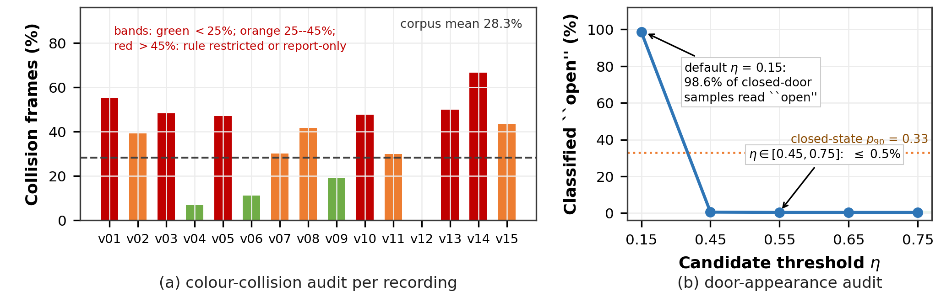
Figure 12. Pre-deployment audits. Left: colour-collision rate per recording (fraction of person-frames whose person boxes contain at least two package-coloured blobs); the corpus mean is 28.3%. Right: door-appearance audit on the smoked-glass locker (v04): fraction of samples classified “open” as a function of the candidate threshold $η$; the default 0.15 misclassifies 98.6% of closed-door samples, while $η∈[0.45,0.75]$ leaves at most 0.5%, with the open-state level (0.94, from the validated episode) far above.

7.3.4. Detector sanity check on field footage
As a final check that the perception front end survives the domain shift, person detection was run on one frame per recording at 55% duration. On every wide shot containing people the detected boxes matched the visible persons (e.g., three persons at the static campus site; single users at five further sites; two couriers at the deposit scenes), and no detection was produced on person-free frames or title cards. Several recordings have no person in the sampled frame (B-roll, screen close-ups), so this is reported as a qualitative sanity check rather than a recall measurement; the numerical detector evidence for the domain shift remains the COCO benchmark (Section 6.3) and the Avenue run (Section 6.7), both of which the field check is consistent with.

8. Discussion

8.1. What each class of evidence supports
The experiments fall into four classes, and each supports a different kind of claim.
Correctness under same-distribution conditions (Sections 6.1–6.4). The rendered benchmark is produced by the same scene generator and uses the same calibrated geometry as the deployed pipeline. The resulting scores verify that the implementation executes the specified decision procedure, that the guards repair the failure modes they were designed for, and that the declared thresholds behave as their definitions require—including the predicted alarm latencies. Generalization is tested by the cross-scene set of Section 6.2—re-rendered under a different camera and illumination with the geometry re-calibrated for that view—which removes the self-consistency and shows which components carry over.
Parameter sensitivity (Section 6.6). Replaying recorded timelines under alternative thresholds shows how far the principal threshold can move before alarm behaviour changes, and locates the two observable quantities that bound it. This is evidence about the method’s parameters: their usable range is measurable per site, at zero experimental cost.
Failure boundaries (Sections 6.7 and 7). On real footage with no calibration, the detector keeps working and the geometric rules do not—one alarm per 28 s on Avenue, and one event per 4.4 s (197 alarms over 1145 s) on locker-dominated content—and the field evidence identifies the three mechanisms behind those numbers. This is the evidence that calibration is load-bearing rather than convenient.
Transfer of the validated components (Section 7). The door statistic’s transfer is established positively on a real episode with measured margins (0.94 versus 0.15, controls $≤0.11$ over the whole window and $≤0.031$ while the door stood open), and its per-site prerequisite ($ε_{c}$) is turned into a measured audit. The colour-collision audit similarly converts a failure mechanism into a measurable deployment-time quantity. What transfers are the metrics and their audits; what must be redone per site are the geometry and, on non-reflective doors, the threshold.

8.2. When should a deployment choose rules, and when learning?
The discussion in Section 2 framed rule-based and learned anomaly detection as ends of a trade-off rather than competitors. The measurements in this paper let that trade-off be stated operationally. A rule-based pipeline is preferable when (i) the alarm vocabulary is enumerable in advance—the operational concerns of a managed facility usually are; (ii) alarms must be attributed and audited (which door, which quantity, which threshold), because responsibility attribution at the facility is a first-class requirement rather than a forensic afterthought; (iii) the compute budget excludes server-side models; and (iv) the site geometry is stable, because the whole design turns stability into calibration. Learned anomaly detection is preferable when the vocabulary cannot be enumerated, when anomalies are defined by deviation from a data distribution rather than by operational states, or when enough labelled or normal-only data exists to train and the hardware budget permits. The two can coexist: the per-compartment state-machine interface of this system is deliberately shaped so that a learned classifier could replace any single predicate while keeping the audit chain—an obvious next step, and one the ablation of Section 6.5 would immediately police. What this paper adds to that discussion is the cost side of the ledger: the calibration, the audits and the threshold replays that make the rule-based side deployable are themselves measurable and cheap, and they are what an operator must do anyway to explain to users what the system will and will not detect.

8.3. Positioning against existing rule-based and edge monitoring
The contribution of this paper is easiest to state against the three bodies of work it is closest to. Rule-based video-surveillance systems such as iSurveillance [15] compose operator-defined spatial rules—tripwires, region entry, dwell—and are, like this pipeline, interpretable by construction; their rules are, however, specified by hand per camera and evaluated largely qualitatively, so neither the usable range of a rule’s parameters nor its site-to-site failure boundary is itself a measured quantity. Locker- and retail-monitoring studies [12,13] analyse door and shelf interactions but report behaviour statistics rather than an actionable alarm contract. Learned edge VAD (Section 2) scores deviation from a normality model and can fit constrained hardware, but its output is a score, not an event attributed to a compartment or a person. What is specific here is deliberately none of those: not a new detector and not a new rule type, but the decomposition of an enumerable alarm vocabulary into calibrated geometric regions, named thresholds and per-compartment state machines; the treatment of pre-deployment audits as first-class measurements that predict, before alarms are enabled, which rules will misfire at a given site; and the replay of recorded timelines to bound each threshold without re-runs. The field study adds the measurement these approaches usually omit—how far the default configuration is from usable on footage the system has never seen—and converts it into an installation procedure. Our claim is that the operator is calibrated, auditable and bounded—and that the bounds are measurable quantities rather than assumptions.

8.4. Back to the large picture: supervision for unattended infrastructure
The introduction framed the problem broadly: unattended delivery infrastructure is becoming public infrastructure, and its supervision is currently reactive. The present study is one instance, but the measured principles generalize to the class. First, calibration-first is a viable alternative to train-first for facilities with fixed geometry: a one-time geometric calibration plus measured audits replaces the data appetite of learned approaches, and the failure boundary it carries (Section 6.7) is sharp, predictable, and testable at installation. Second, alarm auditability is an achievable and useful property, not a philosophical one: every event in this system names a compartment, a quantity and a threshold, and the system stores the evidence snapshot; the same discipline applies to any state-based anomaly vocabulary for lockers, vending machines, or self-service kiosks. Third, audits before alarms generalize: the geometric and colour checks run here in minutes per site and prevent the dominant failure modes at their root. Fourth, the limits generalize too: appearance-based proxies (colour, darkness) are domain-dependent and must be measured per site; anything requiring individual identification is out of scope for a privacy-preserving, appearance-only system—and should remain so. For the operator of a multi-site network, the natural rollout is therefore: calibrate, audit, run in report-only mode for a soak period, then enable alarms after replaying thresholds on the site’s own footage—a workflow this paper supports tool-by-tool rather than as a slogan.

8.5. Scaling, cost and privacy, closed
The cost model (19) and the measurements of Section 6.4 bound a single machine at one 15–25 fps view comfortably, with the observation stage nearly free compared with detection. Serving several lockers per machine requires either a geometric cascade—keeping the cheap per-compartment estimator on every view and running deep detection only on views whose door state changed—or one process per view sharing an event store; both are compatible with the present interfaces and neither is implemented here, so the claim we make is the measured envelope, not a plan. On privacy, the design is conservative by construction: all processing is local, every event stores a snapshot, and no face recognition or identity inference exists anywhere in the pipeline; the field corpus was used strictly as input footage, with aggregate statistics and a handful of frames reported. Any deployment should still be transparent to the facility’s users about the existence and purpose of the monitoring—the survey numbers of Section 1 suggest users support supervision that is non-intrusive, which is an obligation as much as an opportunity.

8.6. Scope of the evidence
Each experiment above establishes a specific kind of claim; this section states where that claim ends and what a deployment must therefore measure for itself. The same-distribution scores of Section 6.1 verify the pipeline; the cross-scene set of Section 6.2 removes that self-consistency and shows an event-level $F_{1}$ of 0.857, with the colour-proxy rule the only component that fails. The field study characterises 15 recordings from six real installations rather than a live deployment: the recordings carry no frame-level ground truth, so what it establishes is measured system behaviour, together with the audit loop of Section 7.3, which is closed at the event-count level on a single site (v04) and is designed to be repeated per site. Calibrated end-to-end precision and recall require annotated field footage from a live installation; to make that measurement reproducible we release the annotation and scoring tooling together with the recorded event timelines, and report measured system behaviour and individually verified episodes in the meantime. Every rate we report carries a Wilson interval, and on the low-count sites those intervals are wide by construction—v14’s 66.7% rests on six person-frames (95% CI 30–90%). Our comparison against learned anomaly detection is analytic (Section 8) and is made on the deployment constraints—attribution, auditability and compute—rather than on an accuracy contest. The per-predicate interface is shaped so that a learned classifier can replace any single rule while the audit chain is preserved, an upgrade path that the ablation of Section 6.5 would immediately police. All timings are single-machine, single-run measurements on one CPU, with the load comparisons of Section 6.4 as the sensitivity control.
Two properties bound where the rules apply, and both are measured per site rather than assumed. The door statistic is a binary appearance proxy: on non-reflective doors it uses the measured recalibration demonstrated in Section 7.3, and on doors visually unlike either hardware example the audit is run rather than assumed. The package colour proxy is tuned to the target domain’s warm-toned containers and is guarded by the collision audit; another packaging culture re-measures it. Finally, the courier-versus-user ambiguity noted in Section 7.1 is a vocabulary boundary rather than a perception failure, and the deployment resolves it by configuration (e.g., shift-based courier modelling).

9. Conclusions
This paper developed and evaluated an auditable anomaly detection layer for unattended delivery lockers under a CPU-only, open-source, fully local budget. The system estimates the state of every compartment from calibrated image regions, tracks users with explicit guards against measured detector failure modes, and raises six event types through per-compartment rules whose every threshold is a named, documented parameter; each alarm therefore names a compartment, a measured quantity and a threshold, and can be audited after the fact. Correctness under same-distribution conditions is established on a 119-clip benchmark (perfect clip- and event-level scores on the rendered benchmark), the mechanism contributions are isolated by a paired ablation, and the door threshold’s usable range is bounded by an analytic replay that reproduces measured counts exactly and requires no re-runs. The field study completes the picture on the other side of the boundary: the pipeline has no uncalibrated operating mode, and the field corpus quantifies why—261 events over 1145 s of real locker footage, 197 of them alarms, one event every 4.4 s, in three mechanisms the pre-deployment audits detect in advance—while a real door-left-open episode is detected by the system’s own statistic with wide margins (0.94 versus a 0.15 threshold, controls below 0.04 during the episode), and the two pre-deployment audits—geometric coverage, and door-appearance plus colour-collision measurement—convert those findings into an installation-time procedure with measured outputs. The transferable parts of the work are the calibration-to-rules decomposition, the audit-before-alarms discipline, and the parameter replay; the parts that must be redone per site are exactly the parts the audits measure.
For an operator the practical reading is narrow and deliberate: run the audit, calibrate, soak in report-only mode, replay the thresholds against the site’s own footage, and only then let the system alarm—and expect each alarm it does raise to be checkable against a stored snapshot and a named threshold. For a researcher, the open frontier this study leaves is the courier-versus-user vocabulary and the learned-per-predicate upgrade path, both of which the present interface was designed to accommodate.
Author Contributions: The author is the sole contributor to this work: conceptualization, methodology, software, validation, formal analysis, investigation, resources, data curation, writing—original draft preparation, writing—review and editing, visualization, supervision, project administration, and funding acquisition. The author has read and agreed to the published version of the manuscript.
Funding: This work was supported by the Undergraduate Innovation and Entrepreneurship Training Program of Northeast Forestry University (project number to be assigned upon provincial-level approval).
Institutional Review Board Statement: Not applicable. This study did not involve humans or animals; all analyzed video material consists of publicly available recordings and programmatically generated synthetic data.
Informed Consent Statement: Not applicable.
Data Availability Statement: The rendered behaviour benchmark is produced programmatically by the scene-generation scripts of the project and can be regenerated from the released code; the COCO val2017 dataset and the CUHK Avenue dataset are publicly available from their original distributors. The field recordings analyzed in Section 7 are publicly available videos published on video-sharing platforms; the evaluation logs record each recording’s published title, and the recordings are used as inputs for analysis only and are not redistributed. The complete system—source code, configuration files, the geometric and door-appearance calibration tools, the pre-deployment audit tools, the experiment drivers and the evaluation scripts—together with the evaluation logs (logs/*.json) from which the numbers in this paper are derived, is openly available at https://github.com/LuoluoKing/locker-audit-vision. The scripts that regenerate the field-study measurements are tools/analyze_field_videos.py (corpus survey), tools/eval_field.py (per-recording event timelines), tools/field_color_audit.py (colour-collision audit), tools/field_door_probe.py and tools/field_study.py (door-state and compartment dark-ratio time series), and tools/analytic_threshold_sensitivity.py (threshold replay).
Acknowledgments: The author thanks the campus users who participated in the questionnaire reported in Section 5. During the preparation of this manuscript, the author used an AI-based assistant (WorkBuddy, based on a large language model) for LaTeX typesetting assistance, code generation for the evaluation scripts, and language editing; the author has reviewed and edited all outputs and takes full responsibility for the content of this publication.
Conflicts of Interest: The author declares no conflicts of interest.

Abbreviations
The following abbreviations are used in this manuscript:
CPU | Central processing unit
COCO | Common Objects in Context (dataset)
HOG | Histogram of oriented gradients
HSV | Hue, saturation, value (colour space)
IoU | Intersection over union
AP | Average precision
SVM | Support vector machine

References
- 1. Lai, P.L.; Jang, H.; Fang, M.; Peng, K. Determinants of Customer Satisfaction with Parcel Locker Services in Last-Mile Logistics. The Asian Journal of Shipping and Logistics 2021, 38, 25–30. https://doi.org/10.1016/j.ajsl.2021.11.002.
- 2. Li, Z.; Li, B. The Data-Driven Optimization of Parcel Locker Locations in a Transit Co-Modal System with Ride-Pooling Last-Mile Delivery. Applied Sciences 2025, 15, 5217. https://doi.org/ 10.3390/app15095217.
- 3. Lu, C.; Shi, J.; Jia, J. Abnormal Event Detection at 150 FPS in MATLAB. In Proceedings of the Proceedings of the IEEE International Conference on Computer Vision (ICCV), 2013, pp. 2720–2727. https://doi.org/10.1109/ICCV.2013.338.
- 4. Pantano, E.; Timmermans, H. What is Smart for Retailing? Procedia Environmental Sciences 2014, 22, 101–107. https://doi.org/10.1016/j.proenv.2014.11.010.
- 5. Shi, W.; Cao, J.; Zhang, Q.; Li, Y.; Xu, L. Edge Computing: Vision and Challenges. IEEE Internet of Things Journal 2016, 3, 637–646. https://doi.org/10.1109/JIOT.2016.2579198.
- 6. Ribariˇc, S.; Ariyaeeinia, A.M.; Paveši´c, N. De-identification for Privacy Protection in Multimedia Content: A Survey. Signal Processing: Image Communication 2016, 47, 131–151. https://doi.org/ 10.1016/j.image.2016.05.020.
- 7. Duong, H.T.; Le, V.T.; Hoang, V.T. Deep Learning-Based Anomaly Detection in Video Surveillance: A Survey. Sensors 2023, 23, 5024. https://doi.org/10.3390/s23115024.
- 8. Zhong, Y.; Zhu, R.; Yan, G.; Gan, P.; Shen, X.; Zhu, D. Inter-Clip Feature Similarity Based Weakly Supervised Video Anomaly Detection via Multi-Scale Temporal MLP. IEEE Transactions on Circuits and Systems for Video Technology 2025, 35, 1961–1970. https://doi.org/10.1109/TCSVT. 2024.3482414.
- 9. Xu, C.; Xu, K.; Jiang, X.; Sun, T. PLOVAD: Prompting Vision-Language Models for Open Vocabulary Video Anomaly Detection. IEEE Transactions on Circuits and Systems for Video Technology 2025, 35, 5925–5938. https://doi.org/10.1109/TCSVT.2025.3528108.
- 10. Barbosa, R.Z.; Oliveira, H.S.; Tavares, J.M.R.S. A Survey on Multi-Modal and Weakly Supervised Approaches for Robust Anomaly Detection in Video Data. Information Fusion 2026, p. 103388. https://doi.org/10.1016/j.inffus.2025.103388.
- 11. Wu, P.; Pan, C.; Yan, Y.; Pang, G.; Yan, Q.; Wang, P.; Zhang, Y. Deep Learning for Video Anomaly Detection: A Review. IEEE Transactions on Neural Networks and Learning Systems 2026, 37, 3010–3030. https://doi.org/10.1109/TNNLS.2025.3647892.
- 12. Lin, T.Y.; Maire, M.; Belongie, S.; Hays, J.; Perona, P.; Ramanan, D.; Dollár, P.; Zitnick, C.L. Microsoft COCO: Common Objects in Context. In Proceedings of the Computer Vision – ECCV 2014, 2014, Vol. 8693, Lecture Notes in Computer Science, pp. 740–755. https://doi.org/10.1007/ 978-3-319-10602-1_48.
- 13. Santra, B.; Mukherjee, D.P. A Comprehensive Survey on Computer Vision Based Approaches for Automatic Identification of Products in Retail Store. Image and Vision Computing 2019, 86, 45–63. https://doi.org/10.1016/j.imavis.2019.03.005.
- 14. Abu Awwad, Y.; Rana, O.; Perera, C. Anomaly Detection on the Edge Using Smart Cameras under Low-Light Conditions. Sensors 2024, 24, 772. https://doi.org/10.3390/s24030772.
- 15. Sun, Z.; Wei, G.; Fu, W.; Ye, M.; Jiang, K.; Liang, C.; Zhu, T.; He, T.; Mukherjee, M. Multiple Pedestrian Tracking Under Occlusion: A Survey and Outlook. IEEE Transactions on Circuits and Systems for Video Technology 2025, 35, 1009–1027. https://doi.org/10.1109/TCSVT.2024.3481425.
- 16. Zin, T.T.; Tin, P.; Toriu, T.; Hama, H. A Markov Random Walk Model for Loitering People Detection. In Proceedings of the Proceedings of the International Conference on Intelligent Information Hiding and Multimedia Signal Processing (IIH-MSP), 2010, pp. 680–683. https: //doi.org/10.1109/IIHMSP.2010.172.
- 17. Fu, A.; Li, J. Anomaly Behavior Detection Based on Deep Learning in an IoT Environment. Sensors 2025, 25, 7605. https://doi.org/10.3390/s25247605.
- 18. Natha, S.; Ahmed, F.; Siraj, M.; Lagari, M.; Altamimi, M.; Chandio, A.A. Deep BiLSTM Attention Model for Spatial and Temporal Anomaly Detection in Video Surveillance. Sensors 2025, 25, 251.
- 19. Redmon, J.; Divvala, S.; Girshick, R.; Farhadi, A. You Only Look Once: Unified, Real-Time Object Detection. In Proceedings of the Proceedings of the IEEE Conference on Computer Vision and Pattern Recognition (CVPR), 2016, pp. 779–788. https://doi.org/10.1109/CVPR.2016.91.
- 20. Zhang, H.; Lin, P.; Zou, L. Optimizing Parcel Locker Selection in Campus Last-Mile Logistics: A Path Planning Model Integrating Spatial–Temporal Behavior Analysis and Kernel Density Estimation. Applied Sciences 2025, 15, 6607. https://doi.org/10.3390/app15126607.
- 21. Reveles-Martínez, R.; Gamboa-Rosales, H.; Sánchez-Femat, E.; Saldívar-Pérez, J.; Ibarra-Pérez, T.; Reveles-Gómez, L.C.; Guirette-Barbosa, O.A.; Galván-Tejada, J.I.; Galván-Tejada, C.E.; Luna- García, H.; et al. Benchmarking YOLOv8 to YOLOv11 Architectures for Real-Time Traffic Sign Recognition in Embedded 1:10 Scale Autonomous Vehicles. Technologies 2025, 13, 531. https://doi.org/10.3390/technologies13110531.
- 22. Jia, P.; Jia, S. LPCF-YOLO: A YOLO-Based Lightweight Algorithm for Pedestrian Anomaly Detection with Parallel Cross-Fusion. Sensors 2025, 25, 2752. https://doi.org/10.3390/s2509275 2.
- 23. Dalal, N.; Triggs, B. Histograms of Oriented Gradients for Human Detection. In Proceedings of the Proceedings of the IEEE Conference on Computer Vision and Pattern Recognition (CVPR), 2005, pp. 886–893. https://doi.org/10.1109/CVPR.2005.177.
- 24. Zhang, Y.; Sun, P.; Jiang, Y.; Yu, D.; Weng, F.; Yuan, Z.; Luo, P.; Liu, W.; Wang, X. ByteTrack: Multi-Object Tracking by Associating Every Detection Box. In Proceedings of the Proceedings of the European Conference on Computer Vision (ECCV), 2022, Lecture Notes in Computer Science, pp. 1–21. https://doi.org/10.1007/978-3-031-20047-2_1.
- 25. Jocher, G.; Chaurasia, A.; Qiu, J. Ultralytics YOLOv8. Software, version 8.0.0, 2023. https: //github.com/ultralytics/ultralytics.
- 26. Ramôa, G.; Lopes, V.; Alexandre, L.A.; Mogo, S. Real-Time 2D–3D Door Detection and State Classification on a Low-Power Device. SN Applied Sciences 2021, 3, 590. https://doi.org/10.100 7/s42452-021-04588-3.
- 27. Lim, M.K.; Tang, S.; Chan, C.S. iSurveillance: Intelligent Framework for Multiple Events Detection in Surveillance Videos. Expert Systems with Applications 2014, 41, 4704–4715. https: //doi.org/10.1016/j.eswa.2014.02.003.

