**Supplemental Table S1– Demographics by Data Source and Diagnosis**

|  |  |  |  |  |  |
| --- | --- | --- | --- | --- | --- |
|  | **Normal Aging Cohort** | **Training Cohort** | **Test**  **Cohort** | **Clinical Cohort – Defined Diagnosis** | **Clinical Cohort – Uncertain Diagnosis** |
| **n** | 383 | 216 | 109 | 426 | 153 |
| **n by Data Source** |  |  |  |  |  |
| DIAN | 134 | 0 | 0 | 0 | 0 |
| OASIS | 249 | 136 | 77 | 0 | 0 |
| ADNI | 0 | 80 | 32 | 0 | 0 |
| MDC | 0 | 0 | 0 | 426 | 153 |
| **Diagnosis (% with symptomatic AD)** | 0 | 43.5 | 43.1 | 61.5 | NA |
| By Data Source | OASIS: 0  DIAN: 0 | OASIS: 22.1  ADNI: 80.0 | OASIS: 24.7  ADNI: 87.5 |  |  |
| **Age (median)** | 18-88 (60) | 57-88 (75) | 57-86 (74) | 46-88 (73) | 55-87 (73) |
| By Data Source | OASIS: 42-88 (68)  DIAN: 18-58 (34) | OASIS: 57-88 (72)  ADNI: 57-88 (76) | OASIS: 57-86 (73)  ADNI: 59-86 (74) |  |  |
| By Diagnosis |  | AD: 57-88 (77)  Non-AD: 57-87 (71) | AD: 59-86 (76)  Non-AD: 57-85 (70) | AD: 50-88 (76)  Non-AD: 46-85 (68) |  |
| **Sex (% Men)** | 35.8 | 49.1 | 52.3 | 48.1 | 49.0 |
| By Data Source | OASIS: 31.7  ADNI: 43.3 | OASIS: 46.3  ADNI: 53.8 | OASIS: 46.8  ADNI: 65.6 |  |  |
| By Diagnosis |  | AD: 50.0  Non-AD: 48.4 | AD: 68.1  Non-AD: 40.3 | AD: 44.7  Non-AD: 53.7 |  |
| **CDR [0,0.5,1,2,3]** | 383,0,0,0,0 | 122,43,44,5,2 | 62,17,26,4,0 | 50,235,97,26,0\* | 8,122,10,3,0\* |
| By Data Source | OASIS: 249,0,0,0,0  ADNI: 134,0,0,0,0 | OASIS: 106,24,6,0,0  ADNI: 16,19,38,5,2 | OASIS: 58,8,10,1,0  ADNI: 4,9,16,3,0 |  |  |
| By Diagnosis |  | AD: 0,43,44,5,2  Non-AD: | AD: 0,17,26,4,0  Non-AD: 62,0,0,0,0 | AD: 2,155,78,20,0\*  Non-AD: 48,80,19,6,0\* |  |
| **MMSE (median)** | 24-30 (30)\* | 7-30 (28) | 9-30 (28) | 1-30 (20)\* | 1-30 (21)\* |
| By Data Source | OASIS: 26-30 (30)  DIAN: 24-30 (30)\* | OASIS: 14-30 (29)  ADNI: 7-30 (24) | OASIS: 19-30 (29)  ADNI: 9-30 (24) |  |  |
| By Diagnosis |  | AD: 7-30 (24)  Non-AD: 26-30 (30) | AD: 9-29 (24)  Non-AD: 25-30 (29) | AD: 1-30 (18)\*  Non-AD: 3-30 (23)\* |  |
| ***APOE* (% with an E4 allele)** | 27.9 | 51.6\* | 39.4 | NA | NA |
| By Data Source | OASIS: 51.5  DIAN: 28.4 | OASIS: 40.7\*  ADNI: 70.0 | OASIS: 26.8  ADNI: 65.6 |  |  |
| By Diagnosis |  | AD: 83.0  Non-AD: 27.3\* | AD: 74.5  Non-AD: 12.9 | NA |  |
| **Amyloid Mean Cortical SUVR rsf – Centiloid (median)** | -9.34-19.0 (-0.880)\* | -8.40-154 (14.0) | -14.0-142 (11.4) | NA | NA |
| By Data Source | OASIS: -9.34-19.0 (-0.880)\*  DIAN: -5.42-6.84 (-0.246)\* | OASIS: -8.40-140 (3.13)  ADNI: -6.22-154 (66.0) | OASIS: -14.0-142 (4.21)  ADNI: -5.73-113 (61.5) |  |  |
| By Diagnosis |  | AD: 21.1-154 (73.7)  Non-AD: -8.40-20.4 (2.10) | AD: 43.0-142 (73.1)  Non-AD: -14.0-18.3 (0.181) | NA |  |
| **Race (% Caucasian)** | 91.2\* | 90.3 | 79.8 | 86.9 | 84.3 |
| By Data Source | OASIS: 88.4  ADNI: 96.9 | OASIS: 86.8  ADNI: 96.3 | OASIS: 71.4  ADNI: 100 |  |  |
| By Diagnosis |  | AD: 97.9  Non-AD: 84.4 | AD: 93.6  Non-AD: 69.4 | AD: 87.8  Non-AD: 85.4 |  |
| **Education (years) (median)** | 9-22 (16)\* | 7-24 (16) | 8-22 (16) | Median Completed College\* | Median Completed College\* |
| By Data Source | OASIS: 10-20 (16)  DIAN: 9-22 (16) | OASIS: 7-24 (16)  ADNI: 8-20 (16) | OASIS: 8-22 (16)  ADNI: 8-20 (16) |  |  |
| By Diagnosis |  | AD: 7-20 (16)  Non-AD: 8-24 (16) | AD: 8-20 (16)  Non-AD: 10-22 (15) | AD: Median Completed College\*  Non-AD: Median Completed College\* |  |

Supplemental Table S1 presents the demographic information for all cohorts separated by data source and diagnosis. The Clinical Cohort has been separated into those given either an AD or non-AD diagnosis vs. those whose diagnosis was uncertain (and thus were not used to measure model accuracy).

A ‘\*’ indicates missing data: 2 MMSEs (DIAN), 124 Amyloid (3 OASIS, 121 DIAN – all under age 45), and 6 Races (DIAN) from the Normal Aging Cohort; 1 *APOE* (OASIS, Non-AD) from the Training Cohort; 4 MMSEs (3 AD, 1 Non-AD), 18 CDRs (7 AD, 11 Non-AD), and 40 Educations (25 AD, 15 Non-AD) from the Clinical Cohort – Defined Diagnosis; 1 MMSE, 10 CDRs, and 11 Educations from the Clinical Cohort – Uncertain Diagnosis

Abbreviations: AD – Alzheimer disease; ADNI – Alzheimer’s Disease Neuroimaging Initiative (http://adni.loni.usc.edu); CDR – Clinical Dementia Rating; DIAN – Dominantly Inherited Alzheimer Network (https://dian.wustl.edu); MDC – Memory Diagnostic Center (<http://memoryloss.wustl.edu/>), soon to be available as OASIS-4; MMSE – Mini Mental State Exam; NA – Data Not Available; OASIS – Open Access Series of Imaging Studies – 3 (LaMontagne et al., 2019)(https://www.oasis-brains.org); SUVR rsf – Standard Uptake Value Ratio (Regional Spread Function applied)

**Supplemental Table S2 – Inclusion Criteria for All Cohorts**

|  |  |  |  |
| --- | --- | --- | --- |
|  | **Normal Aging Cohort** | **Training and Test Cohorts** | **Clinical Cohort** |
| Sources | -OASIS  -DIAN | -OASIS  -ADNI | MDC |
| Inclusion Criteria – AD |  | -Structural MRI  -CDR > 0 within 1 year of MRI  -Positive Amyloid PET scan within 1 year of MRI  -Clinical evaluation with a diagnosis of "Alzheimer disease" or "Dementia of Alzheimer Type"\* | -Structural MRI  -Clinician visit between January 25, 2015 and June 01, 2018  -Age over 45  -Clinical assessment supports an AD diagnosis\* |
| Inclusion Criteria – Non-AD | -Structural MRI  -CDR = 0 within 1 year of MRI  If over age 45:  -CDR remained 0 at least 3 years after MRI  -Negative amyloid PET scan within 1 year of MRI  If from DIAN:  -non-mutation carrier | -Structural MRI  -CDR = 0 within 1 year of MRI  -Amyloid negative scan within 1 year of MRI  -Clinical evaluation with a diagnosis of "Cognitively Normal" or "Not Demented"  -Age ≥ 56 (age of the youngest AD participant included in the Training and Test Cohorts) | -Structural MRI  -Clinician visit between January 25, 2015 and June 01, 2018  -Age over 45  -Clinical assessment supports a non-AD diagnosis\* |

Supplemental Table S2 describes the data sources and inclusion criteria that defined the AD and Non-AD participants for each cohort.

\*Participants in the Clinical Cohort not given a diagnosis that clearly supported or rejected AD formed a third “Uncertain” category.

Abbreviations: AD – Alzheimer disease; ADNI – Alzheimer’s Disease Neuroimaging Initiative (http://adni.loni.usc.edu); CDR – Clinical Dementia Rating; DIAN – Dominantly Inherited Alzheimer Network (https://dian.wustl.edu); MDC – Memory Diagnostic Center (<http://memoryloss.wustl.edu/>), soon to be available as OASIS-4; OASIS – Open Access Series of Imaging Studies – 3 (LaMontagne et al., 2019)(https://www.oasis-brains.org); SUVR rsf – Standard Uptake Value Ratio (Regional Spread Function applied)

**Supplemental Table S3 – Specific Diagnostic Groups in the Clinical Cohort – Definitions and Group Size**

|  |  |  |
| --- | --- | --- |
|  | **N** | **Description** |
| **AD Diagnoses** |  |  |
| AD Variant | 11 | Includes Posterior Cortical Atrophy and other less common presentations of AD |
| AD with Additional Non-Neurodegenerative Condition | 10 | Patients with AD where other factors such as mood disorders, medications, and sleep disorders were thought to be contributing to symptoms |
| Early-Onset AD | 26 | Early onset indicated either in physician notes or by patient age at time of diagnosis being less than 65 |
| Typical AD | 215 | AD diagnoses given without any other indications and so assumed to be amnestic, late-onset AD. Does not rule out the possibility of atypical presentation or other non-neurodegenerative conditions. |
| **Neurodegenerative Non-AD Diagnoses** |  |  |
| Dementia with Lewy Bodies | 45 | Dementia with Lewy bodies |
| Frontotemporal Dementia | 27 | Includes those with behavioral variant, those that overlap with ALS or motor neuron disease, and those with unspecified subtypes. Those with Primary Progressive Aphasia are not included and are instead in the “Other Neurodegenerative Disorders” group. |
| Other Neurodegenerative Disorders | 18 | Less common neurodegenerative disorders (including Primary Progressive Aphasia, Parkinson’s, and Corticobasal Degeneration), as well as patients with multiple possible non-AD neurodegenerative disorders listed |
| Vascular Cognitive Impairment | 15 | Vascular Cognitive Impairment |
| **Non-Neurodegenerative Non-AD Diagnoses** |  |  |
| Cognitively Normal | 10 | Includes diagnoses of cognitively normal, subjective impairment only, or age-related cognitive changes |
| Miscellaneous | 20 | All other patients that did not fit into any of the other seven non-AD groups but whose diagnoses nonetheless indicate a non-AD etiology |
| Mood/Pharmacy/Sleep | 15 | Symptoms were attributed singularly or to a combination of mood disorders, medications (polypharmacy in some cases), and sleep disorders |
| Neurologic Disease | 14 | Broad range of (non-neurodegenerative) neurological problems such as traumatic brain injury or seizures |

Supplemental Table S3 describes the more specific AD and Non-AD diagnostic groups the Clinical Cohort was split into, and the number of patients in each group.

Abbreviations: AD – Alzheimer disease

**Supplemental Figure S1 – Histogram of Ages in the Normal Aging Cohort**

C:\Users\koenigl\AppData\Local\Microsoft\Windows\INetCache\Content.Word\Normal_Aging_AgeHist.tif  
Supplemental Figure S1 shows the number of participants present by age in the Normal Aging Cohort.

**Supplemental Table S4 – Imaging Acquisition Details**

|  |  |  |  |  |
| --- | --- | --- | --- | --- |
|  | **OASIS** | **DIAN** | **ADNI** | **MDC** |
| **MRI** |  |  |  |  |
| Scanners | Primarily Siemens Biograph mMR  PET/MR and Siemens Trio MR | Siemens BioGraphmMR PET/MR | Mix of Siemens, GE, and Philips MR | Mix of Siemens MR |
| Scanner Strength (T) | 3 (n=440)  1.5 (n=22) | 3 | 1.5 (n=23)  3 (n=89) | 1.5 (n=30)  3 (n=549) |
| Repetition Time (ms) | Primarily 2.3 and  2.4 | 2.3 | 2.3-10.4 | Primarily 2.3 and 2.4 |
| Echo time (ms) | Primarily 2.95 3.16 | 2.95 | 2.98-4.1 | Primarily 2.95 and 3.05 |
| Flip Angle (degrees) | Primarily 8 and  9 | 9 | 8-11 | Primarily 8 and 9 |
| Slice Thickness (mm) | 1 or 1.2 | 1.1 | 1 or 1.2 | 1 or 1.1 |
| FreeSurfer Version | Primarily 5.3 | 5.3 | 5.3 | 5.3 |
| **PET** |  |  |  |  |
| Scanners | Mix of Siemens PET/MR and PET/CT | Siemens BioGraphmMR PET/MR | Mix of Siemens, Phillips, and GE PET/CT |  |
| Tracer | Pittsburgh Compound B (n=337) and Florbetapir (n=122) | Pittsburgh Compound B | Florbetapir |  |
| Tracer Dosage (mCi) | Pittsburgh Compound B: ~13  Florbetapir: ~10 | Pittsburgh Compound B: ~15 | Florbetapir: ~10 |  |
| Data collection post-injection (minutes) | Pittsburgh Compound B: 30-60  Florbetapir: 50-70 | Pittsburgh Compound B: 40-70 | Florbetapir: 50-70 |  |

Supplemental Table S4 describes the details of the MRI and PET imaging acquisition for each cohort. Numbers are often approximate due to the large number of studies used.

Abbreviations: ADNI – Alzheimer’s Disease Neuroimaging Initiative (http://adni.loni.usc.edu); DIAN – Dominantly Inherited Alzheimer Network (https://dian.wustl.edu); MDC – Memory Diagnostic Center (<http://memoryloss.wustl.edu/>), soon to be available as OASIS-4; OASIS – Open Access Series of Imaging Studies – 3 (LaMontagne et al., 2019)(<https://www.oasis-brains.org>)

**Supplemental Table S5 – Detailed Description of Centiloid Conversion**

a.

|  |  |  |
| --- | --- | --- |
| Pittsburgh Compound B Calibration Cohort | Young Controls | Clinically Diagnosed AD |
| N | 34 | 45 |
| Age (SD) years | 31.5 (6.3) | 67.5 (10.5) |
| Male (%) | UNK | UNK |
| APOE ε4+ (%) | 8 (25) | 28 (64) |
| CDR > 0 (%) | 0 (0) | 1. 100) |

b.

|  |  |  |
| --- | --- | --- |
| Florbetapir Calibration Cohort | DIAN Non-carrier | DIAN Carrier |
| N | 15 | 22 |
| Age (SD) years | 39.3 (4.6) | 54.5 (6.3) |
| Male (%) | 7 (46.7) | 14 (63.6) |
| APOE ε4+ (%) | 4 (26.7) | 9 (40.9) |
| CDR > 0 (%) | 0 (0.0) | 16 (72.7) |

c.

FlorbetapirPET data

Centiloid = 53.6×SUVR\_RSF – 43.2

Pittsburgh Compound B data from OASIS (processed in the 30-60 minute time window):

Centiloid = 45.0×SUVR\_RSF – 47.5

Pittsburgh Compound B data from DIAN (processed in the 40-70 minute time window):

Centiloid = 40.7×SUVR\_RSF – 42.9

Supplemental Table S5 describes the Centiloid conversion process in detail. The procedure and requirements to define the Centiloid scale are documented in the initial Centiloid paper (Klunk et al., 2015). The Centiloid scale is defined by two anchor points: the mean amyloid burden measurement of a young control group with no amyloid pathology in their brain, represented as 0 in the Centiloid scale, and the mean amyloid burden of an AD group, represented as 100 in the Centiloid scale (level 1 calibration). Subsequently, a Deming regression and a linear transformation are performed to calibrate the tracer and the local processing methods to the Centiloid scale (i.e. level 2 calibration). The Pittsburgh Compound B-Centiloid equations were defined using a subset of the Global Alzheimer’s Association Information Network dataset (GAAIN, <http://www.gaain.org>), described in S5a. The FlorbetapirCentiloid conversion equations were obtained using linear regression performed between Florbetapir mean cortical SUVRs and Pittsburgh Compound BCentiloid SUVRs for a subset of DIAN-TU (<https://www.clinicaltrials.gov/ct2/show/study/NCT01760005>), again using the level-2 (Klunk et al., 2015), described in S5b. The specific equations used, as listed in Su et al. 2019, are in S5c.

Abbreviations: AD – Alzheimer disease; CDR – Clinical Dementia Rating; DIAN – Dominantly Inherited Alzheimer Network (https://dian.wustl.edu);OASIS – Open Access Series of Imaging Studies – 3 (LaMontagne et al., 2019)(<https://www.oasis-brains.org>) ; SUVR rsf – Standard Uptake Value Ratio (Regional Spread Function applied)

**Supplemental Table S6 – Age-Related Atrophy Adjustment Reduces Volumetric Correlation with Age.**

|  |  |  |  |  |
| --- | --- | --- | --- | --- |
|  | Unadjusted for Age-Related Atrophy | | Adjusted for Age-Related Atrophy | |
|  | R | P-value | R | P-value |
| Hippocampal Volume | -0.602 | <0.001 | -0.177 | 0.0163 |
| Inferior Lateral Ventricle Volume | 0.580 | <0.001 | 0.186 | 0.0115 |
| Entorhinal Thickness | -0.428 | <0.001 | -0.227 | 0.00193 |
| Amygdala Volume | -0.505 | <0.001 | -0.144 | 0.0510 |
| Inferior Parietal Thickness | -0.474 | <0.001 | -0.150 | 0.0423 |

Supplemental Table S6 provides the correlation between the regions used in the optimal model and age for the cognitively normal controls in the combined Training and Test Cohorts. While correlations are not entirely removed, they are strongly reduced by the z-score procedure we used to adjust for age-related atrophy.

**Supplemental Figure S2 – Frequency of Region Selection for AD Classification**

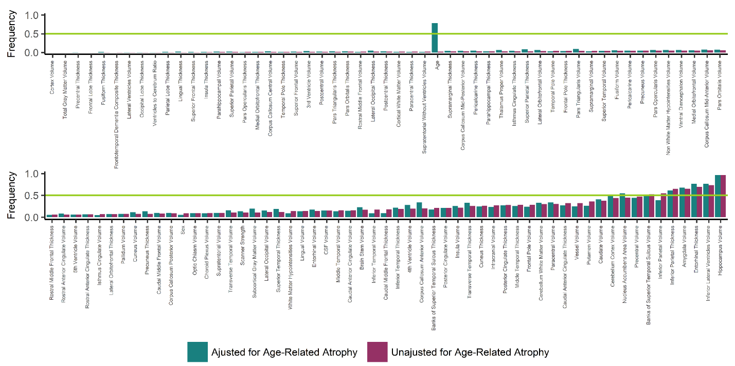

Supplemental Figure S2 graphs the frequency each region was selected in the 1000 iterations of random sampling and least absolute shrinkage and selection operator logistic regressions during the region selection process for both the unadjusted and adjusted for age-related atrophy data. The green line indicates the 50% frequency threshold that both datasets needed to meet for a region to be included in the SARA model.

Abbreviations: AD – Alzheimer disease; SARA – Select Atrophied Regions in Alzheimer disease

**Supplemental Table S7 – Coefficients for All Classification Models**

|  |  |  |  |  |  |  |  |
| --- | --- | --- | --- | --- | --- | --- | --- |
| **Model** | **Intercept** | **Age** | **Hippocampal Volume** | **Inferior Lateral Ventricle Volume** | **Entorhinal Thickness** | **Amygdala Volume** | **Inferior Parietal Thickness** |
| Age | -5.51 | 0.0714 | NA | NA | NA | NA | NA |
| HCV | 9.03 | NA | -0.00142 | NA | NA | NA | NA |
| SARA | 14.5 | NA | -0.00067 | 0.000247 | -0.68 | -0.00056 | -3.28 |
| HCV +Age | 11.1 | -0.0227 | -0.00149 | NA | NA | NA | NA |
| SARA + Age | 19.7 | -0.0523 | -0.0007 | 0.000329 | -0.628 | -0.00072 | -3.78 |
| HCVadj | -1.42 | NA | -1.06 | NA | NA | NA | NA |
| SARAadj | -1.7 | NA | -0.411 | 0.253 | -0.296 | -0.261 | -0.415 |
| HCVadj + Age | -7.3 | 0.079 | -1.08 | NA | NA | NA | NA |
| SARAadj+ Age | -6.65 | 0.0667 | -0.502 | 0.24 | -0.21 | -0.203 | -0.426 |

Supplemental Table S7 displays the rounded coefficients (unstandardized B values) for each of the classification models. Volumes are input into the models as ml (cm3), while cortical thicknesses are input in mm. The SARA models include hippocampal volume, inferior lateral ventricle volume, entorhinal thickness, amygdala volume, and inferior parietal thickness. X + Age indicates model Xwith age added as a covariate; Xadj indicates Model X using volumes and cortical thicknesses that have been adjusted for age-related atrophy.

Abbreviations: HCV – Hippocampal Volume; SARA – Select Atrophied Regions in Alzheimer disease

**Supplemental Table S8 – Select Models’ AUCs for the Specific Diagnoses in the Clinical Cohort**

|  |  |  |  |
| --- | --- | --- | --- |
| **Specific Diagnosis** | **Age Model’s**  **AUCs**  **(95% CI)** | **HCV Model’s**  **AUCs**  **(95% CI)** | **SARA Model’s**  **AUCs**  **(95% CI)** |
| **AD Diagnoses** |  |  |  |
| AD Variant | 0.502  *(0.342-0.663)* | 0.697  *(0.566-0.829)* | 0.795  *(0.689-0.901)* |
| AD with Additional Non-Neurodegenerative Condition | 0.686  *(0.526-0.846)* | 0.781  *(0.707-0.855)* | 0.852  *(0.786-0.917)* |
| Early-Onset AD | 0.680  *(0.563-0.798)* | 0.701  *(0.596-0.806)* | 0.767  *(0.668-0.866)* |
| Typical AD | 0.808  *(0.763-0.852)* | 0.819  *(0.775-0.863)* | 0.827  *(0.783-0.871)* |
| **Non-Neurodegenerative Non-AD Diagnoses** |  |  |  |
| Cognitively Normal | 0.748  *(0.671-0.826)* | 0.893  *(0.838-0.948)* | 0.914  *(0.856-0.971)* |
| Miscellaneous | 0.755  *(0.631-0.878)* | 0.813  *(0.686-0.940)* | 0.852  *(0.731-0.973)* |
| Mood/Pharmacy/Sleep | 0.798  *(0.710-0.885)* | 0.828  *(0.729-0.926)* | 0.862  *(0.772-0.952)* |
| Neurologic Disease | 0.883  *(0.801-0.965)* | 0.794  *(0.680-0.910)* | 0.830  *(0.717-0.943)* |
| **Neurodegenerative Non-AD Diagnoses** |  |  |  |
| Dementia with Lewy Bodies | 0.537  *(0.366-0.708)* | 0.581  *(0.396-0.765)* | 0.467  *(0.242-0.692)* |
| Frontotemporal Dementia | 0.780  *(0.690-0.871)* | 0.805  *(0.688-0.923)* | 0.818  *(0.707-0.929)* |
| Other Neurodegenerative Disorders | 0.712  *(0.595-0.830)* | 0.720  *(0.563-0.877)* | 0.735  *(0.589-0.882)* |
| Vascular Cognitive Impairment | 0.592  *(0.445-0.738)* | 0.686  *(0.532-0.841)* | 0.694  *(0.544-0.845)* |

Supplemental Table S8 displays the AUCs for the Age, HCV, and SARA models when the AD or Non-AD Diagnoses are restricted to each of the more specific diagnoses along with the associated 95% CIs. For example, the AD Variant AUC is the AUC calculated using participants with AD Variant diagnosis and all Non-AD Diagnoses participants, but excludes participants with an AD with Additional Non-Neurodegenerative Condition, Early-Onset AD diagnosis, or Typical AD.

Abbreviations: AD – Alzheimer disease; AUC – Receiver Operating Characteristics Area Under the Curve; CI – Confidence Interval; HCV – Hippocampal Volume; SARA – Select Atrophied Regions in Alzheimer disease

**Supplemental Figure S3 – CDR Aligns,but is Not Equivalent, to Predicted Probability in SARA**

**a.**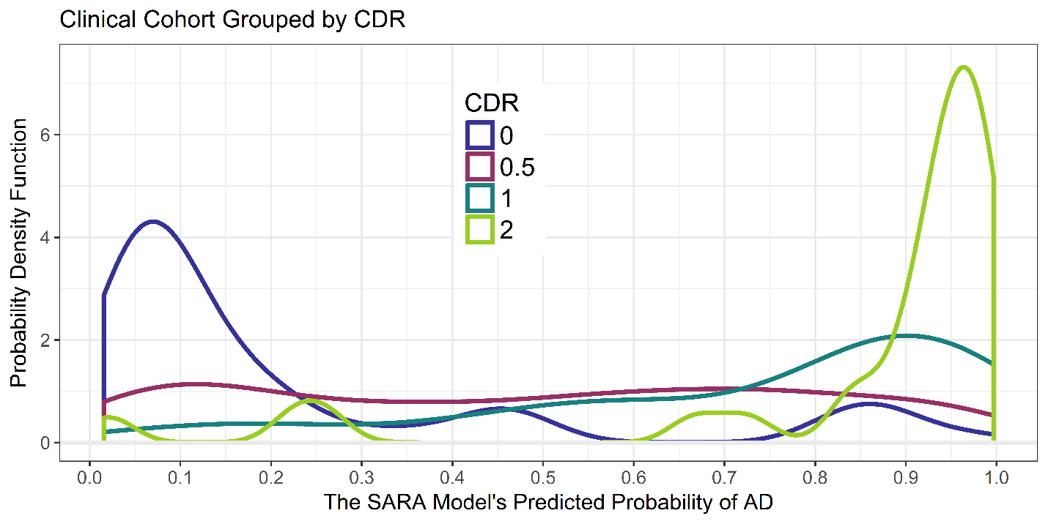

**b.**

**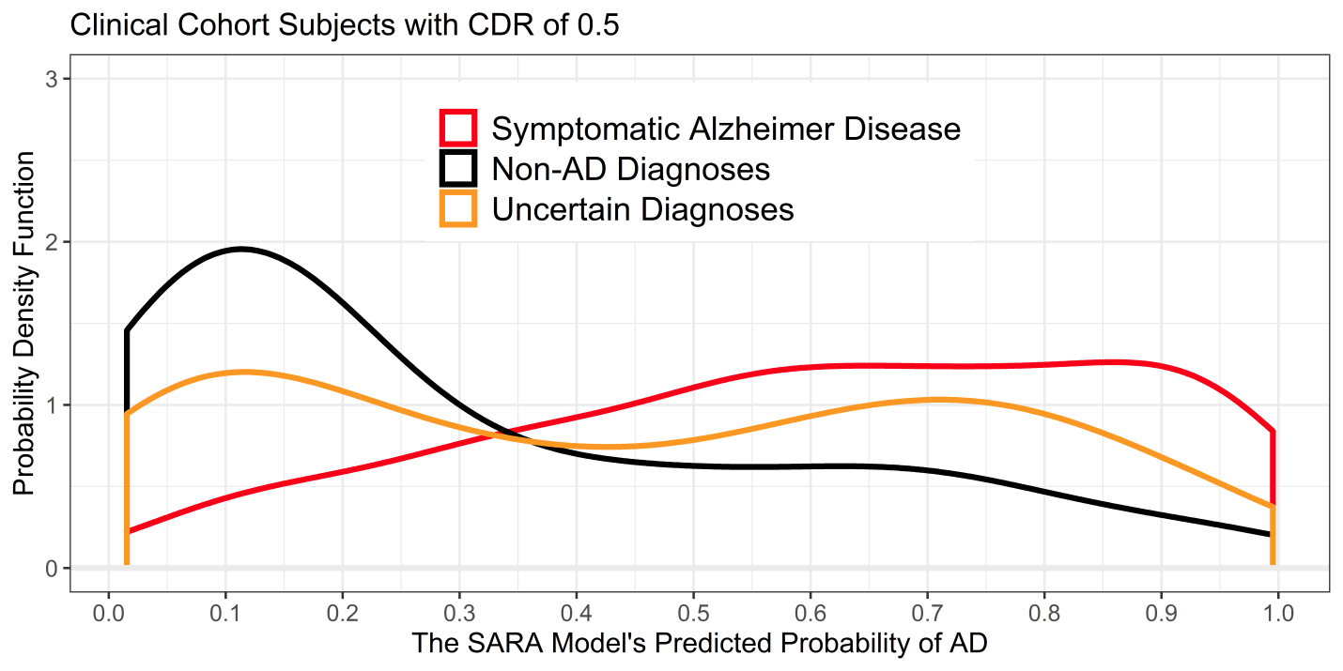**

Supplemental Figure S3a displays the distributions of the SARA model’s predicted probability of Alzheimer disease (AD), grouped by global CDR instead of by diagnosis. This includes the AD, Non-AD, and Uncertain diagnoses. Note the change in y-axis scale from previous figures due to the tight distribution of CDR = 2 participants. S3b displays the distribution of SARA model’s predicted probability of AD as in Figure 2b, but shows only patients with CDR 0.5 (n=101).

Abbreviations: AD – Alzheimer disease; AUC – Receiver Operating Characteristics Area Under the Curve; CDR – Clinical Dementia Rating; SARA – Select Atrophied Regions in Alzheimer disease

Reference

Klunk, W.E., Koeppe, R.A., Price, J.C., Benzinger, T.L., Devous, M.D., Jagust, W.J., Johnson, K.A., Mathis, C.A., Minhas, D., Pontecorvo, M.J., Rowe, C.C., Skovronsky, D.M., Mintun, M.A., 2015. The centiloid project: standardizing quantitative amyloid plaque estimation by PET. Alzheimer&#x0027;s Dement. 11, 1-15.e4. 10.1016/j.jalz.2014.07.003.