一、整体概况

开放获取系列成像研究（OASIS）是一个旨在向科学界免费提供大脑神经成像数据集的项目。

OASIS Brains Datasets

OASIS-1: Cross-sectional MRI Data in Young, Middle Aged, Nondemented and Demented Older Adults

OASIS-2: Longitudinal MRI Data in Nondemented and Demented Older Adults

OASIS-3: Longitudinal Multimodal Neuroimaging, Clinical, and Cognitive Dataset for Normal Aging and Alzheimer’s Disease

OASIS-3 TAU: OASIS-3 Flortaucipir F18 (AV1451) PET

OASIS-4: Clinical Cohort

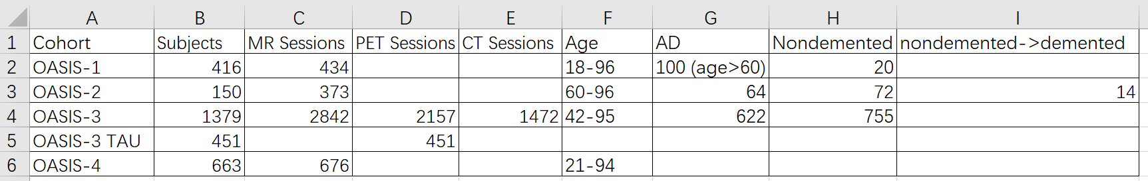

往期论文所采用的数据特征

OASIS-2:

demographics and clinical characteristics: Number, age, sex, CDR(Clinical Dementia Rating), MMSE(Mini Mental State Exams), Prescriptions, Systolic BP, Diastolic BP, Reported HBP, Diabetes, Education

Measures Included in the Data Set: Age, Sex, Education, SES, MMSE, CDR, ASF, eTIV, nWBV

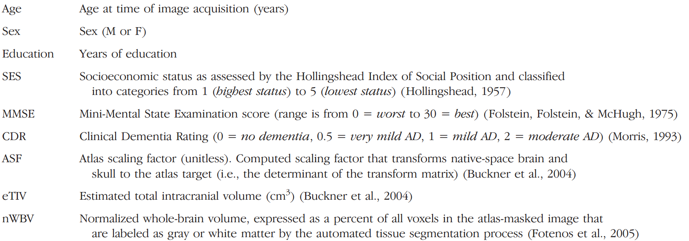

OASIS-3:

Subject Demographics: Number, age, sex, Right Handed, APOE, Race

OASIS-4:

demographic information: age, sex, CDR(Clinical Dementia Rating), MMSE(Mini Mental State Exams), APOE, Amyloid Mean Cortical SUVR rsf – Centiloid(SUVR rsf – Standard Uptake Value Ratio), Race, Education

hippocampal volume, inferior lateral ventricle volume, amygdala volume, entorhinal thickness, and inferior parietal thickness

二、OASIS-1

1、介绍

OASIS-1: Cross-sectional MRI Data in Young, Middle Aged, Nondemented and Demented Older Adults 年轻、中年、非痴呆和痴呆老年人的横断面MRI数据

Subjects: 416

MR Sessions: 434

这一组包括416名年龄在18至96岁之间的受试者。对于每个受试者，包括在单次扫描中获得的3或4次单独的T1加权MRI扫描。受试者都是右撇子，包括男性和女性。在纳入的60岁以上受试者中，有100人被临床诊断患有非常轻中度阿尔茨海默病（AD）。此外，还包括一个可靠性数据集，其中包含 20 名没有痴呆症的受试者，这些受试者在初次治疗后 90 天内的后续访问中进行了成像。

Data from each

MRI session exists in its own directory labeled by the subject ID.

随机受试者标识使用OAS1_xxxx格式，其中“xxxx”表示00001至9999之间的数字（例如，OAS1_0012）。对于受试者的每个成像会话，都分配了一个格式为OAS1_xxxx_MRy的ID，其中y表示一个递增的数字，以反映受试者成像就诊次数（例如，OAS1_0012_MR1）。

Demographics

Gender (M/F), Handedness (Hand), Age, Education (Educ), socioeconomic status (SES) (Rubin et al., 1998). Education codes correspond to the following levels of education: 1: less than high school grad., 2: high school grad., 3: some college, 4: college grad., 5: beyond college.

Clinical

Mini-Mental State Examination (MMSE) (Rubin et al., 1998), Clinical Dementia Rating (CDR; 0= nondemented; 0.5 – very mild dementia; 1 = mild dementia; 2 = moderate dementia) (Morris, 1993). All participants with dementia (CDR >0) were diagnosed with probable AD.

Derived anatomic volumes

Estimated total intracranial volume (eTIV) (mm^3) (Buckner et al., 2004), Atlas scaling factor (ASF) (Buckner et al., 2004), Normalized whole brain volume (nWBV) (Fotenos et al., 2004).

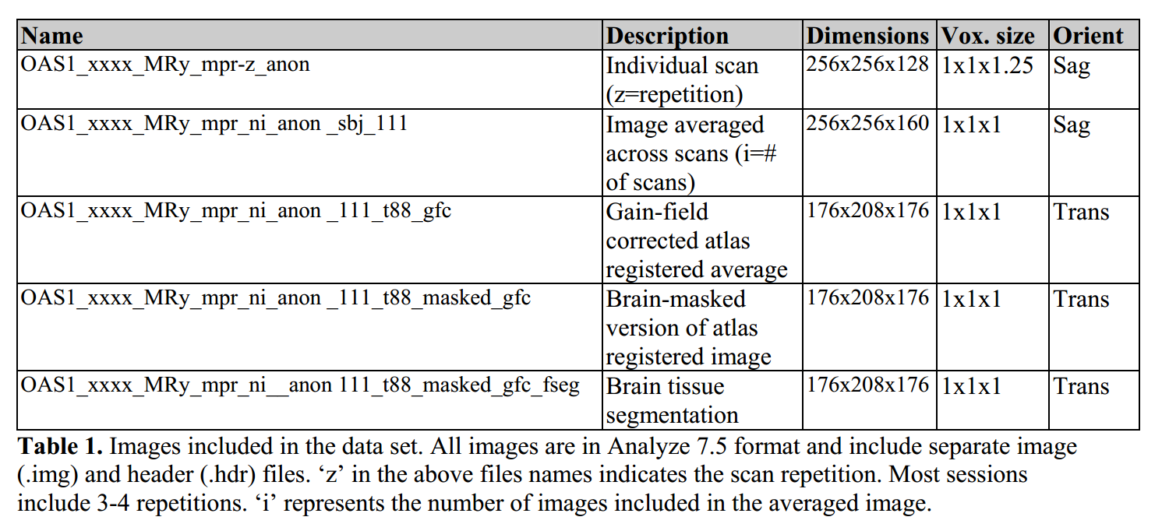

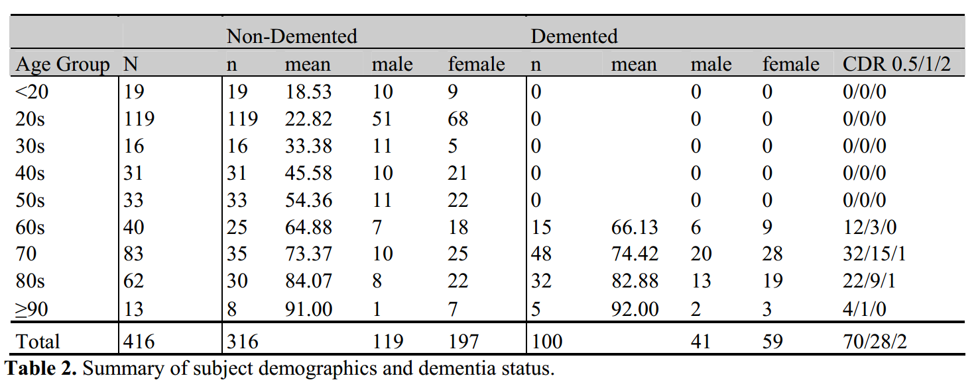

2、下载

The full set is 15.8 GB compressed and 50 GB uncompressed. The data are available at

<https://www.oasis-brains.org/#data>

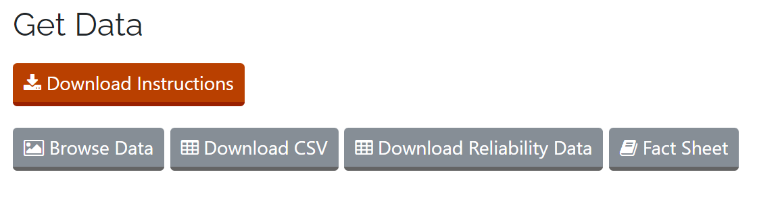

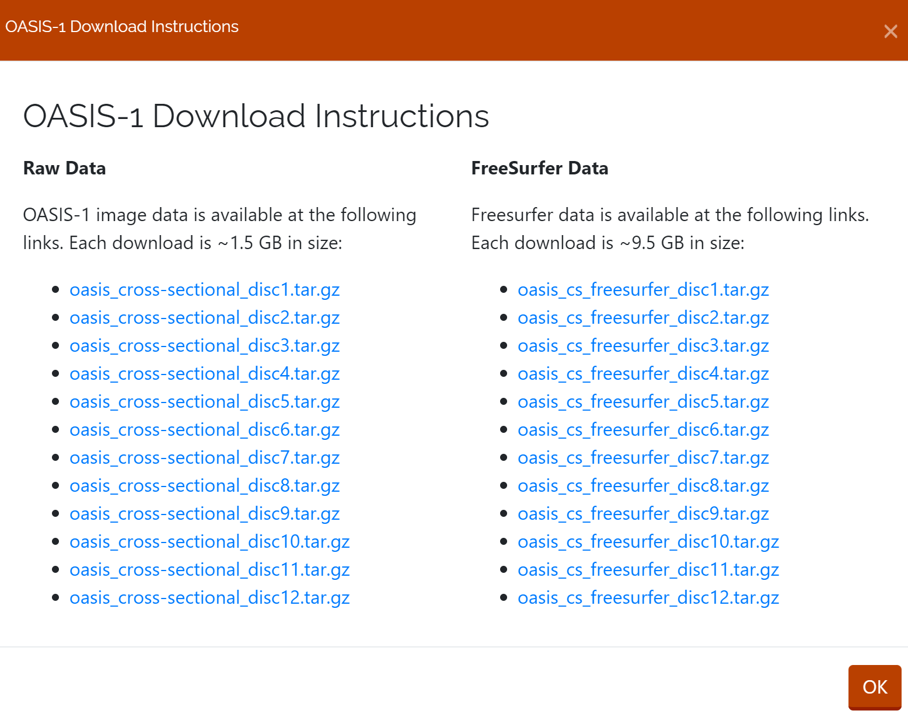

Raw data 已下载至服务器并解压

/public/home/tianting/23dachuang/Gzm/OASIS-1/

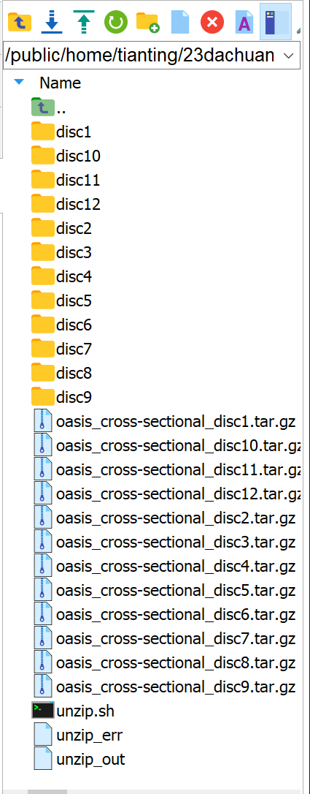



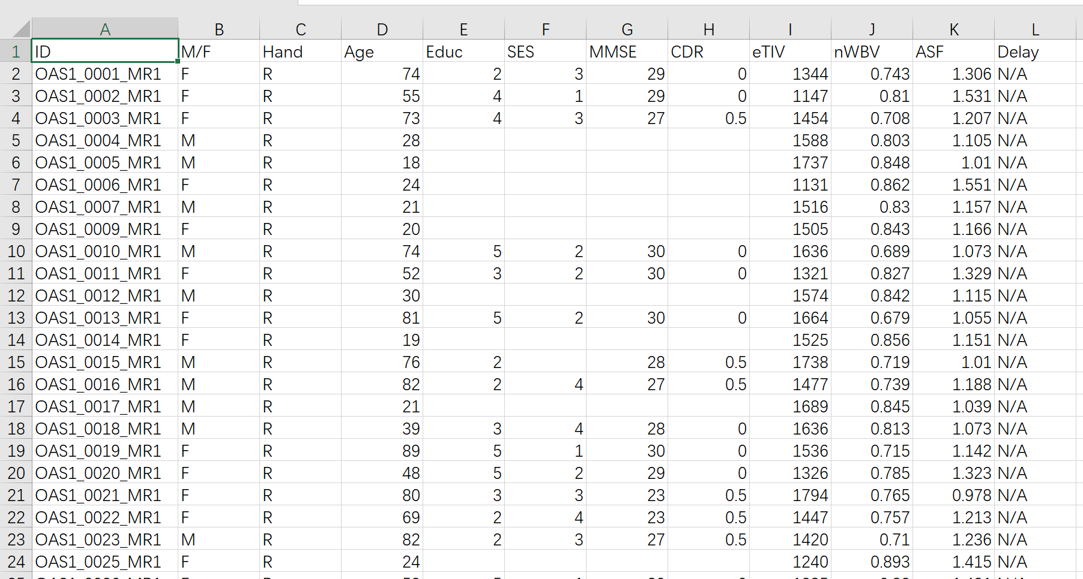



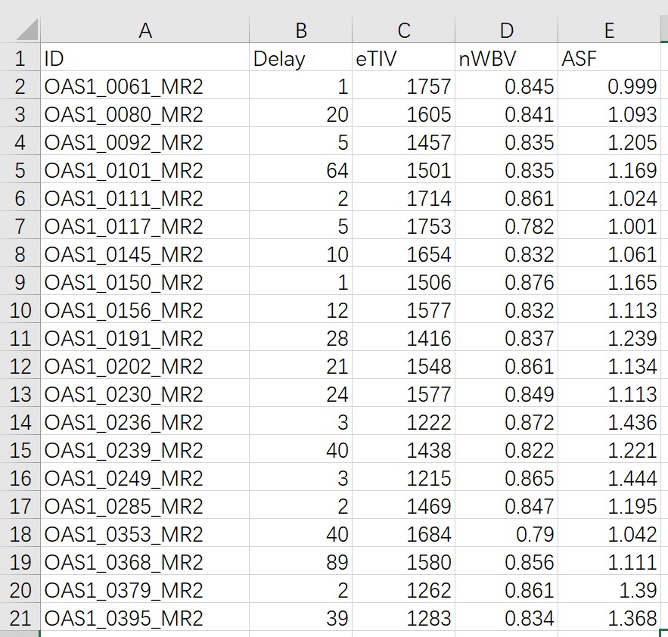

三、OASIS-2

1、介绍

OASIS-2: Longitudinal MRI Data in Nondemented and Demented Older Adults 非痴呆和痴呆老年人的纵向MRI数据

Subjects: 150

MR Sessions: 373

这一组由150名年龄在60岁至96岁之间的受试者组成。每个受试者在两次或两次以上的访视中进行扫描，间隔至少一年，共进行373次成像。对于每个受试者，包括在单次扫描中获得的3或4次单独的T1加权MRI扫描。受试者都是右撇子，包括男性和女性。在整个研究过程中，72名受试者被描述为未退化。64名受试者在初次就诊时被定性为痴呆，并在随后的扫描中保持这种状态，其中包括51名轻度至中度阿尔茨海默病患者。另有14名受试者在初次就诊时被定性为未痴呆，随后在随后的就诊中被定性为痴呆。

2、下载

The data are available at

<https://www.oasis-brains.org/#data>

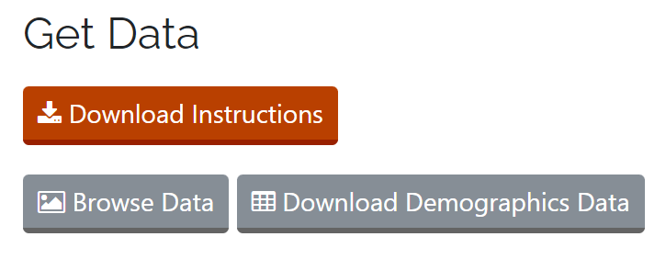

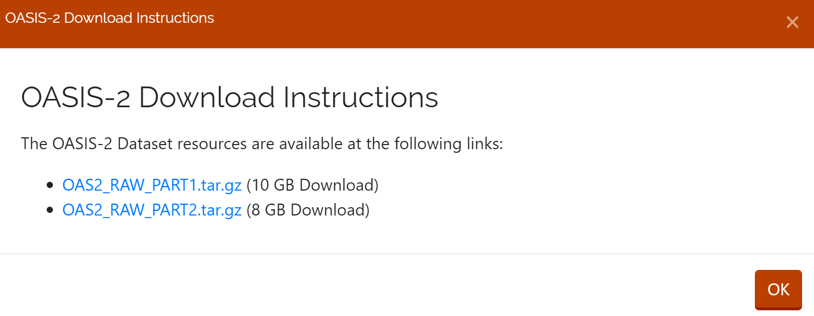

Raw data 已下载至服务器并解压

/public/home/tianting/23dachuang/Gzm/OASIS-2/

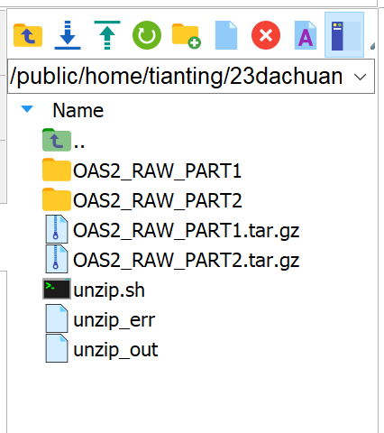



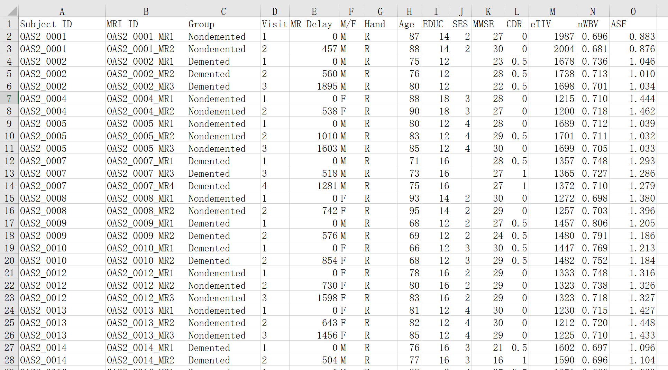

四、OASIS-3

1、介绍

OASIS-3: Longitudinal Multimodal Neuroimaging, Clinical, and Cognitive Dataset for Normal Aging and Alzheimer’s Disease 正常衰老和阿尔茨海默病的纵向多模式神经影像、临床、认知和生物标志物数据集

Subjects: 1379

MR Sessions: 2842

PET Sessions: 2157

CT Sessions: 1472

OASIS-3是对1378名参与者的数据的回顾性汇编，这些数据是在30年的时间里通过WUSTL Knight ADRC在几个正在进行的项目中收集的。参与者包括755名认知正常的成年人和622名处于不同认知衰退阶段的人，年龄从42-95岁不等。所有参与者都被分配了一个新的随机标识符，所有日期都被删除并归一化，以反映进入研究的天数。The dataset contains 2842 MR sessions which include T1w, T2w, FLAIR, ASL, SWI, time of flight, resting-state BOLD, and DTI sequences. Many of the MR sessions are accompanied by volumetric segmentation files produced through FreeSurfer processing. PET imaging from different tracers, PIB, AV45, and FDG, totaling over 2157 raw imaging scans and the accompanying post-processed files from the Pet Unified Pipeline (PUP) are also available in OASIS-3. Additionally, 451 Tau PET sessions and post-processed PUP are now available for OASIS-3 subjects in a sub-project ‘OASIS-3_AV1451’.

OASIS-3 TAU: OASIS-3 Flortaucipir F18 (AV1451) PET

Subjects: 451

PET Sessions: 451

This set is a subset of OASIS-3 subjects that have also undergone TAU (AV1451) PET imaging.

2、下载

The data are available at

<https://www.oasis-brains.org/#data>

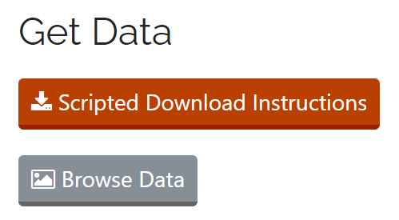

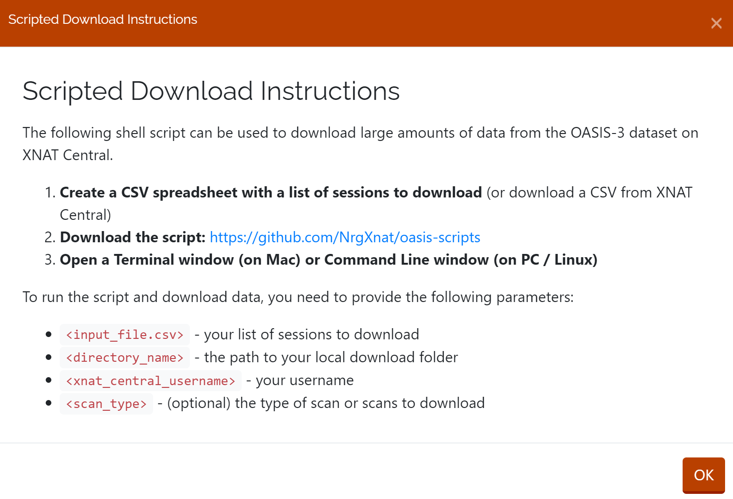

<https://github.com/NrgXnat/oasis-scripts#brief-description-of-scan-and-participant-data>

This repository contains scripts that can be used to download files from the OASIS3 or OASIS4 projects on XNAT Central. In order to access the OASIS data you must have signed the OASIS Data Use Agreement and have access to the OASIS3 or OASIS4 project on XNAT Central at central.xnat.org.

包括：

Downloading MR and PET Scan files

Downloading MR and PET Scan files in BIDS format

Downloading Freesurfer files

Downloading PET Unified Pipeline (PUP) files

Matching Up Session Data by Days From Entry

To run any of these scripts, follow the steps below.

1. Download the script from this Github repository by clicking "Clone or download" and choose Download ZIP. This will download a zip file containing all the scripts in the repository and this README file.
2. Extract the .zip file onto your local computer and move the download_oasis_scripts.sh (or whichever script file you would like to use) into the folder you will be working from.
3. Download or create a CSV of OASIS experiment IDs to use as an input to the script, or multiple CSVs of data if you are using the matchup script. Instructions for this can be found in the "Creating a CSV file" section of this README.

Move the resulting csv file(s) into the same folder as the script.

1. If you are running a download script, create an empty directory in the same folder as your script and make a note of its name. This is the directory where your scan files will be downloaded to.
2. Go into your command line. On Windows you can use a terminal system like MobaXTerm. If you're using a Mac you can use Terminal. Make sure you are not running the script while logged in as the root user. Change directories to the folder your scripts and empty folder are in using the cd command.（失败）

五、OASIS-4

1、介绍

OASIS-4: Clinical Cohort 包含出现记忆问题的个体的 MR、临床、认知和生物标志物数据。

Subjects: 663

MR Sessions: 676

This set consists of a collection of 663 subjects aged 21 to 94. This clinical cohort was evaluated for memory disorders and dementia including clinical, csf, neurospychometric, and neuroimaging assessments. This is a unique dataset and not an update to the OASIS-3 Longitudinal Multimodal Neuroimaging dataset.

2、下载

同 OASIS-3