STARSHATTER^{tm} DEMO 2.0
Player Manual
Copyright © 2000 John DiCamillo

http://members.home.net/milod
milod@home.com

INTRODUCTION

Thank you for downloading the Starshatter Demo 2.0. This Player Manual will give you a brief introduction to the game and how to play it. It will also help you to evaluate the demo, and explain the best ways to provide feedback.

What Is Starshatter?

Starshatter is a new space combat simulation game that is currently in the middle stages of development. The game offers a new type of combat experience in an original science fiction universe. Unlike most other games, which limit the player to flying fighters and other small craft, Starshatter gives you the opportunity to directly command a wide variety of ships, from agile atmospheric and space-based fighters to giant battleships and fleet carriers. Starshatter aims to simulate the complete space combat experience -- from planet surface to interstellar space -- with several dynamic campaigns set in a persistent simulated universe.

Starshatter is being developed for IBM PC compatibles running Microsoft Windows 95, Windows 98, Windows NT, or Windows 2000.

Game Features

- Intelligent Combat Scenarios
- Realistic Physics
- Newtonian Space Combat (with computer assist)
- Hardcore Atmospheric Flight Modeling
- Realistic Sensors and Avionics
- Realistic Space Environments
- Stunning 3D Accelerated Graphics
- Stereo Sound

What Is This Demo All About?

This early demo is being released to solicit feedback from the space sim community. If you've ever wanted to influence a space sim game design, now's your big chance! At this stage of development, the graphics engine and basic gameplay mechanics are complete. Advanced AI, the dynamic campaign engine, and multiplayer features are still being developed.

After you've had a chance to play the game a bit, please tell me what you think of it! Any and all comments are welcome -- good and bad alike. The main thing I want to know is: did you enjoy the demo? And are you interested in playing the full game when it is complete? Are there any other features you really want to see? Send your comments to milod@home.com.

What Is Required to Play?

Hardware Requirements

Recommended Minimum System:
Pentium II 400 MHz (or equivalent)
64 MB system RAM
24 MB available hard disk space
Direct3D compatible 3D accelerator with AGP 2x and 32 MB RAM
DirectX compatible Sound Card
3 or 4 Axis Joystick with 4 buttons and hat switch
Mouse

Operating System and Drivers

Starshatter is being developed for IBM PC compatibles running Microsoft Windows 95, Windows 98, Windows NT 4 (SP 3+), and Windows 2000. It should also work under Windows ME, but this has not been tested. Starshatter uses DirectX to access audio and video hardware. You must have at least DirectX version 3.0 installed for the game to run, but either DirectX 6.1 or DirectX 7 is strongly preferred.

Note that 3D accelerated graphics are available under Windows 95, Windows 98, and Windows 2000 only. When Starshatter is run under Windows NT 4, it will use a custom software rendering mode. The software rendering mode can also be used if there are any problems getting Starshatter to work with your 3D hardware.

INSTALLATION

The Starshatter demo is being distributed as a compressed archive (ZIP file). To install the demo, create a directory of your choice (e.g. C:\Games\StarDemo) and unzip the contents of the archive into it. To play the demo, double click the stars.exe icon in the new directory.

To uninstall the demo, simply delete the directory and all its contents. The Starshatter demo will not modify the system registry, or any other directory on your computer.

SETUP / OPTIONS

The Starshatter demo can be completely configured from within the game itself, no separate setup program is needed. Just select the OPTIONS button in the main menu before starting a mission to configure the demo for your video card.

Video Options

The Starshatter demo supports screen resolutions of 640x480, 800x600, and 1024x768. The software rendering mode can operate in 256 color palette mode (recommended for slower computers) or 16 bit high color mode. The Direct3D hardware accelerated renderer can operate in 16 bit or 32 bit true color modes.

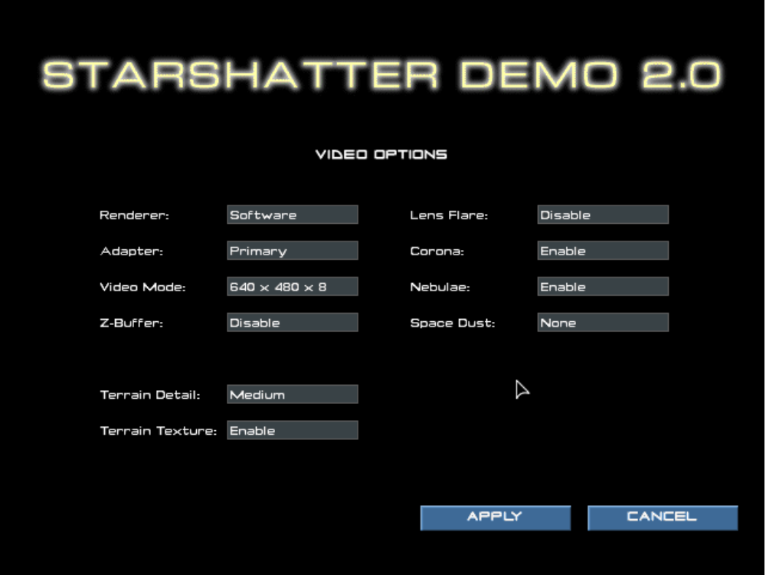

Direct3D Options

The Starshatter demo supports Direct3D versions 3, 6.1, and 7. Choose the highest version of Direct3D that will run on your computer. You can download the latest version of DirectX from the Microsoft web site http://www.microsoft.com/directx.

The Direct3D renderer supports the use of a hardware Z buffer for visible surface determination. Using the Z buffer will produce a better looking image than using the software depth sorting algorithm. However, the Z buffer does take up some video memory. Most first generation 3dfx Voodoo Graphics accelerators can only use a Z buffer in 640x480 display mode. If you have a card of this type and want to use the 800x600 display mode, you can turn off the Z buffer by deselecting the button in the options menu.

By default, the Direct3D renderer will use the primary 3D device if more than one are present. For example, if your computer has both an nVIDIA GeForce card and a 3dfx Voodoo2 card installed, the Starshatter demo Direct3D renderer will use the GeForce card. If you wish to use your secondary 3D device instead of the primary 3D device, select the Secondary Adapter option in the options menu.

Detail Options

The Starshatter demo allows you to configure a variety of settings to control the graphical detail of the simulation. You can enable or disable lighting effets such as coronas and lens flares to suit your taste. By default, the space scenes in Starshatter are rendered with beautiful alpha blended digital matte paintings of colorful nebulae. The background paintings are designed to be rendered in a 32 bit true color display mode. If your video card is limited to 16 bit high color modes, or if it is short on fill rate or slow at alpha blending, you may wish to disable the nebula effect.

NOTE

Changes you make to video settings do not become permanent until you exit the demo normally. If you select video options that cause the game to crash or otherwise hang your computer, the demo will automatically revert to the last known working set of video options when you restart.

Control and Keyboard Configuration

The Starshatter demo 2.0 remap the default keyboard control bindings to suit your taste. Note that you are limited to changing bindings for the keyboard. You can not remap joystick buttons to different functions, and for the demo at least, the mouse is not supported as a flight control device.

The Control dialog also allows you to select the joystick device you wish to use as a flight controller, and to enable or disable the rudder and throttle control axes to match your system. The two sliders in the lower right of the Control dialog allow you to set the joystick sensitivity and dead zone, respectively. If you are seeing a slight drift in the simulation that can be canceled by the trim pots on your joystick, you may need to increase the dead zone setting to keep your ship on a straight path.
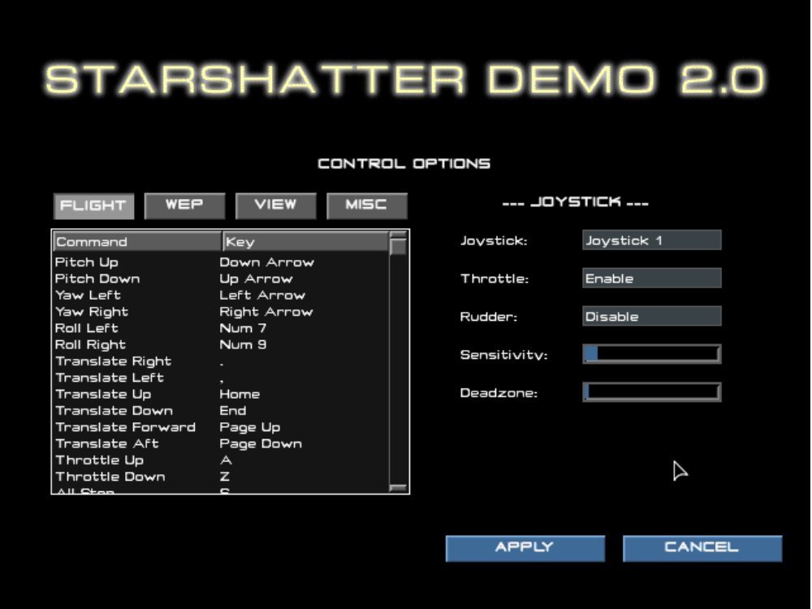

The keyboard command bindings are displayed in the listbox on the left. There are four categories of commands: Flight Controls, Weapons and Targeting, View Controls, and Miscellaneous Controls. You can view and edit the bindings in any category by first clicking on the button corresponding to the category. The Control dialog will then display the keyboard and joystick bindings for the selected category in the list box.

To remap a keyboard command binding, simply double-click the listbox item which corresponds to the binding you wish to modify. This will display the Key Map dialog box for the selected command. To change the binding to a new keystroke, press the desired key combination on your keyboard, and then click the Accept button with your mouse. The old binding is discarded and replaced with the new binding.

Keyboard command bindings are stored in the file KEY.CFG in the game directory. To discard all of your changes and revert to the default keyboard bindings, simply delete or rename this file and restart the demo.

GAMEPLAY INSTRUCTIONS - Quick Start

Main Menu Screen

Mission List

This list box contains the names of the four missions in the demo. Choose the mission you want to play by clicking on it with the mouse.

Mission Info

When you select a mission in the mission list, this display will show you a brief description of the mission.

Start Game

Once you have selected a mission, left-click the START GAME button to begin or resume play. If you exit a mission and return to the main menu screen, you can return to the action where you left off by clicking START GAME again. If you choose a different mission from the mission list and click START GAME, you will abort the first mission and start the new mission from the beginning.

Exit

Click this button to quit the demo and return to Windows. You can also press Esc on the keyboard to quit.

Basic Controls

This is the minimum set of controls you need to know to control your ship and play the game:

Pitch Up Arrow Down Joystick Back
Pitch Down Arrow Up Joystick Forward
Yaw (Turn) Left Arrow Left Joystick Left
Yaw (Turn) Right Arrow Right Joystick Right

Increase Throttle A
Decrease Throttle Z
Full Stop (Zero Throttle) S

Target Ship in Reticle T
Fire Primary Weapons F Joystick Button 1
Fire Secondary Weapons Space Joystick Button 2

Exit to Menu Esc

GAMEPLAY INSTRUCTIONS - Maneuvering

Fighters and Starships

In the Starshatter universe, the military space force uses two broad categories of spacecraft: fighters and starships.

Fighters are small, highly maneuverable space ships that are similar in function to modern jet aircraft. Fighters usually have a crew of one or two, and are the only combat ships capable of atmospheric operation. In exchange for their strengths, fighters are only lightly shielded and are incapable of long distance travel through space. They are used to escort high value assets and attack enemy targets in space or on the ground. But they are limited to the space around a single planet. They do not have the fuel or life support necessary even for the relatively short trip between a planet and its moon, much less a trip between stars.

Starships are large, heavy, and expensive space ships that are similar in function to modern naval surface ships. Starships are built in several classes, from small destroyers up through giant battleships and fleet carriers. They are all heavily armored and shielded, which makes them incapable of atmospheric operation. However, they do have a Quantum Translation Drive which enables them to make the long jump between star systems. Many starships are used primarily in attack roles, while carriers are used primarily to deliver fighters and other dropships to the area of battle.

In the full Starshatter game, you will be able to take command of every fighter and starship class in the space force. For this demo, you are limited to one class of fighter, one class of frigate, and one class of destroyer.

The StormHawk is a multi-role fighter, equally capable of performing fighter sweeps in orbit and attacking assets on the ground. For this demo, the ship is always equipped for an anti-fighter role, with twin laser cannon and four short range missiles.

The Spectre class destroyer is the mainstay of the fleet's attack capability. Armed with four forward facing beam laser turrets, the Spectre is a devastating anti-ship platform. Side mounted secondary laser batteries can be tasked with point defense in case of fighter attack. Although the Spectre class is usually deployed in squadrons of four, for this demo you will be operating in pair formation.

Learning to Fly a Fighter

Whether you are a budding starship commander or a veteran fighter driver, you may be in for a few surprises when first taking control of your craft in Starshatter. All space ships in the game obey a modified form of Newtonian mechanics. This means that they have inertia, or more properly, linear and angular momentum. Since there is no appreciable drag in the vacuum of space, once your ship starts moving in one direction it will keep moving in that direction until you apply some thrust to stop it. Likewise, once a ship begins to rotate about any axis, it will keep spinning about its center of mass until some force is applied to counter the rotation. To minimize problems due to space sickness, all ships are equipped with a Flight Control System (FLCS, pronounced “flickus”) which automatically fires attitude control thrusters to keep the ship under control.

The FLCS is also responsible for controlling the aerodynamic control surfaces when a fighter is operating within a planet’s atmosphere. When you take your fighter out of orbit to engage enemy units within a planet’s atmosphere, the fighter will fly like an airplane instead of a space craft. Fighters have wings that generate lift, and they are subject to gravity and atmospheric drag that varies with altitude, air speed, and angle of attack. Furthermore, the small thrusters which control attitude in space are shut down in the atmosphere. Instead, the ship turns by operating control surfaces (such as ailerons and rudders). This means that pitch and yaw rates will vary with the air speed and atmospheric density as well.

Fighter Maneuvering

The best way to learn is by doing. Run the Starshatter demo, and load Mission 1. Target Practice. In this mission you will start out by learning to fly a fighter, and then move on to commanding a destroyer.

The basic flight controls are illustrated in Figure 1. Using the joystick, push forward to dive and pull back to climb. Deflecting the joystick left or right causes the fighter to turn (yaw) left or right. To roll using the joystick, press and hold Joystick Button 3 while moving the stick left or right. If you prefer using the keyboard, the “inverted T” arrow keys can also be used to steer your ship. Press the up arrow to dive and the down arrow to climb. The left and right arrow keys cause the fighter to turn left and right. You can roll the ship using the keyboard by pressing and holding the Ctrl key while pressing the left or right arrow key.
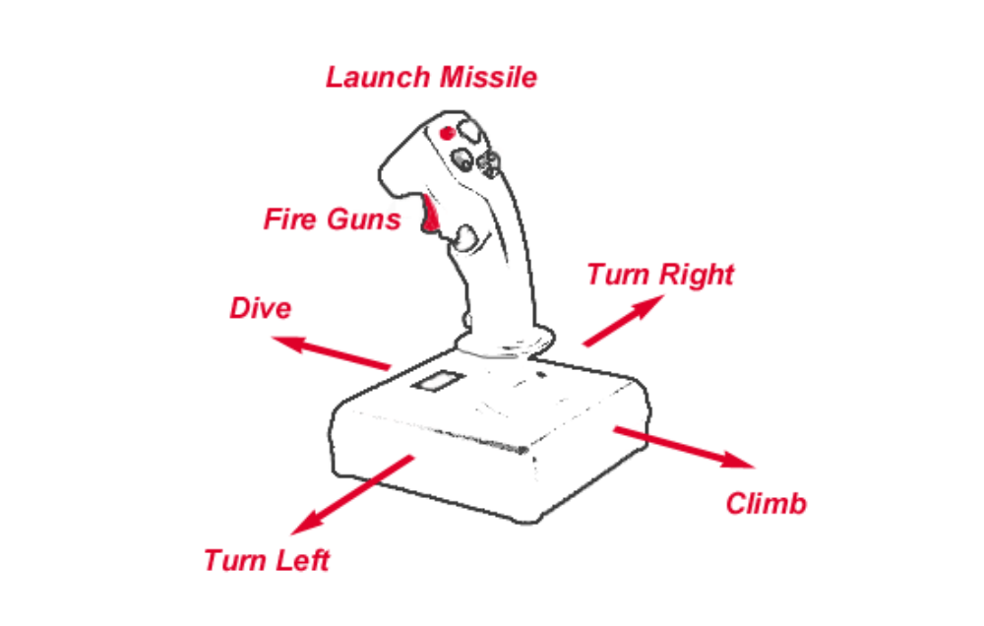Figure 1. Flight Controls

If you are used to playing aircraft simulations, you can set the controls to behave like an airplane joystick. Press the J key to swap the yaw and roll functions of the joystick and keyboard. Now, moving the stick left or pressing the left arrow key will cause the ship to roll left, just like a fighter jet. With the axes swapped, you can command rudder authority to initiate a flat turn by pressing and holding Joystick Button 3 or the Ctrl key while moving the stick or pressing the left or right arrow key. Note that this is exactly the opposite of the default configuration. You can swap back to the default mode at any time by pressing the J key again.

Because Starshatter models inertia, your ship will not always be pointing in the exact same direction that it is flying. This can be a little confusing until you get the hang of it. The Head-Up Display (HUD) can help you out. The left side of the HUD contains several indicators that tell you exactly how your ship is performing at any given time.
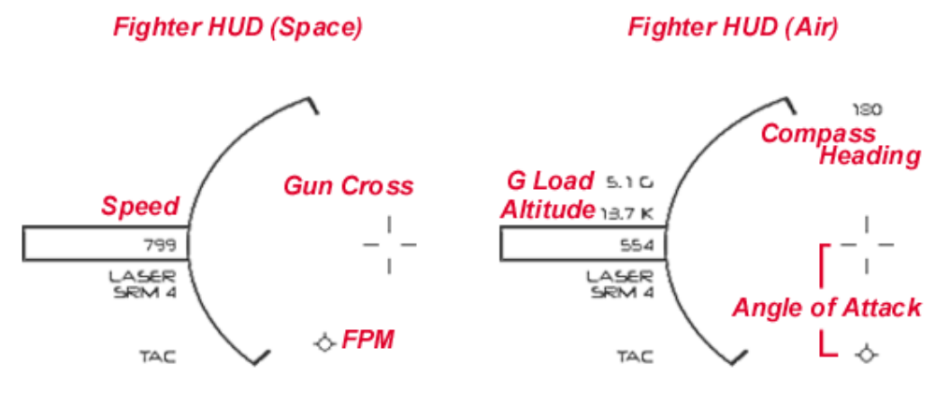
Figure 2. Fighter HUD

The gun cross is at the exact center of the HUD and represents the nose of your ship. This indicator tells you what direction you are pointing your ship. When you move the joystick to change your attitude, the gun cross will follow along immediately.

The flight path marker (FPM) represents the direction of your motion through space. If you place the FPM at a precise point on the side of a space station and hold it there, your ship will impact the station and explode at exactly that point. Note that the reverse is also true: if you keep the FPM pointed at the space near a large object, you know that you are safe from collision.

In space, under normal circumstances, your ship’s FLCS will try to keep the FPM and the gun cross in the same spot no matter what you do with your joystick. However, due to inertia, the FPM will not respond immediately to your control inputs. The FPM will “lag” the gun cross. Keep this in mind when you are barnstorming the local space station.

Fighter Aerodynamics

When you are operating your fighter in space, there is very little performance difference between the yaw axis and the pitch axis of rotation. In space, the fighter uses attitude control thrusters to maneuver, and these are equally effective in both directions. Now let’s look at how the ship handles in the atmosphere. Press O on your keyboard to break orbit. Wait until the altimeter reads “10.0K” for ten thousand meters above base level. Then pull back gently on the stick to level out somewhere around seven thousand meters.

Once you drop into the atmosphere, everything changes. To turn effectively in atmosphere, you must perform a coordinated turn. Instead of using the rudders to command a flat turn, you should roll the ship onto one side and pull back on the stick to pitch through the turn. In atmosphere, most of your turning ability comes from lift generated by the wings. This lifting force is always directed through the lift line, up through the top of your head. So if you want to turn to the right, roll 90 degrees to the right so that the top of your head is pointing in the direction you want to turn. The horizon should be nearly vertical, with the ground on your right and the sky on your left. Then pull back on the stick to generate lift in that direction. Once you have the nose pointing where you want to go, roll 90 degrees back to the left to straighten out and fly level.

Notice that in the right hand side of Figure 2 the FPM is some distance below the gun cross. This is normal when flying in atmosphere. Your fighter’s wings generate lift only when they are inclined to the air stream. The angle between your nose and the air stream is called the angle of attack, and is represented in the HUD by the angle between your gun cross and the FPM. As angle of attack increases, so does the lifting force generated by your wings. In order to maintain level flight, your wings must produce enough lift to counter the force of gravity pulling your ship downward. This means that if you want to keep your flight path level you need to keep your nose high by a couple of degrees.

You can increase your angle of attack at any time by pulling back on the stick to bring your nose even higher. This will result in increased lift, increased drag, and an increased G load on you and the ship. The current G load is displayed at the top of the left column of numbers on the HUD. When you are flying straight and level, the G load indicator displays the local gravity in terms of Earth standard gravity (9.8 m/s²). To prevent damage to you and your ship, the FLCS will attempt to correct for overzealous pitch inputs. The FLCS will try to keep you from pulling more than +9 or less than -3 Gs, but it is not perfect and you may occasionally feel a few extra kilos squashing you into the pilot’s couch. We apologize for this slight inconvenience.

Let’s head back into space to look at using the FLCS modes. Start climbing. Pull back on the stick until you can’t see the horizon anymore. Watch your altimeter. When your fighter climbs above 35,000 meters, you will automatically be inserted into orbit.

Flight Control System (FLCS) Modes

So far we have talked about attitude control, but said nothing about throttle control or speed. In order to discuss throttle inputs, we need to understand the FLCS modes. As a fighter pilot, you will need to get familiar with three FLCS modes: two for space flight and one for atmospheric flight. While in space you can switch between modes by pressing the M key on your keyboard. Your ship will automatically switch to the aerodynamic mode when entering atmosphere.

The default space flight mode is FLCS AUTO. In this mode, the FLCS will try to keep the FPM aligned with the gun cross by automatically firing the attitude control thrusters to zero out any component of the ship’s velocity that is not in the desired direction. Once the ship is going in the right direction, the FLCS will try match the desired speed. In this mode, the throttle control indicates the desired speed as a percentage of the ship’s maximum rated cruising speed. For example, the StormHawk fighter has a maximum cruising speed of 800 m/s. If the throttle is set to 75%, then the FLCS will try to match a speed of 600 m/s. This maximum speed is pre-programmed into the FLCS by the manufacturer and can not be changed.

The alternate space flight mode is FLCS MANUAL. In this mode, the ship’s flight path and orientation are unrelated. You control the orientation of the ship directly with the joystick and you control the drive output directly with the throttle. In this mode, the throttle indicates the desired drive output as a percentage of maximum thrust. If the throttle is reduced to zero, the ship will drift through space in whatever direction and at whatever speed it is going until it hits something. When you zero the throttle in FLCS MANUAL mode, the FPM will appear to “freeze” onto a particular point in space.

When in FLCS manual mode, most of your ship’s velocity comes from the main drive. However, you can also make minor course adjustments by directly firing the translation thrusters. Translation thrusters are controlled through the joystick hat switch, or through the keyboard <, >, Page Up, and Page Down keys. You can use these keys to steer the FPM around the HUD, for example to ensure that you will miss a large obstacle or so that you will enter a docking bay.

The final flight mode for fighters is FLCS AIR. This mode is essentially the same as FLCS MANUAL, except that the ship is controlled by aerodynamic surfaces instead of thrusters. This means that the translation thrusters can not be operated in FLCS AIR mode. In this mode, the throttle indicates the desired drive output as a percentage of maximum thrust.

Learning to Maneuver a Starship

Now let’s try taking a destroyer out for a spin. If you have dropped back into the atmosphere, return to orbit by climbing above 35,000 meters. If you have switched the control axes to “airplane” style by pressing the J key, switch them back to the default mode by pressing the J key again. Now press Tab to transfer yourself onto the bridge of the destroyer that is orbiting the planet with you. Welcome aboard, Captain!

Even though all space ships are subject to the same kinds of forces, their different sizes and combat roles dictate that they use different control mechanisms. When you fly a fighter, you control its orientation in space directly by pointing the nose of the ship with a joystick or the keyboard arrow keys. You can then use the throttle control to accelerate in the direction the ship is pointing. In contrast, you control a starship’s orientation indirectly through use of a helm order. The starship’s forward velocity is controlled by a helm speed setting as a percentage of the ship’s maximum rated cruising speed.

Remember that you are the captain of your ship, not the pilot. You control your starship indirectly by telling the crew where you want to go. They will do their very best to take you there.

Starship Helm Control
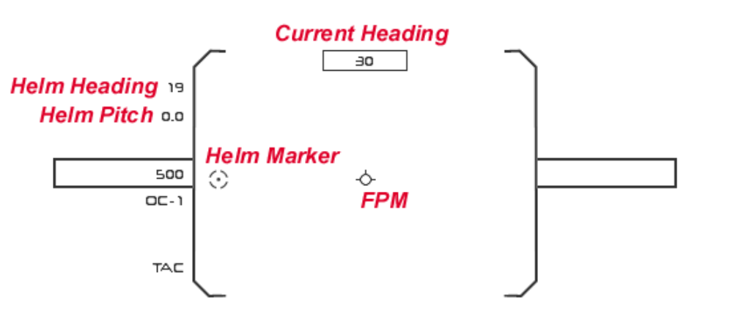
Figure 3. Starship HUD

You maneuver your starship by issuing a helm order to your crew. The helm order describes the direction you want to travel in terms of heading and pitch. The current helm order is visible on the left side of the starship HUD, as shown in Figure 3. In addition to the numeric readout of heading and pitch, the HUD also displays the helm order graphically with the Helm Marker.

Instead of barking out numbers, you input a helm order with the joystick or keyboard in much the same way that you steer a fighter. If you want to turn your ship to port move the joystick to the left or press and hold the left arrow key. Instead of turning the ship directly, your control inputs steer the helm marker. The helm marker moves much more quickly than the ship itself can turn. This allows you to quickly enter a new heading, and move your attention elsewhere while the crew works to turn the ship.

Note that you can’t do “barrel rolls” in a starship. The helm interface will not respond to roll commands, only pitch and yaw. If you prefer using airplane style controls for flying fighters, you will need to press J to switch back to starship controls.

As soon as you change the helm heading or pitch, your crew will begin turning the ship to satisfy your command. At the same time, the ship’s FLCS will fire attitude thrusters to align your flight path with the ship’s nose. If you hold to a single course long enough, eventually the helm marker and the flight path marker (FPM) will meet at the center of the HUD.

Spend a little time getting the feel of maneuvering your starship. Try executing a box patrol pattern. First, bring your destroyer to a heading of 0°. Then execute four right angle turns to starboard, assuming headings of 90°, 180°, 270°, and back to 0°. Your destroyer handles a bit differently than a fighter, doesn’t she?

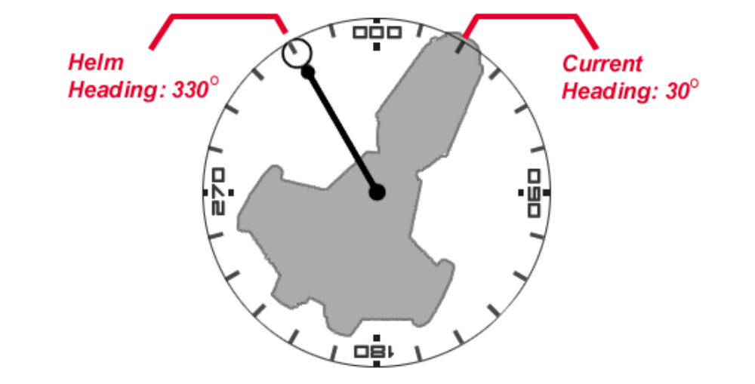
Figure 4. Starship Compass

Before we close out the mission, we will learn to control your destroyer from the outside view. Press F3 to switch to Orbit Cam. This is a tactical evocation view which allows you to see the universe through the eye of an imaginary camera that you control. In orbit view, the camera is always pointed at your ship and moves as your ship moves. As you command helm orders, the ship’s compass will be displayed as shown in Figure 4 above. Once your ship has come onto the new heading, the compass will disappear. Now might be a good time to try that box patrol pattern again.

GAMEPLAY INSTRUCTIONS - Fighter Combat

Now that you have learned basic maneuvering, let’s take a look at fighter combat. Like a real jet fighter, your ship is easy to fly but challenging to fight well. In order to fight efficiently, you will need to develop situational awareness. You will need to understand how your ship’s avionics work and what they are telling you about the universe. You will need to manage your sensors to find, track, and target enemy threats. And you will need to understand the performance envelope of your own weapons and how best to employ them. Let’s get started!

Run the Starshatter demo, and load Mission 2. Fighter Sweep. In this mission you and your wingman will have to take out three flights of enemy interceptors in orbit above a planet. Increase your throttle to maximum and then press P to pause the action. In the Starshatter demo, the pause function freezes the action in the simulation but still allows you to control the user interface. We will now use this feature to explore some of the interface options without getting killed in the process.

HUD - Main View

The main Head-Up Display (HUD) is the default viewing mode when the simulation starts. This view is shown in Figure 5 below. The HUD consists of a central reticle adorned with critical performance and targeting information, surrounded by four multi-function displays (MFDs) in the four corners of the display.

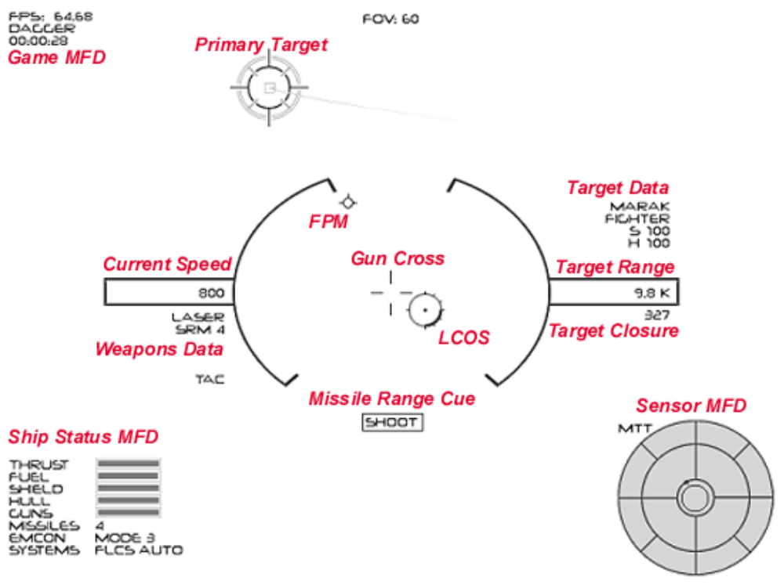
Figure 5. Fighter HUD

The left hand side of the HUD displays information about your ship, while the right hand side displays information about your current target. The left half of the reticle shows your current speed in meters per second, plus information about your current weapons loadout. When operating in atmosphere, the left half of the reticle also displays altitude and G load information for your ship.

The right side of the reticle indicates your current target’s name, type, and shield and hull strength (as percentages). Range to the current target is shown in the right side box. Target closure rate in meters per second is shown below the box. Positive numbers for closure mean that you are merging with the target, negative numbers mean that you are separating. Note that until you have locked onto a target, all of the target data fields in the HUD will be blank.

The central part of the reticle displays information about your flight path and firing solutions for the target. If you are in range for a missile shot, you will see the missile range cue “SHOOT” at the bottom of the reticle. For more on missile engagements, see the section Engaging with Missiles below. The HUD uses a Lead Computing Optical Sight (LCOS) to display gun solutions For more on gun solutions, see the section Engaging with Guns.

The default arrangement for the MFDs is depicted in the figure above. The upper left corner shows the Game MFD, including your ship name and mission clock. The lower left corner shows the Ship Status MFD, which displays throttle, fuel supply, ship integrity, weapons stores, and FLCS mode information.

The lower right corner shows the Sensor Field of View MFD. This is the default sensor MFD and shows a boresight view of the sensor picture in front of your ship. Targets are displayed in azimuth and elevation relative to the nose of your ship. This view shows the entire hemisphere of space in front of your ship. There are other sensor MFD modes that show the sensor picture from different viewpoints. This demo does not include an “Elite-style” 3D sensor MFD, but the full game will have one.

While the game is paused, you can try other MFD modes. Cycle the MFD modes by pressing the bracket keys on the keyboard. The [ key cycles the lower left MFD and the ] key cycles the lower right MFD. Use Shift + bracket to change the upper left and right MFDs.

Other Combat Views

The Starshatter demo provides four different views of the action, accessed by the first four function keys F1-F4. Press F1 to display the main view (this is the view you are in now). The main view uses a full screen HUD shown from a view point inside the cockpit or starship bridge.

Press F2 to display the Chase Cam. This shows you a view from above and behind your ship with the full HUD still displayed on the screen. The HUD targeting cues are all properly adjusted for the new point of view.

Press F3 to display the Orbit Cam. This shows you a view from outside your ship and focused on your ship. You can move the camera around by pressing and dragging the right mouse button. Zoom the view in and out by pressing and holding shift while right-dragging the mouse up and down. Repeatedly pressing F3 will change focus from your ship to every other ship you can detect with your sensors.

Press F4 to display the External Padlock view. This shows you a view from outside your ship focused on your target. This is a good way to maintain visual contact with your target if it is able to maneuver behind your ship. Repeatedly pressing F4 will change focus from your target to every other ship you can detect with your sensors.

Sensors

Space is a big empty place, and enemy ships can be small and very far away. In order to destroy the enemy, you must first find the enemy. Specifically, you must first detect the enemy’s presence. Then you must collect information about his flight path to track him through space. Finally you must lock the target to calculate a firing solution for your weapons. Your fighter is equipped with an advanced integrated sensor package that will help with all three tasks, while also keeping you informed if an enemy threat tries to do the same to you.

Be advised that this is a sensor package, not the psychic friends network. Your sensor can not see ships on the other side of the galaxy, and it can not effectively track ships that are behind you. Instead, your sensor is somewhat like a flashlight in a pitch black room. It can help you to see what it is pointed at, but it can only be pointed in one direction at a time. And like a flashlight, it will tend to give away your position to anyone who may be hiding in the shadows.

The sensor package operates in four different modes that are optimized to deal with one of the targeting phases described above. The first two modes, PAS and RWS, are search modes that help you detect targets. In both of these modes, the sensor works by scanning the sky directly in front of your fighter. The only difference between them is that the PAS mode is a passive-only search, while the RWS (Range While Search) mode uses both passive and active sensors.

The search pattern is a cone which extends 45° in azimuth and elevation to either side of your fighter’s nose as shown in Figure 6, below. Whenever the sensor array passes over a ship it will register a contact if the return is strong enough. The contact will be displayed in both the Sensor MFD and the main HUD. It takes about three seconds for the sensor to sweep the entire search pattern from left to right. If you turn your ship too rapidly, you can cause the sensor to miss contacts even if they are in range.

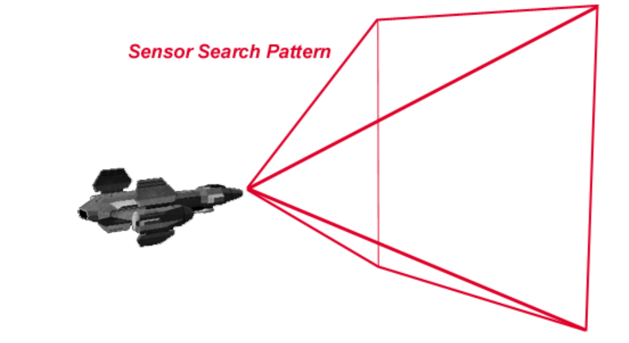
Figure 6. Sensor Cone

If the return from the active sensor scan is strong enough, your onboard computer can usually determine the contact type (fighter or starship), range, and closing velocity. This information will be shown in the contact code on the HUD. To the right of each contact marker diamond will be a contact code. “F” means the contact is a fighter and “S” means it is a starship. Range to the target in kilometers is displayed as a number from 1 to 999. Following the range number is either a plus sign “+” for positive closure or a minus sign “-” for negative closure. If you see a plus sign the contact is moving towards your ship.

If you are using your sensors to perform a passive search to reduce your emissions and limit your visibility to the enemy, range and closure data will not be available. In that event, the range and closure part of the contact code will be replaced with a “*”.

In addition to directly detecting contacts by scanning them in search mode, you can also detect enemy threats that have locked onto your ship with their own sensor packages. Your ship’s integrated sensor package include a Sensor Warning Receiver (SWR). This subsystem will detect the focused emissions of any sensor that has locked onto your ship. Any ships that have you locked up will be registered as contacts and will be visible in both the Sensor MFD and the main HUD. Unlike the main scanning sensor array, the SWR is active 360° around your ship. In addition to the normal contact diamond symbol, threats detected by the SWR will be marked with a circle in both the HUD and the Sensor MFD.

Unpause the simulation by pressing P, and fly in a slow circle. Your sensor is in RWS mode by default. Watch as it picks up contacts and displays them on the Sensor MFD and the HUD. Enemy contacts are shown in red, friendly contacts in blue. If the sensor return is too weak to make a friend-or-foe judgment, the HUD and the Sensor MFD will display the contact in gray. Aim your ship at one of the enemy contacts and press P again to pause the simulation.

Locking On

Now it is time to take the fight from the search phase to the engagement phase. This means that you need to select, track, lock, and fire upon one of the enemy contacts. The best way to do this is to designate the contact in your reticle as the current target, but you can’t do that while the game is paused. Press P to unpause the game. Then press T to lock onto the contact. Your HUD should update to show that the contact is being tracked. Press P to pause the game again while we examine the HUD and Sensor MFD.

If the you were able to lock on, the HUD should show the primary target crosshair on the target you selected. The right side of the HUD reticle should fill in with data on the target including range and closure rate. The LCOS pipper should be visible to give you a guns solution on the target. And if you are in missile range of the target you selected, you should see a SHOOT cue at the bottom of the HUD reticle.

When you lock onto a target from a search sensor mode such as RWS, you are telling the sensor that you want to stop searching for new targets and concentrate on destroying the particular target you have designated. In order to help you do this, the sensor will automatically change modes to Multi-Target Track (MTT). In this mode, the sensor will stop scanning space for new contacts and will start staring directly at each contact that it has already detected. This allows the sensor and fire control computer to do the best possible job of computing a firing solution on the target.

In order to maintain track on each contact in MTT mode, you must keep the contacts fairly close to the sensor boresight. The MTT envelope is shown in the sensor MFD as a small circle. As long as the contact stays inside the circle the sensor can keep tracking it on a regular basis. If the contact stays outside of the circle for more than ten seconds, the sensor will lose track and drop the contact. You can only re-acquire the contact by returning to a search mode such as PAS or RWS. You can switch back to a search mode by pressing F5 until the sensor MFD displays PAS or RWS.

Note that up until now, you have been acting relatively harmless. While the enemy ships may have been aware of your presence, they were unsure of your intentions. By locking onto them, you have removed all doubt from their minds. They now consider you very hostile, and will do whatever they can to prepare for the engagement.

Engaging with Missiles

The purpose of combat is to destroy the enemy, or at least to convince him to return to base without accomplishing his mission. In most situations, victory will go to the fighter who can attack effectively first. That means you should attack your target at the greatest range you can do so consistent with having a high probability of success. If you can get a good missile shot before the engagement merges to gun range, take the shot and move on to your next objective.

Your StormHawk fighter is equipped with four short range passive seeking missiles. The Hammer missile is a heavy duty anti-fighter munition with an all aspect passive seeker. You can engage with this weapon from any angle against any enemy fighter. The missile seeker is cued to the target you have selected in your HUD and will attempt to guide on that source. However, the seeker head will lock onto any hot target it can find even if you don’t have a target locked with your onboard sensors.

These missiles have a maximum effective range against a non-maneuvering target of about 30 kilometers. Your fire control computer knows this range and is constantly calculating a missile solution for the current target. As soon as the computer determines that the missile flight path could intersect the target flight path in 30 kilometers or less it will display the missile range SHOOT cue on the HUD.

For a face shot against an approaching target, this is usually at a range of 33 to 35 kilometers. If you are chasing the target from his six, the range will be a bit less than 30 kilometers. In any case, just because you see the word SHOOT on the HUD does not mean that you will get a hit if you release the weapon at that moment. It just means that your missile has enough fuel to cover the distance to the target if the target does not attempt to evade. The practical range against a maneuvering target is about 20 to 25 kilometers maximum and 5 to 8 kilometers minimum. You want to drive your fighter to a point about 10 to 20 kilometers from the target before releasing the weapon.

At the moment you release the weapon it will have the exact same orientation and velocity as your ship. Once it is clear of the launch rail the missile will light off its own motor and start accelerating rapidly in the same direction that you are facing. Throughout the missile’s flight time it will continuously correct its orientation to bring its flight path into a collision with the target. Obviously, the missile will have an easier time doing this if it starts out with a velocity and orientation that is already in the general direction of the target.

To maximize the missile’s probability of kill, you want to maneuver your fighter so that the target, your own FPM, and the LCOS pipper are all within center reticle of your HUD at the moment you reach optimal firing range. Those are listed in order of importance, so if you can’t get the LCOS to settle down don’t worry about it. Release the weapon using Joystick Button 2 or the spacebar on your keyboard.

Even though the Hammer missile is a “launch and leave” weapon remember that it is not a death ray. It won’t always score a complete kill on the enemy. If missiles always hit the target they wouldn’t be called missiles. If you are not already engaged defensive it is a good idea to watch the missile all the way to the target. If you lose sight of the enemy and don’t get the kill, you will give up the initiative in the fight. This is always a bad idea. Keep fighting while the missile is in flight. Plan ahead. Think about where you need to be if the target evades your shot and figure out how you will get there.

Keep an eye on the target status display in the upper right quadrant of the center reticle. Even if you only score a near miss on the target it may take some damage when the warhead detonates. If you don’t score the kill on the first shot you may still get another opportunity to try again. Remember that you only have four missiles and there may be more enemy fighters still out there.

Engaging with Guns

Just in case things get up close and personal, your StormHawk fighter is equipped with guns. The standard configuration is a pair of wing mounted laser cannons. Actually these weapons are not lasers at all. They fire short bursts of energetic charged particles collected from your fusion reactor. But the word “laser” gets the point across well enough. The minimum effective range on even short range missiles is about five kilometers. If your target gets within this range you will need to go to guns to get the kill.

Your laser cannons are very different weapons from your short range missiles. They fire unguided high speed projectiles with a high rate of fire and unlimited ammunition. The gun shots destabilize over time and become less effective with range. To maximize damage to the target, fire at the closest range possible.

Even though your gun shots are “high speed” they are not instantaneous. They take a small amount of time to travel from the gun barrel to the target. During that time of flight the target continues to move through the sky. Therefore in order to hit the target with a gun shot you need to lead the target, just like shooting a clay pigeon or throwing a long pass in a football game.
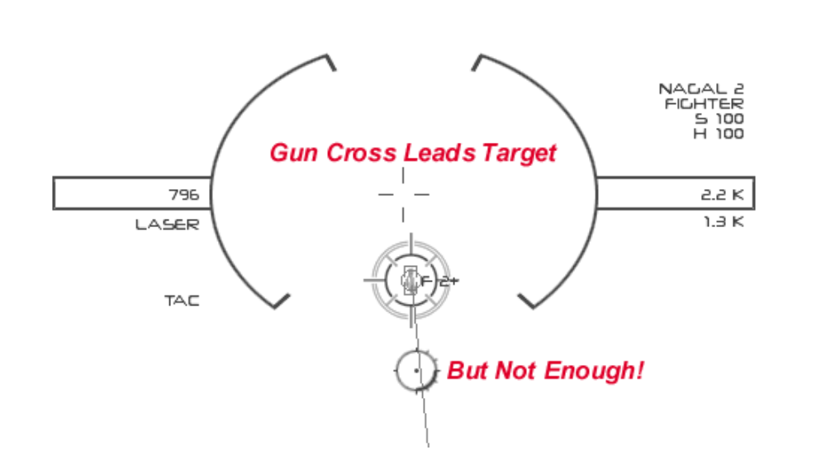
Figure 7. Insufficient Lead for Gun Solution

The central part of the reticle displays information about your flight path and firing solutions for the target. The HUD uses a Lead Computing Optical Sight (LCOS) to display gun solutions The LCOS pipper shows where your shot will lie with respect to the target. If the pipper is behind the target you are not “leading” enough. This is the situation shown in Figure 7. If the pipper is in front of the target you are leading too much. To maximize the chance of your shot hitting the target, pull the trigger when the pipper is right on top of the target.

If the engagement collapses into a furball, events may happen too rapidly to manage the normal search-track-lock-fire sensor sequence efficiently. At that point it may become advantageous to switch to the ACM sensor mode. This mode is designed especially for close range dogfighting. ACM mode is a “hands-free” sensor mode that automates the search-track-lock process so that you can concentrate on delivering maximum ordnance on target.

Press F5 repeatedly until the sensor MFD reads ACM. In this mode, the sensor will scan a small patch of sky around the nose of your ship, and it will automatically lock onto the first target it finds. As soon as you destroy the target, the sensor will return to search mode until it can lock onto another target.

Now that you have the tools, put them to use! Engage and destroy the six enemy fighters in this training mission. Your wingman is weapons free, and he will assist you. Good luck!

Atmospheric Combat

The tactics of atmospheric combat are very similar to those of orbital combat. The sensors and weapons have nearly identical performance under atmospheric conditions. The major differences derive from atmospheric density and the presence of terrain.

Since your fighter uses aerodynamic control surfaces to turn when it is operating in atmosphere, you must trade off speed for maneuverability. The higher you fly the less atmospheric drag you will encounter and the faster your fighter will be able to go. On the other hand, less air means less bite for your controls and slower turn rates with larger turn radii. You will turn much faster and tighter at an altitude of two thousand meters than at twenty thousand meters.

The other effect atmospheric drag has on combat is commonly called “speed bleed.” In order to turn your ship you need to generate lift with your wings by increasing angle of attack. Along with increased lift comes greatly increased drag which causes your ship to slow down. The more G load you place on your fighter, the more speed you will lose. You need to balance turn performance and air speed if you want to survive.

Terrain affects combat in two ways. First and most importantly, the terrain is a big hard thing that you don’t want to run into accidentally. Secondly, terrain plays a significant role in combat by masking your sensor returns in ground clutter. As you take your ship below one hundred meters AGL your sensor return will become less and less distinct until you seem to fade into obscurity. Of course, it takes a certain amount of skill to fly ten meters off the deck at three hundred meters per second over rolling terrain.

Let’s give it a try! Load Mission 3. Air Superiority. In this mission you and your wingman will have to take out two flights of enemy interceptors in the air space above Emperion on the terrestrial moon Navara. Note that the Starshatter simulation of this moon exists in real time even when you are not playing the game. If the real time clock on your computer indicates that the sun should be up at your location on Earth, you can expect to fly in daylight over Emperion. Likewise if you are playing the demo at night, it will be very dark in the simulation.

GAMEPLAY INSTRUCTIONS - Starship Combat

Starship combat is quite different from fighter combat. The ships are larger and less maneuverable which makes the pace of maneuver somewhat slower. Starship sensors and weapons are much more powerful and offer more complete coverage which widens the scope of battle considerably from the fighter experience.

Run the Starshatter demo, and load Mission 4. Destroyer Duel. In this mission you will command the Spectre while the computer commands the Phantom. Your small squadron will face a pair of enemy destroyers, the Mortak and the Narlak. For this demo, the enemy is using the exact same destroyer that you are commanding. This will not be the case in the full version of the game.

Tactical Views

Due to the wide-ranging nature of starship combat, you will seldom control your ship from the standard first person HUD view. You really need to be able to see the situation all around your ship, and it is much easier to do that from a tactical view like F3 Orbit Cam. This shows you a view from outside your ship and focused on your ship. You can move the camera around by pressing and dragging the right mouse button, or by holding the Shift key and using the keyboard arrow keys.. Zoom the view in and out by pressing and holding Shift while right-dragging the mouse up and down, or by using the + and - keys on the keyboard. Repeatedly pressing F3 will change focus from your ship to every other ship you can detect with your sensors.

While in this camera mode, you can left click to select any visible ship. Once you have selected a ship, it will be highlighted with small green selection brackets at the corners of its visible extent. You can change the view focus directly to the selected ship by pressing the V key on the keyboard. This will place the selected ship at the center of the display and allow you to move the camera around to view it from all sides. Sometimes you may want to get a picture of both the selected ship and your own ship at the same time. Press Shift+V to view a point half-way between the two ships. You can then use the zoom keys (+/-) to move the camera to a point where both ships are visible.

Often you will select a ship because you want to designate it as your current target. You can target the selected ship by pressing Shift+T. As a shortcut, you can simultaneously select and target any ship simply by double clicking it.

Starship Sensors

Because starships are so much larger than fighters, they have room for a much wider array of sensing and processing equipment. As a result, starship sensors are much more capable than the limited fire control systems on fighters. Starships can continuously search for new contacts even while tracking existing targets, and they can do this almost 360° around the ship. As a result, starship sensors only operate in a single mode, displayed as SCAN on the sensor MFD. The only real limitation to starship sensors is that they have a blind spot directly aft of the ship caused by the shower of high energy particles emitted from the drive projectors.

Starship Weapons

The Spectre class destroyer used in this demo mounts three different types of weapon systems. Larger ships of the line usually carry even more.

Main Laser Batteries

The centerpiece of the destroyer’s offensive capability are the four x-ray beam laser turrets mounted on the primary hull. When fired in concert they deliver a devastating punch to enemy shields and hull armor. Like all energy weapons, the main laser batteries are primarily used in short range situations. They have a maximum effective range of 100 kilometers.

Each laser beam is generated in one of the long gun tubes affixed to the primary hull. At the business end of each tube is an electro-mechanical optics assembly that can slew the beam up to 45° off centerline in azimuth and up to 25° of centerline in elevation. The optics are tied in to the targeting system and will automatically focus the beam on the current target as long as it is within the gimbal limits of the optics. Although in theory they are separately targetable, in practice all four are always slaved to the same target to concentrate fire and maximize probability of kill.

Fusion Torpedoes

For long range engagements, the Spectre class destroyer mounts two fusion torpedo launchers each of which carries eight fusion torpedoes. The torpedo is a long range autonomously guided anti-ship munition powered by a fusion reactor drive. When the torpedo is within range of the target it overloads the reactor resulting in a fusion detonation in the five kiloton range. They have an effective range of over 200 kilometers against most starship types.

Point Defense Batteries (PDBs)

For fighter defense, the destroyer mounts two point defense batteries, one on either side of the central hull. These weapons are rapid fire particle cannon turrets. They are similar to, but much more powerful than, the guns found on most fighters. Normal procedure is to configure these weapons for point defense mode, in which they will automatically engage any hostile target that falls within their range.

Tactical Console

While it is possible to directly control the primary and secondary weapons from the first person view much as you would do when flying a fighter, you can get much more precise control over the full range of weapons from the tactical console. Press P to pause the simulation and then press W to display the tactical console.

Note: To save space, the Starshatter demo does not include high resolution versions of the Tactical, Engineering or Navigational consoles. If you are running the demo at a screen resolution of 1024 x 768, these consoles will not use the full screen display. Full resolution versions of these screens will be included in the full game. The recommended resolution for the demo is 800 x 600.

Along the left side of the tactical console is a list of the various weapon control groups available on your ship. You can select one weapon system at a time by clicking the button marked with its name in this window. Once you have selected a weapon system, information about it will be shown in the detail panel at the bottom of the console. You can individually target each weapon system by selecting the target in the 3D camera window and then pressing the TGT button next to the weapon system. You can manually fire each weapon by pressing the FIRE button next to the weapon system.

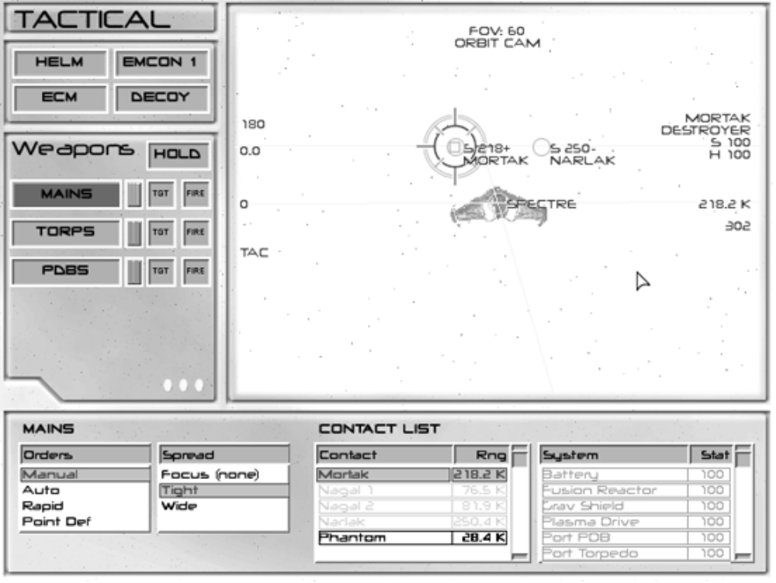

Figure 8. Tactical Console

The detail panel allows you to control targeting and firing orders for the currently selected weapon system. On the right side of the panel is the contact list. You can assign a target to the current weapon by clicking on it in the contact list. Next to the contact list is the system list. Once a contact has been selected, the system list displays the name and status of each major system on that ship. If you want more precise control over aiming, you can click on one of the systems in this list and the weapon will try to aim at that system on the ship. If no subtarget is selected, the weapon will aim at the center of the target ship.

On the left side of the detail panel are firing and aiming orders for the current weapon. Each weapon can be assigned one of four firing orders:

Manual - The weapon will fire only when directly ordered by the FIRE button (or the equivalent button on the joystick or keyboard). This is the default mode.

Auto - The weapon will fire on the target whenever the target is in range, within the aiming cone for the weapon, and the weapon has a full charge. All manual fire controls are disabled for this weapon in this mode.

Rapid - The weapon will fire on the target whenever the target is in range, within the aiming cone for the weapon, and the weapon has at least the minimum charge needed to operate. All manual fire controls are disabled for this weapon in this mode.

Point Def - The weapon will automatically engage any enemy ship that comes within range. You can not specify a specific target for the weapon in this mode. All manual fire controls are disabled for this weapon in this mode.

Beam lasers can also be assigned an aiming order called a spread. To increase the chances of hitting a particular system on an enemy ship, beam lasers will automatically sweep the area around the specified system. The aiming order controls how wide a pattern they use to sweep the target. The choices are Focus, Tight, and Wide spread. In general, you should use a tighter spread at longer ranges and a wider spread at closer ranges.

Stealth and Countermeasures

At the top left of the tactical console are controls for emission control (EMCON), electronic countermeasures or “jammers” (ECM) and decoy deployment. These controls are not available in the demo.

Engineering Console

No matter how careful you are, various systems on your ship will probably take some damage during combat. The engineering console provides a means for you to evaluate the damage, initiate repairs, and control power distribution aboard your vessel. Press E to display the engineering console.

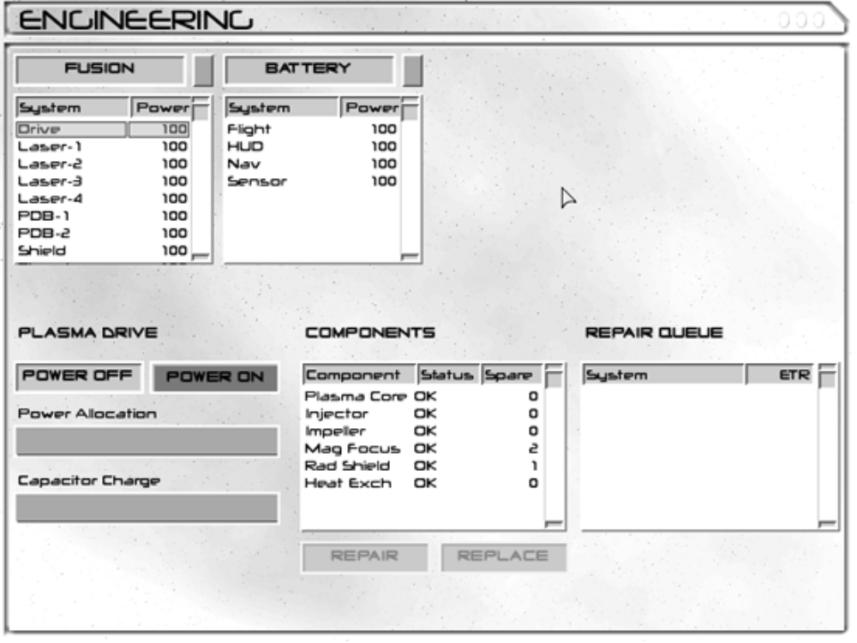

Figure 9. Engineering Console

Power Management

Each system on board your ship needs power to operate. To provide that power, your ship is equipped with a number of power sources. Across the top of the engineering console you will see a button representing each available power source. The Spectre class destroyer uses a single fusion reactor as the main power source, and also provides a battery system for backup power.

Below each power source button is a list of the systems that are currently attached to that power source. You can re-assign systems to different power sources whenever you want simply by left-clicking on them and dragging and dropping them to the list where you want them assigned.

On the bottom left part of the console are controls for setting the power level for the currently selected system. Simply click on a system or a power source button to select it. Then left-drag the Power Allocation slider to adjust the power level. If you reduce the power level for a power source, you are reducing the amount of power it produces, whereas if you reduce the power level for a system, you are reducing the amount of power it will get from the power source it is attached to.

Note that each power source has a maximum output rating in Watts. Each system requires a certain amount of power to run. If you assign more systems to a power source than it can supply, the power source will be forced to ration output (called a brown-out) to each system. This will reduce the efficiency of most systems, but is very bad for computer systems. If a computer system does not get its rated allocation of power it will shut itself down to prevent damage.

You can turn systems on and off using the Power On and Power Off buttons above the allocation slider.

Damage Control

When a system is hit by enemy fire, some of its components may be damaged or destroyed. To repair a system, you must repair or replace the damaged components. Damaged components are shown in yellow and have a status of WARN, while destroyed components are shown in red and have a status of FAIL.

To repair or replace a component simply select it from the component list and left-click the Repair or Replace button below the component list. Repair and replace times are displayed below the buttons. Note that some components are quicker to replace than repair.

Once you select a component for repair, the entire system will be shut down and placed in maintenance mode. A repair crew will begin work on the order you submitted. Your ship has multiple repair crews that can repair multiple systems at the same time, but each repair crew can only work on one system. When the repair work is completed, the system will be returned to operational status. You can then restore power to the system and resume using it.

Tactics

Press P to unpause the simulation. Press W to display the tactical console. Target the Martak, and fire all of your torpedoes at maximum range. Come right 90° and go to full thrust. Stay away from the enemy ships until after your torpedoes have hit. Then close and mop up with your main guns.

TROUBLESHOOTING

General Troubleshooting

For an alpha demo release, the Starshatter Demo 2.0 is pretty stable. There are no known crash bugs in this release. However, it has not been tested on a wide variety of configurations, so there may be compatibility problems getting it to run on your particular system.

If the demo refuses to run, locks the machine, or crashes to the desktop, first check to make sure that your system meets the minimum requirements. In particular, make sure that you have adequate swap space. Check with your computer and video card manufacturer for updated drivers.
If the demo still crashes, check the errlog.txt file. It may be able to diagnose the problem. If you can, please e-mail a copy of this file to milod@home.com, and I will try to assist you through e-mail.

Video Troubleshooting

When the Starshatter demo is first installed, it defaults to 640x480 256 color mode with a software renderer. Once you configure the video options, they are stored in the file video.cfg in the game directory. If you manage to select video options that are incompatible with your video card, just delete the video.cfg file. This will cause the demo to return to its default settings, and allow you to try another set of options.

To save space, the Starshatter demo does not include high resolution versions of the Tactical, Engineering or Navigational consoles. If you are running the demo at a screen resolution of 1024 x 768, these consoles will not use the full screen display. Full resolution versions of these screens will be included in the full game. The recommended resolution for the demo is 800 x 600.

CREDITS AND CONTACT INFO

Development
Producer milo
Designer milo

Lead Programmer milo
nGen Programmer milo
Magic3D Programmer milo

Lead Artist milo
Player Manual milo

Creative Consultants
Design Greg Eakin
Graphics Mark DiCamillo

Technical Consultants
Digital Control Systems David Jenkins
Aerodynamics Joseph R. DiCamillo

Public Relations
Web Site http://members.home.net/milod
E-mail milod@home.com

The Starshatter Universe and all related indicia
Copyright © 1997-2000 John DiCamillo
All rights reserved.

KEYBOARD REFERENCE CARD

Game Controls
Exit to Menu Esc
Pause Game P
Accelerate Time 1,2,4,8x Insert
Decelerate Time Delete
Jump to Next Ship Tab
Take Screenshot F12

Flight Controls
Pitch Up Arrow Down Joystick Back
Pitch Down Arrow Up Joystick Forward
Yaw (Turn) Left Arrow Left Joystick Left
Yaw (Turn) Right Arrow Right Joystick Right
Roll (Bank) Left Ctrl + Arrow Left Joystick Left + Button 3
Roll (Bank) Right Ctrl + Arrow Right Joystick Right + Button 3

Translate Up Page Up Joystick Hat Up
Translate Down Page Down Joystick Hat Down
Translate Left < Joystick Hat Left
Translate Right > Joystick Hat Right
Translate Forward Home
Translate Backward End

Increase Throttle A
Decrease Throttle Z
Full Stop (Zero Throttle) S

Toggle FLCS Mode (Fighters only) M
Break Orbit (Fighters only) O

Fire Controls
Target Ship in Reticle T
Target Selected Ship Shift + T
Fire Primary Weapon F Joystick Button 1
Fire Secondary Weapon Space Joystick Button 2
Cycle Sensor Mode F5

View Controls
Main View F1
Chase View F2
Orbit View F3
External Padlock View F4

Zoom In (Orbit View) +
Zoom Out (Orbit View) -
View Selection V

HUD Mode Cycle H
Caution / Warning Indicators C
Toggle Normal / Wide Angle K
Swap Control Axes (Yaw/Roll) J
NAV Console N
ENG Console E
WEP Console W

Lower Left MFD Mode [
Lower Right MFD Mode ]
Upper Left MFD Mode Shift + [
Upper Right MFD Mode Shift +]

