STARSHATTER^{tm} DEMO 2.0
Player Manual
Copyright © 2000 John DiCamillo

http://members.home.net/milod
milod@home.com

INTRODUCTION

Thank you for downloading the Starshatter Demo 2.0. This Player Manual will give you a brief introduction to the game and how to play it. It will also help you to evaluate the demo, and explain the best ways to provide feedback.

What Is Starshatter?

Starshatter is a new space combat simulation game that is currently in the middle stages of development. The game offers a new type of combat experience in an original science fiction universe. Unlike most other games, which limit the player to flying fighters and other small craft, Starshatter gives you the opportunity to directly command a wide variety of ships, from agile atmospheric and space-based fighters to giant battleships and fleet carriers. Starshatter aims to simulate the complete space combat experience -- from planet surface to interstellar space -- with several dynamic campaigns set in a persistent simulated universe.

Starshatter is being developed for IBM PC compatibles running Microsoft Windows 95, Windows 98, Windows NT, or Windows 2000.

Game Features

- Intelligent Combat Scenarios
- Realistic Physics
- Newtonian Space Combat (with computer assist)
- Hardcore Atmospheric Flight Modeling
- Realistic Sensors and Avionics
- Realistic Space Environments
- Stunning 3D Accelerated Graphics
- Stereo Sound

What Is This Demo All About?

This early demo is being released to solicit feedback from the space sim community. If you've ever wanted to influence a space sim game design, now's your big chance! At this stage of development, the graphics engine and basic gameplay mechanics are complete. Advanced AI, the dynamic campaign engine, and multiplayer features are still being developed.

After you've had a chance to play the game a bit, please tell me what you think of it! Any and all comments are welcome -- good and bad alike. The main thing I want to know is: did you enjoy the demo? And are you interested in playing the full game when it is complete? Are there any other features you really want to see? Send your comments to milod@home.com.

What Is Required to Play?

Hardware Requirements

Recommended Minimum System:
Pentium II 400 MHz (or equivalent)
64 MB system RAM
24 MB available hard disk space
Direct3D compatible 3D accelerator with AGP 2x and 32 MB RAM
DirectX compatible Sound Card
3 or 4 Axis Joystick with 4 buttons and hat switch
Mouse

Operating System and Drivers

Starshatter is being developed for IBM PC compatibles running Microsoft Windows 95, Windows 98, Windows NT 4 (SP 3+), and Windows 2000. It should also work under Windows ME, but this has not been tested. Starshatter uses DirectX to access audio and video hardware. You must have at least DirectX version 3.0 installed for the game to run, but either DirectX 6.1 or DirectX 7 is strongly preferred.

Note that 3D accelerated graphics are available under Windows 95, Windows 98, and Windows 2000 only. When Starshatter is run under Windows NT 4, it will use a custom software rendering mode. The software rendering mode can also be used if there are any problems getting Starshatter to work with your 3D hardware.

INSTALLATION

The Starshatter demo is being distributed as a compressed archive (ZIP file). To install the demo, create a directory of your choice (e.g. C:\Games\StarDemo) and unzip the contents of the archive into it. To play the demo, double click the stars.exe icon in the new directory.

To uninstall the demo, simply delete the directory and all its contents. The Starshatter demo will not modify the system registry, or any other directory on your computer.

SETUP / OPTIONS

The Starshatter demo can be completely configured from within the game itself, no separate setup program is needed. Just select the OPTIONS button in the main menu before starting a mission to configure the demo for your video card.

Video Options

The Starshatter demo supports screen resolutions of 640x480, 800x600, and 1024x768. The software rendering mode can operate in 256 color palette mode (recommended for slower computers) or 16 bit high color mode. The Direct3D hardware accelerated renderer can operate in 16 bit or 32 bit true color modes.

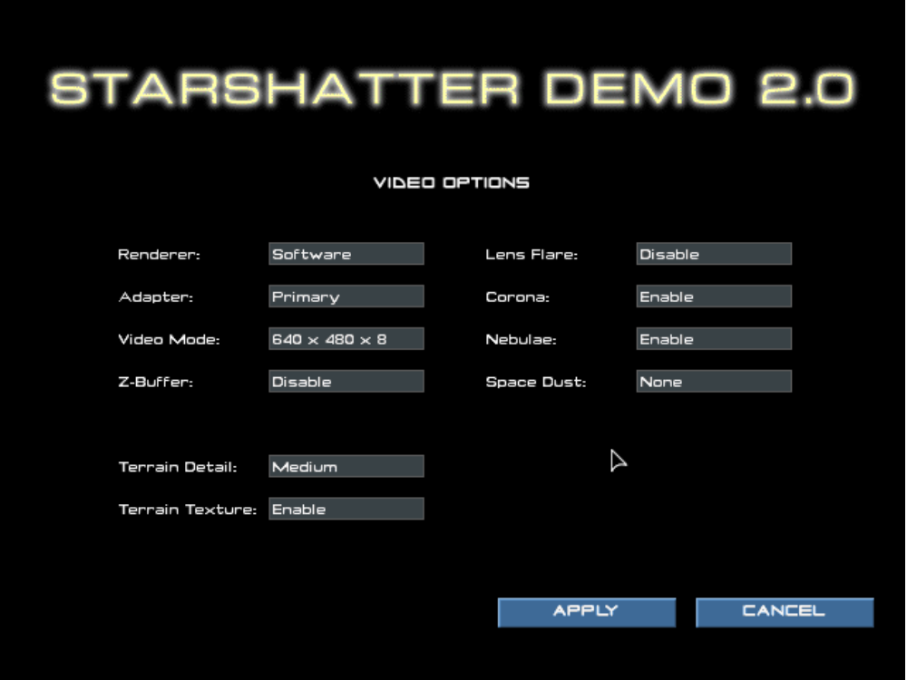

Direct3D Options

The Starshatter demo supports Direct3D versions 3, 6.1, and 7. Choose the highest version of Direct3D that will run on your computer. You can download the latest version of DirectX from the Microsoft web site http://www.microsoft.com/directx.

The Direct3D renderer supports the use of a hardware Z buffer for visible surface determination. Using the Z buffer will produce a better looking image than using the software depth sorting algorithm. However, the Z buffer does take up some video memory. Most first generation 3dfx Voodoo Graphics accelerators can only use a Z buffer in 640x480 display mode. If you have a card of this type and want to use the 800x600 display mode, you can turn off the Z buffer by deselecting the button in the options menu.

By default, the Direct3D renderer will use the primary 3D device if more than one are present. For example, if your computer has both an nVIDIA GeForce card and a 3dfx Voodoo2 card installed, the Starshatter demo Direct3D renderer will use the GeForce card. If you wish to use your secondary 3D device instead of the primary 3D device, select the Secondary Adapter option in the options menu.

Detail Options

The Starshatter demo allows you to configure a variety of settings to control the graphical detail of the simulation. You can enable or disable lighting effets such as coronas and lens flares to suit your taste. By default, the space scenes in Starshatter are rendered with beautiful alpha blended digital matte paintings of colorful nebulae. The background paintings are designed to be rendered in a 32 bit true color display mode. If your video card is limited to 16 bit high color modes, or if it is short on fill rate or slow at alpha blending, you may wish to disable the nebula effect.

NOTE

Changes you make to video settings do not become permanent until you exit the demo normally. If you select video options that cause the game to crash or otherwise hang your computer, the demo will automatically revert to the last known working set of video options when you restart.

Control and Keyboard Configuration

The Starshatter demo 2.0 remap the default keyboard control bindings to suit your taste. Note that you are limited to changing bindings for the keyboard. You can not remap joystick buttons to different functions, and for the demo at least, the mouse is not supported as a flight control device.

The Control dialog also allows you to select the joystick device you wish to use as a flight controller, and to enable or disable the rudder and throttle control axes to match your system. The two sliders in the lower right of the Control dialog allow you to set the joystick sensitivity and dead zone, respectively. If you are seeing a slight drift in the simulation that can be canceled by the trim pots on your joystick, you may need to increase the dead zone setting to keep your ship on a straight path.
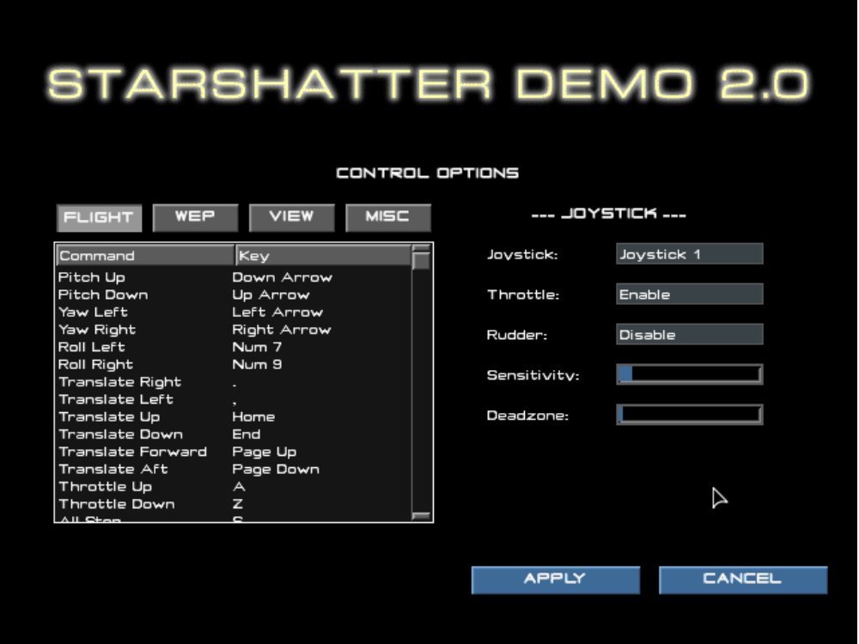

The keyboard command bindings are displayed in the listbox on the left. There are four categories of commands: Flight Controls, Weapons and Targeting, View Controls, and Miscellaneous Controls. You can view and edit the bindings in any category by first clicking on the button corresponding to the category. The Control dialog will then display the keyboard and joystick bindings for the selected category in the list box.

To remap a keyboard command binding, simply double-click the listbox item which corresponds to the binding you wish to modify. This will display the Key Map dialog box for the selected command. To change the binding to a new keystroke, press the desired key combination on your keyboard, and then click the Accept button with your mouse. The old binding is discarded and replaced with the new binding.

Keyboard command bindings are stored in the file KEY.CFG in the game directory. To discard all of your changes and revert to the default keyboard bindings, simply delete or rename this file and restart the demo.

GAMEPLAY INSTRUCTIONS - Quick Start

Main Menu Screen

Mission List

This list box contains the names of the four missions in the demo. Choose the mission you want to play by clicking on it with the mouse.

Mission Info

When you select a mission in the mission list, this display will show you a brief description of the mission.

Start Game

Once you have selected a mission, left-click the START GAME button to begin or resume play. If you exit a mission and return to the main menu screen, you can return to the action where you left off by clicking START GAME again. If you choose a different mission from the mission list and click START GAME, you will abort the first mission and start the new mission from the beginning.

Exit

Click this button to quit the demo and return to Windows. You can also press Esc on the keyboard to quit.

Basic Controls

This is the minimum set of controls you need to know to control your ship and play the game:

Pitch Up Arrow Down Joystick Back
Pitch Down Arrow Up Joystick Forward
Yaw (Turn) Left Arrow Left Joystick Left
Yaw (Turn) Right Arrow Right Joystick Right

Increase Throttle A
Decrease Throttle Z
Full Stop (Zero Throttle) S

Target Ship in Reticle T
Fire Primary Weapons F Joystick Button 1
Fire Secondary Weapons Space Joystick Button 2

Exit to Menu Esc

TROUBLESHOOTING

General Troubleshooting

For an alpha demo release, the Starshatter Demo 2.0 is pretty stable. There are no known crash bugs in this release. However, it has not been tested on a wide variety of configurations, so there may be compatibility problems getting it to run on your particular system.

If the demo refuses to run, locks the machine, or crashes to the desktop, first check to make sure that your system meets the minimum requirements. In particular, make sure that you have adequate swap space. Check with your computer and video card manufacturer for updated drivers.
If the demo still crashes, check the errlog.txt file. It may be able to diagnose the problem. If you can, please e-mail a copy of this file to milod@home.com, and I will try to assist you through e-mail.

Video Troubleshooting

When the Starshatter demo is first installed, it defaults to 640x480 256 color mode with a software renderer. Once you configure the video options, they are stored in the file video.cfg in the game directory. If you manage to select video options that are incompatible with your video card, just delete the video.cfg file. This will cause the demo to return to its default settings, and allow you to try another set of options.

To save space, the Starshatter demo does not include high resolution versions of the Tactical, Engineering or Navigational consoles. If you are running the demo at a screen resolution of 1024 x 768, these consoles will not use the full screen display. Full resolution versions of these screens will be included in the full game. The recommended resolution for the demo is 800 x 600.

CREDITS AND CONTACT INFO

Development
Producer milo
Designer milo

Lead Programmer milo
nGen Programmer milo
Magic3D Programmer milo

Lead Artist milo
Player Manual milo

Creative Consultants
Design Greg Eakin
Graphics Mark DiCamillo

Technical Consultants
Digital Control Systems David Jenkins
Aerodynamics Joseph R. DiCamillo

Public Relations
Web Site http://members.home.net/milod
E-mail milod@home.com

The Starshatter Universe and all related indicia
Copyright © 1997-2000 John DiCamillo
All rights reserved.

KEYBOARD REFERENCE CARD

Game Controls
Exit to Menu Esc
Pause Game P
Accelerate Time 1,2,4,8x Insert
Decelerate Time Delete
Jump to Next Ship Tab
Take Screenshot F12

Flight Controls
Pitch Up Arrow Down Joystick Back
Pitch Down Arrow Up Joystick Forward
Yaw (Turn) Left Arrow Left Joystick Left
Yaw (Turn) Right Arrow Right Joystick Right
Swap Roll / Yaw J

Translate Up Page Up Joystick Hat Up
Translate Down Page Down Joystick Hat Down
Translate Left < Joystick Hat Left
Translate Right > Joystick Hat Right
Translate Forward Home
Translate Backward End

Increase Throttle A
Decrease Throttle Z
Full Stop (Zero Throttle) S
Max Throttle Shift + A

Toggle FLCS Mode (Fighters only) M
Break Orbit (Fighters only) O

View Controls
Main View F1
Chase View F2
Orbit View F3
External Padlock View F4

Zoom In (Orbit View) +
Zoom Out (Orbit View) -
View Selection V
View Both Self and Selection Shift + V

HUD Mode Cycle H
HUD Color Cycle Shift + H
Caution / Warning Indicators C
Toggle Normal / Wide Angle K

NAV Console N
ENG Console E
WEP Console W

Lower Left MFD Mode [
Lower Right MFD Mode ]
Upper Left MFD Mode Shift + [
Upper Right MFD Mode Shift +]

Fire Controls
Target Ship in Reticle T
Target Threat (Combat Drone) Shift + T
Fire Primary Weapon F Joystick Button 1
Fire Secondary Weapon Space Joystick Button 2
Release Decoy Drone D

Cycle Sensor Mode F5
Cycle Sensor Azimuth F6
Decrease Sensor Range F7
Increase Sensor Range F8
Launch Sensor Probe F9

Decrease Shield Power F10
Increase Shield Power F11

