  L1 FA24

Q1:

Software Requirements Specification

for

DTFPT – DAO TAO FPT

Version 1.0 approved

Prepared by

Nguyen Quang Gia Khoi – DE190016

FPT University Da Nang Campus

18/7/2025

Q2:

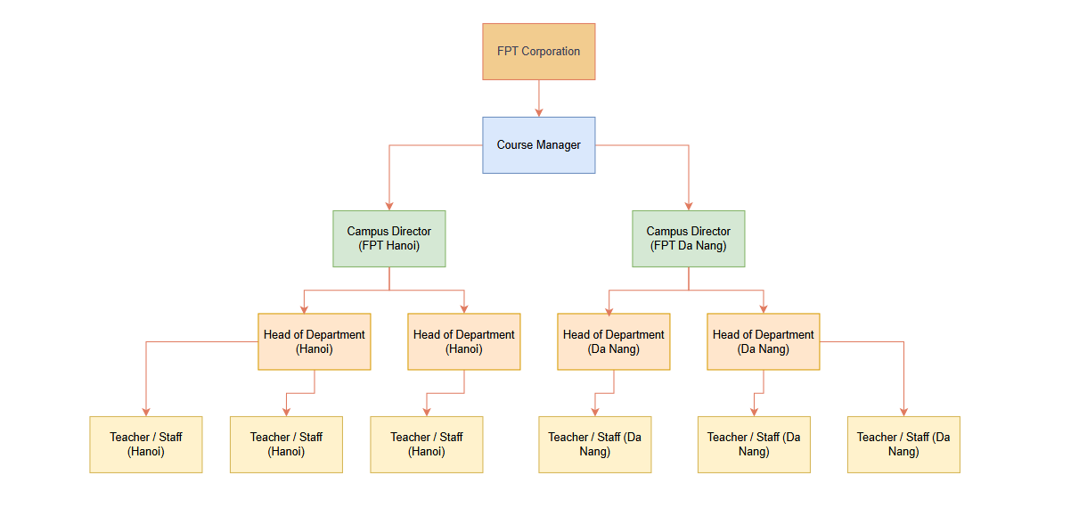 Q3:

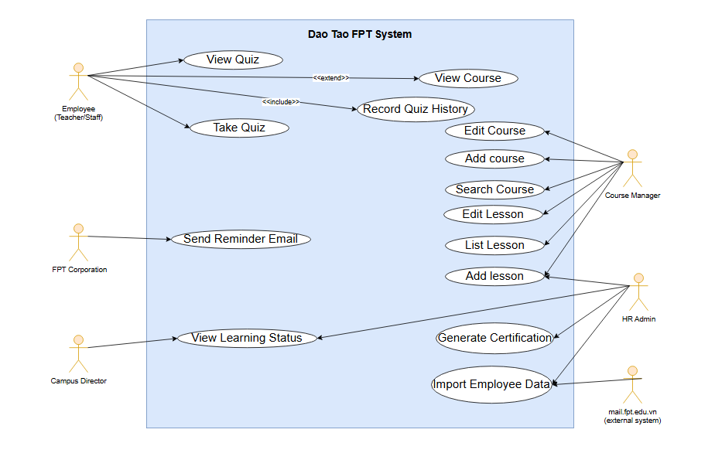**Q4:**

|  |  |  |  |
| --- | --- | --- | --- |
| UC ID and Name: | UC-1 Add Lesson | | |
| Created By: | giakhoiquang@gmail.com | Date Created: | 18/07/2025 |
| Primary Actor: | Course Manager | Secondary Actors: | HR Admin |
| Trigger: | Course Manager selects an existing course and chooses to add a new lesson | | |
| Description: | - The Course Manager is logged in to the DTFPT system.  - The course to which the lesson will be added already exists.  - The Course Manager has permission to modify the course. | | |
| Preconditions: | - A new lesson is successfully created and linked to the selected course.  - The lesson becomes visible to authorized roles for further actions (e.g., editing, adding quizzes) | | |
| Post conditions: | - A new lesson is successfully created and linked to the selected course.  - The lesson becomes visible to authorized roles for further actions (e.g., editing, adding quizzes). | | |
| Normal Flow: | 1. Course Manager logs in.  2. Navigates to Course Management.  3. Selects a course from the list.  4. Clicks "Add Lesson" button.  5. Fills in the lesson title, description, and optional resources.  6. Clicks "Save".  7. System stores the lesson and confirms success. | | |
| Alternative Flows: | A1: Course Manager leaves required fields empty → System shows validation errors.  A2: Course Manager clicks “Cancel” → System discards changes and returns to course page. | | |
| Exceptions: | E1: Network interruption → System shows error and allows retry.  E2: Server/database error → System logs the issue and notifies the Course Manager with an error message. | | |
| Priority: | High | | |
| Frequency of Use: | Frequently, especially before a new course starts | | |
| Business Rules: | - Lesson name must be unique within its course.  - Only Course Managers are allowed to add lessons.  - Each lesson must have a title and be linked to a course. | | |
| Other Information: | The lesson can later be edited, and quizzes can be added by the same or other authorized users. | | |
| Assumptions: | The system is online, the user has appropriate rights, and the course data is not corrupted. | | |

**Q5:**

**a. Most important non-functional requirement: Performance**

| **No** | **Description** |
| --- | --- |
| **1** | The DTFPT system must respond to course page requests (including course listing and viewing lessons) in less than 2 seconds for 95% of users. |
| **2** | The system must be able to support at least 10,000 concurrent users during peak working hours |

**b. Second most important non-functional requirement: Availability**

| **No** | **Description** |
| --- | --- |
| **1** | The DTFPT system must be available **at least 99.5% of the time per month,** excluding planned maintenance. |
| **2** | The system must have **automatic recovery and error logging** so that critical services are restored within **10 minutes** after unexpected failures. |