

**CAPSTONE PROJECT REPORT**

**BUILDING JAPANESE COMMUNICATION AND CULTURE LEARNING PLATFORM**

**Report 3 – Software Requirement Specification**

– Da Nang, June 2025 –

**Table of Contents**

**I. Record of Changes 5**

II. Software Requirement Specification 6

1. Product Overview 6

2. User Requirements 7

2.1 Actors 7

2.2 Use Cases 8

2.2.1 Diagram(s) 8

2.2.2 Descriptions 9

2.2.2.1 UC-01: Register an Account 11

2.2.2.2 UC-02: Apply as Native Partner 12

2.2.2.3 UC-03: Submit Verification Documents 13

2.2.2.4 UC-04: Admin Review Partner Application 14

2.2.2.5 UC-05: View Public Courses and Classrooms 15

2.2.2.6 UC-06: View Course Details as Guest 16

2.2.2.7 UC-07: View Account Information 17

2.2.2.8 UC-08: Change Password 18

2.2.2.9 UC-09: Change Account Information 19

2.2.2.10 UC-10: Manage User Accounts 20

2.2.2.11 UC-11: View Unapproved Partners 21

2.2.2.12 UC-12: View Unapproved Partner’s Documents 22

2.2.2.13 UC-13: Approve Partner Status 23

2.2.2.14 UC-14: Reset User Password 24

2.2.2.15 UC-15: View Classroom List 25

2.2.2.16 UC-16: Search a Classroom 26

2.2.2.17 UC-17: View Classroom Details 27

2.2.2.18 UC-18: View My Classrooms 28

2.2.2.19 UC-19: View Classroom Dashboard 29

2.2.2.20 UC-20: Join Video Call 30

2.2.2.21 UC-21: Manage My Classrooms 31

2.2.2.22 UC-22: View Enrolled Learners 32

2.2.2.23 UC-23: Host a Video Call 33

2.2.2.24 UC-24: View Courses List 34

2.2.2.25 UC-25: Search a Course 35

2.2.2.26 UC-26: View Course Details 36

2.2.2.27 UC-27: Buy Course 37

2.2.2.28 UC-28: Confirm Course Payment 38

2.2.2.29 UC-29: View My Courses 39

2.2.2.30 UC-30: Watch Video Lessons 40

2.2.2.31 UC-31: Rate Course 41

2.2.2.32 UC-32: Manage Courses 42

3. Functional Requirements 43

3.1 System Functional Overview 43

3.1.1 Screens Flow 43

3.1.2 Screen Descriptions 47

3.1.3 Screen Authorization 50

3.1.4 Non-Screen Functions 52

3.1.5 Entity Relationship Diagram 53

3.2 User Account Management 57

3.2.1 Register Account 57

3.2.2 Login System 57

3.2.3 Logout System 57

3.2.4 Reset Password 57

3.2.5 Change Password 57

3.2.6 Change Account Information 57

3.3 Partner Application & Verification 57

3.3.1 Apply as Native Partner 57

3.3.2 Submit Verification Documents 57

3.4 Admin User Management 57

3.4.1 Manage User Accounts 57

3.4.2 View Unapproved Partner List 57

3.4.3 View Unapproved Partner’s Documents 57

3.4.4 Approve Partner 57

3.4.5 Reset User Password 57

3.5 Course Management and Enrolment 57

3.5.1 View Course List 57

3.5.2 Search a Course 57

3.5.3 View Course Details 57

3.5.4 Buy Course 57

3.5.5 Confirm Course Payment 57

3.5.6 View My Courses 57

3.5.7 Watch Video Lessons 57

3.5.8 Rate Course 57

3.5.9 Manage Courses 57

3.6 Classroom Management and Interaction 58

3.6.1 View Classrooms List 58

3.6.2 Search a Classroom 58

3.6.3 View Classroom Details 58

3.6.4 View My Classrooms 58

3.6.5 View Classroom Dashboard 58

3.6.6 Manage My Classrooms 58

3.6.7 View Enrolled Learners 58

3.6.8 Join Video Call 58

3.6.9 Host a Video Call 58

4. Non-Functional Requirements 59

4.1 External Interfaces 59

4.1.1 User Interfaces 59

4.1.2 Hardware Interfaces 59

4.1.3 Software Interfaces 59

4.1.4 Communication Interfaces 60

4.2 Quality Attributes 60

4.2.1 Usability 60

4.2.2 Reliability 60

4.2.3 Performance 61

4.2.4 Maintainability 61

4.2.5 Compatibility 61

4.2.6 Testability 61

4.2.7 Security 61

5. Requirement Appendix 62

5.1 Business Rules 62

5.2 Common Requirements 63

5.2.1. Authentication and Access Control 63

5.2.2. Session Management 63

5.2.3. Device and Platform Compatibility 63

5.2.4. Language and Localization 63

5.2.5. Email Communication 64

5.2.6. Security and Privacy 64

5.2.7. Role-Based Feature Access 64

5.2.8. Navigation and UI Behavior 64

5.2.9. File and Document Handling 64

5.2.10. System Scalability and Extensibility 65

5.3 Application Messages List 65

# I. Record of Changes

| **Date** | **A* M, D** | **In charge** | **Change Description** |
| --- | --- | --- | --- |
| 10/05/2025 | A | All | Initial |
| 30/05/2025 | A | M.Phu, V.Hoang | Initial draft of UC-01 to UC-07 (registration & auth) |
| 01/06/2025 | A | M.Khoi | Added UC-24: View Courses List |
| 02/06/2025 | A | M.Khoi | Added UC-25 through UC-32 (Search, Buy, Watch, Rate, Manage) |
| 03/06/2025 | M | All | Standardized PRE_/POST_ notation across all UCs |
| 04/06/2025 | M | All | Integrated Business Rules references into each UC |
| 05/06/2025 | A | T.Hung | Created Context Diagram & ERD |
| 06/06/2025 | M | All | Refined table layouts for Word copy/paste; updated triggers/IDs |
|  |  |  |  |
|  |  |  |  |
|  |  |  |  |
|  |  |  |  |
|  |  |  |  |

*A - Added M - Modified D - Deleted

# II. Software Requirement Specification

## 1. Product Overview

*The Nihongo Sekai platform is a modern web-based learning system designed to support learners in mastering Japanese communication and cultural skills through interactive courses and native partner exchanges. It aims to replace fragmented self-learning tools and unstructured language exchanges by offering an integrated solution for structured learning, live class participation, and cultural interaction.*

*The system allows learners to enroll in curated courses created by admins and to join virtual classes hosted by verified native Japanese speakers (Native Partners). These classes are centered not only on language practice but also on fostering understanding of real-life Japanese customs and social contexts. The platform streamlines communication between learners and native partners while enabling efficient administration of courses, schedules, and learning progress.*

*The context diagram for the platform identifies the core system boundary and interactions with external entities. These include learners (registered users), guest users (unregistered visitors), native partners (instructors), and the admin staff (system managers). Additional external systems include PayPal for course payment processing and email services for account verification and notifications. Future releases will consider integration with digital whiteboard tools and calendar synchronization for live session management.*  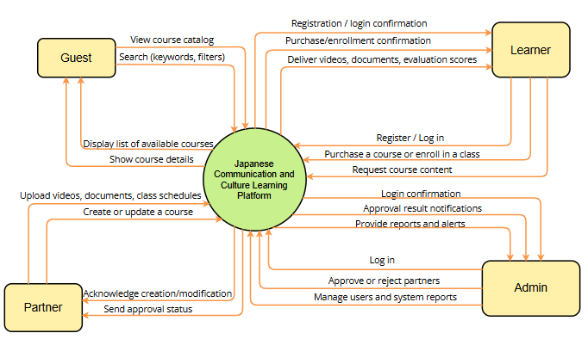

## 

## 

## 2. User Requirements

### 2.1 Actors

### 

| **#** | **Actor** | **Description** |
| --- | --- | --- |
| 1 | **Guest** | A user who visits the platform without creating an account. Can browse public content such as general platform information, sample courses. Has limited access and must register to join a partner's classroom, access courses, or interact with other users. |
| 2 | **Learner** | A user who learns Japanese, joins the platform to practice communication, explore culture with exchange partners, and participate in courses from beginner to advanced. |
| 3 | **Exchange Partner** | A native Japanese speaker or someone fluent in Japanese who joins to share their language and culture through creating their classrooms on the platform. |
| 4 | **Admin** | The highest-level user with full authority to manage users, content, system statistics, and ensure stable platform operation. Also who creates courses and handles user feedback. |

### 2.2 Use Cases

#### 2.2.1 Diagram(s)

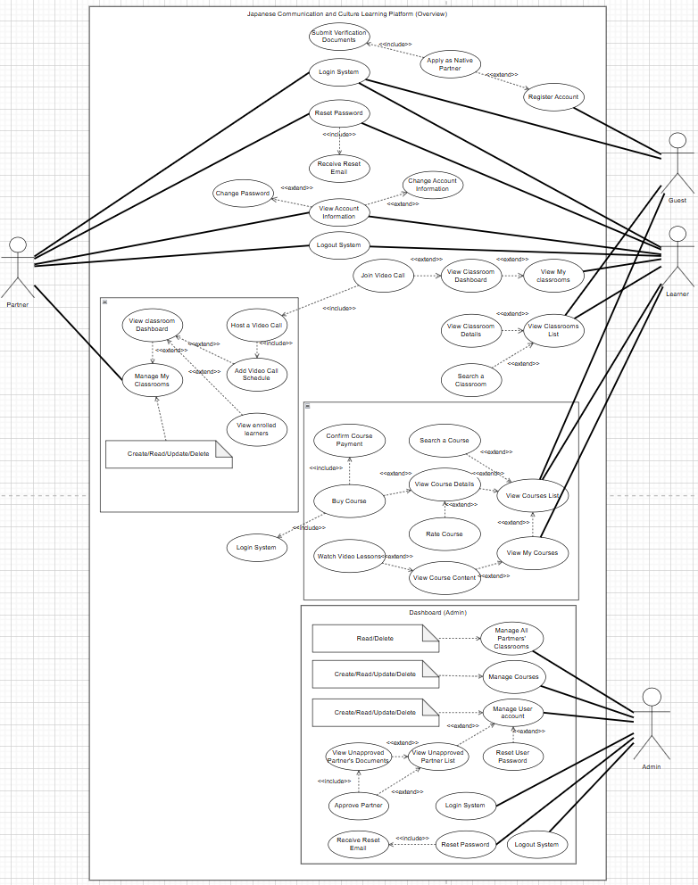

#### 2.2.2 Descriptions

*This part describes the use cases, you can follow the table form as below]*

| **ID** | **Use Case** | **Actors** | **Use Case Description** |
| --- | --- | --- | --- |
| UC-01 | Register Account | Guest | Guest registers a learner account with basic info. |
| UC-02 | Apply as Native Partner | Guest | Guest applies to be a native partner by providing extra information and required documents. |
| UC-03 | Submit Verification Docs | Guest | Guest uploads documents required for partner approval. |
| UC-04 | Login System | Guest | User logs in using email and password. |
| UC-05 | Reset Password | User | User requests a password reset. |
| UC-06 | Logout System | User | Users logs out and ends their session. |
| UC-07 | Change Password | User | Users view their account information such as name, email, gender. |
| UC-08 | Change Account | User | Logged-in users update their password. |
| UC-09 | Change Account Information | User | Users view and update their account information. |
| UC-10 | Manage User Accounts | Admin | Admin view list of all users with their basic information and can update or delete their account. |
| UC-11 | View Unapproved Partner List | Admin | Admin view list of all native partners that are registered but not yet approved. |
| UC-12 | View Unapproved Partner’s Docs | Admin | Admin view a particular unapproved partner’s documents. |
| UC-13 | Approve Partner | Admin | Admin approves or rejects native partner request. |
| UC-14 | Reset User Password | Admin | Admin resets password for a user manually. |
| UC-15 | View Classrooms List | Learner | Guest/Learner can view a list of classrooms organized by partners. |
| UC-16 | Search A Classroom | Learner | Guest/Learner searches for a partner by inputting the classroom name. |
| UC-17 | View Classroom Details | Learner | Guest/Learner views additional information about a classroom. |
| UC-18 | View My Classrooms | Learner | Learner views a list of classrooms they have joined. |
| UC-19 | View Classroom Dashboard | Learner/Partner | Learner/Partner views a classroom content. |
| UC-20 | Join Video Call | Learner/Partner | Learner joins a Video Call Session hosted by the corresponding partner. |
| UC-21 | Manage My Classrooms | Partner | Partner views and manages their classrooms such as creating, deleting. |
| UC-22 | View Enrolled Learners | Partner | Partner views a list of enrolled learners of a classroom. |
| UC-23 | Host a Video Call | Partner | Partners hosts a Video Call session of a classroom, so that learners can join in and learn. |
| UC-24 | View Course List | Learner | View a public list of all available courses. |
| UC-25 | Search A Course | Learner | Search for courses using keywords. |
| UC-26 | View Course Details | Learner | View detailed information of a specific course. |
| UC-27 | Buy Course | Learner | Pay for a course to gain access to its content. |
| UC-28 | Confirm Course Payment | Learner | Display confirm dialog box for course payment. |
| UC-29 | View My Courses | Learner | Learners can view a list of their paid courses. |
| UC-30 | Watch Video Lessons | Learner | Begin learning a paid course by watching video lessons. |
| UC-31 | Rate Course | Learner | Review and rate a course by a 5-star rating system. |
| UC-32 | Manage Courses | Admin | Admins manage existing courses, such as creating new, updating or deleting existing courses. |

##### 2.2.2.1 UC-01: Register an Account

| **Objective:** | Allow a guest to register a new account to access platform features such as purchasing courses, joining classrooms, or applying to be a partner. |
| --- | --- |
| **Actor:** | Guest |
| **Trigger:** | The guest clicks the “**Sign Up**” button on the platform homepage. |
| **Pre-condition:** | PRE-1: The user is not logged in.  PRE-2: The user has access to a valid email address. |
| **Post-condition:** | POST-1: A new user account is created and stored in the database.  An email verification is sent. The user must verify their email before gaining full access. |

**Activities Flow**

1. **Guest accesses the homepage and clicks “Register.”**
2. **The system displays the registration form.**
3. **Guest fills in required fields (name, email, password, role selection).**
4. **Guest submits the form.**
5. **System validates all inputs.**
6. **System hashes the password before storing.**
7. **System stores user data in the database.**
8. **System sends a verification email with OTP or link.**
9. **User account remains inactive until email verification is completed.**

**Business Rules**

| **Step** | **BR Code** | **Description** |
| --- | --- | --- |
| 6 | **BR1** | All user passwords must be hashed using the BCrypt algorithm before storage. |
| 8 | **BR2** | All users must verify their email via an OTP sent to a valid Gmail address before activating their account. |
| 3 | **BR15** | A user can only register as one role per session. |

##### 

##### 2.2.2.2 UC-02: Apply as Native Partner

| **Objective:** | Enable a guest or newly registered user to apply for a Native Partner account by providing additional identity and teaching information. |
| --- | --- |
| **Actor:** | Guest |
| **Trigger:** | User selects "**Apply as Native Partner**" during or after registration. |
| **Pre-condition:** | PRE-1: User is not yet an approved Partner.  Required documents and information are available.. |
| **Post-condition:** | POST-1: An application for Partner role is stored with status "**Pending**."  Admin is notified.  User is informed that application is under review. |

**Activities Flow**

1. **User clicks on "Apply as Native Partner."**
2. **System displays the partner application form.**
3. **User enters personal and teaching details.**
4. **User uploads required identity/proof documents.**
5. **User submits the application.**
6. **System stores the data with status "Pending."**
7. **Admin reviews the application.**
8. **If approved:**
   * **System updates user role to Partner.**
   * **Confirmation email is sent.**
9. **If rejected:**
   * **Rejection email is sent.**
   * **Account is deleted (optional).**

**Business Rules**

| **Step** | **BR Code** | **Description** |
| --- | --- | --- |
| 6 | **BR3** | Partner accounts must be reviewed and approved by an Admin. |
| 8 | **BR13** | System must notify user of approval or rejection |
| 9 | **BR4** | Rejected applications result in email notification and optional account deletion. |

##### 2.2.2.3 UC-03: Submit Verification Documents

| **Objective:** | Enable a user applying to be a Native Partner to submit required verification documents. |
| --- | --- |
| **Actor:** | Guest (Partner Applicant) |
| **Trigger:** | User proceeds to upload documents during or after completing the Partner application form. |
| **Pre-condition:** | PRE-1: The user has begun or submitted a partner application.  The user is logged in. |
| **Post-condition:** | POST-1: Required documents are stored securely.  Admins have access to documents for review. |

**Activities Flow**

1. **User navigates to the "Submit Documents" page.**
2. **System shows a checklist of required documents.**
3. **User selects files and uploads them.**
4. **System validates file type and size.**
5. **System stores files securely.**
6. **System confirms successful upload to the user.**

**Business Rules**

| **Step** | **BR Code** | **Description** |
| --- | --- | --- |
| 4 | **BR5** | Only PDF, JPG and PNG file formats are allowed. |
| 4 | **BR6** | Maximum upload size is 10 MB per file. |
| 5 | **BR7** | All uploaded documents must be securely stored with restricted access. |

##### 2.2.2.4 UC-04: Admin Review Partner Application

| **Objective:** | Allow Admins to review and decide on Partner applications submitted by users. |
| --- | --- |
| **Actor:** | Admin |
| **Trigger:** | Admin accesses the partner application management interface. |
| **Pre-condition:** | PRE-1: Partner application exists with status "Pending."  Admin is authenticated. |
| **Post-condition:** | POST-1: Application is marked as Approved or Rejected.  User is notified via email. |

**Activities Flow**

1. **Admin logs into the admin dashboard.**
2. **Admin selects "Pending Partner Applications."**
3. **Admin reviews applicant details and documents.**
4. **Admin selects "Approve" or "Reject."**
5. **If approved:**
   * **System updates user role to Partner.**
   * **Sends approval email.**
6. **If rejected:**
   * **System deletes account (optional).**
   * **Sends rejection email.**

**Business Rules**

| **Step** | **BR Code** | **Description** |
| --- | --- | --- |
| 4 | **BR3** | Partner account approval must be performed by an Admin. |
| 5-6 | **BR13** | Approval or rejection must trigger an email notification to the user. |
| 6 | **BR4** | Rejected accounts are optionally deleted after notification. |

#### 

##### 2.2.2.5 UC-05: View Public Courses and Classrooms

| **Objective:** | Allow guests to browse available courses and classrooms without registration. |
| --- | --- |
| **Actor:** | Guest |
| **Trigger:** | Guest navigates to the **Courses** or **Classrooms** page. |
| **Pre-condition:** | PRE-1: No login required. |
| **Post-condition:** | POST-1: Guest can see basic information about available courses and classrooms. |

**Activities Flow**

1. **Guest visits homepage.**
2. **Guest clicks on "Courses" or "Classrooms."**
3. **System shows available courses/classrooms with titles, instructors, and summary.**

**Business Rules**

| **Step** | **BR Code** | **Description** |
| --- | --- | --- |
| 3 | **BR5** | Guests may only view high-level information, not content. |

##### 2.2.2.6 UC-06: View Course Details as Guest

| **Objective:** | Allow guests to view basic information about a specific course (e.g., title, description, instructor) before registering. |
| --- | --- |
| **Actor:** | Guest |
| **Trigger:** | Guest clicks on a specific course from the course list. |
| **Pre-condition:** | PRE-1: No login required.  The course is publicly listed. |
| **Post-condition:** | POST-1: Course detail information is displayed without content access. |

**Activities Flow**

1. **Guest clicks on a course from the public list.**
2. **System retrieves course information.**
3. **System displays public-facing details: title, description, objectives, instructor info.**

**Business Rules**

| **Step** | **BR Code** | **Description** |
| --- | --- | --- |
| 3 | **BR5** | Guests cannot access lessons, only view basic course info. |

##### 2.2.2.7 UC-07: View Account Information

| **Objective:** | Allow a logged-in user to view their own account details, including personal information, role, and optionally learning or teaching activity data depending on user type. |
| --- | --- |
| **Actor:** | Authenticated User (Admin, Learner, or Native Partner) |
| **Trigger:** | The user navigates to their profile or account information section. |
| **Pre-condition:** | PRE-1: User is logged into the system.  PRE-2: User account exists and is active. |
| **Post-condition:** | POST-1: The user's profile information is displayed.  POST-2: No changes are made to the data. |

**Activities Flow**

1. The user clicks on the profile/account icon in the navigation bar.
2. The system retrieves the user’s profile data from the database.
3. The system displays the information, including:
   * Full name
   * Email address
   * User role (Learner, Native Partner, or Admin)
   * Language level or teaching profile (if applicable)
   * Join date and last login
   * Profile picture (if any)

**Business Rules**

| **Step** | **BR Code** | **Description** |
| --- | --- | --- |
| 3 | **BR19** | Users may view their account information but cannot change roles, registration email, or account status from the interface. |

##### 2.2.2.8 UC-08: Change Password

| **Objective:** | Allow a logged-in user to change their current password by providing the existing password and setting a new one that complies with password policies. |
| --- | --- |
| **Actor:** | Authenticated User (Admin, Learner, or Native Partner) |
| **Trigger:** | The user selects the "Change Password" option from the account settings. |
| **Pre-condition:** | PRE-1: The user is logged into the system.  PRE-2: The user has an active and valid account.  PRE-3: The authentication system is available. |
| **Post-condition:** | POST-1: The user's password is updated in the system.  POST-2: The user may be logged out from all other devices (optional).  POST-3: A confirmation message is shown or sent. |

**Activities Flow**

1. The user navigates to the account settings page.
2. The user selects the “Change Password” option.
3. The system displays a form with fields for:
   * Current password
   * New password
   * Confirm new password
4. The user enters the current password and the new password (twice for confirmation).
5. The system verifies the current password.
6. The system validates the new password against the defined password policy.
7. The system updates the password in the user database.
8. The system shows a success message: “Your password has been successfully changed.”
9. (Optional) The system logs the user out from all other active sessions.

**Business Rules**

| **Step** | **BR Code** | **Description** |
| --- | --- | --- |
|  |  |  |

##### 2.2.2.9 UC-09: Change Account Information

| **Objective:** | Allow a logged-in user to update their personal information, such as full name, bio/introduction, avatar, and language background, depending on their role. |
| --- | --- |
| **Actor:** | Authenticated User (Admin, Learner, or Native Partner) |
| **Trigger:** | The user selects the option to edit their account/profile information from the account interface. |
| **Pre-condition:** | PRE-1: The user is logged into the system.  PRE-2: The user has access to the account/profile page.  PRE-3: The profile data exists in the system. |
| **Post-condition:** | POST-1: The updated information is saved in the system.  POST-2: The user sees the updated profile reflected immediately.  POST-3: A success message is displayed. |

**Activities Flow**

1. The user navigates to the profile or account settings page.
2. The system displays the current account information in editable form fields.
3. The user updates one or more fields (e.g., name, bio, language level, avatar).
4. The user clicks the “Save” or “Update” button.
5. The system validates the input (e.g., required fields, file type for avatar).
6. The system updates the user profile in the database.
7. The system displays a confirmation message: “Your account information has been updated successfully.”

**Business Rules**

| **Step** | **BR Code** | **Description** |
| --- | --- | --- |
| 3 | **BR17** | Users can only edit non-critical information such as name, avatar, and bio. Email and user role are read-only. |

##### 2.2.2.10 UC-10: Manage User Accounts

| **Objective:** | Allow Admin to manage user accounts within the system. This includes searching for users, viewing profile details, editing non-sensitive information, suspending or reactivating accounts, and removing users when necessary. |
| --- | --- |
| **Actor:** | Admin |
| **Trigger:** | The Admin selects “User Management” from the admin dashboard. |
| **Pre-condition:** | PRE-1: The Admin is logged in with appropriate privileges.  PRE-2: The system contains registered users. |
| **Post-condition:** | POST-1: Any changes made to user accounts are reflected in the system.  POST-2: Optional notifications may be sent to the affected user (e.g., if suspended or reactivated). |

**Activities Flow**

1. The Admin navigates to the "Manage Users" section of the admin dashboard.
2. The system displays a list of registered users with search and filter options.
3. The Admin selects a user to view full details.
4. The Admin optionally performs one of the following actions:
   * Edit user information (e.g., name, language level)
   * Change user status (e.g., activate, deactivate/suspend)
   * Delete user account
5. The system validates the action, updates the user record, and confirms success.
6. (Optional) The system logs the change and notifies the user of any status update.

**Business Rules**

| **Step** | **BR Code** | **Description** |
| --- | --- | --- |
| 4 | **BR20** | Admins cannot modify their own role or status through the user management interface. |

##### 2.2.2.11 UC-11: View Unapproved Partners

| **Objective:** | Allow Admin to view a list of users who have applied to become Native Partners but have not yet been approved or rejected. |
| --- | --- |
| **Actor:** | Admin |
| **Trigger:** | The Admin selects the option to view pending Native Partner applications from the admin dashboard. |
| **Pre-condition:** | PRE-1: The Admin is logged in with appropriate privileges.  PRE-2: There are one or more users with partner application status set to “Pending.”. |
| **Post-condition:** | POST-1: The system displays a list of pending Native Partner applicants. |

**Activities Flow**

1. The Admin navigates to the "Partner Applications" section.
2. The system retrieves a list of all users with application status = “Pending.”
3. The system displays the list including key information:
   * Applicant full name
   * Email
   * Date of application
   * Submitted documents status (if applicable)
   * Action buttons (e.g., “View Details”, “Approve”, “Reject”)

**Business Rules**

| **Step** | **BR Code** | **Description** |
| --- | --- | --- |
| 2 | **BR3** | Partner accounts created through the “Apply as Native Partner” process must be reviewed and approved by an Admin before login is allowed. |
| 3 | **BR21** | The system must support previewing JPG, PNG, and PDF file types when viewing submitted documents. |

##### 2.2.2.12 UC-12: View Unapproved Partner’s Documents

| **Objective:** | Allow Admin to view the verification documents submitted by a pending Native Partner applicant. These documents typically include identity proof, language certification, or teaching qualifications, and are used to evaluate the application before approval. |
| --- | --- |
| **Actor:** | Admin |
| **Trigger:** | The Admin selects “View Details” or clicks on a pending Native Partner’s application from the unapproved list. |
| **Pre-condition:** | PRE-1: The Admin is logged in with appropriate privileges.  PRE-2: There are one or more users with partner application status set to “Pending.”.  PRE-3: The selected applicant has uploaded at least one required document. |
| **Post-condition:** | POST-1: The Admin is able to view the submitted documents on-screen.  POST-2: No changes are made to the documents at this stage. |

**Activities Flow**

1. The Admin opens the list of unapproved Native Partners.
2. The Admin selects a specific applicant by clicking “View Details” or equivalent.
3. The system retrieves and displays the applicant’s submitted documents, such as:
   * Government-issued ID (e.g., passport, national ID)
   * Language proficiency certificate (if required)
   * Teaching resume or qualifications
4. The Admin views each document either as inline preview or in downloadable format.
5. The Admin proceeds to take further action (approve/reject) via a separate use case.

**Business Rules**

| **Step** | **BR Code** | **Description** |
| --- | --- | --- |
| 2 | **BR3** | Partner accounts created through the “Apply as Native Partner” process must be reviewed and approved by an Admin before login is allowed. |
| 3 | **BR21** | The system must support previewing JPG, PNG, and PDF file types when viewing submitted documents. |

##### 2.2.2.13 UC-13: Approve Partner Status

| **Objective:** | Allow Admin to approve a pending Native Partner application. Once approved, the user's role is updated, and they are granted access to Native Partner functionalities. |
| --- | --- |
| **Actor:** | Admin |
| **Trigger:** | The Admin selects an application from the list of unapproved Native Partner applicants and chooses to approve it. |
| **Pre-condition:** | PRE-1: The Admin is logged in with appropriate privileges.  PRE-2: The selected user has submitted a complete application with status = “Pending.”  PRE-3: Required documents have been reviewed. |
| **Post-condition:** | POST-1: The user's role is updated to “Native Partner.”.  POST-2: Application status is updated to “Approved.”.  POST-3: A confirmation email is sent to notify the user of the approval. |

**Activities Flow**

1. The Admin views the list of unapproved partner applications.
2. The Admin selects a specific applicant and reviews the profile and submitted documents.
3. The Admin clicks “Approve” or equivalent confirmation action.
4. The system updates the user role to partner.
5. The system updates the application status to “approved”.
6. The system sends a confirmation email to the user stating that their application has been approved.
7. The user gains access to Native Partner features upon next login.

**Business Rules**

| **Step** | **BR Code** | **Description** |
| --- | --- | --- |
| 2 | **BR3** | Partner accounts created through the “Apply as Native Partner” process must be reviewed and approved by an Admin before login is allowed. |
| 6 | **BR4** | If a partner application is rejected, the system must notify the applicant via email and delete the associated account. |
| 6 | **BR13** | Upon approval or rejection of a partner account, the system must send an appropriate notification email to the user. |

##### 2.2.2.14 UC-14: Reset User Password

| **Objective:** | Allow Admin to reset the password of a user account upon request (e.g., due to support issue, lost access). The system either generates a temporary password or sends a reset link to the user via email. |
| --- | --- |
| **Actor:** | Admin |
| **Trigger:** | The Admin selects a specific user account from the user management interface and chooses the "Reset Password" option. |
| **Pre-condition:** | PRE-1: The Admin is logged in with appropriate privileges.  PRE-2: The target user account exists and is in an active or recoverable state.  PRE-3: The user has a valid email address on file. |
| **Post-condition:** | POST-1: A temporary password is assigned, or a reset link is sent to the user.  POST-2: The user is able to log in and create a new password. |

**Activities Flow**

1. The Admin accesses the “Manage Users” section.
2. The Admin searches for or selects a specific user.
3. The Admin clicks on “Reset Password.”
4. The system presents two reset options:
   * Generate and display a temporary password, or
   * Send a password reset link to the user’s email.
5. The Admin selects an option and confirms the action.
6. The system performs the selected reset method.
7. The system notifies the Admin of success.
8. (If sending email) The system sends the reset email to the user.
9. (If generating temporary password) The Admin provides the new password to the user through a secure channel.

**Business Rules**

| **Step** | **BR Code** | **Description** |
| --- | --- | --- |
| 4-6 | **BR1** | All user passwords must be hashed using the BCrypt algorithm before storage. |
| 3-6 | **BR14** | Admin users may reset passwords for any user through the user management interface. |

##### 2.2.2.15 UC-15: View Classroom List

| **Objective:** | Allow Guests and Learners to discover available classrooms organized by approved Native Partners. |
| --- | --- |
| **Actor:** | Learner |
| **Trigger:** | The user navigates to the “Classrooms” section or selects “View Classrooms.” |
| **Pre-condition:** | * PRE-1: The Native Partners have created at least one classroom. * PRE-2: The user is connected to the platform (as Guest or logged in as Learner). |
| **Post-condition:** | * POST-1: The system displays a paginated or scrollable list of available classrooms. * POST-2: The user can select a classroom to view more details or proceed to enroll (if eligible). |

**Activities Flow**

1. **Users access the “Classrooms” section.**
2. **System queries available classrooms.**
3. **System displays a list of classrooms with key information.**
4. **User browses through the list.**
5. **User may click a classroom to view more details (see related use case: View Classroom Details).**

**Business Rules**

| **Step** | **BR Code** | **Description** |
| --- | --- | --- |
| 02 | **BR5** | Guests may only view high-level classroom/course information but cannot access lesson content or dashboards. |
| 02 | **BR8** | Only approved Partners can create and manage Classrooms. No minimum number of enrolled learners is required to create a Classroom. |
| 04 | **BR16** | "Classroom Detail" is public-facing information; "Classroom Dashboard" includes private class operations and content. |

#### 

##### 2.2.2.16 UC-16: Search a Classroom

| **Objective:** | Enable users to search and find specific classrooms by entering keywords. |
| --- | --- |
| **Actor:** | Guest, Learner |
| **Trigger:** | The user enters a search query (e.g., classroom name or topic) into the search bar. |
| **Pre-condition:** | * PRE-1: Classrooms exist in the system. * PRE-2: User has access to the classroom search interface. |
| **Post-condition:** | * POST-1: Matching classrooms are displayed based on the search criteria. * POST-2: The user may continue to browse or view a specific classroom. |

**Activities Flow**

1. **User accesses the “Search Classroom” feature.**
2. **User types a search query (e.g., “Beginner Conversation”).**
3. **System filters the list based on the query.**
4. **System displays matching classroom results.**
5. **User may refine the query or select a classroom to view more information.**

**Business Rules**

| **Step** | **BR Code** | **Description** |
| --- | --- | --- |
| 04 | **BR5** | Guests may only view high-level classroom/course information but cannot access lesson content or dashboards. |
| 03 | **BR8** | Only approved Partners can create and manage Classrooms. No minimum number of enrolled learners is required to create a Classroom. |
| 05 | **BR16** | "Classroom Detail" is public-facing information; "Classroom Dashboard" includes private class operations and content. |

#### 

##### 2.2.2.17 UC-17: View Classroom Details

| **Objective:** | Provide detailed information about a selected classroom for better decision-making. |
| --- | --- |
| **Actor:** | Guest, Learner |
| **Trigger:** | User selects a classroom from the classroom list to view more details. |
| **Pre-condition:** | * PRE-1: The classroom exists and is published. * PRE-2: The user has access to the platform. |
| **Post-condition:** | * POST-1: The system displays all public classroom details. * POST-2: If logged in, the user may proceed to join or express interest. |

**Activities Flow**

1. **User clicks on a classroom from the list.**
2. **System retrieves classroom information from the database.**
3. **System displays classroom detail page with title, description, schedule, and host info.**
4. **If the user is logged in and eligible, an "Enroll" or "Join" option is shown.**

**Business Rules**

| **Step** | **BR Code** | **Description** |
| --- | --- | --- |
| 03 | **BR5** | Guests may only view high-level classroom/course information but cannot access lesson content or dashboards. |
| 02 | **BR8** | Only approved Partners can create and manage Classrooms. No minimum number of enrolled learners is required to create a Classroom. |
| 03 | **BR16** | "Classroom Detail" is public-facing information; "Classroom Dashboard" includes private class operations and content. |

#### 

##### 2.2.2.18 UC-18: View My Classrooms

| **Objective:** | Allow Learners to track and access the classrooms they have joined. |
| --- | --- |
| **Actor:** | Learner |
| **Trigger:** | Learner selects “My Classrooms” from the navigation or dashboard. |
| **Pre-condition:** | * PRE-1: Learner is logged in. * PRE-2: Learner has enrolled in at least one classroom. |
| **Post-condition:** | * POST-1: System displays a list of classrooms the Learner has joined. * POST-2: Learner can click to access classroom materials or details. |

**Activities Flow**

1. **Learner navigates to “My Classrooms.”**
2. **System retrieves list of classrooms where Learner is enrolled.**
3. **System displays classrooms with title, status, and access links.**
4. **Learner may click any entry to view classroom details or enter a live session (if available).**

**Business Rules**

| **Step** | **BR Code** | **Description** |
| --- | --- | --- |
| 03 | **BR8** | Only approved Partners can create and manage Classrooms. No minimum number of enrolled learners is required to create a Classroom. |
| 04 | **BR9** | Only enrolled Learners and the Partner who owns the class can access the Classroom Dashboard. |
| 04 | **BR16** | "Classroom Detail" is public-facing information; "Classroom Dashboard" includes private class operations and content. |

#### 

##### 2.2.2.19 UC-19: View Classroom Dashboard

| **Objective:** | Give enrolled Learners and the Partner access to private classroom content and tools. |
| --- | --- |
| **Actor:** | Learner, Partner |
| **Trigger:** | The user (Learner or Partner) selects a classroom from their list of enrolled/created classrooms. |
| **Pre-condition:** | * PRE-1: The user is logged in. * PRE-2: The user is either enrolled in or owns the selected classroom. * PRE-3: The classroom is active and accessible. |
| **Post-condition:** | * POST-1: The classroom dashboard is displayed. * POST-2: The user can interact with content depending on their role. |

**Activities Flow**

1. **User logs into the platform.**
2. **User navigates to “My Classrooms.”**
3. **User selects a classroom.**
4. **System verifies user’s role and classroom access rights.**
5. **System displays the classroom dashboard with appropriate content and tools.**
6. **User views lessons, materials, or upcoming sessions.**

**Business Rules**

| **Step** | **BR Code** | **Description** |
| --- | --- | --- |
| 02 | **BR9** | Only enrolled Learners and the Partner who owns the class can access the Classroom Dashboard. |
| 03 | **BR16** | "Classroom Detail" is public-facing information; "Classroom Dashboard" includes private class operations and content. |

#### 

##### 2.2.2.20 UC-20: Join Video Call

| **Objective:** | Allow Learners to join a scheduled live video session hosted by a Partner. |
| --- | --- |
| **Actor:** | Learner |
| **Trigger:** | Learner clicks the “Join Call” button on the classroom dashboard at a scheduled time. |
| **Pre-condition:** | * PRE-1: Learner is enrolled in the classroom. * PRE-2: The classroom has a scheduled video call. * PRE-3: It is within the allowed time window to join. |
| **Post-condition:** | * POST-1: Learner successfully joins the call session. * POST-2: Attendance may be logged by the system. |

**Activities Flow**

1. **Learner logs into the platform.**
2. **Learner accesses the Classroom Dashboard.**
3. **Learner clicks “Join Video Call” at the scheduled time.**
4. **System verifies session availability and user eligibility.**
5. **System connects Learner to the live video session.**
6. **Learner participates in the call until the session ends or they leave.**

**Business Rules**

| **Step** | **BR Code** | **Description** |
| --- | --- | --- |
| 03 | **BR9** | Only enrolled Learners and the Partner who owns the class can access the Classroom Dashboard. |
| 01 | **BR16** | "Classroom Detail" is public-facing information; "Classroom Dashboard" includes private class operations and content. |

#### 

##### 2.2.2.21 UC-21: Manage My Classrooms

| **Objective:** | Enable Partners to create, edit, or delete the classrooms they own. |
| --- | --- |
| **Actor:** | Partner |
| **Trigger:** | Partner navigates to “My Classrooms” dashboard. |
| **Pre-condition:** | * PRE-1: Partner is logged in. * PRE-2: Partner has been approved by the Admin. * PRE-3: Partner has access to the “My Classrooms” section. |
| **Post-condition:** | * POST-1: A classroom is created, updated, or deleted as requested. * POST-2: Changes are reflected in the classroom list. |

**Activities Flow**

1. **Partner logs in and accesses “My Classrooms.”**
2. **System displays a list of the Partner’s classrooms.**
3. **Partner selects “Create,” “Edit,” or “Delete.”**
4. **System performs the requested action with confirmation.**
5. **Classroom list is updated accordingly.**

**Business Rules**

| **Step** | **BR Code** | **Description** |
| --- | --- | --- |
| 01 | **BR3** | Partner accounts created through the “Apply as Native Partner” process must be reviewed and approved by an Admin before login is allowed. |
| 02 | **BR8** | Only approved Partners can create and manage Classrooms. No minimum number of enrolled learners is required to create a Classroom. |

#### 

##### 2.2.2.22 UC-22: View Enrolled Learners

| **Objective:** | Let Partners see who has enrolled in their classrooms to manage interaction and engagement. |
| --- | --- |
| **Actor:** | Partner |
| **Trigger:** | Partner navigates to “My Classrooms” dashboard. |
| **Pre-condition:** | * PRE-1: Partner is logged in. * PRE-2: Partner has at least one published classroom with enrollments. |
| **Post-condition:** | * POST-1: The list of enrolled learners is displayed. * POST-2: Partner may export or message learners if permitted. |

**Activities Flow**

1. **Partner accesses the dashboard.**
2. **Selects a classroom.**
3. **Clicks on “View Enrolled Learners.”**
4. **System retrieves the list and displays learner names and statuses.**

**Business Rules**

| **Step** | **BR Code** | **Description** |
| --- | --- | --- |
| 01 | **BR8** | Only approved Partners can create and manage Classrooms. No minimum number of enrolled learners is required to create a Classroom. |
| 02 | **BR9** | Only enrolled Learners and the Partner who owns the class can access the Classroom Dashboard. |

#### 

##### 2.2.2.23 UC-23: Host a Video Call

| **Objective:** | Allow Partners to initiate a scheduled video session with enrolled Learners. |
| --- | --- |
| **Actor:** | Partner |
| **Trigger:** | Partner clicks “Start Video Call” within a classroom at the scheduled session time. |
| **Pre-condition:** | * PRE-1: Partner is logged in. * PRE-2: Classroom has an active schedule. * PRE-3: Video call is supported for the session time. |
| **Post-condition:** | * POST-1: A live session is initiated and joined by learners. * POST-2: Attendance is logged. |

**Activities Flow**

1. **Partner logs into the dashboard.**
2. **Navigates to the classroom scheduled for the session.**
3. **Clicks “Start Video Call.”**
4. **System launches integrated video call interface.**
5. **Learners receive a notification and join the session.**
6. **Partner hosts the call (e.g., leads lesson, shares screen).**
7. **Session ends, and attendance records are saved.**

**Business Rules**

| **Step** | **BR Code** | **Description** |
| --- | --- | --- |
| 02 | **BR8** | Only approved Partners can create and manage Classrooms. No minimum number of enrolled learners is required to create a Classroom. |
| 06 | **BR9** | Only enrolled Learners and the Partner who owns the class can access the Classroom Dashboard. |

#### 

##### 2.2.2.24 UC-24: View Courses List

| **Objective:** | **Allow a Learner or Partner to browse all available courses in the catalog.** |
| --- | --- |
| **Actor:** | Learner (Primary), Partner (Secondary) |
| **Trigger:** | Learner or Partner clicks the “Courses” link in the main menu or dashboard. |
| **Pre-conditions:** | * PRE_1: User is logged in. * PRE_2: Course catalog service is operational. |
| **Post-conditions:** | * POST_1: System displays a paginated list of active courses with thumbnail, title, price, and rating. |

**Activities Flow**

1. **User navigates to “Courses List” page.**
2. **System fetches active courses (paginated, 10/page).**
3. **System renders course cards with key info.**
4. **User browses the list.**

**Business Rules**

| **Step** | **BR Code** | **Description** |
| --- | --- | --- |
| 2 | **BR24** | Lists must be paginated in sets of 10 items per page. |

#### 

##### 2.2.2.25 UC-25: Search a Course

| **Objective:** | **Allow a Learner or Partner to find courses by entering keywords.** |
| --- | --- |
| **Actor:** | Learner (Primary), Partner (Secondary) |
| **Trigger:** | Learner or Partner enters keywords and clicks the “Search” button. |
| **Pre-conditions:** | * PRE_1: User is logged in. * PRE_2: Search service is available. |
| **Post-conditions:** | * POST_1: System displays matching courses or “No results” message. |

**Activities Flow**

1. **User types keywords in search field.**
2. **User clicks “Search.”**
3. **System validates input (non-empty).**
4. **System queries titles, descriptions, tags.**
5. **System shows paginated results.Business Rules**

**Business Rules**

| **Step** | **BR Code** | **Description** |
| --- | --- | --- |
| 1–5 | **BR25** | Users may perform no more than 10 search queries per minute. |

#### 

##### 2.2.2.26 UC-26: View Course Details

| **Objective:** | **Show full details of a selected course, with purchase/start option for Learners.** |
| --- | --- |
| **Actor:** | Learner (Primary), Partner (Secondary) |
| **Trigger:** | Learner or Partner clicks “View Details” on a course card or search result. |
| **Pre-conditions:** | * PRE_1: User is logged in. * PRE_2: Course exists and is active in catalog. |
| **Post-conditions:** | * POST_1: Course detail page displayed. * POST_2: Enrollment controls shown by role. |

**Activities Flow**

1. **User selects a course to view.**
2. **System retrieves full course record.**
3. **System renders: title, full description, syllabus, instructor, price, rating, enrollment status.**
4. **User reads details; Learners see “Buy”/“Start,” Partners see view-only.Business Rules**

**Business Rules**

| **Step** | **BR Code** | **Description** |
| --- | --- | --- |
| 2–3 | **BR5** | Guests may only view high-level info, not lesson content or dashboards. |
| 2–3 | **BR6** | Learners must purchase before accessing content. |
| 2–3 | **BR26** | Partners may view analytics but cannot preview lesson videos. |

#### 

##### 2.2.2.27 UC-27: Buy Course

| **Objective:** | **Enable a Learner to purchase a course via PayPal.** |
| --- | --- |
| **Actor:** | Learner (Primary) |
| **Trigger:** | Learner clicks “Buy Course” on course details. |
| **Pre-conditions:** | * PRE_1: User is logged in. * PRE_2: Course not already owned. * PRE_3: PayPal reachable. |
| **Post-conditions:** | * POST_1: System redirects to PayPal with order details. |

**Activities Flow**

1. **User clicks “Buy Course.”**
2. **System shows order summary.**
3. **User confirms and selects PayPal.**
4. **System redirects to PayPal with transaction.**
5. **PayPal processes payment and returns user.Business Rules**

**Business Rules**

| **Step** | **BR Code** | **Description** |
| --- | --- | --- |
| 1–5 | **BR6** | Learners must purchase before accessing content. |
| 1–5 | **BR10** | Payment must complete via supported provider (PayPal or VNPay). |
| 1–5 | **BR11** | All purchases are final and non-refundable. |

#### 

##### 2.2.2.28 UC-28: Confirm Course Payment

| **Objective:** | **Verify PayPal payment and enroll Learner in the course.** |
| --- | --- |
| **Actor:** | Learner (Primary) |
| **Trigger:** | Learner returns from PayPal or system receives payment notification. |
| **Pre-conditions:** | * PRE_1: Payment initiated (UC-27). * PRE_2: System received PayPal callback. |
| **Post-conditions:** | * POST_1: If successful, Learner is enrolled. * POST_2: Confirmation shown. |

**Activities Flow**

1. **User returns via PayPal return URL.**
2. **System receives callback details.**
3. **System verifies with PayPal.**
4. **If OK → enroll learner, record purchase.**
5. **System displays confirmation and emails receipt.Business Rules**

**Business Rules**

| **Step** | **BR Code** | **Description** |
| --- | --- | --- |
| 2–5 | **BR6** | Learners must purchase before accessing content. |
| 2–5 | **BR10** | Payment must complete via supported provider. |
| 2–5 | **BR12** | Only store course enrollment, not full transaction history. |

#### 

##### 2.2.2.29 UC-29: View My Courses

| **Objective:** | **Let Learners view all courses they own.** |
| --- | --- |
| **Actor:** | Learner |
| **Trigger:** | Learner clicks “My Courses” in dashboard. |
| **Pre-conditions:** | * PRE_1: User is logged in. * PRE_2: Learner has at least one enrolled course. |
| **Post-conditions:** | * POST_1: System displays owned courses with progress/status links. |

**Activities Flow**

1. **User selects “My Courses.”**
2. **System fetches learner’s enrollments.**
3. **System renders list with title, thumbnail, progress, and access link.Business Rules**

**Business Rules**

| **Step** | **BR Code** | **Description** |
| --- | --- | --- |
| 2–3 | **BR6** | Learners must purchase before accessing content. |
| 2–3 | **BR12** | Only store enrollments, not full transaction histories. |

#### 

##### 2.2.2.30 UC-30: Watch Video Lessons

| **Objective:** | **Stream video lessons for an enrolled course.** |
| --- | --- |
| **Actor:** | Learner |
| **Trigger:** | Learner clicks a lesson “Play” button. |
| **Pre-conditions:** | * PRE_1: User is logged in. * PRE_2: Course is enrolled. * PRE_3: Video available. |
| **Post-conditions:** | * POST_1: Video streams; progress tracked. |

**Activities Flow**

1. **User selects a lesson.**
2. **System loads video player and streams content.**
3. **System marks lesson as viewed.**

**Business Rules**

| **Step** | **BR Code** | **Description** |
| --- | --- | --- |
| 1–5 | **BR6** | Learners must purchase before accessing content. |

#### 

##### 2.2.2.31 UC-31: Rate Course

| **Objective:** | **Allow Learners to rate and review completed courses.** |
| --- | --- |
| **Actor:** | Learner |
| **Trigger:** | Learner clicks “Rate this Course.” |
| **Pre-conditions:** | * PRE_1: User is logged in. * PRE_2: Course completed or in progress. |
| **Post-conditions:** | * POST_1: Rating saved. * POST_2: Overall rating updated. |

**Activities Flow**

1. **User opens rating form.**
2. **System shows star selector + text box.**
3. **User selects stars and enters review.**
4. **User submits.**
5. **System validates and stores rating.**
6. **System recalculates course average.**

**Business Rules**

| **Step** | **BR Code** | **Description** |
| --- | --- | --- |
| 3–6 | **BR22** | Only learners who have completed at least one lesson may submit a rating. |
| 3–6 | **BR23** | Each learner can rate a course only once (updates overwrite previous rating). |

#### 

##### 2.2.2.32 UC-32: Manage Courses

| **Objective:** | **Enable Admins to create, update, or delete course records.** |
| --- | --- |
| **Actor:** | Admin |
| **Trigger:** | Admin selects “Manage Courses” in dashboard. |
| **Pre-conditions:** | * PRE_1: Admin is logged in with privileges. * PRE_2: Course list accessible. |
| **Post-conditions:** | * POST_1: Catalog updated per action * POST_2: Changes reflected immediately. |

**Activities Flow**

**1.** **Admin opens course management.**

**2.** **System displays list + “Create” button.**

* **3a. Create: Admin fills form → submits → system validates → saves.**
* **3b. Update: Admin edits → submits → system validates → updates.**
* **3c. Delete: Admin confirms → system removes/archive.**

**3. System confirms action and refreshes list.**

**Business Rules**

| **Step** | **BR Code** | **Description** |
| --- | --- | --- |
| 3a–3c | **BR7** | Only Admin users can create, update, or delete courses. |

#### 

## 3. Functional Requirements

### 3.1 System Functional Overview

#### 3.1.1 Screens Flow

### 

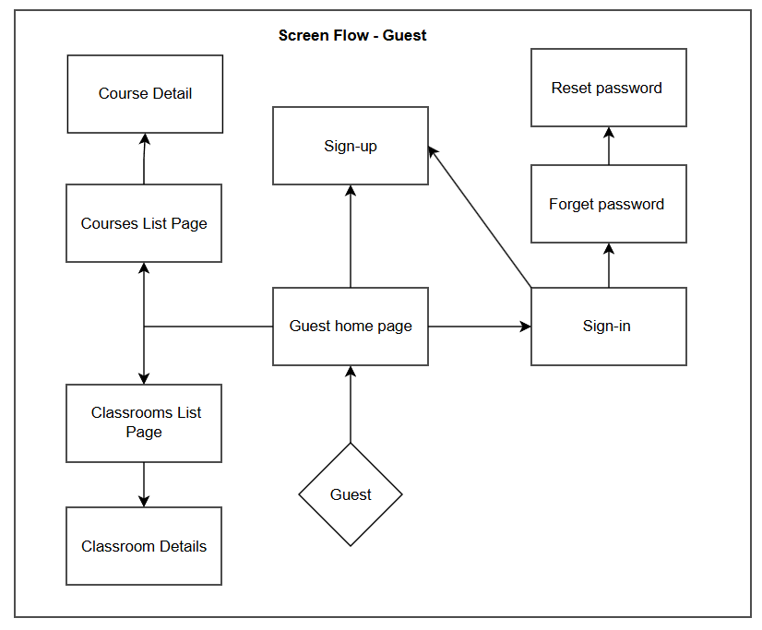

**Screen Flow - Guest**

### 

### 

**Screen Flow - Learner**

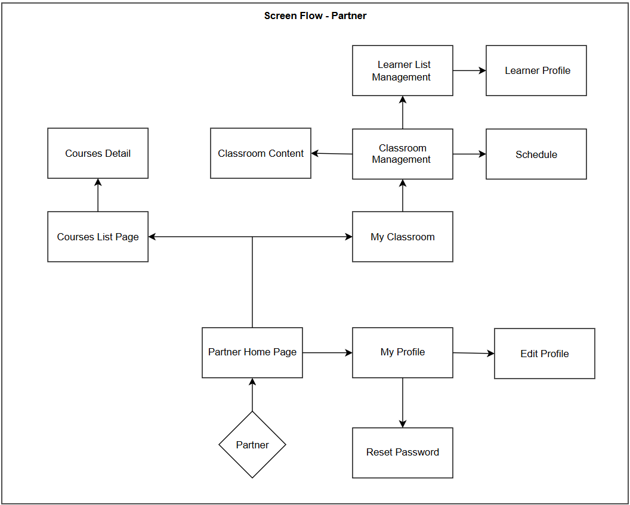

**Screen Flow - Partner**

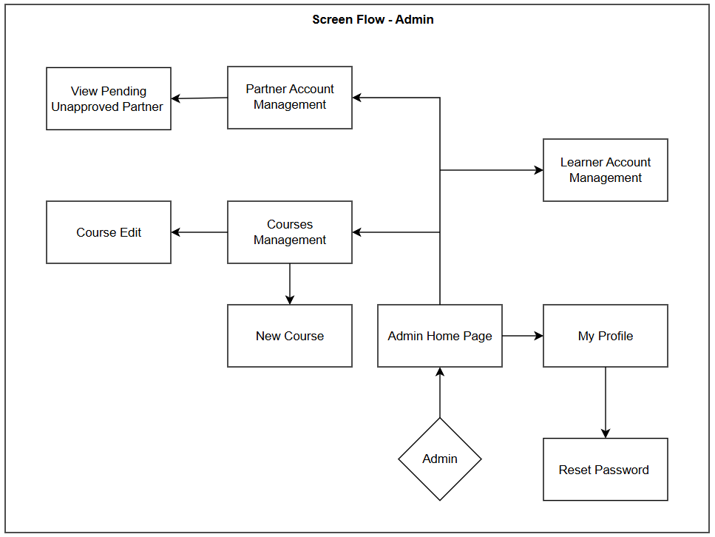

**Screen Flow - Admin**

#### 3.1.2 Screen Descriptions

| **#** | **Feature** | **Screen** | **Description** |
| --- | --- | --- | --- |
| 1 | Register an account | Sign up | Displays the form to enter the necessary information to register a new account |
| 2 | Login to account | Login to account | Log in to the user account via email or via password |
| 3 | Reset password | Forgot password | Send OTP to user’s email to confirm and change password |
| 4 | Reset password | Reset password | Enter OTP and confirm new password |
| 5 | Course Access | Courses List Page | Enter course list and optional manipulate |
| 6 | View Course List | Course Detail Page | Provides detailed information about courses |
| 7 | View List of Classroom | Classroom List Page | View list of available classes |
| 8 | View Classroom Overview | Classroom Detail | View general course information |
| 9 | User’s Home Page | Leaner,Partner Home Page | Main page interface for students and partners |
| 10 | Administration | Admin Home Page | Main admin page |
| 11 | Learner,Partner, Admin Profile | My Profile | A place to manage personal information and view information about courses and classes attended |
| 12 | Edit Individual Information | Edit Profile | Edit personal information |
| 13 | Flowing Classroom | My Classroom | Learners and Partners can view class information here |
| 14 | Managing Classroom | Classroom Management | Partner manages the class you are teaching |
| 15 | View Available Courses | My Courses | View specific information about courses taken |
| 16 | View Schedule | Schedule | View scheduled classes with teachers, receive links to join classes with teachers |
| 17 | View Classroom Content | Classroom Content | Join the course to view specific course content including related materials |
| 18 | View Partner Profile | Partner Profile | Students can view uploaded teacher personal information |
| 19 | Entering Courses | Course Content | Students can use the course with all registered materials. |
| 20 | Managing Learners | Learner List Management | Partners can manage Learners in their classrooms |
| 21 | View Learner Information | Learner Profile | Partner can view information on Learner's page |
| 22 | Managing Learner Account | Learner Account Management | Admin has the right to manage Learner's account to be able to support and handle when necessary. |
| 23 | Managing Partner Account | Partner Account Management | Admin has the right to manage Partner accounts to support and handle when necessary. |
| 24 | Managing Courses | Course Edit | Admin can edit the course as needed |
| New Course | Admin can create new courses |
| 25 | Approving Partner Request | View Pending Unapproved Partner | Admin can review pending partners |

#### 3.1.3 Screen Authorization

| **Screen** | **Guest** | **Learner** | **Partner** | **Admin** |
| --- | --- | --- | --- | --- |
| Login | X | X | X | X |
| Learner,Partner Registration | X |  |  |  |
| Reset Password |  | X | X | X |
| Guest Home Page | X |  |  |  |
| Partner Home Page |  |  | X |  |
| Learner Home Page |  | X |  |  |
| Admin Home Page |  |  |  | X |
| Courses List Page | X | X | X |  |
| Course Detail | X | X | X |  |
| My Courses |  | X |  |  |
| Course Content |  | X |  | X |
| Classroom List Page |  | X | X |  |
| Classroom Detail | X | X |  |  |
| My Classroom |  | X | X |  |
| Classroom Management |  |  | X |  |
| Schedule |  | X | X |  |
| Classroom Content |  | X | X |  |
| Partner Profile |  | X |  |  |
| My Courses |  | X |  |  |
| Course Content |  | X |  |  |
| Edit Profile |  | X | X | X |
| Learner List Management |  |  | X |  |
| Learner Profile |  |  | X |  |
| Schedule |  | X | X |  |
| Learner Account Management |  |  |  | X |
| Partner Account Management |  |  |  | X |
| Course Edit |  |  |  | X |
| New Course |  |  |  | X |
| View Pending Unapproved Partner |  |  |  | X |

#### 3.1.4 Non-Screen Functions

| **#** | **Feature** | **System Function** | **Description** |
| --- | --- | --- | --- |
| 1 | User Authentication | Validate Credentials | Authenticates user credentials (email/password) against stored encrypted data. |
| 2 | Course Management | Auto-enroll on Signup | Automatically enrolls new learners into a default onboarding course upon signup. |
| 3 | Notification | Send Email Notification | Sends email alerts for registration, password reset, and enrollment confirmations. |
| 4 | Access Control | Role-based Authorization | Grants or restricts access to features/screens based on the user's role. |
| 5 | Logging & Monitoring | Track User Activity | Records user actions such as login, course views, and updates for auditing. |

## 

#### 3.1.5 Entity Relationship Diagram

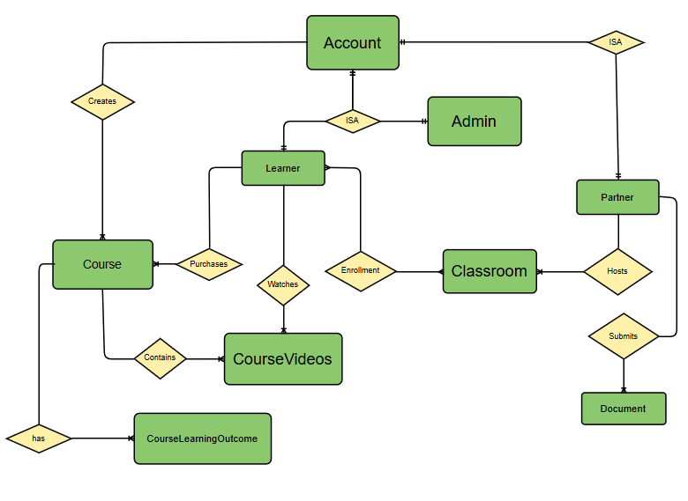

**Entities Description**

| **#** | **Entity** | **Description** |
| --- | --- | --- |
| 1 | *Account* | *Stores login credentials and basic role information for all users in the system.*  ***Primary Key****: accountID*  ***Fields****:*   * *- accountID (PK)* * *- name* * *- avatar* * *- email* * *- password* * *- role* * *- status* * *- createdAt* |
| 2 | *Learners* | *Stores additional information of a Learner account.*  ***Primary Key:*** *learnerID*  ***Foreign Key:*** *learnerID references Accounts.accountID*  ***Fields:***   * *learnerID (PK)* * *level* * *interest* |
| 3 | *Partners* | *Stores additional information of a Partner account.*  ***Primary key:*** *partnerID*  ***Foreign key****: partnerID references Accounts.accountID*  ***Fields:***   * *partnerID (PK, FK)* * *bio* * *isApproved* |
| 4 | *Partner Documents* | *Stores verification documents published by a partner.*  ***Primary key:*** *documentID*  ***Foreign key:***   * partnerID * documentType * filePath |
| 5 | *Admin* | *Stores additional information of an Admin account.*  ***Primary key:*** *adminID*  ***Foreign key****: adminID references Accounts.accountID*  ***Fields:***   * *adminID (PK, FK)* |
| 6 | *Courses* | *Stores basic information of a Course.*  ***Primary key:*** *courseID*  ***Foreign key:*** *createdBy references Admin.adminID*  ***Fields:***   * *courseID (PK)* * *createdBy (FK)* * *name* * *description* * *coverImage* * *numberOfView* * *tuition* * *evaluationPoint* * *createdAt* |
| 7 | *Course Videos* | *Stores information about videos inside a particular course.*  ***Primary key:*** *videoID*  ***Foreign key****: courseID references Courses.courseID*  ***Fields:***   * *videoID (PK)* * *courseID (FK)* * *videoLink* |
| 8 | *Course Learning Outcomes* | *Stores information about learning outcomes of a particular course.*  ***Primary key:*** *outcomeID*  ***Foreign key:*** *courseID references Courses.courseID*  ***Fields:***   * *outcomeID (PK)* * *courseID (FK)* * *description* |
| 9 | *Purchased Courses* | *Stores information about courses purchased by a learner.*  ***Primary key:*** *learnerID + courseID*  ***Foreign key:*** *learnerID references Learners.learnerID and courseID references Courses.courseID*  ***Fields:*** |
| 10 | *Watches* | *Stores information about course videos watched by a learner.*  ***Primary key:*** *learnerID + videoID*  ***Foreign key****: learnerID references Learners.learnerID and videoID references CourseVideos.videoID*  *Fields:* |
| 11 | *Classrooms* | *Stores information of a video-call classroom.*  ***Primary key:*** *classroomID*  ***Foreign key:*** *partnerID references Partners.partnerID*  *Fields:*   * *classroomID (PK)* * *partnerID (FK)* * *title* |
| 12 | *Enrollment* | *Stores information about a learner enrolls in a classroom.*  ***Primary key:*** *learnerID + classroomID*  ***Foreign key:*** *learnerID references Learners.learnerID and classroomID references Classrooms.classroomID*  *Fields:*   * *learnerID (PK, FK)* * *classroomID (PK, FK)* * *enrolTime* |

#### 

### 3.2 User Account Management

#### 3.2.1 Register Account

| **Data element** | **Description** | **Composition or Data type** | **Length** | **Value** |
| --- | --- | --- | --- | --- |
| Name | Input field to enter full name | Alphabet | 100 | N/A |
| Email | Input field to enter email address | Alphanumeric | 30 | Valid email format |
| Password | Input field to enter password | Alphanumeric | 8 – 32 | Must match policy |
| Confirm Password | An input field to enter again Password. | Alphanumeric | 8 - 32 | Must match Password |
| Sign Up | This button allows the users to sign up. | Button | N/A | N/A |
| Sign In | Button to go to login screen | Button | N/A | N/A |
| Screen Actions | | | | |
| **Action Name** | **Description** | **Success** | **Failure** | |
| Submit register form | User fills all fields and clicks Sign Up or presses Enter | Show message “Sign up successfully”, redirect to Login | 1. Missing Name → “Full name is required”  2. Missing Email → “Email is required”  3. Invalid Email → “Invalid format”  4. Missing Password → “Password required”  5. Passwords don’t match | |

#### 3.2.2 Login System

| **Data element** | **Description** | **Composition or Data type** | **Length** | **Value** |
| --- | --- | --- | --- | --- |
| Email | Input field to enter email address | Alphanumeric | 30 | Must be registered |
| Password | Input field to enter password | Alphanumeric | 8 – 32 | N/A |
| Sign In | Button to login | Button | N/A | N/A |
| Screen Actions | | | | |
| **Action Name** | **Description** | **Success** | **Failure** | |
| Submit Login | User enters credentials and clicks Sign In | Redirect to dashboard by role | 1. Invalid credentials → “Email or password incorrect”  2. Unverified → “Verify email” | |

#### 3.2.3 Logout System

| **Action Name** | **Description** | **Success** | **Failure** | |
| --- | --- | --- | --- | --- |
| Logout | User clicks logout on any screen | Redirects to homepage, session destroyed | Network error → try again | |

#### 3.2.4 Reset Password

| **Data element** | **Description** | **Composition or Data type** | **Length** | **Value** |
| --- | --- | --- | --- | --- |
| Email | Input field to enter email address | Alphanumeric | 30 | Valid email format |
| OTP | One-time password for reset | Numeric | 6 | Sent to email |
| New Password | Input for new password | Alphanumeric | 8 - 32 | Must match policy |
| Confirm Password | Confirmation for new password | Alphanumeric | 8–32 | Must match above |
| Screen Actions | | | | |
| **Action Name** | **Description** | **Success** | **Failure** | |
| Request Reset | Enter email, click "Send reset link" | Show: “OTP sent to email” | Empty/Invalid Email → error message | |
| Submit New Pass | Enter OTP + new password + confirm | Show: “Password reset successful” | 1. Wrong OTP  2. Passwords mismatch  3. Policy violation | |

#### 3.2.5 Change Password

| **Data element** | **Description** | **Composition or Data type** | **Length** | **Value** |
| --- | --- | --- | --- | --- |
| Current Password | Field to input existing password | Alphanumeric | 8–32 | Must be correct |
| New Password | Field to enter new password | Alphanumeric | 8–32 | Must match rules |
| Confirm Password | Confirm new password | Alphanumeric | 8–32 | Must match above |
| Screen Actions | | | | |
| **Action Name** | **Description** | **Success** | **Failure** | |
| Change Pass | User updates password in profile | “Password successfully changed” | 1. Wrong current password  2. Mismatch  3. Policy error | |

#### 3.2.6 Change Account Information

| **Data element** | **Description** | **Composition or Data type** | **Length** | **Value** |
| --- | --- | --- | --- | --- |
| Name | Editable name | Alphabet | 100 | Any |
| Avatar | Upload new profile image | File | N/A | JPG/PNG < 2MB |
| Bio/Intro | Short text about user | Text | 200 | Optional |
| Screen Actions | | | | |
| **Action Name** | **Description** | **Success** | **Failure** | |
| Update Profile | Edit and save information | “Profile updated successfully” | Empty required field or invalid img | |

### 3.3 Partner Application & Verification

#### 3.3.1 Apply as Native Partner

| **Data element** | **Description** | **Composition or Data type** | **Length** | **Value** |
| --- | --- | --- | --- | --- |
| Bio | Input for personal introduction | Text | 300 | Required |
| Teaching Info | Experience or language proficiency | Text | 300 | Optional |
| Apply Button | Submit the partner application | Button | N/A | N/A |
| Screen Actions | | | | |
| **Action Name** | **Description** | **Success** | **Failure** | |
| Submit Application | User fills form and clicks Apply | “Application submitted successfully” | 1. Bio empty → “Bio is required”  2. System error → try again later | |

#### 3.3.2 Submit Verification Documents

| **Data element** | **Description** | **Composition or Data type** | **Length** | **Value** |
| --- | --- | --- | --- | --- |
| Document Type | Dropdown for document category | String | N/A | e.g., ID Card, Certificate |
| File Upload | Upload supporting document | File | N/A | PDF/JPG/PNG, max 10MB |
| Submit Button | Confirm upload | Button | N/A | N/A |
| Screen Actions | | | | |
| **Action Name** | **Description** | **Success** | **Failure** | |
| Upload Document | Upload file for verification | “Document uploaded successfully” | 1. Unsupported file → “Only JPG, PNG, PDF allowed”  2. Oversize → “Max 10MB” | |

### 3.4 Admin User Management

#### 3.4.1 Manage User Accounts

| **Data element** | **Description** | **Composition or Data type** | **Length** | **Value** |
| --- | --- | --- | --- | --- |
| Search Field | Input for name or email to filter | Alphanumeric | 100 | Partial match supported |
| Edit Button | Opens edit form for selected user | Button | N/A | Admin-only |
| Delete Button | Triggers user account deletion | Button | N/A | Admin-only |
| Screen Actions | | | | |
| **Action Name** | **Description** | **Success** | **Failure** | |
| Edit User | Admin edits user info and submits | “User updated successfully” | Invalid or missing input | |
| Delete User | Admin deletes user account | “User deleted successfully” | Linked data exists / insufficient rights | |

#### 3.4.2 View Unapproved Partner List

| **Data element** | **Description** | **Composition or Data type** | **Length** | **Value** |
| --- | --- | --- | --- | --- |
| Applicant Info | Includes Name, Email, Date applied | Text | N/A | Auto-generated |
| View Button | Opens application details page | Button | N/A | N/A |
| Screen Actions | | | | |
| **Action Name** | **Description** | **Success** | **Failure** | |
| Open Details | Load profile and application data | “Partner application loaded” | Application not found / error | |

#### 3.4.3 View Unapproved Partner’s Documents

| **Action Name** | **Description** | **Success** | **Failure** | |
| --- | --- | --- | --- | --- |
| Preview Documents | Admin views uploaded partner documents | Document previews load successfully | File unsupported or access error | |

#### 3.4.4 Approve Partner

| **Data element** | **Description** | **Composition or Data type** | **Length** | **Value** |
| --- | --- | --- | --- | --- |
| Approve Button | Approves pending partner application | Button | N/A | Admin-only |
| Reject Button | Rejects and deletes pending applicant | Button | N/A | Admin-only |
| Screen Actions | | | | |
| **Action Name** | **Description** | **Success** | **Failure** | |
| Approve Partner | Confirms application and updates user role | “User approved as Native Partner” + email sent | Email delivery failed / status conflict | |
| Reject Partner | Rejects request and removes user/account | “Application rejected and account deleted” | Error removing user / email failure | |

#### 3.4.5 Reset User Password

| **Data element** | **Description** | **Composition or Data type** | **Length** | **Value** |
| --- | --- | --- | --- | --- |
| Reset Button | Initiates reset for selected user | Button | N/A | Admin-only |
| Method Selector | Choose between email or temporary pass | Dropdown | N/A | Email / Manual |
| Screen Actions | | | | |
| **Action Name** | **Description** | **Success** | **Failure** | |
| Reset Password | Sends email or shows temp password for Admin | “Password reset instruction sent” / shown password | User not found / email failure / access denied | |

### 3.5 Course Management and Enrolment

#### 3.5.1 View Course List

| **Data element** | **Description** | **Composition or Data type** | **Length** | **Value** |
| --- | --- | --- | --- | --- |
| Course Title | Title of the course | Text | 100 | N/A |
| Instructor | Admin who created the course | Text | 100 | Display only |
| Tuition | Course fee | Currency | N/A | VNĐ / USD |
| Rating | User-generated average rating | Decimal | N/A | 1.0 - 5.0 |
| Screen Actions | | | | |
| **Action Name** | **Description** | **Success** | **Failure** | |
| Load Courses | Display paginated list of available courses | List shown with pagination | Course catalog not available | |

#### 3.5.2 Search a Course

| **Data element** | **Description** | **Composition or Data type** | **Length** | **Value** |
| --- | --- | --- | --- | --- |
| Search Box | Keyword input to filter courses | Alphanumeric | 50 | Partial match |
| Screen Actions | | | | |
| **Action Name** | **Description** | **Success** | **Failure** | |
| Search Course | Filter courses by keyword | List of relevant results shown | “No results found” / timeout | |

#### 3.5.3 View Course Details

| **Data element** | **Description** | **Composition or Data type** | **Length** | **Value** |
| --- | --- | --- | --- | --- |
| Course Title | Full course title | Text | 100 | Display only |
| Description | Long course description | Text | 500 | Display only |
| Syllabus | Learning outline | Text | 1000 | Display only |
| Instructor Name | Creator’s name | Text | 100 | Display only |
| Buy Button | Begins the purchase process | Button | N/A | N/A |
| Screen Actions | | | | |
| **Action Name** | **Description** | **Success** | **Failure** | |
| View Course Info | Open course detail page | All course details shown | Course ID not found | |

#### 3.5.4 Buy Course

| **Data element** | **Description** | **Composition or Data type** | **Length** | **Value** |
| --- | --- | --- | --- | --- |
| Confirm Button | Confirms and redirects to payment | Button | N/A | Initiates payment gateway |
| Course Price | Displays total course cost | Currency | N/A | Read-only |
| Screen Actions | | | | |
| **Action Name** | **Description** | **Success** | **Failure** | |
| Purchase Course | Redirects to PayPal/VNPay | User redirected for payment processing | Gateway unreachable / timeout | |

#### 3.5.5 Confirm Course Payment

| **Action Name** | **Description** | **Success** | **Failure** | |
| --- | --- | --- | --- | --- |
| Payment Confirmation | System verifies payment and grants access | “Payment successful – course enrolled” | Payment failed / invalid response | |

#### 3.5.6 View My Courses

| **Data element** | **Description** | **Composition or Data type** | **Length** | **Value** |
| --- | --- | --- | --- | --- |
| Course Title | Title of enrolled course | Text | 100 | Display only |
| Progress Status | Completion status or percent | Text | N/A | e.g., 60% complete |
| Access Button | Opens course content | Button | N/A | Only if enrolled |
| Screen Actions | | | | |
| **Action Name** | **Description** | **Success** | **Failure** | |
| Load My Courses | Show list of purchased courses | List shown with access options | No enrollments / connection error | |

#### 3.5.7 Watch Video Lessons

| **Data element** | **Description** | **Composition or Data type** | **Length** | **Value** |
| --- | --- | --- | --- | --- |
| Video Title | Lesson video name | Text | 100 | Display only |
| Video Player | Plays selected course video | Media | N/A | Embedded stream |
| Screen Actions | | | | |
| **Action Name** | **Description** | **Success** | **Failure** | |
| Stream Video | Play video on lesson page | Video loads and plays | Access denied / video missing | |

#### 3.5.8 Rate Course

| **Data element** | **Description** | **Composition or Data type** | **Length** | **Value** |
| --- | --- | --- | --- | --- |
| Rating Stars | Choose rating level (1–5) | Integer | 1 | 1 to 5 |
| Review Text | Optional review comment | Text | 250 | Optional |
| Submit Button | Submit the rating | Button | N/A | N/A |
| Screen Actions | | | | |
| **Action Name** | **Description** | **Success** | **Failure** | |
| Submit Review | User rates and comments on course | “Review submitted. Thank you!” | Already reviewed / rating not selected | |

#### 3.5.9 Manage Courses

| **Data element** | **Description** | **Composition or Data type** | **Length** | **Value** |
| --- | --- | --- | --- | --- |
| Course Name | Text input for course title | Text | 100 | Required |
| Description | Long text for course details | Text | 500 | Required |
| Tuition Fee | Price of the course | Currency | N/A | Must be numeric |
| Upload Button | For cover image or syllabus | File | N/A | Optional JPG/PDF <5MB |
| Save Button | Save or update the course | Button | N/A | N/A |
| Screen Actions | | | | |
| **Action Name** | **Description** | **Success** | **Failure** | |
| Add Course | Create new course | “Course created successfully” | Validation error / incomplete | |
| Edit Course | Modify existing course | “Changes saved” | Course not found or conflict | |
| Delete Course | Remove selected course | “Course deleted” | Linked data / permission denied | |

### 3.6 Classroom Management and Interaction

#### 3.6.1 View Classrooms List

| **Data element** | **Description** | **Composition or Data type** | **Length** | **Value** |
| --- | --- | --- | --- | --- |
| Search Bar | Text input for filtering by keyword | Alphanumeric | 100 | Title / Topic |
| Category Filter | Dropdown to filter by type or instructor | Dropdown | N/A | Optional |
| Classroom Cards | Grid of classroom summaries | UI Component | N/A | Title, instructor, schedule |
| Pagination | Controls for page navigation | UI Component | N/A | 10 per page |
| Screen Actions | | | | |
| **Action Name** | **Description** | **Success** | **Failure** | |
| Load Classroom List | Display available classrooms | Classrooms shown in paginated view | No classes / timeout | |

#### 3.6.2 Search a Classroom

| **Data element** | **Description** | **Composition or Data type** | **Length** | **Value** |
| --- | --- | --- | --- | --- |
| Search Field | Input text for classroom search | Alphanumeric | 100 | Keyword-based search |
| Search Button | Execute classroom search | Button | N/A | N/A |
| Screen Actions | | | | |
| **Action Name** | **Description** | **Success** | **Failure** | |
| Search Class | Query classrooms by keyword | Matching classrooms listed | No result / invalid keyword | |

#### 3.6.3 View Classroom Details

| **Data element** | **Description** | **Composition or Data type** | **Length** | **Value** |
| --- | --- | --- | --- | --- |
| Title | Classroom title | Text | 100 | Display only |
| Description | Classroom overview | Text | 300 | Display only |
| Schedule | Time/day info | Text | 100 | Display only |
| Instructor | Owner/partner of the classroom | Text | 100 | Display only |
| Enroll Button | Join class (if eligible) | Button | N/A | Learner only |
| Screen Actions | | | | |
| **Action Name** | **Description** | **Success** | **Failure** | |
| View Details | Click on classroom to see more info | Public details displayed | Class not found | |

#### 3.6.4 View My Classrooms

| **Data element** | **Description** | **Composition or Data type** | **Length** | **Value** |
| --- | --- | --- | --- | --- |
| Joined Classes | List of enrolled classrooms | List/Grid | N/A | Dynamic per user |
| Access Button | Navigate to classroom dashboard | Button | N/A | Shown per classroom |
| Screen Actions | | | | |
| **Action Name** | **Description** | **Success** | **Failure** | |
| View Enrolled | Load list of joined classrooms | List displayed | No classes / not enrolled | |

#### 3.6.5 View Classroom Dashboard

| **Data element** | **Description** | **Composition or Data type** | **Length** | **Value** |
| --- | --- | --- | --- | --- |
| Lesson Materials | List of files, videos, instructions | List/Grid | N/A | Class-specific |
| Upcoming Sessions | Schedule overview | Text | N/A | Upcoming video sessions |
| Screen Actions | | | | |
| **Action Name** | **Description** | **Success** | **Failure** | |
| Open Dashboard | Enter full class content dashboard | Content available to role-based users | Access denied or not joined | |

#### 3.6.6 Manage My Classrooms

| **Data element** | **Description** | **Composition or Data type** | **Length** | **Value** |
| --- | --- | --- | --- | --- |
| Title | Name of the classroom | Text | 100 | Required |
| Description | Class overview | Text | 300 | Required |
| Schedule Time | Date and time of session | DateTime | N/A | ISO format |
| Submit/Save | Save or update class | Button | N/A | N/A |
| Screen Actions | | | | |
| **Action Name** | **Description** | **Success** | **Failure** | |
| Create/Edit Class | Create new or modify existing class | “Classroom saved successfully” | Missing info / invalid data | |
| Delete Class | Remove a class | “Classroom deleted” | Dependency error | |

#### 3.6.7 View Enrolled Learners

| **Data element** | **Description** | **Composition or Data type** | **Length** | **Value** |
| --- | --- | --- | --- | --- |
| Learner Name | Full name of enrolled user | Text | 100 | Read-only |
| Enrollment Date | Timestamp of enrollment | DateTime | N/A | Display only |
| Screen Actions | | | | |
| **Action Name** | **Description** | **Success** | **Failure** | |
| Load Enrollees | Show all students in class | List displayed | No learners enrolled | |

#### 3.6.8 Join Video Call

| **Data element** | **Description** | **Composition or Data type** | **Length** | **Value** |
| --- | --- | --- | --- | --- |
| Call Join Button | Joins session via video | Button | N/A | Enabled at valid time |
| Call Info | Class/session time | Text | N/A | Display only |
| Screen Actions | | | | |
| **Action Name** | **Description** | **Success** | **Failure** | |
| Join Session | User joins active class call | Learner enters video interface | Session not started / permission | |

#### 3.6.9 Host a Video Call

| **Data element** | **Description** | **Composition or Data type** | **Length** | **Value** |
| --- | --- | --- | --- | --- |
| Start Call Button | Triggers start of live session | Button | N/A | Visible to partner only |
| Session Details | Date, title, and student list | Text | N/A | Display only |
| Screen Actions | | | | |
| **Action Name** | **Description** | **Success** | **Failure** | |
| Start Session | Begin live video call with class | Video call launches for all learners | No learners / error joining | |

## 4. Non-Functional Requirements

### 4.1 External Interfaces

#### 4.1.1 User Interfaces

*The platform provides a responsive and bilingual web interface accessible from both desktop and mobile browsers.*

*Users interact with the system through:*

* *Public pages (e.g., Homepage, Course List, Classroom Detail)*
* *Authenticated dashboards (for Learners, Native Partners, Admin)*
* *Modal dialogs and multi-step forms (e.g., Registration, Partner Application)*
* *Real-time validated input fields and confirmation messages*
* *Language toggle switch for English and Japanese interface*

*The interface is developed using* ***ASP.NET Razor Pages*** *with* ***server-side rendering****, and supports* ***resource localization*** *for multilingual content.*

#### 4.1.2 Hardware Interfaces

* ***None.****The platform is a cloud-hosted web application and does not interface directly with any physical hardware or local peripheral devices.*

#### 4.1.3 Software Interfaces

| ***External System*** | ***Description*** |
| --- | --- |
| ***SMTP Email Service*** | *Used for email verification, password reset, and account notifications.* |
| ***Payment Gateway*** | *Integration with* ***VNPay*** *or* ***PayPal*** *for secure course purchase.* |
| ***Cloud Storage (optional)*** | *Used to store uploaded documents (PDF, JPG, PNG) from Partner applicants.* |
| ***Authentication Module*** | *Manages login, session, password encryption (BCrypt), and role-based access.* |

#### 4.1.4 Communication Interfaces

| ***Protocol/Standard*** | ***Purpose*** |
| --- | --- |
| ***HTTPS*** | *All data exchanges between client and server are encrypted for security.* |
| ***SMTP (TLS)*** | *Secure delivery of emails using TLS encryption.* |
| ***REST API (JSON)*** | *Communication between components uses RESTful APIs with JSON format.* |
| ***OAuth 2.0 (optional)*** | *Future integration for secure third-party authentication and SSO.* |

### 4.2 Quality Attributes

#### 4.2.1 Usability

* *The system must be usable by first-time users without training.*
* *Basic user tasks (e.g., registration, course browsing) must be completable in under 5 minutes.*
* *Learners must be able to enroll in a course and access content within 3 clicks.*
* *UI must comply with Google Material Design and WCAG 2.1 accessibility standards.*
* *Mobile UI must support tap targets ≥ 44x44px.*
* *Tooltips and short field descriptions are required on all user input forms.*

#### 4.2.2 Reliability

* ***Availability:*** *System must maintain* ***≥ 99.5% uptime per month****, excluding planned maintenance.*
* ***MTBF:*** *≥ 1,000 hours.*
* ***MTTR:*** *≤ 4 hours after critical failure.*
* ***Accuracy:*** *100% accuracy in course access and enrollment records.*
* ***Data Integrity:*** *No user data loss (accounts, purchases, progress) is acceptable under any scenario.*
* ***Bug Tolerance:***
* *Critical bugs: ≤ 0.5 per 1,000 LOC, fixed in ≤ 2 business days.*
* *Major bugs: ≤ 1 per 1,000 LOC, fixed in ≤ 5 business days.*
* *Minor bugs: Allowed if non-disruptive.*

#### 4.2.3 Performance

* **Login response time:** ≤ 2 seconds.
* **Course page load time:** ≤ 3 seconds for 95% of users.
* **Document preview latency (Admin):** ≤ 2 seconds.
* **Concurrent users (min):** Support 200 active users with no degradation.
* **Concurrent users (max):** Scalable to 1,000+ with proper resource allocation.
* **Upload success rate:** ≥ 99.9% for files ≤ 5MB.
* **Server resource usage:** CPU ≤ 70%, Memory ≤ 80% under normal load.

#### 4.2.4 Maintainability

* **Modularity:** System architecture must support modular code updates per feature/module.
* **Documentation:** All components must include technical documentation and inline comments.
* **Bug Resolution SLA:** Minor bugs within 5 days; significant bugs within 3 days.
* **Hotfix Ready:** Emergency fixes must be applicable without full redeployment.

#### 4.2.5 Compatibility

* **Browsers:** Chrome, Firefox, Safari, Edge (latest 3 versions).
* **Devices:** Full support for desktop, tablet, and smartphones (iOS ≥ 14, Android ≥ 9).
* **Resolution Range:** Supports layouts from 360px to 4K displays.
* **Libraries:** All third-party dependencies must be stable releases with known open-source licenses.

#### 4.2.6 Testability

* **Unit Tests:** Minimum 80% code coverage for business logic functions.
* **Integration Tests:** REST API endpoints must be tested for correctness, auth, and schema.
* **Acceptance Tests:** Use case-driven acceptance tests executed per sprint.
* **Environment Separation:** Maintain staging and production environments with rollback capabilities.

#### 4.2.7 Security

* **2FA (Planned):** Architecture must allow for future 2-Factor Authentication integration.  
  **CAPTCHA:** Required on login, registration, and password reset to prevent bot abuse.
* **Audit Logs:** All admin actions (e.g., user ban, course deletion) must be logged with timestamp.
* **Rate Limiting:** REST APIs must enforce a rate limit of 100 requests/min per IP/user.

## 5. Requirement Appendix

### 5.1 Business Rules

| **ID** | **Rule Definition** |
| --- | --- |
| BR1 | All user passwords must be hashed using the BCrypt algorithm before storage. |
| BR2 | All users must verify their email via an OTP sent to a valid Gmail address before activating their account. |
| BR3 | Partner accounts created through the “Apply as Native Partner” process must be reviewed and approved by an Admin before login is allowed. |
| BR4 | If a partner application is rejected, the system must notify the applicant via email and delete the associated account. |
| BR5 | Guests may only view high-level classroom/course information but cannot access lesson content or dashboards. |
| BR6 | Learners must complete a successful purchase before gaining access to course content (e.g., video sessions). |
| BR7 | Only Admin users can create and manage courses available on the platform. |
| BR8 | Only approved Partners can create and manage classrooms. No minimum number of enrolled learners is required to create a classroom. |
| BR9 | Only enrolled Learners and the Partner who owns the class can access the Classroom Dashboard. |
| BR10 | Learners must complete payment via a supported payment provider (PayPal or VNPay) to finalize course environment. |
| BR11 | All course purchases are final and non-refundable. |
| BR12 | The system does not store detailed payment transaction histories, only the list of purchased courses per learner. |
| BR13 | Upon approval or rejection of a partner account, the system must send an appropriate notification email to the user. |
| BR14 | Admin users may reset passwords for any user through the user management interface. |
| BR15 | A user account can only act in a single role pẻ login session (e.g., cannot act as both Partner and Learner at once). |
| BR16 | “Classroom Detail” is public-facing information, “Classroom Dashboard” includes private class operations and content. |
| BR17 | Users can only edit non-critical information such as name, avatar, and bio. Email and user role are read-only. |
| BR18 | Logout must clear all session data and redirect the user to the public homepage within 3 seconds. |
| BR19 | Users may view their account information but cannot change roles, registration email, or account status from the interface. |
| BR20 | Admins cannot modify their own role or status through the user management interface. |
| BR21 | The system must support previewing JPG, PNG and PDF file types when viewing submitted documents. |

### 5.2 Common Requirements

*(For Japanese Communication and Culture Learning Platform)*

#### 5.2.1. Authentication and Access Control

* *RE-01: All users must log in using their registered email and password before accessing any dashboard, course content, or class features.*
* *RE-02: Only verified users (with confirmed email) may access protected features.*
* *RE-03: Guest users are allowed to browse only public-facing content (e.g., course summaries, classroom previews).*

#### 5.2.2. Session Management

* *RE-04: Each login session must be tied to a single user role (e.g., Learner or Native Partner) and cannot switch roles mid-session.*
* *RE-05: Sessions automatically expire after* ***30 minutes*** *of inactivity.*
* *RE-06: Upon logout, all session data must be cleared and the user redirected to the homepage.*

#### 5.2.3. Device and Platform Compatibility

* *RE-07: The system must support modern desktop and mobile browsers including Chrome, Firefox, Safari, and Microsoft Edge.*
* *RE-08: The platform must be responsive and fully usable on both desktop and mobile devices.*

#### 5.2.4. Language and Localization

* *RE-09: The platform interface must support* ***at least two languages****: English and Japanese.*
* *RE-10: Language is selected automatically based on the user's browser setting or manually via a language switcher.*

#### 5.2.5. Email Communication

* *RE-11: The system must send automated email notifications for the following events:*
  + *Account registration and verification*
  + *Partner application submission, approval, or rejection*
  + *Password reset and change confirmations*
  + *Course enrollment confirmations*
* *RE-12: All emails must be sent using a secure, verified sender domain.*

#### 5.2.6. Security and Privacy

* *RE-13: All passwords must be stored using a strong hashing algorithm (e.g., BCrypt).*
* *RE-14: Sensitive data (e.g., documents, emails) must not be exposed through client-side scripts or URLs.*
* *RE-15: Uploaded verification documents must be securely stored and only accessible to authorized Admins.*

#### 5.2.7. Role-Based Feature Access

* ***RE-16: Learners*** *can browse, purchase, and access courses.*
* ***RE-17: Native Partners*** *can create and manage classrooms only after admin approval.*
* ***RE-18: Admins*** *have access to user management, course/classroom control, and system settings.*
* *RE-19: Guests cannot access dashboards, course content, or class interactions.*

#### 5.2.8. Navigation and UI Behavior

* *RE-20: A persistent navigation bar must be shown on all authenticated pages.*
* *RE-21: After login, users must be redirected to a role-specific dashboard.*
* *RE-22: The system should provide clear success/error messages for all major actions (form submission, uploads, etc.).*

#### 5.2.9. File and Document Handling

* *RE-23: The system must support preview and upload of files in* ***PDF, JPG, and PNG*** *formats, with a size limit of* ***5 MB*** *per file.*
* *RE-24: All uploaded partner verification documents must be retained for at least* ***30 days****, even if the application is rejected.*

#### 5.2.10. System Scalability and Extensibility

* *RE-25: Features such as course creation, classroom tools, and payment handling must be implemented as modular components to allow future extension (e.g., live lessons, chat features).*
* *RE-26: The system must support the addition of new user roles or permissions with minimal architectural change.*

### 5.3 Application Messages List

| **#** | **Message Code** | **Message Type** | **Context** | **Content** |
| --- | --- | --- | --- | --- |
| **1** | MSG01 | Error | Registration – duplicate email | "This email is already registered. Please use a different email or login." |
| **2** | MSG02 | Success | Registration – after verification link sent | "A verification link has been sent to your email. Please check your inbox." |
| **3** | MSG03 | Error | Login – invalid credentials | "Username or password is incorrect. Please try again." |
| **4** | MSG04 | Warning | Login – session expired | "Your session has expired due to inactivity. Please log in again." |
| **5** | MSG05 | Success | Password change | "Your password has been successfully changed." |
| **6** | MSG06 | Error | Change password – policy violation | "Password must be 8+ characters and include uppercase, number & special character." |
| **7** | MSG07 | Info | Partner application submission | "Your application has been submitted and is pending admin approval." |
| **8** | MSG08 | Success | Admin – partner approval | "The account has been approved. The user can now log in as a Native Partner." |
| **9** | MSG09 | Error | Partner rejection – notifying user | "The application has been rejected and the account deleted. Notification email has been sent." |
| **10** | MSG10 | Info | Admin – reset user password | "A password reset link has been sent to the user’s email." |
| **11** | MSG11 | Error | File upload – unsupported format | "Unsupported file format. Please upload PDF, JPG, or PNG (max 5MB)." |
| **12** | MSG12 | Success | File upload – document uploaded | "Your document has been uploaded successfully and awaits review." |