  L1 FA24

Q1:

Software Requirements Specification

for

DTFPT – Internal Training Tool

Version 1.0 approved

Prepared by

Luong Minh Phu – DE190150

FPT University Da Nang Campus

18/7/2025

Q2:

<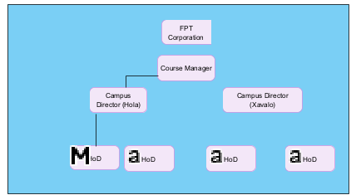

Q3:

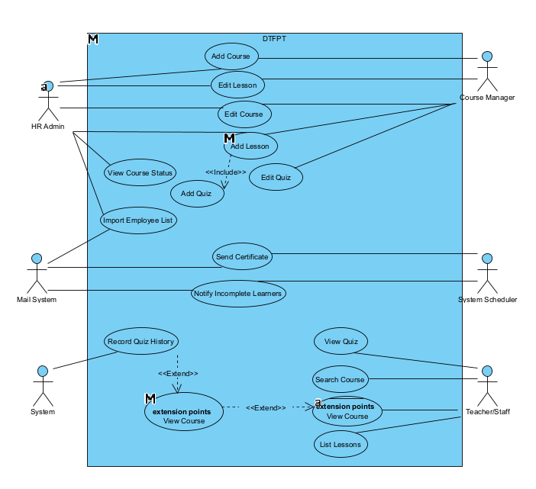

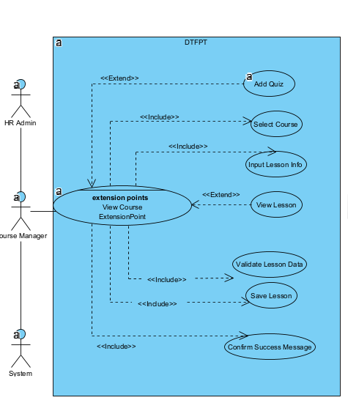

Q4:

< Student must replace this line, answer of Q4 by filling the content into the below table that reflects this exam paper. NOTE: Student must remove the guideline in and after the (….).>

|  |  |  |  |
| --- | --- | --- | --- |
| UC ID and Name: | (0.1 point) the UC – 1 Add Lesson | | |
| Created By: | lmp14589@gmail.com | Date Created: 18/7/2025 | 18/7/2025 |
| Primary Actor: | Course Manager | Secondary Actors: | HR Admin |
| Trigger: | Course Manager selects a course and clicks “Add Lesson” button | | |
| Description: | Allows a Course Manager to add a new lesson to an existing course in the DTFPT system. | | |
| Preconditions: | 1. The Course already exists in the system. 2. The Course Manager is authenticated and authorized. | | |
| Post conditions: | 1. A new lesson is created and stored in the database. 2. The lesson is associated with the selected course. 3. HR Admin can view and edit the lesson. | | |
| Normal Flow: | 1. Course Manager logs in. 2. Navigates to course management screen. 3. Selects a course from the list. 4. Clicks “Add Lesson”. 5. Inputs lesson title, description, and content. 6. Clicks “Save” and system confirms lesson creation. | | |
| Alternative Flows: | 1a. If no course is selected.  1b. System displays error message and blocks action.  2a. If lesson content is too short  2b. Validation error shown, user must edit input.  3a. If user cancels  3b. System returns to course detail screen. | | |
| Exceptions: | 1a. Database connection fails  1b. System displays “Failed to save. Please try again.”  2a. Session expired  2b. Redirect to login screen.  3a. Unauthorized access attempt  3b. Show access denied message. | | |
| Priority: | High – this is a critical function required for course delivery. | | |
| Frequency of Use: | Daily – Course Managers frequently add lessons to active courses. | | |
| Business Rules: | * Lesson must be linked to one existing Course * Lesson title must be unique in that Course | | |
| Other Information: | System should display “Lesson added successfully” in green text color after saving | | |
| Assumptions: | The user has valid session and Course already exists in database | | |

**Q5:**

1. The DTFPT system shall respond to any user action (such as viewing course, submitting quiz, or adding lesson) within **2 seconds** in **95% of test cases**, measured using load testing tools such as Apache JMeter under normal network conditions.
2. The system must support **at least 10,000 concurrent users** (FPT employees across Vietnam), based on internal HR reports estimating total active learners during peak periods (e.g., one week before training deadlines). This will be tested using simulated load under cloud deployment conditions.
3. All users must authenticate through their **@fpt.com.vn email** domain using corporate Single Sign-On (SSO) integration, and login tokens must expire after **30 minutes of inactivity** to reduce risk of unauthorized access.
4. The system must prevent brute-force login attacks by limiting login attempts to **5 per 15 minutes per IP**, tracked via audit logs and enforced through middleware authentication logic. The limit is based on OWASP security guidelines for enterprise systems.