

**NIHONGOSEKAI**

**JAPANESE COMMUNICATION AND CULTURE LEARNING PLATFORM**

**Final Release Document**

– Da Nang, July 2025 –

**Table of Contents**

I. Deliverable Package 2

II. Installation Guides 2

1. Prerequisites 2

2. Clone the Repository 3

3. Database Configuration 3

4. Google Login Configuration 3

5. Build and Run the Application 4

6. Default Admin Account 4

III. User Manual 4

1. Overview 4

2. Register a Learner Account and Login 5

a. Overview 5

b. Step-by-step Guideline 6

# I. Deliverable Package

| **No.** | **File** | **Notes** |
| --- | --- | --- |
| 1 | D11-RT01_DB_final.sql | Database, including both table structures and table data |
| 2 | D11-RT01 _SRS_final.docx | Final SRS (Requirement) Document |
| 3 | D11-RT01_SDS_final.docx | Final SDS (Design) Document |
| 4 | D11-RT01_Project_Tracking.xlsx | Final status for the application functions, which include:  - Function name, feature, roles, function description (changes compared to the original requirements are highlighted)  - In Charge, Planned iteration & Actual iteration  - Final status & note on the update you made  - The links to the SRS & SDS are tracked |
| 5 | D11-RT01_Issues Report.xlsx | Final issues tracking list of the whole project |

Other related deliverables:

* Tagged source codes: [github.com/LuongFu/SWRT_D11-RT01_Nihongo_Sekai](http://github.com/LuongFu/SWRT_D11-RT01_Nihongo_Sekai)

# 

# II. Installation Guides

## 1. Prerequisites

Before installing, ensure that your system meets the following requirements:

* **Operating System**: Windows 10/11 or Linux (Ubuntu 20.04+)
* **.NET SDK**: Version **.NET 8.0** or higher  
   [Download .NET 8](https://dotnet.microsoft.com/download/dotnet/8.0)
* **SQL Server**: Version 2019+ (or Azure SQL Database)
* **Entity Framework Core Tools**:

Install using: *dotnet tool install --global dotnet-ef*

* **Git**: To clone the project repository
* **Recommended IDE**: Visual Studio 2022 (with ASP.NET and Web Development workload installed)

## 2. Clone the Repository

Clone the NihongoSekai project source code:

git clone https://github.com/LuongFu/SWRT_D11-RT01_Nihongo_Sekai.git

## 3. Database Configuration

1. **Create a Database**

Create a new empty database named NihongoSekaiDB.

Open the appsettings.json file and update the connection string:

"ConnectionStrings": {

"DefaultConnection": "Server=localhost;Database=NihongoSekaiDB;Trusted_Connection=True;TrustServerCertificate=True;"

}

1. **Apply Migrations and Seed Data**

Run the following commands from the project root:  
  
 dotnet ef database update

This will create all tables and insert initial seed data (roles, admin account, sample courses, classroom templates, etc.).

## 4. Google Login Configuration

To enable Google login functionality:

1. Create an **OAuth 2.0 Client ID** in [Google Cloud Console](https://console.cloud.google.com/).
2. Add your **ClientId** and **ClientSecret** to the appsettings.json:  
     
    "Authentication": {

"Google": {

"ClientId": "<YOUR_GOOGLE_CLIENT_ID>",

"ClientSecret": "<YOUR_GOOGLE_CLIENT_SECRET>"

}

}

## 5. Build and Run the Application

1. **Restore Dependencies:** dotnet restore
2. **Build the Project:** dotnet build
3. **Run the Application:** dotnet run
4. The application will be available at:  
   1. https://localhost:5001 (HTTPS) or
   2. http://localhost:5000 (HTTP)

## 6. Default Admin Account

* **Email:** lmp14589@gmail.com
* **Password:** Phu123123@  
   Use this account to access the admin dashboard at /Admin.

# 

# III. User Manual

## 1. Overview

NihongoSekai is an online Japanese learning platform designed to help learners improve their communication skills and cultural understanding through interactive courses, live classrooms with native speakers, and quizzes.  
The application provides role-based access for Guests, Learners, Partners, and Admins, ensuring that each user type has the right set of tools and features.

**Key Features:**

* Browse and purchase Japanese courses with video lessons and quizzes.
* Track learning progress through video completion and quiz scores.
* Join live classroom sessions via a built-in video call feature, hosted by native speakers.
* Manage personal profiles, including password changes and course history.
* Admin dashboard for managing users, courses, and orders.

**Basic Workflow:**

1. **Registration/Login:** Users create an account or log in using Google or email credentials.
2. **Explore Courses:** Browse available courses and view detailed content (videos, outcomes, quizzes).
3. **Purchase & Enroll:** Add courses to the cart, complete payment, and gain immediate access.
4. **Start Learning:** Watch videos, take quizzes, and track progress in the “My Courses” section.
5. **Join Live Classrooms:** Participate in real-time interactive sessions with native speakers using the built-in video call system.

## 

## 2. Register a Learner Account and Login

### a. Overview

This workflow guides new users (learners) through the account creation process on the NihongoSekai platform and explains how to verify their email address before logging into the system. By completing this workflow, the user gains access to all learner features such as purchasing courses, joining classes, and tracking their learning progress.

### b. Step-by-step Guideline

**Step 1: Access the main website**

* Open the NihongoSekai homepage.
* Click the **"Tài khoản"** dropdown and choose **"Đăng ký"**.  
    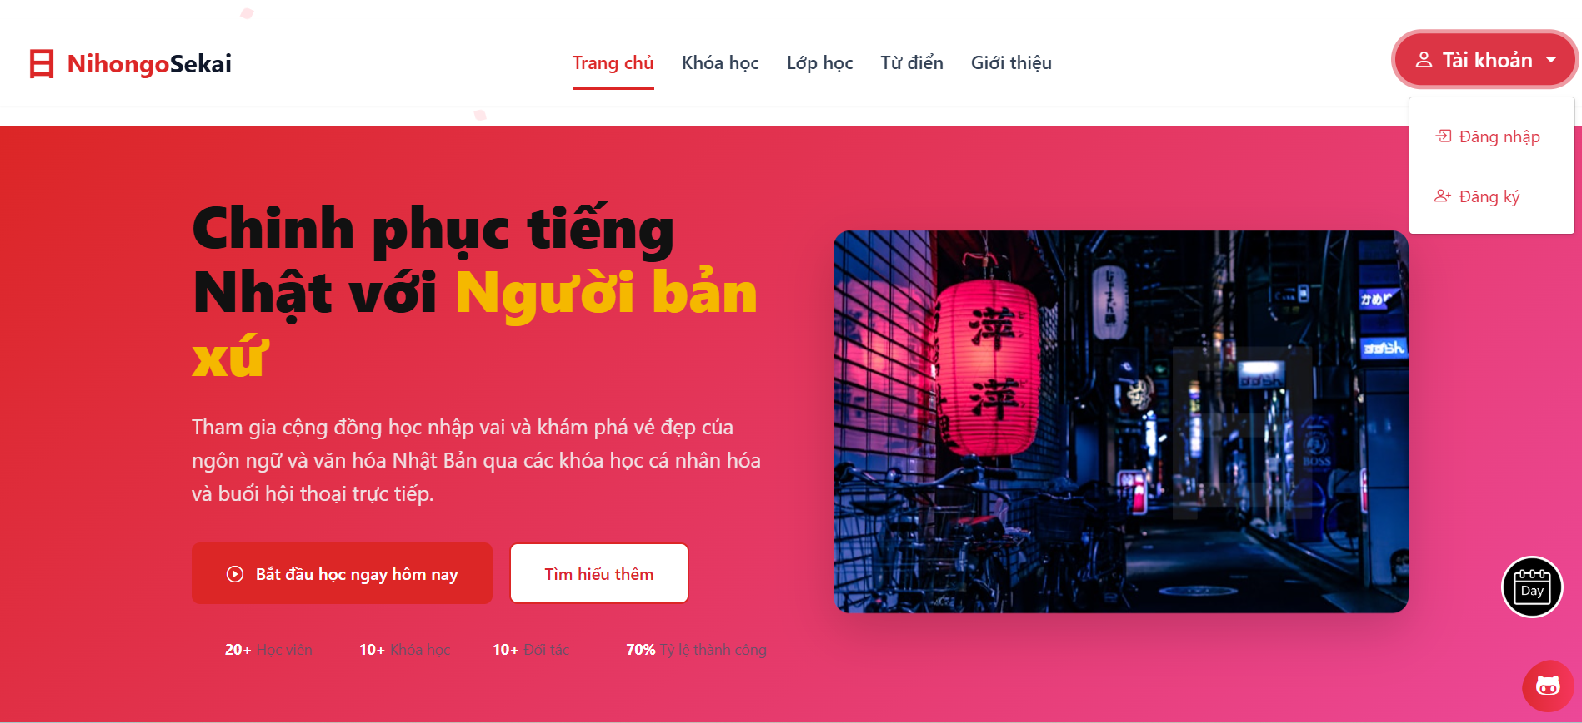

*Image 1 - Main Page*

**Step 2: Fill in registration details**

* On the registration page, select the role **"Người học"**.
* Enter the required information: Full Name, Email, Password, and Password Confirmation.
* Check the box to accept the Terms of Service and Privacy Policy.
* Click the **"Tạo tài khoản"** button.

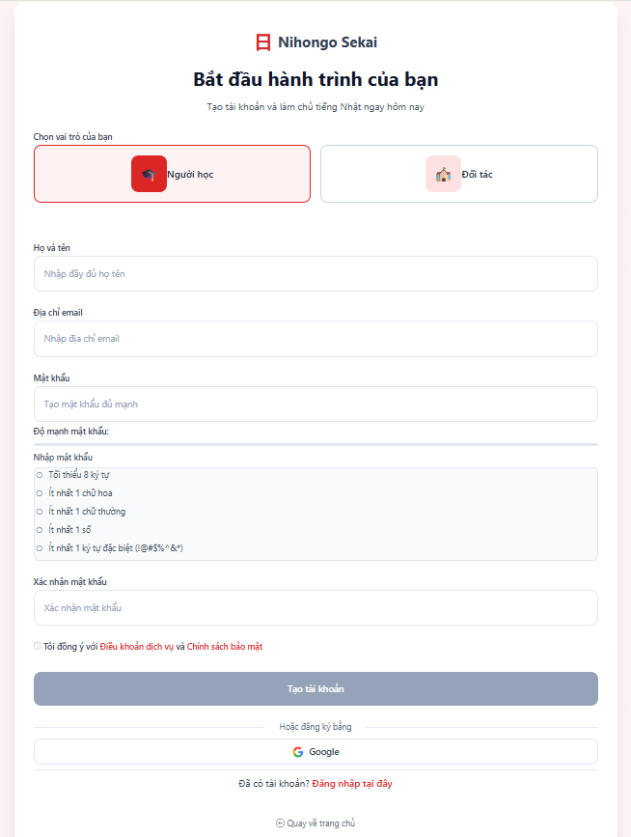

*Image 2 - Learner Registration Page*

**Step 3: Account creation confirmation**

* After successful registration, a confirmation screen appears, informing the user to verify their email address.  
   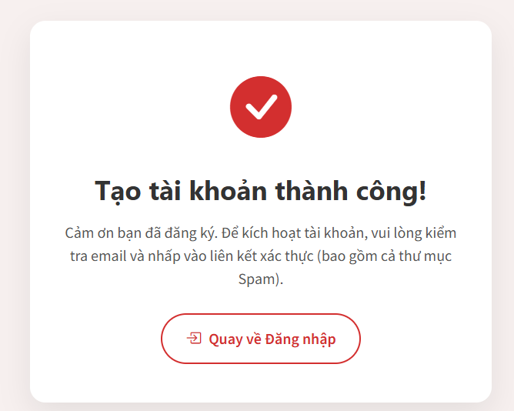

*Image 3 - Confirmation account creation successful and waiting for email verification*

**Step 4: Verify your email**

* Check your inbox for an email from NihongoSekai.
* Click the verification link in the email.  
   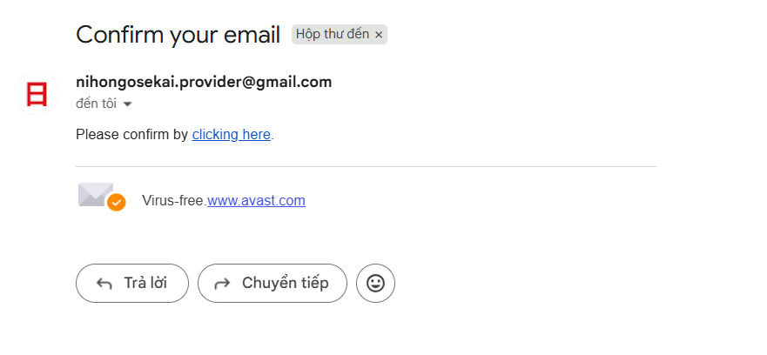

*Image 4 - Verification email after creating an account*

**Step 5: Email verification success**

* After clicking the link, you will see a success message confirming that your email address is verified.

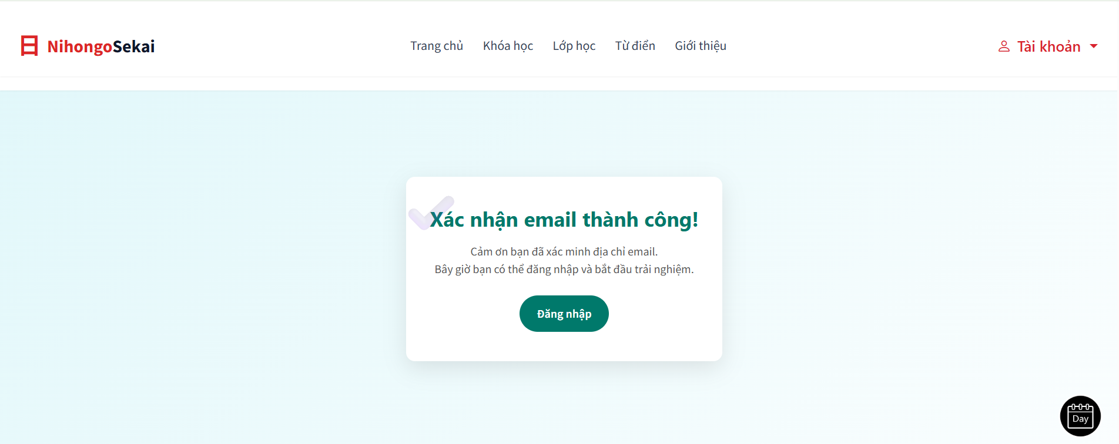

*Image 5 - Email verification successful confirmation page*

**Step 6: Login to the system**

* Return to the NihongoSekai homepage.
* Click **"Tài khoản" → "Đăng nhập"**.
* Enter your email and password.
* Click the **"Đăng nhập"** button to access your learner dashboard.

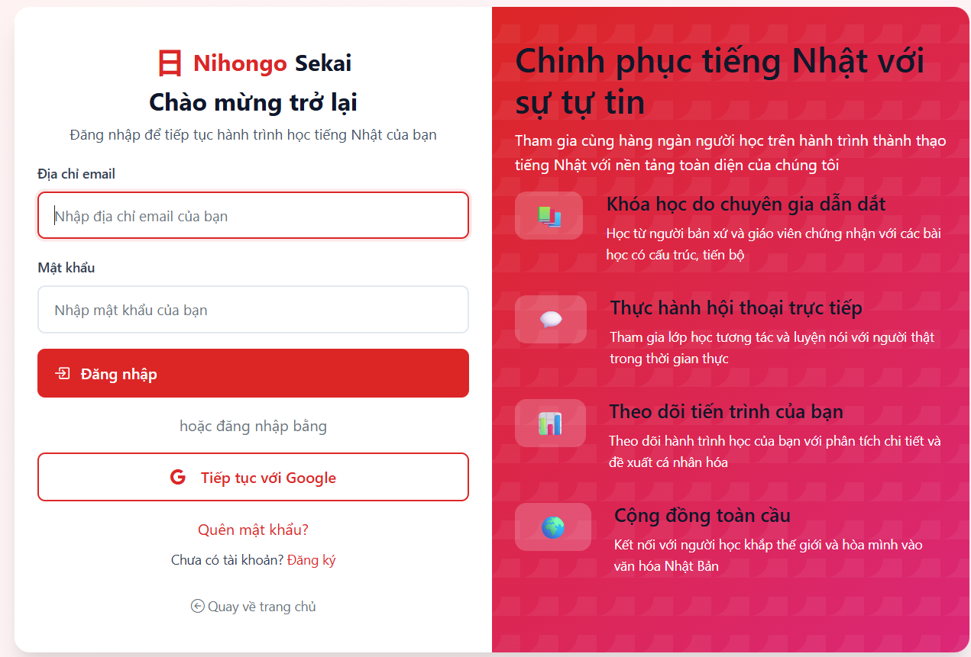

*Image 6 - Login Page*