**Subject: PRF192- PFC**

**Workshop 01**

**Part 1: Number systems**

**Exercise 1** **(2 marks): Convert decimal numbers to binary ones**

|  |  |  |  |  |  |
| --- | --- | --- | --- | --- | --- |
| **Decimal** | **4-bit Binary** | **Decimal** | **8-bit Binary** | **Decimal** | **16-bit Binary** |
| 9 | 1001 | 7 | 0000 0111 | 255 | 0000 0000 1111 1111 |
| 7 | 0111 | 34 | 0010 0010 | 192 | 0000 0000 1100 0000 |
| 2 | 0010 | 125 | 0111 1101 | 188 | 0000 0000 1011 1100 |
| 15 | 1111 | 157 | 1001 1101 | 312 | 0000 0001 0011 1000 |
| 12 | 1100 | 162 | 1010 0010 | 517 | 0000 0010 0000 0101 |
| 11 | 1011 | 37 | 0010 0101 | 264 | 0000 0001 0000 1000 |
| 6 | 0110 | 66 | 0100 0010 | 543 | 0000 0010 0001 1111 |
| 5 | 0101 | 77 | 0100 1101 | 819 | 0000 0011 0011 0011 |
| 8 | 1000 | 88 | 0101 1000 | 1027 | 0000 0100 0000 0011 |
| 13 | 1101 | 99 | 0110 0011 | 2055 | 0000 1000 0000 0111 |
| 14 | 1110 | 109 | 0110 1101 | 63 | 0000 0000 0011 1111 |

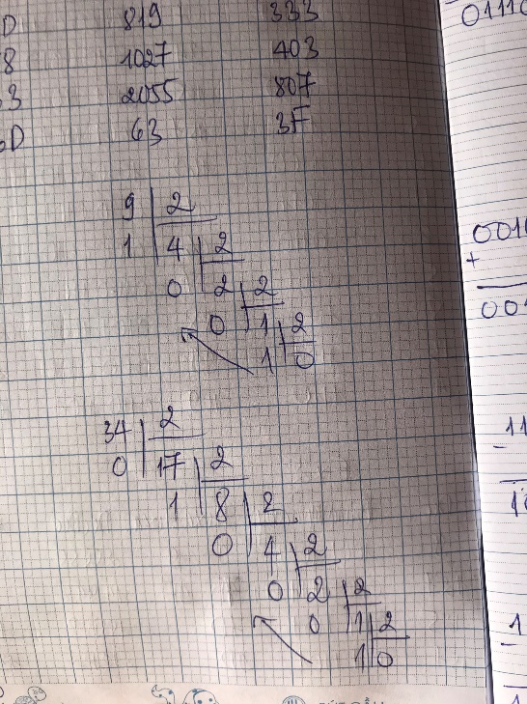

**Exercise 2(2 marks): Convert decimal numbers to binary and hexadecimal ones**

|  |  |  |  |  |  |
| --- | --- | --- | --- | --- | --- |
| **Decimal** | **Binary** | **Hexa.** | **Decimal** | **16-bit Binary** | **Hexadecimal** |
| 9 | 1001 | 9 | 255 | 0000 0000 1111 1111 | 00FF |
| 127 | 0111 1111 | 7F | 192 | 0000 0000 1100 0000 | C0 |
| 125 | 0111 1101 | 7D | 188 | 0000 0000 1011 1100 | BC |
| 157 | 1001 1101 | 9D | 312 | 0000 0001 0011 1000 | 138 |
| 162 | 1010 0010 | A2 | 517 | 0000 0010 0000 0101 | 205 |
| 37 | 0010 0101 | 25 | 264 | 0000 0001 0000 1000 | 108 |
| 66 | 0100 0010 | 42 | 543 | 0000 0010 0001 1111 | 21F |
| 77 | 0100 1101 | 4D | 819 | 0000 0011 0011 0011 | 333 |
| 88 | 0101 1000 | 58 | 1027 | 0000 0100 0000 0011 | 403 |
| 99 | 0110 0011 | 63 | 2055 | 0000 1000 0000 0111 | 807 |
| 109 | 0110 1101 | 6D | 63 | 0000 0000 0011 1111 | 3F |

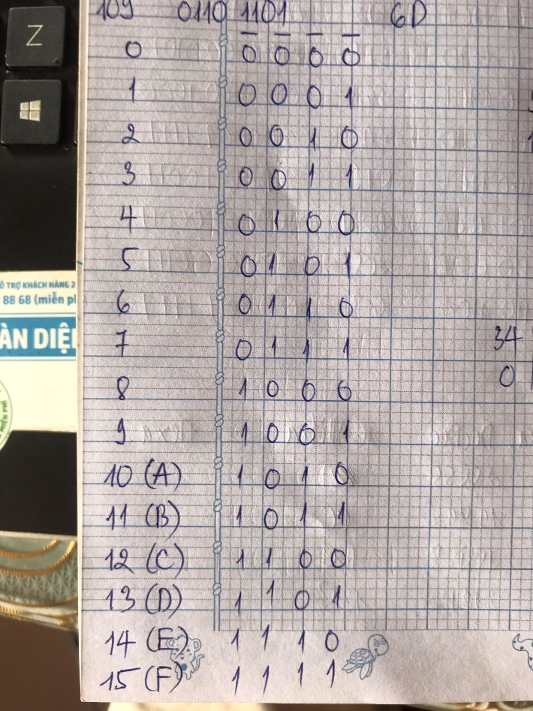

**Exercise 3(2 marks): Compute**

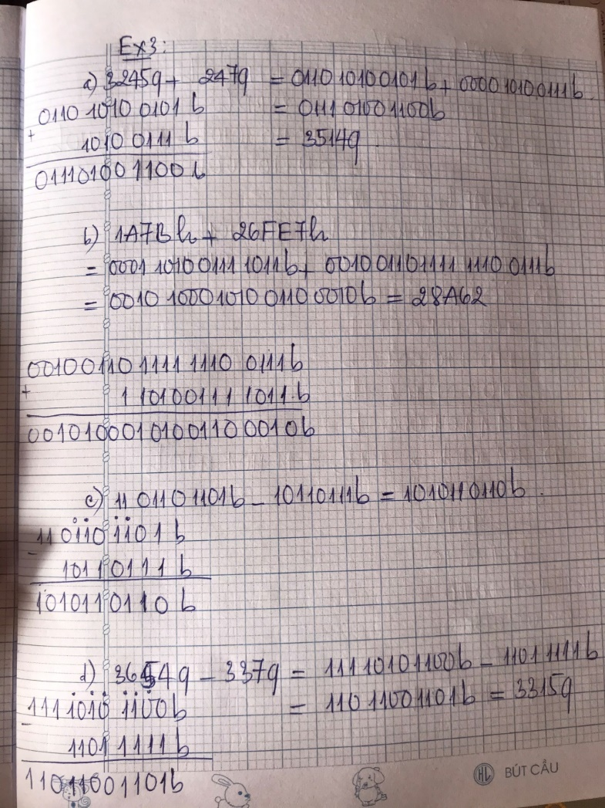(b: binary, q: octal, h: hexadecimal)

1. **3245q + 247q = 3514q =**

**0111 0100 1100b**

1. **1A7Bh + 26FE7h = 28A62h =**

**0010 1000 1010 0110 0010b**

1. **1101101101b - 10110111b =10 1011 0110b**
2. **3654q – 337q = 3315q = 110 1100 1101b**
3. **3AB7h – 1FAh = 38BDh =**

**11 1000 1011 1101b**

1. **36Ah – 576q = 1EC h = 01 1110 1100b**
2. **64AEh – 1001101b= 62141 q**

101101111 b

h) + 100111011 b  
 110110001 b  
 110001101 b

10111101000 b

i) 1011010 b* 1011b = 11 1101 1110b

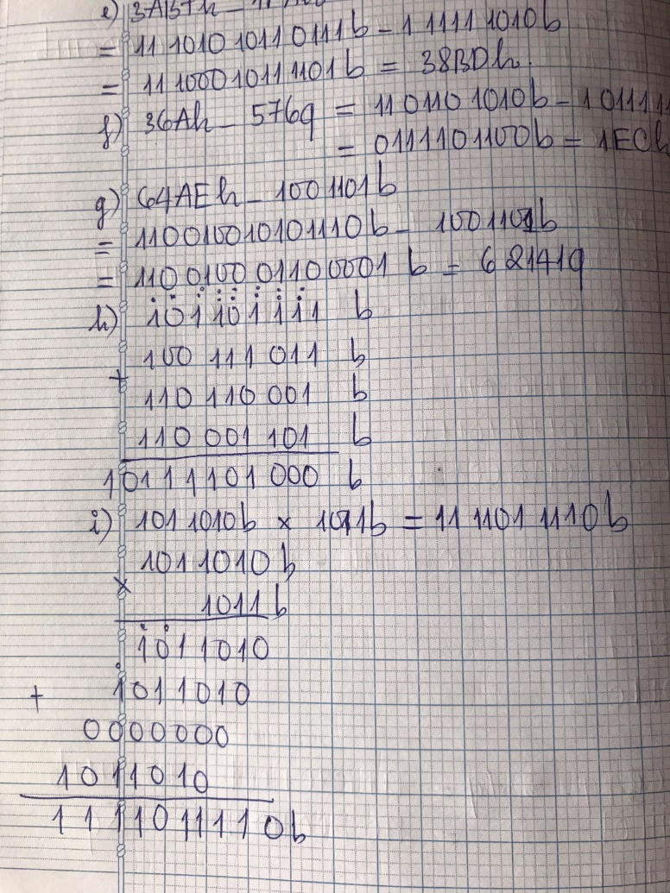j) 1101000b + 2AB h + 345 q = 3F8 h = 1770 q

k) 3AFh / 1Ch = 10 0001 b = 33d

l) 3ACh – 562q = 10 0011 1010b = 570 d

m) 3FFA h / 327q = 100 1100b = 76 d

**Exercise 4 (2 marks)**

1. Show binary formats of 1-byte unsigned numbers: 251 , 163, 117

* 251d = 1111 1011b
* 163d = 1010 0011b
* 117d = 0111 0101b

1. Show binary formats of 2-byte unsigned numbers: 551 , 160, 443

* 551d = 0000 0010 0010 0111b
* 160d = 0000 0000 1010 0000b
* 443d = 0000 0001 1011 1011b

1. Show binary formats of 1-byte signed numbers: -51 , -163, -117, -20

* -51d = 1100 1100b
* -163d = 0101 1101b
* -117d = 1000 1011b
* -20d = 1110 1100b

1. Show the decimal values of 1-byte unsigned representations: :

01100011 b , 10001111 b , 11001010 b , 01001100 b

* 0110 0011b = 99d
* 1000 1111b = 143d
* 1100 1010b = 202d
* 0100 1100b = 76d

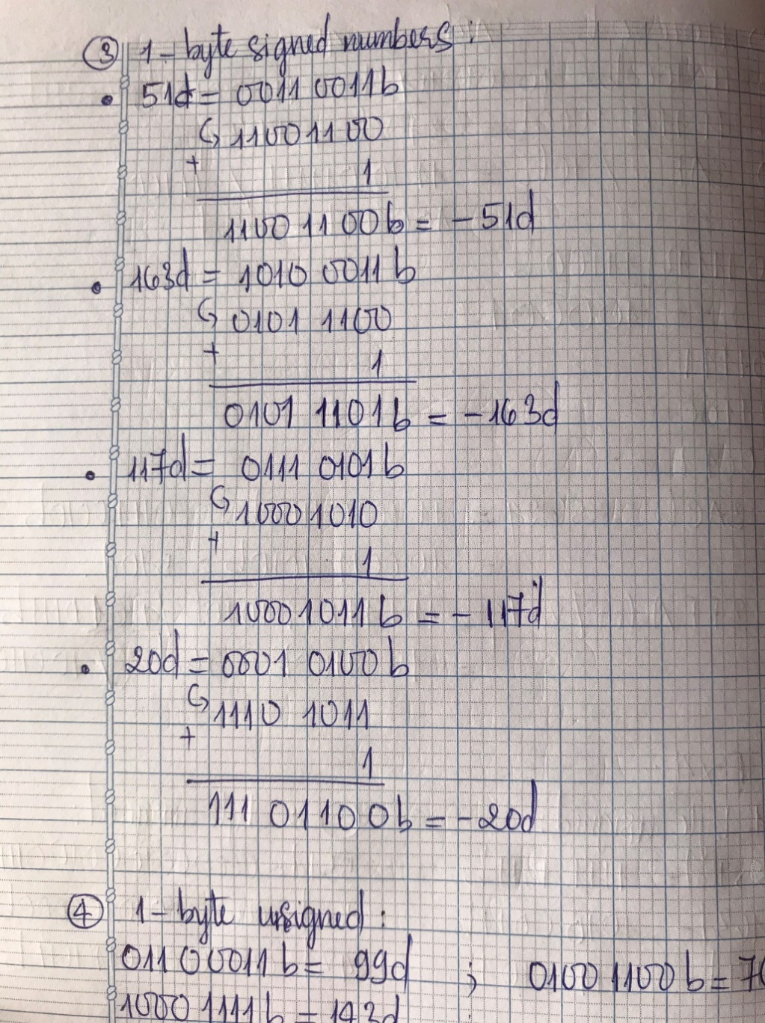

**Part 2: Explore memory structure of programs**

**Sample**

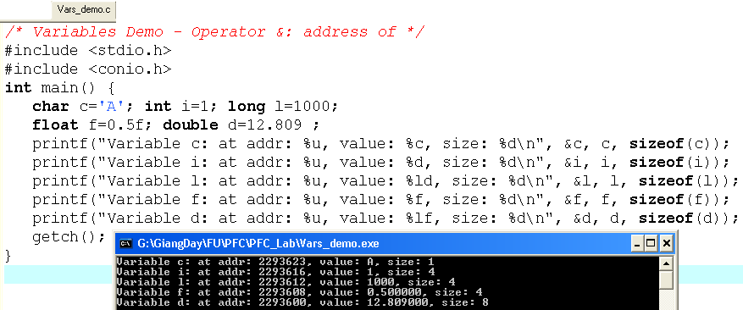

12.809

0.5

1000

‘A’

1

**d**:2293600

**f**:2293608

**l**:2293612

**i**:2293616

**c**:2293623

**Complete the code of following program then draw it’s memory structure**

**(2 marks)**

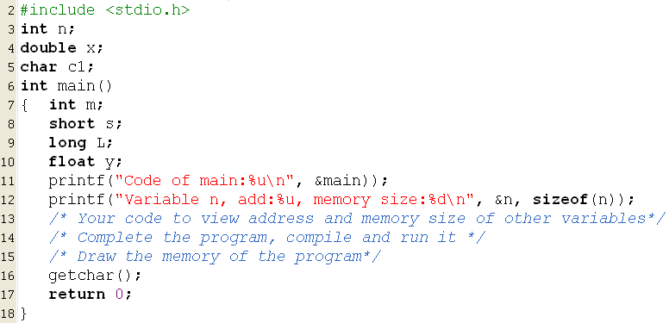

**Code:**

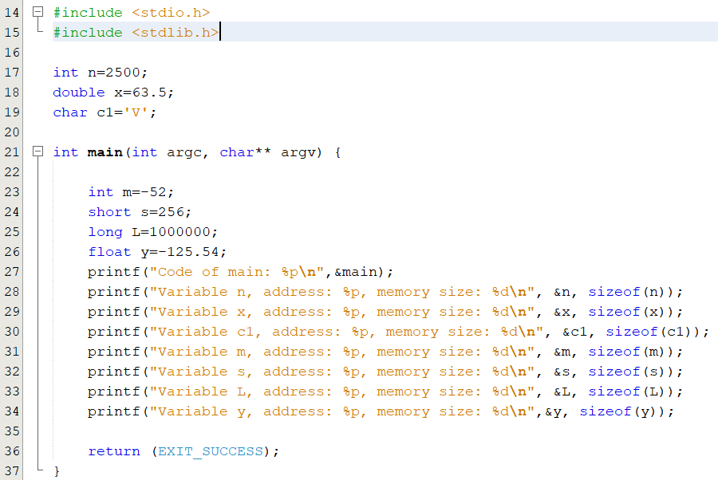

**Result:**

