**Subject: PRF192- PFC**

**Workshop 04**

**Part 1: Use notebook**

**Exercise 1** (1 mark) : Explain outputs:

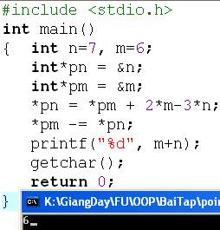

*pn = *pm + 2*m – 3*n

🡪 n = *pn = 6 + 2*6 – 3*7 = -3

*pm -= *pn

🡪 m = *pm = 6 – (-3) = 9

* Output: m + n 🡪 6

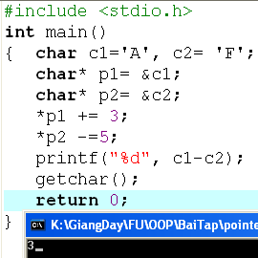

*p1 += 3

🡪 c1 = *p1 = ‘A’ + 3 = ‘D’

*p2 -= 5

🡪 c2 = *p2 = ‘F’ – 5 = ‘A’

🡺 Output: c1 – c2 (%d) 🡪 3

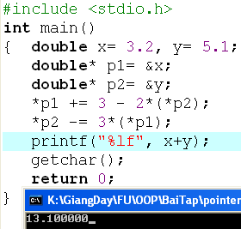

*p1 += 3 – 2*(*p2)

🡪 x = *p1 = x + 3 – 2*y = 3.2 + 3 – 2*5.1 = -4

*p2 -= 3*(*p1)

🡪 y = *p2 = y – 3*x = 5.1 – 3*(-4) = 17.1

🡺 Output: x + y 🡪 13.100000

**Exercise 2: (1 marks) What are outputs**

int n=7,m=8;

int* p1= &n, *p2=&m;

*p1 +=12-m+ (*p2);

*p2 = m + n- 2*(*p1);

printf(“%d”, m+n);

What is the output?

*p1 += 12 – 3 + (*p2)

🡪 n = *p1 = n + 12 – m + n = 7 + 12 – 8 + 7 = 18

*p2 = m + n – 2*(*p1)

🡪 m = *p2 = m + n – 2n = 8 + 18 – 2*18 = -10

🡺 Output: m + n 🡪 8

int n=7,m=8;

int* p1= &n, *p2=&m;

*p1 +=12-m+ (*p2);

*p2 = m + n- 2*(*p1);

printf(“%d”, m+n);

What is the output?

*p1 += 12 – 3 + (*p2)

🡪 n = *p1 = n + 12 – m + n = 7 + 12 – 8 + 7 = 18

*p2 = m + n – 2*(*p1)

🡪 m = *p2 = m + n – 2n = 8 + 18 – 2*18 = -10

🡺 Output: m + n 🡪 8

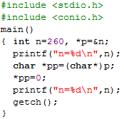

**Exercise 3: (2 marks) Walkthroughs**

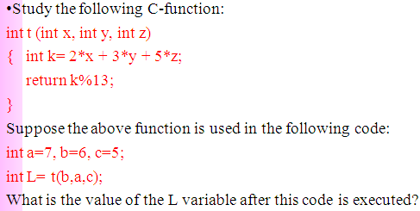



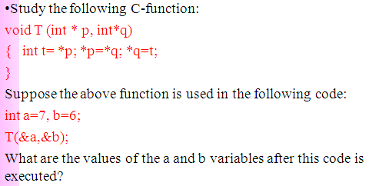

|  |  |
| --- | --- |
| T  a = 6  b = 7 | t = 7  *p = *q = 6  *q = 7 |

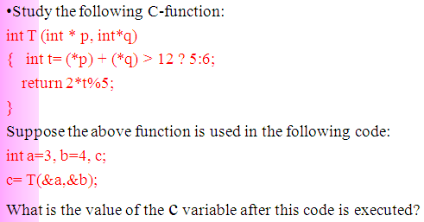

|  |  |
| --- | --- |
| T | *p = a = 3  *q = b = 4  (*p) + (*q) = 7 < 12 🡪 t = 6  🡪 return: |