**Subject: PRF192- PFC**

**Workshop 08**

**Objectives:**

Managing text files

**Problem 1(1 mark):**

Implement the problem introduced in the demonstration 1 of the lecture

**Problem 2(1 mark):**

Implement the problem introduced in the demonstration 2 of the lecture

**Problem 3(1 mark):**

Implement the problem introduced in the demonstration 3 of the lecture

**Problem 4(1 mark):**

Implement the problem introduced in the demonstration 4 of the lecture

**Problem 5(1 mark):**

Implement the problem introduced in the demonstration 5 of the lecture

**Problem 6(3 mark):**

* Data representing a student include: name, address, mark.
* A list of students are stored in the file **students.txt** as below:

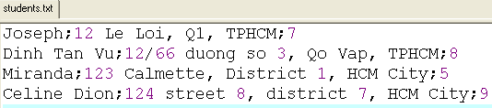

* Write a C-program that will print out the list of students in descending order based on their marks then the list will be written to the file students_2.txt with the same format as the previous file.

***(Hint: Refer to the lecture’s slide when this problem is solved)***