LAB02

# Using command line in Linux (shell script)

## su

**Syntax:** **su** [OPTION]… [-] [USER [ARG]…]

**What does it do?** Change the effective user id and group id to that of the USER.

**Example:**

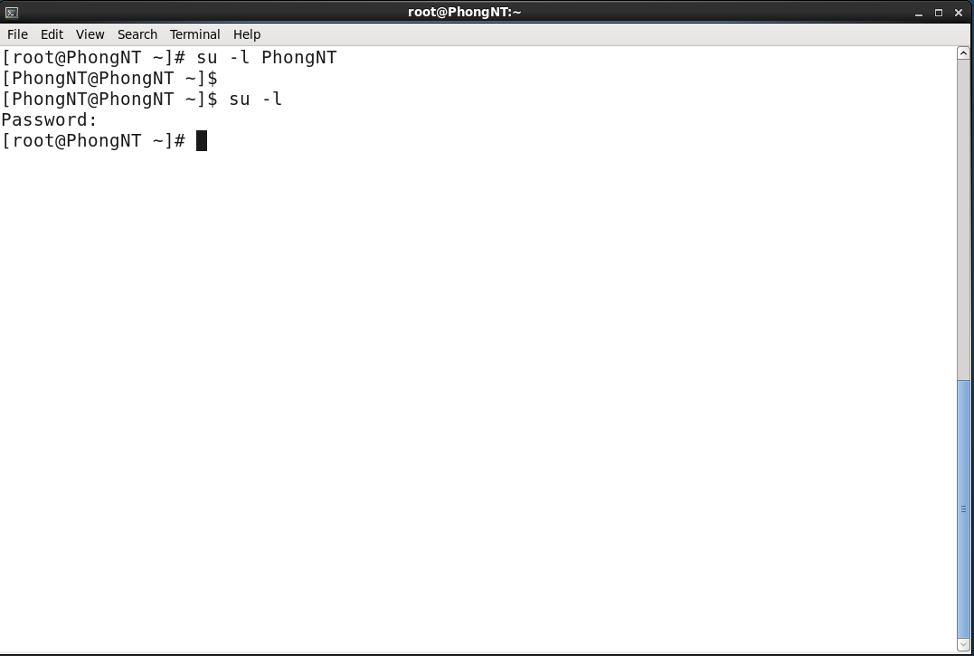

Chuyển tài khoản đăng nhập từ root sang user thường (PhongNT) và ngược lại

## env

**Syntax:** **env** [OPTION]… [-] [NAME=VALUE]… [COMMAND [ARG]…]

**What does it do?** Set each NAME to VALUE in the environment and run COMMAND.

**Example:**

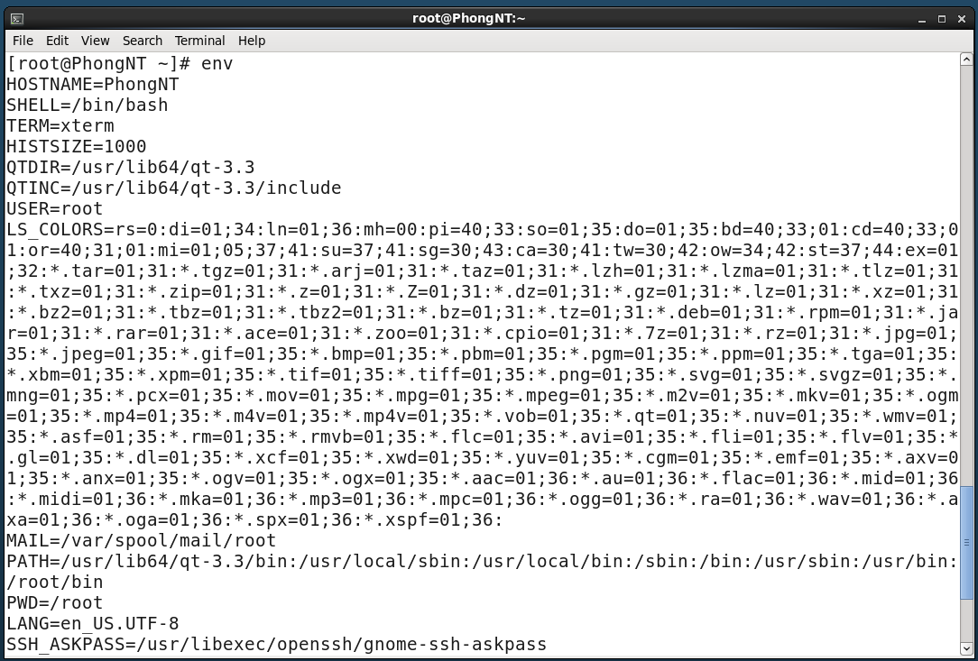

View all the environment variables with the command 'env' withour any argument

## mkdir

**Syntax:** **mkdir** [OPTION]… DIRECTORY…

**What does it do?** Create the DIRECTORY(ies), if they do not already exist.

**Example:**

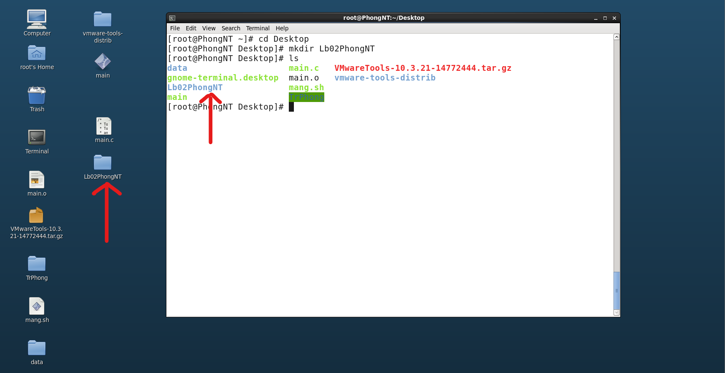

Create the directory 'Lb02PhongNT' on Desktop

## cp

**Syntax:**

**cp** [OPTION]… [-T] SOURCE DEST

**cp** [OPTION]… SOURCE… DIRECTORY

**cp** [OPTION]… -t DIRECTORY SOURCE…

**What does it do?** Copy SOURCE to DEST, or multiple SOURCE(s) to DIRECTORY.

**Example:**

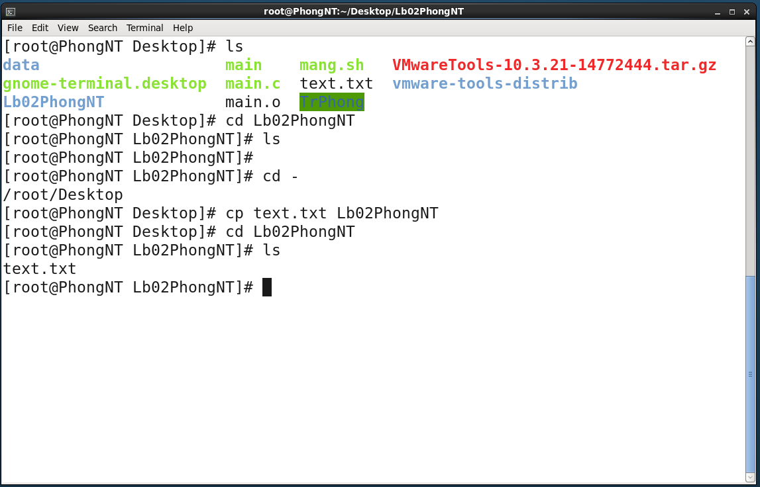

Copy the file 'text.txt' from Desktop to Lb02PhongNT

## mv

**Syntax:**

**mv** [OPTION]… [-T] SOURCE DEST

**mv** [OPTION]… SOURCE… DIRECTORY

**mv** [OPTION]… -t DIRECTORY SOURCE

**What does it do?** Rename SOURCE to DEST, or move SOURCE(s) to DIRECTORY.

**Example:**

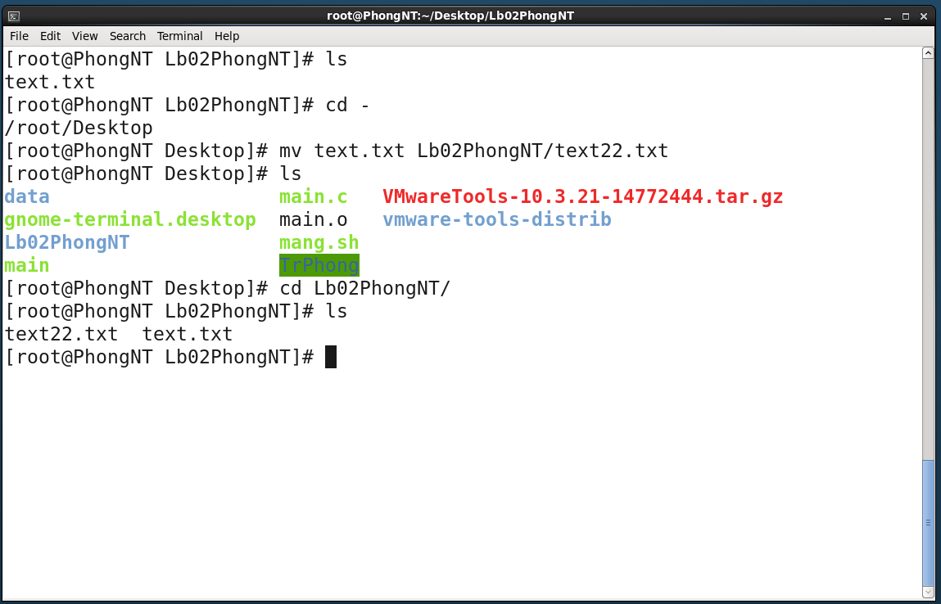

Move the file 'text.txt' from desktop to Lb02PhongNT and rename it to 'text22.txt'

## rmdir

**Syntax:** **rmdir** [OPTION]… DIRECTORY…

**What does it do?** Remove the DIRECTORY(ies), if they are empty.

**Example:**

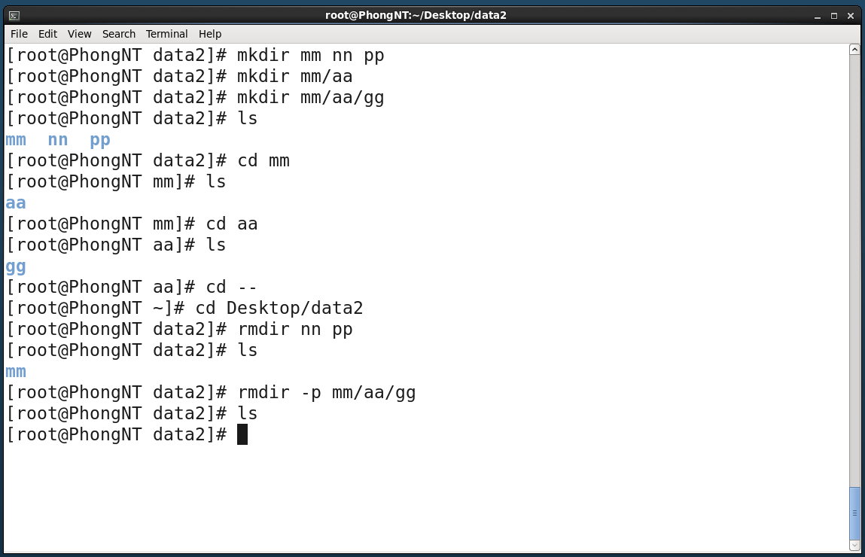

Remove the empty directories ‘data2/nn’ & ‘data2/pp’; and remove all of the empty directories in 'mm' folder

## ln

**Syntax:**

**ln** [OPTION]… [-T] TARGET LINK_NAME (1st form)

**ln** [OPTION]… TARGET (2nd form)

**ln** [OPTION]… TARGET… DIRECTORY (3rd form)

**ln** [OPTION]… -t DIRECTORY TARGET… (4th form)

**What does it do?**

In the 1st form, create a link to TARGET with the name LINK_NAME.

In the 2nd form, create a link to TARGET in the current directory.

In the 3rd and 4th forms, create links to each TARGET in DIRECTORY.

Create hard links by default, symbolic links with **--symbolic**. When creating hard links, each TARGET must exist. Symbolic links can hold arbitrary text; if later resolved, a relative link is interpreted in relation to its parent directory.

**Example:**

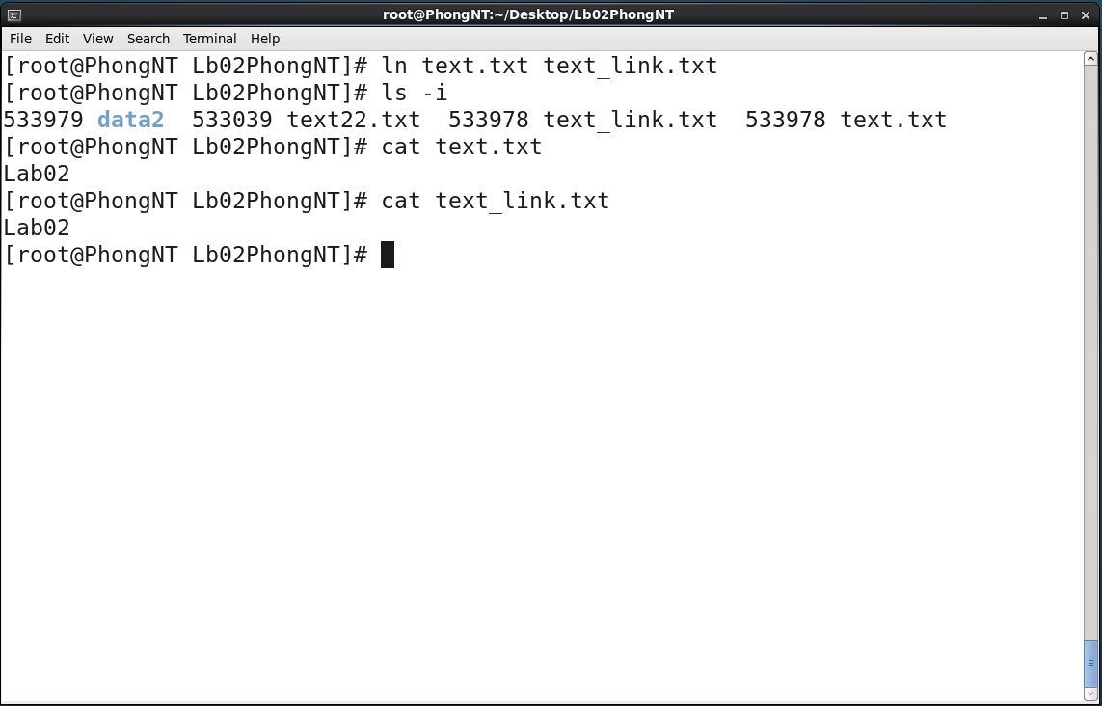

Create a softlink between 'text.txt' and 'text_link.txt'

## cat

**Syntax:** **cat** [OPTION]… [FILE]…

**What does it do?** Concatenate FILE(s), or standard input, to standard output.

**Example:**

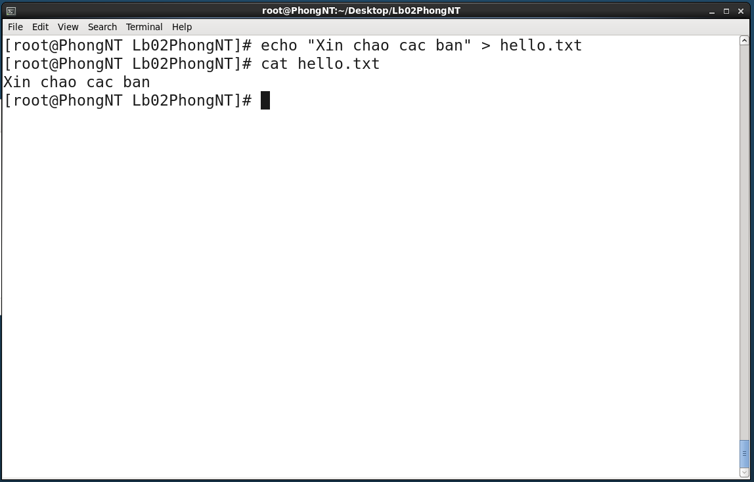

View content of the file 'hello.txt'

## rm

**Syntax:** **rm** [OPTION]… FILE…

**What does it do?** Remove files or directories (with their contents recursively).

**Example:**

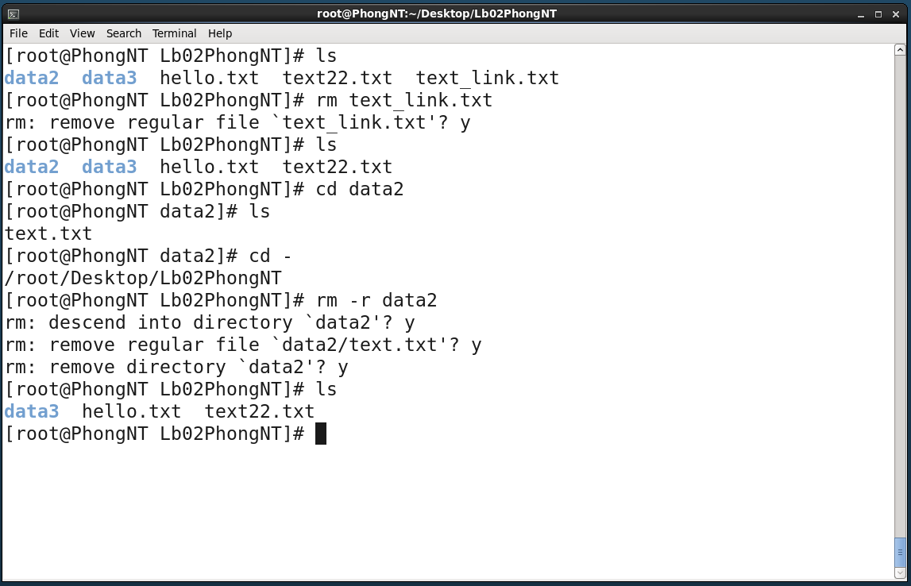

Delete file and directory

## chown

**Syntax:**

**chown** [OPTION]… [OWNER] [:[GROUP]] FILE…

**chown** [OPTION]… --reference=RFILE FILE…

**What does it do?** Change file owner and group.

**Example:**

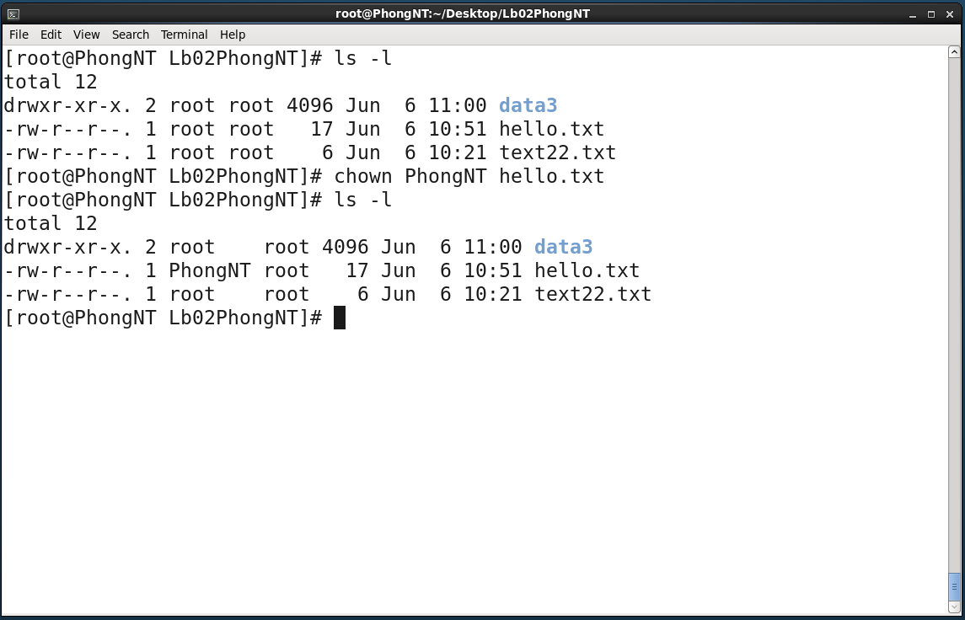

Change the owner from 'root' to 'PhongNT'

## chgrp

**Syntax:**

**chgrp** [OPTION]… GROUP FILE…

**chgrp** [OPTION]… --reference=RFILE FILE…

**What does it do?** Change the group of each FILE to GROUP. With **–reference**, change the group of each FILE to that of RFILE.

**Example:**

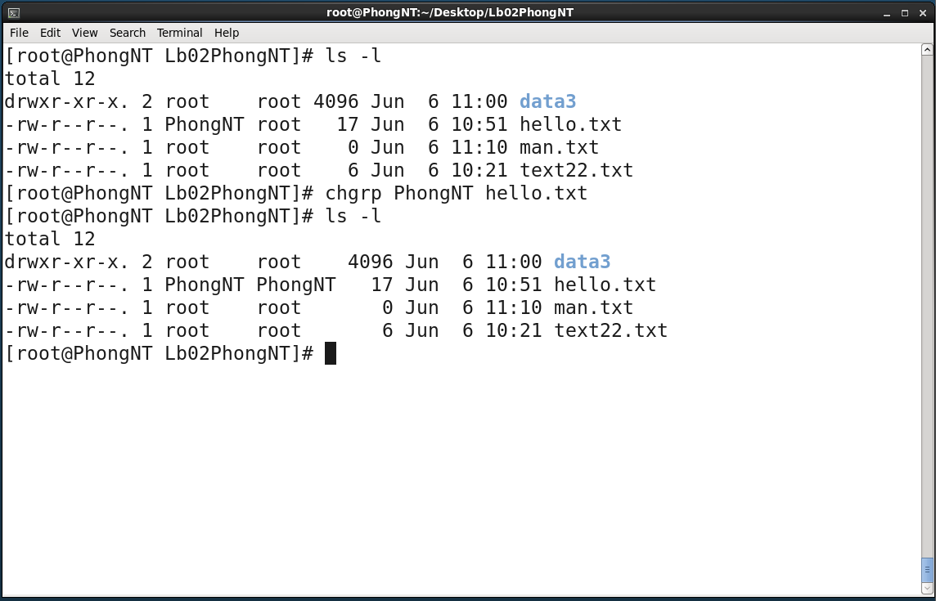

Change the Group Ownership from 'root' to 'PhongNT' of the file 'hello.txt'

## chmod

**Syntax:**

**chmod** [OPTION]… MODE[ ,MODE]… FILE…

**chmod** [OPTION]… OCTAL-MODE FILE…

**chmod** [OPTION]… --reference=RFILE FILE…

**What does it do?** Change file mode bits

**Example:**

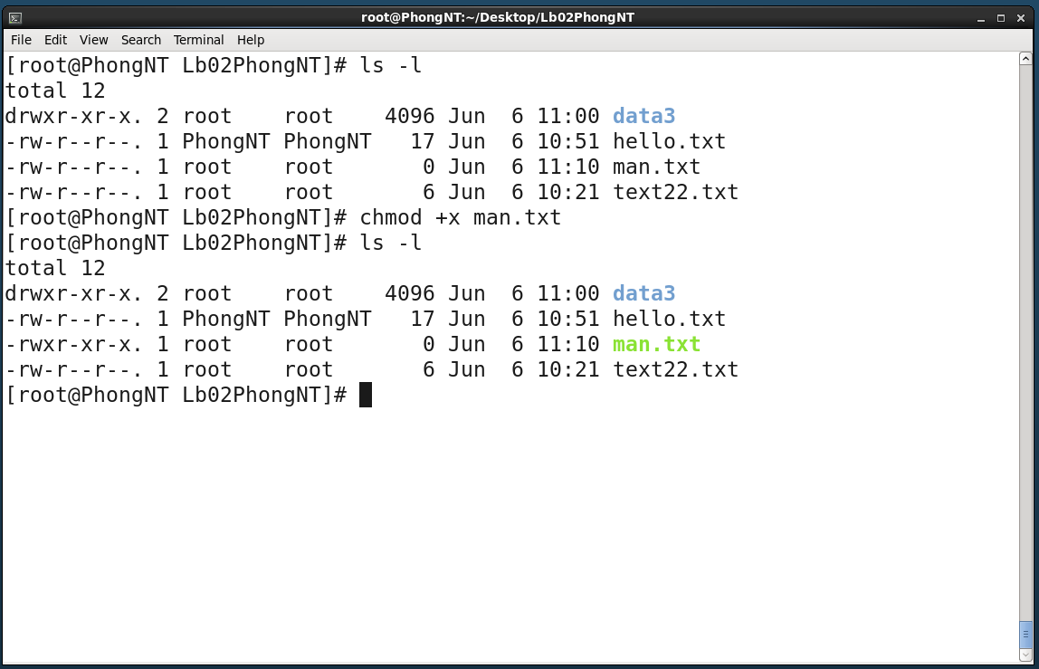

Add the permission to execute to the file 'man.txt'

## find

**Syntax:** **find** [-H] [-L] [-P] [-D debugopts] [-0level] [path…] [expression]

**What does it do?** Search for files in a directory hierarchy

**Example:**

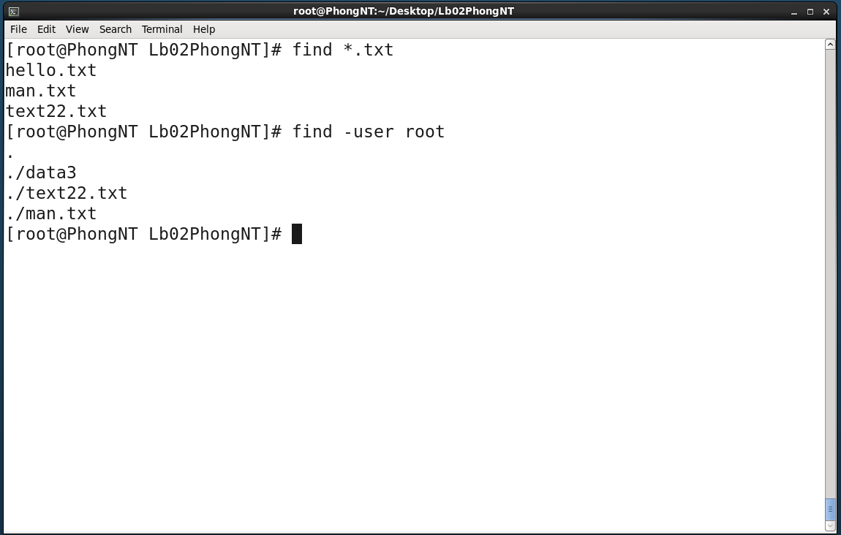

Find Files with the format '*.txt' and files / folder with user owner of root

## ds

**No such a command**

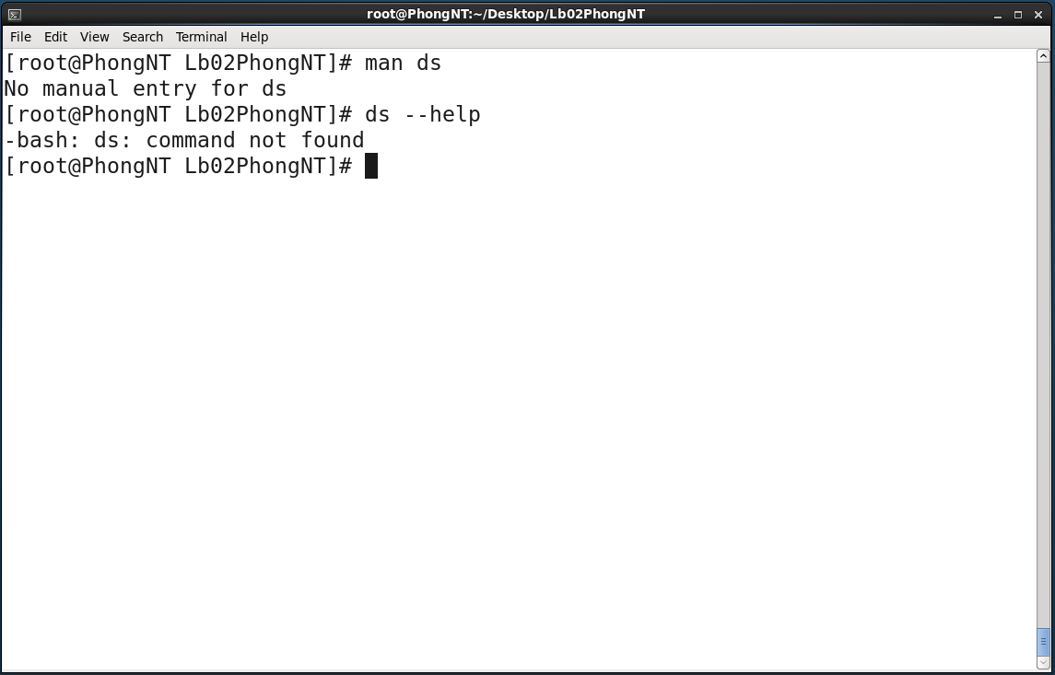

## df

**Syntax:** **df** [OPTION]… [FILE]…

**What does it do?** Report file system disk space usage.

**Example:**

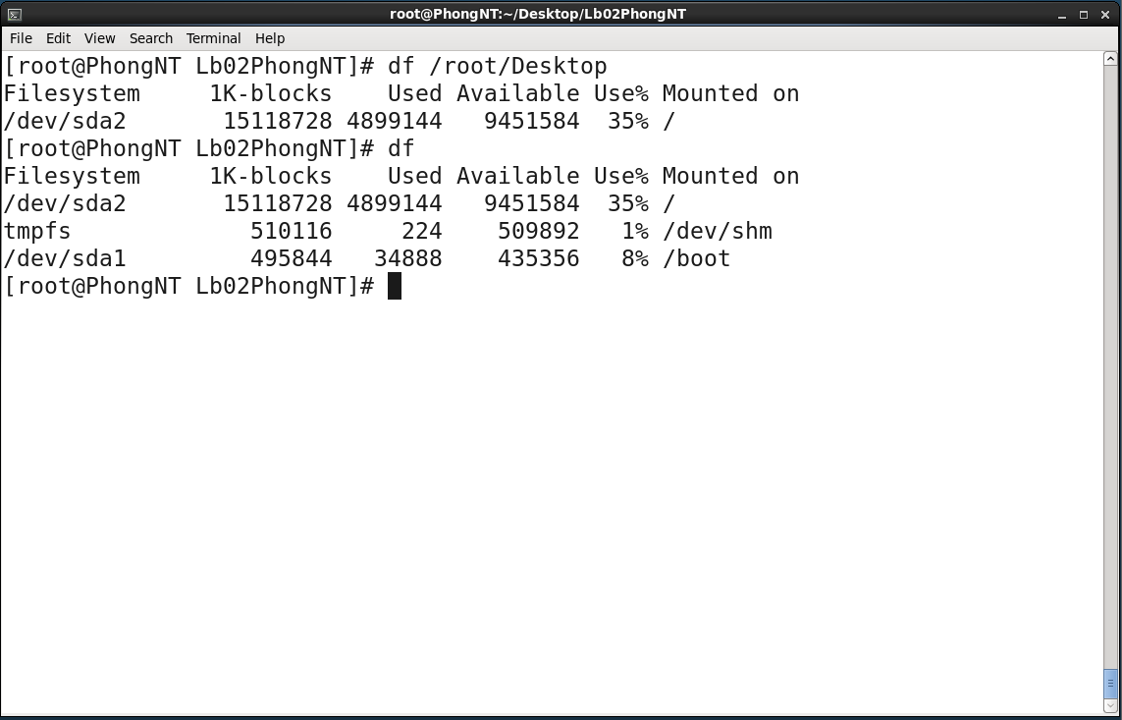

## ps

**Syntax:** **ps** [options]

**What does it do?** Report a snapshot of the current processes.

**Example:**

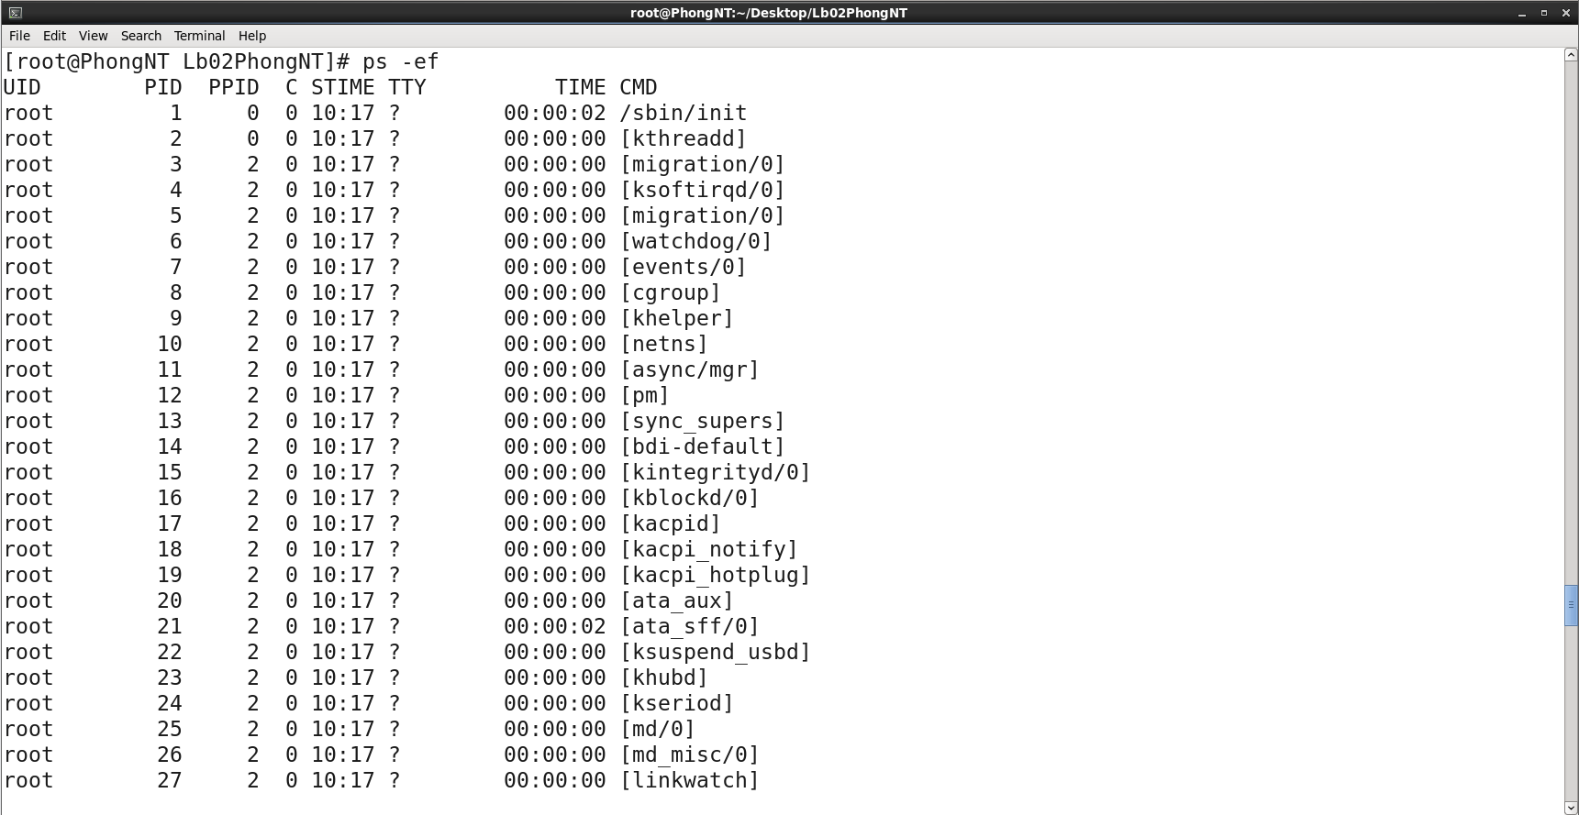

## top

**Syntax:** **top –hv | -abcHimMsS –d** delay **–n** iterations **–p** pid [, pid …]

**What does it do?** Display Linux tasks.

**Example:**

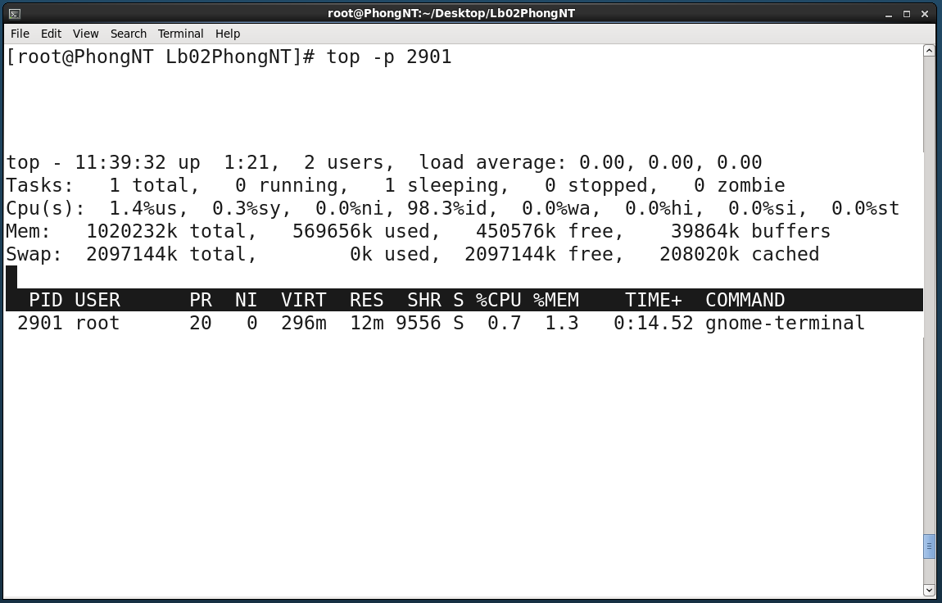

See details of the 'terminal' process - pid: 2901

## kill

**Syntax:**

**kill** [**-s** signal | **-p**] [--] pid…

**kill** **–l** [signal]

**What does it do?** Terminate a process.

**Example:**

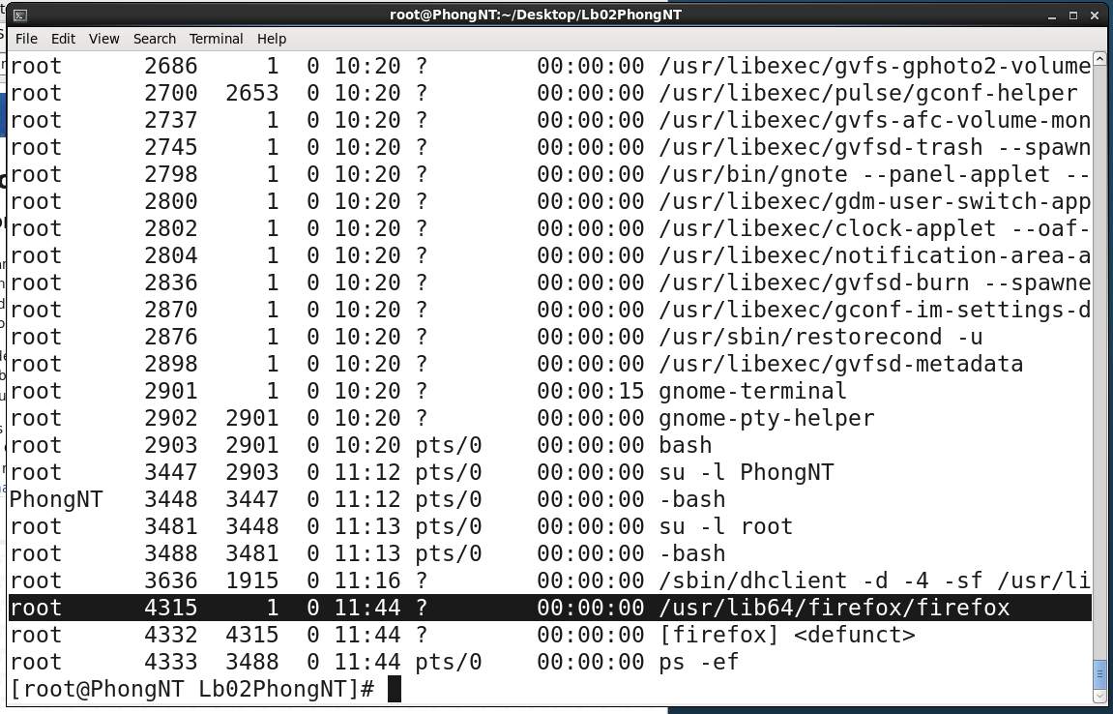

FIREFOX IS RUNNING WITH PID = 4315

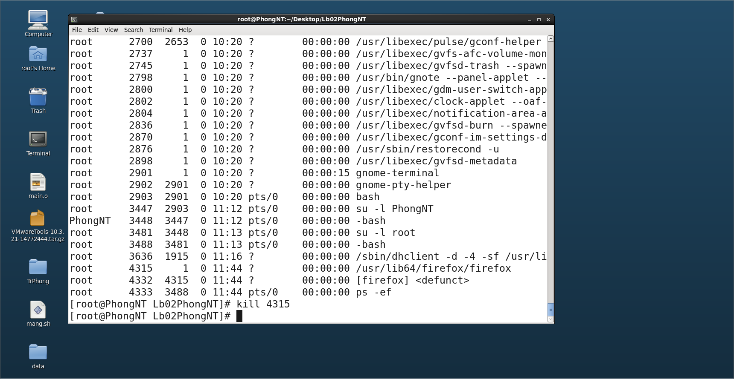

Firefox disappeared

## jobs

**Syntax:**

**jobs** [**-lnprs**] [ jobspec …]

**jobs** **–x** command [ args …]

**What does it do?** List the active jobs.

**Example:**

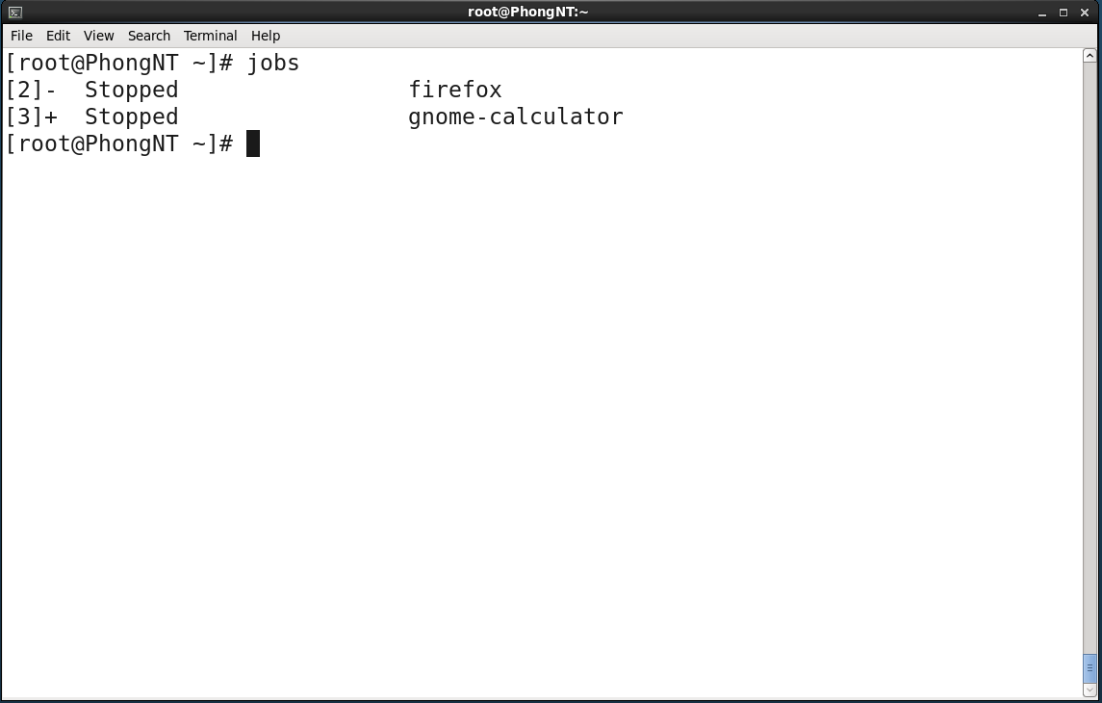

# File management

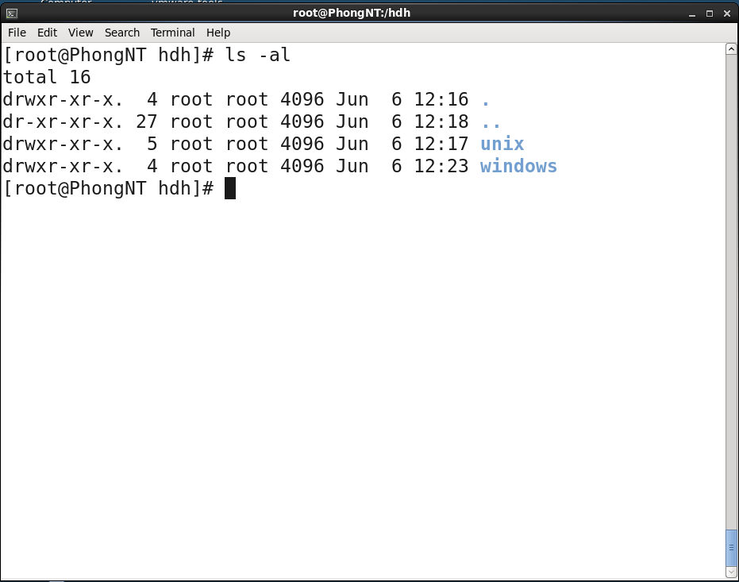

The 'hdh' folder

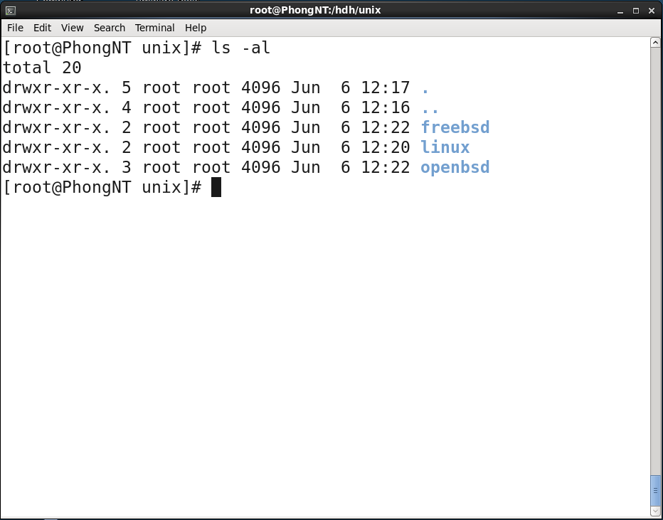

The 'unix' folder

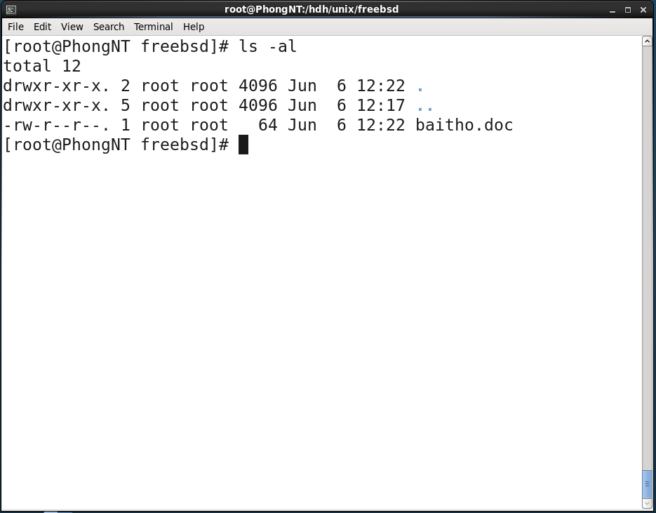

The 'freebsd' folder

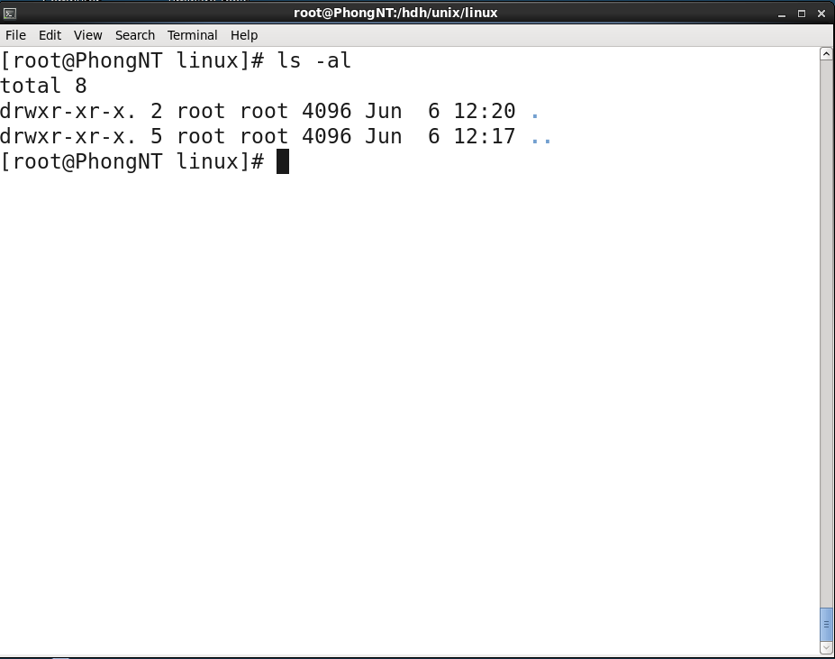

The 'linux' folder

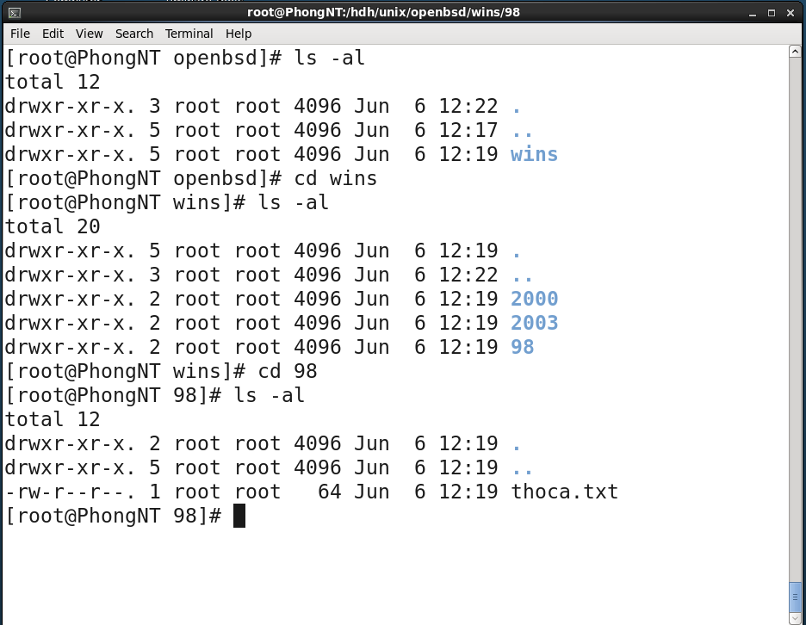

The 'openbsd' folder

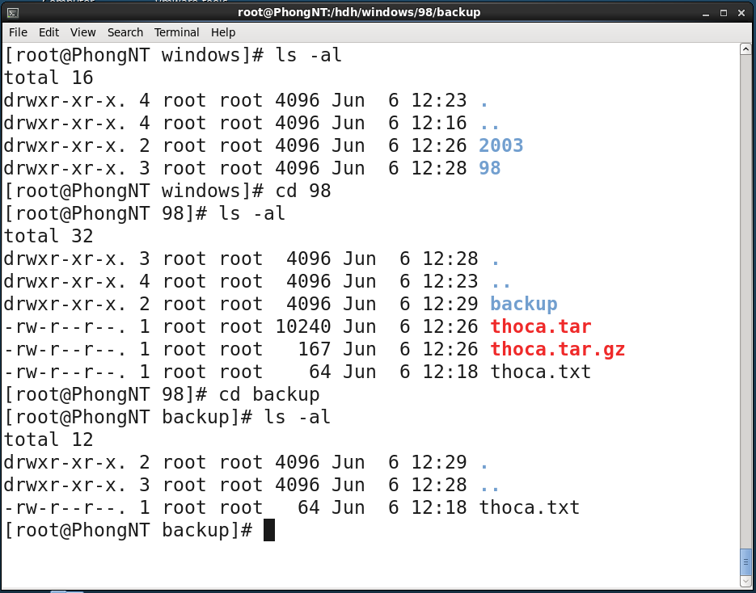

The 'windows' folder