OSG202 – LAB1

1. **Install CentOS 6.5 on VMWare Workstation.**
   1. Get the VMWare Workstation 15.0 installation from its official website.
   2. Get the ISO file for CentOS 6.5 from its official website.
   3. Run VMWare Workstation.
   4. On the Home tab, click on **Create a New Virtual Machine**.
   5. Choose **Custom** and then click **Next**.

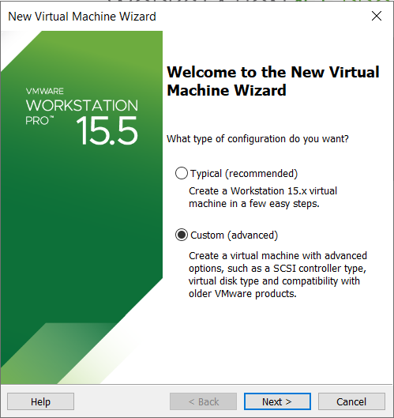

* 1. Click **Next** and then choose **I will install the operating system later**, click **Next**.

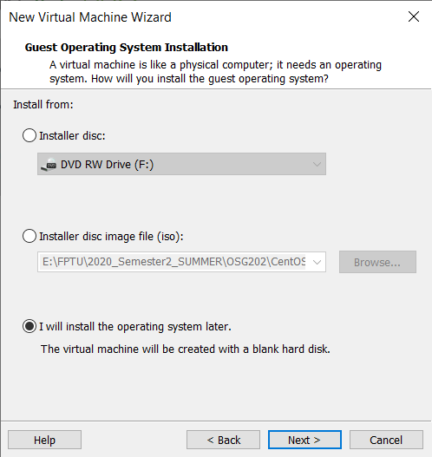

* 1. Choose **Linux**, version **CentOS 6** on the next screen, then click **Next**.
  2. Choose your Virtual machine name and its Location. Then click **Next**.

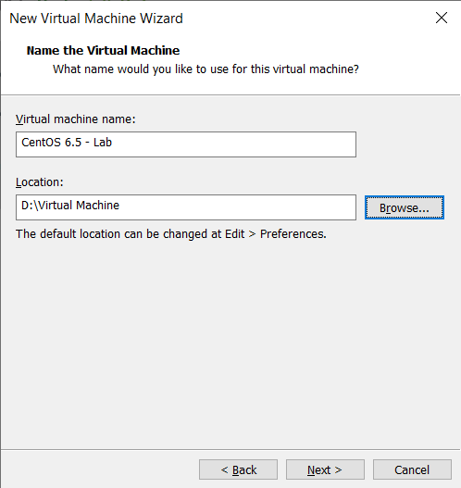

* 1. Choose number of processors and cores per processor (1 each by default). Click **Next**.
  2. Specify the amount of memory allocated to the virtual machine (by default: 1024 MB). Click **Next**.
  3. Choose **NAT** for Network connection. Then click **Next**.
  4. Click **Next** 5 times for the recommend options for your virtual machine. Finally, click **Finish**.
  5. On the left navigation, click on the name of your new virtual machine. Then click on **CD/DVD (IDE)** in the **Devices** section on the right hand.
  6. *Virtual Machine Settings* should appear. Choose **Use ISO image file** on the right side. Click *Browse…* and point to the destination of your ISO file of CentOS 6.5. Then click **OK**.

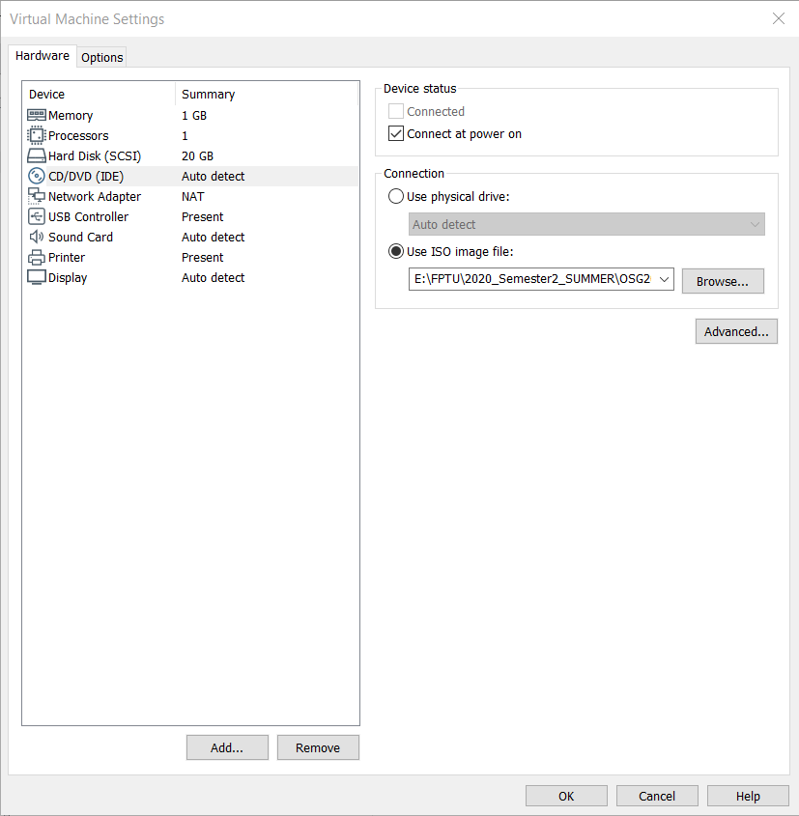

* 1. After that, click on *Power on this virtual machine* to continue setup.
  2. Click on the screen of the VM and press Enter to choose *Install or upgrade an existing system*.
  3. Press Tab to choose **Skip** and then press Space.

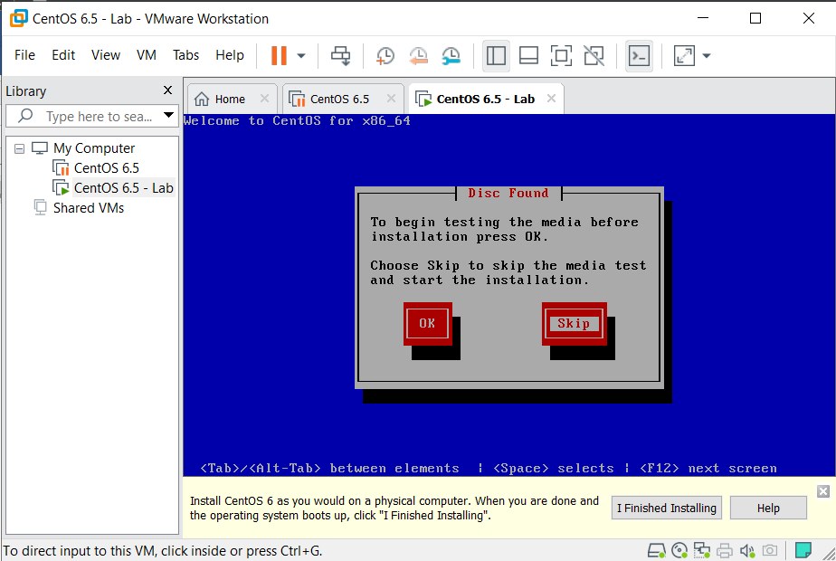

* 1. Click **Next** on the next screen.

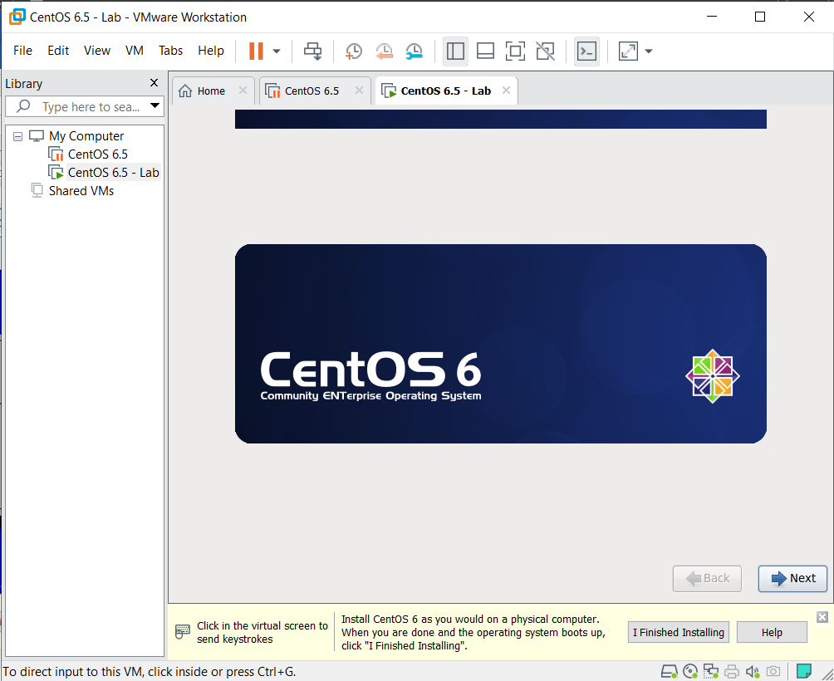

* 1. Click **Next** 3 times to make the settings default. Then click to choose **Yes, discard any data**.

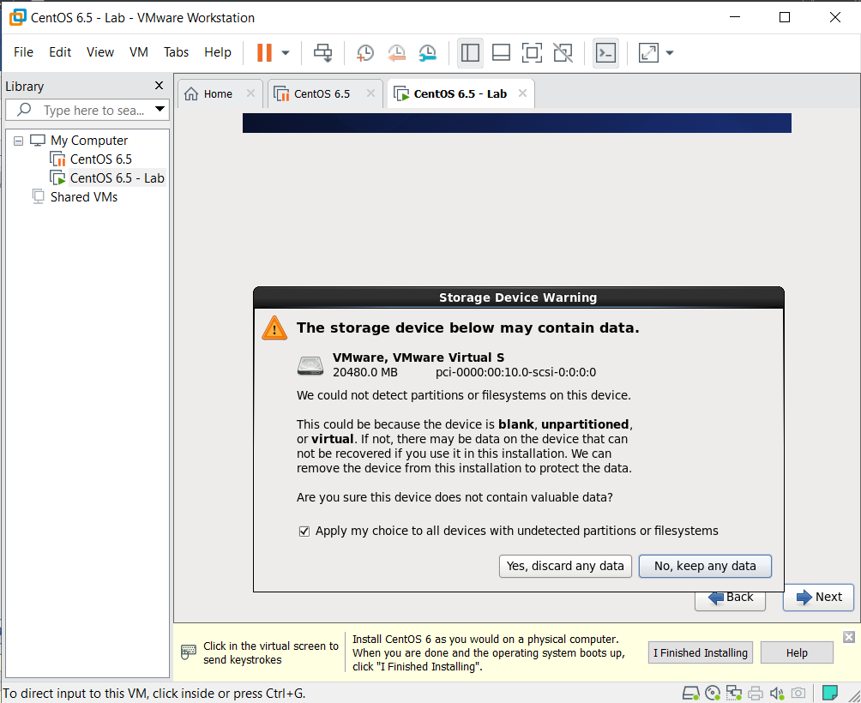

* 1. Type in your Hostname (Computer’s name). Then click **Next**.
  2. Choose your timezone then click **Next**.
  3. Choose a password for the **root** user. Click **Next**.
  4. On the next screen, choose **Create Custom Layout** to configure your disk space on your own. Click **Next**.
  5. On the next screen, click on *Free* space, click **Create**, and **Create** one more time. Choose the mount point, file system type and size for the **boot, swap** and **/** memory space.
  6. After configuring all, click **Next**, then click **Format** and **Write changes to disk**.
  7. Click **Next**, then click on *Customize now* option on the next screen and click **Next** one more.

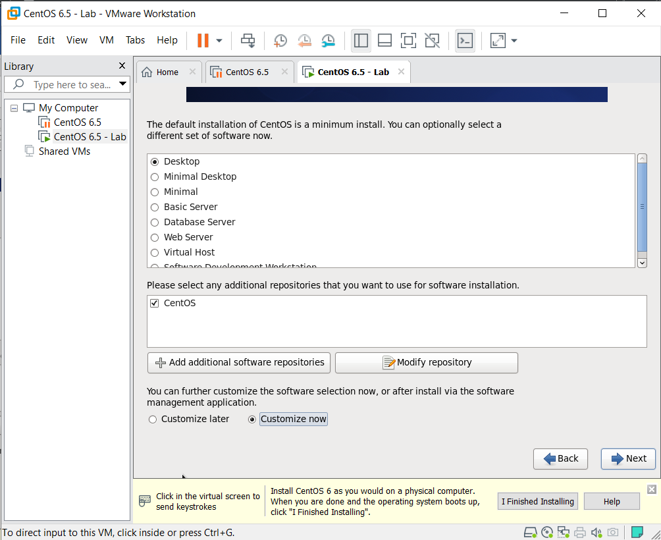

* 1. On the left navigation, click on **Development**, then choose **Additional Development**  and **Development Tools** in order to run C program afterward. Then click **Next**.

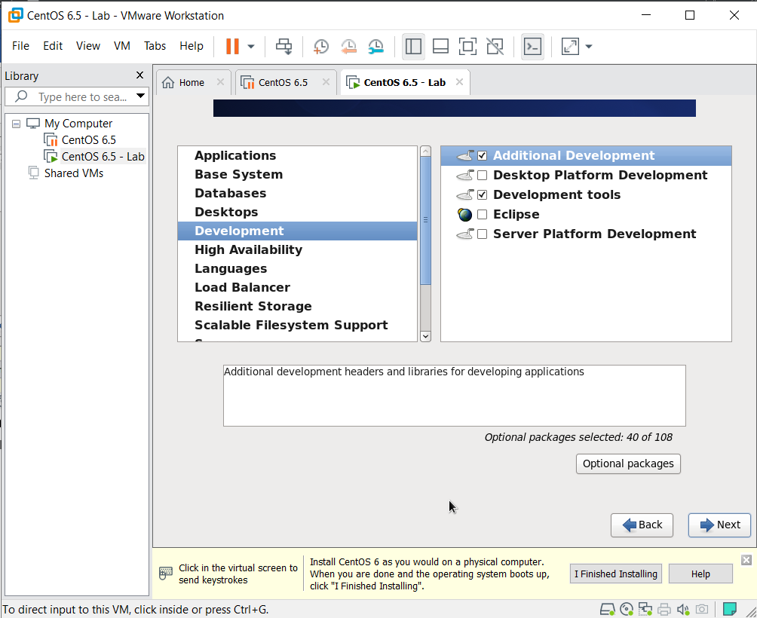

* 1. Wait for the install completion and the VM power on.
  2. Log in the *root* user with your password.

1. **Instal VMWare Tools on CentOS 6.5.** 
   1. Click on VM tab on the left corner of the VMWare screen, choose **Install VMware Tools**.
   2. The folder *Vmware Tools* shoud appear. Drag the file *VMwareTools-10.3.21-14772444.tar.gz* to Desktop.

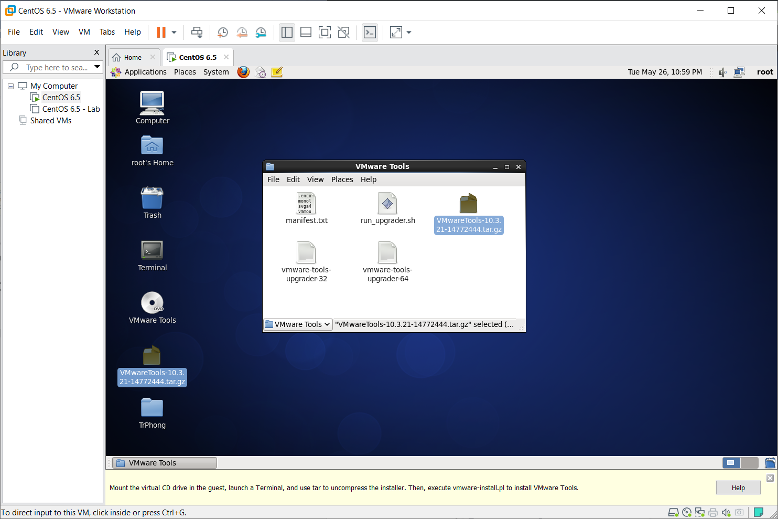

* 1. Open the Terminal point to Desktop for the *root* user.
  2. Type in *tar –xvzf VMwareTools-10.3.21-14772444.tar.gz* and press Enter. After that, your Desktop should have the folder *vmware-tools-distrib*.
  3. Type in *cd vmware-tools-distrib* and press Enter.
  4. Type in *./vmware-install.pl* and press Enter to start installation.
  5. Press Enter for any question to set by default.
  6. Succesfully!

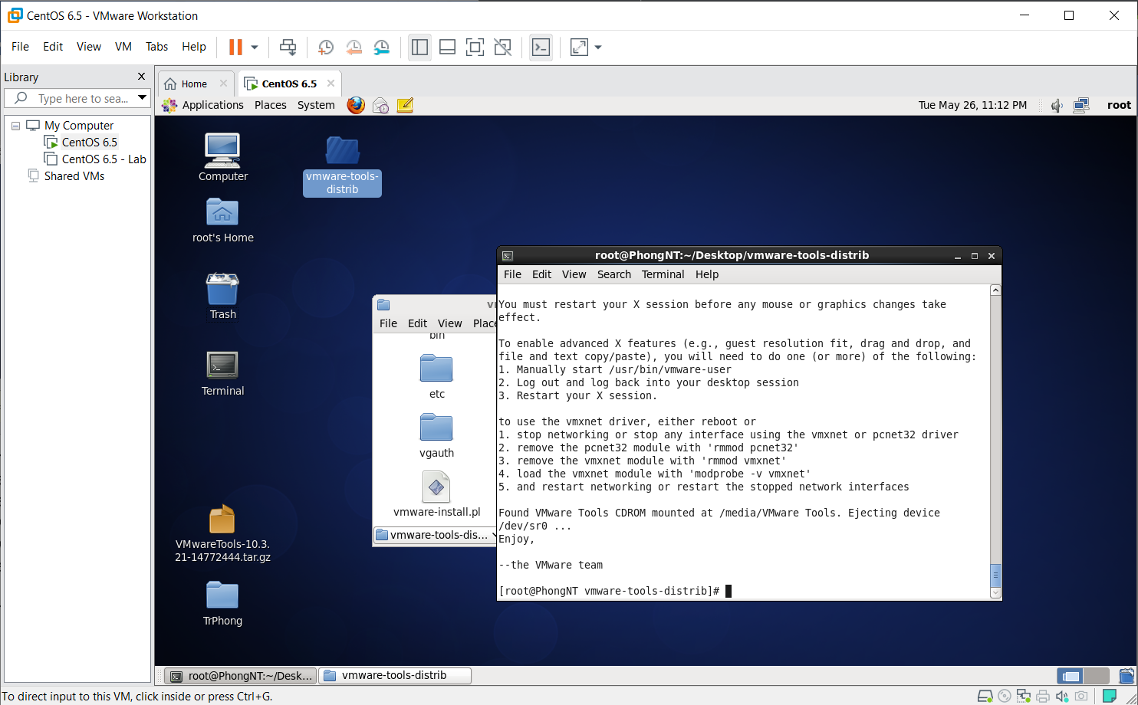

1. **Run a C source code on Terminal in CentOS (Do this after having installed VMWare Tools).**
   1. Prepair a C source file.
   2. Drag that C source file from your real computer to your Virtual Machine Desktop.
   3. Open Terminal pointing to Desktop.
   4. Type in *gcc –c main.c* (where *main.c* is the name of your C source code file) then press Enter.
   5. Type in *gcc main.o –o main* (where *main.c* is the name of your C source code file) then press Enter.
   6. Type in *./main* and press Enter to run that Source code!
   7. Enjoy the code!

