Automatic Fire Alarm Project using  
a combination of infra-red, heat, and  
gas concentration sensors

*By Nguyễn Trần Phong (SE150974)*

*Nguyễn Tuấn Anh (SE150633)*

*Võ Văn Thanh Phúc (SE150980)*

**CONTENTS**

I. INTRODUCTION 3

II. Hardware Specifications 4

III. Software specifications 9

IV. Implementation and Inspection 14

V. Conclusion 14

VI. References 15

# INTRODUCTION

* Fire hazards are amongst the most devastating causes regarding domestic damage and losses. According to statistics manifested in the annual report of *Vietnam’s Police Department of Fire Prevention and Fighting and Rescue* in 2020, there was a total of approximately 5000 fire incidents nation-wide, of which 50% was deemed as being civilian-related, resulting in a grim figure of 75 casualties and thousands of billions regarding monetary loss. The report imputed the eminent cause of such accidents as being electrical malfunctions, as well as misuse of heat and fuel sources, whose figures are reported to be 60% and 25%, respectively. Furthermore, human factors were considered to be the pivot in minimizing such, as urban dwellers’ ignorance of fire prevention responsibilities and skills has been proven to bear detrimental consequences. (Đ.V. Mạnh, 2018).
* These aforementioned arguments have lucidly solidified the necessity of a reliable, affordable, and dynamically operable fire alarm system. These criteria are the essential motives of the project. Our group endeavored to harbor a system which can be easily obtainable and implemented at minimized operating costs, thus enabling effective fire prevention schemes even in low to medium income households. Hence, the concentration of the product is that of simplicity, cost-efficiency and effectiveness.
* Mechanism:
  + The fire and heat sensors are placed together to observe inflammable objects, i.e.: sofas, beds, bookshelves, etc., in environments where fire is least expected to combust.
  + The gas sensor is placed in the vicinity of the gas source, i.e.: LPG container, heater, etc., to continuously measure the gas concentration of the environment.
  + If one, or any combination, of the following conditions is satisfied: a fire is detected within the specified range, temperature increased exceeded the designated value, or gas concentration exceeds the safe recommended value of 1000ppm (Proctor et al. 1988), the alarm is triggered.
  + The user can disable the alarm via the built-in RESET button on the Arduino. Then the system will continue to measure the environment.
  + The user can disable the system entirely by simply deactivating the power supply.

# Hardware Specifications

## Components

* Arduino UNO R3 ATmega328P

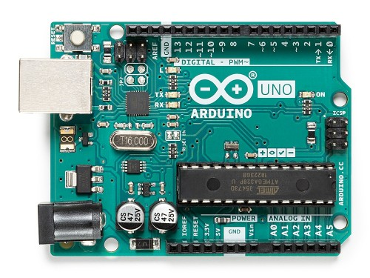

* MQ2 Gas Sensor (LPG 20 ~ 5000/CO 200~10000ppm)

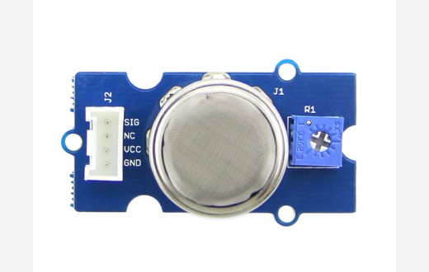

* YG1006-based IR Flame Sensor

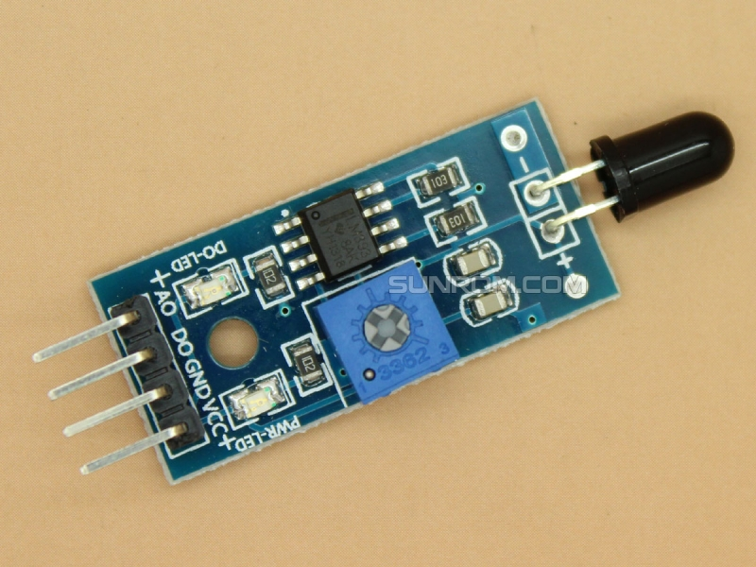

* LM35DZ temperature sensor:

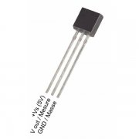

* 16x2 LCD i2c Display

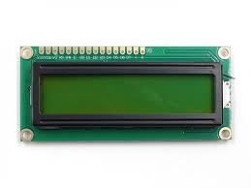

* Alarm bell / Alarm speaker (24V-220V)

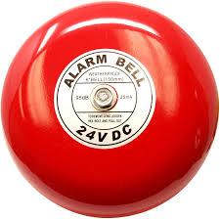

* B5K 10K Potentiometer

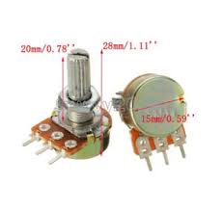

## Analysis of each component

* **Arduino UNO ATmega328P:** Main component of the system. Reads and processes data from the sensors.
* **MQ2 gas detector:** A robust, adjustable gas sensor. Passes analog input reading to the UNO’s CPU for processing. Its A0 port output an analog value proportional to the concentration of gas it detects. “Gas Sensor (MQ2) module is useful for gas leakage detection (home and industry). It is suitable for detecting H2, LPG, CH4, CO, Alcohol, Gas or Propane.” (Seeed, 2020).
* **YG1006-based IR Flame Sensor:** a module consists of a photodiode (IR receiver), resistor, capacitor, potentiometer, and LM393 comparator in an integrated circuit. The Analog output allows for measuring temperature, converting thermal changes into resistance change, increasing the resistance if fire is detected.
* **LM35DZ temperature sensor:** A low-cost, flexible sensor whose output voltage is proportional to Centigrade degree. Suitable for indoor usage, the Arduino’s analog output can be converted to any wanted temperature scale. (x2)
* **16x2 LCD i2c Display:** Used to display the current temperature, gas concentration, and alarm threshold. (x2)
* **Common fire alarm bell:** The sound module to alarm users whenever the sensors detect the presence of a flame, or any concentration of gas leak.
* **B5K 10K Potentiometer:** Used to adjust the concentration threshold needed to trigger the alarm and, if needed, the contrast of the LCD display.
* **Wires:** Connect the various components.

## Schematic Design

**Wiring connectivity**

*(Concept only, a buzzer is used instead of an actual alarm bell, a breadboard is used instead of a soldered board)*

**Household implementation**

*(Concept only, only the 1st floor is shown)*

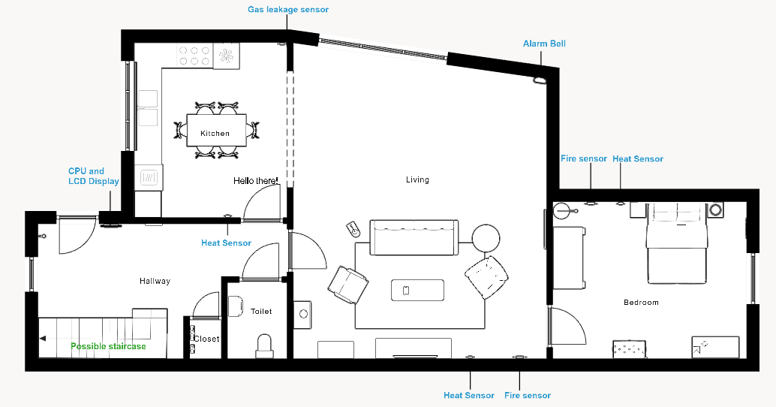

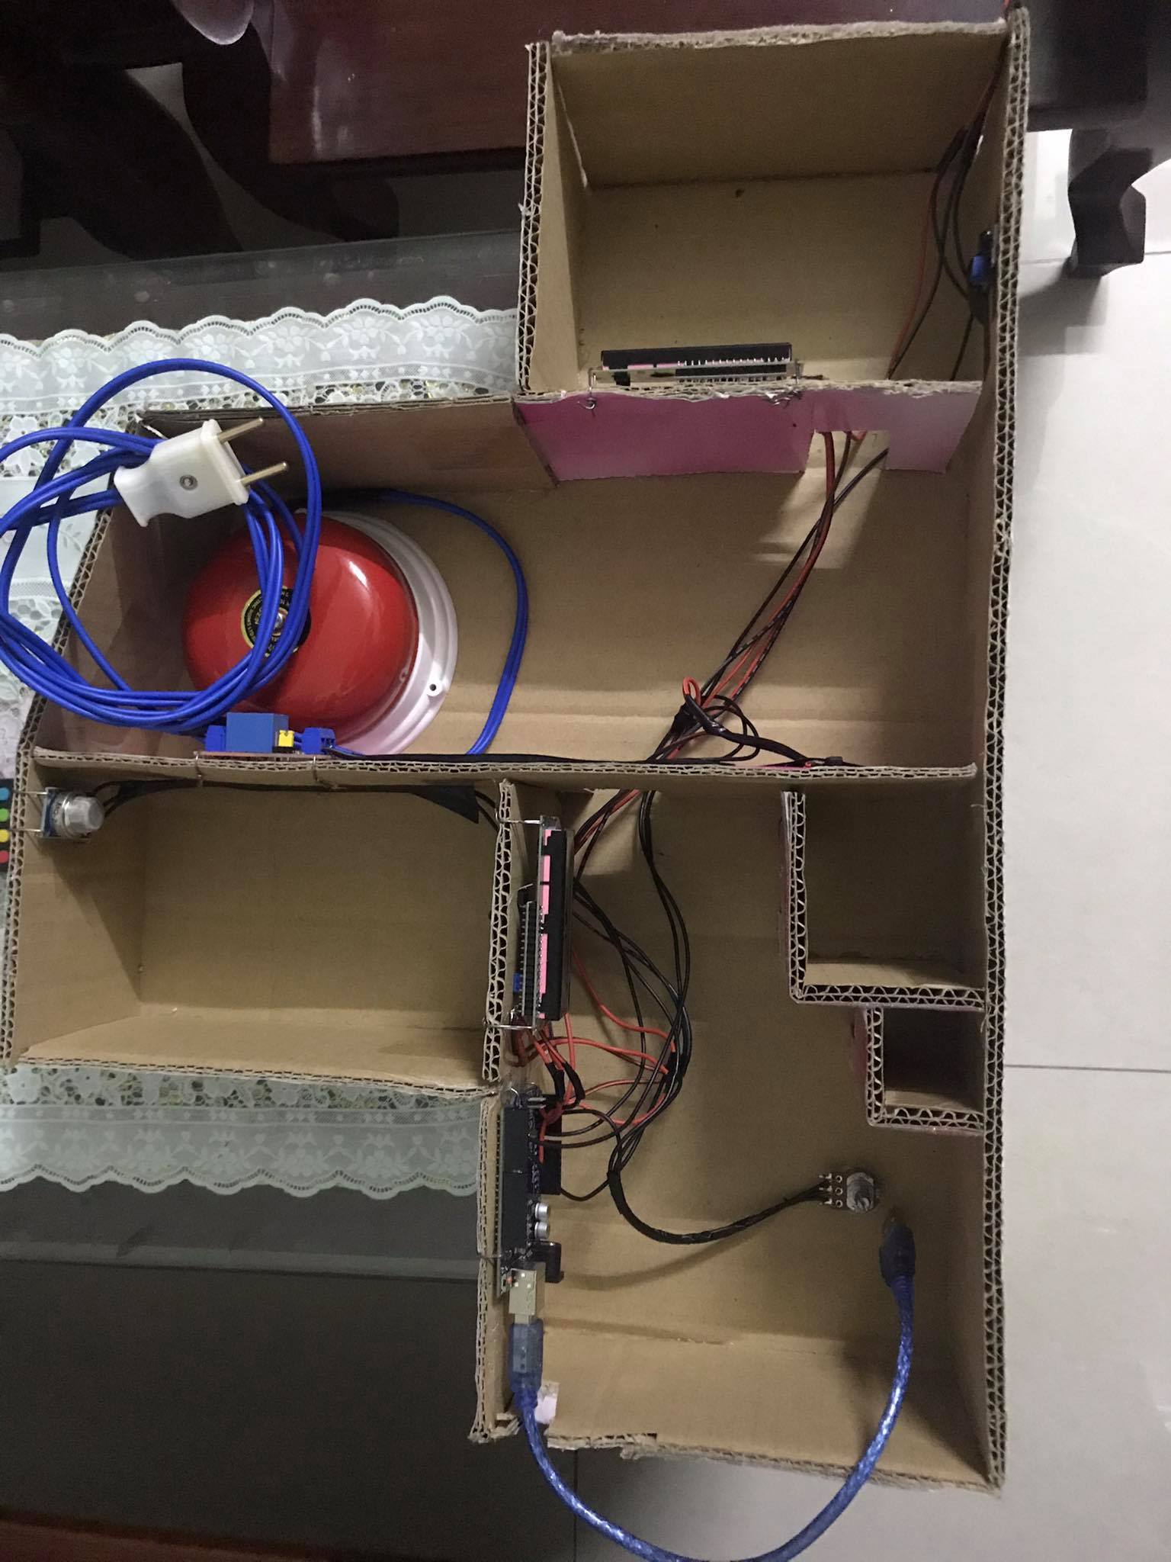

# Software specifications

## Requirement Analysis

* Simplicity is prioritized. User can manually disable the system.
* Must cover most scenarios, considerate of false alarms.
* Integrable despite hardware changes.

## Decision Flowchart

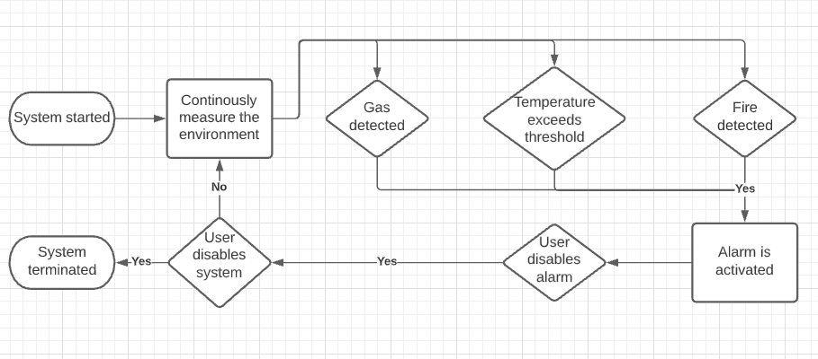

## Pseudo Code and Source Code

### Pseudo Code

|  |
| --- |
| lcd.start();  defaultTempThreshold = read(potentiometed);  while(systemNotTerminated){  lcd.display(defaultTempThreshold);  currentGas = read(gasSensor);  currentTemp = read(heatSensor);  currentFire = read(fireSensor);  lcd.display(currentTemp);  if(currentGas == true){  alarm();  }  else if(currentTemp >= defaultTempThreshold){  alarm();  }  else if(currentFire == true){  alarm();  }  } |

### Source Code

|  |
| --- |
| #include "LiquidCrystal_I2C.h"  const int DANGEROUS_GAS = 1000;  int interval = 1000;  int potPinDef = A3;  int defHeatValue;  int gasPin = A0;  int gasValue;  int firePin = 2;  int fireValue;  int heatPin = A1;  int heatValue;  int bellPin = 4;  *//Create the LCD object*  **LiquidCrystal_I2C** lcd(0x27, 16, 2);  void setup() {  pinMode(firePin,INPUT);  *//Set up the LCD's rows and columns*  lcd.init();  lcd.backlight();  *//Activate bell's digital pin*  pinMode(bellPin,OUTPUT);  lcd.print("Welcome! Welcome!");  delay(interval);  }  void alarm(){  digitalWrite(bellPin,HIGH);  delay(3000);  digitalWrite(bellPin,LOW);  }  void displayTemp(int reading){  delay(interval);  lcd.clear();  *//Set the LCD to start displaying on the first row*  lcd.setCursor(0,0);  *//Display the threshold value*  lcd.print("THRESHOLD(C):");  lcd.print(defHeatValue);  *//Set the LCD to start displaying on the second row*  lcd.setCursor(0,1);  *//Print out current temperature*  lcd.print("CURRENT(C):");  lcd.print(reading);  *//Room's temperature exceeds specified value*  if(reading > defHeatValue){  lcd.setCursor(0,0);  lcd.print("MAXIMUM EXCEEDED!");  alarm();  }  }  void displayGas(int reading){  delay(interval);  lcd.clear();  *//No gas leakage yet*  if(reading < DANGEROUS_GAS){  lcd.setCursor(0,0);  lcd.print(" NORMAL STATUS");  }  *//Gas leakage exceeds the recommended level*  else if(reading >= DANGEROUS_GAS){  lcd.setCursor(0,0);  lcd.print(" GAS DETECTED!");  alarm();  }  }  void displayFire(int reading){  delay(interval);  lcd.clear();  lcd.setCursor(0,0);  *//No fire detected*  if(reading == 0){  lcd.setCursor(0,1);  lcd.print(" NO FLAME");  }  */* A fire's IR is sufficient to decrease the sensor's thermal resistance* *\*/*  else{  lcd.setCursor(0,1);  lcd.print("FLAME DETECTED");  alarm();  }  }  void loop() {  lcd.clear();  */* Read the default thresholds, adjustable with the potentiometer */*  defHeatValue = (analogRead(potPinDef)*5.0/1024)*100;  *//Read the MQ2's sensor values*  gasValue = analogRead(gasPin);  *//Read the fire sensor values*  fireValue = digitalRead(firePin);  *//Read the heat sensor values*  heatValue = (analogRead(heatPin)*5.0/1024)*100;  displayTemp(heatValue);  displayGas(gasValue);  displayFire(fireValue);  delay(interval);  } |

# Implementation and Inspection

* The system worked as intended.
* Flame detected within an acceptable distance.
* Preempt most situations, which can, at times, lead to false alarms.
* Gas leakage detection is dependent on external factors such as winds and humidity. Requires further calibrations.
* Alarm bell is dependent on the main power source to operate, no backup power due to cost limitation. Requires further subsidiary.
* The fire sensor does not cover a comparatively wide angle.

# Conclusion

* Expected cost is reasonably affordable.
* The system is relatively simple to implement in a practical setting.
* Can be further improved via the usage of more advanced and precise measurement modules.

# References

* Vietnamese Police Department of Fire Prevention and Fighting and Rescue. (2020). *Annual report regarding the process of fire prevention, fighting, and rescue of 2020*. Retrieved from: <http://canhsatpccc.gov.vn/ArticlesList/tabid/192/cateid/1172/language/vi-VN/default.aspx>
* Đ.V. Mạnh. (2018). *Vietnam’s state of fire incidents in recent years, and preemptive measures to be applied*.   
  Retrieved from: <http://csnd.vn/Home/Nghien-cuu-Trao-doi/3983/Tinh-hinh-chay-no-o-Viet-Nam-trong-nhung-nam-gan-day-va-mot-so-giai-phap-phong-ngua-ngan-chan>
* Seeed. (2020). *Grove - Gas Sensor (MQ2)*.   
  Retrieved from: <https://wiki.seeedstudio.com/Grove-Gas_Sensor-MQ2/>
* Proctor NH, Hughes JP, Fischman ML [1988]. Liquified petroleum gas. In: *Chemical hazards of the workplace*. 2nd ed. Philadelphia, PA: J.B. Lippincott Company, pp. 301, 420-421.