

**Happy Programming**

**Software Requirement Specification**

– TP HCM, April 2021 –

**Table of Contents**

**I. Overview** 3

1. Introduction 3

2. Purpose 3

3. Project Scope 3

4. References 3

**II. Overall Description** 4

1. Product Perspective 4

2. User Classes and Characteristics 5

3. Operating Environment 5

4. Design and Implementation Constraint 5

5. Assumptions and Dependencies 5

**III. System Features** 5

1. Mentee Create, View, Update, and Delete Requests 5

2. Mentor Accept, Reject Request 6

3. Administrative Operations 6

4. User Log In, Update Profile 6

5. Guest Browsing and Searching Mentors, Registering 7

6. Mentor Create, View, Update CVs 8

7. Mentee Rating, Commenting on Mentor 9

**IV. Data Requirements** 9

1. Logical Data Model 9

2. Data Dictionary 9

3. Data integrity, Retention, and Disposal 10

**V. Quality Attributes** 11

1. Usability Requirements 11

2. Performance Requirements 11

3. Security Requirements 11

4. Safety Requirements 11

5. Availability Requirements 12

6. Robustness Requirements 12

**VI.** **Business Rules** 12

1. **Overview**
   1. **Introduction**

- The Happy Programming System (HPS) is a platform built to alleviate potential impediments inherent in the process of finding appropriate mentors for aspiring workers and learners in the technological field.

- The application aims to establish and maintain connections, via the Internet, between users in need of assistance and experienced members of the industry.

- The system is intended to provide students with the capability to seek mentorship programs with high degree of compatibility and assist these individuals in achieving optimal results.

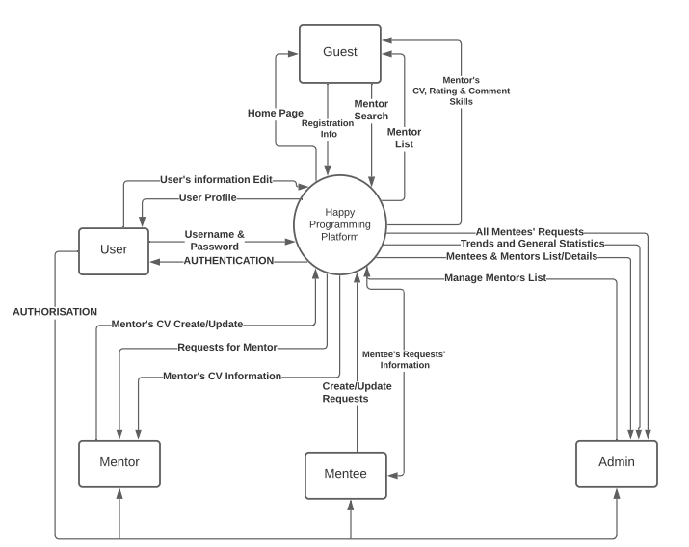

FIGURE F-1 The Context Diagram for version 1.0 of the Happy Programming System

* 1. **Purpose**

- This SRS specifies the functional and non-functional requirements of the HPS (Happy Programming System). This document is structured for internal use by the team of developers who implement the system only. All information included within this SRS all bears relevance to, unless stated otherwise, the context, the scope of the 1.0 version of the product.

* 1. **Project Scope**

- The HPS will allow learners to browse and select arbitrary mentoring programs. The system shall also aids users in the process of finding the most appropriate mentor via promotional materials such as a system for personal suggestions and trending mentors’ statistic. This instalment will only covers the most basic functionalities of the system, while more advanced features such as Progress Tracking and Mentor-to-Mentee Compatibility Measurement will be gradually introduced in future releases.

* 1. **References**

1. Anh, N.T, Phong, N.T, Phuc, V.V.T & Giang, N.T (2021). Happy Programming System.

2. Happy Programming Team (2021). Contacts: [happyprogramming.swp391@gmail.com](mailto:happyprogramming.swp391@gmail.com)

1. **Overall Description**
   1. **Product Perspective**

- The Happy Programming System is a software built to shorten, optimise, and simplify the process of finding suitable tutors for struggling learners. The Context Diagram shown in Figure F-1 delineates the external entities involved in the system. The product is expected to be introduced in incremental releases, spanning over the time period of 10-week.

* 1. **User Classes and Characteristics**

|  |  |
| --- | --- |
| **User Classes** | **Description** |
| Guest | A Guest is an Unregistered User who is curious in the System and browsing with limited capabilities. This individual is allowed to freely search for and view mentors’ information (for example: CV, skills, ratings), perform registration, as well as view the list of all active Mentors. |
| User | A User is a registered member of the System, categorized into 3 sub-divisions of Mentee, Mentor, and Administrator. A normal User is allowed to alter his profile and basic information (username, password, full name, email). |
| Mentee | A Mentee is the default Registered User. Mentees will make requests to specific Mentors asking for assistance on certain problems or personal tutelage. The Mentees also may change their requests as wanted, as well as view all past and pending requests. The Mentees can rate and comment Mentors on the Mentors’ service. |
| Mentor | A Mentor is a designated User. Mentors will accept requests from Mentees and assist the Mentees with their concurrent problems. A Mentor can create and upload his own CV to the system, view, accept or deny addressing requests. |
| Administrator | An Administrator is a privileged User. An Admin can manage all available Mentors, add new Mentors, view the site’s relevant data such as trends, Mentors’ statistics, Mentees’ list, and Mentees’ requests. |

* 1. **Operating Environment**

- OE-1: Version 1.0 of the System is designed to operate most effectively on the following web browsers: Internet Explorer 10.0 and 11.0, Mozilla Firefox versions 74 through 88, Google Chrome (all versions).

- OE-2: The HPS will be operating on the stable, commercially approved web server of Apache-tomcat version 8.5.60.

* 1. **Design and Implementation Constraint**

- CO-1: The coding, maintenance, and implementation shall conform to Java Code Conventions, issued September 12, 1997.

- CO-2: The system shall use mainly Java EE technologies, such as JSP and Servlet.

- CO-3: The system shall use Microsoft’s SQL Server 2019 as the primary database engine.

* 1. **Assumption and Dependencies**

- AS-1: An Administrator can elevate another user’s privilege.

- AS-2: A Mentor can deny pending requests from subscribed Mentee.

- AS-3: A Mentee can subscribe and follow a Mentor.

1. **System Features**
   1. **Mentee Create, View, Update, and Delete Requests**
      1. **Description**

- A Guest or registered Mentee can make requests to a Mentor to seek guidance. The Mentee can then update the request, view the list of requests, and check the requests’ statistic. Priority: **HIGH**.

* + 1. **Functional Requirements**

|  |  |
| --- | --- |
| **Request.Mentee.Create:**  .Register:  .No | **Make a Request** The HPS shall check if the User is a registered Mentee. If the User is not a registered Mentee, the HPS shall then prompt the User with a sign up form. |
| **Request.Mentee.Update:**   .Edit:  .Content:  .Mentor:  .Confirm:  .Yes  .No | **Update the content of a Request** The Mentee shall be shown and allowed to modify an editable version of the chosen Request.  The HPS shall allow the Mentee to edit the Request’s content. The HPS shall allow the Mentee to edit the addressed Mentor.  When the Mentee indicates that all changes have been made, the HPS shall present the Mentee with a confirmation prompt.  If the Mentee selects yes, all changes will be committed.  If the Mentee selects no, no changes will happen. |
| **Request.Mentee.List:**  .View:  .Update:  .Cancel  .Status | **Viewing the List of Requests**  The Mentee shall be able to view all past and pending requests.  The HPS shall present an option to update individual requests. Please refer to **Request.Update**.  The HPS shall present an option to cancel individual requests.  The HPS shall display the status of all listed requests (Pending/Approved/Rejected). |
| **Request.Mentee.Stats**  .Count  .RejectionRate | **Viewing the statistic of the Requests**  The HPS shall present the Mentee with the total number of requests made within the last year (Please refer to **DI-1**).  The HPS shall display the ratio between rejected and approved requests |

* 1. **Mentor Accept, Reject Request**
     1. **Description**

- A Mentor shall be allowed to view, accept, reject, and conclude requests from addressing Mentees. Priority: **HIGH**

* + 1. **Functional Requirements**

|  |  |
| --- | --- |
| **Request.Mentor.View**  .List  .Detail | **View all addressing Requests**  The HPS shall present the Mentor with a List of all Requests addressed to the particular Mentor.  A Mentor shall be able to view a Request’s details. |
| **Request.Mentor.Accept:**  .List  .Detail | **Accept a Request**  The Mentor shall be able to accept any listed **pending** Request.  The Mentor shall be able to accept a **pending** Request while viewing its Details. |
| **Request.Mentor.Reject**  .List  .Detail | **Reject a Request** The Mentor shall be able to reject any listed **pending** Request.  The Mentor shall be able to reject a **pending** Request while viewing its Details. |
| **Request.Mentor.Conclude**  .List  .Detail | **Conclude a Request** The Mentor shall be able to conclude any **accepted** Request.  The Mentor shall be able to conclude an **accepted** Request while viewing its Details. |

* 1. **Administrative Operations**
     1. **Description**

- An Administrator is allowed to perform managerial operations on a system-wide scale such as managing Mentors, viewing the site’s data, and accessing personal Mentees’ information. Priority: **HIGH**

* + 1. **Functional Requirements**

|  |  |
| --- | --- |
| **Admin.Mentor**  .List  .Filter  .Search  .View  .Add  .Edit | **Manages all Mentors**  An Administrator shall be allowed to view a list of both operating and decommissioned Mentors  An Administrator shall be able to retrieve a filtered list of Mentors based on the Mentor’s basic information (Please refer to the **User class’ Description**).  The HPS shall support Administrator in searching for a specific Mentor based information such as names or skills.  An Administrator can choose to view a specific Mentor’s detailed information.  An Administrator can promote the status of a Mentee account to that of a Mentor.  An Administrator can alter the working status of existing Mentors (Operating/Decommissioned) . |
| **Admin.Site**  .Trend  .Statistic | **Viewing the site’s data**  The HPS shall present trends of the requests, for example: popular topics, most requested mentors.  The HPS shall assist the Administrator in viewing the site’s performance data such as uptime, average response time. |
| **Admin.Mentee**  .List  .AllRequest  .AllStatistic | **Manage the Mentees**  An Administrator can view a list of all registered Mentees and their basic information (Please refer to the **User class’ Description**).  An Administrator can view a list of all past and pending requests made by all Mentees.  An Administrator can view a list of all Mentees’ statistic. |

* 1. **User Log In, Update Profile**
     1. **Description**

- A User shall be allowed to log in and modify his personal profile. Priority: **MEDIUM**

* + 1. **Functional Requirements**

|  |  |
| --- | --- |
| **User.LogIn:**  .Register  .No  .SignUp  .Forgot | **Log in with registered username and password**  The HPS shall check for the existence of the username and the associated password in the database.  If such account cannot be found, the HPS shall announce the user.  The HPS shall allow user to register.  The HPS shall allow user to recover their account’s password. |
| **User.Update**  .Edit | **Update the profile of a User** The User shall be shown and allowed to modify an editable version of his profile. |

* 1. **Guest Browsing and Searching Mentors, Registering**
     1. **Description**

- A Guest shall be allowed to browse the Mentors list, search for a specific Mentor, and view a Mentor’s CV. Priority: **MEDIUM**

* + 1. **Functional Requirements**

|  |  |
| --- | --- |
| **Guest.Register:**  .Username  .Email  .Verification | **Guest registering**  A Guest shall be able to register with an available username.  A Guest shall be able to register with a valid Email .  A Guest’s registration shall be verified via an Email. |
| **Guest.Browse**  .MentorList  .Notable    .All  .Search  .Skills  .MentorView  .CV  .Ratings | **Browsing the Website**  A Guest shall be able to see the list of operating Mentors. The HPS will, by default present the Guest with a list of notable Mentors in the system.  If desired, the HPS shall present a list of all operating Mentors instead.  The HPS shall assist a Guest in searching for a Mentor by name or by skills.  The HPS shall present a list of Skills that current Operating Mentors can provide.  A Guest shall be able to view the specific details of a Mentor.  A Guest shall be able to view the CV of a Mentor.  A Guest shall be able to view the Ratings of and Comments about a Mentor. |

* 1. **Mentor Create, View, Update CVs**
     1. **Description**

- A Mentor shall be allowed to create, upload, view, and modify his personal CV. Priority: **LOW**

* + 1. **Functional Requirements**

|  |  |
| --- | --- |
| **CV.Create:**  .Content  .Upload  .Format | **Create or upload a CV** The HPS shall allow the Mentor to create his CV on-site.  Mentor is also allowed to upload his CV in approved format.  Please refer to **BR-1** |
| **CV.Update**  .Edit  .Replace | **Update the content of a CV** The Mentor shall be shown and allowed to modify an editable version of the submitted CV.  The Mentor shall be able to upload a new CV to replace the existing version. Please refer to **CV.Create.Upload** |
| **CV.View**  .Public | **View the CV**  The Mentor shall be presented with the public view of his CV. |

* 1. **Mentee Rating, Commenting on Mentor**
     1. **Description**

- The HPS shall periodically allow Mentees to rate and comment subscribed Mentors. Priority: **LOW**

* + 1. **Functional Requirements**

|  |  |
| --- | --- |
| **Mentee.Rate**  .End | **Rating a Mentor**  The HPS shall prompt the Mentee to rate the Mentor once the request is concluded. |
| **Mentee.Comment**  .End | **Commenting on a Mentor**  The HPS shall prompt the Mentee to leave a comment about the Mentor once the request is concluded. |

1. **Data Requirements**
   1. **Logical Data Model**

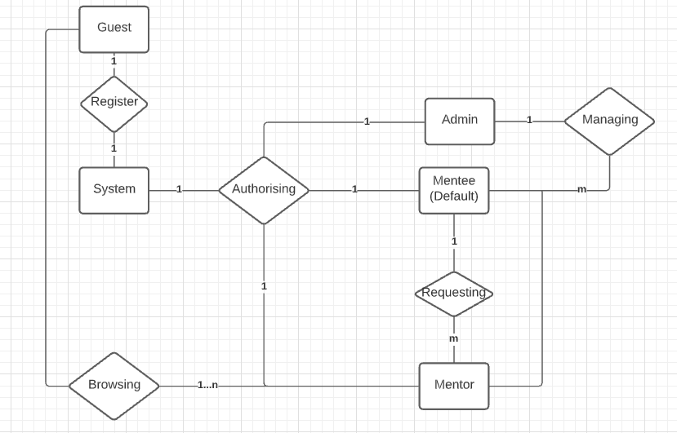

FIGURE F-2 The Data Model for version 1.0 of the Happy Programming System

* 1. **Data Dictionary**

|  |  |  |  |  |
| --- | --- | --- | --- | --- |
| **Data Element** | **Description** | **Composition of data type** | **Length** | **Values** |
| Request content | The specific content of a request | Request’s information:  + Request’s Title  + Deadline (Date and Time)  + Content  + Topic (Skills)  + Addressed Mentor |  |  |
| Requests’ statistic | A compilation of the site’s committed Requests | Request’s information:  + Request’s ID  + Issued Mentee  + Title  + Status |  |  |
| Request’s ID | a unique ID assigned to each Request | Alphanumeric | 25 | The Format will follow BR-3 |
| Request’s status | a marker to indicate whether a request has been accepted | Alphabetic | 1 | + P: Pending  + A: Accepted  + R: Rejected  + C: Closed |
| Mentor CV | A textual description about a Mentor | Mentor’s information:  + Mentor’s avatar  + Mentor’s full name  + Mentor’s expertise (job)  + Introduction  + Mentees’ Rating  + Comments  + Mentor’s Achievement  + Mentor’s Skill Rating  + Mentor’s specialized Framework |  | The CV Format will follow BR-1 |
| Mentor Rating | A figure to indicate how Mentees perceive a particular Mentor | Numeric, stars | NN:Stars |  |
| Mentor Comment | Comments from past Mentees about a particular Mentor | Alphanumeric | 1500 |  |
| Mentor’s Statistic | A compilation of site’s data about a Mentor | Mentor’s statistic:  +  +  + |  |  |
| Trends (Mentor) | List showing which Mentor is currently most request | Mentor’s information:  + Mentor’s name  + Mentor’s rating |  | Top 10 most-requested Mentors |
| Trends (Topic) | List showing which Topic is currently most request | + Topic’s name  + Number of total requests |  | Top 5 most-requested Topic |
| Request Number | Unique request that the HPS assigns to each Request | Integer | 10 | Initial value is 1 |
| Mentees’ Statistic | A compilation of the site’s registered Mentees’ data | Registered Mentees’ Statistic:  + Full Name  + Username  + Number of Mentees  + Request’s solution time  + Request’s required skills |  |  |
| Request’s solution time | The duration needed for a given Mentor to provide the Mentee’s Request with an answer | Time | HH:MM | Please refer to BR-6 |
| Request’s required skills | The skills involved in solving the Request | Alphabetical | 100 |  |
| User | A registered User of the system | User’s information:  + username  + password  + avatar  + Date of Birth  + Email  + Full name  + Gender  + Address  + ID |  | Images are allowed |
| User’s username | The username used to log into the HPS | Alphanumeric | 20 |  |
| User’s password | The password used to log into the HPS | Alphanumeric | 8 to 20 | Special characters are allowed |
| User’s avatar | The avatar of the User | .png,.jpeg |  |  |
| User’s Date of Birth | The Date of Birth of the User | MM/DD/YYYY |  |  |
| User’s Email | The email of the User | Alphanumeric | 254 |  |
| User’s full name | The full name of the User | Alphabetic | 50 | Only ASCII characters are supported |
| User’s Gender | The Gender of the User | Alphabetic | 1 | Please refer to BR-5 |
| User’s ID | A unique string assigned to each User by the HPS | Alphanumeric | 10 | Please refer to BR-2 |

* 1. **Data integrity, Retention, and Disposal**

- DI-1: The HPS shall retain the Mentee’s requests’ information for up to 1 year following the concluding of the request.

- DD-1: The HPS shall dispose of accounts which have been inactive for over 6 months.

1. **Quality Attributes**
   1. **Usability Requirements**

**-** USE-1: The HPS shall provide a tutorial option for Mentees on how to make a Request.

**-** USE-2: 90% of newly registered Mentee shall be able to make a Request with no difficulty.

-USE-3: The HPS shall provide a tutorial option for Mentors on how to interact with Mentees’ Requests.

-USE-4: The HPS shall provide a tutorial option for Mentors on how to modify and view CVs

-USE-5: The HPS shall provide a tutorial option for new Administrator on site’s management.

* 1. **Performance Requirements**

**-** PER-1: The HPS shall accommodate up to 1000 users (Mentors and Mentees), and 150 concurrent users at peak time windows such as: 7AM to 11AM, and 1PM to 5PM from Monday to Friday.

- PER-2: The HPS shall update a Request’s status in a minimum of 30 seconds and a maximum of 2 minutes from the moment of Request’s status’ modification.

- PER-3: 95% of the screens shall load with the maximum time of 3 seconds from the moment the client send a request

* 1. **Security Requirements**

**-** SR-1: All registered accounts’ passwords shall be encrypted using SHA-256 encryption.

- SR-2: All Users shall be asked to register to use the system’s full functionalities.

- SR-3: Administrators shall be externally appointed. Please refer to BR-4.

- SR-4: Only **associated** Mentees can rate and comment on a Mentor.

* 1. **Safety Requirements**

**-** SAFE-1: All topics available on HPS shall only consist of legal topics.

**-** SAFE-2: Topics marked as sensitive will be highlighted and require User’s confirmation before proceeding.

* 1. **Availability Requirements**

**-** AVL-1: The HPS shall be available at least 95% of the time between 5 A.M to midnight Coordinated Universal Time (UTC) +7, and 90% between midnight and 5 A.M Coordinated Universal Time (UTC) UTC +7.

* 1. **Robustness Requirements**

**-** ROB-1: If a Request is broken while the Request is being made (please refer to PER-2), the HPS shall attempt to re-submit the Request with an automatically drafted version of the Request.

- ROB-2: If a Mentee’s connection is severed while a Request is being made, the HPS shall automatically save the last version of the Request and allow the Mentee to continue working with a drafted version of said Request.

1. **Quality Attributes**

|  |  |  |  |  |  |
| --- | --- | --- | --- | --- | --- |
| ID | Definition | | Type | Static or Dynamic | Source |
| BR-1 | | The CV shall follow APA’s writing style:  Set page margins to 1 inch on all sides.  Double-space all text, including headings.  Indent the first line of every paragraph 0.5 inches.  Use an accessible font (e.g., Times New Roman 12pt., Arial 11pt., or Georgia 11pt.).  Include a page number on every page. | Constraint | Static | Happy Programming Institute |
| BR-2 | | A User’s ID shall start with one of the following:  + ME for Mentee  + MT for Mentor  + AD for Administrator  And followed by a sequence of 6 numbers starting from 000000 (incremental) | Constraint | Dynamic | Happy Programming Institute |
| BR-3 | | A Request’s ID shall start with the name of a chosen topic, for example: JAVA for Java, CSHARP for CSharp.  Followed by a sequence of 6 numbers starting from 000000 (incremental) | Constraint | Dynamic | Happy Programming Institute |
| BR-4 | | Administrative accounts shall be exclusively appointed to on-site managers only. | Constraint | Static | Happy Programming Manager |
| BR-5 | | The User’s gender shall be marked with following characters:  F for Female  M for Male  X for undefined | Fact | Dynamic | Happy Programming Institute |
| BR-6 | | The solution time for a Request is calculated by taking closing time minus the accepting time | Computational | Static | Happy Programming Accounting Manager |