## Guest – Get Notification on Mobile

### Get Notification when guest is invited to an event

* Function trigger: Event Manager adds the guest to the guests list of an event.
* Function description:
  + Role: Guest.
  + Purpose: Notify the guest to check their calendar and events to response to the invitation.
  + On the Notification: Title: **“You are invited to an event”**, Description: **“<<Name of the event>>“**.
* Function details:

The Guest is added to the Guest List of an event.

The system is informed with the change, and it triggers this function.

Guest’s smart phone get notified and then he/she should hit on the notification pop-up and is navigated to the details screen of the event.

### Get Notification when guest has a question from users

* Function trigger: User submits a question to the guest.
* Function description:
  + Role: Guest.
  + Purpose: Notify the guest to check their questions list to prepare the event well.
  + On the Notification: Title: **“You have a new question”**, Description: **“<<Title of the event>>“**.
* Function details:

A question is submitted to the guest.

The system is informed with the change, and it triggers this function.

Guest’s smart phone get notified and then he/she should hit on the notification pop-up and is navigated to the details screen of the question.

## Guest – Event Management

### View all events

* Function trigger: Guest clicks **“Events”** on the menu.
* Function description:
  + Role: Guest.
  + Purpose: Allow the guest to view information about the events that are about to take place.
* Screen layout:

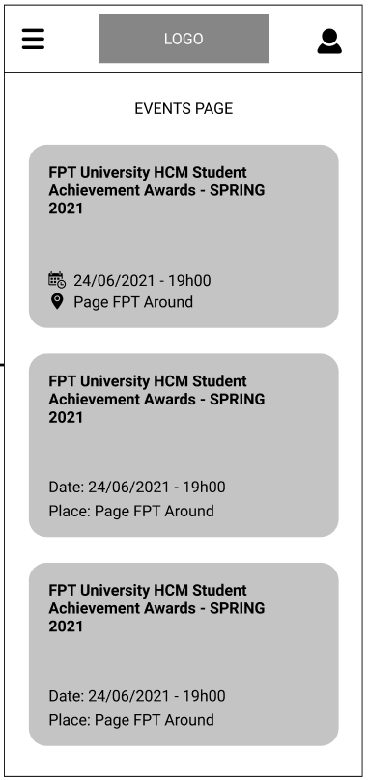

* Function details:
  + Data: The events are displayed with its summary of Title, Date, Time, and Place. All the information is read from database.
  + Validation: No.
  + Business logic:
    - The guest clicks on **“Events”** item on the Main Menu.
    - Normal case: The screen **“Events Page”** is displayed with all information about the events that are about to take place.
    - Abnormal cases:
      * If the user is not authenticated, the **“Login”** screen will display.
      * If there is no event, a message of **“There is no event right now, please check back later!”** will display on the screen.

### View event details

* Function trigger: Guest clicks on one of the events on **“Events”** screen.
* Function description:
  + Role: Guest.
  + Purpose: Allow the guest to view details of an event.
* Screen layout:

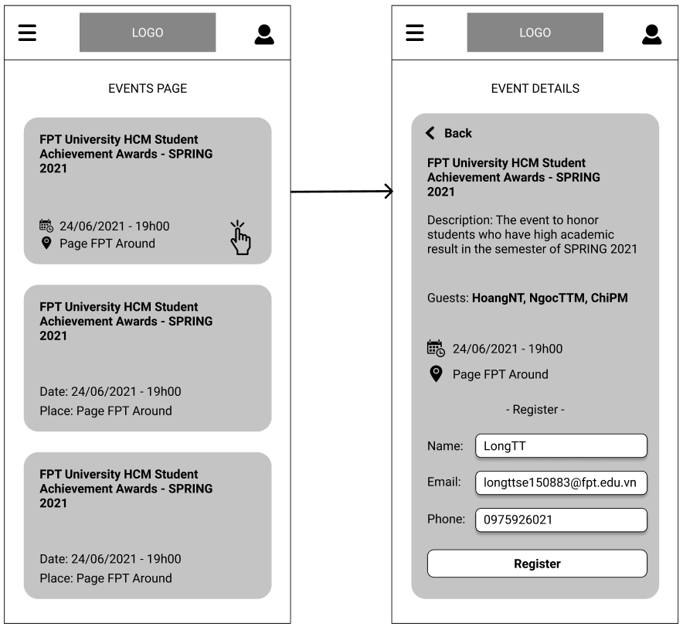

* Function details:
  + Data: The information is displayed in detail including Title, Description, Guests List, Date, Time, Place, and a form for guest to register to join the event.
  + Validation: No.
  + Business logic:
    - The guest clicks on one of the events on **“Events”** screen.
    - Normal case: The screen **“Events Details”** is displayed with all information about the event.
    - Abnormal cases:
      * If the user is not authenticated, the **“Login”** screen will display.
      * If the event had taken place, a message of **“The event had been taken place!”** will display.
      * If the event was deleted, a message of **“The event does not exist!”** will display.

### Register to participate in an event

* Function trigger: Guest clicks **“Register”** button at the **“Event Details”** page.
* Function description:
  + Role: Guest.
  + Purpose: Allow the guest to register to participate in an event.
* Screen layout:



* Function details:
  + Data: The information of Name, Email and Phone of the guest must be filled in.
  + Validation:
    - **“Name”** must be the guest’s full name, just alphabetical characters.
    - **“Email”** must be in email format.
    - **“Phone”** must be the phone number to contact with the guest, just numeric.
  + Business logic:
    - Guest click on the event he/she wants to participate in to navigate to the **“Event Details”** page, then fill out all the information and hit **“Register”** button.
    - Normal case: A pop-up displays and says that the guest has registered to participate in the event successfully. A mobile notification is displayed.
    - Abnormal cases:
      * If one of the required information is filled incorrectly, an error message will display to remind the guest to correct it.
      * If the guest had already registered before, an error message will display to inform them.

## Guest – Calendar Management

### View all events that the guest joined

* Function trigger: Guest clicks on **“Calendar”** item on the Main Menu.
* Function description:
  + Role: Guest.
  + Purpose: Give the guest an ability to view all events that he/she joined.
* Screen layout:

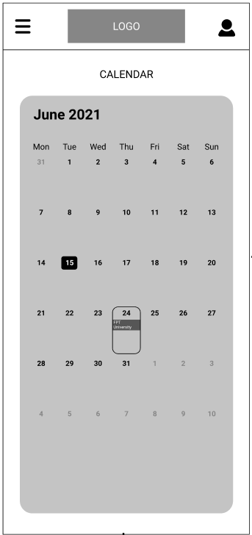

* Function details:
  + Data: Events information.
  + Validation: No.
  + Business logic:
    - Guest clicks on **“Calendar”** item on the Main Menu and a calendar-like screen is displayed with the title of event on the day on when the event will take place.
    - Normal case: A calendar-like screen is displayed with the title of event on the day on when the event will take place.

### Choose time to view the events

* Function trigger: Guest clicks on the date title of the screen.
* Function description:
  + Role: Guest.
  + Purpose: Allow the guest to choose time to filter the events.
* Screen layout:

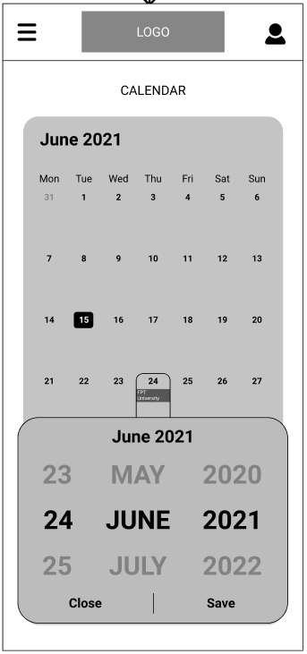

* Function details:
  + Data: Date information.
  + Validation: No.
  + Business logic:
    - Guest clicks on the date title of the screen, for example: **June 2021**. A pop-up shows up for the guest to choose the date. Then click **“Save”**.
    - Normal case: The data of events is refreshed, and the **“Calendar”** screen will refresh to display new filtered events.

### View all events in one date

* Function trigger: Guest clicks on any date on the **“Calendar”** screen.
* Function description:
  + Role: Guest.
  + Purpose: Guest can see list of events which take place on a particular date.
* Screen layout:

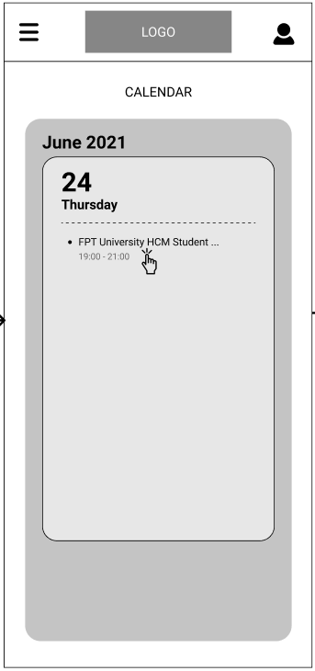

* Function details:
  + Data: Information about all events of the date.
  + Validation: No.
  + Business logic:
    - Guest clicks on any date on the **“Calendar”** screen and a pop-up with information of the events in that date including Title and Time of the event will display.
    - Normal Case: All the events on that date will be displayed.

### View event details

* Function trigger: Guest clicks on the event on the **“Calendar”** screen.
* Function description:
  + Role: Guest.
  + Purpose: Guest can view the detail information about an event that he/she joined.
* Screen layout:

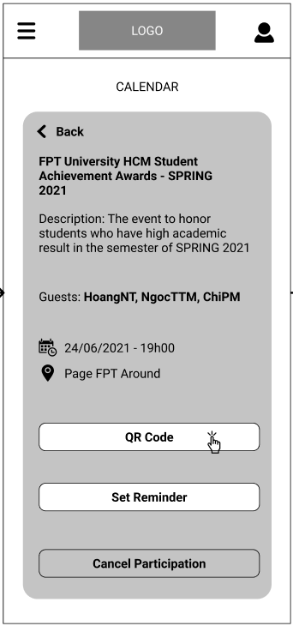

* Function details:
  + Data: Information about the specific event.
  + Validation: No.
  + Business logic:
    - Guest clicks on the event on the **“Calendar”** screen and a new screen will display with all information of that event.
    - Normal Case: Event Details will display.

### View QR Code to check-in an event

* Function trigger: Guest clicks **“QR Code”** button on the Event Details screen.
* Function description:
  + Role: Guest.
  + Purpose: The QR Code to check-in at the event.
* Screen layout:

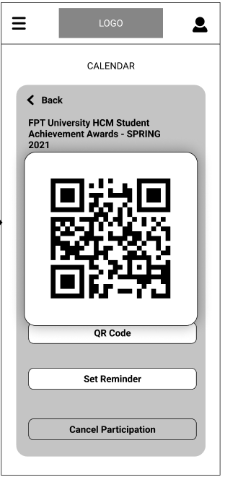

* Function details:
  + Data: Automatic-generated QR code.
  + Validation: No.
  + Business logic:
    - Guest clicks **“QR Code”** button on the Event Details screen and the QR code will be displayed on a pop-up window.
    - Normal Case: QR Code is displayed.

### Set Reminder

* Function trigger: Guest clicks **“Set Reminder”** button on the Event Details screen.
* Function description:
  + Role: Guest.
  + Purpose: Add Reminder into the Calendar app on guest’s mobile.
* Screen layout:



* Function details:
  + Data: Title and date, time of the event.
  + Validation: No.
  + Business logic:
    - Guest clicks **“Set Reminder”** button on the Event Details screen and the event is added to the Calendar app on the guest’s smart phone with its corresponding information.
    - Normal Case: The Reminder is set.
    - Abnormal Case: The app is not granted for the reminder setting permission and an error message will display to inform the guest.

### Cancel the participation

* Function trigger: Guest clicks **“Cancel Participation”** button on the Event Details screen.
* Function description:
  + Role: Guest.
  + Purpose: Allow the guest to cancel their participation in an event.
* Screen layout:



* Function details:
  + Data: No.
  + Validation: No.
  + Business logic:
    - Guest clicks **“Cancel Participation”** button on the Event Details screen. A confirm pop-up will display to ask again. The guest clicks **“Yes, I am sure!”** and the participation is deleted.
    - Normal Case: The participation is deleted successfully.
    - Abnormal Case: An error message will display if the guest is the only guest on the event.

## Guest – Events Statistics

### View All Events statistics

* Function trigger: Guest clicks on the **“Events Statistics”** item on the Main Menu.
* Function description:
  + Role: Guest.
  + Purpose: Allow the guest to view statistics about all the events that he/she has checked-in and not checked-in.
* Screen layout:

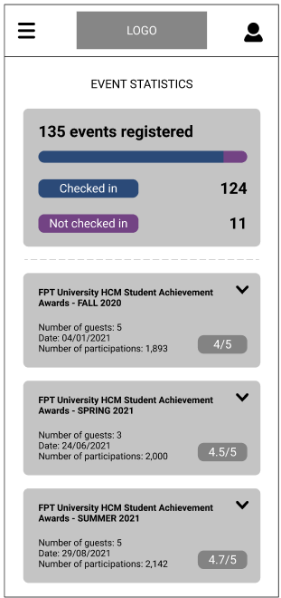

* Function details:
  + Data: Number of checked- and not checked-in events of the guest, and some statistics information of all that events.
  + Validation: No.
  + Business logic:
    - Guest clicks on the **“Events Statistics”** item on the Main Menu. The **“Events Statistics”** screen will display with the information of number of checked- and not checked-in events of the guest. Information including title of events, number of guests, date, and number of participants of those events and the rating is also displayed.
    - Normal Case: All the information is displayed successfully.
    - Abnormal Case: A message will display if the guest had not been to any event.

### View Event Statistics Details

* Function trigger: Guest clicks on any of the Event on the **“Event Statistics”** screen.
* Function description:
  + Role: Guest.
  + Purpose: Allow the guest to view details statistics about a specific event.
* Screen layout:

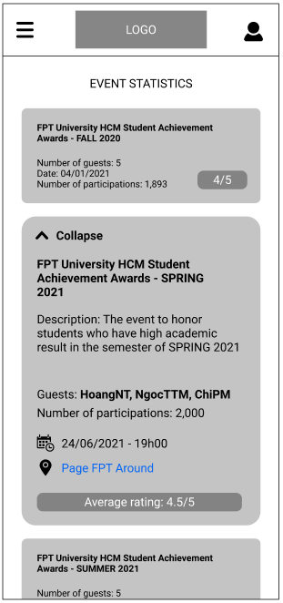

* Function details:
  + Data: Number of checked- and not checked-in events of the guest, and some statistics information of all that events and detail information of the event.
  + Validation: No.
  + Business logic:
    - Guest clicks on any of the Event on the **“Event Statistics”** screen. The details will drop down.
    - Normal Case: All the information is displayed successfully.

## Guest – Question Statistics

* Function trigger: Guest clicks on the **“Question Statistics”** item on the Main Menu.
* Function description:
  + Role: Guest.
  + Purpose: Allow the guest to view the trend of their questions.
* Screen layout:

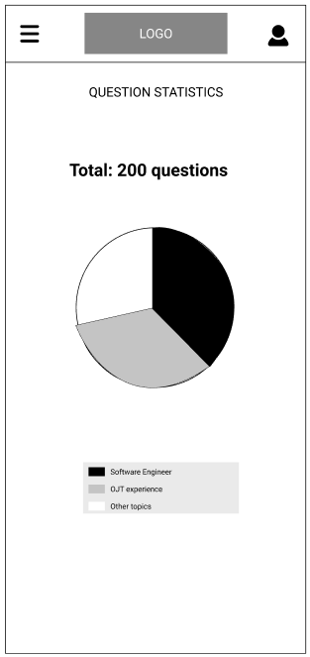

* Function details:
  + Data: Total of questions the guest has been asked and percentage of each subject of the questions.
  + Validation: No.
  + Business logic:
    - Guest clicks on the **“Question Statistics”** item on the Main Menu. All the trends will display.
    - Normal Case: All the information is displayed successfully.
    - Abnormal Case: An error message will display to inform the guest if they had no questions at all.

## View Questions

### View all questions in summary

* Function trigger: Guest clicks on the **“Your Questions”** item on the Main Menu.
* Function description:
  + Role: Guest.
  + Purpose: Allow the guest to view the summary of all questions that belong to them.
* Screen layout:

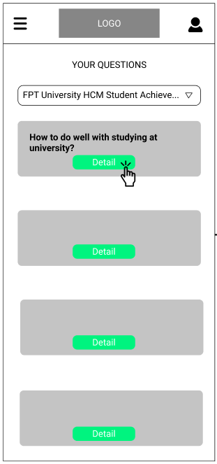

* Function details:
  + Data: All the questions that belong to the guest.
  + Validation: No.
  + Business logic:
    - Guest clicks on the **“Your Questions”** item on the Main Menu. The questions are displayed including only the questions’ title.
    - Normal Case: All the questions are displayed.
    - Abnormal Case: An error message will display to inform the guest if they had no questions at all.

### View question detail

* Function trigger: Guest clicks **“Details”** button on a specific question on **“Your Questions”** screen.
* Function description:
  + Role: Guest.
  + Purpose: Allow the guest to view the detail of a question.
* Screen layout:

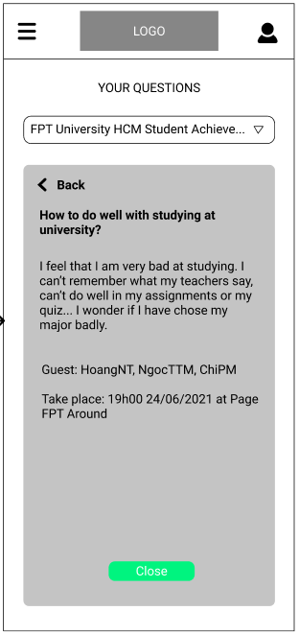

* Function details:
  + Data: All the information about the question including Title, Description and Event detail that the question belongs to.
  + Validation: No.
  + Business logic:
    - Guest clicks **“Details”** button on a specific question on **“Your Questions”** screen. All information about the question is displayed.
    - Normal Case: All the information is displayed.