1. WEB SOCKET, SOCKET
   1. Khái niệm chung

* Handshaking
  + handshaking can be defined as gripping and shaking of right hands by two individuals, as to symbolize greeting, congratulations, agreement or farewell.
  + In computer science, handshaking is a process that ensures the server is in sync with its clients. Handshaking is the basic concept of Web Socket protocol.

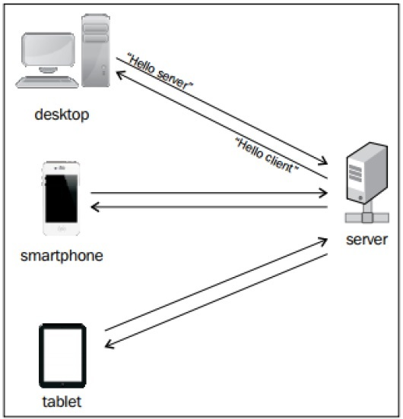

* Khái niêm webSocket:
  + Web sockets are defined as a two-way communication between the servers and the clients, which mean both the parties communicate and exchange data at the same time(giao tiếp 2 chiều giữa client và server, 2 bên có thể giao tiếp và truyền data 1 cách đồng thời)
  + The key points of Web Sockets are true concurrency and optimization of performance, resulting in more responsive and rich web applications.
* WEB SOCKET PROTOCOL FEATURE:
  + Web socket protocol is being standardized, which means real time communication between web servers and clients is possible with the help of this protocol.( có thể giao tiếp theo thời gian thực )
  + Web sockets are transforming to cross platform standard for real time communication between a client and the server
  + This standard enables new kind of the applications. Businesses for real time web application can speed up with the help of this technology
  + The biggest advantage of Web Socket is it provides a two-way communication (full duplex) over a single TCP connection
* URL:

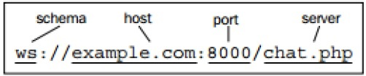

* + The latest specification of Web Socket protocol is defined as RFC 6455 – a proposed standard. RFC 6455 is supported by various browsers like Internet Explorer, Mozilla Firefox, Google Chrome, Safari, and Opera.
  1. Duplex Communication
* Kĩ thuật giao tiếp song công giữa client và server:
  + Polling
  + Long Polling
  + Streaming
  + Postback and AJAX
  + HTML5
* Polling:
  + Polling can be defined as a method, which performs periodic requests regardless of the data that exists in the transmission.
  + The periodic requests are sent in a synchronous way.
  + The client makes a periodic request in a specified time interval to the Server.
  + The response of the server includes available data or some warning message in it.
* Long Polling:
  + The client and the server keep the connection active until some data is fetched or timeout occurs
  + If the connection is lost due to some reasons, the client can start over and perform sequential request.
* Streaming:
  + best option for real-time data transmission
  + The server keeps the connection open and active with the client until and unless the required data is being fetched.
  1. WebSockets – Functionalities
* Web Socket helps in dynamic flow of the connections that are persistent full duplex. Full duplex refers to the communication from both the ends with considerable fast speed.
* Importance of Web Socket Feature:
  + Web Socket is an independent TCP-based protocol, but it is designed to support any other protocol that would traditionally run only on top of a pure TCP connection.( không phụ thuộc vào giao thwucs TCP nhưng có thể hỗ trợ bất cứ giao thức nào dựa trên kết nối TCP)
  + Web Socket is a transport layer on top of which any other protocol can run. The Web Socket API supports the ability to define sub-protocols: protocol libraries that can interpret specific protocols.
  + Examples of such protocols include XMPP, STOMP, and AMQP. The developers no longer have to think in terms of the HTTP request-response paradigm.
  + The only requirement on the browser-side is to run a JavaScript library that can interpret the Web Socket handshake, establish and maintain a Web Socket connection.
  + On the server side, the industry standard is to use existing protocol libraries that run on top of TCP and leverage a Web Socket Gateway.