Xây Dựng Ứng Dụng Theo Mô hình MVC:
-----------------------------
cos

..\MVCSample\WebContent
- login.jsp
- welcome.jsp
..\MVCSample\SRC
- controller\CheckLoginServlet.java
- model:
+ bean: Wife.java
+ bo: CheckLoginBO.java
+ dao: CheckLoginDAO.java
login.jsp:
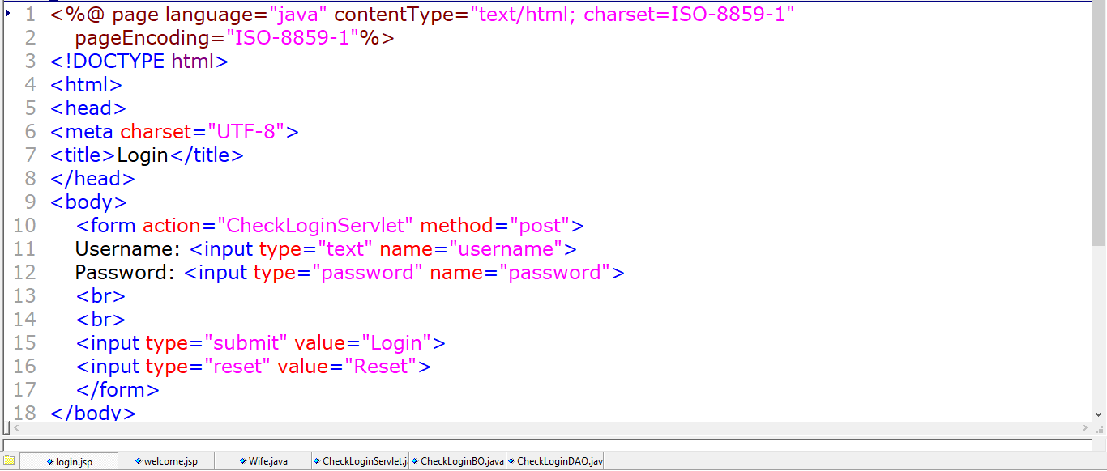
CheckLoginServlet.java:
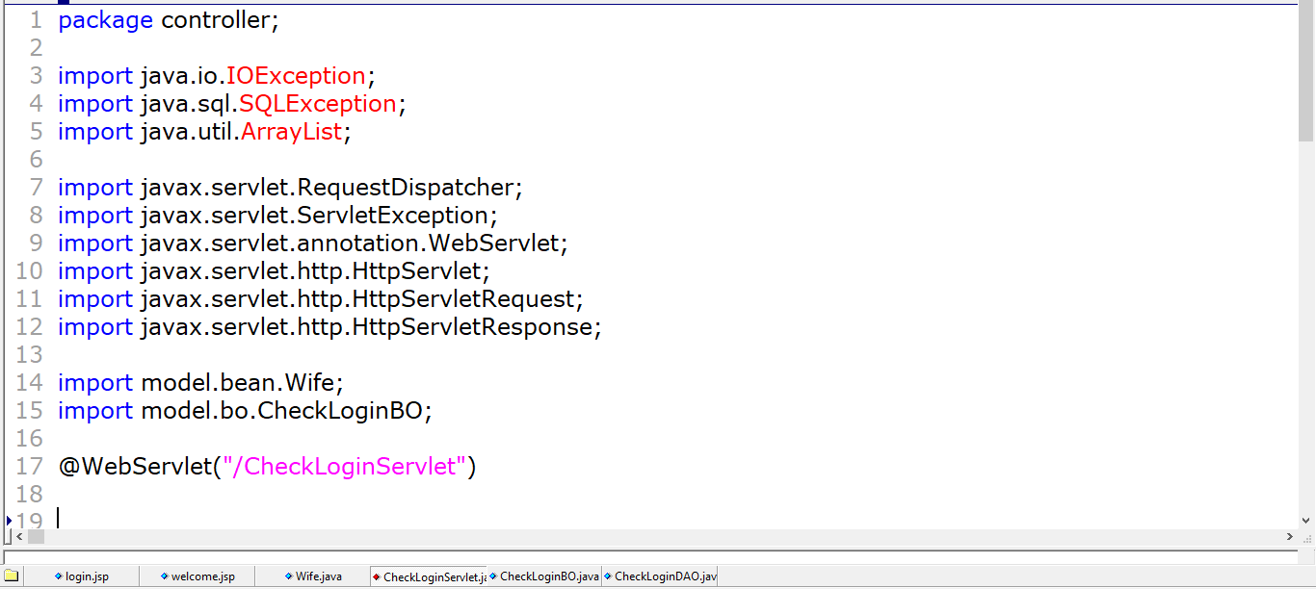
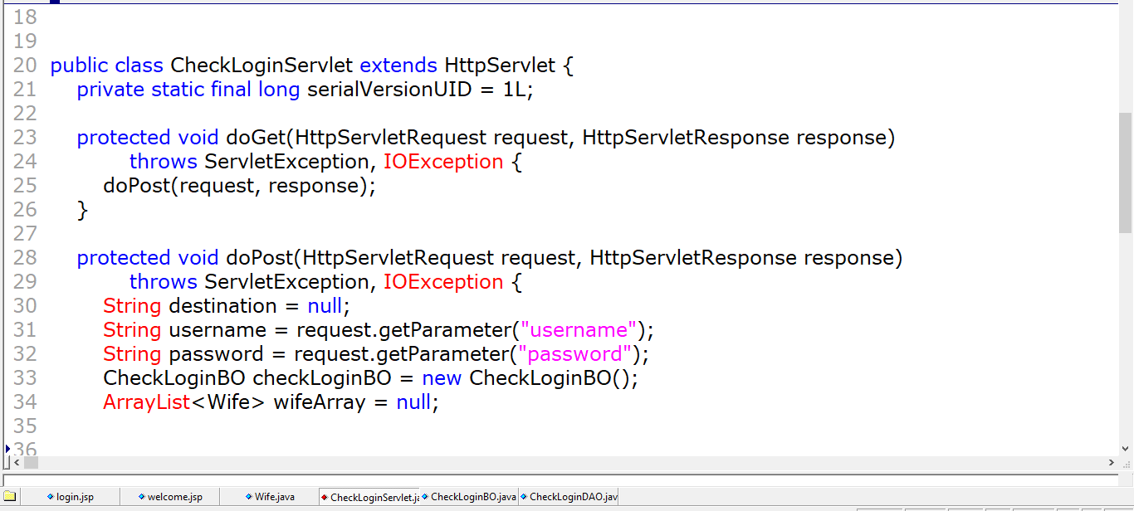
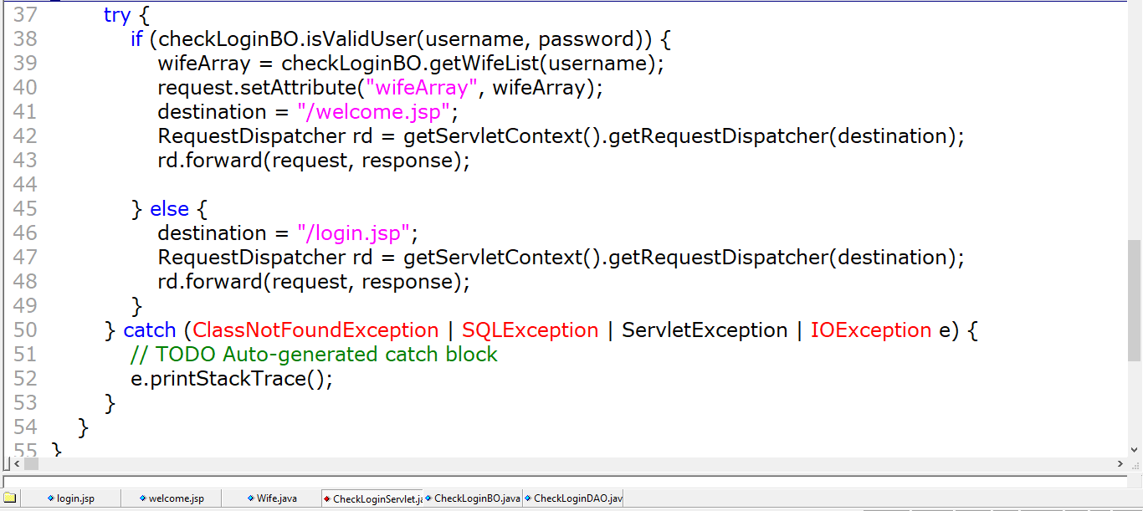
CheckLoginBO:
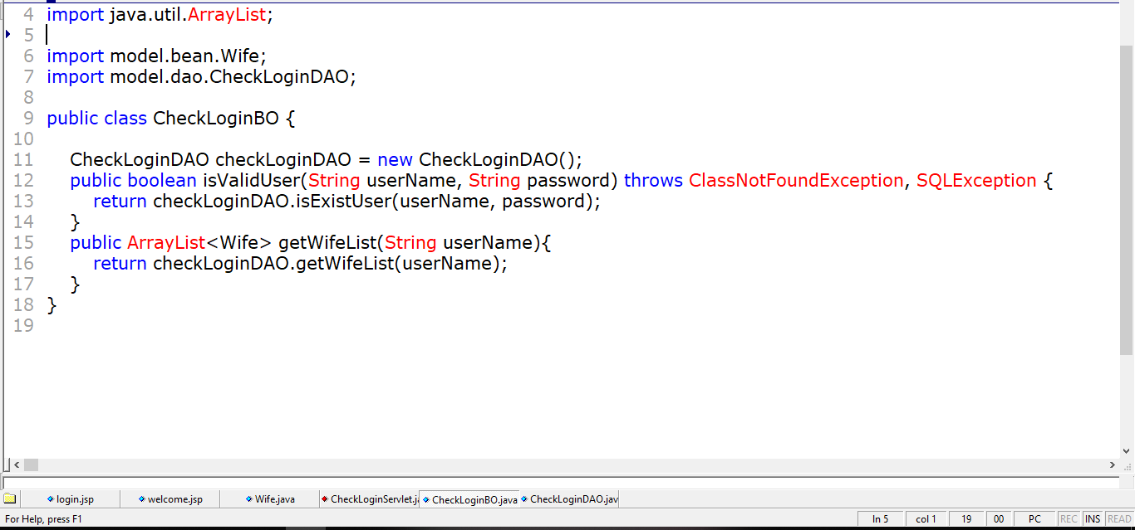
CheckLoginDAO:
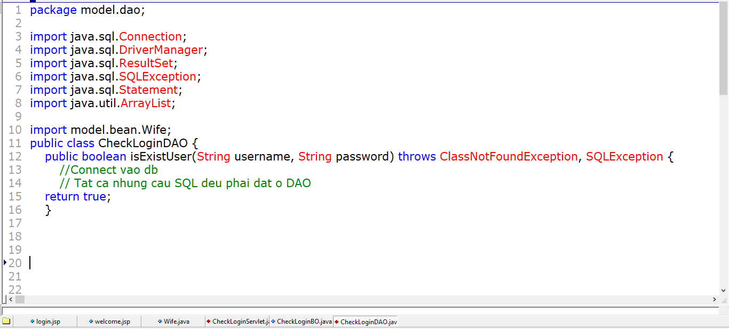
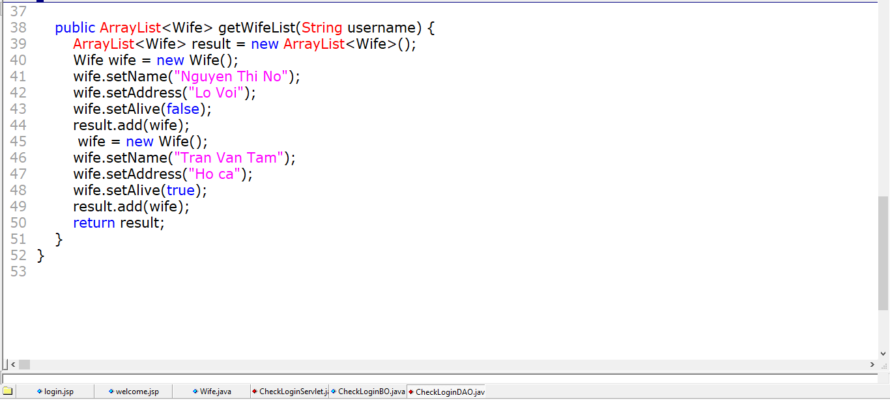
Bean\Wife.java:
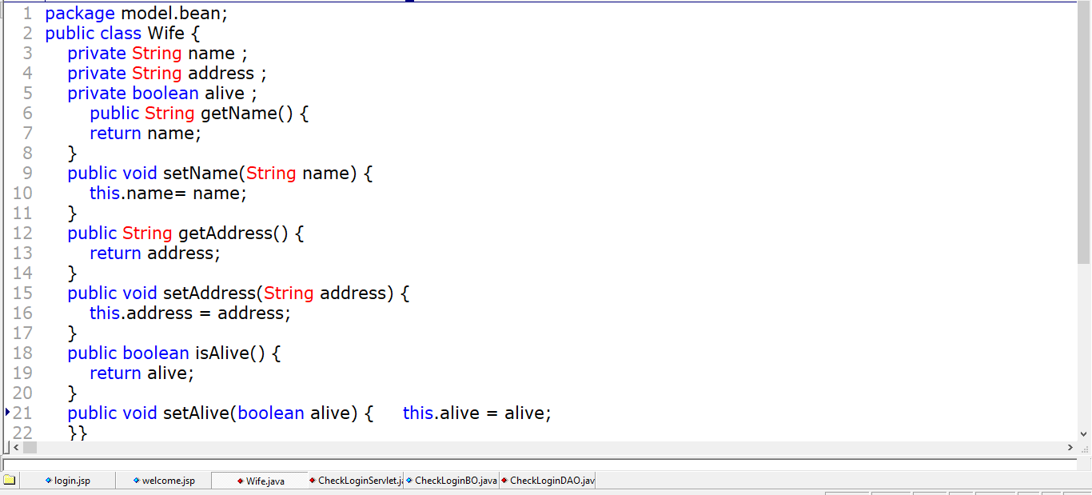
welcome.jsp:



