

**Git and GitHub**



**Git and Git Hub:**

• Git and GitHub are 2 different things

1. **Git:**

• Git is a software that comes with the computer if you have Mac or Linux

• For windows you have to download it – Git Bash

• Git is a memory card for your cod

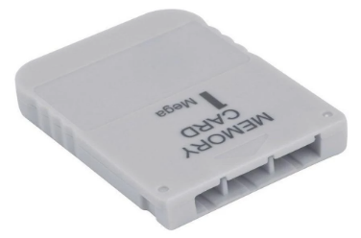

⏵ If you have a project with a bunch of files (html, css, js) you want just like you have a video game you want to save your progress as you go, that way if you die you don’t loose all your progress

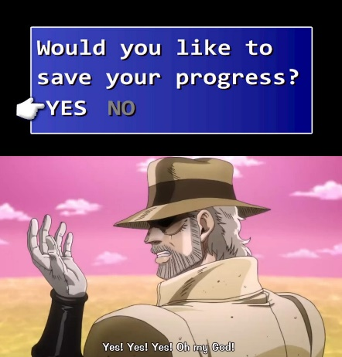

⏵This will be saved locally on your computer, nobody can access this

**• Example:**

mkdir gitVideo **<-** create a folder named gitVideo

cd gitVideo **<-** access the file

touch index.html app.css **<-** create index and app files

* 1. **How to use Git:**

1. **Initialize your folder with git:**

git init = put the memory card into the game system, because you cannot save game without memory

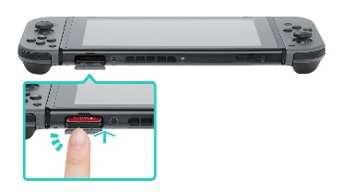**Now we can use Git!**

1. **Save our progress:**

git add = is used to save, we can choose all the project with a dot or a specific file like index.html

git add .