Conexiune oracle cloud

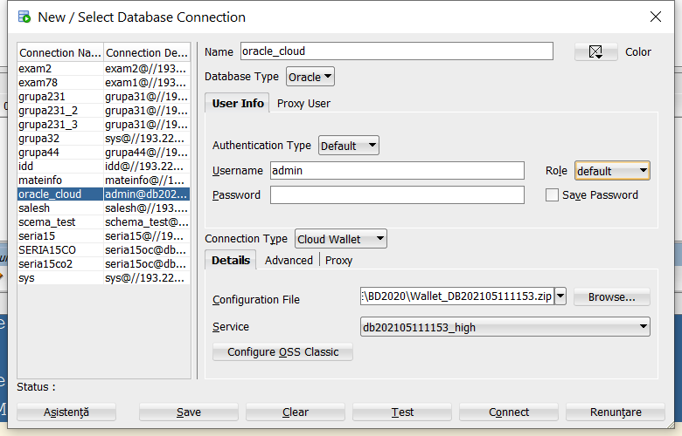

CREARE USER oracle:

-- USER SQL

CREATE USER seria15oc IDENTIFIED BY "ParolaOracleCloud15!" ;

-- ROLES

GRANT "CONNECT" TO seria15oc ;

GRANT "RESOURCE" TO seria15oc ;

-- SYSTEM PRIVILEGES

GRANT CREATE ANY INDEX TO seria15oc ;

GRANT CREATE ANY VIEW TO seria15oc ;

ALTER USER seria15oc DEFAULT TABLESPACE "DATA";

ALTER USER seria15oc QUOTA 500M ON "DATA";

--GRANT UNLIMITED TABLESPACE TO seria15oc;