Easy install Linux over Internet with an USB Memory Stick

This guide will help you install a basic Ubuntu Linux on any x86 comuter (most Intel and AMD processors) by using an USB stick (also called flash drive, thumb drive, USB Mass Storage, …). See project page http://laptops.thereshope.eu.
Installing with an USB stick is more common today, than burning a CD or DVD. It is easy, faster and the stick can be used for other tasks later, so save the environment.

Creating the USB stick don’t take longer as 30 minutes. The Installer is very small (about 1 MB).
As the installation will download the packages for the operating system from the Internet, the installation itself depends on your bandwidth. For example a German language installation with a 50Mbit fiber: 464 MB in 1min 32s (5072 kB/s).

1. How to get started
To install Linux from an USB Stick you need:
- An USB memory stick. It will be erased during the process!
- A computer that ...
  - can boot from USB. If unsure, check the BIOS settings.
  - have at least 512 MB RAM (System memory)
  - have 5 GB available on hard disk drive (HDD or SSD).
  - have 700 MHz or faster x86 CPU (processor).
- A working Internet connection (wired LAN referred during the installation)

2. Get the installer
You need to download the installer so you can put it on an USB stick
- Go to our releases page here: https://github.com/sokoow/globalhack-laptop-installer/releases
- From the latest release, section Assets, download a file called boot.zip
- Unzip this file, you will get a ipfx.iso file as a result of this step
- Your ipfx.iso file is ready to be booted from CD, if you're into it

3. Write the Installer on an USB stick
On Windows:
- Plug your USB stick to any USB Port on your computer
- Go to https://www.balena.io/etcher/ and download the latest release
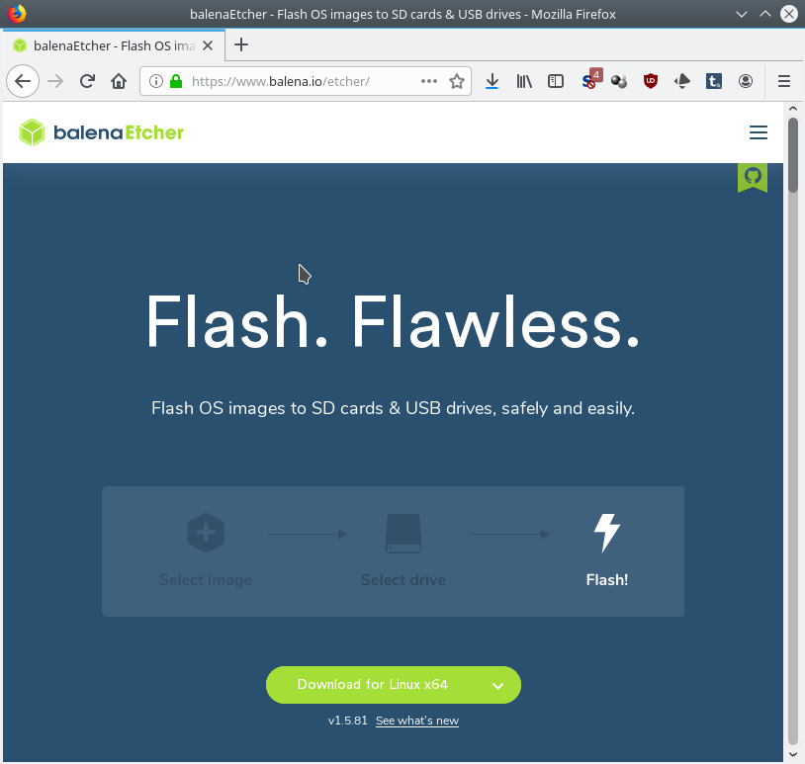
- Execute the installer, agree the license and wait.
- After the Installation, Etcher will start itself. Later you’re able to start it from the windows start menu.
- Select the ipfx.iso as image
- Select your plugged-in USB stick as target
- Flash! = write the image to the USB stick.
Your data on the stick will be erased!

4. Start the Installer
To start your computer from an USB stick, you might need to change the boot order. Different systems with different BIOS need different keys to be pressed during the boot.
- Shutdown the system
- Plug-in the USB stick
- Start the system
- If you’ll see the blue ‘iPXE boot menu’, skip the rest of this chapter
- If you’ll don’t see the ‘iPXE boot menu’, restart the system again.
- Here exists no ‘general answer’ for all systems, we have to try and error. During the boot, press every two seconds one of the following keys:
[F1], [F2], [F8], [F10], [F12], [Del] or [Esc] (See Appendix for further Information).
Sometimes the needed key is shown at the boot screen. On Lenovo Laptops it is the purple ‘ThinkVantage’ button.
  - Maybe you’re going direct to the ‘Select a boot device’ part. Search for something like ‘USB-HDD’, ‘USB Mass Storage’ or ‘USB’ and the vendor name of your USB Stick.
  - Sometimes you come to the ‘BIOS Setup’ part. Here you’re able to change the Bootorder in the Tab ‘Boot’. After you have changed the bootorder, save the changes and restart the system.
- Now you should see the iPXE installer. If not, try another key from point 6.

Hint: If your system is not able to boot from USB, but have got a CD ROM drive, you can burn the ipfx.iso with any CD burn application to a Compact Disc and also boot it. Maybe here you’ll also need to change the boot order (see point 6).

5. Install Linux
If you have successfully booted from your memory stick (or maybe CD ROM), you should now see a blue dialog with headline ‘iPXE boot menu’
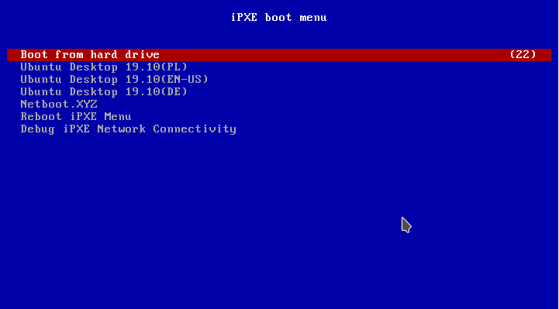

‘Boot from hard drive’ will start the previous installed OS without any change on the system. It will automatic be executed after the timer on the right counted to 0 (30 seconds).
‘Ubuntu Desktop 19.10(PL)’ will install Ubuntu in Polish language
‘Ubuntu Desktop 19.10(EN-US)’ will install Ubuntu in English language
‘Ubuntu Desktop 19.10(DE)’ will install Ubuntu in German language
The other options are for advanced tasks.

Most parts of the installation are fully automatic. During the setup, the system only will ask if LVM should be written on the disk.
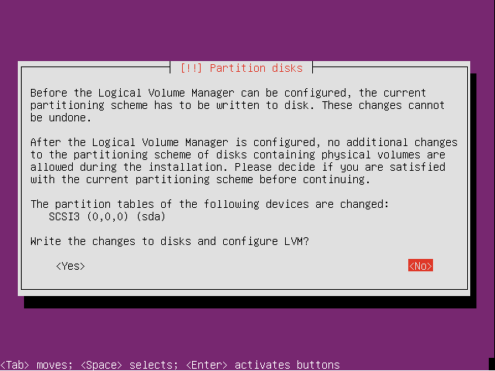
Answer ‘Yes’ to continue.

If you answer ‘No’, the result will be a unusable computer and you need to start over again. If you are familiar with the debian install system, you’re able to tweak some settings here, but than you shouldn’t use this installer.

The Download of the sources and the installation will take some time, but need no more interaction.
At the end the system will reboot. If the USB stick isn’t removed during the last reboot, maybe it will start again from the stick. It isn’t a problem, because the first option is still ‘Boot from hard drive’, and after 30 seconds your fresh installed Ubuntu Linux will start. Don’t remove the stick during the boot, better when the Ubuntu login screen is visible.

6. What is next?
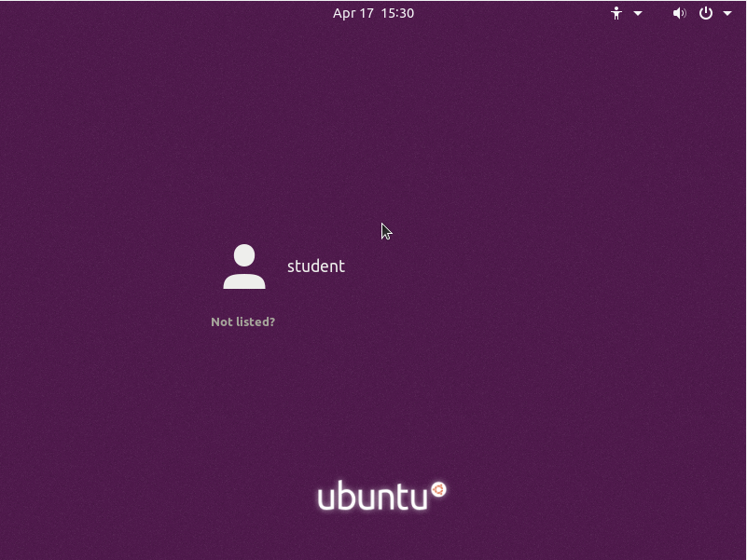
You have a full functional Linux installed. Just login with
Name: student
Password: student
and play around.

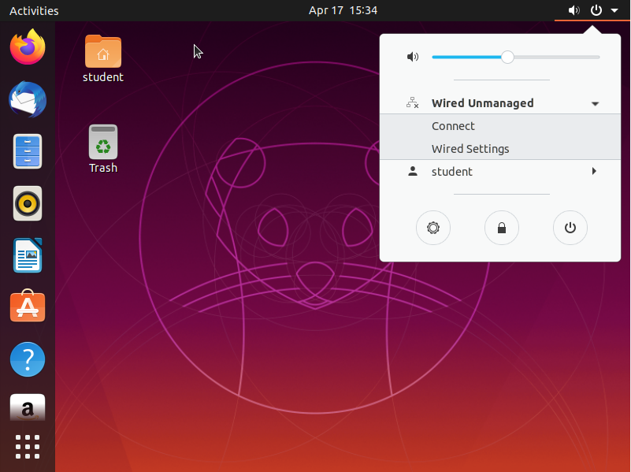

After successful login, may you’ll want to start with setting up the Network on the top right. May you ‘ll need to install your wireless network drivers first. The procedure depends on your Wireless Card.

To configure the user just click the menu icon left on the bottom and select the App ‘Settings’. In the dialog choose ‘Details’ (last option in the menu) and click ‘user’. Here you’re able to change Name and Password.

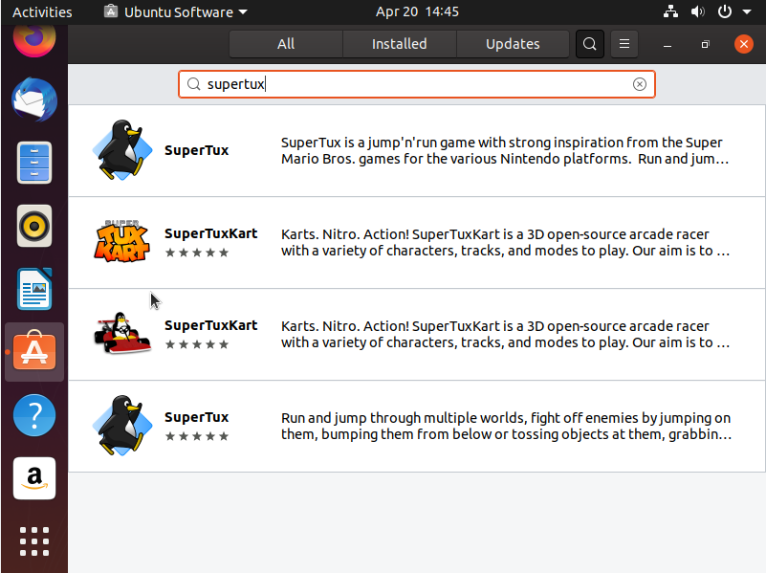
Also from the menu bar left, you can reach ‘Ubuntu Software’ to upgrade the system or install new software from the repository.

Appendix

Common keys to get into the BIOS
- ASRock: [F2] or [DEL]
- ASUS: [F2] for all PCs, [F2] or [DEL] for Motherboards
- Acer: [F2] or [DEL]
- Dell: [F2] or [F12]
- ECS: [DEL]
- Gigabyte / Aorus: [F2] or [DEL]
- HP: [F10]
- Lenovo (Consumer Laptops): [F2] or [Fn]+[F2]
- Lenovo (Desktops): [F1]
- Lenovo (ThinkPads): [Enter] then [F1] or ThinkVantage Button.
- MSI: [DEL] for motherboards and PCs
- Microsoft Surface Tablets: Press and hold [volume up] button.
- Origin PC: [F2]
- Samsung: [F2]
- Toshiba: [F2]
- Zotac: [DEL]

Further Information
Project page: http://laptops.thereshope.eu
Issue Tracker: https://github.com/sokoow/globalhack-laptop-installer/issues

Tipps
Use SSD. If possible, using a SSD hard drive is recommended. Even if the cheap SSD got much less storage capacity, than a common HDD, the speed boost will bring a whole new experience to legacy laptops and desktops.

