Review and summary CRISPR/Cas technology as a promising weapon to combat viral infections.

* CRISPR/Cas system can be classified as Class1 or Class 2:
  + Class 1 includes multi-subunit-protein complexes.
  + Class 2 comprises single-effector proteins. Consists of a Cas nuclease in complex with a guide RNA (crRNA) that can cleave a complementary target nucleic acid (DNA or RNA)
* Class 2 systems:
  + Class 2, type II systems are characterized by the presence of a Cas9 effector nuclease and a dual RNA-guide (sgRNA), including a trans-activating crRNA and a crRNA.
  + The Cas9-sgRNA complex or RNP recognizes a G-rich 3t’ end-located protospacer adjacent motif (PAM) on a double-stranded DNA (dsDNA) target.
  + PAM recognition leads to the complementary annealing of the sgRNA and the DNA and the activation of the nuclease to induce a blunt-ended double stranded break (DSB) on the target.
  + Class 2, type V system is mainly represented by a single RNA – guided dsDNA targeting effector proteins known as Cas12 (Cas12a or Cpf1 and Cas12b)
  + Upon Cas12-crRNA complex formation, the recognition of a T-rich 5’tend-located PAM enables crRNA pairing with a dsDNA target.
  + Active Cas12 produces a site-specific dsDNA cleavage (cis-cleavage activity) and generates a DSB with staggered ends. Furthermore, Cas12-crRNA binding to the target strand triggers multiple-turnover non-specific single-stranded DNA (ssDNA) trans-cleavage.
* Cas9 and Cas12-induced DSBs can be repaired by the cells through 2 different pathways:
  + 1. non-homologous lend joining (NHEJ)
  + 2. Homology directed repair (HDR)
* Class 2 type VI CRISPR/Cas system:
  + Includes a group of single RNA guided nucleases known as Cas13 (Cas13a, Cas13b, Cas13c, and Cas13d)
  + They target single-stranded RNA (ssRNA). Although Cas13 lacks PAM requirements, some orthologs are activated upon protospacer flanking sites (PFS) recognition.
  + Following PFS (when required) and ssRNA target recognition, the Cas13-nrRNA complex becomes active, cleaving not only guide-complementary ssRNA (cis-cleavage activity), but also other surrounding ssRNAs (trans-cleavage activity).
  + CRISPR-Cas13 can be programmed to mediate efficient and specific RNA knock-down and also RNA editing by using catalytically inactive Cas13 (dCas13)

Main featural summary of main Class 2 CRISPR/Cas effector proteins.

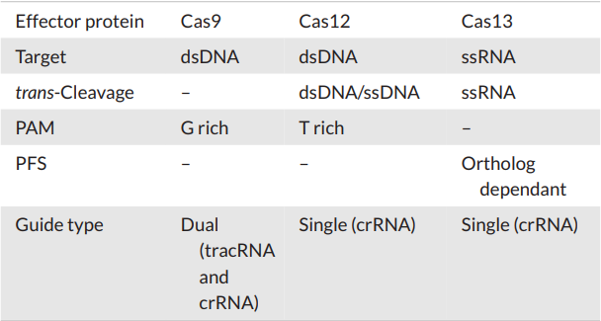

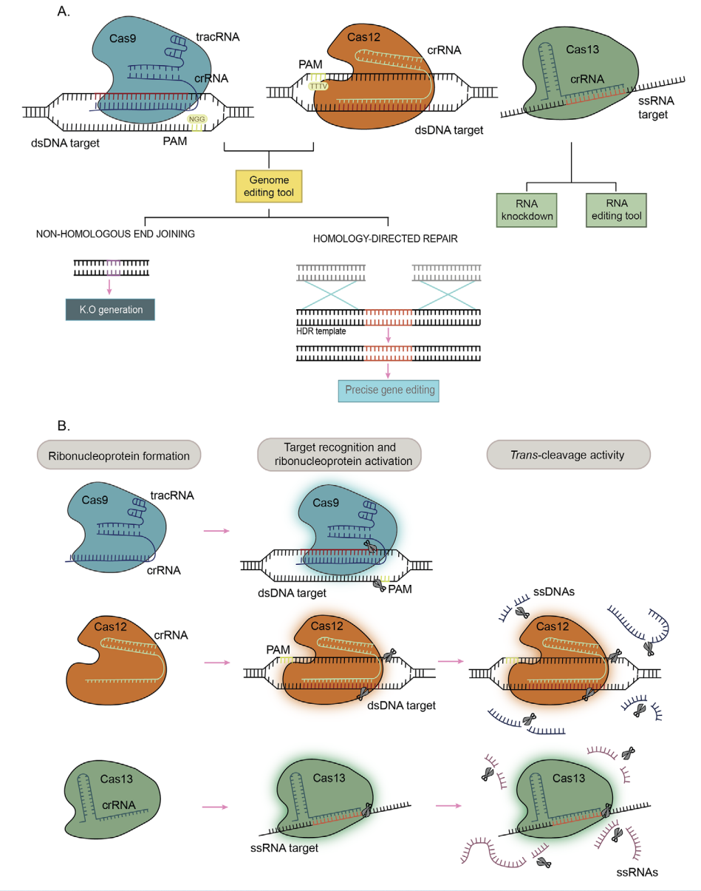

The CRISPR-Cas system would have potential in treating both acute and chronic infections. Many clinically relevant viral diseases often become chronic due to viral latency, a phase in which viral activity is minimal. Current treatments frequently lack efficacy in those cases. E.g. highly active antiretroviral therapy, the treatment of choice against HIV-induced acquired immunodeficiency syndrome, fails to target latent virus reservoirs

* + Latent virus reservoirs: Cells infected by a virus that have low viral activity and are not actively reproducing viruses. When a latently infected cell is reactivated, it will start to produce viruses again.
* CRISPR/Cas technology has shown potential to tackle the following viruses:
  + 1. Hepatitis B virus
  + 2. Herpes virus
  + 3. Human papilloma virus (HPV)
  + 4. Dengue virus
  + 5. Corona virus
  + 6. Influenza A virus
  + 7. Lymphocyte choriomeningitis virus
  + 8. Vesicular stomatitis virus
* Cas 12a and Cas9 are great against DNA viruses and RNA viruses with dsDNA intermediates inside cells. While Cas13 can directly target RNA viruses. It is arguably true that Cas13 would be much safer in terms of in vivo applications as it cannot induce permanent genetic alterations in host cells. Thus off-target activity would not be a severs problem when using Cas13.
* Most experiments on CRISPR anti-viral potential is limited in vitro. However, exhaustive in vivo studies are required.

Target Genes: Viral genome versus host factors

* The success of antiviral CRISPR therapy strongly relies on the choice of optimal target genes.
* The targeting of host factors can also constitute a valuable approach.
  + Targeting host factors against HIV virus:
  + Elimination of CCR5 and CXCR4 co-receptors block HIV direct entry and recognition of immune cells. HIV viruses recognize the CD-4 main receptor on immune cells, however it is too big of a risk to alter the CD-4 therefore co-receptors are targeted.
  + Most others target the long terminal repeat (LTR) promoter regions. LTRs flank retroviruses integrated genetic material and regulate pro-viral transcription, constituting thus a specially suited target for therapy.
  + In the case of latent infections, CRISPR Cas technology allows to reserve viral quiescence by specifically activating viral promoters using catalytically dead versions of Cas nucleases.
  + Latency reversal can boost host’s immune response and improve the efficacy of antiviral treatments.
* Genetic modifications are irreversible, host targets must be carefully selected to avoid deleterious side effects

.

* Generally targeting the viral genome is a much more straight forward, simple, safer and preferred way.

GUIDE RNA DESIGN: VIRAL ESCAPE MUTANTS AND THE IMPORTANCE OF MULTIFLEX APPROACHES

* Guide RNA’s must simultaneously display high on-target activity and minimize off-target recognition.