Operand1:32'h01010101

Operand2:32'h01011111

Operation:4'h0

Signed:0

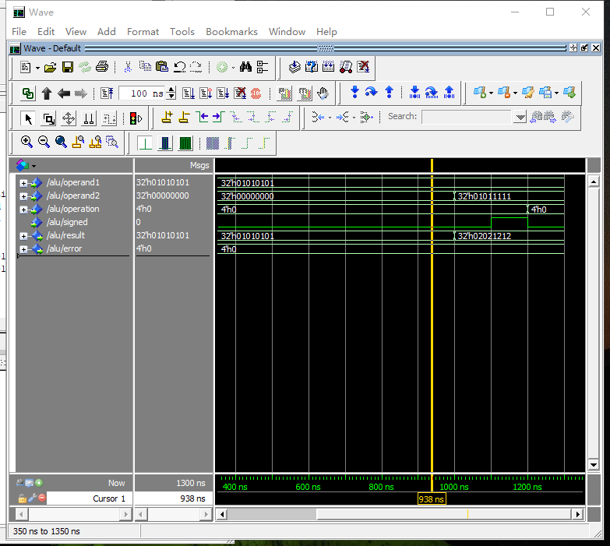

Operand1:32'h01010101

Operand2:32'h01011111

Operation:4'h0

Signed:1

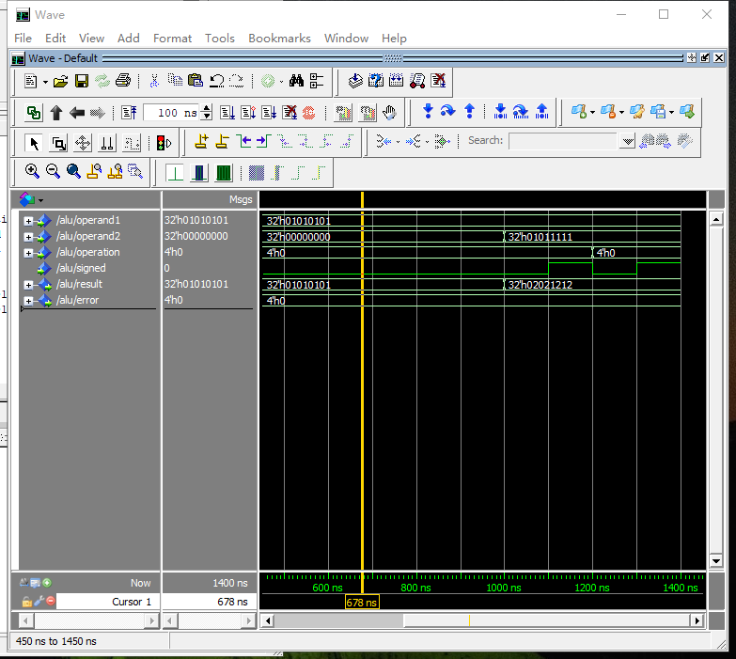

Operand1:32'h01010101

Operand2:32'h01011111

Operation:4'h1

Signed:1

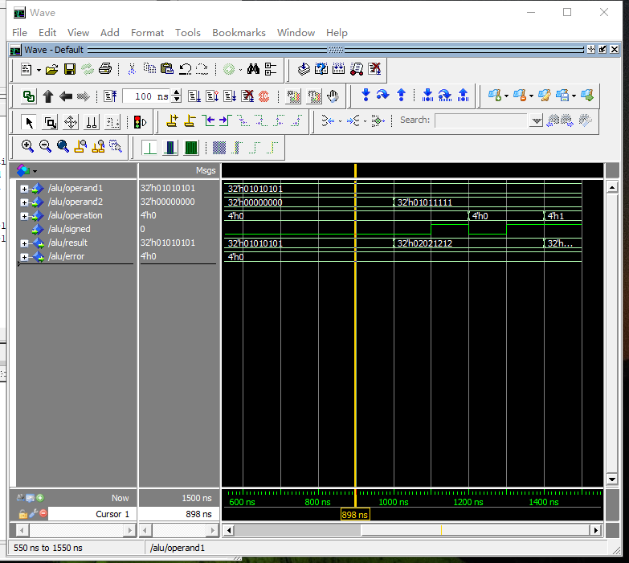

Operand1:32'h01010101

Operand2:32'h01011111

Operation:4'h1

Signed:0

