At this time, I meet many problems for my homework. Firstly, I am not sure am I download all the staff I need because My Visual Studio2017 download in the last semester.

First of all, When I create the new project in the final step, it will change the setting.

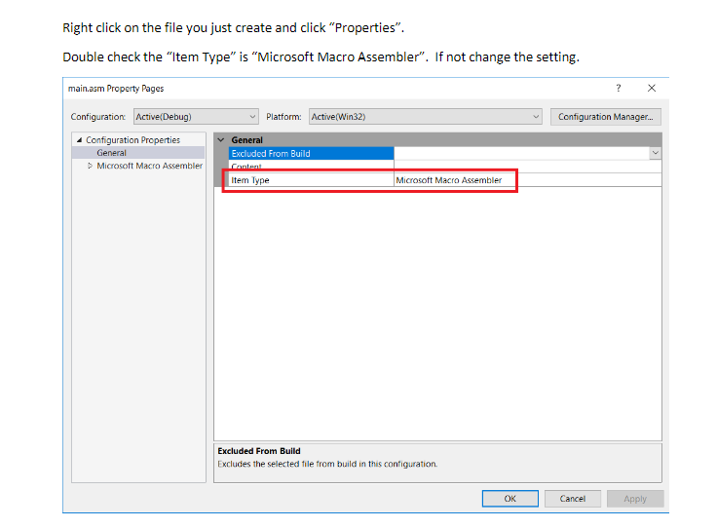

Secondly, for the Irvine.zip, I download the zip from the Canvas and watch the book from the page 63 to 65. It seem just a guide for telling the basic structure about the assembly program. ( I just unzip the files and double click the AddTwo.asm )

Thirdly, for project32, I try to do it as the book, but I failed in the step 4. Sow as the picture

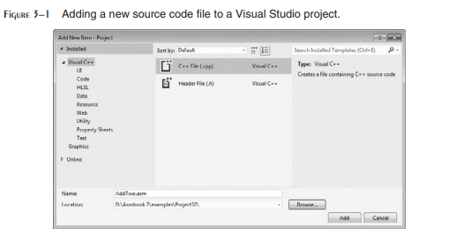

This is the picture from the book. My problem is in the picture blew:

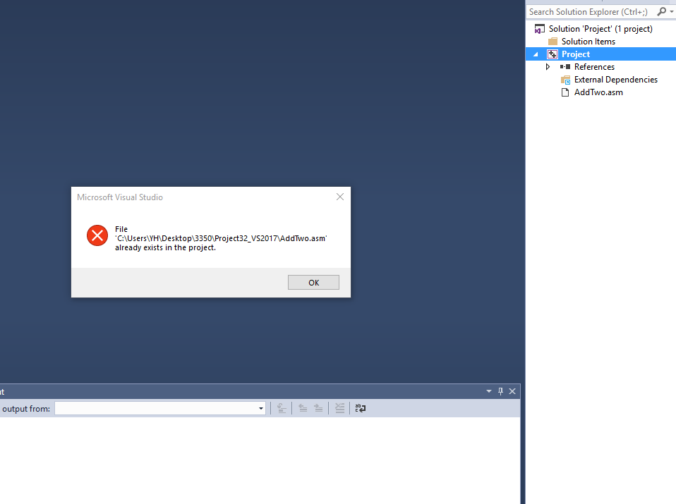

It shows that AddTwo.asm already exists in the project. After that, I start to debug AddTwo.asm. It shows that



Also, When I debug as the book, it shows

