Course Project
Name Muhammad Luqman
Roll Number MSCS25007
Git Hub repo link: https://github.com/Luqman0033/Tools_project
Data set: I get data from Kaggle and that is Stock Market sensex + nifty. Here is link https://www.kaggle.com/datasets/rockyt07/stock-market-sensex-nifty-all-time-dataset?resource=download
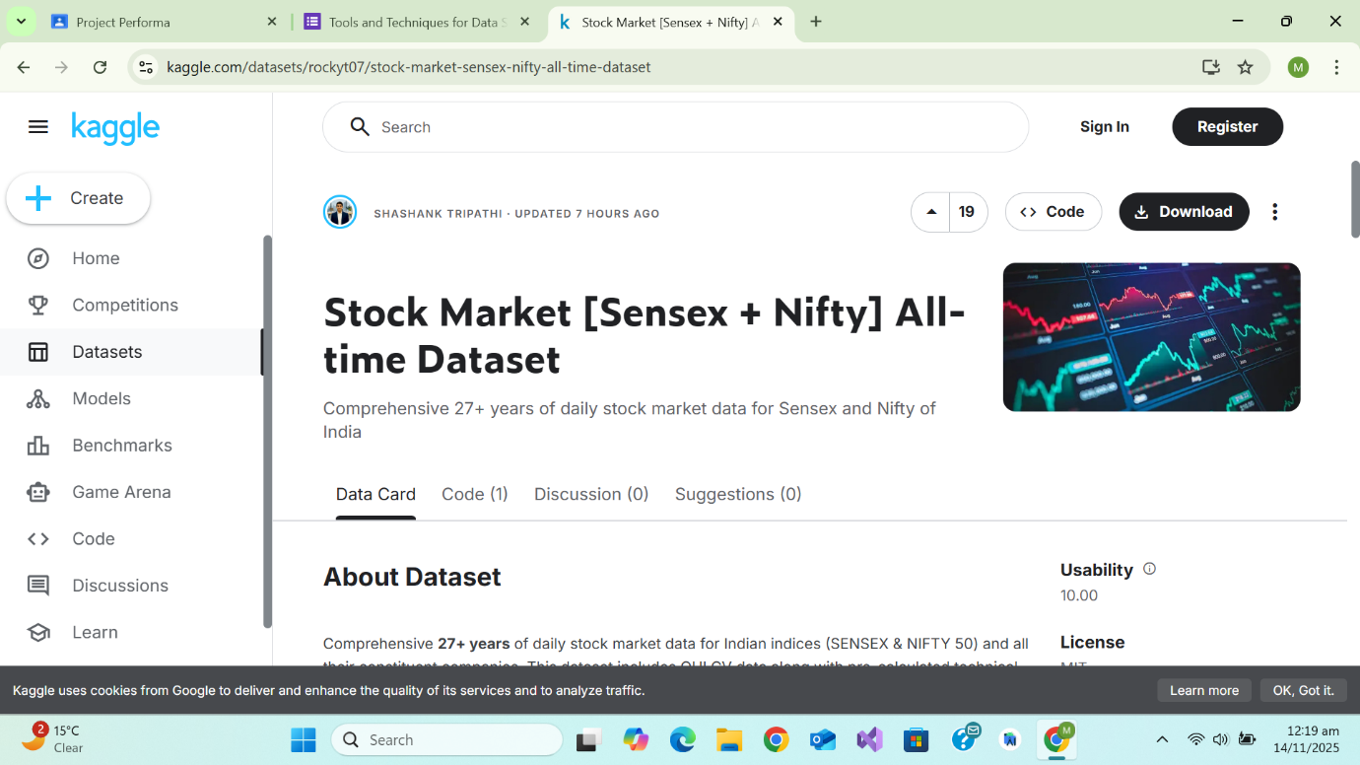
Load Data set:

Code for uploading 4 .csv files
from google.colab import files
import pandas as pd

print("Upload 4 files:")
uploaded = files.upload()

dataframes = []

for file_name in uploaded.keys():
if file_name.endswith(".csv"):
df = pd.read_csv(file_name)
elif file_name.endswith(".xlsx") or file_name.endswith(".xls"):
df = pd.read_excel(file_name)
else:
print(f"Unsupported file: {file_name}")
continue

print(f"\nLoaded: {file_name}")
print(df.head())
dataframes.append(df)

# Assign to variables
if len(dataframes) >= 4:
df1, df2, df3, df4 = dataframes[:4]

print("\nFiles loaded successfully!")

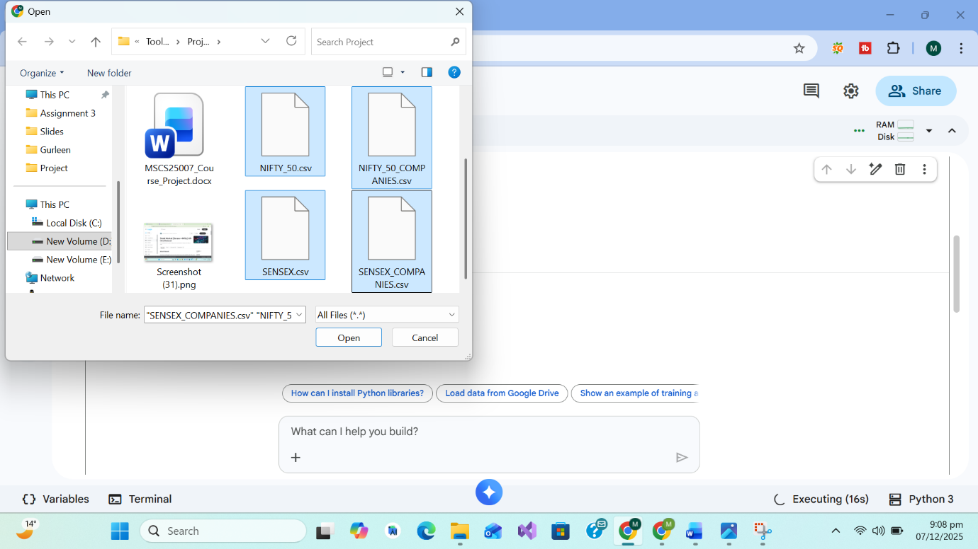
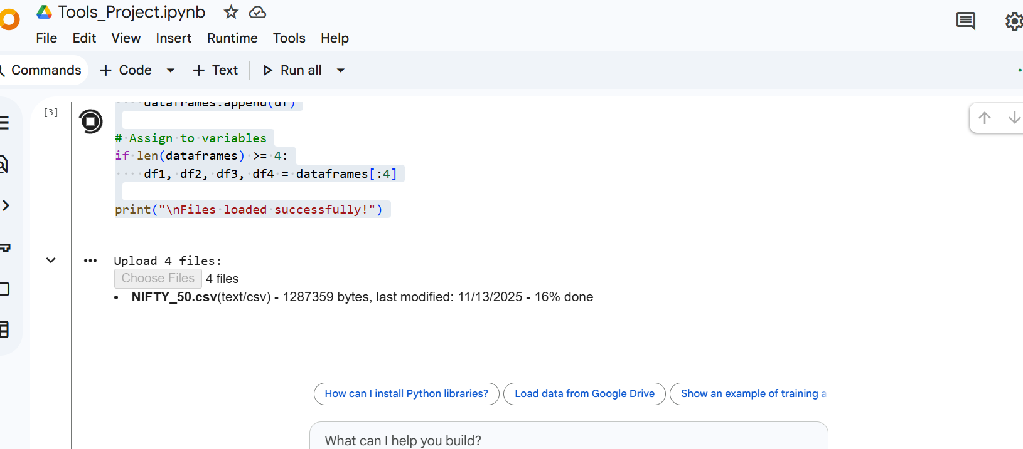
Data loaded successfully
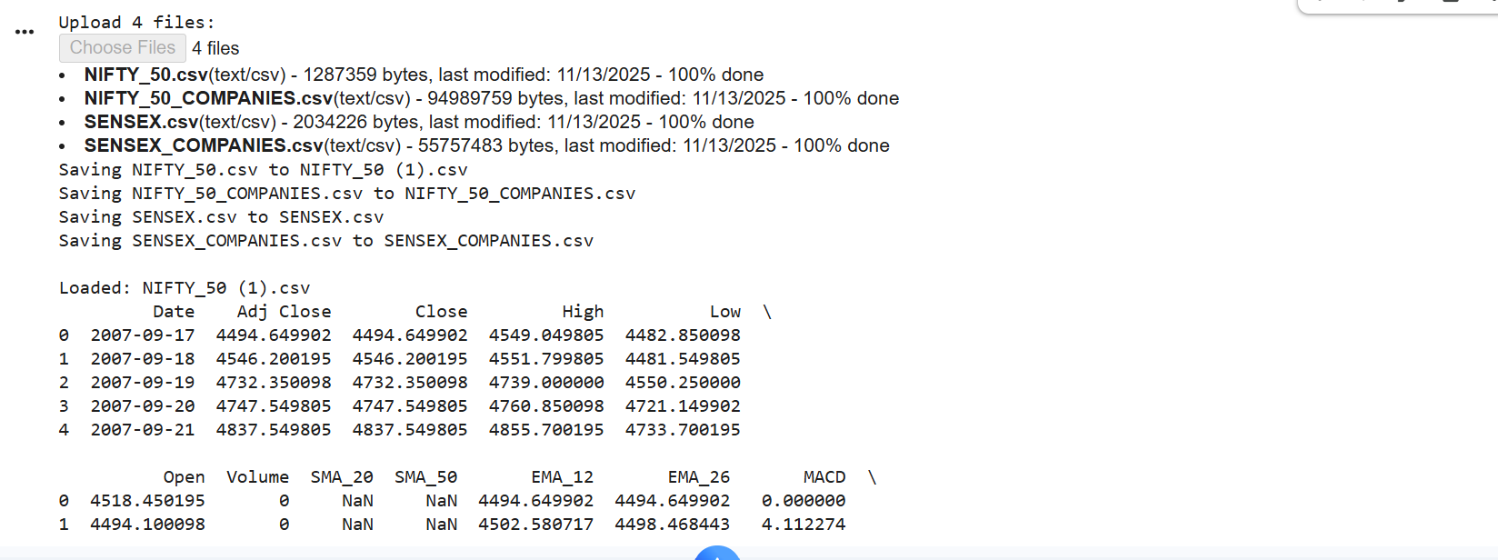
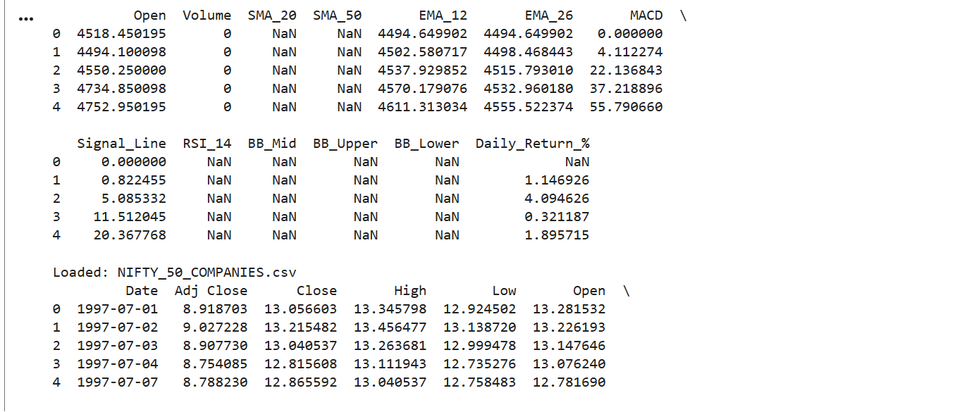
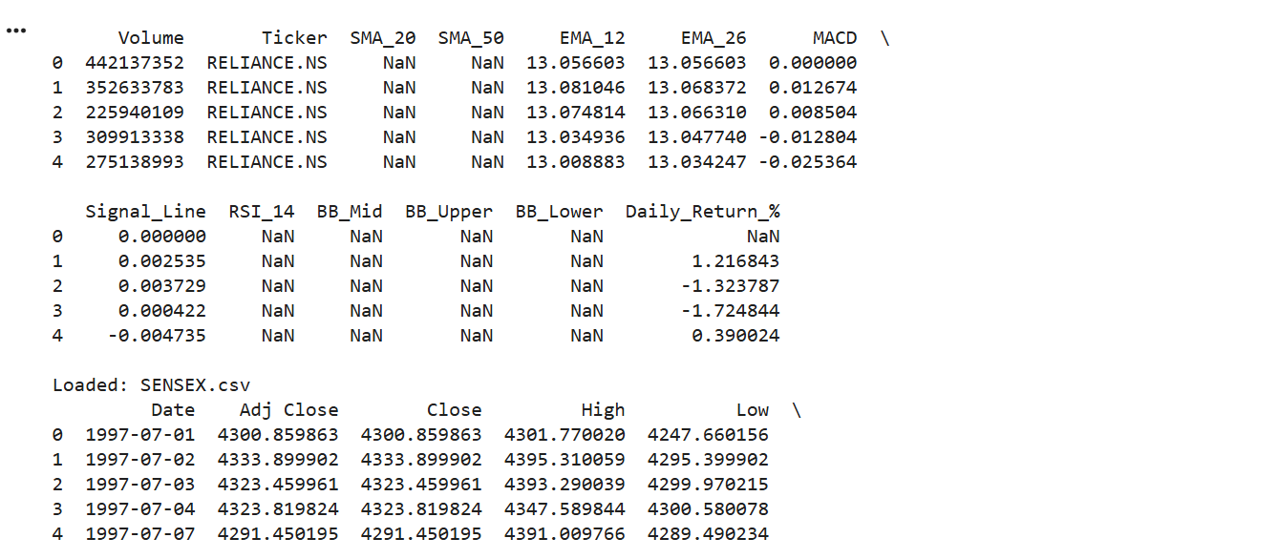
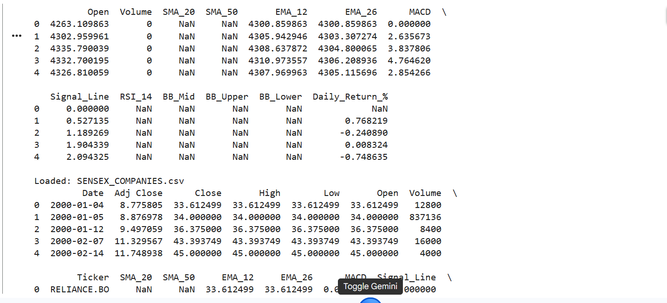
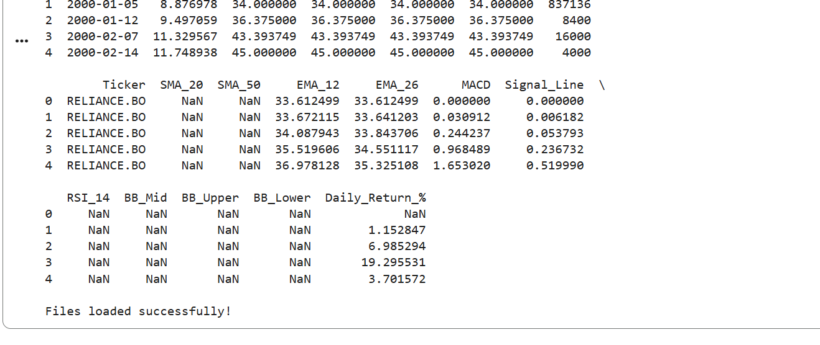
Dataset Description:
The dataset used in this project contains historical stock market data of the Indian stock indices Sensex and Nifty. It includes information such as opening price, closing price, highest price, lowest price, and trading volume recorded over multiple dates. This dataset is useful for analyzing market trends, price movements, and performing predictive analysis using machine learning techniques. The data helps in understanding the behavior of stock markets over time.
Git and github use:
Created github repo
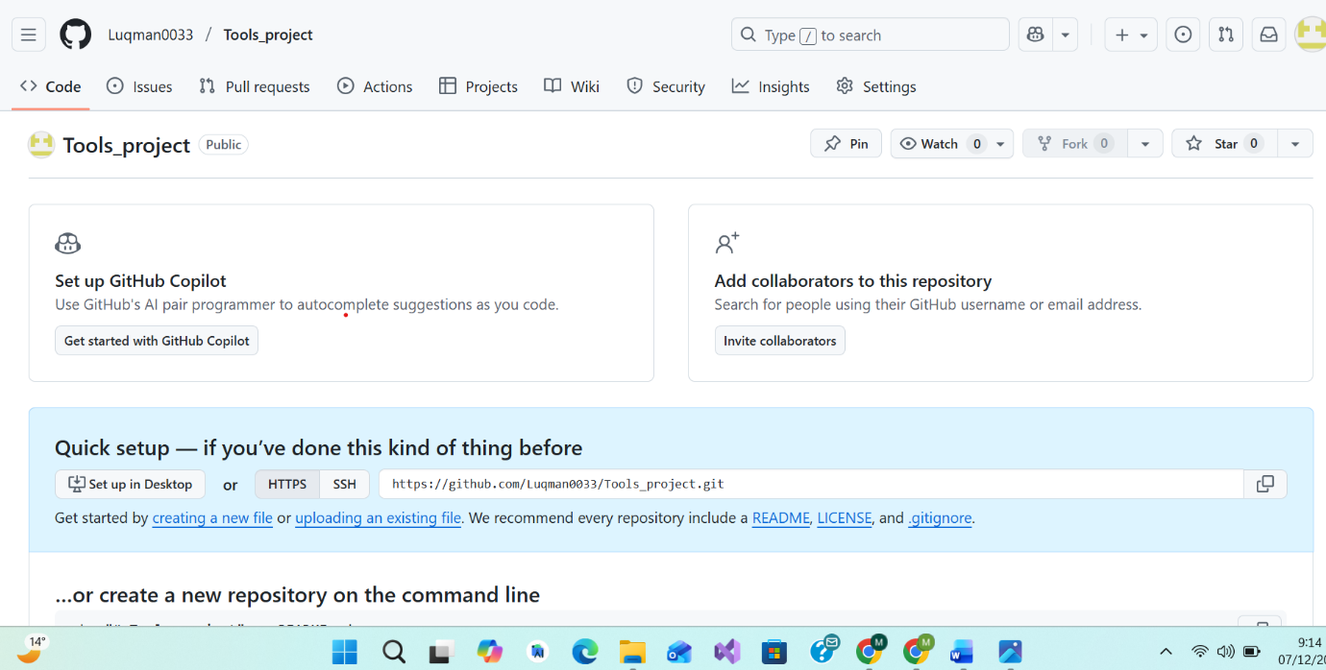

Connecting my google colab with github
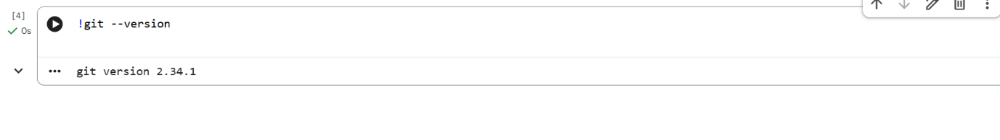
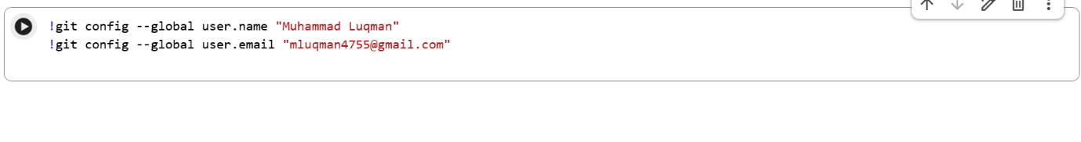
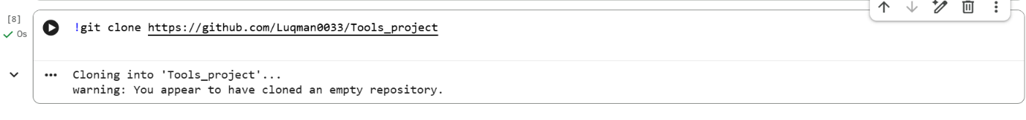
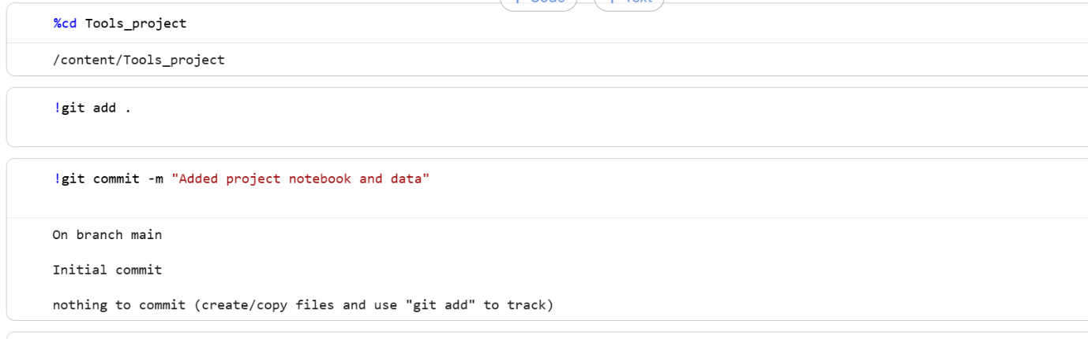

EDA using Python:

