PROGRAMMER SPECIFICATION
Clinical Decision Support System (CDSS) for Atrial Fibrillation Management
Integrated with Electronic Medical Record (EMR)

Item | Specification
Document purpose | Functional, business-rule, data-capture, and audit-trail specification for an EMR-integrated AF CDSS.
Clinical scope | Outpatient cardiology clinic encounters; expandable to other clinics if approved later.
Target users | Clinicians in cardiology clinic, clinical pharmacy/research team, system developers, and programmers.
System role | Supportive clinical alert and nudge tool. It does not replace clinical judgement.
Version | Amended version based on revised workflow diagrams and requested data-capture requirements.
Major amendments | AF selection expanded to five domains; additional demographics; 6-month pre/during/post data capture; comorbidity missing-data alerts; anticoagulant-specific rules; next appointment and doctor plan; clinician actions and audit logging.

Important safety note: All clinical rules, dose recommendations, and thresholds must be reviewed and approved by the clinical governance team before deployment. The CDSS is intended to support, not replace, the treating clinician’s judgement.

1. System Purpose and Scope
This CDSS is designed to identify patients with atrial fibrillation (AF) or AF-related clinical evidence from the EMR, assess selected stroke risk, bleeding risk, comorbidity status, anticoagulant suitability, and present all triggered findings in a single combined clinical alert panel.
- The workflow should run when a patient record is opened during a cardiology clinic encounter.
- The workflow should apply only to patients classified as AF-positive based on the five-domain identification logic defined in this specification.
- The system must capture data for research evaluation at three time points: 6 months before the alert/nudge encounter, on the day of the alert/nudge encounter, and 6 months after the alert/nudge encounter.
- The system must record clinician response to each alert, including accept, alternative option, override, and defer.

2. Trigger Point in EMR
The AF CDSS workflow should be executed only under the following condition:
IF clinic_location = "Cardiology Clinic" AND patient_record_opened = TRUE THEN run AF CDSS screening workflow. If the patient is seen outside cardiology clinic, the AF CDSS should not run unless the project team later enables additional sites.

3. Core Data Sources Required from EMR
Data domain | Required fields | Purpose
Demographics | MRN, patient_id, DOB, calculated age, gender/sex, ethnicity, nationality | Patient identification, subgroup analysis, age-based scoring and dose rules.
Encounter | visit_id, clinic_location, clinic_date, clinician_id, encounter_type, appointment date | Triggering, research timeline, audit trail, and next appointment planning.
Diagnosis / PMH | ICD-10, ICD-11, coded diagnosis, problem list, past medical history, discharge diagnosis if available | AF identification and comorbidity identification.
ECG | ECG interpretation, ECG coded result, ECG date | AF identification.
Medication | Active medication list, medication start/stop dates, anticoagulant name, dose, frequency, indication | AF identification and anticoagulant-specific rule checks.
Vitals | Latest BP, second latest BP, BP dates, latest body weight and date | BP review and Cockcroft-Gault ClCr calculation.
Laboratory | Serum creatinine and date, creatinine unit, eGFR if available, HbA1c, FBG, potassium and date, INR values with dates | ClCr, diabetes review, GDMT safety, INR/TTR and anticoagulant review.
Heart failure data | HF diagnosis/PMH, LVEF/EF value and date if available, active GDMT medication list | HFrEF/GDMT review.
Hospitalisation | Admission date, discharge date, diagnosis, discharge summary, cause of admission | 6-month post-alert outcome tracking.
Clinician plan | Doctor’s plan, medication plan, monitoring plan, next appointment date | Documentation of intended clinical action and follow-up.

4. Additional Demographic and Encounter Variables
Variable | Requirement | Implementation note
MRN | Mandatory | Hospital medical record number.
Patient ID | Mandatory | Internal system identifier if different from MRN.
DOB | Mandatory | Date of birth used for age calculation.
Age | Auto-calculated | Age at clinic encounter date: floor((encounter_date - DOB) / 365.25).
Gender / sex | Mandatory | Required for CHA2DS2-VASc and Cockcroft-Gault formula.
Ethnicity | Mandatory if available | For research description and subgroup analysis.
Nationality | Mandatory if available | For research description and subgroup analysis.
Clinic date | Mandatory | Date of encounter when alert/nudge appears.
Next appointment date | Mandatory if documented | Future follow-up date recorded from appointment module or clinician plan.
Doctor’s plan | Mandatory if documented | Free-text or structured plan recorded during encounter.

5. Data Capture Windows for Research Evaluation
For every patient who encounters an AF CDSS alert/nudge, the system must create a research timeline anchored to the first alert/nudge encounter date. The anchor date is called index_alert_date.
Window | Time range | Purpose
Pre-alert period | index_alert_date minus 6 months to the day before index_alert_date | Baseline clinical and treatment status before any alert/nudge exposure.
Index encounter | On index_alert_date | Clinical data, alert output, clinician action, doctor plan, and medication decision at the time of alert/nudge.
Post-alert period | Day after index_alert_date to index_alert_date plus 6 months | Follow-up outcomes, medication changes, lab/vital changes, admissions, discharge summaries.

Data to capture in each relevant window | Details to store
Medication received | Drug name, dose, frequency, start date, stop date, indication, date of order/change.
HbA1c | Value and laboratory result date.
Fasting blood glucose | Value and laboratory result date.
Blood pressure | Systolic/diastolic readings and BP measurement date.
Creatinine clearance | Calculated ClCr value, serum creatinine used, weight used, calculation date, source data dates.
Hospital admission | Admission date, discharge date, admission diagnosis, discharge summary within 6 months after alert/nudge.
CDSS action | Alert type, options shown, option chosen by clinician, override reason, defer reason, timestamp.
Appointment and plan | Next appointment date, clinic date, doctor’s plan, monitoring plan.
Heart failure and EF/LVEF | HF evidence source, HF status, latest EF/LVEF value and report date.
GDMT medication classes | Detected GDMT classes, missing classes, GDMT_count, GDMT_status, drug name, dose and dates.
Potassium and renal safety data | Potassium, serum creatinine, eGFR/ClCr and result dates.
Heart rate | Latest heart rate/pulse and measurement date.

6. Module 1: AF Patient Identification Based on Five Domains
A patient should be considered AF-positive if at least one of the following five domains is positive. The system should record the source domain(s) that triggered AF classification.
Domain | Rule | Accepted values / examples
A. ICD-10 | Any AF-related ICD-10 code is found in active diagnosis, encounter diagnosis, problem list, or past medical history. | I48.0, I48.1, I48.2, I48.91, I48.92
B. ICD-11 | Any AF-related ICD-11 code is found in diagnosis, problem list, or past medical history. | BC81.3, BC81.31, BC81.32, BC81.3Z
C. ECG | ECG interpretation or coded ECG result indicates AF or atrial flutter. | Text/coded result containing AF, atrial fibrillation, atrial flutter, or approved synonyms.
D. Medication | Active anticoagulant medication is present with AF indication. | Warfarin, edoxaban, rivaroxaban, dabigatran, apixaban
E. Diagnosis / PMH | Free-text or structured diagnosis/past medical history indicates AF or related diagnosis. | Diagnosis terms such as atrial fibrillation, AF, Atrial Fibrillation, Afib, Atrial fibrillation, Atrial Flutter

Business rule: IF ICD-10_AF = TRUE OR ICD-11_AF = TRUE OR ECG_AF = TRUE OR medication_AF = TRUE OR diagnosis_PMH_AF = TRUE THEN patient_status = "AF-positive" ELSE patient_status = "Not AF". If patient_status = "Not AF", terminate the AF CDSS workflow immediately.
The system must store AF_source as a list, because a patient may be identified through more than one domain.

7. Module 2: CHA2DS2-VASc Workflow
For AF-positive patients, the system should first attempt automatic calculation using structured EMR data. If required data cannot be fully retrieved or mapped, the system must display a manual CHA2DS2-VASc calculator for clinician completion.
CHA2DS2-VASc component | Points | EMR source / note
Congestive heart failure / LV dysfunction | 1 | Diagnosis/PMH or structured HF/LV dysfunction flag.
Hypertension | 1 | Diagnosis/PMH or antihypertensive treatment or structured hypertension flag.
Age >=75 years | 2 | Calculated from DOB and encounter date.
Diabetes mellitus | 1 | Diagnosis/PMH or structured diabetes flag.
Prior stroke/Transient Ischaemic Attack /thromboembolism | 2 | Diagnosis/PMH/problem list.
Vascular disease | 1 | CAD, PAD, previous MI, aortic plaque, or approved local mapping.
Age 65-74 years | 1 | Calculated from DOB and encounter date.
Sex category: female | 1 | Structured gender/sex field.

Condition | System action
All required structured elements available | Calculate automatically; display total score and contributing items.
One or more elements unavailable or unmapped | Do not guess from unsupported free text. Display manual calculator and store source = manual.
Male with score >=2 | Add alert: Anticoagulation indicated for stroke prevention. Please review current antithrombotic management.
Female with score >=3 | Add alert: Anticoagulation indicated for stroke prevention. Please review current antithrombotic management.

8. Module 3: HAS-BLED Workflow
HAS-BLED should be displayed for AF-positive patients. Unless all required variables are reliably mapped in structured EMR fields, the calculator should require manual clinician input.
HAS-BLED acronym | Clinical characteristic | Points
Hypertension | Uncontrolled blood pressure / systolic BP >160 mmHg | 1
Abnormal renal/liver function | 1 point each | 1 or 2
Stroke | Prior stroke | 1
Bleeding | Bleeding history or predisposition | 1
Labile INR | Poor INR control, if available | 1
Elderly | Age >65 years | 1
Drugs/alcohol | Concomitant drugs or excess alcohol use, 1 point each | 1 or 2

If HAS-BLED >3, add alert: High bleeding risk. Review modifiable bleeding risk factors. The alert must clearly state that oral anticoagulation is not contraindicated solely because of a high HAS-BLED score.

9. Module 4: Comorbidity Review

9.1 Hypertension / Blood Pressure Review
The system should use the two most recent BP readings and must not average readings. BP dates must be displayed.
Condition | System action
Two latest BP readings available and both >140/90 mmHg | Add alert: Blood pressure uncontrolled - review antihypertensive therapy, adherence, and follow-up monitoring.
Only one BP reading available | Add pop-up/reminder: Insufficient BP data. Please arrange BP monitoring or update BP reading.
No BP reading available | Add pop-up/reminder: No BP data available. Please perform or arrange BP monitoring.

9.2 Diabetes Review Using HbA1c and Fasting Blood Glucose
Condition | System action
Latest HbA1c available | Display value and result date. If above 7, add alert to review diabetes therapy/adherence.
HbA1c not available but FBG available | Display FBG value and result date. If above 7, add alert to review diabetes therapy/adherence.
Neither HbA1c nor FBG available | Add pop-up/reminder: No recent HbA1c or fasting blood glucose available. Please arrange diabetes monitoring.

9.3 Heart Failure / HFrEF and GDMT Completeness Review
For AF-positive patients, the system should only perform a simplified heart failure / HFrEF review to determine whether guideline-directed medical therapy (GDMT) appears complete. The purpose of this module is not to generate individual GDMT drug initiation or titration recommendations. It should only inform the clinician when GDMT appears incomplete and allow the clinician to document the action taken or reason for override/deferment.

9.3.1 Heart Failure / HFrEF Identification for GDMT Completeness Check
Item | Specification
Patient group | Run this review only for AF-positive patients.
HF identification sources | ICD-10 / ICD-11 heart failure codes/ Diagnosis/past medical history  - ICD-10: I50.2 or  - ICD-11: BD11.2 or  - Diagnosis/past medical history: HFrEF / HFREF/HFref/ heart failure with reduced ejection fraction/ reduced EF/ LVEF <40%/ EF <40%
HFrEF classification | If latest EF/LVEF <40%, classify as AF with HFrEF and proceed to GDMT completeness review.
HF present but EF missing | Do not classify as HFrEF. Add reminder: Heart failure is documented but latest EF/LVEF is unavailable. Please review echocardiography status.
No HF evidence | No GDMT completeness alert is required.

9.3.2 GDMT Classes for Completeness Check
GDMT class to check | Examples to map in active medication list | Counting rule
ARNI / ACE inhibitor / ARB | Sacubitril/valsartan (ARNI), enalapril (ACE inibitor), perindopril (ACE inhibitor), ramipril (ACE inhibitor), losartan (ARB), valsartan (ARB), candesartan (ARB) | Count as 1 class if at least one active medicine from this group is present.
Evidence-based beta-blocker | Bisoprolol, carvedilol | Count as 1 class if active.
Mineralocorticoid receptor antagonist (MRA) | Spironolactone | Count as 1 class if active.
SGLT2 inhibitor | Dapagliflozin or empagliflozin. | Count as 1 class if active.
Diuretics such as furosemide should be captured in the medication list but should not be counted as one of the four core GDMT classes for completeness scoring.

9.3.3 GDMT Completeness Logic
GDMT status | Criteria | System output
Complete GDMT | GDMT_count = 4 | Display GDMT status as complete. No GDMT incomplete alert is required.
Incomplete GDMT | GDMT_count = 0-3 | Add alert to Combined Clinical Alert Panel: AF with HFrEF - GDMT appears incomplete. Please review eligibility, contraindications, tolerability and current management plan.
Unable to assess | Medication list unavailable or incomplete | Add reminder to Combined Clinical Alert Panel: Unable to assess GDMT completeness because active medication data are unavailable or incomplete.
Suggested logic: GDMT_count = number of active GDMT classes detected from the four classes above. If AF_positive = TRUE AND latest_EF/LVEF <40% AND GDMT_count <4, add a GDMT incomplete alert into the Combined Clinical Alert Panel. The alert should list the GDMT classes detected and the GDMT classes not detected, without giving drug-specific dose recommendations.

9.3.4 Data to Display and Log for GDMT Completeness
Data element | Requirement
Latest EF/LVEF and date | Display and log the value used to classify HFrEF.
GDMT_count | Display and log value from 0 to 4.
Detected GDMT classes | Display and log all active GDMT classes detected.
Missing GDMT classes | Display and log GDMT classes not detected when GDMT_count <4.
Clinician response | Log Accept, Alternative Option, Override, or Defer with reason and timestamp.
Doctor plan and next appointment date | Capture from structured clinic plan / appointment module when available.

10. Module 5: Automatic Creatinine Clearance Calculation
Creatinine clearance should be calculated automatically using Cockcroft-Gault when age, gender/sex, body weight, serum creatinine value, serum creatinine unit, and required dates are available.
Input | Requirement
Age | Calculated from DOB at clinic encounter date.
Sex | Required for formula.
Body weight | Latest available weight; display value and date.
Serum creatinine | Latest available result; display value, unit, and date.
Unit conversion | If serum creatinine is in micromol/L, convert to mg/dL using Scr_mgdl = Scr_umolL / 88.4.

If age, sex, weight, or serum creatinine is missing, do not calculate ClCr. Add reminder: Unable to calculate ClCr due to insufficient data. The reminder should specify which data item is missing.

11. Module 6: Warfarin INR and TTR Review
Parameter | Specification
Data source | All INR values and INR dates pulled from EMR.
Lookback period | Last 6 months before and including the index encounter.
Therapeutic INR range | 2.0 to 3.0
Minimum requirement | At least 2 INR results.
Calculation method | Rosendaal interpolation method if feasible.
Alert threshold | TTR <65%.

If INR_count <2, TTR must be null and the system should add reminder: Insufficient INR data to calculate TTR. If TTR is calculated, display TTR percentage, number of INR readings used, and date range used.

12. Module 7: Anticoagulant-Specific Rules
The anticoagulant review module should run only for AF-positive patients. The system must identify the current anticoagulant, dose, frequency, indication, order date, and relevant renal/age/weight/lab parameters before generating any recommendation.
Anticoagulant | Rule trigger | Suggested action | Alert summary
Warfarin | Latest INR <2.0 or >3.0 | Review dose, adherence, interactions, and monitoring frequency. | Latest INR outside therapeutic range.
Warfarin | TTR <65% | Review adherence, interactions, monitoring frequency, and dose adjustment. | Warfarin control is suboptimal.
Edoxaban | ClCr 15-50 mL/min OR body weight <=60 kg | Consider 30 mg once daily, subject to clinical review. | Dose reduction may be required.
Rivaroxaban | ClCr <15 mL/min | Avoid / not recommended; consider alternative anticoagulant. | Not recommended due to severe renal impairment.
Rivaroxaban | ClCr 15-49 mL/min | Consider 15 mg once daily, subject to clinical review. | Dose reduction may be required.
Dabigatran | ClCr <30 mL/min | Avoid / consider alternative anticoagulant. | Not recommended due to renal impairment.
Dabigatran | ClCr 30-50 mL/min | Consider dose reduction, subject to clinical review. | Dose reduction may be required.
Dabigatran | Age >80 years | Consider dose reduction, subject to clinical review. | Dose reduction may be required due to age.
Apixaban | At least 2 of 3 criteria: age >=80 years, body weight <=60 kg, serum creatinine >=133 micromol/L | Consider 2.5 mg twice daily, subject to clinical review. | Dose reduction criteria met.

For apixaban, use a simple criteria counter: age >=80, body_weight <=60 kg, serum_creatinine >=133 micromol/L. If criteria_count >=2, add alert: Consider reducing apixaban dose to 2.5 mg twice daily.
All anticoagulant-specific rules must include an override option with structured reasons relevant to the specific drug and rule. Examples: renal function reviewed, dose already appropriate, specialist decision, bleeding risk, thrombosis risk, temporary acute illness, patient preference, adherence issue, monitoring/titration in progress, or other free text.

13. Module 8: Combined Clinical Alert Panel
All triggered alerts, missing-data reminders, monitoring prompts, anticoagulant-specific findings, and AF + HFrEF GDMT completeness findings must be aggregated into one combined clinical alert panel. The panel should appear on the cardiology clinic encounter / patient profile page. For AF + HFrEF, the panel should only show GDMT completeness status and a GDMT incomplete alert if GDMT_count <4; it should not generate individual GDMT drug-dose recommendations.
Panel component | Required content
Panel header | AF CDSS Combined Clinical Alert Panel.
Patient summary | MRN, age, gender/sex, ethnicity, nationality, clinic date, AF identification source(s).
Risk scores | CHA2DS2-VASc score with source automatic/manual; HAS-BLED score.
Comorbidity findings | BP, HbA1c/FBG, HF/HFrEF/GDMT findings and missing-data reminders.
Anticoagulant findings | Current anticoagulant, dose/frequency, ClCr, INR/TTR if warfarin, drug-specific alerts.
Clinician plan fields | Doctor’s plan, monitoring plan, next appointment date.
Action buttons | Accept, Alternative Option, Override, Defer.
Documentation | Structured reason fields and optional free-text comment.
AF + HFrEF GDMT completeness section | For patients with AF and HFrEF, display latest EF/LVEF with date, GDMT_count, detected GDMT classes, and missing GDMT classes.
GDMT incomplete alert | If GDMT_count <4, display: GDMT appears incomplete for AF with HFrEF. Please review eligibility, contraindications, tolerability, and management plan.
GDMT unable-to-assess reminder | If active medication list or EF/LVEF data are unavailable, display missing-data reminder rather than a GDMT incomplete alert.
Clinician response for GDMT alert | Allow Accept, Alternative Option, Override, or Defer. Log selected action, reason, doctor plan, next appointment date, clinician ID, and timestamp.

14. Clinician Action Buttons and Override Requirements
Action | Meaning | System requirement
Accept | Clinician agrees with the alert and proceeds with the suggested action. | Open medication review/order screen or monitoring order screen; log action and timestamp.
Alternative Option | Clinician chooses a different clinically appropriate action instead of the suggested option. | Require selection or free-text description of alternative plan; log action and plan.
Override | Clinician intentionally dismisses the alert without following the recommendation. | Require structured reason and optional free text; log reason, clinician ID, timestamp.
Defer | Clinician postpones action to a later time or next visit. | Require follow-up plan or next appointment date where possible; log defer reason and timestamp.

Override reason | Example / description
Dose already appropriate | Already at recommended dose / current plan is appropriate.
Clinical judgement | Benefit outweighs risk or patient-specific decision.
Contraindication / intolerance | Contraindication, previous adverse reaction, intolerance.
Renal function issue | Renal function unstable, acute kidney injury, or dose intentionally adjusted.
Bleeding risk | High bleeding risk or active/recent bleeding concern.
Adherence issue | Medication adherence problem identified and being addressed.
Monitoring / titration | Ongoing dose titration, awaiting labs, or early follow-up planned.
Patient preference | Patient declined or prefers current plan after discussion.
Temporary factor | Acute illness, peri-procedure, admission, or transient clinical factor.
Other | Free-text reason required.

15. Missing Data Handling Principles
Module | If data is insufficient | System response
Demographics | DOB, sex, MRN, or key identity field missing | Do not proceed with age/sex-dependent calculation; display missing-data reminder.
CHA2DS2-VASc | Required structured EMR variables unavailable | Display manual calculator; store source = manual.
HAS-BLED | Inputs unavailable | Display manual calculator for clinician entry.
ClCr | Age, sex, weight, or serum creatinine missing | Do not calculate; add reminder specifying missing variable.
BP review | Fewer than 2 BP readings | Do not trigger uncontrolled BP rule; add monitoring reminder.
Diabetes review | No HbA1c and no FBG | Add monitoring reminder.
HFrEF/GDMT | EF unavailable where HFrEF is suspected | Add reminder to review echocardiography/LVEF documentation.
TTR | Fewer than 2 INR results in last 6 months | Do not calculate TTR; add reminder.
Anticoagulant dose rule | Required renal, weight, age, or lab value missing | Do not generate invalid dose recommendation; add missing-data reminder.
HF/HFrEF classification | Heart failure evidence present but EF/LVEF unavailable | Do not classify as confirmed HFrEF; add reminder to review or arrange EF/LVEF assessment.
GDMT review | Medication list unavailable/incomplete | Do not calculate GDMT_count; add reminder that GDMT cannot be assessed.
GDMT safety review | Potassium, renal function, BP or heart rate missing | Avoid direct start/increase recommendation; add safety-data reminder and prompt clinician review.

16. Audit Trail and Logging for Research Evaluation
The system must log each CDSS activation and each clinician response. Logs should be stored in a structured table that can be exported for research evaluation.
Log category | Required fields
CDSS activation | patient_id, MRN, visit_id, clinic_location, clinic_date, clinician_id, activation timestamp.
Eligibility | AF-positive status, AF source domain(s), ICD/ECG/medication/diagnosis evidence.
Data values used | DOB, age, gender, ethnicity, nationality, BP values/dates, HbA1c/FBG values/dates, serum creatinine/date, weight/date, ClCr, INR/TTR.
Scores | CHA2DS2-VASc score, source automatic/manual, HAS-BLED score.
Rules triggered | Rule name, trigger condition, alert severity, alert text.
Panel display | Whether combined alert panel was displayed, date/time displayed.
Clinician action | Accept, Alternative Option, Override, or Defer for each alert.
Reason and plan | Override/defer/alternative reason, free-text notes, doctor plan, monitoring plan.
Medication workflow | Whether medication order/review screen was opened; medication changes if captured.
Follow-up outcomes | Next appointment date, hospitalisation/discharge summary within 6 months after alert/nudge.

17. Recommended Data Objects / Variables
Recommended variables include: MRN, patient_id, visit_id, clinic_location, clinic_date, index_alert_date, next_appointment_date, clinician_id, DOB, age_at_encounter, gender, ethnicity, nationality, patient_status, AF_source[], ICD10_codes[], ICD11_codes[], ECG_result, diagnosis_text, PMH_text, active_medication_list[], current_anticoagulant, anticoagulant_dose, anticoagulant_frequency, anticoagulant_indication, body_weight_kg, body_weight_date, serum_creatinine_value, serum_creatinine_unit, serum_creatinine_date, ClCr, BP_latest_systolic, BP_latest_diastolic, BP_latest_date, BP_second_systolic, BP_second_diastolic, BP_second_date, HbA1c_value, HbA1c_date, FBG_value, FBG_date, EF_value, EF_date, HFrEF_flag, GDMT_classes_present[], latest_INR, latest_INR_date, INR_history[], TTR, CHA2DS2_VASc_score, CHA2DS2_VASc_source, HAS_BLED_score, alerts[], reminders[], clinician_action, action_reason, doctor_plan, monitoring_plan, admission_records[], discharge_summary_records[]., HF_evidence_source, latest_EF_LVEF_value, latest_EF_LVEF_date, HF_status, heart_rate, potassium_value, potassium_date, eGFR, GDMT_count, GDMT_status, GDMT_detected_classes, GDMT_missing_classes, GDMT_alert_flag, GDMT_override_reason

18. End-to-End Pseudocode
ON patient profile open:
IF clinic_location != "Cardiology Clinic": STOP

Set index_alert_date = clinic_date when first alert/nudge is displayed
Retrieve demographics: MRN, DOB, age, gender, ethnicity, nationality
Retrieve encounter data: visit_id, clinician_id, clinic_date, next appointment, doctor plan
Initialize alerts = [] and reminders = []

# AF identification based on five domains
IF ICD10_AF OR ICD11_AF OR ECG_AF OR medication_AF OR diagnosis_PMH_AF:
patient_status = "AF-positive"
store AF_source[]
ELSE:
STOP

# Scores
IF all structured CHA2DS2-VASc elements available:
calculate CHA2DS2-VASc automatically
ELSE:
display manual CHA2DS2-VASc calculator
display HAS-BLED calculator
apply stroke-prevention and bleeding-risk alert thresholds

# Comorbidity review
review BP using two latest readings; if insufficient, add BP monitoring reminder
review HbA1c and FBG; if both unavailable, add diabetes monitoring reminder
review HF/HFrEF status; if latest EF/LVEF <40%, calculate GDMT_count from 4 core GDMT classes and add GDMT incomplete alert to Combined Clinical Alert Panel only when GDMT_count <4

# Renal and anticoagulant review
calculate ClCr if age, sex, weight and serum creatinine are available
apply anticoagulant-specific rules for warfarin, edoxaban, rivaroxaban, dabigatran and apixaban
if warfarin: retrieve INR history, calculate TTR if >=2 INR readings, and apply TTR alert threshold

# Combined panel
IF alerts or reminders exist:
display Combined Clinical Alert Panel
show actions: Accept, Alternative Option, Override, Defer
require reason for Override, Defer and Alternative Option
log all values, triggered rules, action selected, reason, clinician ID and timestamp

# Research data capture
capture data 6 months before index_alert_date, on index_alert_date, and 6 months after index_alert_date
include medications, lab results and dates, BP dates, ClCr, admissions, discharge summaries, doctor plan and next appointment date

19. Safety and Governance Notes
- The CDSS provides recommendations, alerts, and reminders only.
- Final clinical decisions remain with the treating clinician.
- If critical data are missing, the system must not generate invalid dosing recommendations.
- Override must always remain available to the clinician, but the reason must be logged.
- All clinical thresholds, medicine dose rules, and GDMT lists must be validated by the clinical governance team before live deployment.
- The system should support future revision of thresholds, medication lists, and alert text without major code changes where possible.

20. Short Programmer Handover Summary
Topic | Programmer handover summary
When to run | Only when a cardiology clinic patient record is opened.
Who is included | Any patient identified as AF-positive by ICD-10, ICD-11, ECG, anticoagulant with AF indication, or diagnosis/past medical history.
Additional demographics | MRN, DOB, calculated age, gender, ethnicity, nationality.
Data capture timeline | 6 months before alert/nudge, at alert/nudge encounter, and 6 months after alert/nudge.
Manual calculators | HAS-BLED; CHA2DS2-VASc only when required EMR data are incomplete.
Automatic calculations | Age, CHA2DS2-VASc when data complete, ClCr, TTR for warfarin if sufficient INR values.
Comorbidity review | BP, HbA1c/FBG, HFrEF/GDMT, with missing-data pop-up reminders.
Anticoagulant review | Warfarin, edoxaban, rivaroxaban, dabigatran, apixaban drug-specific rules.
Output | One combined clinical alert panel with alerts, reminders, data dates, doctor plan, next appointment, and action buttons.
Clinician actions | Accept, Alternative Option, Override, Defer.
Audit trail | Log activation, values used, rules triggered, panel displayed, action selected, reason, clinician ID, timestamp, and follow-up data.
AF + HFrEF/GDMT review | If AF-positive patient has documented HF and EF/LVEF <40%, classify as AF with confirmed HFrEF; check four GDMT classes, calculate GDMT_count/status, list missing classes, display GDMT review alert and log clinician action/override reason.
AF + HFrEF GDMT completeness | For AF-positive patients with EF/LVEF <40%, check only whether the four GDMT classes are complete. If GDMT_count <4, add one GDMT incomplete alert to the Combined Clinical Alert Panel and log clinician action.

Appendix A: Workflow Diagrams Submitted for Amendment Reference
The following workflow images were provided as reference diagrams for the amended specification. They are included here to help programmers cross-check the business logic against the visual workflow.
Figure A1. Submitted workflow reference image 1.
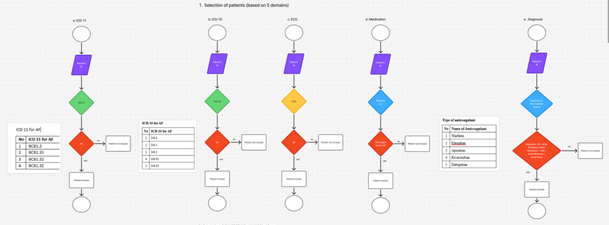

Figure A2. Submitted workflow reference image 2.
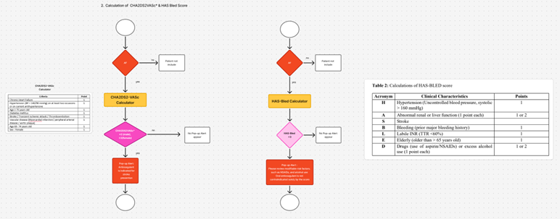

Figure A3. Submitted workflow reference image 3.
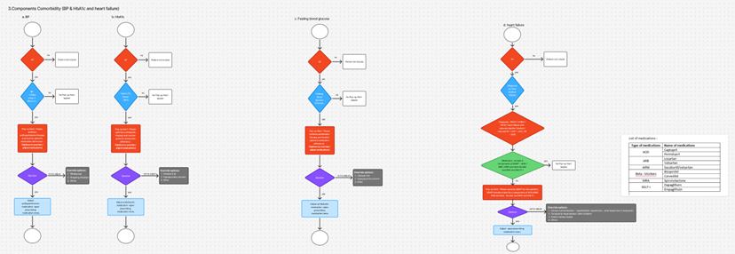

Figure A4. Submitted workflow reference image 4.
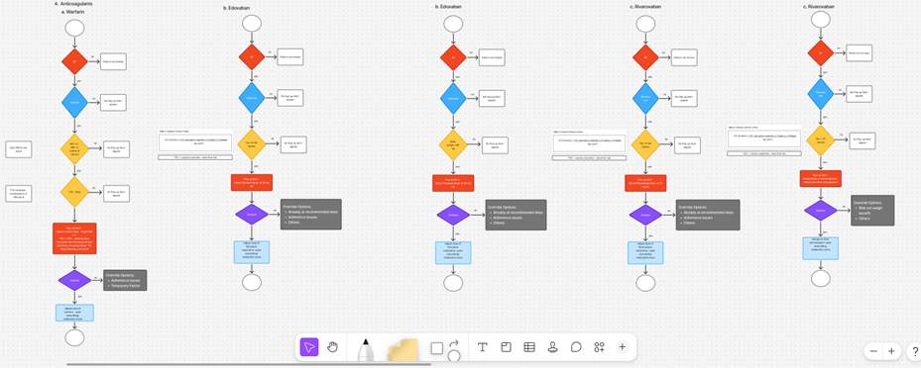

Figure A5. Submitted workflow reference image 5.
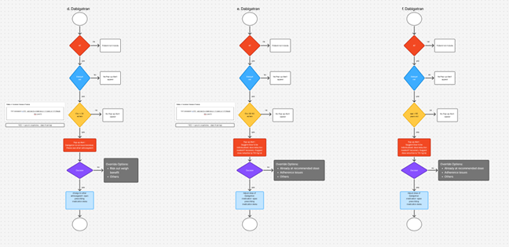

Figure A6. Submitted workflow reference image 6.
