  
(All rights reserved)

**UNIVERSITY OF GHANA**

**COLLEGE OF BASIC AND APPLIED SCIENCES**

**DEPARTMENT OF COMPUTER ENGINEERING**

**SCHOOL OF ENGINEERING SCIENCES**

**SEMESTER 1 2022/2023 ACADEMIC YEAR**

**Course Code and Title: CPEN 211 Database System Design**

**Project 2**

**ID:** 10975589

**Question: 1**

1. Understand the business processes: To automate the activities of Airport Shell, I will need to understand the various business processes involved in running a filling station. This includes understanding the sales process, fuel dispensing process, customer management process, employee management process, inventory management process, and other related processes.

2. Gather Requirements: I will first gather all the requirements from the stakeholders, including management, employees, and customers to understand their needs and expectations from the automated system.

3 . Analyze and Design the System: Based on the requirements gathered, I will create a conceptual, logical and physical model of the database. This model will outline all the entities and relationships required for the automated system.

4. Develop the Database: Using the conceptual, logical and physical models, I will develop the database that stores all the information required for the automated system. This includes the creation of tables, relations, indexes, and keys.

5. Test and Deploy the System: Once the database is developed, it will be tested to ensure that it meets the requirements and is fully functional. After testing, the system will be deployed for use by management, employees, and customers.

**Question: 2**

**ENTITIES AND RELATIONSHIPS:**

Based on the requirements gathered, the following entities and relationships will be created in the Airport Shell database:

1. Customers: This entity will store the customer's personal information such as name, address, contact details, and payment details.

2. Products: This entity will store information about the products sold at the filling station such as fuel, oil, and lubricants.

3. Orders: This entity will store information about the customer's orders such as the type of products bought, quantity, and amount paid.

4. Employees: This entity will store the employee's personal information such as name, contact details, and role at the filling station.

5. Shifts: This entity will store information about the employee's shifts, including the time, date, and duration of the shift.

1. Sales: This entity will store information about the sales made at the filling station, including the date, time, and amount.
2. Supplier: This entity will store information about the supplier of the filling station, including the quantity supplied.
3. Fuel: This entity will store information about the fuel sold at the filling station, including the price and quantity.

**Question: 3**

Entity Relationship Diagram:

The entity relationship diagram (ERD) for the Airport Shell database is as follows:

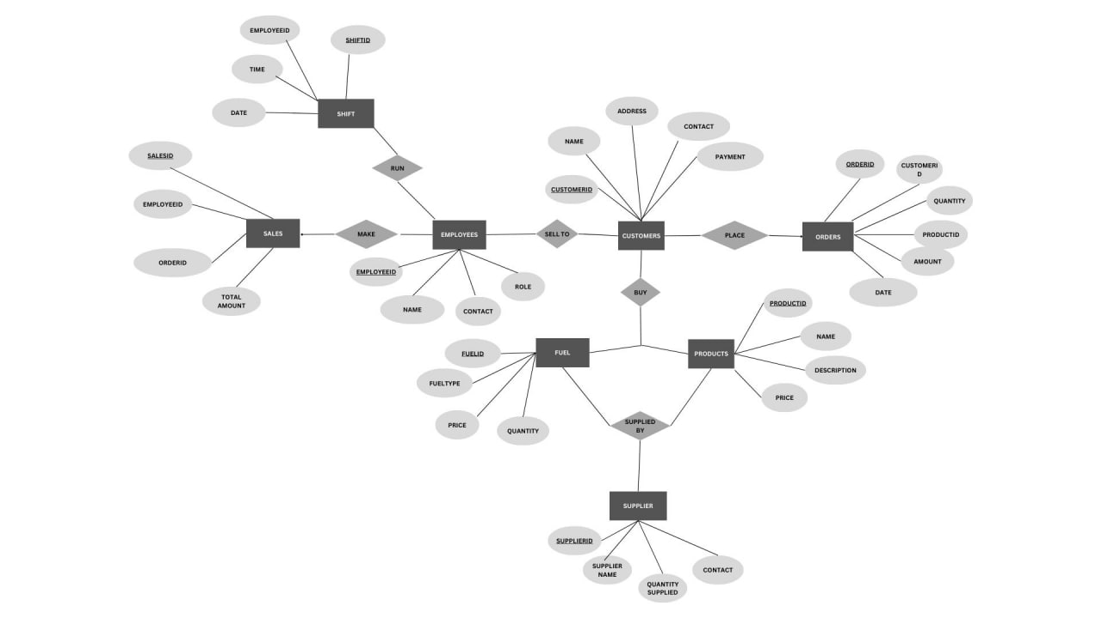

Database Implementation:

Using the design and ERD described above, I will implement the database using PostgreSQL database management.

To implement the ERD, the following SQL code can be used:

CREATE TABLE Customers (

CustomerID INT PRIMARY KEY,

Name VARCHAR NOT NULL,

Address VARCHAR NOT NULL,

Contact VARCHAR,

Payment VARCHAR NOT NULL

);

CREATE TABLE Products (

ProductID INT PRIMARY KEY,

Name VARCHAR NOT NULL,

Description VARCHAR,

Price DECIMAL NOT NULL

);

CREATE TABLE Orders (

OrderID INT PRIMARY KEY,

CustomerID INT REFERENCES Customers(CustomerID),

ProductID INT REFERENCES Products(ProductID),

Quantity INT NOT NULL,

Amount DECIMAL NOT NULL,

Date DATE NOT NULL

);

CREATE TABLE Employees (

EmployeeID INT PRIMARY KEY,

Name VARCHAR NOT NULL,

Contact VARCHAR NOT NULL,

Role VARCHAR NOT NULL

);

CREATE TABLE Shifts (

ShiftID INT PRIMARY KEY,

EmployeeID INT REFERENCES Employees(EmployeeID),

Start_time TIMESTAMP NOT NULL,

End_time TIMESTAMP NOT NULL,

Da_te DATE NOT NULL

);

CREATE TABLE Sales (

SaleID INT PRIMARY KEY,

EmployeeID INT REFERENCES Employees(EmployeeID),

OrderID INT REFERENCES Orders(OrderID),

TotalAmount DECIMAL NOT NULL,

Date DATE NOT NULL  
);

create table Supplier(

SupplierID varchar primary key not null,

SupplierName varchar not null,

QuantitySupplied int not null,

PhoneNumber varchar not null,

SupplierEmail varchar not null

);

create table Fuel(

FuelID varchar primary key not null,

FuelType varchar not null,

Price_per_litre decimal(10,2) not null,

Quantity_ltr int not null

);

In the Airport Shell database, the primary keys and foreign keys are as follows:

Primary Keys:

1. Customers - CustomerID

2. Products - ProductID

3. Orders - OrderID

4. Employees - EmployeeID

5. Shifts - ShiftID

6. Sales - SaleID

7. Supplier - SupplierID

8. Fuel - FuelID

1. Orders - CustomerID (refers to the primary key in Customers table)

2. Orders - ProductID (refers to the primary key in Products table)

3. Sales - EmployeeID (refers to the primary key in Employees table)

4. Sales - OrderID (refers to the primary key in Orders table)

This code creates the necessary tables for the entities, as well as defining their relationships and constraints. Additional data can then be added to the tables as needed.